PFII/2007/WS.4/11
Original: English
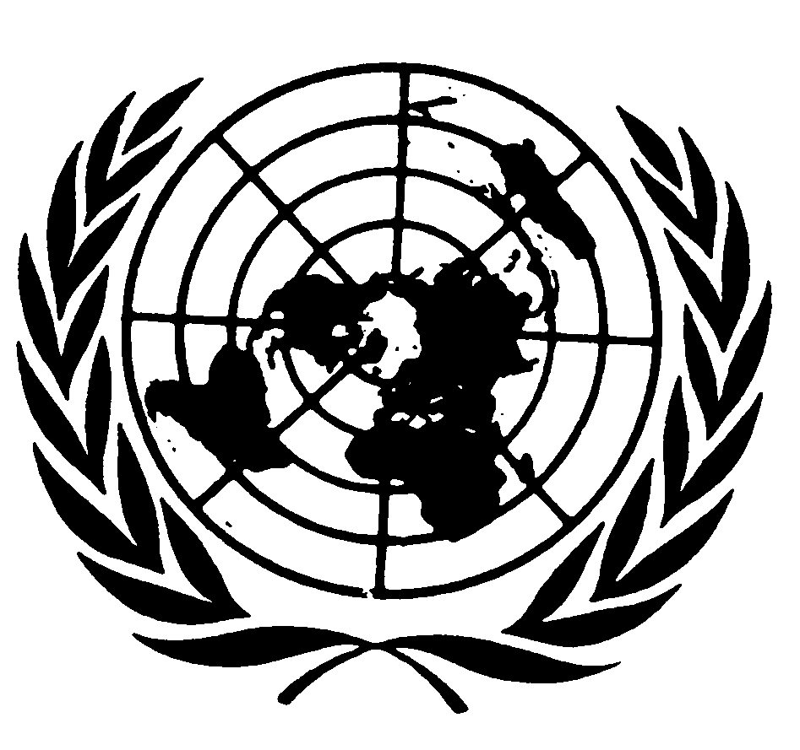
UNITED NATIONS NATIONS UNIES

DEPARTMENT OF ECONOMIC AND SOCIAL AFFAIRS
Division for Social Policy and Development
Secretariat of the Permanent Forum on Indigenous Issues

INTERNATIONAL EXPERT GROUP MEETING ON THE CONVENTION ON BIOLOGICAL DIVERSITY’S INTERNATIONAL REGIME ON ACCESS AND BENEFIT-SHARING AND INDIGENOUS PEOPLES’ HUMAN RIGHTS
17 – 19 January 2007, New York

RECENT DEVELOPMENTS ON
ACCESS TO GENETIC RESOURCES
AND BENEFIT-SHARING
UNDER THE CONVENTION ON BIOLOGICAL DIVERSITY
by
John Scott
Secretariat of the Convention on Biological Diversity

