 |  |  | 
Book launch
and panel discussion

Indigenous peoples’ right to adequate housing:
A global overview
Jointly published by:  UN-HABITAT and the Office of the United Nations High Commissioner for Human Rights |  | 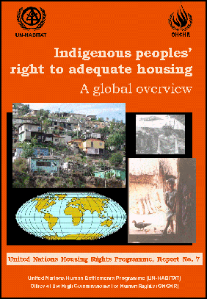
“The report constitutes a preliminary but important first step toward understanding the relationship between all economic, social and cultural rights and the progressive realization of the right to adequate housing of indigenous peoples…. The report calls for further attention to be given to this critical human rights concern. Above all, it calls for renewed commitment from the international community to improve the living conditions of the world’s indigenous peoples.”
Mrs. Anna K. Tibaijuka, Executive Director, UN-HABITAT
Mrs. Louise Arbour, UN High Commissioner for Human Rights
When: | 18 May 2005, 1.15-2:45 P.M.
Where: | Conference Room 9,  United Nations, New York
Guest of Honour: | Mrs. Anna K. Tibaijuka, Executive Director, UN-HABITAT
Panellists: | Ms. Ida Nicolaisen, PFII  Ms. Victoria Tauli-Corpuz, PFII  Mr. Parshuram Tamang, PFII  Ms. Elissavet Stamatopoulou, PFII Secretariat  Mr. Julian Burger, OHCHR  Mr. Selman Ergüden UN-HABITAT

 |  | United Nations Housing Rights Programme (UNHRP) report No. 7
For more information contact:
Mr. Selman Ergüden
Chief, Housing Policy and Development Section
Coordinator, UNHRP
UN-HABITAT
PO Box 30030, Nairobi 00100, KENYA
Tel: (254-20) 624231
Fax: (254-20) 624265
E-mail: Housing.Policy@unhabitat.org
Web-site: http://www.unhabitat.org/housing

