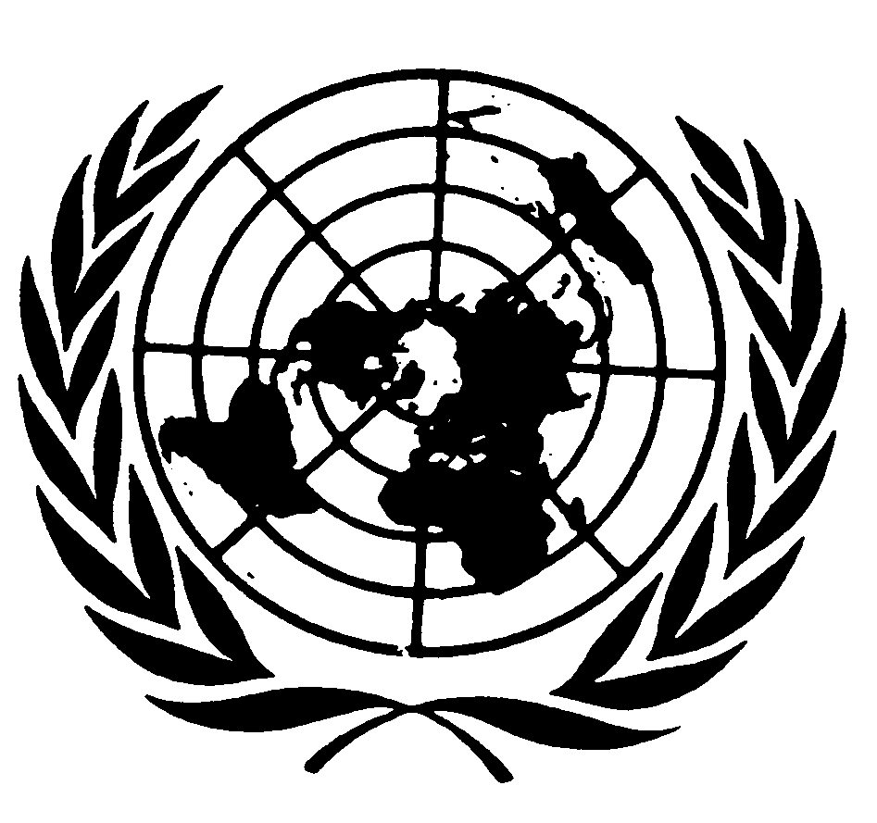
U N I T E D N A T I O N S N A T I O N S U N I E S

Statement by
Mr. Sha ZUKANG
Under-SECRETARY-GENERAL for economic and social affairs
and coordinator of the second decade of
the world’s INDIGENOUS peopleS
to the ninth session of
the united nations permanent forum on indigenous issues

New York, 19 April 2010

Distinguished Members of the Permanent Forum on Indigenous Issues,
Distinguished representatives of Member States, Indigenous Peoples’ Organizations and Non-Governmental Organizations,
Distinguished representatives of the UN system and other intergovernmental organizations,
Mr. Ahmed Djoghlaf, Executive Secretary of the Convention on Biological Diversity,
Distinguished Elders,
Ladies and Gentlemen,

I welcome you all to the ninth session of the UN Permanent Forum on Indigenous Issues.

We meet at a time when the United Nations, indigenous peoples and Member States have achieved extraordinary progress. These include the establishment of the Permanent Forum itself, the 2007 adoption of the UN Declaration on the Rights of Indigenous Peoples, the establishment of a Special Rapporteur role which focuses on human rights abuses, and the creation of the Expert Mechanism on the Rights of Indigenous Peoples.

I welcome the ever-growing engagement of Member States in the Permanent Forum. This year, fifteen Member States have submitted voluntary reports on indigenous issues to the Forum – a record number.

In recent years, the Forum has influenced the agendas of other organizations. UN agencies, international financial institutions and other organizations have developed guidelines, policies and safeguards that recognize and support the needs of indigenous peoples. This ripple effect across organizations is testament to the ability of the Forum to change awareness levels and prompt actions on indigenous issues.
The United Nations has brought global attention to these issues through two “international decades” on the World’s Indigenous Peoples. The resulting commemorations and public information activities have increased awareness levels and educated millions of people. We are reaching the midway point of the Second Decade. We will mark that milestone with a mid-term report by the Secretary-General that evaluates the progress made towards advancing the civil, economic, cultural, political and social rights of indigenous peoples.

Ladies and gentlemen,

In spite of these remarkable advances, we must recognize that the situations of indigenous peoples in many parts of the world are critical. They continue to suffer from prejudice and marginalization, and they are subject to disproportionate and extreme poverty.

Moreover, we have seen that some development efforts have damaged rather than improved their well-being. In many cases their land rights, traditional sources of knowledge and cultural priorities have not even been recognized, much less respected and incorporated into development plans.

For this reason, the Forum will focus this year on how the culture and identity of indigenous peoples can be integrated into development agendas and practices.

Distinguished representatives,

It is not only indigenous peoples but society at large that loses out when development approaches ignore values, customs and ancient practices. Indigenous peoples have a great deal to teach us. Their natural resource management systems, for example, are ecologically sustainable. Their lifestyles and habits result in low carbon economies. We can learn from these techniques and bring them to the attention of environmental specialists and to the general population. Indeed, as we face a lingering global economic crisis which has exacerbated the effects of climate change, it is crucial that we consider alternative ways of preserving our environment.

During this session I urge you to thoroughly investigate the ways in which other visions and perspectives of indigenous peoples can become central to international, regional, national, and local development agendas. How can agricultural technology work with ancient farming practices? How can Governments and health organizations expand services to indigenous peoples and respect their spiritual practices at the same time?

In your discussions of these topics, please also focus on how to reflect the voices of indigenous women and youth. Their inclusion will benefit not only their societies but the larger societies that surround them.

Articles 3 and 32 of the United Nations Declaration on the Rights of Indigenous Peoples should inform your work. Article 3 states their right to self-determine their political status and their pursuit of economic, social and cultural development. Article 32 states their right to self-determine how their lands, water, minerals and other resources will be used. How can these articles be used to inspire and empower indigenous peoples? How can they help protect the cultures and traditions of people with long histories of discrimination and oppression? Your guidance, expertise and collaboration are needed in answering these questions.

May I remind you to work with an awareness of internationally agreed development goals, especially the Millennium Development Goals. They should form the backdrop of your consultations and your recommendations. As you know there will be a Summit on the MDGs in September of this year and so your input at this time is critical.

Before concluding, allow me to say a few words on the process of the Permanent Forum. I wish to commend its new methodology of holding in-depth dialogues with UN agencies. This year’s dialogue will engage the Secretariat of the Convention on Biological Diversity. It will provide Forum Members and observers the opportunity to learn more about its work with indigenous peoples and how it can be furthered strengthened.

The Forum will also hold dialogues with the Governments of Bolivia and Paraguay about the conditions faced by indigenous peoples of the Chaco region. These dialogues mark the Forum’s first in-depth discussions with Member States based on voluntary reports from them. I hope these talks will be productive and prove useful for future sessions.

I would also like to thank the Government of the Plurinational State of Bolivia for hosting the pre-sessional meeting of the Permanent Forum last month. We are very grateful for your support.

Many thanks also, to the Member States who have made contributions to the Trust Fund of the Permanent Forum in 2009: Algeria, Bolivia, Canada, Chile, Colombia, Cyprus, Denmark, Estonia, Finland, Madagascar, Mexico and Norway.

Mr. Chairperson,
Distinguished Members of the Forum,
Ladies and gentlemen,

The work of the Permanent Forum is invaluable. It brings together on a global stage all the key players that can effect change for indigenous peoples: indigenous representatives themselves, Member States, the United Nations system, other inter-governmental organizations and non-governmental organizations. The Forum gives voice to people who, in many cases, would be otherwise voiceless. May you maximize this ninth session by sharing best practices and strategizing on new, alternative development models that not only protect but incorporate the knowledge and wisdom of indigenous cultures.

I wish you every success at this year’s session of the Permanent Forum and I thank you in advance for your hard work and dedication in the coming weeks.

******

These include the Asian Development Bank, European Bank for Reconstruction and Development, European Investment Bank, Inter-American Development Bank, World Bank, United Nations Collaborative Program on Reducing Emissions from Deforestation and Forest Degradation (UN REDD), and the International Fund for Agricultural Development (IFAD).

