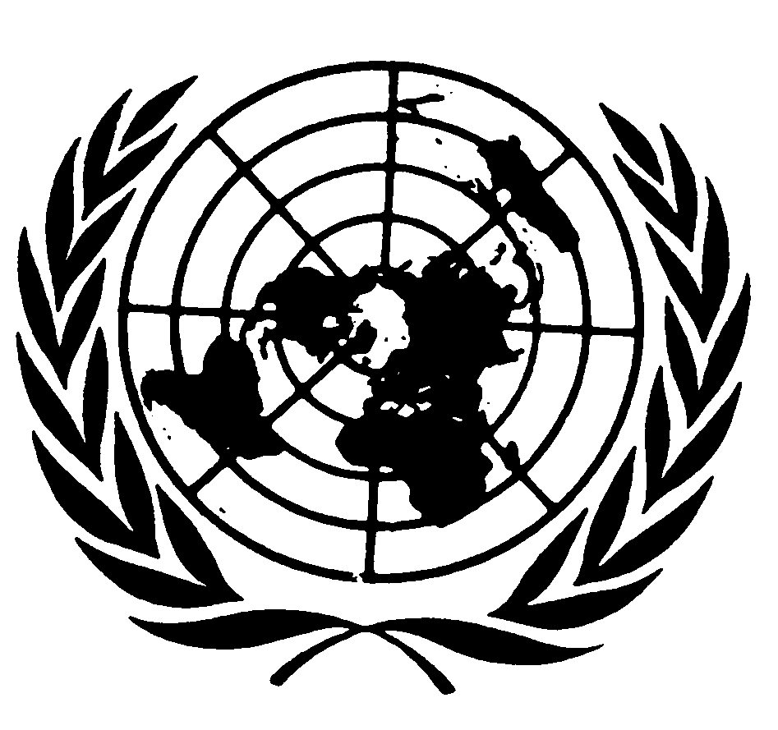
U N I T E D N A T I O N S N A T I O N S U N I E S

THE SECRETARY-GENERAL
--
REMARKS AT OPENING OF THE NINTH SESSION OF THE
UNITED NATIONS PERMANENT FORUM ON INDIGENOUS ISSUES
New York, 19 April 2010

Your Excellency Mr. President of the General Assembly,
Distinguished Elders,
Distinguished representatives of Indigenous Peoples’ Organizations,
Excellencies,
Ladies and Gentlemen,

It is my great pleasure to welcome you to this Ninth Session of the United Nations Permanent Forum on Indigenous Issues.

Many of you have traveled long distances to be here today. Thank you.

Indigenous peoples often live in the most isolated places on earth – from the Arctic to the African savannah.

But the United Nations is working to make sure that indigenous people themselves are not isolated.

You have a unique place in the global community. You are full and equal members of the UN family.

And we will continue to support and protect your human rights and fundamental freedoms, and your right to pursue social and economic development.

I attach great importance to the United Nations Declaration on the Rights of Indigenous Peoples, which was adopted in September 2007.

In that landmark document, UN Member States and indigenous peoples sought to reconcile with their painful histories and resolved to move forward together towards human rights, justice and development for all.

I congratulate you once again on this achievement.

Ladies and gentlemen,

We have made significant progress on indigenous peoples’ issues at the United Nations over the past forty years.

Apart from the Declaration on the Rights of Indigenous Peoples, other notable achievements include the establishment of this Permanent Forum… the mandate of the Special Rapporteur… and the Expert Mechanism on the Rights of Indigenous Peoples.
Indigenous issues are more prominent on the international agenda than ever before.
And yet… we can not even begin to be content with our progress.

The first-ever United Nations report on the State of the World’s Indigenous Peoples in January set out some alarming statistics.

Indigenous peoples suffer high levels of poverty, health problems, crime and human rights abuses all over the world.

You make up some five per cent of the world’s population – but one-third of the world’s poorest.

In some countries, an indigenous person is 600 times more likely to contract tuberculosis than the general population.

In others, an indigenous child can expect to die twenty years earlier than his non-native compatriots.

Every day, indigenous communities face issues of violence, brutality and dispossession.

Indigenous cultures, languages and ways of life are under constant threat from climate change, armed conflict, lack of educational opportunities and discrimination.

Elsewhere, your cultures are being distorted, commodified, and used to generate profits which do not benefit indigenous people, and can even lead to harm.

This is not only a tragedy for indigenous people.

It is a tragedy for the whole world.

Slowly but surely, people are coming to understand that the well-being and sustainability of indigenous peoples are matters that concern us all.

Diversity is strength – in cultures and in languages, just as it is in ecosystems.

The loss of irreplaceable cultural practices and means of artistic expression makes us all poorer, wherever our roots may lie.

According to current forecasts, ninety per cent of all languages could disappear within 100 years. The loss of these languages erodes an essential component of a group’s identity.

That is why the special theme of your forum this year, “Development with Culture and Identity,” is particularly appropriate. It highlights the need to craft policy measures that promote development while respecting indigenous peoples’ values and traditions.

We need development that is underpinned by the values of reciprocity, solidarity and collectivity. And we need development that allows indigenous peoples to exercise their right to self-determination through participation in decision-making on an equal basis.

Ladies and Gentlemen,

The United Nations will continue to support you.

I call on all Governments, indigenous peoples, the UN system and all other partners to ensure that the vision behind the Declaration on the Rights of Indigenous Peoples becomes a reality for all.

I wish you a very successful Forum.

Thank you.

