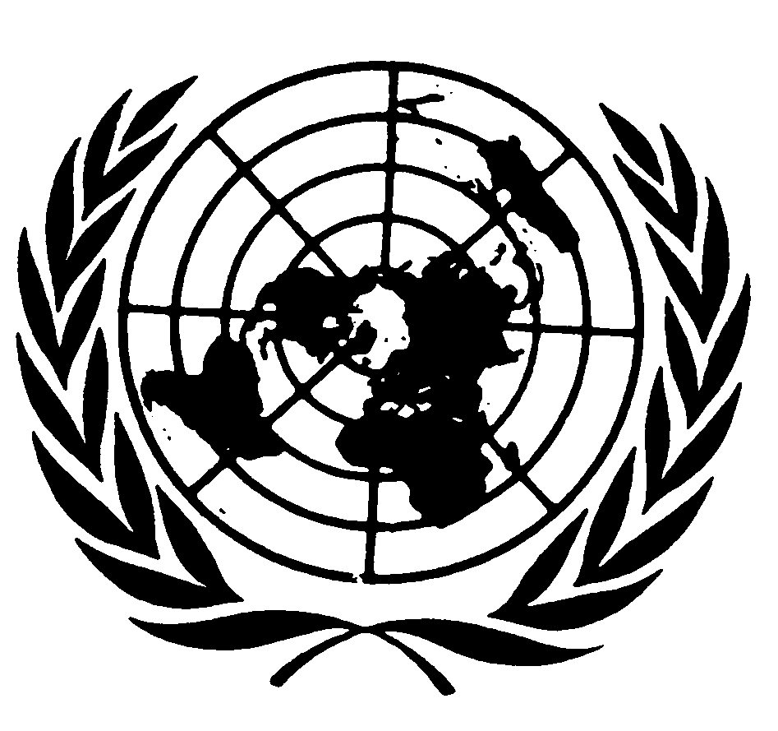
U N I T E D N A T I O N S N A T I O N S U N I E S

Statement by
Mr. Sha Zukang
under-SECRETARY-GENERAL for economic and social affairs
and coordinator of the second INTERNATIONAL decade
of the world’s indigneous people

on the
2010 international day of the World’s indigenous people

New York, 9 August 2010

Excellencies,
Dear colleagues,
Ladies and Gentlemen,

Welcome to this special celebration of the 2010 International Day of the World’s Indigenous People.

I begin by thanking our partners that organized this event: the NGO Committee on the UN International Decade of the World’s Indigenous People and its Chairperson, Mr. Roberto Múcaro Borrero. The Committee’s hard work in preparing for this day is much appreciated.

As the Secretary-General said in his message, today we honour indigenous filmmakers for their exceptional work in raising awareness about the culture, history and everyday life of indigenous peoples. These filmmakers capture aspects of our common humanity that would otherwise go unknown. Their work enriches our minds, our societies, and the lives of future generations.

Ladies and Gentlemen,

This year, 2010, marks the midpoint of the Second International Decade for the World’s Indigenous People. As you know, the Decade initiative was created to galvanize action toward improving all aspects of the lives of indigenous peoples.

A main achievement of the Second Decade was the adoption by the General Assembly in 2007 of the Declaration on the Rights of the Indigenous People. The Declaration came after years of negotiations and was a landmark in the struggle of indigenous people for justice, equal rights and development. It pleases me to say that in a few countries, mainly in Latin America, the Declaration has become a part of constitutional reform processes. This integration is so vital for building strong foundations for the political, social and economic future of the indigenous in these countries.

The Declaration and the Second International Decade has also provided impetus for some governments - such as those of Japan, Canada and Australia - to recognize the existence and rights of indigenous people and in some cases to offer apologies to them for past injustices.

Other recent achievements include the creation of consultative institutions for indigenous peoples and the formation of their own political parties. Russia, Nepal and Ecuador have set examples in these arenas.

The promotion of films like the ones we have seen today, along with other indigenous art forms, is also encouraged and supported by the Declaration and the Second Decade. These initiatives not only address the social, political and economic rights of indigenous communities. They also draw attention to the need to protect cultural manifestations – in technological, visual and performing art forms.

Excellencies,

These signs of progress are promising. But we must recognize that many objectives of the Second Decade are in danger of going unfulfilled. As Coordinator of the Decade, I must be forthright about this. It is clear that Member States and civil society groups, in tandem with the UN system, must do more to equalize and elevate the status of indigenous people.

Most countries have yet to recognize their indigenous communities. Without recognition, their land and resources claims are denied, and all aspects of their advocacy work are handicapped.

International financial institutions and development organizations need to meet with indigenous groups more frequently and more formally. Indigenous concerns and policy requests need to be considered with increased seriousness and urgency.

In places where indigenous people do have recognition, their level of direct political participation is very low. The numbers of women representing their communities are at unacceptably low levels.

The upcoming report of the Secretary-General will present more information about progress and gaps toward fulfilling the goals and objectives of the Declaration and the Second International Decade. The report will be launched in time for the sixty-fifth General Assembly this year. I urge all of you to give it your fullest attention.

I also call your attention to an activity guide that my Department has created. It provides ideas on practical activities for indigenous peoples’ organizations, NGOs and local governments to improve collaboration, increase awareness and cultural sensitivity and create policies to better address the human rights and concerns of indigenous peoples I encourage all Member States, UN agencies and intergovernmental organizations to read this guide and make use of its recommendations.

Ladies and Gentlemen,

I thank you for your participation here today. This celebration is a unique, inspiring event. Let us leave with a richer appreciation for cultures, traditions and languages beyond our own. May we also leave here with a renewed sense of responsibility about what we, the international community, can do to advance the overall status and human rights of indigenous people and to protect their cultural treasures.

