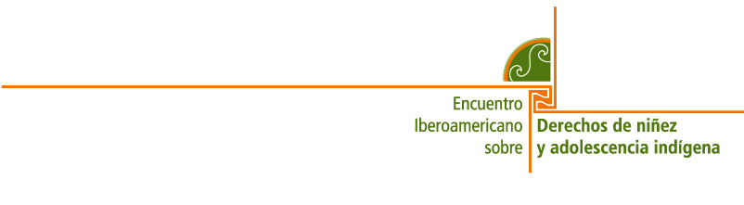

DECLARATION FROM THE INDIGENOUS CHILDREN AND ADOLESCENTS OF LATIN AMERICA
TO THE 2005 IBERO-AMERICAN SUMMIT MEETING

We are children and adolescents from indigenous populations of 17 Latin American countries, who have gathered in Madrid on 7-8 July 2005, for the Ibero-American Meeting on the Rights of Indigenous Children and Adolescents. We want to speak out about our needs, concerns and visions and demand that you, adults and authorities from our countries, commit yourselves to create the conditions for us to be able to exercise all of our rights enshrined in the Convention on the Rights of the Child.

We are boys, girls and adolescents belonging to 34 indigenous peoples; we are creators, bearers and transmitters of our cultures whose contributions to humankind contribute to coexistence, diversity and peace. But we live under conditions of exclusion, marginalization, racism and discrimination that prevent us from developing as human beings and full citizens with specific rights of our own.

We have come together because we want to know and respect one another as different peoples, to share our desire to participate in the building of a more just world. For this reason, we demand that our elders and governments listen to what we have to say and solve our problems so that we may exercise our rights to territory, identity and culture, health and nutrition, education, protection and participation, among other fundamental rights.

In view of this situation, we call on:

Governments to fulfil the rights of all indigenous boys, girls and adolescents in Latin America:
- Devote a specific part of the public budget to the development and fulfilment of indigenous rights.
- Ensure that indigenous peoples are recognized under the constitutions of all the countries in which they live, in order to guarantee mutual respect between indigenous and non-indigenous populations and eradicate racism and discrimination of all kinds.
- Ensure access by all indigenous boys, girls and adolescents to quality education based on our peoples’ cultures, including access to appropriate technology and infrastructure.
- Ensure that we have access to high quality health care and nurturing of our full physical, mental and emotional development, incorporating our traditional healing traditions and medicines.
- Guarantee our protection against mistreatment, child labour, exploitation, armed conflicts and abuse of all kinds.
- Eradicate the illegal use of our traditional crops and support the development of other productive crops. .
- Implement ways in which children and adolescents are consulted and are able to participate and monitor the functioning of State bodies so that they report back to indigenous children on issues that affect them.

Indigenous peoples’ organizations, movements and leaders to:
- Promote meetings between indigenous children and adults so that we have a chance to express what we want and need and thereby help to find solutions that allow us to live better together, based on the identity of each of the peoples.
- Demand that governments and States respect and fulfil our rights.
- Include our needs and demands in your plans and proposals.
- Help establish and organize a council of youths within indigenous organizations, so that we can work with them and establish and carry out our own plans.

International agencies to:
- Demand that governments fulfil all of the rights enshrined in the international agreements, treaties and conventions that protect us.
- Provide technical support to our States, governments, organizations and authorities for the implementation of the commitments made by each country to children, especially indigenous children.
- Publicize the situation facing indigenous peoples and us as boys, girls and adolescents regarding our rights.
- Help us keep our promises.
- Demand that States address the situation of children and adolescents affected by armed conflicts.

We commit ourselves to:
- Contribute our ideas, voice our needs and demand our rights.
- Tell our friends, schoolmates and families what we have learned here about our rights.
- Ask our relatives, communities, peoples and governments to help us to learn more about our history and cultures, while deepening our spirituality and collective identities.
- Organize children and adolescents to follow up on the commitments we have made during this Ibero-American Meeting.

With the support of all the agencies, with the contribution that each and every one of us is going to make, and with the wisdom of the grandfathers and grandmothers, together we can achieve a better world in which our rights are respected.

Madrid, 8 July 2005

