PFII/2010/EGM
Original: English, Russian

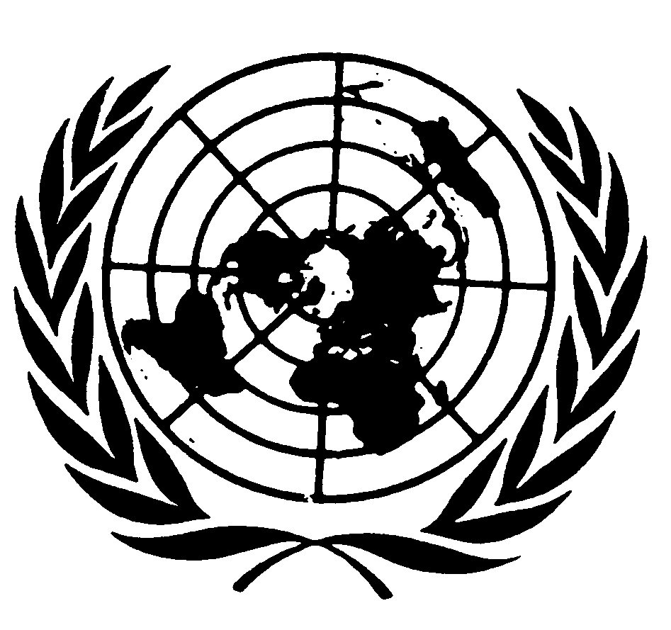
UNITED NATIONS NATIONS UNIES

DEPARTMENT OF ECONOMIC AND SOCIAL AFFAIRS
Division for Social Policy and Development
Secretariat of the Permanent Forum on Indigenous Issues

INTERNATIONAL EXPERT GROUP MEETING
Indigenous Peoples: Development with Culture and Identity
Articles 3 and 32 of the United Nations Declaration on the Rights of Indigenous Peoples
(New York, 12 - 14 January 2010)

Contribution by

Ms Anna Naikanchina
Vice-President of RAIPON,
Chair of Information and Legal Center of Indigenous Peoples of the North of the Republic of Buryatiya ”Nerilik”(Hope)
e-mail: naikanchina@inbox.ru

Russia is one of the polyethnic countries in the world in spite of the fact that about 80% of citizens identify themselves as Russian people. There are 200 ethnic groups residing on the territory of the Russian Federation and apart from the Russian people the population of a million or about this number is reached by buryats, yakuts, bashkirs, kalmyks and others. Nevertheless, most of the peoples living in Russia are ethnic groups not exceeding 50 thousand people, who live densely or are dispersed over 64% of the territory of the country. The population of indigenous peoples of the North, Siberia and Far East is 243,982 peoples (by the All-Russia census of 2002) which makes 0.2 of the total population of Russia.

The indigenous peoples of the North have preserved their traditional lifestyle on the lands of their ancestors, their distinct culture, language, traditions and customs. They continue to be engaged in reindeer herding, fishing and hunting. Their well-being and sustainable development is critically dependent on the wellness of their original habitat, access to their lands, traditional territories and natural resources. However, their rights and interests are infringed in the course of exploration and development of oil and gas, gold and diamonds, uranium and coal, harvesting of wood and industrial felling. As a result, irreparable damage is being caused to the habitat and traditional lifestyle of the indigenous peoples.

In Russia, like many other countries, the state enjoys the exclusive right of ownership of mineral resources. Most of the lands, territories and natural resources are state property. The relationship pertaining to protection and use of natural resources, as well as lands, water bodies, forest and mineral resources is regulated by federal law. However, many norms in the federal laws are declarative in nature, or their implementation requires issuance of subordinate legislations, or they are extinguished by other laws. For indigenous people it is important that the federal laws on land and mineral resources include the principle of free, prior and informed consent of indigenous peoples. This principle, however, is not captured by the Russian law. Even though in 2007 V.V.Putin said: “We have laws in place towards support of the indigenous peoples of the North, their national cultures. We will attach priority importance to this. Russia is unique by its national and cultural make-up. This is our richness and we cannot be wasteful in this respect. We will do everything to preserve and maintain our wealth. This also concerns the Russian business: in implementation of investment projects due regard should always be given to the interests of local inhabitants and particularly the indigenous peoples of the North. Major companies in case of investments should care about preservation of traditional activities of these peoples and maintaining the ecological stability and ecological situation. This is a very important direction.”
The indigenous peoples are well aware of the importance of state interests of Russia in the Arctic region, strengthening of economic potential and development of resource base and they hope that their rights will not be infringed in this process. Nevertheless, the authorities concurring projects on traditional territories of indigenous peoples with industrialists, do not take into account the interests of the indigenous population and therefore violate their rights. Plenty of examples in Russia can be provided: the Evenkiyskaya hydropower plant, construction of East Siberia-Pacific oil pipeline, development of Kamchatka shelf, Sakhalin projects etc. Clearly, the federal law and international agreements are not observed in those cases. The principle of free, prior and informed consent of indigenous peoples is not realized at the national level, even though this principle has been recognized by the ILO Convention # 169 and Convention on Biodiversity and is crucial for recognition of the rights of indigenous peoples for lands, territories and resources.

In the United Nations Declaration on the Rights of Indigenous Peoples this principle is set out in five articles. Article 32 recognizes the right of indigenous peoples to determine and develop priorities and strategies for the development or use of their lands or territories and other resources. The states, in turn, should not only consult and cooperate in good faith with the indigenous peoples prior to approval of any project affecting their lands or territories and other resources, particularly in connection with the development, utilization or exploration of mineral, water or other resources, but also provide effective mechanisms for just and fair redress of any such activities and take appropriate measures to mitigate adverse environmental, economic, social, cultural or spiritual impact.

What is the most acute problem associated with implementation and protection of the rights of the indigenous peoples in Russia today?

In the latest years, not only did the state stop pursuing the particular northern policy to allow for distinct features of the Far North areas and equated localities and indigenous peoples, but has no single state national policy. More frequently the norms related to the rights of indigenous peoples are diluted from federal laws.

The thing is that without the right to free use of lands and natural resources, the right of access for using them in compliance with the customary law, there is little sense in constitution guarantees, uniting as communities and setting up traditional nature use territories. The Federal law “About territories of traditional nature use of the indigenous peoples of the North, Siberia and Far East of the Russian Federation” adopted in 2001 has not been observed for 8 years.

Without the rights to free use and ownership, in the conditions of the North, management of biological resources and adaptation to changing social, environmental and climate conditions is impossible.

Therefore:
The most important thing is the right to their land (territory) which for indigenous peoples is their true home bearing the experience of dozens and hundreds of generations, a feeding part of tundra or taiga, mountain or coast, sacred sites and ancestor burials. The existing land law in Russia practically does not give any rights to free use of lands, nor protection from their confiscation.

Secondly, the right for preserving traditional lifestyle, native language, original culture and transfer of traditional knowledge. This should be done without paternalism and imposing modern models of cultural development under new conditions. In many regions of Russia rural schools are being closed. Learning of native languages is not only limited, but practically abandoned altogether. In rural settlements clubs are closed, folklore groups do not receive necessary financing. Powers in the culture sphere have been delegated to the municipal level and the culture sector is financed in the last turn.

Thirdly, the right to traditional use of biological and other resources such as reindeer pastures, harvesting fauna, fish, non-wood resources of forest including wild plants, with due regard to the priorities of indigenous peoples. Communities cannot become owners of hunting lands, finishing areas, pastures and agricultural lands. Communities cannot obtain long-term licenses for the wildlife use rights, quotes for fishing. Fishing and hunting areas are leased for long-term tenure to fishery and industrial companies, because by the current federal law everything is subject to tendering and bidding. Many communities are not able to compete with major companies. As a consequence, the indigenous peoples do not conduct traditional economic activities, nor do they consume traditional food, which poses a threat to their traditional lifestyle and health.

Fourth, the right to advocate the interests of indigenous peoples in all institutions of state authority, have guaranteed representation and set up self-government bodies.

The Russian Federation does not fulfils the Millennium Declaration that calls for ensuring by states of participation of indigenous peoples in decision making on the issues of vital importance for them. Two international pacts on human rights of 1966 begin with the declaration about the right of nations for self-determination. In fact, the concept of equality and self-determination has been laid out in the UN Charter on Huamn Rights and represents one of the core principles of the international law today. Article 3 of the UN Declaration on the Rights of Indigenous Peoples states the right of indigenous peoples for self-determination. This document says that by virtue of that right they freely determine their political status and freely pursue their economic, social and cultural development. In exercising this right indigenous peoples have the right to autonomy or self-government in matters relating to their internal and local affairs.

However, today in Russia the constituents (subjects) of the Russian Federation are being consolidated and in doing so, few subjects based on the national principle are left (Komi-Permyatsky autonomous okrug has become part of the Perm kray, Taymyr (Dolgano-Nenets) autonomous okrug and Evenkiysky autonomous okrug have merged withthe Krasnoyrsky kray, Koryaksy autonomous okrug is now part of the Kamchatka kray etc)

For protection of the rights of indigenous peoples some of the constituents of the Russian Federation establish representation forms not provided by the federal law such as two-chamber parliaments, deputy associations in one-chamber parliaments, assemblies of representatives of indigenous peoples (Khanty-Mansyisk autonomous okrug), institutions of envoys plenipotentiaries of indigenous peoples (Sakhalin oblast, Khabarovsk kray).With aggregation of the constituents of the Russian Federation, the administrative units are given the status of territory.

Article 11 of the Federal Law “On guarantees of the rights of indigenous peoples of the Russian Federation” entitles indigenous peoples to establish territorial public self-government, while the annulled Article 13 of this Law prescribed for representation of indigenous peoples in legislative bodies of the subjects of the Russian Federation and local self-government institutions. In addition, the federal law “On general principles of organization of the communities of the indigenous peoples of the North, Siberia and Far East of the Russian Federation” provides a possibility for awarding the communities, unions (associations) of indigenous peoples with special powers of local self-government. But the Russia-wide process of reforming the administrative system and division of powers going on since 2004 has revoked many articles and changes and amendments, in particular, those concerned with the rights of indigenous peoples and setting up their communities.

Fifth, legally established rights of indigenous peoples to monitor themselves, the environmental and resource situation on the lands of traditional occupation and traditional economic activity. The right to participate in decision making on any issue concerning the interests of indigenous peoples and to demand, if necessary, conducting environmental and ethnological evaluation. The right to take part in public evaluations of projects to be implemented on their territories. It clearly becomes vital to demand compulsory procedure of impact assessment for prospective economic activity in order to ensure preservation and development of indigenous peoples and ethnic groups living in the impact area.

Another hindrance to execution of the rights of indigenous peoples in the Russian Federation is the fact that these peoples fall under different regimes of legal protection and these regimes per se have not been clearly defined.

The above issues are pressing and important and they call for an integrated and targeted approach to establish a special regime for managing the territories of traditional occupation and nature use, which would rely, first of all, on the customary law of indigenous peoples. The laws on the rights of indigenous peoples should be codified, i.e. a sort of Code of the rights of the indigenous peoples of Russian Federation needs to be drawn up. Most destructive, in our view, are attempts of the state to unify ways of life and nature use practices of the indigenous peoples, to define rigidly through regulations what they need, without allowance for any deviations. For example, prescribed quantities such as the amount of wood for personal need or fish for personal consumption, or permissible square area of pasture per one reindeer. Traditional knowledge formed through the centuries and the customary law are being substituted by unified approaches, quotes, administrative procedures, templates of documents to be concurred, land tenure regulations.

Lastly:
- historically indigenous peoples have been self-governed with their own languages, cultures, laws and traditions;
- indigenous peoples are independent peoples and communities having the right to self-determination including the right to autonomy, self-government and identity;
- self-government and independent decision making on administrative and economic issues of indigenous peoples are elements of political autonomy;
- the territory of indigenous peoples and resources on it are vital for their subsistence, cultural and spiritual life and for achieving and implementing autonomy and self-government. This territory and resources should be guaranteed to the indigenous peoples in order to ensure their subsistence and sustainable development of their communities and culture.

