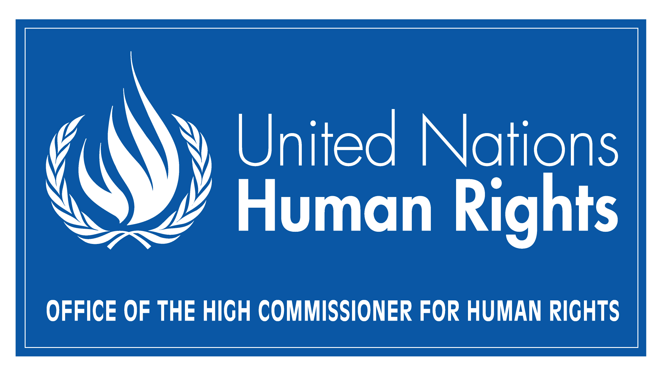

Information on recent activities of the Office of the High Commissioner for Human Rights related to the rights of indigenous peoples

Contribution to the ninth session of the UN Permanent Forum on Indigenous Issues

8 April 2010

Introduction

The rights of indigenous peoples have continued to be a priority issue for the Office of the High Commissioner for Human Rights, and indigenous issues figure prominently in the High Commissioner’s Strategic Management Plan for 2010-2011. The Declaration on the Rights of Indigenous Peoples is OHCHR’s central framework for action in this area, and the work of the Office seeks to contribute to the promotion and implementation of this key instrument.

Many of the OHCHR’s on-going activities on indigenous peoples reflect the recommendations made by the Permanent Forum on Indigenous Issues. As indicated during the constructive in-depth dialogue OHCHR carried out with the Forum during the eight session of the Forum on 22 May 2009, all recommendations that the Forum addresses to the Office are considered very seriously, and they have in many cases prompted concrete thematic and other activities.

This report highlights a number of pertinent activities carried out by OHCHR since the eight session of the Permanent Forum in May 2009. It is important to note, however, that this overview is by no means exhaustive, and there are a range of additional initiatives that field presences and other representatives of OHCHR have pursued to advance the implementation of the rights of indigenous peoples.

Engagement with National Human Rights Institutions and regional bodies

OHCHR has for several years supported national human rights institutions (NHRIs) in building capacity and developing their activities in line with the Principles relating to the Status of National Institutions (the Paris Principles). At the same time, in the area of indigenous peoples’ rights, OHCHR has led efforts to ensure better human rights protection in law and in practice. In December 2009, OHCHR brought these two key areas of work together by organising a global roundtable in Bangkok, Thailand, to further integration of the UN Declaration on the Rights of Indigenous Peoples in the work of NHRIs. The expert meeting brought together selected national human rights institutions and indigenous representatives from all regions to share good practices and to propose ways in which the Declaration could be invoked more regularly in the work of national human rights institutions in areas of concern for indigenous peoples. The possible role of sectoral human rights bodies devoted to indigenous peoples’ issues – the establishment of which was encouraged by the UN Expert Mechanism on the Rights of Indigenous Peoples in August 2009 – was also discussed. Although the focus of the discussions was on action and challenges at the country-level, the meeting also provided an opportunity to move towards stronger engagement of national human rights institutions with the three UN mandates devoted to indigenous peoples, all of which were represented at the roundtable. A range of concrete proposals were made by the participants, and OHCHR intends to support their follow-up.

OHCHR has also continued its co-operation with regional bodies dealing with indigenous peoples. For example, in connection with the 46th session of the African Commission on Human and Peoples’ Rights in Banjul in November 2009, OHCHR briefed the NGO Forum on how indigenous representatives and NGOs can use the Universal Periodic Review (UPR) process of the Human Rights Council, and it held meetings with representatives of the African Commission’s Working Group on Indigenous Populations/Communities to discuss co-operation in various fields.

Indigenous peoples in voluntary isolation

OHCHR has continued to address specific thematic and regional issues that merit increased attention, including the rights of indigenous peoples in voluntary isolation or in initial contact. The Office has pursued its work towards guidelines on this topic by presenting the draft guidelines at the 2nd session of the Expert Mechanism in August 2009 and, most recently, through missions to Ecuador and Colombia on 14 - 28 March 2010. The missions included consultation meetings with governmental officials, indigenous peoples, NGOs and other experts in Quito and Bogota, two field trips to regions where indigenous peoples in initial contact live as well as consultations with other actors including UN agencies, the security forces, academics and NGOs. The next steps in the project include workshops in Paraguay and Brazil, to be held in May 2010.

Training and dialogue on the Declaration

OHCHR has also pursued a range of other important regional initiatives to advance the implementation of the Declaration on the Rights of Indigenous Peoples, reflecting relevant recommendations by the Permanent Forum. It organised and participated in regional and country specific training and dialogue on the Declaration on the Rights of Indigenous Peoples with OHCHR staff, UNCTs and indigenous representatives in several countries in Africa, Asia, Latin America and Caribbean.

For example, the OHCHR Regional Office for Central America, located in Panama, together with its UN partners, co-organized regional seminar on the Declaration on the Rights of Indigenous Peoples, for indigenous representatives, Government officials as well as for national human rights institutions. In addition, many field presences – including country offices in Bolivia, Nepal and other countries, as well as Human Rights Advisors in Ecuador, the Russian Federation and elsewhere -- often addressed issues related to indigenous peoples and engaged in dialogue with indigenous representatives.

Furthermore, OHCHR Regional Office for South-East Asia and the UNDP Regional Centre in Bangkok convened the 2nd Interactive Regional Dialogue on the UN Declaration on the Rights of Indigenous Peoples and the UN Mechanisms on the Promotion and Protection of the Rights of Indigenous Peoples in December 2009 in Bangkok. The Dialogue gave participants an opportunity to share experiences and engage with UN experts, including the UN Special Rapporteur on the situation of human rights and fundamental freedoms of Indigenous People and Members of the Expert Mechanism on the Rights of Indigenous Peoples, the Permanent Forum on Indigenous Issues as well as the Committee on Economic, Social and Cultural Rights.
Supporting indigenous mandates

In addition to supporting human rights treaty bodies and the Human Rights Council’s UPR that often touched upon issues concerning indigenous peoples, OHCHR continued to support two mandates devoted to the rights of indigenous peoples. It assisted the Special Rapporteur on the Situation of Human Rights and Fundamental Freedoms of Indigenous People in implementing his mandate, which included dealing with communications and carrying out country visits, including to Australia and to the Russian Federation. OHCHR also supported the Expert Mechanism on the Rights of Indigenous Peoples. It organized the 2nd session of the Expert Mechanism in August 2009 and well as related events, such as the celebration of the International Day of the World’s Indigenous People, and it contributed to the preparation of the first thematic study of the Expert Mechanism, devoted to the right to education, which was submitted to the Human Rights Council in September 2009.

The 2nd study of the Expert Mechanism will deal with the right to participate decision-making, and OHCHR has contributed to this task, including by organising a technical workshop devoted to this theme in Geneva in March 2010. The workshop brought together experts, including representatives of the Permanent Forum and its Secretariat, to discuss the content of the forthcoming progress report of the Expert Mechanism on the right to participate. It is worth noting that the High Commissioner’s Strategic Management Plan envisages that the support to the work of the Expert Mechanism will be enhanced further.

The Office has also supported co-operation and interaction between the three UN mandates devoted to indigenous peoples. It invited, on a regular basis, representatives of different mandates to the relevant meetings and also facilitated interaction between mandates by organising with the Secretariat of the Permanent Forum a joint meeting in January 2010 in New York for the three indigenous mandates and their secretariats to discuss co-operation and synergies.

OHCHR has also provided direct input to the work of the Permanent Forum in the run-up to the ninth session, including at the International Expert Group Meeting “Indigenous Peoples: Development with Culture and Identity”, organized by the Permanent Forum on 12 - 14 January 2010 in New York.

OHCHR has continued its activities in terms of informing key actors about the work of mechanisms dealing with human rights and indigenous peoples. In this connection, it is noteworthy that the Human Rights Council requested in its resolution on human rights and indigenous peoples, adopted at the twelfth session of the Council on 1 October 2009 (A/HRC/RES/1213), that the High Commissioner present an annual report on the rights of indigenous peoples to the Council, containing information on relevant developments of human rights bodies and mechanisms and activities undertaken by the Office of the High Commissioner at Headquarters and in the field that contribute to the promotion of and respect for, and the full application of, the provisions of the United Nations Declaration on the Rights of Indigenous Peoples, and follow up the effectiveness of the Declaration. In the same resolution, the Human Rights Council decided, in line with a recommendation made by the High Commissioner, that the future reports of the Special Rapporteur on the situation of human rights and fundamental freedoms of indigenous people, the Expert Mechanism and of the High Commissioner will all be considered by the Council at its annual September session.

Capacity-building with indigenous peoples

In order for the Declaration to yield concrete results, there is a need to build capacity and expertise at the national level. OHCHR’s indigenous fellowship programme is one important tool to build such capacity within civil society. In 2009, 23 fellows - thirteen women and ten men from Australia, Indonesia, the Philippines, Uganda, Kenya, Bolivia, Colombia, Guatemala, Argentina, Peru, Canada, Burundi, Mali, the Democratic Republic of Congo and the Russian Federation - received extensive training from OHCHR and its partners. In addition to fellowship programmes in English, Spanish and Russian, OHCHR was able to re-introduce its fellowship programme in French, which had been suspended in 2008 due to a partner’s lack of resources.

OHCHR has continued to support the participation of indigenous representatives in the Expert Mechanism on the Rights of Indigenous Peoples and in the Permanent Forum, including by servicing the Voluntary Fund on Indigenous Populations. The Fund supports the participation of some 70 indigenous representatives - selected by the Board of Trustees at its meeting in February 2010 - in the ninth session of the Permanent Forum. The Expert Mechanism has proposed the expansion of the mandate of the Fund further to cover treaty bodies and the Human Rights Council, and OHCHR has been requested by the Human Rights Council to report on the implications that an expansion of the mandate would have. In terms of indigenous participation in UN fora, it also worth noting that OHCHR launched in February 2010 a new partnership with doCip, in order to facilitate indigenous participation and networking in UN meetings.

Since the eight session of the Forum, there have been some organisational changes in OHCHR’s structures dealing with the rights of indigenous peoples. In particular, the former “Indigenous Peoples and Minorities Unit” is now entitled “Indigenous Peoples and Minorities Section”, with distinct components dealing with indigenous peoples and minorities. The section is also pursuing further initiatives to raise awareness about OHCHR activities in the field of indigenous peoples, including by providing more up-to-date information on its web site and by launching a quarterly electronic newsletter, which will provide information on OHCHR’s activities in this area.

