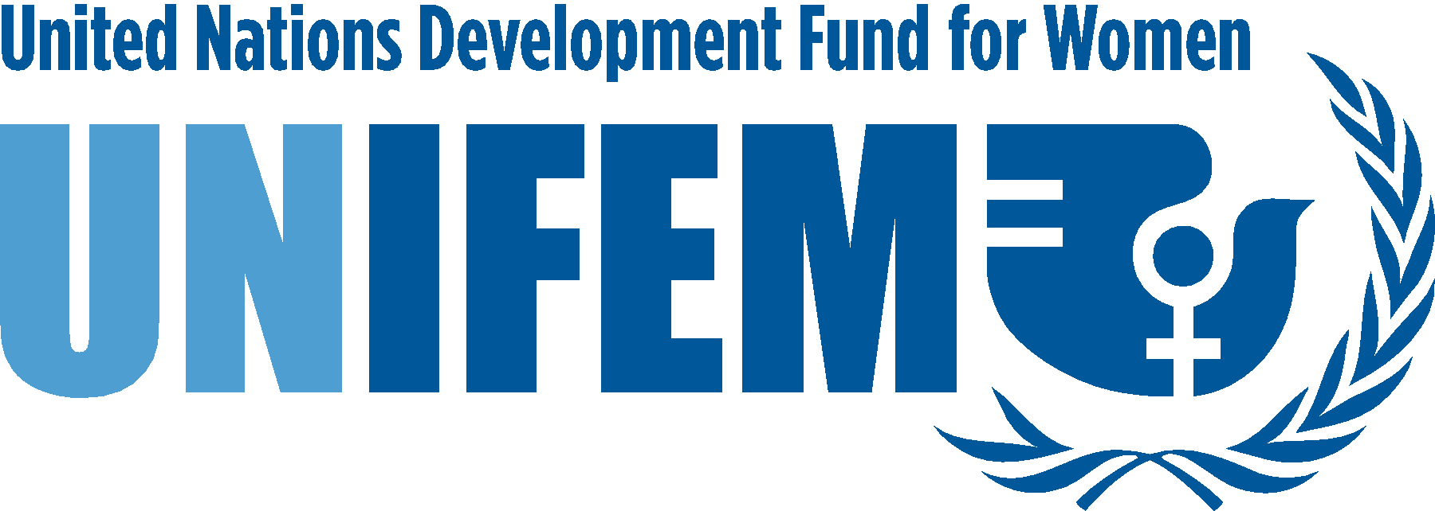

Message from UNIFEM on the International Day of the World’s Indigenous People
Noeleen Heyzer, Executive Director
9 August 2007

On this International Day of the World’s Indigenous People, UNIFEM is pleased to reaffirm its commitment to work in close partnership with indigenous women worldwide.

As the women’s fund at the United Nations, UNIFEM works to promote gender equality and the human rights of all women, especially poor and marginalized women. It has incorporated the rights of indigenous women in all of its programming, including strengthening women’s economic security and rights; increasing their political participation and leadership; eliminating violence against women during armed conflict and at times of peace; and combating the spread of HIV/AIDS among women and girls.

Violence against women is a major concern in many indigenous communities, along with threats to their lands and livelihoods. We look forward to the adoption of the proposed UN Declaration on the Rights of Indigenous Peoples, which will then provide an international standard for the protection of indigenous women against all human rights violations.

UNIFEM joins other UN partners in working for a more equitable and just equal world, recognizing the needs and contributions of indigenous women, engaging them in all aspects of development; and building strategic partnerships to promote the creation of a world free of violence, poverty and discrimination.

UNIFEM looks forward to new and strengthened partnerships to promote the rights of indigenous women and to create a world where all, including indigenous women, enjoy full and equal human rights.

