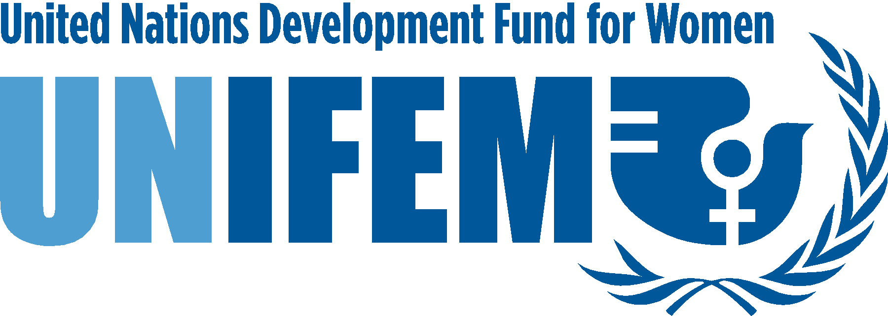

Message from UNIFEM on the International Day of the World’s Indigenous People
Noeleen Heyzer
Executive Director of the United Nations Development Fund for Women
9 August 2006

On behalf of the United Nations Development Fund for Women (UNIFEM), I congratulate you all on the International Day of the World’s Indigenous People. As the women’s fund at the United Nations, UNIFEM works to promote gender equality and the human rights of all women, especially the poor and more marginalized. We regard our support to indigenous women as a long-term commitment, a necessary part of our vision of full human rights for women in all parts of the world.

UNIFEM programmes incorporate the rights of indigenous women in all of our programming, from strengthening women’s economic security and increasing their political participation to preventing the spread of HIV/AIDS among women and girls and securing their right to live free of violence. Our approach is based on engaging women’s and indigenous groups, building and strengthening their strategic partnerships with advocacy groups, policy makers and UN agencies.

We believe that if the United Nations system is truly committed to the protection of human rights, the rights of indigenous women have to be an integral part of this commitment. In this Second International Decade of the World’s Indigenous People we have an opportunity to realize that commitment.

If we are to succeed in creating a world free of violence, free of poverty and free of all kinds of discrimination, we must use the power of ideas, resources and partnerships at all levels to make sure that in the 21st century, laws that discriminate against women, especially poor women, ethnic and religious minority women and indigenous women, are no longer tolerated. UNIFEM will continue to promote the rights of indigenous women in our effort to help bring about a world in which all women are able to enjoy full and equal human rights.

