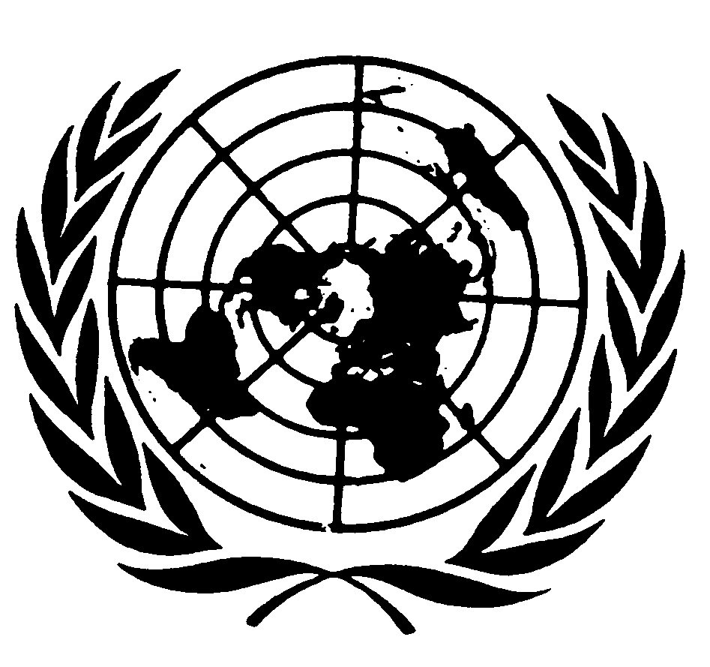
U N I T E D N A T I O N S N A T I O N S U N I E S

Message of
Mr. JOsÉ Antonio Ocampo
Under-SECRETARY-GENERAL for economic and social affairs
And coordinator of the second international decade
of the world’s indigenous people
on the international day of the world’s indigenous people

New York, 9 August 2006

Indigenous peoples have come a long way at the United Nations since the first time we celebrated the International Day of the World’s Indigenous People. In a prominent example, from just a few weeks ago, our newly constituted Human Rights Council adopted the United Nations draft Declaration on the Rights of Indigenous Peoples. We hope that the General Assembly will formally adopt the Declaration at its 61st session, precipitating a shift in the paradigm of human rights and development discourse and action that will itself make a marked and positive difference in the lives of indigenous peoples.

Calling for the adoption of this transformative draft Declaration was one of a number of ways in which the 2005 World Summit injected new energy and momentum into international efforts on indigenous issues. In the Summit’s Outcome Document, world leaders committed to the sustainable development of indigenous peoples and their communities as a “crucial” element “in our fight against hunger and poverty”. They underscored the need “to adequately and urgently address food security and rural and agricultural development”, not least by enhancing the contributions of indigenous and local communities. They also decided on a range of specific policy and institutional measures to strengthen integrated and effective implementation of the whole array of internationally agreed development goals, including the Millennium Development Goals (MDGs).

The Second International Decade of the World’s Indigenous People coincides with the global initiative to achieve the MDGs by 2015. The comprehensive Programme of Action for the Decade is playing a critical role in efforts to advance progress on the broader UN development agenda. As Coordinator of the Decade, I have begun working with the UN system on strengthening the effectiveness of the UN Permanent Forum on Indigenous Issues in helping to mainstream indigenous issues in the UN system’s work at the country level and to implement the Decade’s Program of Action in the form of action-oriented programs and specific projects at the global, regional and country levels.

This work already is benefiting from the outcome of the Permanent Forum’s fifth session, held this past May. The session focused on the MDGs and produced valuable recommendations on how to interpret and apply the MDGs in practice so that indigenous peoples can be included in and benefit from efforts to achieve the goals. We have learnt through our work and through positive achievements over the years that indigenous peoples’ full and effective participation and good governance are crucial in MDG processes, as well as other processes of development management.

On this year’s International Day of the World’s Indigenous People, as we mark the significant international achievements on indigenous issues, we must not lose sight of the situation of many indigenous peoples around the world, mired in extreme poverty, social exclusion and threat to their culture, with some indigenous peoples facing conflict and even the threat of extinction. It is therefore imperative to strengthen our collaboration, cooperation and partnerships in order to sustain and extend the gains achieved by and with indigenous peoples in realizing their aspirations for peace, development and human rights.

