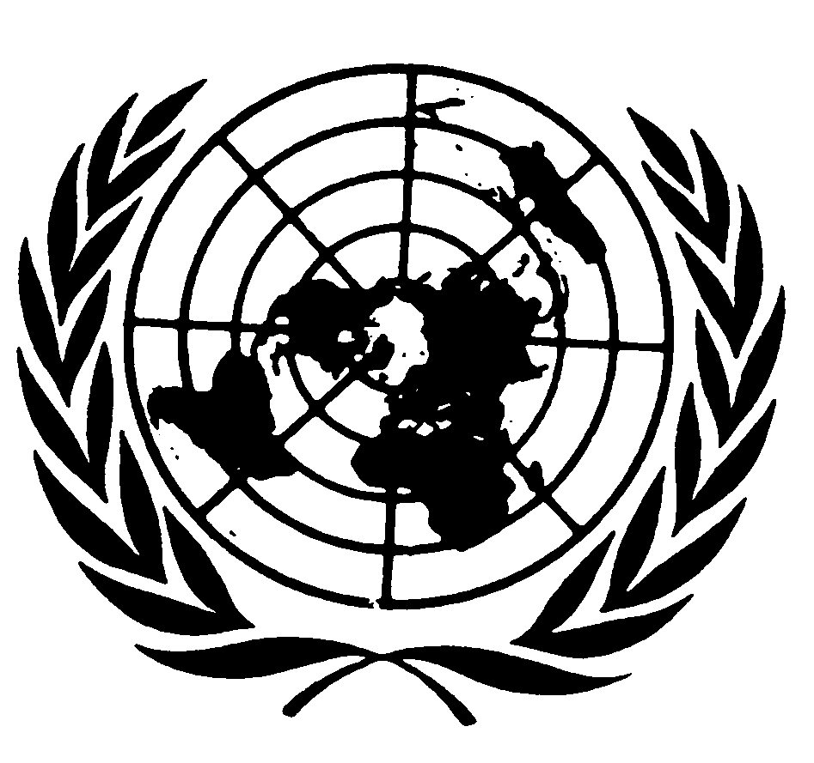
U N I T E D N A T I O N S N A T I O N S U N I E S

Statement by
Mr. Sha Zukang
under-SECRETARY-GENERAL for economic and social affairs
and coordinator of the second INTERNATIONAL decade
of the world’s indigneous people
on the 2009 international day of the World’s indigenous people

New York, 10 August 2009

Let me begin this day of celebration by thanking the NGO Committee on the UN International Day of the World’s Indigenous People and its Chairperson, Mr. Roberto Múcaro Borrero along with the UN Permanent Forum on Indigenous Issues, our partners in organizing today’s events.

The main goal of the Second Decade and The International Day of the World’s Indigenous People is to celebrate and strengthen partnerships and to further strengthening of international cooperation for the solution of problems faced by indigenous people.

As Coordinator of the Second International Decade of the World’s Indigenous People I am therefore very pleased to act on the General Assembly’s decision to call for a mid-term assessment to be elaborated regarding the achievement of the goals and objectives of the Second Decade. The assessment of how far we have come in reaching the goal and objectives of the Second Decade will be an important instrument in guiding and strengthening our common efforts in the achievement of the objectives of the Decade.

I encourage all relevant Member States, UN agencies and intergovernmental organizations along with indigenous people’s organizations to submit their assessment of the achievements made in the implementation of the Second Decade.

The International Day of the World’s Indigenous People is an important occasion to highlight and celebrate the gains we have archived, while we reflect on the areas where more effort has to be made. HIV/AIDS is one such area.

Indigenous peoples are more likely to suffer from extreme poverty, geographical isolation, political marginalization, lack of access to adequate health care. All of these factors influence the manner of which the HIV/AIDS manifests itself among indigenous peoples.

Our shared commitment to combat HIV/AIDS must be a commitment based on inclusion and understanding of the disadvantages facing and impeding on indigenous peoples’ livelihood. A main instrument in this work is the United Nations Declaration on the Rights of Indigenous Peoples, which clearly underlines the right of indigenous peoples to the enjoyment of the highest attainable standard of physical and mental health along with the right to maintain their health practices and traditional medicine among others.

It is the obligation of the Member States, the UN family and of the international society in all not to let the pandemic of HIV/AIDS be yet another area of exclusion and marginalization suffered by the world’s indigenous peoples and as Under-Secretary for Economic and Social Affairs, and especially as Coordinator of the Second International Decade of the World’s Indigenous People I am fully committed to this work.

