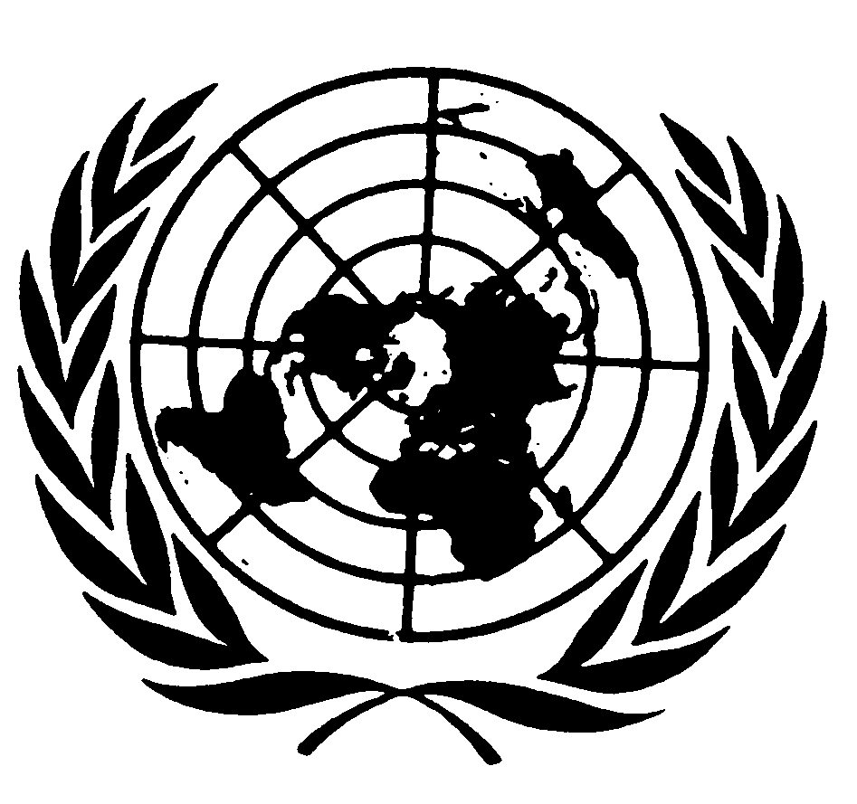
U N I T E D N A T I O N S N A T I O N S U N I E S

THE SECRETARY-GENERAL
--
MESSAGE ON THE INTERNATIONAL DAY OF
THE WORLD’S INDIGENOUS PEOPLES
New York, 9 August 2010

The world’s indigenous peoples have preserved a vast amount of humanity’s cultural history. Indigenous peoples speak a majority of the world’s languages, and have inherited and passed on a wealth of knowledge, artistic forms and religious and cultural traditions. On this International Day of the World’s Indigenous Peoples, we reaffirm our commitment to their wellbeing.

The landmark United Nations Declaration on the Rights of Indigenous Peoples, adopted by the General Assembly in 2007, lays out a framework for governments to use in strengthening relationships with indigenous peoples and protecting their human rights. Since then, we have seen more governments working to redress social and economic injustices, through legislation and other means, and indigenous peoples’ issues have become more prominent on the international agenda than ever before.

But we must do even more. Indigenous peoples still experience racism, poor health and disproportionate poverty. In many societies, their languages, religions and cultural traditions are stigmatised and shunned. The first-ever UN report on the State of the World’s Indigenous Peoples in January 2010 set out some alarming statistics. In some countries, indigenous peoples are 600 times more likely to contract tuberculosis than the general population. In others, an indigenous child can expect to die twenty years before his or her non-indigenous compatriots.

The theme of this year’s Day of the World’s Indigenous Peoples is indigenous filmmakers, who give us windows into their communities, cultures and history. Their work connects us to belief systems and philosophies; it captures both the daily life and the spirit of indigenous communities. As we celebrate these contributions, I call on Governments and civil society to fulfil their commitment to advancing the status of indigenous peoples everywhere.

