2007/WS.3
Original: English

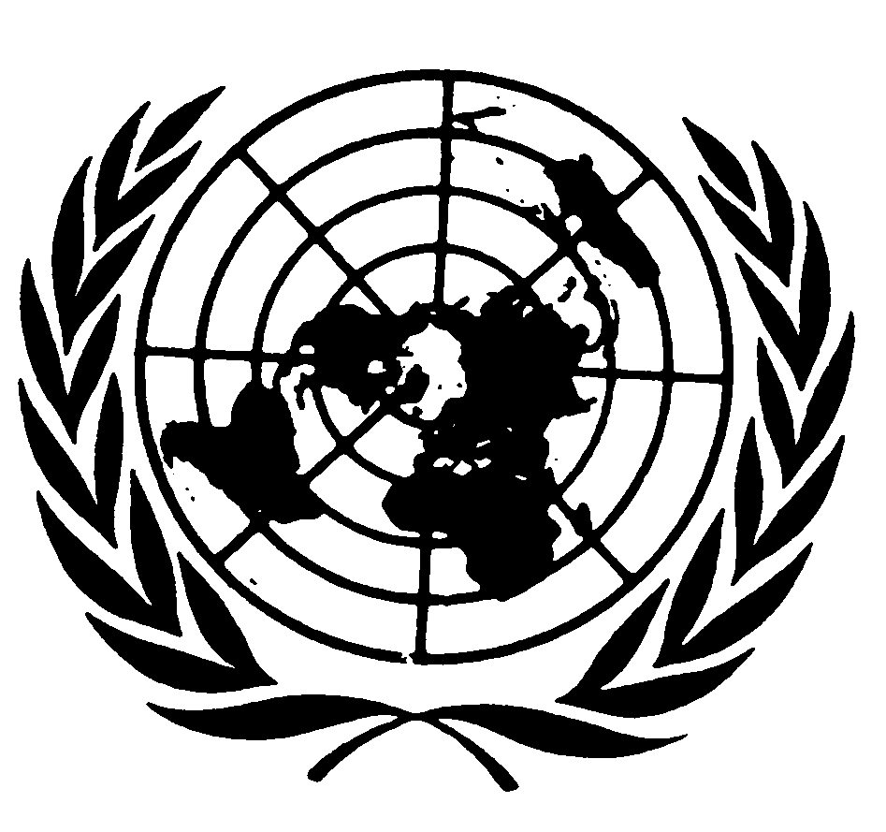
UNITED NATIONS NATIONS UNIES

Co-organizers
United Nations University – Institute of Advanced Studies, Secretariat of the United Nations Permanent Forum on Indigenous Issues, North Australian Indigenous Land and Sea Management Alliance (NAILSMA)

INTERNATIONAL EXPERT GROUP MEETING ON INDIGENOUS PEOPLES AND CLIMATE CHANGE

DARWIN, AUSTRALIA

APRIL 2-4, 2008

Contribution by Mr Fiu Mataese Elisara/Executive Director/OLSSI/Samoa

Theme 1 – Effects of Climate Change on Indigenous Peoples
A Pacific Presentation

This paper is about climate change in the Pacific from the perspective of Indigenous Peoples - The Liquid Continent! On average, more than 90% of Pacific peoples are Indigenous and have been involved for many years in the UNFCCC and Kyoto Protocol as well other climate change processes to call for climate justice in our region and to support similar calls by other indigenous brothers and sisters around the world to stop the injustices that impact on our rights and lands because of the issue of climate change. The flawed so-called solutions promoted in Bali in December 2007 are cases in point. As we continue to witness the natural and manmade disastrous phenomenon in our world of today, it brings home to us the reality that the world of today is a disaster machine producing crises with distressing regularity, unprecedented global catastrophe of apocalyptic proportions like social disintegration, and man induced environmental disasters such as climate change!

The IPCC4 report presented a stark and dire warning about climate change with human induced links! This IPCC Synthesis Report and the Valencia Spain Meeting on 12-17 November 2007, just prior to the Bali meetings, were unanimous about this warning in its finalized “Climate Change 2007” during its one week of talks. The facts are therefore out! The scientists and government representatives in their shorter Summary for Policy Makers adopted on 17 November and launched at a ceremony by UN Secretary General Mr. Ban Ki-Moon is the scientific basis on which policy decisions will be taken in the future and the one used as the reference science throughout the Bali meetings! Excuses by developed countries claiming uncertainties to delay further actions on climate change can no longer be accepted.

Dealing with crisis such as climate change is expensive! Sometimes bloody and in human terms invariably late! We in the Pacific firmly believe that it would be more humane and less expensive to act preventively to focus on resilience strategies and to meet threats upstream rather than to have them confront us as crisis downstream! However, after ravaging the resources of Mother Earth for longer than history, those responsible are only now beginning to realize how little they know about what they have done to themselves and unfortunately to the rest of us!

Most of the Pacific island states are Small Island Developing States (SIDS) characterized by their smallness, narrow coral- and reef-islands which have very low average elevation above mean sea level. Most of our island countries are especially vulnerable because of their geological formation, and the destructive forces of human induced climate change are already causing havoc in our lives and lands.

The Republic of the Marshall Islands consists of 34 coral islands, 870 reefs with an average elevation of just 2.13 meters (7ft). The widths of the islands are often so narrow that it is possible to see from one side to the other. It is clear that such islands are especially vulnerable to extreme weather conditions and the rising of the sea-level.

Tuvalu has an average altitude of 1.83 meters (6ft) with a maximum elevation of only 4.88 meters (16ft) above sea level. Fresh ground water mixes with salty sea-water and some Tuvaluan farmers are forced to grow their root crops in tin containers.

Kiribati almost entirely consists of low lying atolls with an average elevation below 2 meters (6.5ft). The small island of Tebua in Tarawa used to be a landmark for fishermen. It cannot be seen any more - it is now knee-deep under water! Kiribati suffers the effects of king tides that wash through the islands from one side to the other with great ease. It is now a common factor in Kiribati to have king tides with waves of 2.8 meters high!

The Cook Islands have experienced sea level rise, changes in storm intensity and frequency, temperature rise, precipitation and storm surges as components of climate change. On January 1987 cyclone Sally extensively damaged Rarotonga, in November 1997 cyclone Martin destroyed 90% of the houses and killed 19 people on Manihiki atoll, and since 1998 the Cook Islands have experienced more intense storms, flooding and wave surges, damaging coastal infrastructure. On January 2004, cyclone Heta caused significant foreshore damage despite “missing” the Cook Islands.

Samoa has similarly experienced the wrath of climate change with cyclones Ofa and Valerie 1992 and 1993 causing total destruction of its economy, social and physical infrastructure, as well as natural resources amounting to more than four times its gross domestic product. With just 4% of its coastline being resilient to disasters, more than 70% of its peoples live along the coast, where services and infrastructures are also located along the coastline, the vulnerability to the whole country to disasters pose a real threat to achieving economic stability, social development, environment conservation, and cultural diversity being the four pillars of sustainable development as we define it in the Pacific.

The low elevation and high quantity of insular coastlines in many of our countries make it obvious that the Pacific is a very vulnerable and high risk region. Increase extreme weather conditions, made worse by the effects of climate change, causes rising of sea level, increase number of cyclones, coral bleaching, and foreshore erosion. The Pacific region now suffer from loss of coastal land and infrastructure due to erosion, inundation and tidal surges; increase in frequency and severity of cyclones; the warming of the oceans destroy coral reefs and the sea eco-systems which the livelihood of many of us islanders depend on; changes in rainfall patterns increase droughts in some areas and more rainfall cause flooding in other areas; increase in dengue fever and diarrhea outbreaks; sugarcane, yams, taro, banana plantations, and cassava which are the mainstay food sources for our peoples are lost due to extreme temperatures, changes in the seasons, and severity of rainfall; our drinkable water sources are affected due to changes in rainfall, sea-level rise, and inundation by sea water.

With this scenario, one is reminded by the voice heard by a logger walking through a pristine rainforest with his chainsaw, the voice said – All things are connected, like the blood that unites us all. Man did not weave the web of life. He is merely a strand in it. Whatever he does to the web, He does to himself! The issue of collective responsibility is indeed urgent with climate change, no less climate justice.

In Bali, developing countries reiterated that the Kyoto Protocol is not dead, nor would its life-span be over in 2012. They insisted that the industrialized countries commit to targets they failed to deliver since Rio-de- Janeiro in 1992. And there is no excuse for reneging in their ongoing responsibilities to cut greenhouse gases in the second commitment period of the Kyoto Protocol, beginning in 2013.

Indigenous Peoples condemn the adaptation fund, whose structure was set up in Bali, as ‘blood money’ because the 2% of adaptation funds from CDM projects have already caused the deaths of many indigenous peoples who refuse to relinquish their lands and territories, and resort to fight to their deaths protecting their lands and rights when their co-opted governments join with partner business companies that force occupation of their traditional lands, trash their indigenous territories, and kill them together along with their community livelihood through CDM projects.

Papua New Guinea said in the February 2008 General Assembly thematic debate on addressing climate change “…that in looking forward from Bali, the next two years will become increasingly complex as we struggle to define "common but differentiated responsibilities" and the steps all nations must undertake to deal with climate change. If we are to succeed, we must acknowledge that primary responsibility for global warming and its consequences today falls primarily upon industrialized nations, including the resulting mitigation and adaptation challenges all of humanity must now face. We are very concerned by the hubris of certain industrialized nations who promote emissions reductions in certain developing countries as a precondition for taking responsibility for carbon emissions at home”
The Pacific Indigenous Peoples seek leadership by example. We say, deep greenhouse gas emissions can be cut in all industrialized countries, rather than simply pointing fingers at the poor in developing countries. All industrialized nations must demonstrate leadership by reducing carbon emissions within their own borders through deep and hard targets. This has to be the bedrock for any future international agreements on climate change.
In addressing the deforestation problem which causes 20% of global emissions, PNG said “…that 20% of available resources must be allocated to address this important source of GHG emissions. The current UNFCCC mechanism to fund adaptation within developing countries is unethical, untenable, and unconscionable. How can you justify taxing our developing countries through a 2% levy on CDM projects through trades only, for adaptation costs that are no fault of ours? This is an ethical and moral discourse! Those primarily responsible for the damage must pay for corrective action. Adaptation taxes should be levied against carbon trading of Annex 1 countries and not be deducted from the fractional revenues derived by developing countries from the CDM”

If climate change is indeed the defining human development challenge of the 21st century as stated in Bali, we cannot delude ourselves into thinking that this challenge can be addressed on the cheap! It is now a costly urgency stemming from the fact that climate change has taken many people by surprise that we are all now, all of us, desperately racing to catch up with a tomorrow already made obsolete by the reality of today.
It is now necessary to also fundamentally review the debt obligations of developing countries through the prism of climate change. Many of them are still paying for infrastructural investments that are no longer viable, or whose effective lifespan will be severely curtailed by climate change. Many have to borrow more to retrofit previous investments, which are often funded, designed, and built by foreign lenders who are the root causes of climate change. How ironical!
The gravity of the climate challenge forces developing countries and indeed indigenous peoples to abandon long standing proprietary paradigms of technological exclusivity. The world cannot sacrifice its collective climate security on the altar of private profit or outmoded concepts of intellectual property. The developed world and the scientific community must find ways to quickly and freely place emerging green technologies and capabilities into the hands of those who need them most urgently. Measurable, reportable and verifiable cooperation in the fields of technology, capacity building and financing are not charity. They are shrewd investments against future global catastrophes such as climate change which must be taken seriously!
Further, the profound developmental implications of climate change must necessarily trigger a fundamental re-examination of the international community's approach to developmental assistance. The Pacific Indigenous Peoples have considered the developmental impact of not only climate change, but also the flawed solutions being employed to address it. The rush to bio-fuel production will barely dent the developed world's appetite for fossil fuels, but has already made the basic foodstuffs more expensive in many developing states with contentious implications to food security for our peoples. The transportation policies of the rich north through bio-fuel production are targeting the lands of indigenous peoples in the south to fuel their cars at the expense of their food sovereignty. We must not allow indigenous peoples and ourselves to be negatively affected by both climate change and its proposed flawed solutions!

On the issue of flawed solutions to climate change, the indigenous peoples in Bali were disappointed to say the least with the Bali outcomes and contend that this:
- Was throwing money at people instead of introducing responsible policies that will alleviate people’s poverty and curb climate change.
- Decided on a two years negotiation process which was very carbon intensive.
- Attempted to keep all the parties on board especially USA and resulting in parties failing to agree upon a firm basis for future actions on mitigating climate change.
- made the proposals for minimum targets for developed countries’ emissions of 25%-40% recommended by IPCC4 only to be watered down in Bali by noting to ‘refer to the IPCC report’ instead of agreeing to the targets.
- on the decision on forests, failed to reconfirm existing legally binding commitments to reduce deforestation as required by CBD and now merely ‘take note’ of these commitments.
- failed to agree on definitions on ‘forests’ and currently allowing any collection of trees be it native, alien, or invasive still counting as forests under the Kyoto Protocol.
- on the flawed definition of forests, ‘allow’ medium scale ‘reforestation’ and ‘afforestation’ projects which are basically tree plantations eligible for funding under CDM.
- were almost totally devoid of any recognition of human rights or social justice and failed to recognize the rights of Indigenous Peoples enshrined in the UN Declaration of the Rights of Indigenous Peoples approved by the UNGA in September 2007.
- enticed donor countries to throw moneys (between 5 million USD and up to 40 million USD) to the World Bank’s newly launched (on 11 December 2007) Forest Carbon Partnership Facility (despite WB huge failures in Congo reported in its AGM inspection panel reports where violation of every international standards and guidelines were committed by large scale logging companies in the Congo Basin destroying massive pristine rainforests and trampled rights and livelihood of Indigenous Peoples and local communities.
- demonstrated that the northern countries are more interested in creating carbon offsets markets from which they can buy cheap emission reduction credits and therefore not interested in rights-based, effective, and equitable forest conservation mechanism and policies.
- encouraged donor countries to contribute to the World Bank Forest Carbon Partnership Facility and these donors find this as an easy way of pretending to be generous and contributing to tropical forests conservation without having to bother about responsible funding strategies – if this fails, they have the World Bank as an easy blame and not the countries contributing to the failure.
- had the Facility encourage the unwilling developing countries to include their forests in the international carbon market after 2012 post Kyoto and provide donors with access to abundance cheap credits that help them avoid emission reductions in their own countries.
- as an extra bonus, the same donor countries to the WB Facility will have their own forest consultancies benefitting from this Facility funds – they will set up monitoring and accounting methodologies to estimate carbon stocks and building country’s capacity to market existing forests conservation as ‘new and additional’ thus making them eligible for carbon credits profitable for businesses – the GFC referred to a WB/GEF project in Bangladesh where 53% of the budget went to international consultants, 19% went to local consultants making it a total of 72% going to consultancies leaving just a mere 28% for actual projects which is less if the administrative and operations costs are further deducted.
- showed that forest peoples lose out due to land grabbing, payment of environmental services which have proven to have negative impacts on IP rights, land reforms, without prior informed consent.
- prove that IPs and local communities cannot benefit from ‘pilot projects’ to reduce deforestation as they have not deforested but have successfully conserved forests for generation.
- clearly show that RED (avoided deforestation) is directed at compensating destructive logging companies and countries engaged in heavy deforestation for years and are now ‘compensated’ for ‘potential willingness’ without any guarantee to do reduce deforestation.
- prove that forest peoples also lose because they are in the frontline of climate change and because RED is one of the many flawed ‘solutions’ to climate change.
- demonstrate that RED will not reduce climate change, rather it will undermine it by including in it carbon trade markets.
- explains how carbon offsets do not reduce emissions, rather they compensate for continuing emissions elsewhere (leakage) thus RED is a deafening rhetoric!
- alleges that monies from RED will go to corrupt governments without any assurance that the Indigenous Peoples and local communities that have conserve forests for generations will receive any of it.

The Indigenous Peoples in the Pacific align themselves to this assessment and find that the insincerity of developed countries, the hidden agendas in their methods, the devil in the detail in their approaches, were, are, and continue to making it more difficult to establish elements of trust that developing countries and indigenous peoples require in this urgent matter of climate change. It is all about business now and money defines even more, the bleak future!

So it is not like developing countries were incapable of taking actions without the Bali agreement. The problem is that the tools promised to enable them to take these actions were never made available. The deficiency has been in the lack of implementation of the commitments by developed countries promised under global agreements.

In this regard, the developing countries of the Pacific and certainly the Indigenous Peoples of the region want to trust Germany when in New York a month ago in February said "We, the industrialized countries, have to remain the driving force. This is a question of fairness and of credibility. We have to reduce our GHG emissions between 25% and 40% (compared to 1990 levels).
In the same light, the EU said it was willing to reduce GHG emissions by 30% by 2020 (compared to 1990 levels) in the framework of an international agreement. It will even commit to a 40% reduction as a climate-friendly restructuring of its economies as it was both possible and affordable! Ambitious climate policy does not constitute an obstacle to economic and sustainable growth, and climate protection makes sound economic sense and a driving force for innovation and employment.

History will judge us, not by the words we have spoken on these important issues, or the outcomes of the many climate change conferences, but by the sincerity of our efforts and the success we achieve in bringing about beneficial and positive changes!

As for the UN, there is urgent need to provide new and additional financial resources to developing countries for addressing climate change, without diverting resources meant for sustainable development. The UN should focus on how developed countries can sharply reduce their GHG emissions. It should play an active role in advocacy by urging developed countries to meet their commitments, to be sincere in their treatment of their common but differentiated obligations, and to take further GHG reduction commitments they promised to take. It can and must make an important contribution, as part of an integrated global approach to sustainable development, in the implementation of the commitments already made to address climate change in the four areas of mitigation, adaptation, technology and finance. It must also ensure that the existing resources are not diverted and that adequate provision for additional resources is made to allow the UN system and agencies to take on the climate change responsibilities.

For us Pacific peoples, the discussion on climate change is not just a theoretical issue that we talk about when we come to these global meetings! It is there and we see the effects in our daily lives. For us it is a matter of life and death! In many cases we have to decide whether to stay on our islands or leave our homes. As sovereign countries, our rights as countries are protected under the Charter of the United Nations. We plead accountability against those causing these violations of our rights to exist as peoples, as countries, and as sovereign nations. Someone must bear responsibility for our demise when we lose our cultures, when our traditional ways of lives are trashed, and we are denied our freedom to exist as peoples. This is an issue of climate justice that we are calling for here and will continue to do so in every opportunity that comes our way!

The Permanent Forum can be the medium to broker our concerns with the large emitters of greenhouse gases causing climate change. This conference is a forum for all the Indigenous Peoples of the world to come together to discuss real solutions for climate change, given that this is the major theme of our two weeks of deliberations here in New York, and in response to the disastrous impacts climate change is already having on our lives.

This is not a mere future horror scenario. Already today many of our peoples are losing their homes. New Zealand had accepted to take 75 Tuvaluans per year in a slow evacuation process of the island. In principle of ethics, and as a rights issue, we must reject this tokenism type of adaptation measure and denounce environmental refugees as an adaptation measure for our sovereign peoples in the Pacific! This should never be accepted or even contemplated against our sovereign rights as countries and peoples in the Pacific.

Weather and climate extremes such as tropical cyclones and El Nino pose the biggest threat now and in the future to the already vulnerable Pacific Islands due to their geographic locations as some 75% of all climate-related disasters occur in the tropical region. Sea level rise pose a threat to low lying island countries such as Tuvalu and could very well see a sovereign country becoming environmental refugees. This is another unacceptable violation of rights of countries to exist as peoples, a threat to cultures and tradition, loss of lives, loss of biodiversity, loss of spiritual connectivity, and loss of settlement. Cyclonic effects from strong sea wave surges cause huge economic losses in coastal roads, services, homes, cultural sites, spiritual places of importance, cultural heritage, and a way of life. Roads, services, utilities, and infrastructures have shifted inland to avoid disastrous effects of climate change. These force resettlement of village communities to new areas and causing old village sites to be abandoned with immense mental stress and spiritual discourse. The impacts of climate change in these scenarios are a direct violation of the sovereignty of independent nations and as members of the UN because of the actions of rich developed industrialized countries continuing to produce green house gas emissions at unsustainable levels.

We call for stricter global legislation on greenhouse gas emissions after 2012 during the post Kyoto Protocol period. The need for more practical actions is obvious because of the already visible destruction in the Pacific caused by climate change. We make this call for action not only as Pacific Islanders but in response to our collective responsibilities as stewards of creation. Our land and moana (ocean) have always sustained us and will continue to refresh our souls and spirit as Indigenous Peoples of the Liquid Continent.

Let us embrace our mutual vulnerability! Your actions or inaction affect us, as our actions or inaction affect you. We can hurt each other very easily – even when we are thousands of kilometers apart. The increasing effects of climate change accompanied by cultural and economic globalization on our Pacific people makes it urgent for us to take responsibility for our lives and living conditions. To the industrialized countries, if you continue to promote unsustainable lifestyles based on high energy consumption and energy sources, global warming will accelerate and we Pacific islanders will suffer the consequences most. We will lose our homes. We will lose our islands. Remember, we are mutually vulnerable if you continue to ignore our calls for action now!

Let us also embrace our accountability to each other. Mother Earth provides beauty every single day giving us the rich natural resources and environment we enjoy in our lives. But we must also recognize that we too have a reciprocal stewardship responsibility to fulfil.
We forget this responsibility in our strife for comfortable lives. As a result, our planet suffers. If we do not change our lifestyle soon, we, the people of the islands from the Pacific, will suffer the most. The rising sea-levels, the increasing number of cyclones, the droughts, the air pollution, increased extreme weather conditions – we are already suffering their consequences.

We the Pacific people are crying. We are crying for our islands, for our homes. We are part of the global family. Give us your support by showing your solidarity to our fight against the causes of climate change. We call on all our governments to accept stricter emissions of greenhouse gases – beyond the rates of the Kyoto Protocol after 2012.

