PFII/2011/EGM
Original: English
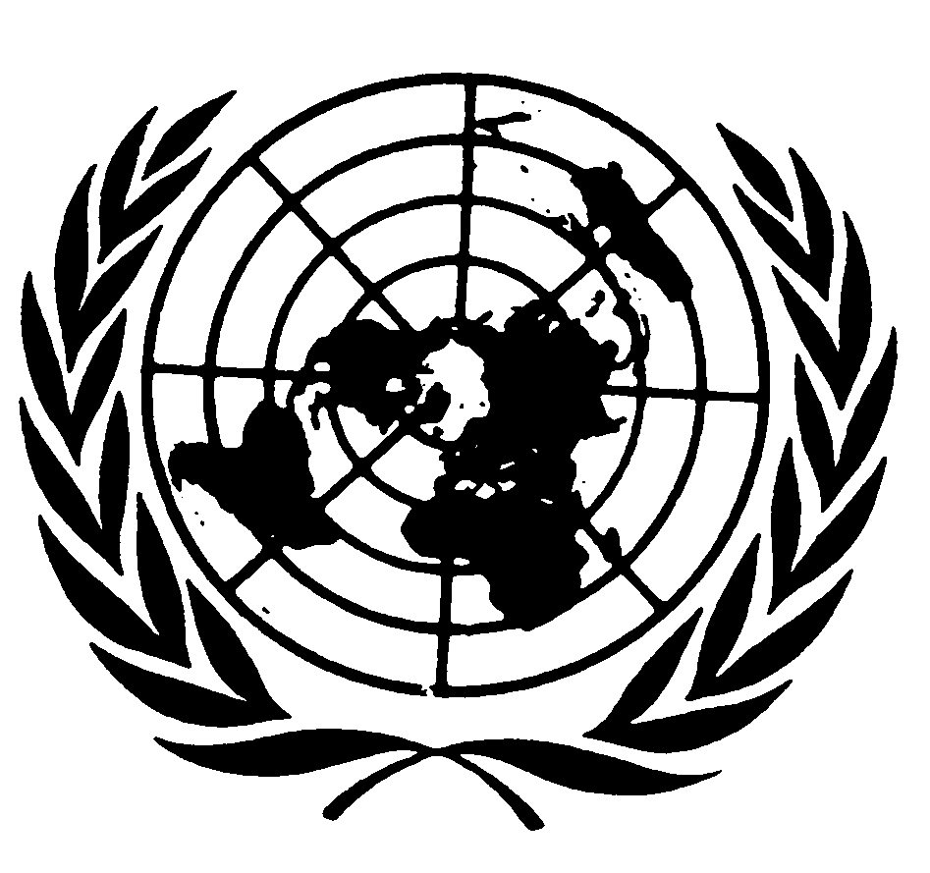
UNITED NATIONS NATIONS UNIES

DEPARTMENT OF ECONOMIC AND SOCIAL AFFAIRS
Division for Social Policy and Development
Secretariat of the Permanent Forum on Indigenous Issues

International Expert Group Meeting on Indigenous Peoples and Forests
12 - 14 January 2011, New York

Concept Paper

Prepared by the Secretariat of the United Nations Permanent Forum on Indigenous Issues
Division for Social Policy and Development
Department of Economic and Social Affairs
United Nations

A. Introduction

1. At its ninth session in April 2010, the United Nations Permanent Forum on Indigenous Issues (UNPFII) recommended the Economic and Social Council authorize a three-day international expert group meeting on the theme: Indigenous peoples and Forests and requested the results of the meeting be reported to the Permanent Forum at its tenth session.

2. At its regular session on 22 July 2010, the Economic and Social Council approved the Permanent Forum’s recommendation in decision 2010/248.

3. This United Nations International Expert Group Meeting on Indigenous Peoples and Forests hereinafter will be referred to as the “Expert Group Meeting” will be held at the United Nations Headquarters in New York 12 - 14 January 2011.

B. Context/Background on the Meeting:

4. Forests account for 30 percent, or 3.2 billion hectares, of the earth’s land area and are the traditional territories for many indigenous peoples. Indigenous peoples living in forests possess clearly defined rights to land and natural resources, including communal ownership of their ancestral lands. They manage the natural resources on their territories, exercise their customary laws, and represent themselves through their own institutions. However, these rights are often denied by development and conservation schemes. Indigenous peoples suffer disproportionately from large-scale development and conservation projects and are often forced to relocate, while their rights to compensation are often denied or overlooked. These actions very often result in serious consequences for indigenous peoples.

5. In 2006, the United Nations General Assembly declared 2011 the International Year of Forests and invited Governments, the United Nations system, relevant non-governmental organizations, the private sector and other actors to make concerted efforts to raise awareness at all levels to strengthen the sustainable management, conservation and sustainable development of all types of forests for the benefit of current and future generations. Sustainable forest management is seen to contribute extensively to the achievement of the internationally agreed development goals, including the Millennium Development Goals with respect to poverty eradication and environmental sustainability. It is also seen to contribute towards the global effort to fight climate change and combat desertification and the conservation and sustainable use of biodiversity, along with numerous other benefits for the betterment of the livelihoods of people. For indigenous peoples, the International Year of Forests has the potential to have a central voice in the global debate on forests, as well as find a way forward to the often contentious interactions that occur between indigenous peoples, States, commercial and corporate forest interests.

6. Traditional forest knowledge forms the basis of indigenous peoples’ views on forests. This knowledge has been emphasized in the global discussions on forests. According to the Secretary-General’s Report prepared for the 4th session of the United Nations Forum on Forests in 2004, traditional forest-related knowledge is:
“a cumulative body of knowledge, practice and belief, handed down through generations by cultural transmission and evolving by adaptive processes, about the relationship between living beings (including humans) with one another and with their forest environment”.
As stated above, indigenous peoples in many parts of the world are faced with continuing encroachment and/or expropriation of their lands, degradation of their forests, and the erosion of their cultures, values, and traditional lifestyles. Hence, it is not surprising that many indigenous peoples and their communities are making concerted efforts to preserve their traditional knowledge and their links to the land for future generations. Further, issues connected to actual or potential expropriation of traditional knowledge by scientists and commercial interests, such as the patenting of medicinal plants that have been used by indigenous peoples for centuries, have both raised public consciousness about the importance and relevance of traditional knowledge, and sparked contentious debates over intellectual property rights. The protection and preservation of traditional forest knowledge is an uphill battle for most indigenous peoples and their communities particularly in the face of rising exploitation pressures on their forest resources.

Development Projects
7. Indigenous peoples are forced to confront outside development plans that inevitably result in forest destruction. This type of development includes among others industrial logging, oil exploitation, mining, dams, pulpwood and oil palm plantations, shrimp farming, monocrop agriculture, cattle-raising and other investments. Between the years 2000-2005, the estimated net forest loss was 7.5 million ha of forest per year. The Intergovernmental Panel on Forests (the predecessor of the United Nations Forum on Forests) noted the critical need to understand the underlying causes of deforestation and forest degradation, and that local initiatives, especially among indigenous peoples could counter current trends of deforestation and forest degradation in regards to their territorial lands, forests and other resources.

8. There are instances where indigenous peoples welcome such projects as logging operations because of possible opportunities for employment, road access, medical clinics, religious centres, and schools. At the same time, there have been exploitative and discriminatory working conditions and high rates of injury among forest and plantation workers. For many indigenous peoples, employment is usually available in low-paid, short-term, arduous and dangerous occupations such as tree-spotters, fellers and debarkers. Moreover, those services provided often fall into disrepair when the industry moves on. Further, the creation of dependency on development projects often result in exploitative relations and corrupt patron-client relations between forestry officials and indigenous peoples.

9. Intensive logging of natural forests is rarely executed in a socially and environmentally sustainable manner. Large-scale logging operations tend to overpower indigenous institutions and decision-making processes and creating social divisions. Further, the free, prior and informed consent of indigenous peoples is rarely considered. Economic benefits that indigenous communities accrue rarely lead to long-term improvements in their well-being. Alternatively, community-based forestry options which prove socially and environmentally beneficial are rarely of the scale necessary to supply significant quantities to global markets. Meanwhile, those that do supply global markets have tended to over-harvest the resource.

10. Another large-scale development project that negatively impacts on indigenous peoples is industrial-scale tree plantations. These plantations on indigenous lands often results in serious problems. For example, indigenous peoples’ rights to land may be denied; their traditional livelihoods undermined; inadequate compensation for land and livelihood loss; migration of indigenous peoples to shanties or forest frontiers; water supplies become polluted with effluents from plantations and processing works; a change in disease ecology leading to increased disease incidence. To date, no best practice examples of large-scale tree plantations that respect indigenous peoples’ rights and provide community benefits have been identified. Furthermore, the demand of single-use products from such plantations is discordant with the multiple-use and community-based forestry proven most viable and beneficial for indigenous peoples.

Protected areas
11. The establishment of ‘protected areas’ like National Parks and Game Reserves in forest areas, as well as the classical response of conservationists to environmental destruction, has led to the takeover of huge expanses of indigenous peoples’ lands. Not surprisingly, addressing indigenous rights in protected areas remains a contested issue. As many as three quarters of all protected areas overlap indigenous territories. In 2003, a total of 102,102 protected areas had been established which cover more than 1.88 billion ha of land, and encompass roughly ten percent of the world’s forests. The impacts on indigenous peoples of the establishment of protected areas for wildlife and other uses has often lead to eviction and forced relocation from their forest lands. Further, conflicts result in indigenous peoples becoming squatters and exploiting wood for building shelters and heating, and poaching animals for their meat. Once evicted, indigenous peoples no longer have access to the resources on their lands, suffer impoverishment, cultural and social collapse; breakdown of their traditional resource management systems; environmental degradation; and political marginalization.

12. There are now some community-base approaches to the establishment and management of forest protected areas which ensures that indigenous peoples’ land rights are recognized. Also, their free, prior and informed consent is obtained before the establishment of protected areas, and they are fully involved and participate in the management of such areas. Some of the large international conservation agencies have now adopted policies that recognize indigenous peoples’ rights and promote their involvement in conservation. However, the situation at the ground level is not very encouraging. Few States recognize indigenous peoples’ rights to secure land tenure and their involvement in national conservation strategies. Further, indigenous peoples continue to be evicted from forest protected areas without compensation. Indigenous peoples must have secure tenure so that they can maintain, cultivate and continually renew their traditional knowledge practices. Protected areas management programs also need to secure indigenous peoples’ access to guaranteed land security and support them in exercising their own governance structures and decision-making authority. The challenge remains as to how to apply such approaches on a wide-scale, all of which requires major reforms in national policies, laws and institutions regarding both indigenous peoples and conservation measures.

Using Forests to fight global warming
13. The idea of using forest conservation as a tool for mitigating climate change was first introduced formally in the negotiations under the UN Framework Convention on Climate Change (UNFCCC) in 2005. In late 2007 it was decided that a policy framework for Reducing Emissions from Deforestation and Forest Degradation (REDD) should be negotiated as part of the new deal in tackling global warming. Scientists estimate that around 20% of the global greenhouse gas emission that cause global warming stem from eradication or serious degradation of forests. REDD aims to generate financial flows for forest related carbon dioxide (CO2) emissions reductions and removals. In line with the Bali Action Plan and the Copenhagen Accord, REDD includes reductions in deforestation and forest degradation as well as the conservation, sustainable management and enhancement of forest carbon stocks.

14. Indigenous peoples have reached different conclusions about whether or not forests should be included in the Clean Development Mechanism (CDM). The CDM, defined in Article 12 of the Kyoto Protocol, allows a country with an emission-reduction or emission-limitation commitment under the Kyoto Protocol (Annex B Party) to implement an emission-reduction project in developing countries. Some indigenous peoples have questioned the ethics of trading carbon stocks on the international market and reject the principle that industrial and corporate polluters can buy permission to continue polluting by trading in forest carbon credits. They also dismiss the notion that the value of forests can be reduced to the monetary value of their carbon stocks, and stress that the non-monetary cultural and spiritual values of their forest are of utmost importance and must be respected. They further maintain that trade in carbon credits is unethical and irrational because it does not tackle the main root cause of climate change. There is also concern that trade in forest carbon credits may establish perverse incentives for governments and big business to expropriate indigenous peoples’ forests and displace their communities in order to capture carbon funds. In other cases, indigenous peoples have called for the inclusion of forests under the Kyoto Protocol and have advocated that indigenous community projects and natural resource management initiatives should be open to payments and credits under Kyoto or other frameworks.

15. There are clear risks, but also potential benefits to be gained by indigenous peoples if forests become part of an international scheme for reducing greenhouse gas emissions from deforestation. Most of the existing REDD proposals make mention of the need for community participation and the provision of local benefits for indigenous peoples. Yet, so far at least, it is not at all clear that indigenous peoples have been consulted about the risks and potential benefits of the avoided deforestation plans being promoted by their governments in league with international agencies.

16. While there has been a welcome normative shift at the international level towards a more people centred approach to forest conservation and protected areas due to pressure from indigenous peoples and human rights activists, many countries continue to deny the rights of forest peoples. Many states fail to recognise the collective customary rights of indigenous peoples over their ancestral forests, or only recognise a small portion of their traditional lands, by legally defining the remaining forests as State lands. This issue is crucially important, because presumably the zoning of forests under any REDD payments scheme and any benefit-sharing plan under REDD contracts would be in part determined by land tenure and ownership rights. In short, there is an urgent need to make sure global climate change mitigation policies on avoided deforestation are formulated with the full and effective participation of indigenous peoples.

17. The UN Permanent Forum on Indigenous Issues has had a strong focus on forests and has endorsed a number of recommendations on forest related issues. Some of the reports and Expert Group Meetings include: the International Expert Group Meeting on Indigenous Peoples: Development with Culture and Identity Articles 3 and 32 of the United Nations Declaration on the Rights of Indigenous Peoples; Study on the Extent to which Climate Change Policies and Projects Adhere to the Standards set forth in the UN Declaration on the Rights of Indigenous Peoples; the Human Development Framework and Indigenous Peoples' Self-determined Development or Development with Culture and Identity; A draft guide on the relevant principles contained in the United Nations Declaration on the Rights of Indigenous Peoples, International Labour Organisation Convention No. 169 and International Labour Organisation Convention No. 107 that relate to Indigenous land tenure and management arrangements. International Expert Group Meeting on Indigenous Peoples and Climate Change; Arctic Regional Workshop on Indigenous Peoples’ Territories, Lands and Natural Resources; Oil Palm and Other Commercial Tree Plantations, Monocropping: Impacts on Indigenous Peoples’ Land Tenure and Resource Management Systems and Livelihoods, and others. The above reports can be found on the UNPFII website.

International Standards

18. There are obligations contained in international standards and recommendations that can be applied to indigenous peoples’ rights in regards to forests. The United Nations Declaration on the Rights of Indigenous Peoples provides a strong basis from which indigenous peoples can affirm their rights and define their aspirations in the debates with States and corporations around forests. Article 1 outlines the right of indigenous peoples to the full enjoyment and collective rights or as individuals to all human rights. Articles 3 and 4 outlines indigenous peoples right to self-determination and the right to determine their political status and freely pursue their economic, social and cultural development as well as the right to autonomy or self-government on internal and local affairs. Article 10 states that indigenous peoples shall not be forcibly removed from their lands and territories and that no forced relocation can take place without their free, prior and informed consent. Article 18 outlines indigenous peoples right to participate in decision-making in matters that affect their rights, through representatives chosen by themselves in accordance with their own procedures, as well as to maintain and develop their own decision-making institutions. There are a number of Articles (26, 27, 28, 29, 31 and 32) that deal with indigenous peoples right to their lands, territories and resources including the right to conserve and protect the environment; the right to maintain, control, protect and develop their cultural heritage and traditional knowledge; and the right to determine and develop priorities and strategies for the development or use of their lands or territories and other resources.

19. The International Labour Organization (ILO) Convention 169 urges governments to acknowledge indigenous peoples’ right of ownership over their traditional lands and the natural resources obtained from their lands so as to protect the economic, political and spiritual interests of indigenous peoples. Furthermore, the Convention requires governments to recognize indigenous customs and institutions and to introduce legislation that allows indigenous peoples the right to maintain and strengthen their legal, political, economic and social systems. Both the ILO 169 and the United Nations Declaration on the Rights of Indigenous Peoples urge states to obtain the free, prior and informed consent of indigenous peoples prior to the approval of any development projects on their lands.

20. Indigenous peoples’ traditional forest-related knowledge (TFRK) is slowly gaining recognition as a form of sustainable forest management in the international arena. Article 10[c] of the Convention on Biological Diversity (CBD) encourages Parties to: “Protect and encourage customary use of biological resources in accordance with traditional cultural practices that are compatible with conservation or sustainable use requirements”. Also, the CBD’s Article 8[j] emphasizes the need to: “respect, preserve and maintain knowledge, innovations and practices of indigenous and local communities embodying traditional lifestyles for the conservation and sustainable use of biological diversity and promotion of their wider application with the approval and involvement of the holders of such knowledge, innovations and practices and encourages the equitable sharing of the benefits arising from the utilization of such knowledge innovations and practices”.

Similarly, other UN entities recognize indigenous peoples rights to forests such as the UN Convention to Combat Desertification (1994) which requires parties to “…protect, integrate, enhance and validate traditional and local knowledge, know-how and practices” and that “…owners of that knowledge will directly benefit on an equitable basis and on mutually agreed terms” (CCD, Article 18[a]). UNESCO also recognises the importance of indigenous peoples’ rights to land and effective participation as prerequisites for cultural security and effective environmental protection. The Convention Concerning the Protection of the World Cultural and Natural Heritage is one such instruments where the listing areas of natural and cultural heritage sites as ‘World Heritage Sites’ is to ensure that they are managed and protected to the highest international standards. The UN Forum on Forests’ Non-legally Binding Instrument on All Types of Forests recognizes indigenous communities in resource management and sustainable forest management.
Objectives and Outcomes of the Meeting:
21. The Expert Group Meeting is intended to:
- Promote an opportunity to exchange information on issues regarding indigenous peoples and forests;
- Draw attention to the impact of large-scale development, conservation projects and climate change mitigation measures in forests on indigenous peoples’ livelihoods, communities, cultural practices and resource management systems;
- Highlight good practices models of forest management and agreement making that address indigenous peoples’ rights;
- Identify gaps and challenges and possible ways forward.

The overall objectives of the Expert Group Meeting are to:
- To analyze enshrined rights within international standards and policies and how they protect indigenous peoples rights to forests;
- Analyze opportunities for partnerships for indigenous peoples on forest issues and how such arrangements might be informed by good practices and Corporate responsibility models;

- Propose strategies to advance indigenous peoples rights in forests including capacity building measures and activities;
- Elaborate recommendations on strategies to strengthen indigenous peoples' rights, livelihoods, communities, cultural practices and resource management systems in forests.

22. The final report and recommendations of the Expert Group Meeting will be to be submitted to the ninth session of the UNPFII.

Proposed Themes for discussions
23. Four major themes of discussion are proposed as follows. Under each of the themes are some preliminary questions that have been identified for consideration and to stimulate discussion.

Theme 1 Concepts and practices of indigenous peoples and forests
- Analysis of international standards and recommendations that could be applied to indigenous peoples in protecting their rights to forests (e.g. United Nations Declaration on the Rights of Indigenous Peoples, Convention on Biological Diversity, United Nations Framework on Climate Change ILO and others);
- Analysis of how the goals and needs of indigenous peoples and forests may differ from the needs and goals of other interested forest stakeholders;

Theme 2 Case Studies on the positive and negative effects of forest development on indigenous peoples and their communities.
- Provide case studies where development projects in forests have had a negative effect on indigenous peoples and their communities by generating further poverty, severe inequality and other social problems. Highlight any lessons learned from such experiences;
- Provide case studies of instances where indigenous peoples are working in forest partnerships with States, United Nations agencies, the private sector, donor agencies on alternative development practices that may have positive outcomes;
- Provide case studies where indigenous peoples are revitalizing and integrating traditional knowledge in forest management.

Theme 3 Factors that enable or obstruct indigenous peoples’ participation development processes.
- Provide examples where indigenous peoples are effectively participating in decision-making at the national level;
- Highlight initiatives that support indigenous peoples’ forest governance and capacity building efforts in forest management activities;
- Highlight measures of accountability and integrity in decision-making and implementation of policies at the international and national levels in regards to indigenous peoples and forests.
- Identify obstacles, including lack of relevant statistics, lack of information and lack of technical support in all matters pertaining to indigenous peoples and forests;
- Highlight the persistent barriers that undermine indigenous peoples in exercising their rights and customary laws in forests;
- Analyze the role of the donor community, conservationists and the private sector in enhancing or weakening indigenous peoples’ livelihoods in forests?

Theme 4 Human Rights and Corporate Responsibility in development programmes and projects.
- Highlight measures to incorporate human rights into programmes and projects on forests;
- Highlight measures to strengthen Corporate responsibility in development programmes and projects on indigenous peoples’ lands and forests;
➢ Highlight measures for States to provide effective mechanisms for just and fair redress for adverse environmental, economic, social, cultural or spiritual impact on indigenous peoples’ forests, territories and resources.

Participant Contributions:
24. The Expert Group Meeting seeks to draw on the expertise of indigenous peoples; United Nations Permanent Forum members; relevant United Nations and other intergovernmental agencies; State and local governments; indigenous peoples’ organizations; non-government organizations and academics that are active within the forest and evironment fields.

25. International indigenous experts will represent each of the seven UNPFII regions. They will be required to prepare papers to present at the meeting on one or more of the themes listed above.

26. Experts are requested to submit their papers (8 pages maximum) to the organizers by 13th December 2010 so that the papers can be distributed before the meeting. Experts will also be informed in due course of the Program of Work for the Expert Group Meeting and the appropriate time to present their papers during the meeting.

Working Language:
27. The working languages will be the UN working languages.

Contact Information:
28. Ms. Sonia Smallacombe, Secretariat of the Permanent Forum on Indigenous Issues,
Division for Social Policy and Development, Department of Economic and Social Affairs
United Nations, New York, NY 10017 (Telephone Number 1 917 367-5066, Fax no: 1 917 365-5102) email: smallacombe@un.org

Marcus Colchester, “Beyond Tenure: Rights-based approaches to peoples and forests, some lessons from the Forest Peoples Programme,” p2. http://www.forestpeoples.org
UN Permanent Forum on Indigenous Issues, Report on the ninth session 19-30 April 2010 (E/2010/43) New York, 2010, para153.
UN Permanent Forum on Indigenous Issues, 9th Session. Backgrounder: Indigenous Peoples and Forests. 28 April 2010.
Marcus Colchester, “Beyond Tenure: Rights-based approaches to peoples and forests, some lessons from the Forest Peoples Programme,” p14. http://www.forestpeoples.org
Report of the Special Session of the UN Forum on Forests (A/65/229) p.3
Preparations for the International Year of Forests 2011, Report of the Secretary-General (A/65/229), para.1
E/CN.18/2004/7. para 3, p3
E/CN.17/IPF/1997/6. (1997), para 18.
Marcus Colchester, “Indigenous Peoples and the new ‘Global Vision’ on Forests: Implications and Prospects,” (28 December 1999), p7.
Ibid, p16.
Ibid, pp10, 16.
Ibid, 12.
UN Permanent Forum on Indigenous Issues, State of the World’s Indigenous Peoples (New York: United Nations, 2009, ST/ESA/328), p91.
Tanya Hayes & Elinor Ostrom, “Conserving the World’s Forests: Are Protected Areas the Only Way?” Indiana Law Review 38:595 (2005), p596.
Marcus Colchester, “Indigenous Peoples and the new ‘Global Vision’ on Forests: Implications and Prospects,” (28 December 1999), pp12, 16.
Silla Stidsen, REDD and Indigenous Peoples, IWGIA, 1-2/09, p5
Tom Griffith Seeing ‘REDD’: Forests, Climate Change and Mitigation and the rights of Indigenous Peoples, Forest Peoples Programme, 1 December 2008, p36
Tom Griffith Seeing ‘REDD’ ‘Avoided Deforestation’ and the rights of Indigenous Peoples, Forest Peoples Programme, June 2007, p10
Ibid, p12
E/C.19/2010/14
E/C.19/2010/7
E /C.19/2010 CRP.4
E/C.19/2009/CRP.7
E/C.19/2008/CRP.9
E/C.19/2007/CRP.5
E/C.19/2007/CRP.6
http://www.un.org/esa/socdev/unpfii/en/workshops.html
Article 15 of ILO Convention 169.
Article 18 of ILO Convention 169.
Article 30 of UN Declaration on the Rights of Indigenous Peoples and Article 15 of ILO Convention 169.
Convention on Biological Diversity 1993, Vol.1760 I-30619.
Ibid.
Poole, P ‘Cultural Mapping and Indigenous Peoples: A report for UNESCO’, March 2003, http://portal.unesco.org/culture/en/files/17109/10787580083cultural_mapping_1.pdf/cultural_mapping_1.pdf
Resolution adopted by the General Assembly on Non-legally Binding Instrument on All Types of Forests (A/RES/62/98) 31 January 2008, pp 4- 8.
Africa; Asia; Central and South America and the Caribbean; the Arctic; Central and Eastern Europe, Russian Federation, Central Asia and Transcaucasia; North America; and the Pacific
English, Spanish, French, Chinese, Arabic and Russian.

