PFII/2011/EGM
Original: Spanish

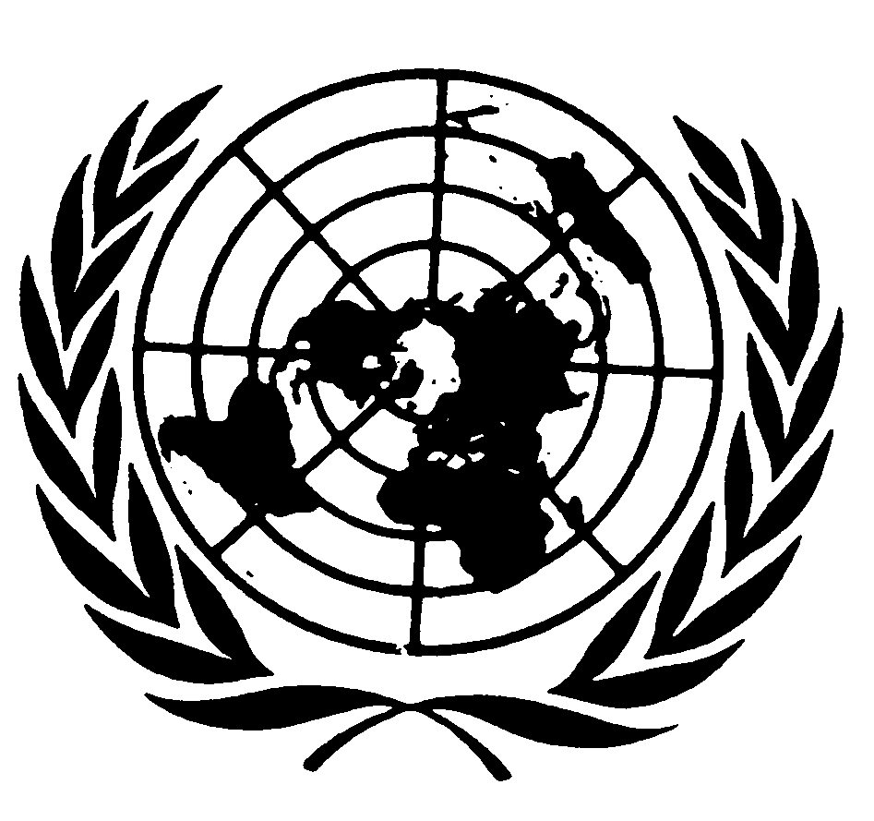
UNITED NATIONS NATIONS UNIES

DEPARTMENT OF ECONOMIC AND SOCIAL AFFAIRS
Division for Social Policy and Development
Secretariat of the Permanent Forum on Indigenous Issues

INTERNATIONAL EXPERT GROUP MEETING
Indigenous Peoples and Forests
(New York, 12 - 14 January 2011)

Paper Prepared by
Ph.D. Myrna Cunningham Kain

Introduction

The global forest crisis continues unabated despite more than 10 years of global forest policy dialogue in the Intergovernmental Panel on Forests (from 1995 to 1997), in the Intergovernmental Forum on Forests (from 1997 to 2000), in the United Nations Forum on Forests (from 2000 onward), and parallel discussions within the framework of legally binding instruments like the Convention on Biodiversity, the Framework Convention on Climate Change and the International Tropical Timber Agreement. Further, the United Nations Framework Convention on Climate Change focuses much of its attention on reducing emissions from deforestation and forest degradation in developing countries as a contribution to climate change mitigation in general .

This paper presents Latin American indigenous peoples’ concepts and practices concerning management, conservation and sustainable development of various forests types. It highlights how these practices contribute to achieving various internationally agreed development goals and, most importantly, to the improvement of the ways of life of the peoples and the future generations. The role of indigenous women as promoters of environment conservation and adaptation measures in the dynamics of the peoples is given special attention. Further, the Amazon basin situation is examined in greater detail, since it constitutes the most important biotic reserve in the world and it is home to a great social and environmental diversity.

- Indigenous Peoples in Latin America

The western development model keeps depredating the region’s human, cultural and natural resources and indigenous peoples are the most affected. For indigenous peoples, the processes of integration, globalization and, more recently, the effects of climate change represent growing challenges with regards to the acknowledgement of their natural, cultural and social heritage.

In this scenario, indigenous peoples demand -in national, regional and international platforms- their full and effective participation in the design of development strategies and in the definition of legal frameworks of the States. Indigenous peoples’ priority demands are: a) Inclusion of ancestral knowledge in natural resources management; b) Respect for their way of life, culture and traditions; c) Collective rights over their lands; d) Respect for their cosmogonic thinking and vision of life; e) The exercise of their own law systems and administration of justice.

- Indigenous Peoples and Forests in Mesoamerica

It is important to stress that the lands of ancestral occupation by indigenous peoples consist of important forest areas, such as: Parque Internacional La Amistad home of Bribris, Cabecares, Guaymíes and Naso-Teribes. In Honduras the Biosphere Reserve Platano River (Reserva Biósfera del Río Platano) home of indigenous Misquitos; the Darien National Park (Parque Nacional Darien) in Panama, inhabited by the indigenous Emberá-Drúa people; the Protected Area of la BOSAWAS in Mayangnas and Miskitus’ lands. This is clear evidence of the ancestral knowledge for the preservation of the natural wealth. Notwithstanding, poverty of indigenous population in Central America is more than twice that of non-indigenous population.

Based in capitalism and individuality, the development model implemented by the States erodes indigenous culture and lifestyle, pushing towards appropriation of lands, territories and natural resources. In the last 20 years, within the frame of the Central-American Integration System (Sistema de Integración Centro Americano-SICA), governments in the region continue to settle agreements, strategies, policies, programmes and projects that timidly recognize indigenous peoples rights and their contributions to attain the Good Living –Buen Vivir. Despite some progress in the implementation of strategies by the States, strongly supported by international cooperation, social and environmental problems remain the same or have even increased.

2.1 Indigenous women and forests
In Mesoamerica, the management of forests has been considered a domain of the community’s men. Differences between men and women regarding use of the forest stem from the social roles assigned to each sex. Indigenous women’s particular interest in forest management is not primarily related to income-generating activities, but rather in protecting forest products essential for the well-being of the community.

On the above basis, it is clear that indigenous women’s relationship with forests takes place under two approaches:

For the well-being of the community
- They protect the forest against deforestation and the introduction of non-indigenous tree- species.
- They pass on cosmogonic knowledge -a key factor for forest conservation.
- They take advantage of the forest’s resources in a rational manner, to build their houses, access to food and provide the community with medicines, clothing, etc.
- The forest, earth and water are considered as everyone’s great home.

As an income generator (secondly)
- Rational extraction of non-wood products (handcrafts, furniture- wicker, gum, xate, etc.)
- Eco-tourism projects
Indigenous women play a crucial role in communities promoting forests’ protection and also as drivers of sustainable measures to adapt to changes. It is therefore of utmost importance to consider their inclusion in the design and implementation of forestry development policies.

  - Ownership of Indigenous Lands: a necessary condition for culture and forests conservation

Historically, indigenous peoples throughout Latin America have faced the plundering of their lands and resources, a violation of their collective rights. In Mesoamerica, indigenous peoples struggle for control of resources and for the official recognition of their ancestral lands.

The political evolution of indigenous peoples’ organizations and the development of international legal instruments, many of which were promoted by indigenous peoples themselves, have resulted in their considerations of subjects of law. This has been reaffirmed after the adoption and, in many cases, ratification of International Labor Organization (ILO) Convention 169 and the adoption of the United Nations Declaration on the Rights of Indigenous Peoples. The degree of recognition and commitment by the States in Mesoamerica varies. For countries have ratified ILO Convention 169, and there are four constitutions in which indigenous peoples’ rights are specifically enshrined. (Guatemala 1985, Honduras 1982, Nicaragua 2010, Panamá 1972).

As a result of their struggle for decades and of their achievements, now it can be affirmed that indigenous peoples:

- Have advanced in the processes of consolidation of the autonomies for Indigenous Peoples and Ethnic Communities from the Autonomous Regions Caribbean Nicaraguan Coast in Nicaragua.
- In Panama, recognition of land rights of Ngöbe Bugle and Emberá Wounan indigenous peoples. However the Naso People are still struggling for recognition of their region and lands.
- In Costa Rica there has been great advance in the recognition of indigenous peoples’ rights.

  - The issue of indigenous peoples, the issue of forests

In the last decades, Maesoamerican States have driven a development model that promoted economic capital investments and made no progress in the reduction of poverty levels and inequalities between the rich and the poor. Today, new problems emerge as an outcome of these policies. The main problems are tied to the pressure of natural resources and of the populations that inhabit them. In response to this environmental situation, States have created and implemented environmental policies for management and conservation of natural resources. In practice, this has mediated their specific forms of political and cultural expression, as is the case of declarations of protected areas, forests’ merchandising and forests pressure through different extensive economic activities. The main issues regarding forests and indigenous peoples are highlighted below.

a. Deforestation
Loss of forests’ vegetal cover, estimated in 988421.5 acres per year contributes to increase poverty and vulnerable conditions of indigenous peoples in the region. Inappropriate extractive activities, invasion of lands, forest fires, advance of the agricultural frontier, development policies for commercial monocultures such as agro fuels and tourist developments, represent the main threats for forest stability and existence.

b. Protected areas overlapping indigenous lands

In the region, protected areas have imposed a type of governance which limits and violates the full exercise of rights recognized in international standards.

Indigenous peoples demand the right to self determination and to reserve the right to establish conservation/management areas under their own normative systems and institutions, which should be granted through the implementation of a legal framework in each State in Mesoamerica. For example, approximately 40 Emberá and Waunan communities and two Kuna communities (Pucuru y Paya) live in Darién National Park. Creating protected areas in these lands involves prohibition of hunting, fishing, agriculture and traditional use of natural resources. Thus, this affects the very existence of these peoples whose cosmology is intimately linked to their relation with Mother Earth..

c. Climate change effects
Today, greater incidence and intensity of floods, droughts and hurricanes as a consequence of climate change is damaging the socio-productive and social infrastructure, as well as the livelihoods of our peoples. In September 2007, Hurricane Felix directly hit the coast and mountainous areas, destroying more than three hundred indigenous Miskitu and sumo-mayangna communities, and the basis for local livelihoods: forests and the coastal fishing area. This time a million hectares of forest forests of hardwoods and conifers were affected, as well as marine and mangrove ecosystems..

d. Market-based climate change mitigation proposals based (Carbon credit sale)
In the frame of international climate negotiations, the vision of forests as carbon producers or settlers has resulted in their acquisition of financial value. This has created processes of discussion on the opportunities and threats of carbon compensation mechanisms (Mechanism of Clean Development and the Reducing Emissions from Deforestation and Forest Degradation REDD). Recently, the post Cancun communication by the International Indigenous Forum on Climate Change states that its rejects the carbon market, since it is a fake solution to climate change.

Particularly, we insist that forest have a variety of functions and are a source of life for the world’s indigenous peoples, including those peoples in voluntary isolation. Therefore, they cannot be part of any program or scheme based in carbon market compensation. Indigenous peoples in Costa Rica have concerns on whether REDD could create a change in the order of priorities, making economic issues prevail over cultural, social, spiritual and environmental issues, as well as whether displacements from traditional lands would take place as a result of implementing REDD mechanisms which do not take indigenous peoples’ rights into consideration.

e) Agro fuel production:
Agro fuel production is producing deforestation and forest degradation. It has created indigenous lands’ re-concentration processes. For example, in Guatemala, agro-fuel expansion, mainly African palm, is taking place at large scale in Petén and Alta Verapaz. This constitutes one of the main reasons for deforestation.

2.5 Opportunities for forests and indigenous peoples in the international context
Throughout the evolution of international and institutional relations, the need to promote more inclusive processes has led indigenous peoples to seek and demand opportunities for participation, consultation and dialogue spaces aimed at generating more equity, equality, justice and considering indigenous peoples’ political, social, cultural, economic and environmental proposals and demands arising from indigenous peoples themselves.

At international level, due to demands and pressures made to the States by indigenous peoples, many governments are taking steps to carry out dialogue processes and recognition of indigenous peoples’ rights. Issues such as the legal acknowledgement of lands, the capacity of adaptation to climate change and the growing interest of industrialized countries in their forests for carbon capture occupy negotiation and dialogue agendas in which indigenous peoples could achieve fulfillment of their historic demands and emerge stronger.

a. Legal recognition of lands

In the current context of climate change negotiations, indigenous peoples are the national and international targets for implementation of mitigation and adaptation measures. Thus, many national States in the region, NGOs and the international cooperation show greater concern and their will to carry out consultation processes with indigenous peoples and to include their input in proposals to address the effects of climate change.

This scenario represents an opportunity for indigenous peoples from the region to introduce their demands on their historic rights for recognition of their lands, backed by an international human rights regime (ILO 169 Convention, UN Declaration on indigenous Rights). Their consideration as subjects of law under a special international rights regime represents an advantage to achieve the aforementioned recognition.

b. Adaptation to climate change

Climate is changing for forests and indigenous peoples who inhabit them. The paradox is that while indigenous peoples are among the most vulnerable to climate change impacts, they are also among those with a minimal ecological footprint in relation to climate change factors. Therefore, sustainable management of forests by indigenous peoples can contribute significantly to increase social and ecologic systems’ adaptation, to improve food security and water supplies and, at the same time, promote a better social organization. Thus, the improvement of sustainable livelihoods based on rational use of forests should be the basis of every action towards climate change adaptation.

c. Reducing Emissions from Deforestation and Forest Degradation REDD, guaranteeing the rights of indigenous peoples including free, prior and informed consent

Literature shows that reducing emissions from deforestation and forest degradation is highly cost-effective and has immediate impact, but it also has additional benefits related to biodiversity conservation, research and development, watershed protection, options for improving living standards of rural populations and reducing vulnerability to catastrophic events (hurricanes, landslides).

Considering the community descent on forest lands in Mesoamerica, the scenario of REDD projects related to indigenous communities in the region offers opportunities to extend its positive impacts to issues of matter for these communities. For example, indigenous lands’ demarcation, entitlement and sanitation, additionally, there is income derived from the adopted compensation mechanism. Importantly, the respect of their rights and the free, prior and informed on this issue is the guarantee that indigenous peoples are inserted into the mechanism and achieve opportunities. It is worth remarking that respect of their rights as well as free, prior and informed consent on this issue are the guarantees for indigenous peoples to be part of the mechanism and gain opportunities.

3. Indigenous peoples and forest in Amazonia
Amazonia is a vast region of South America. The Amazon is a vast region of South America. It has an area of 7.8 million km², covering 9 countries and hosts great social and environmental diversity.
The Amazon basin constitutes the world’s largest existing biotic reserve. Its wealth consists of numerous ecosystems in interaction. This creates complex ecological processes, regarding both its dynamics and their interdependence. Two thirds of the planet’s tropical forests are in the Amazon Region. About 70% of tropical rainforests are in Amazonia. Further, between 60 and 80% of all species in the world can be found in 8 or 10 countries, known as "mega territories”. Four of these countries have lands in the Amazon Basin: Brazil, Colombia, Ecuador and Peru.

3.1 Indigenous peoples in the Amazons: situation

The region’s primary forest hosts around 20 millions indigenous peoples, including around 180000 natives and cablocos (traditional inhabitants of the Amerindian and Portuguese forest), who are divided into 215 different ethnic groups and 170 languages.

Today, the Amazon occupation has intensified due to political, economic and social factors, in a search to integrate the Amazons to the respective national economies as a strategy to alleviate the effects of poverty and growing social tensions. Furthermore, a globalization process driven by aggressive economic systems has also resulted in a higher pressure to natural resources in the Amazon.

Land reform takes place through deforestation of Amazonian lands, to be offered to population lacking territories, without considering the presence of indigenous peoples living there. Hence, for decades indigenous peoples have continued to withstand the arrival of new settlers and multinationals, the development of export agriculture, extensive cattle ranching and of illegal loggers such as gold miners and wood cutters. This factors contribute to the advancement of the agricultural frontier in the Amazon and to overlaps with lands occupied by indigenous peoples, threatening the survival of peoples and their cultures.

3.2 Indigenous peoples’ knowledge on forest protection

Amazon indigenous peoples conceive reality as an integrated whole involving nature, society, culture, economics and religion. They don’t conceive the gaps and separation present in western thought and exacerbated by the neo-liberal economic thought.

Nature’s essential center is the land concretely expressed in the Forest, integrated by water, flora, fauna, earth and air. The self that determines and justifies existence is the free land, solidary and collectively used. Unquestionably, indigenous peoples’ preservation of the Amazonian ecosystems is one of the main contributions to humanity. But to balance the great Amazonian territory it has taken thousands of years of accumulated knowledge on plants, animals, rivers, streams, wetlands, and rain cycles. In short, invaluable amounts of knowledge that every Amazonian people and culture have accumulated and communicated orally, through their elders. For this reason, after hundreds of years of man’s history in the Amazons, the fragile Amazon ecosystem remains; not only as an essential region to our planet’s life balance, but also, it is one of the richest areas in biodiversity, aquatic ecosystems and cultural diversity.

3.3 Amazonian indigenous women and forests
Amazonian indigenous women play an essential role in the care of trees and other forms of biodiversity management. In the traditional knowledge of indigenous women, spirituality and the sacred are directly related to nature. Her spirit, her gods and devils are linked to her from birth. Hence, it comes as no surprise that indigenous women appear as nature’s guardians; that is the reason for management and respect for their environment and for the other living beings with which she shares life. Conservation is inherent to them. Care and the relationship with nature are a material and spiritual means for survival, given that they depend on nature and an essential part of it; they live with and from her.

3.4 The problem of deforestation in Amazonian forests
16% of the Amazonian forest has disappeared and each day 7000 forest hectares, a surface of 7 to 10 km. It proves important to note that those most responsible for deforestation high rates in the region are other actors than indigenous peoples living in the Amazon. Aiming at industrial and economic development, the former have indiscriminately exploited resources in this important ecological region. Some of them are logging companies (handlers of valuable timber, gum, etc), the companies, organizations and franchisers in charge of access roads and hydroelectric plants, large landowners who expand their lands for bovine cattle and settlers.

The causes of deforestation are complex and are often interconnected. Some of them are:
a. Agriculture: In Brazil, oil palm and soy companies have been involved in devastating forest fires and destroyed more than 3.3 million forest hectares and other kind of vegetation in the state of de Roraima in Brazilian Amazonia north.
b. Livestock: Between 1966 y 1978 8000 km2 of Brazilian Amazon forest were destroyed to make way for 366 cattle ranches that had 6 million cattle units, sponsored by de Amazonian Development Superintendence (SUDAM).
c. Logging: The logging of high commercial value wood produces fragmentation and loss of biodiversity. Trees that have not yet reached the age are often exploited, threatening the species.
d. Hydroelectric dams, flooding large areas of forest.
e. Road construction: Governments promote road constructions for soybeans and other monoculture exports. Once the roads are built, they open the forest to sawmills, landless peasants, mining companies and many other actors, resulting in immediate and widespread deforestation
f.Forest plantations: It is important to note the negative role of large forest plantations as a direct cause of deforestation. However odd this may sound, in this case, planting tress causes deforestation.

3.5 Amazonian indigenous peoples’ legal frame

During the past 20 years an international legal body has been developed regarding rights of indigenous and tribal peoples ranging from the recognition and protection of their territories to the recognition of the right to self-determination of peoples.

Only in the Amazon basin almost all the countries ratified the ILO Convention 169 (except for Guyana and Suriname), promoted and adopted in September 2007 the Declaration on the Rights of Indigenous Peoples (except for Colombia who endorsed it later) and, again with the exception of Guyana, all have ratified the American Convention on Human Rights (ACHR) and recognize the jurisdiction of the Inter-American Human Rights System.

The following rights of indigenous peoples in Amazonia are supported by regional and international legal instruments:

a. Right of possession and ownership of lands traditionally occupied by indigenous peoples.
Indigenous peoples’ right to land is perhaps the linchpin of all other special rights granted to indigenous peoples in an attempt to guarantee their survival as distinct cultural communities. Important rights derive from it, such as those concerning the use and enjoyment of natural resources, and the main political right of self-determination or self-government.

b. Right of use and enjoyment of forest resources of the lands traditionally occupied by indigenous Amazonian peoples.
Indigenous peoples have the right to own the natural resources they have traditionally used within their lands, as well as the right to own the land they have traditionally occupied. Article 15, no. 1 of ILO Convention 169 explicitly states the obligation of States to particularly protect natural resources pertaining to lands of the peoples and the UN Declaration states that indigenous peoples have rights to resources traditionally owned and occupied by them as well as to the productive capacity of their lands, territories and resources.

c. Right to consultation and to free, prior and informed consent
The right to consultation and to free, prior and informed consent over administrative decisions and legislation affecting indigenous peoples is explicitly recognized in ILO Convention Articles 2, 4, 6, 7, 13, 14 and 15, and in articles 10, 11, 15, 17,19,28, 29, 30, 32, 36 y 38 of the UN Declaration.

4. Recommendations

Indigenous peoples demand the governments, the States and the United Nations System:

- Recognize, respect and support the traditional rights of indigenous peoples living in forests and depending on them for subsistence.
- Consider and support cultural, traditional and spiritual aspects of indigenous peoples regarding forests.
- Promote and review laws, policies or programs of work on forests and protected areas at the international, national and local levels to guarantee and respect the various aspects of indigenous peoples such as their cultural and spiritual life, their lands and territorial rights, including sacred places, needs and benefits and their rights to access and control forest’s management.
- Promote the establishment if an international code of ethics on bio-prospecting so as to avoid bio-piracy and ensure respect to indigenous cultural and intellectual heritage.
- Guarantee the full and effective participation of indigenous peoples in environmental processes and conventions, such as those concerning desertification, wetlands and climate change.
- Recognize the unique contributions made by indigenous women regarding possession and intergenerational transmission of the wealth of traditional knowledge on biodiversity conservation and the environment’s sustainable development.
- Promote the recognition of community conserved areas and of indigenous protected areas and ensure respect for the free, prior and informed of land in the management of any land that affects the lives of indigenous peoples.
- Establish a mechanism, with participation of indigenous peoples, to assess compliance with governmental and intergovernmental commitments and the obligation to uphold and respect the rights of indigenous peoples.
- Ensure participation of indigenous peoples as stewards of the world's biological and cultural diversity in the design and implementation of mitigation and adaptation measures.
- Ensure participation of indigenous peoples in the drafting of the route for the low carbon release and sustainable communities.
- Develop popular education materials on climate change mitigation, adaptation measures and carry out education and training activities at the local level.
- Include indigenous peoples in policy decisions and forestry programs at all levels.
- Ensure indigenous peoples’ full and effective participation in REDD negotiations, and their inclusion in decision making levels.

Chairwoman of Center for the autonomy and development of Indigenous Peoples (NICARAGUA). Also, UNPFII member from 1 January 2011.
See E/CN.18/2009/13/Add.3 Paper for discussion presented by a coalition of non-governmental organizations and indigenous peoples’ organizations working together in the Global Forest Coalition. United Nations Forum on Forests, Eighth Session period, New York, April 20-May 1st 2009.
Monterroso, I (2002). Mujer y recursos boscosos: Dos casos centroamericanos. WRM Newsletter Nº 63.
Barragán. L. (2008). Pueblos Indígenas y Áreas Protegidas en América Latina. Programa FAO/OAPN. Chile p.58.
The Informe Regional sobre Desarrollo Humano para América Latina y el Caribe (Regional Report on Human Development) 2010 shows that 26.1% of the African-descent and indigenous population in Honduras lives with less than a dollar a day, while for European descent population the ratio is 14.7%.
400,000 hectares. CCAD-PPP. (2008). Estrategia Mesoamericana de Sustentabilidad Ambiental (EMSA). México. p. 82
WRM (2002). Newsletter Nº 57
Cunningham, M. Mairena, D. Pacheco, M. (2010).Cambio climático: medidas de adaptación en comunidades de las Regiones Autónomas de la Costa Caribe de Nicaragua. – 1ª Ed. Managua, February 2010, 82 pp.
http://www.cicaregional.org/leer.php/3337861
Global Forest Coalition (2009). Realidades REDD: Cómo podrían impactar las estrategias para reducir las emisiones por deforestación y degradación forestal sobre la diversidad biológica y los Pueblos Indígenas en los países en desarrollo. Paraguay. p. 98.
Davis, A (2010). Reducción de Emisiones por Deforestación y Degradación en Guatemala: Iniciativas, territorios y actores de un proceso en marcha. Fundación PRISMA. El Salvador. p. 40.
El dominical (2009). Mapas que Revelan la Amazonía. Lima
Lenin Cardozo – lenincardozo.blogspot.com
www.ecoportal.net/Temas_Especiales/Cambio_Climatico/Cambios_en_el_Amazonas
Rojas, B. (2009). REDD en Territorios Indígenas de la Cuenca Amazónica ¿Serán los pueblos indígenas los directos beneficiarios? Instituto Socio ambiental ISA. Brazil. p. 93

