PFII/2008/EGM1/3
Original: English
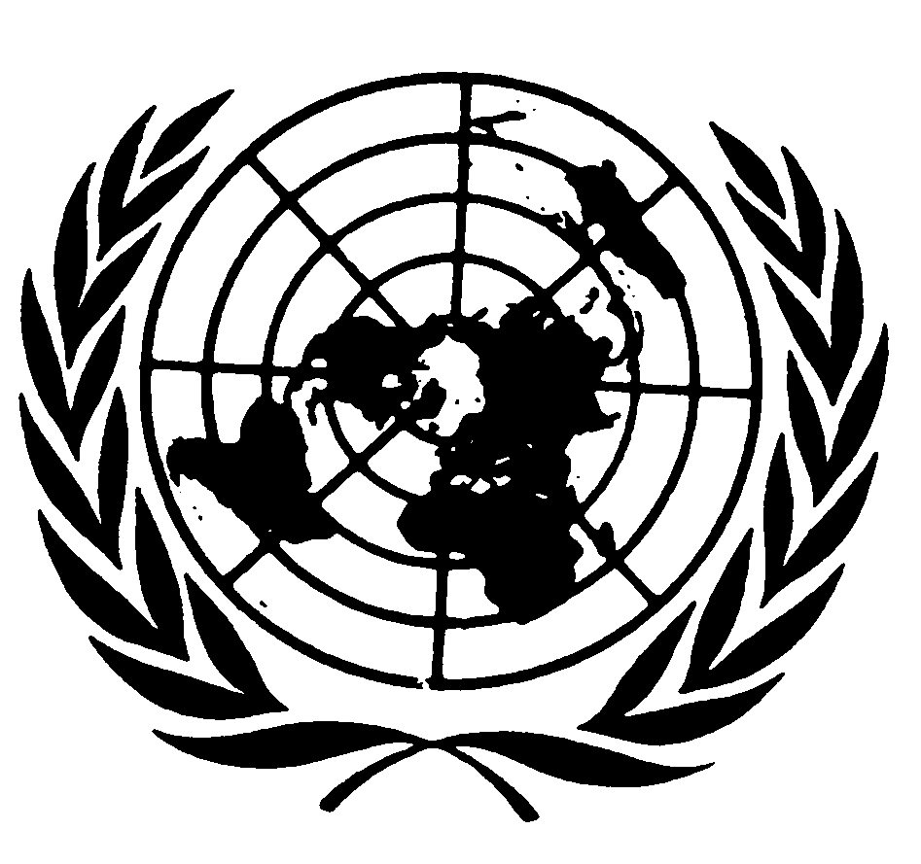
UNITED NATIONS NATIONS UNIES

DEPARTMENT OF ECONOMIC AND SOCIAL AFFAIRS
Division for Social Policy and Development
Secretariat of the Permanent Forum on Indigenous Issues

INTERNATIONAL EXPERT GROUP MEETING
ON INDIGENOUS LANGUAGES
8-10 January 2008, New York

Draft Programme of Work

DRAFT PROGRAMME OF WORK

Tuesday 8 January

10.00am – 10.30am

Opening of the Workshop by Mr. Johan Schölvinck, Director Division for Social Policy and Development, DESA.

Item 1 Election of Chairperson and Rapporteur

Item 2 Adoption of agenda and organization of work

10.30am – 1pm
Item 3 Working towards concrete actions and legislative development aimed at eliminating discrimination against the current use of indigenous languages

Presentations
Ms. Lydia Nyati-Ramahobo
Mr. Carl Christian Olsen

3 – 6pm
Item 4 Developing programmes aimed at promoting the empowerment of indigenous languages through all mediums, including radio and television;

Presentations
Ms. Jeanie Bell
Ms. Fenya Likhanova

Wednesday 9 January

10.00am – 1pm
Item 5 Supporting and increasing the number of centres for the study of indigenous languages;

Presentations
Ms. Anne Lasimbang
Mr. Hassan Id Balkassm

3 – 6pm
Item 6 Financing and supporting schemes for special projects that are formulated by indigenous peoples and are focused on revitalization and rescue of threatened languages;

Presentations
Ms. Priscilla Settee
Mr. Luis Montaluisa Chasiquiza

Thursday 10 January

10.00am – 1pm
Item 7 Designing, in consultation with indigenous peoples and the Permanent Forum, the organization of a world conference on linguistic diversity, indigenous languages, identity and education, as a contribution to the programme of the Second International Decade of the World’s Indigenous People.

Presentations
UNESCO

3 – 6pm
Item 8 Adoption of conclusions and recommendations

