PFII/2008/EGM1/16
Original: English

UNITED NATIONS 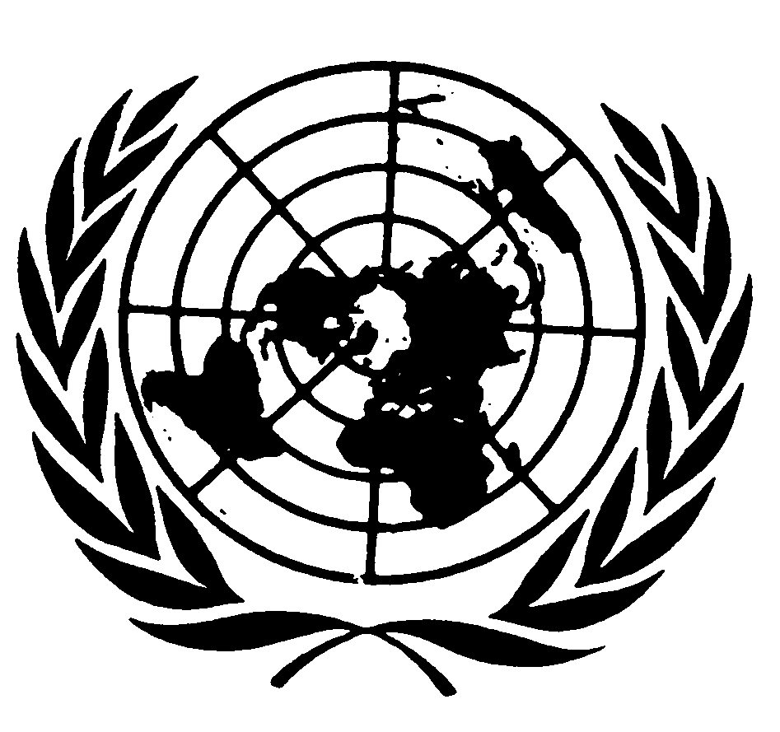 NATIONS UNIES

DEPARTMENT OF ECONOMIC AND SOCIAL AFFAIRS
Division for Social Policy and Development
Secretariat of the Permanent Forum on Indigenous Issues

INTERNATIONAL EXPERT GROUP MEETING
ON INDIGENOUS LANGUAGES
8-10 January 2008, New York

FAO’s Contribution to the International
Expert Group Meeting on Indigenous Languages

FAO
FAO and communication

The Food and Agriculture Organization of the United Nations (FAO) acts as a neutral forum where all nations meet as equals to negotiate agreements and debate policy. The Organisation constitutes a source of knowledge and information, assisting developing countries and countries in transition in the modernization and improvement of agriculture, forestry and fisheries practices to ensure good nutrition for all.

The Organisation currently stresses its evolving role as a “knowledge organisation”. A commitment that goes beyond dissemination of data, methodologies and statistics. It includes the task of fostering dialogue and sharing of experiences and best practice. However, access to knowledge remains problematic for many, particularly for people living in rural areas of difficult access. Bridging this rural digital divide has become a core focus for FAO and all forms of effective communication is accordingly of great interest to FAO.

Communication is a process that allows individuals and groups to exchange information. Essential to all exchange is that it requires feedback, it is a mutual activity. Knowledge about different languages and their use is thus extremely important for a knowledge managing organisation like FAO, which is aware of the fact that to be successful, communication strategies must take into account the cultural values of marginal groups as an avenue for their participation, rather than borrowing communication strategies from outside that promote change without due consideration for culture. Preserving cultural diversity, local languages and traditional systems of communication constantly remains a major challenge.

Languages, the most important component of communication, find themselves in a state of constant change - they live, die, move from place to place, and change over time. Any language that stops changing is destined to die. Accordingly, an organisation that has its mandate based on communication must constantly be attentive to the importance of languages and adapt to their dynamic nature.

Language and development

Languages are carriers of cultural characteristics and thus include several dimensions and aspects. They may express gendered values and behaviour, differentiating between masculine and feminine spheres of expression and being. Language may also be used to cover up uncertainty and as a means for exercising power. It may be used in a simple “monochrone” fashion, meaning that expressions are endowed with fixed, unchanging meanings, though it is more likely that language usage is multi-layered and “polychrone”, in the sense that expressions contain several meanings (of which some may be hidden) and need to be interpreted and analyzed while keeping in mind that meanings may change over time and from one situation to another. To complicate matters further, the use of language is dependent on the personality of the speaker; his/her value orientations, experience of time and space, selective perceptions, non/verbal capacities, and specific patterns of behaviour, etc., etc.

The definition and boundaries of indigenous groups depend on how people perceive themselves and others. Language differences have traditionally served as a partial basis for ethnic classification and as symbols of ethnic identity. Language, cultural characteristics, and common ancestry may be used as markers of ethnic identity. However, they do not always define groups of people.

As an international organisation co-operating with the entire world population, FAO is keenly aware of the various dimensions and various meanings of languages. Knowledge and information are essential if people are going to respond successfully to opportunities and challenges of social, economic and technological changes, including those that help to improve agricultural productivity, food security and rural livelihoods. To be useful, knowledge and information must be effectively communicated.

Communication for development encompasses many different media and approaches - folk media and traditional social groupings, rural radio for community development, video and multimedia modules for farmer training, and the Internet for linking researchers, educators, extensionists and producer groups to each other and to global information sources. Whether villages are connected to the outside world through modern telecommunications, learn about health care from folk proverbs and songs or listen to radio broadcasts on better farming practices, the processes are the same - people communicating and learning together.

The systematic use of communication can support livelihoods and development initiatives by: giving a voice to relevant stakeholders - rural people, development workers, local authorities and national decision makers; fostering policy acceptance; mobilising people for participation and action; conveying information for education and training; and disseminating new technology. Communication methods and tools used for development purposes can help overcome barriers of literacy, language, cultural differences and physical isolation. Communication is essential for enhancing livelihood of indigenous people and rural communities.

Development goals can only be achieved if knowledge and information are shared effectively, if rural stakeholders and indigenous groups are actively involved in decision making process. Communication systems can support field programmes by linking up research, training, extension and education efforts, but they have to reflect different cultural contexts and audience characteristics.

Indigenous languages

A great part of the approximately 7 000 languages spoken today are indigenous and each of these contain knowledge that is lost when they are extinguished. Just as biological diversity is essential to livelihoods, linguistic diversity is essential to human existence. Loss of traditional languages can have a dramatic effect on population groups’ ability to maintain traditional knowledge and food systems. Studies among indigenous peoples in Mexico have, for example, found that knowledge of plant use dropped as their Spanish speaking skills increased. Similar observations have been made among Amerinidians in Venezuela, whose knowledge of the use of forest trees declined with an increase in formal schooling, and/or fluency in spoken Spanish. Neglect, or outright suppression, of indigenous languages and the values they carry may have disastrous effects not only on the accumulated know-how of humankind, but also on the self-esteem of speakers of such languages. In spite of well-known negative implications for children’s development and well-being many nations deny people’s right to be taught in their autochthonous tongues.
The World Rainforest Movement Charter of the Indigenous-Tribal Peoples of the Tropical Forests called in 1992 for the establishment of bilingual and intercultural educational systems that “revalidate our beliefs, religious traditions, customs, and knowledge; allowing our control over these programmes, by the provision of suitable training, in accordance with our cultures; in order to achieve technical and scientific advances for our peoples, in tune with our own cosmovisions, and as a contribution to the world community.”

The loss of language associated with food and agro-ecological systems has been considered as a proxy indicator of the loss of knowledge associated with agro-biodiversity. The use of domesticated crops and livestock, as well as wild food plants and game, is shaped by culture and associated knowledge expressed through (among other things) language. The preservation of cultural systems (including languages) is accordingly as important as the conservation of the associated biological resources. The relationship works the other way as well: with the loss of agro-biodiversity and biodiversity comes the loss of associated language terms.

Indigenous communities possess often very detailed knowledge of their surrounding biodiversity, which has been passed from generation to generation across many centuries. Knowledge of biological diversity exists – indeed, may be particularly rich - inside communities who speak languages that are facing extinction. A book published by UNESCO, Sharing a World Difference: The Earth’s Linguistic, Cultural and Biological Diversity (2003), suggests that many areas of the world where biodiversity is richest are also places where many languages are spoken. As an example - a quarter of the world's spoken languages are in Papua New Guinea and Indonesia, both countries are also on a list of twelve “megadiverse countries” (i.e. countries harbouring in between 60 and 70 percent of the total biodiversity of the planet).

In order to know, use and to a certain degree control its environment humankind have invented systems to classify things surrounding them and thus make it possible to know them better and manipulate them for their own benefit. In biology such behaviour is labelled as “taxonomy”, from the Greek τάξις, taxis, “order'” and νόμος, nomos, “law” or “science”.

Languages classify almost anything — animate objects, inanimate objects, places, concepts, events, properties, and relationships — according to taxonomic schemes. Thus names of various species often contain essential information about their place and use within specific cultures and livelihood systems. For instance, in the Philippines names assigned to sweet potatoes may be based on: i) a distinguishing characteristic (e.g. Amsitan for bland taste); ii) the person who introduced a particular specie (e.g. Batong); iv) the place from which it originates (e.g. Kapangan); or a particular/popular personality (e.g. Imelda). Similar, and even more elaborate, examples can be found in almost any language/culture. If a language disappears, such exclusive knowledge disappears with it. One of the marvels connected with learning new languages is the fact that knowing a language means that you also learn about new ways to perceive things.

When an indigenous community is no longer allowed to pray, sing, or tell stories in its language, it is denied a fundamental human right. Unfortunately, linguistic rights have been seriously abused for hundreds of years by banning specific languages and indirectly by assaulting language-support structures such as land, economies and religions.

Appreciating, protecting and learning indigenous languages do not mean that you have to abolish the learning and appreciation of other, often dominant languages as well. Being multi-lingual opens up possibilities. Suppressing a mother tongue in benefit of another language is often contra-productive. It has been established that a thorough knowledge of a mother tongue facilitates the learning of another language. Accordingly, using and appreciating traditional knowledge does not have to mean a negation of “modern” scientific knowledge. On the contrary, knowledge of various thought systems and languages benefits the identification of new solutions and is furthermore culturally enriching.

A systematic use of communication can support livelihoods and development initiatives by giving a voice to relevant stakeholders - rural people, development workers, local authorities and national decision makers; fostering policy acceptance; mobilising people for participation and action; conveying information for education and training; as well as disseminating new technology. Communication methods and tools used for development purposes can help overcome barriers of literacy, language, cultural differences and physical isolation. Communication is essential for enhancing livelihood of indigenous people and rural communities.

By acknowledging the importance of indigenous languages, both benefits and hindrances to development may be discerned. An interest in autochthonous expressions may reveal aspects of other cultures and world views that would not have been discerned otherwise. For example, many people use expressions that are exclusive to their social and gendered roles within a specific social context. In order to reach out to, for example, women and socially excluded groups, it might be useful to know if they use expressions specific to their gender and/or social roles. While talking to a group of mixed people it might be useful to be aware of the fact that not all of them speak the same language, not only in a strict linguistic sense, but also in a social sense. For example, it is common that in several indigenous communities it is the men who understand and know how to express themselves in a foreign tongue, while women often only speak their mother tongue. It is also common, in most cultures, that for example men, who tend to have a more “public” social role than women, know how to handle the formal language used by, for example, representatives of power and bureaucracy.

Some examples of FAO initiatives related to indigenous languages

Since FAO is supporting agriculture, forestry and fisheries practices all over the world and often at “field level”, the Organisation is forced to use means of expression that allows individuals and groups to exchange information and provide essential feed-back. To that end information frequently has to be translated and transmitted in such a way that it is well understood and adaptable to various cultural contexts. The Organisation also collects and tries to learn from traditional farming systems and livelihood systems. For example, in 2002 FAO initiated a programme on conservation and adaptive management of “Globally Important Agricultural Heritage Systems” (GIAHS) aiming to establish the basis for the global recognition, conservation and sustainable management of such systems and their associated landscapes, biodiversity, knowledge systems and cultures: http://www.fao.org/sd/giahs/

FAO is recurrently compelled to disseminate information outside the realm of the UN official languages (Arabic, Chinese, English, French, Russian, and Spanish) and publish manuals and other information in indigenous languages. One example is provided by FAO’s Fisheries Department that recently published information on “the Code of Conduct for Responsible Fisheries” in several Pacific languages (Fijian, Kirbati, Motu, Gela, Tongan, Tuvaluan, Bislama, Samoan, and Maori)
http://www.fao.org/fishery/ccrf/7

FAO has over thirty years of experience in the field of communication to support agriculture and rural development. In 1969, the Organisation became a pioneer in the UN system when it established a “Development Support Communications (DSC) Branch”, later transformed to a “Communication for Development Group”, which currently manages around 50 projects in collaboration with Governments, UN agencies, donors and NGOs.

FAO has been a leader in promoting community participation in rural radio programming and is now facilitating links with new information and communication technologies, consciously producing services with audience participation in local languages, while taking into account local cultures. Efforts are also being made to enhance the use of traditional and folk media that form an integral part of rural life, like proverbs, poems, songs, dances, plays and stories. Traditional media offer an effective means to integrate local agricultural knowledge with new scientific knowledge from outside sources. At the same time as new media can be appropriated and managed locally by Indigenous People for their own purposes.

One example of FAO’s communication strategies is offered by a on-going collaboration with Guaraní communities in Bolivia, with whom FAO’s Communication Department is developing an alternative communication model, combining several media and communications systems (audiovisual, press, radio, etc.), trying to ensure that the emerging model will be useful for the Guarani people and that the system will be managed entirely by them. Experiences are described throughout a publication entitled YASAREKOMO, the indigenous term for “to awaken”, which also refers to an awakening of consciousness and a new way of thinking that responds to the challenges which face us in today’s world. The initiative has:

- identified key area topics and experiences about the best communication methods and strategies applicable for the promotion of sustainable livelihood;
- systematized methodologies and tools for communication strategy design and service delivery for sustainable rural livelihood to be used at different levels, and
- facilitated information exchange and collaboration on the topic between development projects, institutions, organizations and communication centres and NGOs through existing networks and community of practice, promoting a regional platform and a plan of action.

The experiment serves as inspiration for other regional communication platforms already established in Central America and the Near East. A new platform for Indigenous People’s Communication & Sustainable Livelihood (established on initiative by the “International Forum on Indigenous Peoples’ Communication and Development” in Bolivia, September 2006) is currently supported by FAO, IFAD, CIDOB and the UN Permanent Forum on Indigenous Issues (UNPFII).

FAO’s commitment to communication and development was demonstrated by the first “World Congress on Communication for Development (WCCD)”, jointly organized by FAO, the World Bank and the Communication Initiative and held at FAO headquarters in Rome in October 2006. The focus of the Congress was to promote the mainstreaming of communication into development policies and programmes, establish strategic partnerships and demonstrate that communication for development is essential for meeting today’s most pressing development challenges. In connection with the Congress FAO implemented a series of regional studies, consultations and workshops to get views and proposals of local practitioners and institutions for mainstreaming communication into policies related to sustainable development. Several of these activities highlighted the importance of establishing links and collaboration with indigenous communities and organisations, not the least when it comes to supporting indigenous languages and their use for transmitting information and experiences related to issues of importance for sustaining livelihoods and support development.

In partnership with Indigenous People’s organisations FAO has developed cultural indicators of “Indigenous Peoples’ Food and Agroecological Systems”. This initiative include several linguistic aspects. The survey methods used for compiling and establishing the indicators were discussed at the “Second Global Consultation on the Right to Food”, coordinated by the International Indian Treaty Council (IITC) in Nicaragua in 2006. A technical paper is currently being finalized. The consultation in Nicaragua agreed on the following indicator categories:

- access to land, territories, natural resources, sacred sites and ceremonial
areas;
- abundance, scarcity and/or threats to traditional seeds, plant foods and
medicines, food animals, and their associated production practices;
- use and transmission of knowledge, methods, language (in particular the preservation and continued use of language and traditional denominations for foods and food practices – such as planting, hunting, gathering, harvesting, fishing and food preparation), ceremonies, dances, prayers and oral histories related to traditional foods and agrofood systems, and the continued use of traditional foods in daily diets;
- capacity for adaptability, resilience and/or restoration of traditional food
uses and production, and
- ability to exercise the rights of self-determination and free, prior and
informed consent and to defend food sovereignty and development.

To sum up, FAO is acutely aware of the importance of safeguarding and making use of indigenous languages, as well as the Organisation acknowledges the valuable insights they provide for an understanding of rural livelihoods, biodiversity, sustainable use of natural resources and many other issues related to food security and rural development. Accordingly, FAO will in partnership and co-operation with other organisations continue to support indigenous and rural communities in the use of their mother tongues and in their efforts to make their means of communications more effective.

