PFII/2008/EGM1/4
Original: English

UNITED NATIONS  NATIONS UNIES

DEPARTMENT OF ECONOMIC AND SOCIAL AFFAIRS
Division for Social Policy and Development
Secretariat of the Permanent Forum on Indigenous Issues

INTERNATIONAL EXPERT GROUP MEETING
ON INDIGENOUS LANGUAGES
8-10 January 2008, New York

Presentation to the Expert Group Meeting on Indigenous Languages

Jeanie Bell
Senior Lecturer, Centre for Australian Language and Linguistics
Batchelor Institute for Indigenous Tertiary Education
Northern Territory, Australia

I have practised as a community linguist since I graduated with my first degree from Monash University in Melbourne Australia in 1980. I am an Aboriginal person with traditional connections to land and languages of both coastal and inland country of South East Queensland which is geographically a part of the top half of Australia. Queensland was historically referred to as the deep north of Australia because of the draconian laws and policies imposed upon Aboriginal and Torres Strait Islander people over many decades.

The traditional land of our ancestors was forcefully taken while their cultural and linguistic practices were discouraged and disrespected. Consequently today many of our traditional languages are now extinct while many others are severely diminished with only a few passive elderly speakers remaining with no active intergenerational transmission happening.

Recent estimates indicate that only 20-30 language groups in the central and northern parts of Australia would today be considered healthy, being spoken on a regular basis by their speakers whose numbers range from 100-3,ooo. However these languages are also considered severely endangered.

Language documentation which has been happening in Australia for the past 150 years, was initially done by missionaries and/or explorers and more recently linguists from Australia and overseas. In recent years much of this material has been useful in the determined efforts of those Aboriginal and Torres Strait Islander community people involved in programs aimed at strengthening their languages. In some situations recovering languages are only spoken in restricted contexts and for limited linguistic purposes, while in other communities where language loss was rapidly encroaching traditional languages are now used across many linguistic domains.

The role of training and education is crucial in this overall process, and the Institute where I am employed has played a major role over the last 30 years in providing courses which assist in the efforts of Indigenous community people. While Batchelor Institute is not the only educational body in Australia providing linguistic training to Indigenous people it has been continuously providing courses in this area over a long period of time.

Batchelor Institute for Indigenous Tertiary Education is located in a small mining town in the central northern part of Australia. It began delivering educational services in the early 1970s as a Technical and Further Education centre offering training programs for Aboriginal people from remote communities in the Northern Territory. These programs included training for bilingual/multilingual community people as teachers and literacy production workers for the numerous bilingual education programs which had at that time been established by the Northern Territory government in selected community schools. In the last decade these bilingual programs have been weakened substantially by the present Northern Territory government primarily because of the fear on the part of bureaucrats and some concerned parents and guardians that Aboriginal children were not gaining adequate English language skills to survive economically outside of their isolated community situation.

The downgrading of these programs has had a serious impact on the maintenance of traditional languages, restricting the opportunities for children to speak their first language to the home situation while they often may choose to speak a local variety of Aboriginal English or creole outside of the home. Our Institution supports the training of community education teachers for these bilingual community schools.

Also in the past 10 years Batchelor Institute has offered a 3tiered Bachelor of Arts higher education degree program to Aboriginal and Torres Strait Islander people from all around Australia, in language and linguistics, as well as a new Diploma level course in learning an Australian language. These courses are unique in Australia as they are the only tertiary level courses designed specifically for Indigenous people to develop specific skills and knowledge to enable them to work in programs directed towards language revival and maintenance.

The Centre for Australian Language and Linguistics at Batchelor Institute also delivers a Vocational Education program in Own Language Work which are 2 Certificate level courses specifically designed to support the custodians of traditional languages living in remote Aboriginal communities in the Northern Territory maintain their highly endangered languages. The custodians and speakers of these endangered languages have chosen for social and economic reasons to live off their traditional country on designated communities which are mainly administered by governments and in the past by various churches in Australia. Members of these churches have for many years engaged in Bible translation in these communities with some work still continuing today with the involvement of local translators. This work contributes to language maintenance for these language groups.

Due to the mixed linguistic situation which has existed over many decades on many Indigenous communities across northern Australia several varieties of a creole language has emerged as the lingua franca, rapidly spreading also to adjacent regional towns. While traditional languages remain strong in some other remote communities the imposing threat of creole looms large.

In September, 2007 staff and students from Batchelor Institute attended a national conference on Indigenous languages where much discussion was focussed on ways of arresting the serious situation we face in Australia to hold back the tide of language loss. Indigenous people from all over Australia came together with linguists from Universities and regional language centres to discuss strategies for successful language maintenance and revival.

At the conference in Adelaide Batchelor students from remote communities in the NT gave group presentations about the language situation and related work they are doing in their communities, and how this work fits in with the course they are currently enrolled in. Following is an extract from the summary outline for their presentation prepared by their lecturers prior to the conference:

‘Delivery (of the course content) is community based and involves students and lecturers collaborating on language projects with community elders. The programs draw on networks of expertise, utilising linguists and language speakers as tutors. Students, tutor and linguists work in teams on language projects in a capacity building framework. These teams aim to integrate a range of skills and language knowledge, enhance intergenerational learning and support language transmission across generations. The Own Language Work programs link closely with the Indigenous Language and Culture programs delivered in remote schools, training language workers and supporting language resource development.’ (July, 2007)

Also at the Adelaide conference we were privileged to have two international guests, Mr Phil Cash Cash from North America spoke to us about documenting cultural landscapes in his homeland and a very inspiring address from an articulate Maori woman from Aotearoa (New Zealand) about the value of Maori television and the important contribution it has made to strengthening traditional language in that country.

While in Australia an Aboriginal owned and managed television station Imparja broadcasts over a wide area of northern Australia it only has the occasional program which uses traditional languages. A new media organisation NITV National Indigenous TV, has formed a partnership with Foxtel (pay television), and while recently discussing the development of a language policy for the use and promotion of Indigenous languages on air, we are yet to see how this will be applied. The two public free to air television stations ABC and SBS have Indigenous specific programs and staff to develop and present these once or twice a week but again only rarely is traditional language part of this programming. Indigenous people in Australia would like to see an increase in the representation of Indigenous language and culture across both free to air and pay television stations, as we believe we are highly under-represented in these forums.

There are many Indigenous radio stations throughout Australia operated by trained Indigenous broadcasters and journalists and CAAMA, the main one in the Northern Territory has been in operation for 30 years and is a passionate advocate of Indigenous languages, broadcasting regularly via this medium as well as the daily playing of modern and traditional music written and sung in traditional languages from this part of the country.

An important outcome from the recent National Indigenous Language Conference was the development of 10 key recommendations which are outlined in the attached letter sent to politicians and other influential people for a response and anticipated action of support for future programs. I present this letter to this United Nations Expert Group meeting for consideration.

I thank you for your invitation to me to make this presentation on behalf of the Indigenous custodians of traditional languages in Australia. I am very honored and humbled by this opportunity, and I look forward to attending the meeting in New York for further exchange and discussion. I will travel with the spirit of my ancestors from this land on which we live down-under and they will guide me in my journey to your country. Our languages are the voice of the land and we cannot allow them to die.

Yours sincerely

Jeanie Bell
2nd December, 2007.
ANNEX

22nd November, 2007

To Whom It May Concern:

Aboriginal and Torres Strait Islander Languages in a State of Crisis

The Aboriginal and Torres Strait Islander Languages of Australia are magnificent and are used by many first Australians as a first language throughout the continent.

However, since European occupation the number of languages spoken in Australia has decreased drastically. In most regional areas throughout the continent, many languages have become extinct and are lost forever. The remaining languages are in a state of disrepair despite ongoing Language Initiatives. According the State of Indigenous Languages in Australia Report (McConvell and Thieberger, 2001)
ALL of Australia’s first languages will be extinct by the year 2050.

State and Territory representatives from Aboriginal Language Centres, Tertiary Institutions recently gathered at a National Indigenous Languages Conference during 25-27th September to talk about current state and territory language initiatives as well as discuss strategies to revitalise, maintain and promote Aboriginal and Torres Strait Languages.

We, the participants of the National Indigenous Languages Conference bring to your immediate attention the Key Recommendations of that conference:

1. That all Aboriginal and Torres Strait Islander languages be written into the Constitution and recognised as Official Languages of our traditional country.

This recognition would respect the rights that all Aboriginal and Torres Strait Islander people have including:
- The right to be educated in their own languages (as stated in the United Nations Declaration of Rights for Indigenous Peoples)
- The right to interpreting and translating in a court of law and elsewhere;
- The right to have our traditional language recognised as the/an official language in our traditional country;
- The right to have Aboriginal and Torres Strait Islander placenames recognised;
- The right to have laws written in traditional languages, when deemed necessary by the community, so as to make them accessible for everyone.

2. That the Federal Government recognise that speaking an Aboriginal or Torres Strait Islander language is a contributor to social cohesion and well being for all Indigenous people which includes knowledge and use of our kinship relationships relevant in a culturally diverse society.

3. That the government and its agencies take Aboriginal and Torres Strait Islander languages seriously and value their importance. Communication about government business (health, social security, policing etc.) and education are most effective if conducted using people’s first language.

4. That Aboriginal and Torres Strait Islander languages and linguistics courses be developed within the national VET curriculum and within teacher training institutions. The delivery of VET programs should be supported across state and territory borders.

5. That Federal and State Education Departments commit funds and resources:

i) to train Aboriginal and Torres Strait Islander speakers to teach their own languages;

ii) to develop ways of recognising prior linguistic and cultural knowledge of community language speakers with the development of national standards to measure language proficiency. This process could be based on the current Competencies model used by Pundulmarra College in Western Australia.

iii) to support communities to develop school curriculum and resources in their own language.

6. That Aboriginal communities have "the right to establish and control their educational systems and institutions providing education in their own languages, in a manner appropriate to their cultural methods of teaching and learning" (Article 15 of the UN Declaration on Indigenous Rights).

Also it is recommended that:

a) Bilingual education programs that have been closed or reduced be reinstated and given continued support.
b) That the community be allowed the right to become involved in curricula and materials development as well as local teacher education. Bilingual education programs should be equally a community development process alongside the educational process.
c) That consultations for bilingual school developments be conducted with all communities and that initiatives be put in place to train local Aboriginal teachers.

7. That the Federal Government in conjunction with Indigenous language speakers and State and Territory governments develop a national Aboriginal and Torres Strait Islander Languages Policy.

8. That a review be called to recommend means of implementation for the recommendations of the National Indigenous Languages Survey report 2005 which to date have not been implemented,. In particular, consideration for the following recommendations:

Recommendation 1: That a pilot national program of Indigenous Language Nests be created and implemented

Recommendation 4. That a feasibility study be undertaken to evaluate the best set up for a National Indigenous Language Centre

9. That the Federal Government become a signatory to the United Nations declaration on the Rights of Indigenous Peoples.

10. That an inquiry be held into the likely effects of the Federal Government intervention into Northern Territory communities on Aboriginal languages and cultures. As a result of this inquiry, immediate steps must be taken to ensure that support structures be put in place and measures be taken to minimise disruptive effects.

The time for talking has long since passed, we strongly urge that immediate and drastic action be taken to preserve our Nation’s most significant heritage- Our Aboriginal and Torres Strait Islander Language.


Mr Bruce Thomas
Chairperson
Wanga Maya Language Centre
Port Hedland, WA

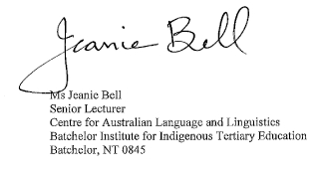



Ms Barbara McGillivray
FATSIL National Secretary, WA representative 288 Hay St, Kalgoorlie Boulder WA 6430 Tel 0890 914 705 Mb: 0448 894 212



Sharon Hume
Manager, Karlkurla language & Culture Aboriginal Corporation
288 Hay St, Kalgoorlie WA 6430, 0890914705

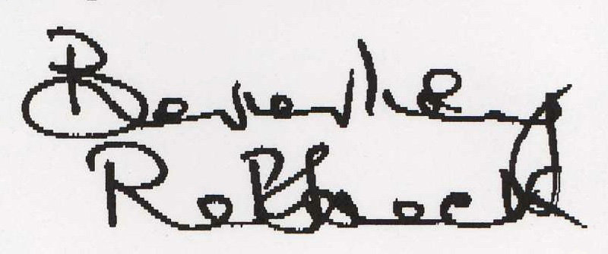
Beverley Rebbeck
Acting Chairperson
Dandjoo Moordyap Dabarkan - Noongar Language Project
Perth, WA

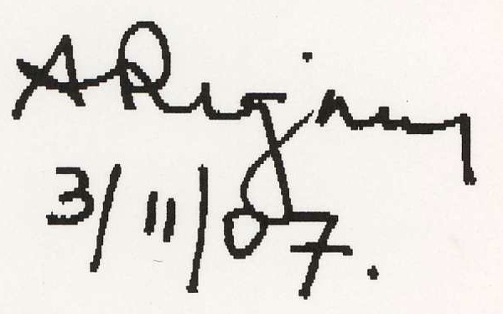
Dr. Alice Rigney
Kaurna Warra Pintyandi
University of Adelaide


Rob Amery
Indigenous Languages Conference - Conference Convenor
Convenor of the Kaurna Warra Pintyandi


Suzanne Bradshaw
Curriculum and Assessment Officer (Languages)
Senior Secondary Assessment Board of South Australia


Katherine Teague,
Senior Secondary Assessment Board of South Australia

Signed on behalf of Indigenous Language Conference delegates and/or their representatives.

