PFII/2010/EGM
Original: English
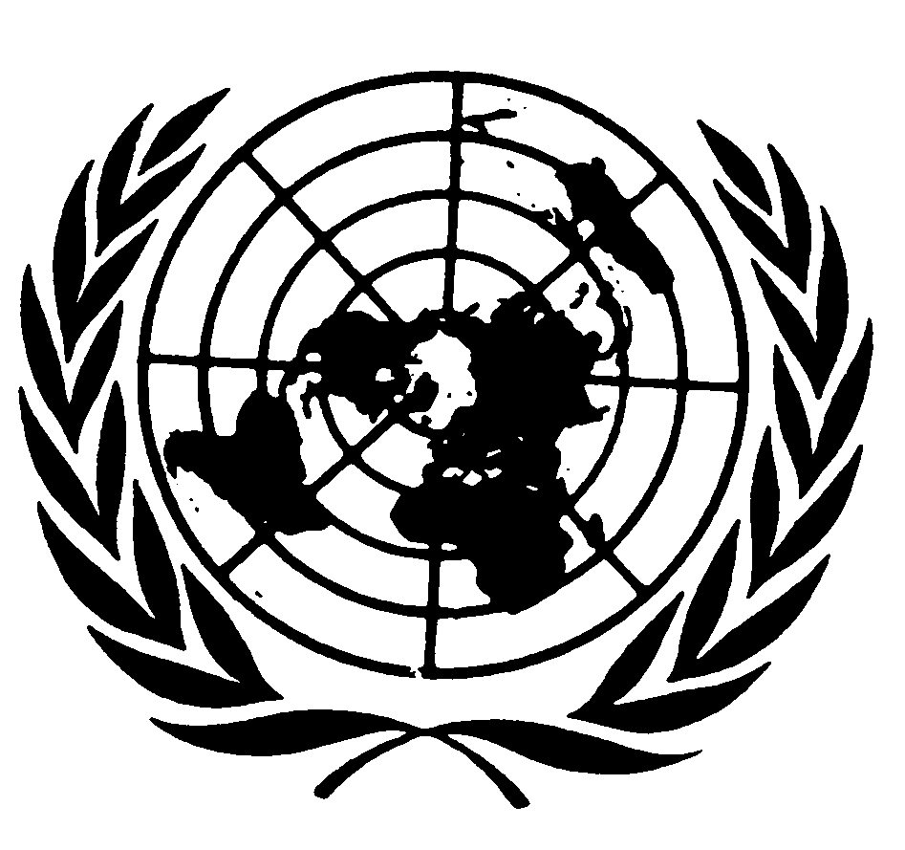
UNITED NATIONS NATIONS UNIES

DEPARTMENT OF ECONOMIC AND SOCIAL AFFAIRS
Division for Social Policy and Development
Secretariat of the Permanent Forum on Indigenous Issues

International Expert Group Meeting on Indigenous Peoples:
Development with Culture and Identity:
Articles 3 and 32 of the United Nations Declaration on the Rights of Indigenous Peoples
12 - 14 January 2010, New York

Concept Paper

Prepared by the Secretariat of the United Nations Permanent Forum on Indigenous Issues
Division for Social Policy and Development
Department of Economic and Social Affairs
United Nations

A. Introduction

1. At its eighth session in May 2009, the United Nations Permanent Forum on Indigenous Issues (UNPFII) recommended that the Economic and Social Council authorize a three-day international expert group meeting on the theme: “Indigenous peoples: development with culture and identity: articles 3 and 32 of the United Nations Declaration on the Rights of Indigenous Peoples” and requested the results of the meeting be reported to the Permanent Forum at its ninth session.

2. At its regular session on 30 July 2009, the Economic and Social Council approved the Permanent Forum’s recommendation in decision 2009/253.

3. This United Nations International Expert Group Meeting on Indigenous People, Development with Culture and Identity hereinafter will be referred to as the “Expert Group Meeting”.

4. The Expert Group Meeting will be held at the United Nations Headquarters in New York 12 - 14 January 2009. The special theme of the ninth session of the UNPFII is also “Indigenous peoples: development with culture and identity: articles 3 and 32 of the United Nations Declaration on the Rights of Indigenous Peoples”

B. Context/Background on the Meeting:

5. Indigenous peoples’ concept of development embraces a holistic approach which includes their aspirations, respect and protection of their diversity and uniqueness. Indigenous peoples want to become agents of their own development and have the foresight to promote a development paradigm that is self-determining, as set out in Articles 3 and 32 of the UN Declaration on the Rights of Indigenous Peoples. Indigenous peoples’ development paradigms could build on collective rights and the ethos of benefit-sharing that affirms their important connection to their lands and territories. It could also promote a strong gender focus, respect for traditional experiences and inclusiveness, and be able to face current challenges. An indigenous paradigm could have a holistic vision that includes economic growth, sustainable development of the environment and affirmation of the social, economic and cultural rights of indigenous peoples.

6. The concept of development has, since the Second World War, often been conceived in strictly economic terms. The main focus has been on the quest for GDP growth and the general belief that economic development would also yield development in other spheres of life. The concept of development was thought to follow an evolutionary process that commenced from basic commodity suppliers, through capital accumulation to industrialization, in turn leading to urbanization and ‘modernization’. According to liberal theorists, the final product of development would be the establishment of meritocratic democracies with market economies, social protection and mild socioeconomic inequality. Marxist theorists went further and posited egalitarian stateless societies with collective ownership of the means of production. In this context, the place of indigenous peoples was seen to be contradictory. On the one hand, Marxists and liberal theorists considered indigenous peoples’ societies to be highly mobile and egalitarian societies and yet, at the same time, were regarded as ‘crude, primitive and uncivilized’ societies where their ‘development’ was understood to be their assimilation into the ‘civilized world’. It could be argued this understanding of indigenous peoples’ ‘development’ continues to exist in the minds of many policy makers today.

7. The current understanding of development entails the exploitation of natural resources where indigenous peoples are seen to be ‘obstacles’ to progress because they often occupy lands that are rich in resources. It is not surprising that the assimilation of indigenous peoples is a means to usurp their lands, a necessary step in fostering development. In this context, the national interest, which is often translated as that of a particular economic group, has always taken precedence over indigenous peoples’ interests. For most of the twentieth century, the treatment accorded to indigenous peoples was very similar to their treatment during the centuries of European colonialism and expansion.
8. Critiques of purely economic development have lead to further elaboration of the concept such as ‘human development’, ‘sustainable development’ and ‘human-rights based approach to development’. These three approaches are most often applicable to indigenous peoples, frequently in discourse rather than action. For example, UNPFII has repeatedly emphasized the need to incorporate a human rights-based approach to development in the United Nations Millennium Development Goals (MDGs) which are to be reached by 2015. Further, there has been some suggestion that in the case of ‘sustainable development’, there is the added risk of equating indigenous peoples with nature. While there has been a focus on indigenous peoples’ development revolving around the issue of land rights, in particular, how to exploit the natural resources, many indigenous peoples argue that their lands and resources should not be reduced to mere economic assets as they also form an important basis for indigenous peoples’ social and cultural integrity.
9. Indigenous peoples are increasingly turning their attention to the need to participate in the policy dialogue on development issues. They have questioned the logic of development particularly in large infrastructure projects on their lands, such as extractive industries, highways or dams, that have in many cases, not only generated poverty and severe inequality but also fueled other social problems such as family breakdowns, alcoholism, and suicide among young people. Indigenous peoples’ role in development continues to shift beyond natural resource management and preservation issues to addressing development in the context of social sector reform and poverty reduction strategies.

10. While the objectives of the Second Decade of the World’s Indigenous People point to development frameworks to be more culturally sensitive and relevant for indigenous peoples, the reality is that in many instances, human rights issues do not form the basis of development projects. Indigenous peoples are also challenging International Financial Institutions, UN Agencies and other funding bodies to reconsider their approach in development projects that affect indigenous peoples and their communities. Human rights and development are still seen as separate by many policy-makers and practitioners, although United Nations agencies are now focusing on a concept of ‘human rights-based approach to development’. The United Nations Development Group Guidelines on Indigenous Peoples’ Issues is an example of a new approach to development. It sets out the normative, policy and operational framework for implementing a human rights based and culturally sensitive approach to development. To date, there have been some case studies of good practices regarding indigenous peoples’ development and there is still room for more case studies as well as lessons learned from negative development projects.

11. At the annual meeting of the Inter Agency Support Group on Indigenous Peoples’ Issues in Paris in September 2008, a thematic roundtable was organized by UNESCO on the theme of this workshop. Speakers included Permanent Forum members Victoria Tauli-Corpuz, Margaret Lokawua and Carlos Mamani Condorí as well as Anaisabel Prera, Guatemala’s Ambassador to France and Permanent Delegate to UNESCO, Darriann Riber of the Danish International Development Agency, Brigitte Feiring, International Labour Organization (ILO) and Katérina Stenou, Director, Division of Cultural Policies and Intercultural Dialogue, UNESCO. The UN Declaration on the Rights of Indigenous Peoples was highlighted as the overarching framework for development regarding indigenous peoples’ issues and the right to self-determination being the key to debates on development. The UNESCO Universal Declaration on Cultural Diversity gives attention to the linkages between culture, development and identity. Also, through ILO Convention 169, there are opportunities to influence country processes in poverty reduction. Capacity building programmes and education programmes to overcome illiteracy rates in indigenous communities were also highlighted.

12. The UNPFII has held previous meetings related to the issue of indigenous peoples’ and development and has endorsed a number of recommendations on: Extractive Industries, Indigenous Peoples’ rights and Corporate Social responsibility: Indigenous Peoples’ Self-Determined Development or Development with Identity: Perspectives of Relationships between Indigenous Peoples and Industrial Companies; Convention on Biological Diversity’s international regime on access and benefit-sharing and indigenous peoples´ rights; Partnership Visions for The Second International Decade of the World’s Indigenous Peoples; Methodologies regarding Free, Prior and Informed Consent and Indigenous Peoples and others. Reports of these workshops can be found on the UNPFII website.

13. In today’s rapid societal transformation and globalization, it is crucial that indigenous peoples’ vision of development be explored and given further consideration. While important issues such as sovereignty, self-government and self-determination are core values in the Western world, they are seldom contemplated in relation to indigenous peoples. However, the United Nations Declaration on the Rights of Indigenous Peoples provides a much stronger basis from which indigenous peoples can affirm their rights and define their aspirations in the debates with states and corporations around development with culture and identity. Certainly, Articles 3 and 32 of the United Nations Declaration on the Rights of Indigenous Peoples affirm their right to self-determination and the right to determine and develop priorities and strategies for development:
Article 3:
Indigenous peoples have the right to self-determination. By virtue of that right they freely determine their political status and freely pursue their economic, social and cultural development.

Article 32:
1. Indigenous peoples have the right to determine and develop priorities and strategies for the development or use of their lands or territories and other resources.
2. States shall consult and cooperate in good faith with the indigenous peoples concerned through their own representative institutions in order to obtain their free and informed consent prior to the approval of any project affecting their lands or territories and other resources, particularly in connection with the development, utilization or exploitation of mineral, water or other resources.
3. States shall provide effective mechanisms for just and fair redress for any such activities, and appropriate measures shall be taken to mitigate adverse environmental, economic, social, cultural or spiritual impact.

Similarly, the Proposed American Declaration on the Rights of Indigenous Peoples (Article 15) stresses indigenous peoples’ right to self-governance in several realms, including culture, religion, education, information, media, health, housing, employment, social welfare and economic activities.

14. The International Labour Organization (ILO) Convention 169 urges governments to acknowledge indigenous peoples’ right of ownership over their traditional lands and the natural resources obtained from their lands so as to protect the economic, political and spiritual interests of indigenous peoples. Furthermore, the Convention requires governments to recognize indigenous customs and institutions and to introduce legislation that allows indigenous peoples the right to maintain and strengthen their legal, political, economic and social systems. Both the ILO 169 and the United Nations Declaration on the Rights of Indigenous Peoples urge states to obtain the free, prior and informed consent of indigenous peoples prior to the approval of any development projects.

15. The right to development was proclaimed by the United Nations in 1986 in the Declaration on the Right to Development, which was adopted by the UN General Assembly resolution 41/128. The Right to Development is also recognized in the African Charter on Human and Peoples’ Rights. It is both an individual and group right and was reaffirmed by the 1993 Vienna Declaration of Programme and Action. The preamble of the Declaration on the Right to Development confirms a number of important human rights standards such as the right of peoples to self-determination, by virtue of which they have the right freely to determine their political status and to pursue their economic, social and cultural development. Article 1 states:
The right to development is an inalienable human right by virtue of which every human person and all peoples are entitled to participate in, contribute to, and enjoy economic, social, cultural and political development, in which all human rights and fundamental freedoms can be fully realized.

16. The United Nations Committee on the Elimination of Racial Discrimination has adopted explicit recommendations with respect to indigenous peoples. The Committee calls upon governments to [p]rovide indigenous peoples with conditions allowing for a sustainable economic and social development compatible with their cultural characteristics; …[e]nsure that members of indigenous peoples have equal rights in respect of effective participation in public life and that no decisions directly relating to their rights and interests are taken without their informed consent;…[and] recognize and protect the rights of indigenous peoples to own, develop, control and use their communal lands, territories and traditionally owned or otherwise inhabited or used without their free and informed consent, to take steps to return those lands and territories.

17. The unethical exploitation and abuse of indigenous peoples and their communities, lands and resources through large scale development projects is also an important issue. At its Seventh Session in 2008, the Permanent Forum adopted a recommendation for holding an expert workshop on extractive industries. The International Expert Group Workshop organized by Tebtebba Foundation in cooperation with the Secretariat of the Permanent Forum on Indigenous Issues, noted that although corporations, due to the pressures and struggles from indigenous peoples, were now more willing to consult with communities, the requirement of free, prior and informed consent was still not realized. Further, there were major problems with the lack of full disclosure of information regarding environmental, social, cultural and human rights impacts. One frequently encountered problem was that corporations, in collusion with government authorities, selected indigenous individuals or specific communities to negotiate without ensuring that they represented their communities and/or the impacted area. By doing this they divide indigenous peoples within the communities. Participants at the Expert Group Workshop expressed frustration that extractive industries often treated benefit-sharing or social programs as charity, rather than a human rights issue.

18. Since the 1970s, the United Nations has sought to establish international standards and operating guidelines for multinational corporations. In 1998, the Sub-Commission on the Promotion and Protection of Human Rights established a working group to examine the working methods and activities of multinational corporations. In 2003 the Sub-Commission adopted the final version of the Norms on the Responsibilities of Transnational Corporations and Other Business Enterprises. The Norms were considered as a mandate for human rights obligations of transnational corporations. While states retain primary responsibility for promoting human rights, the Norms underscore human rights obligations of multinational corporations. However, due to opposition from corporate groups, and following consultation and a 2-day workshop on the Norms, a report published by OHCHR in February 2005 recommended that the Norms be maintained among existing initiative and standards, with a view to their further consideration. In 2005, Professor John Ruggie of the Kennedy School of Government at Harvard University was appointed Special Representative of the Secretary-General on the issue of human rights and transnational corporations and other business enterprises.

19. In 2000, parallel to the drafting of the Norms, the UN Secretary General launched the Global Compact which is a voluntary initiative, engaging international business and civil society organizations in promoting human rights, labour standards, environmental protection and anti-corruption. The Global Compact is recognized as an important step towards acknowledging the role of multinational corporations in the world. As a body, it comprises over 3,000 companies from 116 countries and while it is an inclusive global political forum, there is some concern that there is no system through which to monitor or enforce compliance of those corporations that have signed up to its ‘ten principles for a better world’.

20. Research and Statistics on indigenous peoples’ concept of development or even their participation in development agendas are severely lacking. Indigenous peoples include very diverse groups of peoples with differentiated poverty levels and other characteristics. Hence, further research and statistical data is required to measure and monitor how indigenous peoples are faring, as well as capture the various characteristics of indigenous communities. Such information and statistics are critical in order to improve targeted development interventions.
Objectives and Outcomes of the Meeting:
21. The Expert Group Meeting is intended to:

- To analyze enshrined human rights within international standards and policies (e.g. The UN Declaration on the Rights of Indigenous Peoples, ILO 169, the UNDG Guidelines on Indigenous Peoples, the UN Declaration on the Right to Development, the recommendation of the UNPFII, the case law and comments on human rights treaty bodies) and how these contribute to indigenous peoples’ concept of development with culture and identity.

- Promote an opportunity to exchange information and analysis on the various concepts of development with culture and identity in the context of the United Nations Declaration on the Rights of Indigenous Peoples .

- Draw attention to the various development concepts and practices and their impact on indigenous peoples’ livelihoods, communities, cultural practices and lands and natural resources.

- Identify options and further plans to build the necessary conditions for development such as empowering and strengthening indigenous peoples’ organizations and governance systems and other capacity enhancement programs for indigenous women and youth.

- To analyze opportunities for partnerships with indigenous peoples on development issues and how such arrangements might be informed by good practices and Corporate responsibility models.

- Highlight both positive and negative development practice models from indigenous peoples’ perspectives; and

- Identify gaps and challenges and a possible way forward.

22. The final report and recommendations of the Expert Group Meeting will be to be submitted to the ninth session of the UNPFII.

Proposed Themes for discussions
23. Four major themes of discussion are proposed as follows. Under each of the themes are some preliminary questions that have been identified for consideration and to stimulate discussion.

Theme 1 Outline various development concepts and practices
- Analysis of international standards and recommendations that could be applied to indigenous peoples’ concept of development with culture and identity (e.g. United Nations Declaration on the Rights of Indigenous Peoples, case law and comments of the Human Rights Committee and other human rights treaty bodies, Human Rights Council, UN Permanent Forum on Indigenous Issues, ILO and others);
- Analysis of how the goals and needs of indigenous peoples may differ from the needs and goals of other interested holders in the development processes;

Theme 2 Case Studies on the positive and negative effects of development on indigenous peoples and their communities.
- Provide case studies where development projects have had a negative effect on indigenous peoples and their communities by generating further poverty and severe inequality and other social problems. Highlight any lessons learned from such experiences;
- Provide case studies of instances where indigenous peoples are working as a community or in partnerships with Governments, United Nations agencies, the private sector, donor agencies on alternative development practices that may have positive outcomes.

Theme 3 Factors that enable or obstruct indigenous peoples’ participation development processes.
- Provide examples where there might be effective participation in decision-making at the national level;
- Highlight capacity building efforts that provide the necessary conditions for development activities;
- Highlight measures of accountability and integrity in decision-making and implementation of policies at the international and national levels in regards to the development processes.
- Identify obstacles, including lack of relevant statistics, lack of information and lack of technical support in the development processes;
- Highlight the persistent barriers that block indigenous peoples’ effective participation in the development process;
- Analyze the role of the donor community and the private sector in enhancing or weakening indigenous peoples’ participation in the development process?

Theme 4 Human Rights and Corporate Responsibility in development programmes and projects.
- Highlight measures to incorporate human rights into programmes and projects of corporations;
- Highlight measures to strengthen Corporate responsibility in development programmes and projects and how they might benefit indigenous peoples concept of development with culture and identity;
➢ Highlight measures for States to provide effective mechanisms for just and fair redress for adverse environmental, economic, social, cultural or spiritual impact by development projects and programmes on indigenous peoples’ lands, territories and resources.

Participant Contributions:
24. The Expert Group Meeting seeks to draw on the expertise of indigenous peoples; United Nations Permanent Forum members; relevant United Nations and other intergovernmental agencies; national and local governments; indigenous peoples’ organizations; non-government organizations and academics that are active within the development field.

25. International indigenous experts will represent each of the seven UNPFII regions. They will be required to prepare papers to present at the meeting on one or more of the themes listed above.

26. Experts are requested to submit their papers (8 pages maximum) to the organizers by 1st November 2009 so that the papers can be distributed before the meeting. Experts will also be informed in due course of the Program of Work for the Expert Group Meeting and the appropriate time to present their papers during the meeting.

Working Language:
27. The working languages will be the UN working languages.

Contact Information:
28. Ms. Sonia Smallacombe, Secretariat of the Permanent Forum on Indigenous Issues,
Division for Social Policy and Development, Department of Economic and Social Affairs
United Nations, New York, NY 10017 (Telephone Number 1 917 367-5066, Fax no: 1 917 365-5102) email: smallacombe@un.org

Poverty in Focus: Indigenising Development, International Policy Centre for Inclusive Growth, Poverty Practice, Bureau for Development Policy, UNDP, Number 17, May 2009, pg3
Ibid
Ibid, p4
See desk reviews of national MDGs, Common Country Assessments and UN Development Assistance Frameworks’ reports http://www.un.org/esa/socdev/unpfii/en/mdgs.html
Ibid
http://www.undp.org/partners/cso/indigenous.shtml
Good Practices on Indigenous Peoples’ Development, Tebtebba and UNPFII, 2006; Poverty in Focus: Indigenising Development, International Policy Centre for Inclusive Growth, Poverty Practice, Bureau for Development Policy, UNDP, Number 17, May 2009; Indigenous Women and the United Nations System: Good Practices and Lessons Learned, DESA 2007; Report of the partnership visions for the Second Decade of the World’s Indigenous Peoples 2006 (E/C.19/2006/4/Add.2); Transnational Governmentality and Resource Extraction: Indigenous Peoples, Multinational Corporations, Multilateral Institutions and the State, Suzana Sawyer and Edmund Terence Gomez Identities, Conflict and Cohesion, Programme Paper Number 13, United Nations Institute for Social Development , September 2008
http://www.undp.org/governance/docs/HR_Pub_Missinglink.pdf
http://www.un.org/esa/socdev/unpfii/en/session_eighth.html see E/C.19/2009/CRP.4
E/C.19/2009/CRP.8
E/C.19/2008/CRP.11
E/C.19/2008/5/Add.6
E/C.19/2007/8
E/C.19/2006/4/Add.2
E/C.19/2005/3
http://www.un.org/esa/socdev/unpfii/en/workshops.html
Proposed American Declaration on the Rights of Indigenous Peoples, Inter-American Commission on Human Rights, Organization of American States. http://pdba.georgetown.edu/IndigenousPeoples/OASdraft.html
Article 15 of ILO Convention 169.
Article 18 of ILO Convention 169.
Article 30 of UN Declaration on the Rights of Indigenous Peoples and Article 15 of ILO Convention 169.
Declaration on the Right to Development http://www2.ohchr.org/english/law/rtd.htm
General Recommendation XXIII, paragraphs 4 and 5 of the Committee on the Elimination of Racial Discrimination, Indigenous Peoples, Fifty-first Session, 1997 http://www.unhchr.ch/tbs/doc.nsf/(Symbol)/73984290dfea022b802565160056fe1c?Opendocument
Report of the international expert group meeting on extractive industries, Indigenous Peoples’ rights and corporate social responsibility, March 2009, E/C.19/2009/CRP. 8 http://www.un.org/esa/socdev/unpfii/documents/E_C19_2009_CRP_8.doc
Transnational Governmentality and Resource Extraction: Indigenous Peoples, Multinational Corporations, Multilateral Institutions and the State, Suzana Sawyer and Edmund Terence Gomez Identities, Conflict and Cohesion, Programme Paper Number 13, United Nations Institute for Social Development , September 2008, pp29-30, See also Report of the International Workshop on Perspectives of Relationships between Indigenous Peoples and Industrial Companies, held in Salekhard, Russian Federation, 2 and 3 July 2007. (E/C.19/2008/5/Add.6)
Ibid, p30
Africa; Asia; Central and South America and the Caribbean; the Arctic; Central and Eastern Europe, Russian Federation, Central Asia and Transcaucasia; North America; and the Pacific
English, Spanish, French, Chinese, Arabic and Russian.

