PFII/2009/EGM1/9
Original: English


UNITED NATIONS NATIONS UNIES

DEPARTMENT OF ECONOMIC AND SOCIAL AFFAIRS
Division for Social Policy and Development
Secretariat of the Permanent Forum on Indigenous Issues

International expert group meeting on the role of the United Nations Permanent
Forum on Indigenous Issues in the implementation of article 42 of the
United Nations Declaration on the Rights of Indigenous Peoples

14-16 January, 2009, New York

UNEP’s Contribution to the International
Expert Group Meeting on the role of the United Nations Permanent
Forum on Indigenous Issues in the implementation of article 42 of the
United Nations Declaration on the Rights of Indigenous Peoples

UNEP

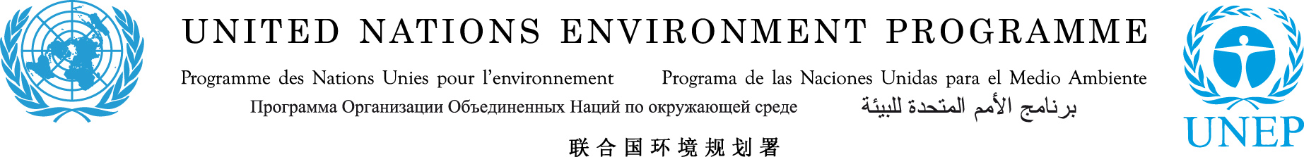

UNEP comments for the

International Expert Group Meeting on the
“Mandate of the UN PFII under Article 42 of the UN declaration on the Rights of Indigenous peoples”

UNEP would like to make general comments and suggestions on some of the proposed themes of the agenda as follows:

Theme 1:
Integration of the UNDRIP into the ongoing work of the PFII

- UNEP supports the idea of an additional special “chamber” or “ rapporteurs”dealing with the achievements made by states and UN agencies in terms of the implementation of the UNDRIP.
- practical implementation guides towards the implementation of the UNDRIP should be considered also
- besides developing relationships with academic institutions that could participate in the development and dissemination of research material, UNEP strongly encourages to also invite legal experts from UN agencies to define modalities and implementation possibilities of the UNDRIP. Each agency possesses strong institutional knowledge as well as legal expertise organized in specific branches and divisions. In this context it might be worth mentioning that some UN agencies have far reaching networks to judges, government officials and parliamentarians as well as experiences in training and capacity building.
UNEP, for example, has a far reaching legal work programme: http://www.unep.org/law/Programme_work/index.asp which also includes a programme designed to sensitizing and strengthening the capacity of the judiciary and other legal stakeholders, including government officials and parliamentarians around the world in implementing environmental law. A similar concept could be considered by the PFII regarding the promotion of the UNDRIP on national level. See also: http://www.unep.org/Law/Programme_work/Judges_programme/index.asp

Theme 2: Capacity development for indigenous and non-indigenous communities and organizations:

- Toolkits for schools and universities to be developed with the help of the legal departments in universities or relevant NGOs as well as UN agencies.

Theme 3: Promotion and respect for and full application of the UN declaration at the state level
- A wide distribution of the UNDRIP needs to be assured in the current year which should include an implementation guide or action plan.
- General conferences and Governing Councils of UN agencies and programmes should be taken advantage of by the PFII as they gather member states and other important stakeholders of a regular basis. Special side events and discussion forums could be organsised with the help of the hosting agency to invite government delegations for an introduction to the UNDRIP as well as its implications and options. UNEP’s upcoming Governing Council in Febuary 2009 for example has a GREEN ROOM facility for special events which are used as forums by governments and NGOs alike.
- The UNDRIP aspects and relevant articles should be included into social corporate responsibility guidelines for the private sector and companies.
- The promotion of good practices of governments and other stakeholders in this context could be promoted through a publically accessible weblink/ network similar to the UNEP Climate Neutral network which has been established to assist those interested in achieving big cuts in greenhouse gas emissions to achieve their goals: Firstly, by making public the inspiring plans and strategies that pioneering partners have drawn up in order to achieve climate neutrality and encouraging them to publicize their achievements—and challenges—via regular up-dates of the web pages.Secondly, by acting as a forum through which those who aspire to climate neutrality may network and learn more to plan their own emissions reductions.Thirdly, by acting as an honest broker, bringing developed and developing country participants together to green the development path and support the Millennium Development Goals. http://www.climateneutral.unep.org/cnn_frontpage.aspx?m=52
- Please also refer to the 3rd bullet point under Theme 1 regarding the dissemination of the UNDRIP to key state actors and parliamentarians.

