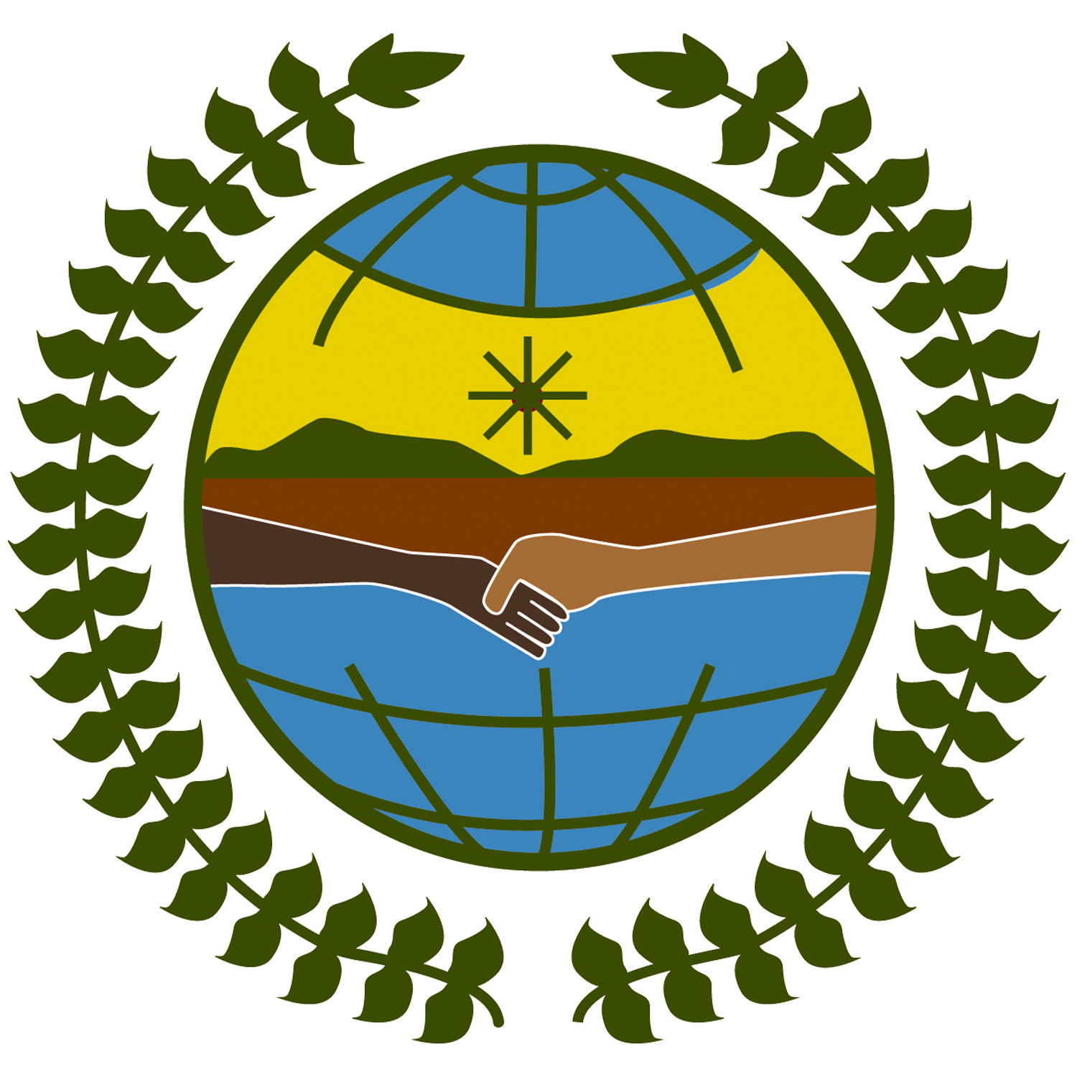

Project:

Engaging indigenous women: local-government capacity-building through new technologies in Latin America

Broad assessment of the communicational situation of indigenous women in Bolivia- Perú -Ecuador

Overview report

Prepared by Mariana López for the Secretariat of the United Nations Permanent Forum on Indigenous Issues.

Introduction

In December 2005, the General Assembly approved a project under the Development Account. The main objective of this project is to strengthen the capacity of institutions at the national and community levels in select Latin American countries such as to better engage indigenous women in decision-making processes by utilizing new information and communication technologies (see document A/60/6 (Sect. 34), annex, sect. W, for a fuller description). The project is being executed by the Secretariat of the UN Permanent Forum on Indigenous Issues (SPFII) in cooperation with various other United Nations organizations and indigenous women’s organizations.

In order to reach the project’s principal goal to “empower indigenous women in decision-making processes” and in keeping with the principle of free, prior and informed consent, arrangements have been made for the effective participation of indigenous women in project planning, implementation, monitoring and evaluation.

The early involvement of both governments/municipalities and indigenous organizations in various stages of the project is essential for its sustainability. By involving authorities at the local and federal level as well as community members, a sense of ownership is created ensuring continuity and sustainability.

Through capacity building and indigenous women’s meaningful participation, the project intends to elevate indigenous women’s self awareness and esteem in critical areas, improve their participation in decision-making processes and promote self-affirmation of their cultural and gender identities.

The project will also establish and/ or support local and regional networks connecting communities with local and national government(s) and promoting self-sustaining connectivity initiatives. The substantive focus of the program lies in the areas of capacity-building, development, analysis, production and dissemination of relevant and appropriate ICT material that will reach a broader number of indigenous women as well as governmental institutions and the UN system.

This overview corresponds to activity 1 of the project: conduct broad assessments of the communicational situation of indigenous women in each country. Full reports for each country are available in Spanish and include a review and identification of:

- Existing connectivity initiatives of indigenous women’s groups. (stakeholders involved, achievements and challenges, sustainability of the initiatives, lessons learned)
- Availability of infrastructure, human, technical and financial resources.
- Strengths and weaknesses of the 3 counterpart indigenous organizations
- Areas where capacity building is needed

To obtain first hand information, three unique missions to the aforementioned countries were organized. A variety of qualitative methodological techniques were implemented and in-depth interviews were conducted following the identification of key actors, including representatives of local governments, the UN system, print, electronic and broadcast media entities, national indigenous organizations, indigenous women leaders and representatives of national institutions dealing with women’s issues, indigenous issues and communications issues.

The assessments are not meant to be exhaustive with regards to the compilation of existing connectivity initiatives pertaining to indigenous women’s groups. Rather, the objective is to make a broad description highlighting the most recurrent issues. Each point raised may well deserve an in-depth analysis of its own that goes beyond the intent of this activity.

- Existing connectivity initiatives of indigenous women’s groups.

In the three countries in question, a wide variety of connectivity initiatives are being implemented. The majority are carried out by NGOs while some are carried out by indigenous organizations that receive support through international cooperation initiatives. In Bolivia and Ecuador, distinct governmental entities are implementing specific programs involving indigenous peoples and their access to and empowerment through various communicational tools (print, electronic, broadcast media etc.)

1.1 The stakeholders involved in the connectivity initiatives are:

- Indigenous organizations.
- Civil society organizations
- National and local governments
- Alternative means of communication
- Mass media
- International cooperation
- United Nations System

1.2 Achievements of existing connectivity initiatives:

- Outreach to vulnerable groups, including indigenous women and the illiterate through traditional means of communication such as the radio.
- Multiplier effect of capacity building processes through means of communication that have an impact at the field level.
- The forging and strength of important networks and partnerships among diverse actors including community radios, capacity building institutions, governmental entities, local governments, media entities and international assistance institutions.
- Development of communication strategies to exert political influence at different levels.
- Utilization of communication strategies to raise awareness regarding indigenous peoples’ problems.

1.3. Challenges of existing connectivity initiatives:

- Empowerment of indigenous peoples, in particular women, to facilitate access to means of communication and eliminate mistreatment and marginalization by the mass media.
- Better coordination of indigenous communicational initiatives and the promotion of effective participation by indigenous organizations.
- Improvement in the internal communication of indigenous organizations.
- Gender perspective in accordance with views of the indigenous peoples’.

1.4. The sustainability of the initiatives is contingent on multiple factors:

- The development of a sense of ownership of communicational technologies.
- Communications processes that have already been developed with regards to the indigenous peoples must be taken into account
- Self management of the projects and income generation.
- Forging and creation of networks and partnerships.
- Active participation of communities and local authorities.

1.5. Lessons learned:

- Respect for the dynamics and logic particular to indigenous societies
- Flexibility in the development of proposals and greater understanding and appreciation of all existing modes of communication.
- Inclusion of men in the processes of women’s empowerment.

- Availability of infrastructure, human, technical and financial resources.

In general, in the realm of ICT, a host of necessities can be identified.

Various scenarios exist with regards to communicational infrastructure at the level of indigenous communities, with each scenario posing its own unique set of challenges. In general, remote towns are not connected to the national grid and subsequently messages reach such communities through battery operated radios connected to loudspeakers. Such a medium serves as a low-cost means to disseminate radio programs produced in the cities and increase communication among community members.

Internet and call centers have also become an increasingly common feature in the small and medium sized towns where cell phone use is also widely prevalent. Such facilities allow the provincial and rural people to access and benefit from innovations in ICT. More and more, government offices and national indigenous organizations are making their presence felt on the Internet via their own websites, making pertinent information available to a broader audience. However, speed and connectivity are not always up to the mark and come at a relative high cost. In addition, indigenous users often lack basic computer literacy and require a minimal level of training even for simple tasks such as basic web browsing. In general, indigenous peoples and communities have expressed a high level of valuation for new information technologies including as the internet and are receptive to their potential for greatly increasing their outreach and voice.

In order to establish a radio station, substantial fixed costs arise as there is a need to invest in infrastructure and equipment. Community radios nonetheless are resourceful and can operate with minimal infrastructure needs where basic equipment is often made available through individual and community efforts. However, in order to reach a larger audience and develop elaborate qualitative programs, it is necessary to have access to new information technologies. Only a small percentage of community radio stations have access to modern transmission equipment that in general is made available through the cooperation of international NGOs and state assistance programs. Consequently, indigenous national organizations have repeatedly expressed the desire to have their own radio stations with the capacity reach a broad audience.

With regards to the process of capacity building, there exists a wide and divergent range of experiences. International development assistance has resulted in substantial funding for capacity building processes. Some NGOs have developed innovative methodologies to adapt ICT to the needs, abilities and interests of a broad spectrum of trainees from varying backgrounds, ranging from rural indigenous women, the illiterate, youth and senior persons among others. It remains a necessity to develop mechanisms to reach the most vulnerable groups.

As far as connectivity initiatives are concerned, some of the major difficulties in the longer term pertain to sustainability and maintenance. Radios, along with other means of communication, necessitate a steady inflow of funds in order to cover the costs of maintaining necessary technical staff and pay for utility costs. Those working in community radios are rarely, if ever, compensated and as such are forced to seek secondary paid employment in order to meet their daily living expenses. External funding, be it through grants or loans, is rarely available for the purpose of meeting the daily operational costs of a radio. In some occasions, radios forge partnerships and obtain funding from the local government. Another alternative is for the radios to finance themselves by carrying ads on their airwaves. This option is more complicated given that certain ads may compromise the community radio’s principles.

- Areas where capacity building is needed.

The following areas have been identified by the key stakeholders as major issues that need to be taken into account in capacity building processes:

- Identity and self-esteem
- Income generating activities and opportunities for indigenous women
- National public policies and development programs relevant to indigenous peoples.
- Strategies to empower indigenous women’s organizations and promote their access to decision-making positions.
- Welfare of indigenous women taking into account health, education, nutrition, birth registration, , etc
- Enhancing indigenous women’s welfare through improvements in maternal health and child nutrition, access to universal primary education and adult literacy programs, proper birth registration, and augmentation of household production for domestic consumption.
- Strategies to prevent and eliminate violence against indigenous peoples, in particular, indigenous women.
- Implementation and enforcement of international human right’s mechanisms and treaties pertinent to indigenous peoples.
- Development of interpersonal and organizational communication skills, particularly as pertains to indigenous women leaders.

- Conclusions and recommendations.

General conclusions and recommendations (in bold) were formulated taking into account the objectives and prospective development of the future project.

1. Local and national level. Ongoing and continual dialogue through established means of communication between indigenous communities and their representatives in national level organizations is very important to sustain and advance the space that has been created to make their voices heard. Due to the favorable political context that currently exists, many indigenous leaders now enjoy unprecedented access to positions of political authority at the national level. These leaders should continue being connected with their communities and their experiences should be transmitted. Communication strategies can play an important role not only in stimulating the link between leaders and their organizations but also contribute to the capacity building processes of up and coming indigenous leaders as they set about their new tasks.

2. Feminist and indigenous women. In all three countries visited, women’s movements are strong and have been working for many years now towards the attainment of political influence. Indigenous people’s movements have also followed a similar parallel path. The specific demands of indigenous women have been appearing in both these spaces, sometimes creating levels of tension. Feminist activists usually argue that rural and indigenous women do not fight for their specific rights but "only for their right to land"; on the other hand indigenous women accuse the feminists of viewing gender rights through the lenses of urbane, western feminists, often ignoring their own national realities. Leaving such tensions aside and without losing their specificity, indigenous women have gradually become more receptive of the strategic need to articulate their demands. It is recommended, therefore, that the project promote dialogue and partnerships among women taking advantage of the multiple channels of visibility and political influence already opened by the women’s movements.

3. Men and women. The Gender perspective is often inaccurately perceived as the separation and struggle of women against men. Such a confrontational positioning is particularly prevalent among indigenous peoples, generating a hesitance among indigenous men to permit their spouses and daughters to attend workshops or meetings with a gender focus. It is important to seek the participation and commitment of men in any communicational process that attempts to empower women. Communications strategies should be developed that are oriented to both men and women, keeping in mind differences in perspectives and promoting reciprocal understanding.

4. Diverse communication initiatives. Various projects and programs are currently being implemented in the field of radio, communications and ICT. In order to coordinate actions some mechanisms are created as the development and expansion of networks, coordinating organizations and elaboration of action plans. However, it is often the case that multiple institutions carry out parallel action plans without any coordination, resulting in a duplication of efforts and wastage of precious resources. It is recommended that all communication strategies take into account processes that are already initiated and established, giving special attention to lessons learned and existing channels of diffusion.

5. Central role of indigenous organizations in communication’s projects/processes. While mechanisms for indigenous’ participation continue to be developed and remain in their early days, most communication initiatives are initiated by NGOs and carried forward by alternative radio networks, local governments and indigenous personalities at the individual level. The resultant effect is that indigenous organizations feel left out and do not consider themselves as protagonists in the process. It is recommended that efficient participatory mechanisms be developed such that communication strategies may be elaborated, implemented, monitored and evaluated with the full participation of indigenous men and women.

6. Establishment of strategic partnerships. The concept of strategic partnerships has been extensively developed by indigenous organizations in congruence with community based media entities. There currently exist various instances of partnerships between community radios, capacity building institutions, national governmental entities and local governments, etc. Such partnerships evolve into information exchange networks that are essential for the development of effective communication among indigenous groups and organizations. It is recommended that the project strengthen the partnerships that already exist and furthermore that it explore new links, particularly with governmental institutions, mass media and the UN System, in order to disseminate the materials produced in the framework of the project

7. Continuity of initiatives. The sustainability of projects and programs is the key to the attainment of impact based results. There are very few indigenous organizations and NGO’s that can develop their activities without depending on external financing. Communication strategies should be oriented toward the implementation of actions that can give continuity to the processes initiated. An alternative is to include spaces of reflection, debate and planning regarding local development, productive processes and the economy in these communities. Debate on how the communication can favorably impact on these actions should be promoted.

8. Central role of community radios. Community radios play a fundamental role in the advancement of indigenous communities, strengthening social ties and promoting their cultural identity. Through radio programs broadcast in indigenous languages, illiterate members of the indigenous communities gain access to useful information that can greatly enhance their well-being. Additionally, training and empowerment programs broadcast through community radios reach thousands of people who would otherwise have no other means to access such training. The strengthening of community radio is consequently recommended in order to reach indigenous people living in remote areas. Different types and forms of media and communication tools should be evaluated in order to determine the most effective mix of such tools for promotion and further development.

