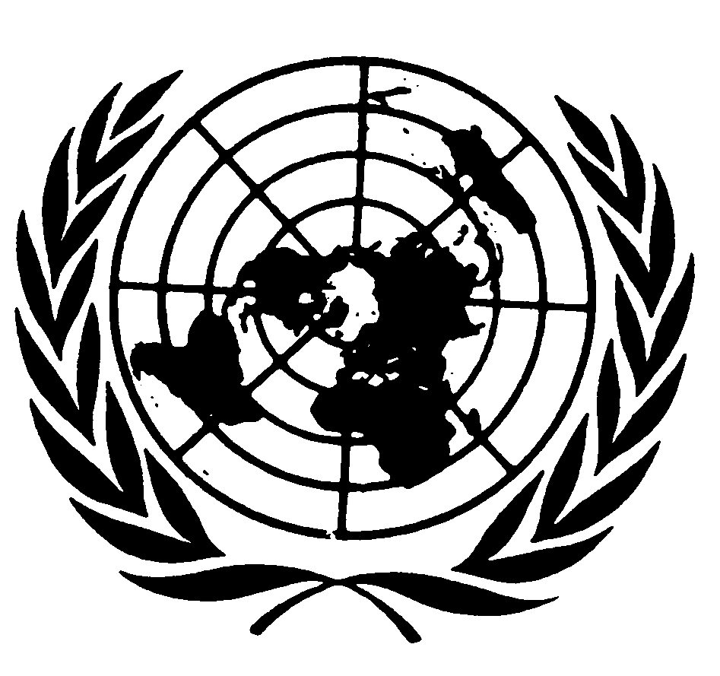
U N I T E D N A T I O N S N A T I O N S U N I E S

Statement by
Mr. JOsÉ Antonio Ocampo
Under-SECRETARY-GENERAL for economic and social affairs
and coordinator of the second decade of
the world’s indigneous people to the sixth session of
the united nations permanent forum on indigenous issues

New York, 14 May 2007

Your Excellencies, Presidents of the General Assembly, the Economic and Social Council and the Human Rights Council,
Madame Chairperson and Members of the Permanent Forum on Indigenous Issues,
Honourable Elders,
Representatives of Member States, Indigenous Organizations, Non-governmental Organizations, and UN system partners and other intergovernmental organizations,
Ladies and Gentlemen:

On behalf of the Secretary-General, it gives me great pleasure to join you once again in opening the UN Permanent Forum on Indigenous Issues and to extend the warmest of welcomes to you all.

During their long journey of engagement with the international community, indigenous peoples have by now reached a stronger platform, where they articulate a clearer voice in the United Nations through this Forum. This body would simply not be what it is without the wide participation it enjoys, because it is through dialogue among all concerned that indigenous issues can reach constructive outcomes for the whole society. In a mark of the Forum’s outreach and awareness-raising, new participants join the Forum’s session every year. For this sixth session, we expect participation by more than 2500 persons.

Our Organization has been strengthening its capacity to respond to global challenges, of the kind that only the United Nations may be called upon to confront. This Forum stands at the centre of that effort. Whether indigenous peoples will continue to survive and pursue a self-determined development, building their societies according to their world views and concepts of well-being, is not just a matter of their own self-interest or only a moral imperative for the dominant parts of society. It is also an issue of the survival of our humanity, with the richness, knowledge, and contributions that the various cultures provide to each person, each country, and to our planet. None of us can ignore for example the loss of traditional knowledge. Nor can we close our eyes to the fact that the map of the world’s richest biospheres coincides with the map of the areas with the largest linguistic diversity. As our Organization gears up to implement the Millennium Declaration, including the Millennium Development Goals, and the global UN development agenda, and to establish the principle of “Delivering as One” in its operational work, it must take indigenous peoples concerns and this Forum’s recommendations into account.

The special theme chosen by the Forum this year—lands, territories, and resources—is fundamental for indigenous peoples. It has been long recognized in this House that indigenous peoples have a profound spiritual and material relationship with the land, on which they often depend both for their physical and cultural survival. Indigenous sacred sites, foundations of indigenous traditional knowledge, indigenous religions, languages, and ways of life are all tied to land. Yet, all too often indigenous peoples have been forcibly displaced from their traditional territories for economic, military, or other interests, without any compensation or other means to sustain themselves. And they have often joined the ever-increasing numbers of migrants that live fragile lives in cities, at home or abroad. Urban indigenous issues, to which the Forum will devote focused attention, are a contemporary reality that governments, indigenous communities, and the whole society need to face today on an urgent basis. Yet, land remains for indigenous peoples living in cities as well a point of profound cultural reference—a living reality, or, as one author put it, “the land within”.

I welcome the wealth of contributions to the special theme, including the reports of regional indigenous peoples’ meetings; the inter-agency paper on lands, territories, and resources; the report of the expert meeting of the Convention on Biodiversity regime on benefit sharing and indigenous peoples human rights; and the expert paper contributed by two Forum members on palm oil development and monocrop cultivation and its impact on indigenous peoples’ territories and livelihoods. These documents point up, among other things, the central importance of recognizing indigenous peoples’ land rights, including the establishment of benefit sharing regimes. The inter-agency paper also shows that the UN system is already generally aware of the centrality of traditional lands for indigenous peoples and this awareness is reflected in the way it carries out operational activities. The Forum’s recommendations expected under the special theme should serve to enhance positive and constructive action at all levels, while this year’s regional focus—on Asia—will provide another way to promote action closer to indigenous communities.

Madame Chairperson,

Implementation of norms and policies is a common challenge in public policy, at the national, regional, and global levels. I congratulate the Forum’s focus on implementation during this session, and I welcome the contribution of agencies, governments, indigenous organizations, and Forum Members to this effort. The documentation on this before you reveals a number of challenges, many of which could be described as deficiencies: in financial, human, and technical resources; in economic incentives; in public awareness of indigenous issues at all levels; in capacity in local communities and national institutions; in synergies at national and international levels; and in appropriate laws and policies.

In its recommendations on economic and social development, the Permanent Forum has promoted a holistic approach, where indigenous peoples should be taken into account across the development process, along with their special, economic, social, political, cultural, and historical contexts, and relevant statistical data. In countries with indigenous peoples, most MDG country reports and UN Common Country Assessments and Development Frameworks (CCAs/UNDAFs) make references, in varying degrees, to the exclusion and disparities affecting indigenous peoples, as well as to targeted interventions to address these challenges. With few exceptions, however, little mention is made of mechanisms through which to ensure the participation and input of indigenous peoples themselves in the design, implementation, and monitoring of these policy interventions.

Continuing lack of effective participation of indigenous peoples in development processes continues to be a major deficiency of efforts at the national level. The relevant international instruments, the Forum’s recommendations, and the goal, objectives, and programme of action of the Second International Decade of the World’s Indigenous People can all be used to establish genuine partnerships with indigenous peoples at country level. Let us all make, at this session, a renewed commitment to using the UN’s normative and policy framework to build the “partnership for action and dignity” that is the lodestar of the Second Decade.

Some country reports suggest promising mechanisms by which to engage effectively with indigenous peoples in development programmes. Case studies should be conducted—through collaboration among the UN system, Governments and indigenous peoples—to further document and analyze how these strategies are implemented—so that they can be replicated in other contexts. In this regard, I would like to congratulate the Inter-Agency Network on Women and Gender Equality and its Task Force on Indigenous Women for coordinating the recent publication of good case studies of the UN system’s work with indigenous women.

As Coordinator of the Second Decade, I have advocated during the last year for concerted action on indigenous issues by UN Country Teams through the UN Development Group (UNDG). This has produced, among others, revised Guidelines of the Common Country Assessment and United Nations Development Assistance Framework (CCA/UNDAF) making substantial reference to indigenous peoples. In that context, the Inter-Agency Support Group on Indigenous Issues, cooperating with the UNDG, has been working since last November to develop, by the end of 2007, further guidelines for the Country Teams to integrate indigenous issues in UN operational activities.

I would like to thank the Inter-Agency Support Group for all of its efforts to promote engagement on indigenous issues at the regional and international levels. I also want to thank the many Governments that have continued to contribute to the work of the Forum, including the Government of China, for hosting the pre-sessional meeting in Beijing in March, and all the Governments that have made contributions to the Trust Fund on Indigenous Issues.

Madame Chairperson,
Distinguished Members of the Forum,

I wish to convey my sincere congratulations to the UN Permanent Forum on Indigenous Issues for having achieved so much as a new UN body, within only five sessions. Progress has been made on several fronts. And this progress should translate also into the adoption of the Declaration on the Rights of Indigenous Peoples by the General Assembly, and I hope before the end of its 61st session. This would precipitate a decisive shift in the paradigm of human rights and development discourse and action that will itself make a marked and positive difference in the lives of indigenous peoples.

For me, this sixth session of the Forum is the last meeting of a subsidiary body of the Economic and Social Council that I will have the honour to inaugurate. So I would like to take this opportunity to underscore two elements permeating the UN Development Agenda that the entire ECOSOC family of organizations is dedicated to advance.

One, which I have touched on throughout my remarks this morning, is the commitment to implement the Agenda in a renewed spirit of partnership, to which the opening of this Forum is always a beautiful testament.

The other is the struggle for equality and equity that underlies two of the central pillars of the United Nations: the quests for human rights and for development. The fight for equality of all persons as human beings and as citizens has been fought once and again throughout history, and, in the case of indigenous peoples, the process remains far from complete. And the principle of equity still manifests inadequately in government policies.

In my eyes, it is this fight for equality and for equity that makes our work in the United Nations so invaluable. It is also, in many ways, what brings civil society to UN, to rally around its work and its participatory processes, as is so clearly the case with indigenous peoples. On a personal note, this is what has made me love the United Nations.

This also takes me back, for a moment, to the Sierra Nevada de Santa Marta, in my native Colombia, where lives an outstanding Indigenous Community, the Kogi. I remember vividly the time when I had the opportunity to discuss with their elders, as Minister of Agriculture, the need to expand their reservation. A most worthwhile endeavour, this expansion has served, among other causes, to regenerate the beautiful natural forest, making the mountains of the Sierra even more majestic. I also vividly remember the special occasion when we were able to deliver to the community access of the reservation to the Caribbean Sea, one of the Kogi’s long-term aspirations. These are, of course, only small steps in indigenous communities’ long fight for equity in the issue area before you in this sixth Forum, the land.

To all indigenous peoples—your energy, commitment, and support raise our hopes and our spirits higher than these roof beams and beyond. I thank you for that, and I wish the entire Forum every success in its deliberations.

