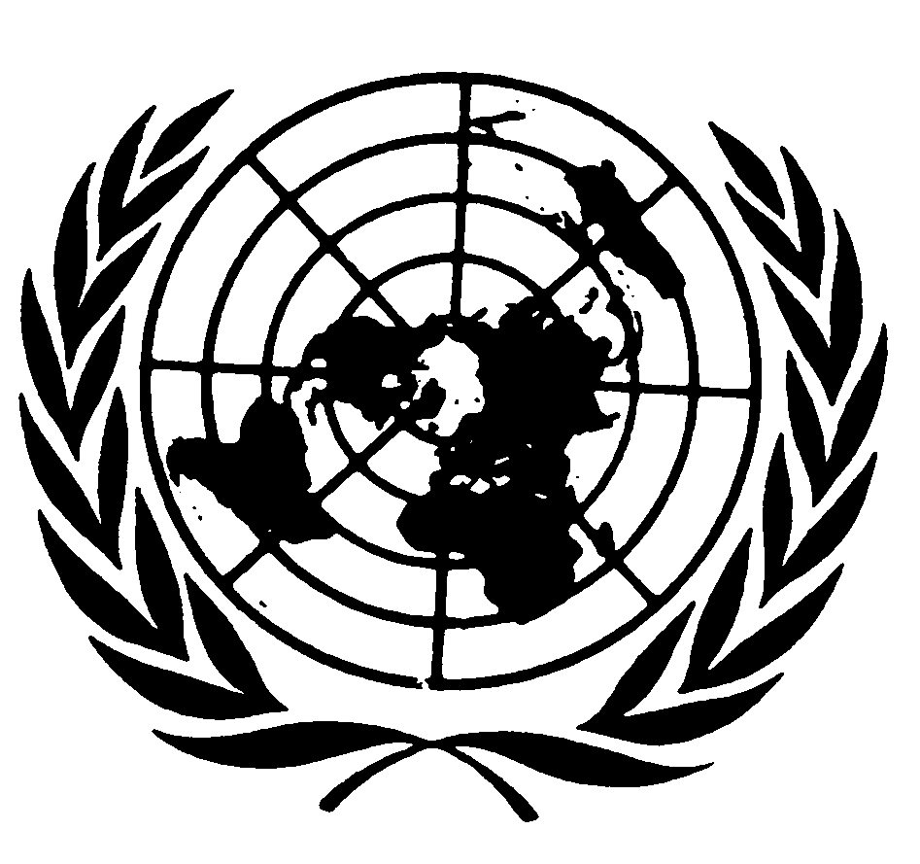
U N I T E D N A T I O N S N A T I O N S U N I E S

Closing Remarks by
Mr. JOsÉ Antonio Ocampo
Under-SECRETARY-GENERAL for economic and social affairs
to the fifth session of the
united nations permanent forum on indigenous issues

New York, 26 May 2006

Madam Chairperson,
Distinguished Members of the Permanent Forum on Indigenous Issues,
Distinguished representatives of Member States, Indigenous Peoples, the United Nations system and other inter-governmental organizations, non-governmental organizations and academic institutions,

It gives me great pleasure to be with you today to witness the end of a most productive session of the Permanent Forum. These halls of the United Nations see some of their most lively and vibrant days when the Forum, one of the largest UN gatherings, holds its annual sessions. Many people have commented in the corridors: “this meeting looks like the real United Nations”. This is also a tribute to the world’s cultural diversity and to the commitment of our organization to confronting some of the most complex issues.

Madam Chairperson,

The substantive output of the session is indeed commendable:

- The Forum reiterated that the human rights-based approach to development, advanced by the UN system, must be given practical effect for indigenous peoples.

- Although well aware that the MDGs are not to be formally amended, the Forum made valuable recommendations on how to interpret and apply the MDGs in practice so that indigenous peoples can be included in and benefit from efforts of the international community to achieve them. Indigenous peoples’ participation and good governance in MDG processes is crucial. And the Forum made strategic recommendations on how to improve indigenous peoples’ inclusion in MDG country reports, poverty reduction strategy papers (PRSPs), and the UN Common Country Assessment and Development Assistance Framework (CCA/DAF).

- Data collection and disaggregation were again stressed by the Forum as a crucial issue. And special emphasis was placed on involving indigenous peoples in building understanding of what poverty and well-being is for indigenous peoples, and in selecting indicators in consultation with indigenous experts designed to capture the poverty situation of indigenous peoples more accurately, as well as benchmarks at the international and national levels for monitoring progress.

- In its gender-related recommendations, the Forum demanded in turn a commitment to implement the MDGs for indigenous peoples on the basis of gender equality.

- On HIV/AIDS, the Forum recommended urgent measures on the part of governments, the UN system and indigenous communities themselves to prevent and face this extraordinary threat to indigenous communities.

- The Forum also recommended special and culturally-sensitive measures for preventing maternal and infant mortality in indigenous communities and called for special and targeted action by governments and the UN system.

- On MDG 8, which requires increased cooperation for development, the Forum requested increased ODA and special measures to lift indigenous peoples out of marginalization. The Forum also noted that MDGs in developed countries are mostly viewed as a foreign policy issue but not applicable to indigenous peoples within their own country context. There was thus a focus on the applicability of the MDGs to indigenous peoples living in developed countries, whose health, education and life expectancy outcomes are comparable to people living in developing countries.

- Indigenous traditional knowledge was a cross-cutting theme this year, namely how it contributes to development and how it needs to be protected so that it can continue to play its role for the well-being of indigenous peoples.

- The half-day discussion on Africa that the Forum held this year allowed
attention to be drawn to the situation and contributions of indigenous peoples in Africa and to engage in a rich dialogue on how to deal with the challenges, with African governments, the UN system and indigenous organizations working together.

Implementation is a major issue and priority for us. The two important strategic papers presented by members of the Forum showed greater engagement and progress in the implementation of the Forum’s recommendations by the UN system and intergovernmental organizations. As Coordinator of the Second International Decade, I welcome the Forum’s initiative to request monitoring reports from my Office, as well as indigenous peoples’ organizations, on progress being made towards implementing the Programme of Action of the Decade.

The impact of UN Reform on indigenous issues has also been a major focus of this session, especially the establishment of the Human Rights Council. The Forum is clearly sending a strong message by calling for the strengthening of the human rights procedures on indigenous peoples’ rights, and for the adoption of the Declaration on the Rights of Indigenous Peoples by the new Human Rights Council. I have personally been in contact with the High Commissioner of Human Rights and the Chairperson of the Council to transmit to them this strong aspiration of the Forum.

The human rights agenda will continue to be part of the core work of the Permanent Forum. I note the substantive recommendations of the Forum in that regard, including recommendations for the protection of indigenous peoples in voluntary isolation in various parts of the world.

Madam Chairperson,

In the next few days, the Forum’s recommendations will feed into the General Assembly’s special session on HIV/AIDS. In the next few weeks, the Forum will participate in the High-Level Segment of the ECOSOC on employment. And in three months’ time, the Forum’s recommendations will contribute to the High-Level Dialogue on International Migration and Development to be held by the General Assembly.

The Forum’s session, with its intensity, its robust debates and its thoughtful conclusions, colourfully and convincingly speaks to our tripartite partnership of member states, the UN system and other intergovernmental organizations, and indigenous peoples. This session renews our commitment to strive, within the framework of the UN Charter, to achieve development, peace and security, and human rights for and with the indigenous peoples of the world.

