UN Enable Newsletter

July – August 2018
The UN Enable Newsletter is prepared by the Programme on Disability / Secretariat for the Convention on the Rights of Persons with Disabilities, Division for Inclusive Social Development, the United Nations Department of Economic and Social Affairs with inputs from UN entities and civil society organizations, including organizations of persons with disabilities. The word and PDF versions of the newsletter can be downloaded from the following links:
Word: http://bit.ly/enablenews-aug18-w
PDF: http://bit.ly/enablenews-aug18-p

In this issue:
- The Convention on the Rights of Persons with Disabilities (CRPD)
- News from UN Headquarters
- News from other UN entities
- Other news
- Calendar of international disability events

The Convention on the Rights of Persons with Disabilities (CRPD)
[Status of the CRPD]
177 ratifications/accessions and 161 signatories to the CRPD
92 ratifications/accessions and 92 signatories to its Optional Protocol (OP)
More on the CRPD can be found by clicking the following link: http://bit.ly/UN_crpd

News from UN Headquarters

The 11th Session of the Conference of States Parties to the Convention on the Rights of Persons with Disabilities
The 11th session of the Conference of States Parties to the Convention on the Rights of Persons with Disabilities took place in the United Nations Headquarters in New York from 12 to 14 June 2018. The overarching theme “leaving no one behind through the full implementation of the CRPD” was supported by many participants who described the theme as timely and appropriate in line with the 2030 Agenda for Sustainable Development. During the Conference, the participants discussed challenges and shared national policies and good practices under the following subthemes: 1) national fiscal space, public-private partnerships and international cooperation for strengthening the implementation of the CRPD; 2) women and girls with disabilities; and 3) political participation and equal recognition before the law. The official report of the Conference will be available soon on the following UN Enable website: http://bit.ly/UN-COSP11
The Secretary-General delivered his statement at the opening session, emphasizing the importance of the full implementation of the CRPD to leave no one behind, including through its integration into national policies, investment, and legal systems. As a commitment to make the United Nations more inclusive and accessible, the Secretary-General initiated a comprehensive review of the work of the United Nations on disability, which will inform a new UN Action Plan and an accountability framework in the area. Member States and the civil society expressed their support for the Secretary-General’s initiative. The Secretary-General’s full statement can be viewed by clicking the following link: http://bit.ly/2NoB4zJ
The Conference was attended by over 1,300 participants from Member States and the civil society. Up to 68 side-events were held. At the General Debate, 102 States Parties, 4 country groups and 25 observers delivered their statements. Many participants highlighted the principle of “leaving no one behind” and that the inclusion of persons with disabilities is key to fully achieve the 2030 Agenda with the SDGs at its core. Many delegations noted that elimination of all forms of discrimination against persons with disability is a priority with particular attention to women and girls with disabilities who often face multiple discrimination. The participation of persons with disabilities as agents of change were well acknowledged in the implementation of the Convention and the 2030 Agenda.
Two rounds of elections were held to elect nine members to the Committee on the Rights of Persons with Disabilities. The following nine candidates were elected as members of the Committee whose terms will begin on 1 January 2019: Ms. Rosemary Kayess (Australia); Ms. Mara Cristina Gabrilli (Brazil); Ms. Gertrude Oforiwa Fefoame (Ghana); Ms. Risnawati Utami (Indonesia); Mr. Jonas Ruskus (Lithuania); Ms. Amalia Eva Gamio Rios (Mexico); Mr. Danlami Umaru Basharu (Nigeria); Ms. Miyeon Kim (Republic of Korea); and Mr. Markus Schefer (Switzerland). Profiles of the selected members can be viewed from the following link: http://bit.ly/2LumUv6
The 12th session of the Conference of States Parties to the CRPD is tentatively scheduled on 13 to 15 June 2019 at UNHQ in New York.
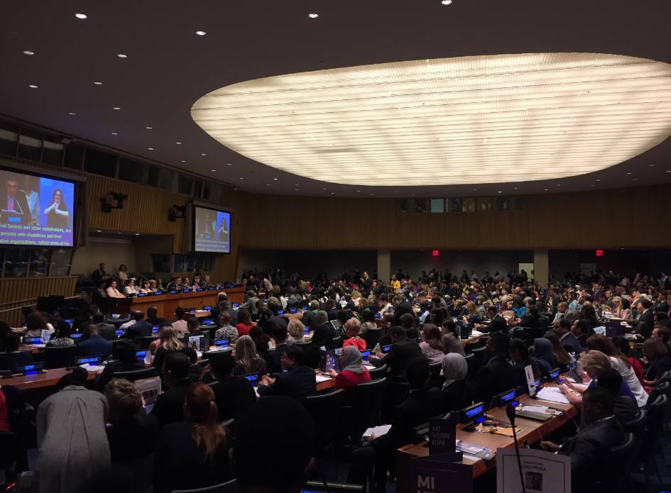

Photo 1: A photo of the 11th session of the Conference of States Parties to the Convention on the Rights of Persons with Disabilities. A large crowd of people are in the UN conference room. Key speakers are seated on the podium including the Secretary-General of the United Nation.

The High-level Political Forum on Sustainable Development 2018: Speech by the Special Envoy on Disability and Accessibility
The High-level Political Forum on Sustainable Development (HLPF) was held at UNHQ in New York from 9 to 18 July 2018 with the theme of "Transformation towards sustainable and resilient societies". In the opening session, the UN Secretary-General’s Special Envoy on Disability and Accessibility, Ms. María Soledad Cisternas Reyes stressed that the 2030 Agenda is a powerful instrument to leave no one behind and emphasised the need to increase funding especially in public and private sectors to make transformative changes. The Special Envoy elaborated the critical role that private companies can play in promoting sustainable development and human rights, and the importance of making information and technology accessible for persons with disabilities to exercise their fundamental rights. The first session of the HLPF including the full speech of the Special Envoy on Disability and Accessibility can be viewed on UN Web TV from the following link: http://bit.ly/2odVsbS and her statement can be downloaded from the following link (in Spanish only): http://bit.ly/2MBEjr2
In addition, almost 40 out of 46 Member States made specific references to disability issues in their voluntary national reviews (VNRs) for the HLPF this year. The list of countries and reports of the VNRs can be found by visiting the website: http://bit.ly/2wifGpg

The 73rd session of the General Assembly to review disability issues
The issues concerning persons with disabilities will be considered in the forthcoming the 73rd session of the General Assembly (GA) of the United Nations. Under the agenda item 28 (b) on social development, the GA will consider and review reports on social development including the Secretary- General’s report entitled “Inclusive Development for Persons with Disabilities” prepared by UN-DESA, in close cooperation with Member States, UN entities and civil society organizations. The provisional agenda of the 73rd session can be downloaded from the following link: http://undocs.org/en/A/73/150
In addition, the Note by the Secretariat on "UN Flagship Report on Disability and Development 2018: Realizing the SDGs by, for and with persons with disabilities" was also prepared by UN-DESA. Both reports will be available online soon.

New United Nations Portal on disability statistics
The United Nations Statics Division of the Department of Economic and Social Affairs, the focal point dealing with official statistics in the UN, recently launched a new portal on disability statistics. Visit the following link and learn key facts about the situation of persons with disabilities in different countries of the world: http://bit.ly/2NkXtOj

Message from the Special Envoy of the Secretary-General on Disability and Accessibility, Ms. María Soledad Cisternas Reyes, on election of a new member of the CEDAW
The election of Ms. Ana Peláez Narváez for the Committee on the Elimination of Discrimination against Women (CEDAW), held in June at the United Nations headquarters in New York, represents a historic moment in the field of human rights. The Spanish expert who is blind, is a symbol of the defense of the rights of women and girls with disabilities in the world. She is widely known by persons with disabilities and now by women's civil society in general. For 8 years she served the Committee on the Rights of Persons with Disabilities of the CRPD, she stood out for her tireless work and conviction, which will also be a valuable contribution to the CEDAW Committee. Congratulations, Ana! - because her achievement represents the voice of women and girls with disabilities in the world for fully exercising their human rights and fundamental freedoms. A well-deserved triumph that highlights the transversality of the human rights model of persons with disabilities. Best wishes for Ana in this great challenge and for the CEDAW Committee that will receive such an outstanding professional.

3 December 2018, the International Day of Persons with Disabilities, United Nations headquarters, New York.
A series of observance events are currently under planning for the Day. Details will be available online soon.

News from other UN entities

OHCHR: 20th session of the CRPD Committee, 27 August to 21 September 2018 - Room XVII of Palais des Nations - Geneva
The 20th session of the Committee on the Rights of Persons with Disabilities will take place in Geneva, Switzerland from 27 August 21 September. The meeting will be followed by the 10th meeting of the pre-sessional working group, from 24 to 27 September. The following countries are coming up for consideration by the Committee: Algeria, Bulgaria, Malta, Philippines, Poland, South Africa and the former Yugoslav Republic of Macedonia. The Committee will also adopt a list of issues prior to reporting regarding the following countries: Austria, Azerbaijan, Germany, Mongolia, and Sweden as well as list of issues on Iraq, Niger, Norway, Rwanda, Saudi Arabia, Senegal, Turkey and Vanuatu. Dialogues with State parties’ delegations can be followed through webcast: http://webtv.un.org/meetings-events/
During its 20th session, the CRPD Committee will adopt its General Comment No.7 on articles 4.3 and 33.3 of the Convention on the Rights of Persons with Disabilities on the participation of persons with disabilities in the implementation and monitoring of the Convention. Two public consultation sessions with representative organizations of persons with disabilities will be held on Monday 27 August and Wednesday 5 September from 15:00 to 16:00.
OHCHR: A celebration of the 10 years of activities of the Committee
A special celebration of the 10 years of achievements of the CRPD Committee will be held on Friday 31 August, from 17:00 to 18:00. The event is meant to reflect on the contributions of different stakeholders in the institution building of the Committee, to highlight the progress made in advancing the rights of persons with disabilities throughout the past ten years, advocating and highlighting the impact of the Convention. The Committee invites participants to also reflect on the main remaining challenges that the Committee faces and the priorities that should guide the Committee in the next decade.

UNOG: First celebration of the International Day of Sign Languages
For the first time the United Nations Office at Geneva (UNOG) is organizing a series of events to raise awareness about the importance of sign languages on 13 September 2018 at the Palais des Nations to coincide with the sessions of the CRPD and the Human Rights Council. This event is organized in response to the resolution 72/161 on the International Sign Languages adopted by the United Nations General Assembly in December 2017. The activities will include: the screening of the Oscar-winning short film "The Silent Child", followed by a discussion with the author of the film, Ms. Rachel Shenton; the display of the short video clip “Signer en Langues” by Director Nurith Aviv around the Palais des Nations; a guided tour of Palais des Nations with sign language interpretation by the Visitor’s Service; and a pop-up sign language café. The Director General of UNOG and representatives from the Deaf community will also participate in a high-level panel organized by the Committee.

UN Women: UN Trust Fund to End Violence Against Women and women and girls with disabilities: New grants for projects announced
UN Trust Fund to End Violence Against Women announced nine grants for projects working to prevent and end violence against women and girls with disabilities. These projects aim to strengthen the response capacity of local grassroots organizations working with women and girls survivors of violence, and are expected to reach almost 100,000 beneficiaries in five regions of the world, including women and girls with disabilities, workers in government institutions and men and boys. More information can be found by visiting the following UN Women's website: http://bit.ly/2witHmW

UN Women: In Serbia, mothers and their children with disabilities find hope in ‘granny's jam’
By making ‘granny's jam’, a woman-run organization, Evo Ruka, is earning money to improve the inclusion of children with disabilities, while also building a whole community of support and encouragement. Evo Ruka’s social enterprise is also a centre for children with disabilities and their parents, mostly mothers. It supports children with disabilities and their parents from day one until they are independent, she explains. More information can be found by visiting the following UN Women's website: http://bit.ly/2ogeVsC

World Bank Group Announces New Commitments on Disability Inclusion through International Development Cooperation
The World Bank Group’s new commitments on Disability-Inclusive Development aim to help developing countries invest more and effectively in persons with disabilities and in accessible services. The areas of the commitments are inclusive education, technology and innovation, data disaggregation, women and girls with disabilities, persons with disabilities in humanitarian context, transport, private sector, social protection, staffing, and disability inclusion and accountability framework. For more detail, please visit the following links: the press release of the commitments: http://bit.ly/2LrY2UU ; the detail of the commitments: http://bit.ly/2BPjjZd

Other News
(DISCLAIMER: The information below is provided by other stakeholders for informational purposes only. This does not constitute endorsement of, or an approval by, the United Nations of any of the products, services, or opinions of the organization or individual. The United Nations bears no responsibility for the accuracy, legality or content of their statements and opinions.)

The Global Disability Summit, 24 July 2018, London
On 24 July 2018, the UK Department for International Development (DFID), along with the International Disability Alliance (IDA) and the Government of Kenya, hosted the first Global Disability Summit in London. The Summit was attended by Ministers, representatives of organisations of persons with disabilities, academia, non-governmental organisations, representatives of the UN System, and many more. The Summit was an opportunity to showcase good practice, as well as to generate sustainable commitments from country governments, donors, civil society, foundations and the private sector. All attendees were also invited to sign the Charter for Change. In addition, in consultation with civil society partners, IDA hosted a Civil Society Forum, to amplify the voice and participation of persons with disabilities and their organisations. A joint civil society statement was read out by the IDA Chair at the opening session of the Summit on 24 July, which reflected on the asks generated from the Civil Society Forum. For more information, visit the following website: http://bit.ly/2wgjIyi
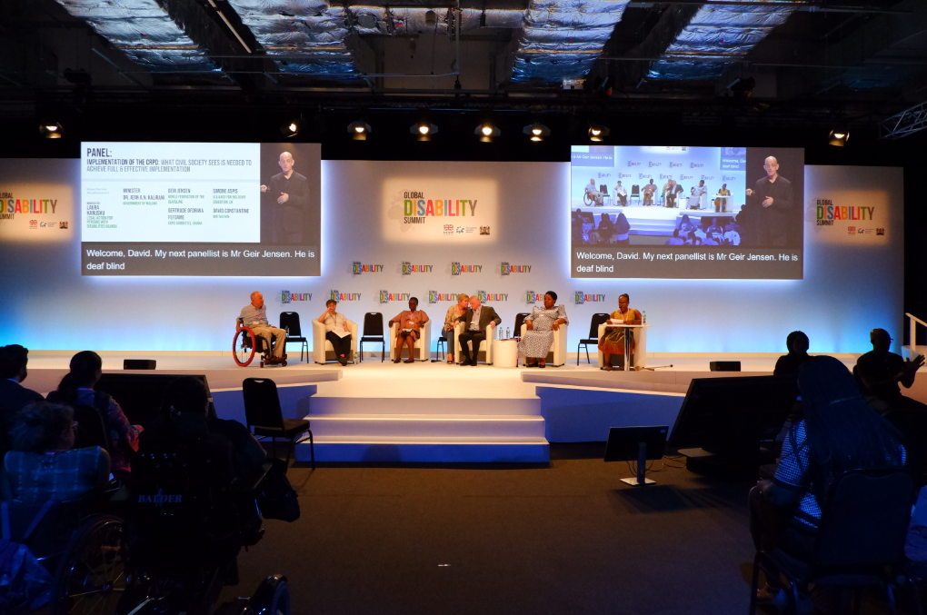
Photo 2: Six panelists seated facing the audience on a stage at the opening session of the Civil Society forum to the Global Disability Summit held in London, 23 July 2018. Photo credit: IDA/FedericaSettimi

Human Rights Watch launches reports on persons with disabilities
Human Rights Watch issued two reports on persons with disabilities in Brazil and Iran, entitled “They Stay Until They Die” and “I am Equally Human” respectively. These reports can be downloaded from the following links: They Stay Until They Die: http://bit.ly/2NaGiT3 ; I am Equally Human: http://bit.ly/2Nuc3TM For more information, please contact Carlos Rios-Espinosa (riosesc@hrw.org) and Jane Buchanan (buchanj@hrw.org) respectively.

Calendar of international disability events
(DISCLAIMER: This section includes the information provided by other stakeholders and for informational purposes only. This does not constitute endorsement of, or an approval by, the United Nations of any of the products, services, or opinions of the organization or individual. The United Nations bears no responsibility for the accuracy, legality or content of their statements and opinions.)

1 October 2018, Green October Event, Lagos, Nigeria
‘’Green October Event’’ is a La Mode Magazine initiative and is an annual event to create awareness on, appreciate and support persons with disabilities. The initiative is an advocacy awareness platform where persons with disabilities are given voices. The theme for the 2018 edition is ‘’Beyond Disabilities’’, which aims to inform individuals and communities that if you are a person with disability you are just like everyone else, just living life in a different way. One of the major goals of ‘’Green October Event Project’’ aside the annual event is to establish a multipurpose disability Job recruitment unit, Awareness, advocacy and information center, as well as giving persons with disabilities job opportunities, all the information, support, training and education they deserve. For more detail on the Green October Event, visit the following link: https://www.greenoctoberevent.com.ng/

12-15 November 2018, the 15th International Conference on Mobility and Transport for Elderly and Disabled Persons, Taipei, Taiwan, China.
The overarching theme is “Mobility for all: Connecting the World with Accessible Transportation”, which focuses on four main areas: Accessible Transportation and Tourism in Air, Land and Water, Safe & Sustainable Mobility for Elderly and Persons with Disabilities, Collaboration and Coordination across Information, Financial and Transportation Services, and Smart City Network & Smart Growth in the Asia Pacific Region and Worldwide. For more detail about the conference, please visit the following web page: http://www.transed2018.com/

CONTACT:
Programme on Disability/Secretariat for the Convention on the Rights of Persons with Disabilities
Division for Inclusive Social Development (DISD)
Department of Economic and Social Affairs (DESA)
United Nations Headquarters, New York, NY 10017, USA
Facebook: http://bit.ly/2MSBukV
Twitter: http://twitter.com/UN_Enable
Website: www.un.org/disabilities
Email: enable@un.org

Call for volunteers to translate the UN Enable newsletter in other languages:
Volunteer your time to translate the UN Enable newsletter in an official UN language or your own local language. We are looking for volunteers to translate the newsletter into the UN official languages of Chinese and Russian. Detail can be found in the following link: http://bit.ly/enablenewslettervolunteer
Call for photos for future inputs:
We will continue working to improve the design of our newsletter while ensuring the accessibility. We welcome your feedback.
To subscribe, click the following link: http://bit.ly/unenablenewsletter

