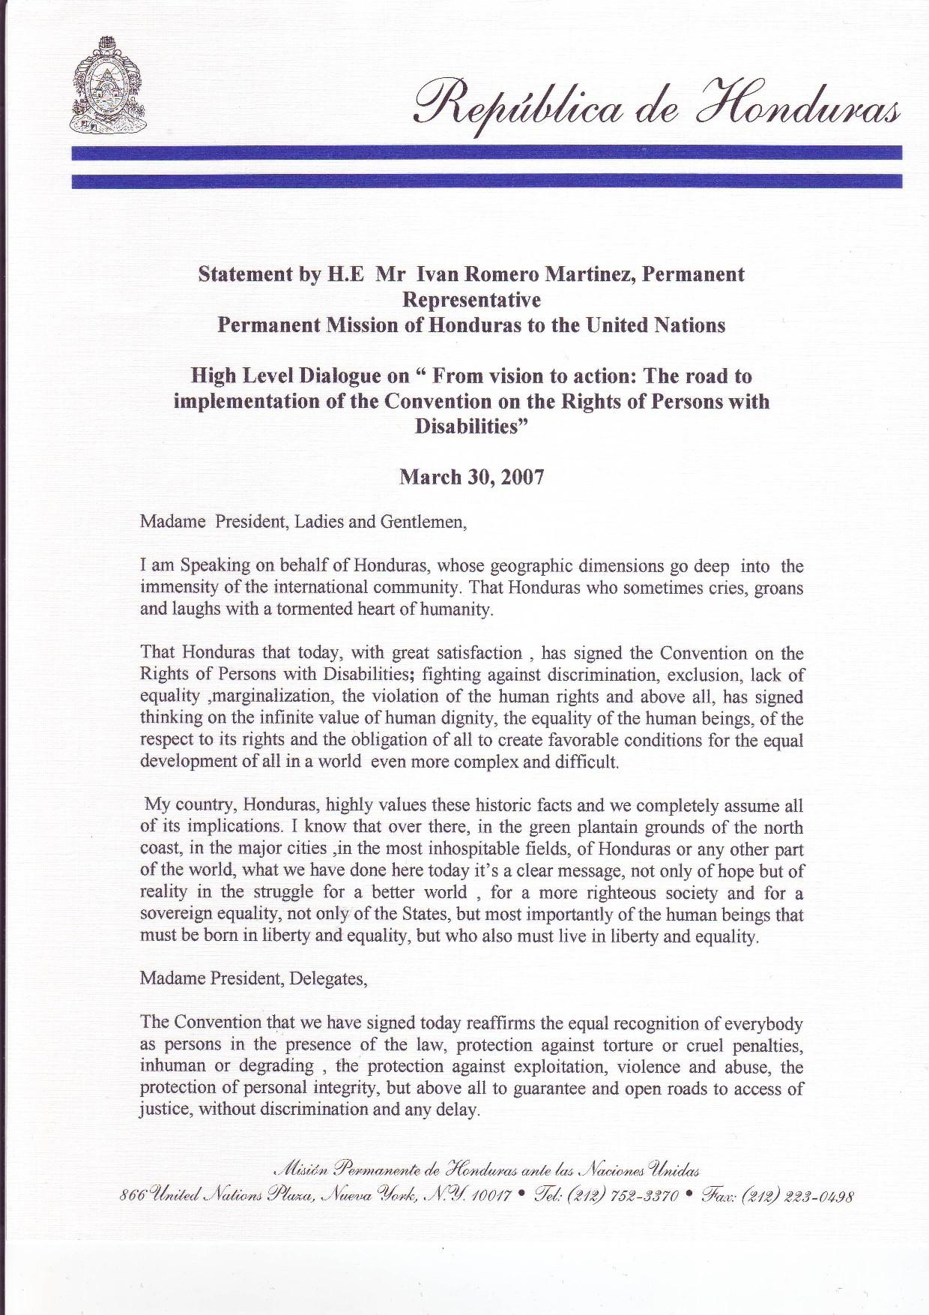

For that and for all the content of the Convention, we congratulate ourselves. It’s a conquest that sometimes has not had any voice, a conquest of our most dignifying human beings, the ones who have made made efforts for a better worlds with facilities for everybody, with equality and rights, and have struggled for a world without any exclusions.

We thank everyone that has made possible de declaration of this historic Convention, specially the Honduran institutions and personalities that have had a broad participation in the discussion of the same.

Thank you Madam President

