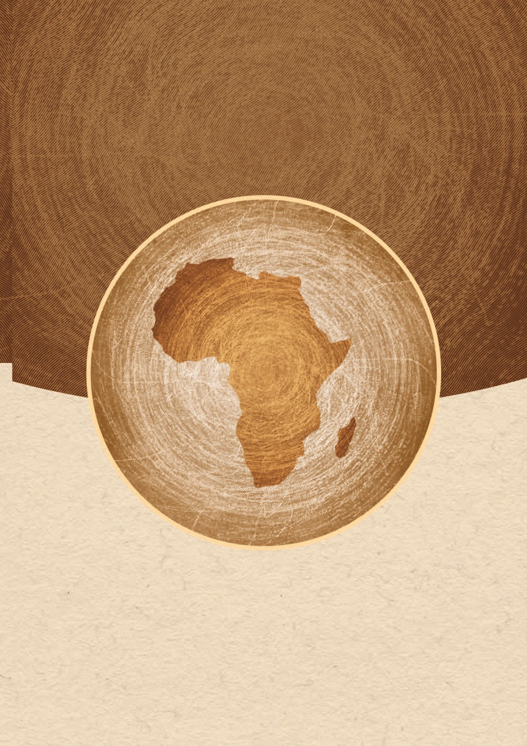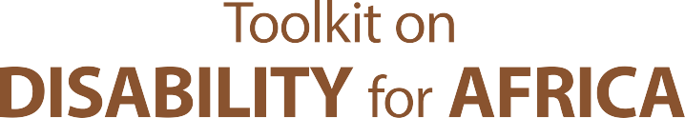

CULTURE, BELIEFS, AND DISABILITY

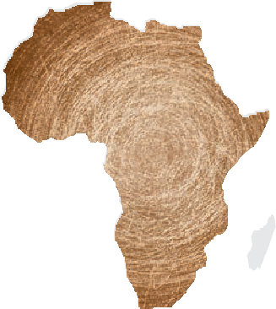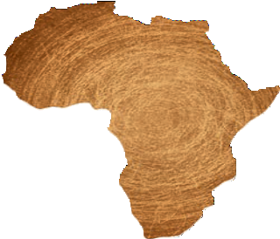

Toolkit on disability for AFRICA

CULTURE, BELIEFS, AND DISABILITY


iii
TOOLKIT ON DISABILITY FOR AFRICA

TABLE OF CONTENTS

- OVERVIEW 1
- TECHNICAL CONTENT 3
  - Background 3
  - Review of the Legal Framework 3
Country Checkpoint 4
  - Harmful Beliefs relating to Disability 5
Country Checkpoint 5
  - Consequences of Harmful Beliefs regarding Disability 6
  - Measures to Combat Harmful Beliefs and Practices regarding Disability Stigma 8
Country Checkpoint 10
- SUMMARY & KEY LEARNING POINTS 14
- USEFUL RESOURCES 15
- LEARNING ACTIVITIES 16
Session Sheet for the Trainer – Culture, Beliefs, and Disability, Session 1 17
Learning Activity 2.A: Stereotypes/Myths about People with Disabilities 18
Handout: Template – Stereotypes about People with Disabilities 19
Session Sheet for the Trainer – Culture, Beliefs, and Disability, Session 2 20
Learning Activity 2.E: Strategies & Campaigns to address Negative Stereotypes/Myths 21
Handout: Case Studies (4) 22

Module 13 - CULTURE, BELIEFS, AND DISABILITY


iv
TOOLKIT ON DISABILITY FOR AFRICA

Acknowledgements

The Division for Social Policy and Development (DSPD) would like to thank all those who contributed to the Toolkit on Disability for Africa, including the United Nations Office for the High Commissioner for Human Rights (OHCHR), the Economic Commission for Africa (ECA), the International Labour Office (ILO), the International Training Centre - ILO (ITCILO), the World Health Organisation (WHO), the African Union and the governments of Kenya, South Africa and Zambia. DSPD also wishes to thank the Government of Italy for its financial support and the numerous African Disabled Peoples Organisations (DPOs) who contributed substantial input to the Toolkit.

Module 13 - CULTURE, BELIEFS, AND DISABILITY

v
TOOLKIT ON DISABILITY FOR AFRICA

List of acronyms

AT Assistive Technology
CEDAW Committee on the Elimination of Discrimination against Women
CEDAW Convention on the Elimination of All Forms of Discrimination against Women
CESCR Committee on Economic, Social and Cultural Rights CRPD Convention on the Rights of Persons with Disabilities CRPD Committee on the Rights of Persons with Disabilities CRC Committee on the Rights of the Child
CRC Convention on the Rights of the Child CRC Convention on the Rights of the Child DFIs Development Financing Institutions DPOs Disabled Persons Organizations
DSPD Division for Social Policy and Development/UNDESA
EC European Commission
G3ICT Global Initiative for Inclusive ICTs
HIV/AIDS Human Immunodeficiency virus / Acquired Immunodeficiency Syndrome
ICCPR International Covenant on Civil and Political Rights
ICESCR International Covenant on Economic and Cultural Rights
ICF International Classification of Function, The World Health Organization
ICT Information and Communication Technology
ILO International Labour Organization ITCILO International Training Centre of the ILO IPU Inter-Parliamentary Union
ITC Information and Communication Technology ITU International Telecommunication Union MDGs Millennium Development Goals
MFIs Microfinance institutions MSPs Multi-stakeholder Partnerships NAPs National Action Plans
NGO Non-Governmental Organization
NVDA Non Visual Desktop Access
OHCHR Office of the High Commissioner for Human Rights
OSISA Open Society Initiative for Southern Africa

Module 13 - CULTURE, BELIEFS, AND DISABILITY

vi
TOOLKIT ON DISABILITY FOR AFRICA

PCM Project Cycle Management
PRP Protracted Relief Programme
SABE Self-Advocates Becoming Empowered SDGs Sustainable Development Goals UDHR Universal Declaration of Human Rights UN United Nations
UN DESA United Nations Department of Economic and Social Affairs
UNAIDS Joint United Nations Programme on HIV/AIDS
UNDP United Nations Development Fund
UNESCO United Nations Educational, Scientific and Cultural Organization
UNICEF United Nations Children's Fund
USAID United States Agency for International Development
VOCA Voice Output Communication Aids
WHO World Health Organization

Module 13 - CULTURE, BELIEFS, AND DISABILITY

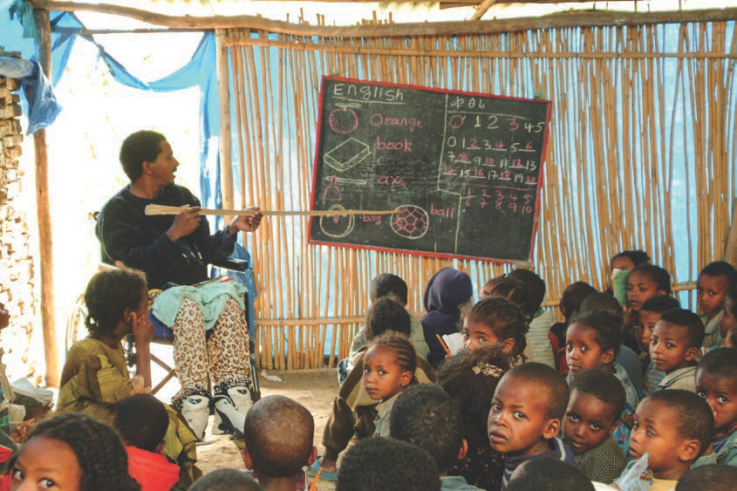TOOLKIT ON DISABILITY FOR AFRICA

OVERVIEW

Module objectives
► To consider the causes and social consequences of harmful beliefs regarding disability and to identify concrete actions to overcome them.

Who is this module for?
This module is relevant to everyone with an interest in disability or a responsibility for addressing issues of disability because of the nature of their work, including persons with or without disabilities in civil society, civil and public service, national human rights institutions, parliaments, development agencies, universities and the private sector.

What is this module about?
The content of this module:
► explains that attitudes about disability vary and that in Africa there are examples both of positive and empowering views regarding disability, and also of negative or harmful views;
► reviews relevant obligations set forth in the Convention on the Rights of Persons with Disabilities (CRPD), including Article 8 on awareness-raising;
► examines the causes and social consequences of harmful beliefs relating to disability;
► explains measures that may be taken to combat stigmatization and harmful practices relating to disability;
► includes learning exercises to accompany the material; and
► lists key resources for additional reference.

Module 13 - CULTURE, BELIEFS, AND DISABILITY 1
© ILO/ M. Crozet


2

Learning objectives
On completion of this module, participants will have:
  - contributed to discussions on harmful beliefs regarding disability in an african context;
  - contextualised the CRPD as an instrument to guide measures to combat harmful practices and beliefs related to disability;
  - developed a strategy for tackling negative beliefs about people with disabilities.

Module map
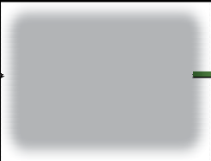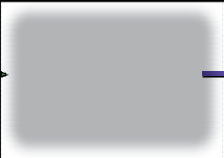

1. OVERVIEW

2. TECHNICAL CONTENT

2.A Background

2.D Consequences of Harmful Beliefs regarding Disability

2.C Harmful Beliefs relating to Disability

2.B Review of the Legal Framework

2.E Measures to Combat Harmful Beliefs and Practices regarding Disability Stigma

3. SUMMARY & KEY LEARNING POINTS
4. USEFUL
RESOURCES

5. LEARNING ACTIVITIES

Module 13 - CULTURE, BELIEFS, AND DISABILITY

3

TECHNICAL CONTENT

Background
In all regions of the world persons with disabilities face attitudinal barriers, including prejudice, low expectations and even fear. Negative attitudes about disability impact on all aspects of the lives of persons with disabilities, including the ability to access education, to participate in non-exploitative work, to live where and with whom one chooses, to marry and start a family, and to move about freely within the community.
Attitudes to disability are not always uniform within a region or even within a country. Different groups or individuals may have beliefs about disability that vary from those held by wider society and beliefs may vary even within small communities and within families.
In African societies, as in societies in other regions, there are examples of positive and empowering beliefs about disability.1 However, as is the case in many settings across the globe, disability is sometimes also associated with negative perceptions resulting in
stigma, discrimination, exclusion and violence, as well as other forms of abuse of persons with disabilities. The present module focuses on understanding and addressing the latter context and also explores approaches to transforming negative perceptions and ending harmful practices towards persons with disabilities.

See Learning Activity 2.A.
titled Stereotypes/Myths about People with Disabilities

Review of the Legal Framework
The present module focuses on the causes and consequences of harmful beliefs regarding disability. International human rights law generally and the CRPD in particular, provide a number of relevant forms of protection, including prohibition of all forms of discrimination on grounds of disability. The CRPD requires State parties to guarantee the right to non-discrimination under the law and to undertake all appropriate measures to eliminate discrimination on the basis of disability by any person, organization or private enterprise.
Article 4 of the Convention sets out the general obligations of State parties, which include the adoption or modification of relevant law and policy to ensure and promote the full realization of all human rights and fundamental freedoms for persons with disabilities, without discrimination of any kind. Article 4 further stipulates that State parties must closely consult with and actively involve persons with disabilities through their representative organizations in the development and implementation of relevant legislative, policy and other decision-making processes. The participation of persons with disabilities, which is a general principle of the CRPD (art. 3(c)), is central to ensuring

1 See, for example, Chomba Wa Munyi, Past and Present Perceptions Towards Disability: A Historical Perspective, Disability Studies Quarterly, available at: http://dsq-sds.org/article/view/3197/3068 ;
Angie Stone-MacDonald, Cultural Beliefs and Attitudes about Disability in East Africa (2014), Review of Disability Studies: An International Journal, available at: http://www.rds.hawaii.edu/ojs/index.php/journal/article/viewFile/110/367

Module 13 - CULTURE, BELIEFS, AND DISABILITY

4

that the formulation of disability-related law, policy, and programming is consistent with human rights and not based on false perceptions of disability.
Under Article 8 of the CRPD, State parties are to undertake awareness-raising activities that address stereotypes, prejudices and harmful practices relating to persons with disabilities.

Areas of Law for Review in Disability Rights Scoping Exercis
State parties are required under Article 8 to adopt immediate, effective and appropriate measures:
z To raise awareness of disability and to foster respect for the rights of persons with disabilities.
z To combat stereotypes, prejudices and harmful practices relating to persons with disabilities, including those based on sex and age, in all areas of life.
z To promote awareness of the capabilities and contributions of persons with disabilities.
Measures to give effect to obligations regarding disability awareness may include the following:
z Public awareness campaigns designed to (1) promote the rights of persons with disabilities, (2) promote positive attitudes to and social awareness of persons with disabilities; and (3) promote recognition of the skills, merits and abilities of persons with disabilities and their contributions to the workplace.
z Efforts at all levels of the education system to promote respect for disability rights and persons with disabilities.
z Media awareness to ensure that persons with disabilities are portrayed respectfully, consistent with the principles of the CRPD.
z Awareness-training programmes throughout society regarding persons with disabilities and their rights.

No exceptions exist for prejudices or harmful practices that may be grounded in specific cultural beliefs. Every person has the right to culture, including the right to enjoy and develop cultural life and identity. However, cultural rights are not boundless. The rights to particular cultural practices become limited at the point where they infringe upon other human rights. This means that cultural rights cannot be invoked as a defence for acts that constitute human rights violations or abuses; and cultural rights cannot be used to justify, for example, torture, murder, discrimination or any of the universal human rights and fundamental freedoms established in international law.2

Country Checkpoint
What is being done in your country to protect persons with disabilities from negative stereotypes and false beliefs or harmful practice?

2 United Nations Background Note, “The Challenge of Human Rights and Cultural Diversity” (1995)

Module 13 - CULTURE, BELIEFS, AND DISABILITY

5

Harmful Beliefs relating to Disability
A number of factors can contribute to the formation and perpetuation of negative beliefs about disability. These include:
► Lack of understanding and awareness of disability.
► Misconceptions or social constructions concerning the causes of disabilities.
► Ill-informed and insensitive media coverage that perpetuates negative views.
► Reinforcement of prejudice and fears through law and policy that may affirm harmful beliefs about disability.
Country Checkpoint
Are you aware of negative or harmful beliefs about the cause of disability, which may be reinforced by laws and policies in your country?

Example
Based upon its field studies in Cameroon, Ethiopia, Senegal, Uganda and Zambia, the African Child Policy Forum (ACPF) reports that common beliefs about the causes of childhood disability include: sin or promiscuity of the mother, an ancestral curse; or demonic possession.
Source: African Child Policy Forum, Violence against Children with Disabilities in Africa: Field Studies from Cameroon, Ethiopia, Senegal, Uganda and Zambia (2011).
In Nigeria, public education and dissemination of information related to disability has been conducted to overcome false beliefs about the causes of disability, which have included:
a curse from God; ancestral violations of societal norms; offenses against the gods of the land; breaking laws and family sins; misfortune; witches and wizards; and adultery, among others.
Source: Eskay M., Onu V.C., Igbo J.N., Obiyo N., Ugwuanyi L., Disability within the African Culture at 478, University of Nigeria, Nsukka, US-China Education Review B 2 (2012).

In many cases negative beliefs about disability differ based on types of impairment, and prejudices are often particularly pronounced in the case of psychosocial disabilities.
Beliefs may vary based on how a disability was acquired. A person born with a physical impairment may experience greater bias than a person who later acquired their impairment, for example through an accident. In some cases those who acquire
impairments in the course of military service may be honoured. Socio-economic issues can also affect attitudes to disability; for example economically disadvantaged persons with disabilities may face more stigma than their wealthier counterparts.
It is important to note that, although false perceptions and beliefs about disability are often difficult to overcome, beliefs can change and evolve over time. Indeed, it may be the case that respectful attitudes towards persons with disabilities held by some
traditional societies gave way to more negative views and beliefs as a result of colonialism and the introduction of medical or charity models of disability by outside actors,. Moving forward, as noted below, some DPOs have found that, by working within communities, negative attitudes and harmful practices can also be transformed into more positive perceptions.

Module 13 - CULTURE, BELIEFS, AND DISABILITY

6

Consequences of Harmful Beliefs regarding Disability
False and harmful beliefs about disability can have implications for all aspects of the lives of persons with disabilities and their families. The following section sets out some of the ways in which such beliefs can impede the ability of persons with disabilities to enjoy their fundamental rights and freedoms, and to participate in society and development on an equal basis with others.

Stigma
Negative attitudes and erroneous beliefs about disability can result in stigma, which may be defined as an attribute possessed by a person or group that is regarded as undesirable or discrediting. For persons with disabilities and their families, stigma often results in a lowering of status within the community.

Discrimination
Stigma in turn can lead to discrimination against a person with a disability, a family member, or someone associated with a person with a disability. Discrimination on the basis of disability is defined in the Convention on the Rights of Persons with Disabilities as any distinction, exclusion or restriction based on disability which has the purpose or effect of impairing or nullifying the recognition, enjoyment or exercise, on an equal basis with others, of all human rights. It includes all forms of disability discrimination and is worded broadly so as to cover not only discrimination experienced by persons with disabilities but also those associated with them, such as family members and other carers.
As a result of stigma and discrimination, persons with disabilities may face exclusion and dehumanizing treatment in all areas of their lives - including work-places, health-care services and educational institutions.
At the individual level, stigma and discrimination against persons with disabilities can also result in internalized oppression and feelings of shame. When confronting stigma on a regular basis, persons with disabilities may face great challenges in overcoming the negative views of their community or societies to achieve self-acceptance and a sense of pride in their lives. In this way, when stigma is internalized by persons with disabilities, it creates yet another barrier that must be overcome.
Negative perceptions in society can also create feelings of shame among families who may hide their child with a disability from public view. For example, surveys conducted in Cameroon, Ethiopia, Senegal, Uganda and Zambia disclosed that 38% of respondent
caregivers of children with disabilities reported hiding them away, or forbidding them to take part in social activities owing to stigma or in order to protect them from perceptions and stigmas. In some instances, as a result of misguided beliefs children with disabilities are not permitted to attend school. For example, fear and ignorance about the causes of epilepsy can result in exclusion from school for children with seizure disorders.3 Advocates in Gabon report that persons who are deaf are considered incapable of pursuing an education.4 Children whose parents have disabilities may also experience stigma on this basis.

3 A. Baruchin, “Stigma is toughest foe in epilepsy fight,” New York Times 29 August 2011, http://www.nytimes.com/2011/08/30/health/30epilepsy.html?pagewanted=all
4 Serge Ogoko, Interview on Disability Rights in Gabon, Harvard Project on Disability (HPOD), June 27, 2013 (on file with HPOD).

Module 13 - CULTURE, BELIEFS, AND DISABILITY

7

At family and community levels, isolation, shunning, and avoidance of contact frequently occurs with persons with disabilities. In some instances persons with disabilities and their families are sent away from their communities. In others, for example, persons with disabilities are, at the time of their death, denied traditional funeral rites.

Physical and Sexual Violence and Other Abuses
In some cases persons with disabilities are subjected to physical violence and assault as a result of stigma and harmful beliefs. There are many examples of people who claim to be able to provide treatments and remedies to “cure” certain types of disability. Some of these treatments are rooted in local custom while others are provided in conventional
biomedical settings, with harmful consequences for the health, life and dignity of persons with disabilities.
Country reports indicate, for example, practices of forcible ingestion of contaminated water or other substances for psychosocial disability5 or epilepsy. In Somalia human rights reports indicate that some serious mental health conditions are subject to local village practices –the so-called ‘hyena cure’– according to which a person with a mental health condition is thrown into a pit with one or more hyenas that have been starved of food on the basis that the hyenas will scare away the djinns, or evil spirits, that inhabit the person.6
In some communities in Tanzania, Malawi and Burundi there is a belief that the body parts of persons with albinism bring good luck, wealth and medical cures, as well as success in elections. As a result, persons with albinism, often children, in these countries have been abducted and wounded or killed.
In many countries there is a common folk belief that, if someone with HIV has sex with a virgin, the virus will be transferred from the infected person to the virgin. The practice,
known as “virgin rape”, has reportedly even involved rape of infants and children. Persons with disabilities, both men and women – often incorrectly assumed to be sexually inactive (hence virgins) – are also now at risk. Accounts from many areas report that persons with disabilities have been raped repeatedly.” 7

5 Janet E. Lord, Shared Understanding or Consensus-Masked Disagreement? The Anti-Torture Framework in the Convention on the Rights of Persons with Disabilities, 33 LOY. L.A. INT’L L. REV. 101 (2011) (detailing customary practices in some communities such as the forced ingestion of harmful substances to heal persons with psycho- social disabilities, a practice observed in Ethiopia).
6 World Health Organization & Mental Health and Poverty Project, Mental Health and Development (2010) at p. 9, available at: http://www.who.int/mental_health/policy/mhtargeting/en/
7 Promoting sexual and reproductive health for persons with disabilities, WHO/UNFPA guidance note (Geneva, 2009)
p. 6, citing to: Groce N, Trasi R. Rape of individuals with disability: AIDS and the folk belief of “virgin cleansing”. Lancet, 2004, 363:1663–1664.

Module 13 - CULTURE, BELIEFS, AND DISABILITY

8

Measures to Combat Harmful Beliefs and Practices regarding Disability Stigma
The present module has considered a number of causes and consequences of harmful beliefs about disability. Although these may differ substantially according to particular local or cultural contexts, there are a variety of measures that Governments, national human rights institutions, disabled peoples organizations (DPOs) and other stakeholders can take to address the impact of those beliefs on the lives of persons with disabilities.
These measures, which should be tailored to address the specific nature of harmful beliefs and practices, include:
    - empowering persons with disabilities;
    - developing community-based sensitization and education campaigns;
    - implementing school-based disability rights awareness programmes;
    - strengthening documentation and reporting on human rights violations against persons with disabilities that are rooted in stigma and customary beliefs;
    - undertaking law and policy reform efforts to combat stigma.

- Empowering Persons with Disabilities
Exposure to stigma can often lead persons with disabilities to experience personal shame and internalization of negative beliefs, making it harder to feel pride in the many aspects of one’s identity and to understand oneself as being equally entitled to all fundamental human rights, as well as inclusion in society and development.
In working to counter stigma, it is therefore imperative that efforts focus not just on broader society but also on persons with disabilities themselves. Support for the
development of leadership skills for persons with disabilities is also critical, as leaders or self-advocates with disabilities can, through their work and participation, serve as role models of inclusion, helping other persons with disabilities to overcome internalized stigma and changing negative perceptions that may exist within communities. Prominent persons with disabilities can also play an important role in this regard. Indeed, across Africa persons with disabilities who are judges, parliamentarians, athletes, musicians and other familiar and respected public figures have taken part in disability awareness campaigns, enhancing their effectiveness and helping to dispel myths and combat stigma.

Example: The Importance of Advocates with Disabilities in Overcoming Negative Beliefs
Supported by the Leonard Cheshire Disability Young Voices programme, young campaigners with disabilities from Zimbabwe went on a speaking tour of six secondary schools, reaching over 12,000 school children over the course of two months in 2014. The campaigners reported that “by speaking from their own experience and showing that people with disabilities can be inspirational role models, [they] transformed the way the school children and their teachers see disability.” Reportedly many of those who attended the tours are going on to raise further awareness of disability within their families and communities.8

8 Leonard Cheshire Disability Young Voices, “Young Voices campaigners from Zimbabwe on the road!,” available at: http://youngvoices.leonardcheshire.org/category/Zimbabwe/

Module 13 - CULTURE, BELIEFS, AND DISABILITY

9

- Developing Community-based Sensitization and Education Campaigns
Very often, stigma and stereotyping connected with disability take on particular forms depending on the specific community context. As a result, in addition to national level campaigns it is also critical to address stigma and stereotyping at community level. Developing community-based disability sensitization and awareness programs campaigns to combat the harmful effects of stigma and stereotyping should engage
disabled people’s organizations and community leaders and stakeholders. Indeed a study conducted by the African Child Policy Forum in Ethiopia revealed that the presence of active DPOs or disability-inclusive NGOs at community level revealed major differences
in attitudes towards children with disabilities. Where there was DPO or NGO support, community leaders reported positive attitudinal changes throughout their communities.9
Human rights education can also be an important tool for combating stigma and the resulting discrimination experienced by persons with disabilities. By developing national human rights education plans and by ensuring that human rights education takes place in schools, children can be reached at an early age. Disability rights awareness should be included in all such education programmes, which can also be used to address specific harmful beliefs that may be held within particular cultures.
Such education materials should be inclusive and available in accessible materials and through accessible approaches to teaching. The policies and practices of schools must also be in accordance with the principles of the Convention on the Rights of Persons with Disabilities. For example, instruction based on a human rights education plan will have little meaning if a school does not permit attendance of children with disabilities or if they are otherwise precluded from attending, for example owing to lack of accessible facilities or approaches to teaching.

Good Practice: Swaziland Ministry of Education
In Swaziland the Ministry of Education introduced a child-to-child methodological approach to combat negative attitudes towards persons with disabilities and underline the need for inclusion. Children composed songs, performed plays and raised awareness of disability issues in the schools and community and also performed hands-on work to build ramps, make toilets accessible and design accessible playgrounds.
Source: World Health Organization & Mental Health and Poverty Project, Mental Health and Development (2010).

At both national and community levels efforts to overcome false beliefs can include celebrations of persons with disabilities and their contributions to society. Such celebrations can include, for instance, the International Day of Persons with Disabilities or other relevant days of celebration, such as the International Day of the African Child and the Day for International Albinism Awareness. The latter was first celebrated internationally in 2015 and was commemorated in a number of African countries, including Kenya, Malawi and Tanzania. In terms of awareness-raising and advocacy efforts, it is important that such initiatives serve to counter stereotypes and not create new ones (for example, they should not be used to invoke pity or purely to inspire persons without disabilities.)

9 ACPR, Children with Disabilities in Ethiopia: the Hidden Reality, p. 28 (2011)

Module 13 - CULTURE, BELIEFS, AND DISABILITY

10

Good Practice Tips for Disability Rights Awareness
z Implementation of national or community-level de-stigmatization campaigns.
z Self-advocacy training for persons with disabilities directed at combating stigma and stereotyping.
z Increasing the visibility of persons with disabilities in society.
z School-based awareness-raising about disability, using human rights education.
z Introducing disability rights training for parent support groups.
z Teacher training on disability and accommodation of students with disabilities.
z Using International Days, such as the International Day of Persons with Disabilities (3 December), to enhance the visibility of persons with disabilities and to raise awareness of disability rights.
z Increasing networking between DPOs and mainstream human rights organizations to encourage greater coverage of disability rights abuses.
z Building relationships between DPOs and national human rights institutions to ensure that disability rights are incorporated into their programmes.
Country Checkpoint
Are you aware of good practice examples in your country to combat stigma rooted in harmful beliefs?

Good Practices from Zambia and South Africa
The Mental Health Users Network of Zambia provides a forum for users of mental health services to support each other and exchange ideas and information through peer support that helps combat internalized oppression and shame. The organization champions the human rights of people with mental disabilities and works with government departments, national and international NGOs and the media to fulfill its objectives. Advocacy
activities include mobilizing and sensitizing communities around mental health issues; identifying needs and lobbying for rights and services for persons with mental disabilities; contributing to the revision of mental health legislation; helping to mitigate the impact of HIV/AIDS on people with mental health conditions; and visiting the homes of people with mental health conditions and sensitizing their families. (WHO)
In Gauteng, South Africa, the Consumer Advocacy Movement advocates for the needs and rights of mental health care users. The committee plays a vital role in raising awareness of mental health issues, addressing cultural attitudes about mental disability and in supporting mental health care users and their families. Its governance structure ensures that its executive committee is comprised of persons with mental disabilities. Since its creation in 2006 it has grown rapidly into an active movement of 280 members. The movement also issues a biannual consumer advocacy journal written by mental health- care users.
Source: World Health Organization & Mental Health and Poverty Project, Mental Health and Development (2010).

- Strengthening Documentation and Reporting
Efforts to tackle abuses against persons with disabilities must be understood within the context of disability stigma and discrimination and their manifestations in different cultural contexts. To this end reliable and credible human rights documentation,
specifically addressing human rights violations against persons with disabilities, is urgently needed across the world. In Africa, as elsewhere, abuses are too often under-reported and

Module 13 - CULTURE, BELIEFS, AND DISABILITY

11

poorly documented in the context of disability. This type of human rights work is essential for bringing little known practices to light and for generating advocacy strategies to combat often deeply-rooted beliefs systems that allow such persecution to continue.
Such monitoring and reporting efforts should be undertaken by governments pursuant to their obligations under the CRPD, by National Human Rights Institutions (NHRIs) in connection with their monitoring responsibilities under the CRPD, and by DPOs and other NGOs. Various organizations have started to make progress and develop useful examples for consideration in this area. (See Practice Highlights: Combating Stigma).

Reporting on Harmful Cultural Beliefs and Practices
There are many examples of documentation of stigma and harmful practices experienced by persons with disabilities, as well as the resultant human rights abuses. Such efforts should be scaled up so that more people can benefit from them.
Sierra Leone Disability Advocacy: local advocates in Sierra Leone have documented widespread stigma based on misperceptions about epilepsy, including a belief that it is contagious and that those who have it are possessed. Attempts to cure persons of epilepsy have included the forced consumption of kerosene.
Tanzania - Albinism Foundation of East Africa: the Albinism Foundation of East Africa, based in Tanzania, is working to expose the experience of persons with albinism who face serious threats to their life and health in many communities. The group has exposed
experiences of discrimination as well as cases of persons being killed for their body organs associated with superstition and witchcraft practices.
Ghana - Human Rights Watch: In a report issued in October 2012 Human Rights Watch documented the situation of thousands of people with mental disabilities in Ghana who are forced to live in psychiatric institutions and spiritual healing centres, often against their will and with little possibility of challenging their confinement. In psychiatric hospitals people with mental disabilities face overcrowding and unsanitary conditions. In some of the spiritual healing centres, known as “prayer camps,” persons with mental disabilities were found chained to trees, frequently in the baking sun, and forced to fast for weeks as part of a “healing process,” while being denied access to medication.
Sources: A. Baruchin, “Stigma is toughest foe in epilepsy fight,” New York Times 29 August 2011, http://www.nytimes.com/2011/08/30/health/30epilepsy.html?pagewanted=all; World Health Organization & Mental Health and Poverty Project, Mental Health and Development (2010);
Albinism Foundation of East Africa, Petition, Dec.13, 2008, http://www.albinismfoundationea.com/index.php?option=com_content&task=view&id=6&Itemid=2 ;
Human Rights Watch, “Like a Death Sentence”: Abuses against Persons with Mental Disabilities in Ghana (Oct. 2012), http://www.hrw.org/reports/2012/10/02/death-sentence-0 .

Reporters can also play an important role in investigating and publicizing abuses experienced by persons with disabilities. To do so journalists themselves may need training in disability awareness and the rights of persons with disabilities. In some cases persons with disabilities are taking this on. For example, in Swaziland young disability advocates, through the Leonard Cheshire Young Voices programme, met with local and national journalists to challenge them to cover disability issues. They also trained reporters from the Times of Swaziland in the best language to use when reporting disability issues. Following the meeting the Sunday Times of Swaziland published several articles on the UN Convention on the Rights of Persons with Disabilities and related topics.10

10 Leonard Cheshire Disability Young Voices, “Sunday Times of Swaziland Covers Young Voices,” available at:
http://youngvoices.leonardcheshire.org/category/Swaziland/

Module 13 - CULTURE, BELIEFS, AND DISABILITY

12

- Undertaking Law and Policy Reform Efforts to Combat Stigma
As detailed in the “Legal Framework” section of the present module, State parties to the CRPD are required to adopt or modify relevant laws and policies to ensure and promote the full realization of all human rights and fundamental freedoms for persons with disabilities.
While laws and policies on their own may not be sufficient to combat deeply-rooted harmful cultural beliefs or practices, they have an important role to play in helping avoid or remedy them. In some cases national laws or policies can have an indirect impact on harmful cultural beliefs or practices. For example the ability of children with disabilities, who would otherwise be hidden away, to attain an education may be enhanced
where the right to inclusive education is well-established in national laws and where implementation measures are in place.
In other cases governments may seek to directly address harmful practices based on false beliefs about persons with disabilities through national policies or programmes. For example, in January 2015 the Government of Tanzania announced that it had formed
a task force to investigate killings of persons with albinism and to review court cases brought against accused attackers, some of whom have gone free. The government has also launched an education campaign to end the attacks. Similar efforts, in some cases with support from the United Nations, are taking place in Malawi where the government has initiated investigative research in districts where abuses against persons with albinism are taking place and is working with police to empower them to build community structures that will help put an end to such abuses and harmful practices.
At national level it is sometimes also the case that, rather than promoting or protecting the rights and inclusion of persons with disabilities, laws and policies perpetuate stigma and discrimination. In such instances they may result in the further stigmatization of persons with disabilities and consequent seemingly legitimate discrimination both within mainstream society and within the context of specific cultures. Numerous countries have laws and policies in place restricting the rights of persons with disabilities.

Examples from the African Region on Stereotyping in Legislation
z Exclusion of coverage for the treatment of mental health conditions through the national hospital insurance fund.
z Exclusion of people living with HIV from certain occupations and types of employment.
z Widespread exclusion of persons with disabilities from voting on the basis of mental disability without any individual assessment or possibility of judicial review.
z Isolation, detention and compulsory medical examination of persons with mental disabilities.
z Limitations on international travel and migration including mandatory HIV testing for those seeking work permits and also the deportation of HIV-positive foreigners.

Module 13 - CULTURE, BELIEFS, AND DISABILITY

13

Examples: Measures to Address Legislative Stereotyping
z Abolishing statutes that remove legal capacity based on disability and replacing with new legislation that incorporates supported decision-making models .
z Amending statutes that restrict the right to serve as a juror on the basis of disability.
z Reforming education legislation that assumes that children with disabilities must be educated in separate schools.
z Abolishing regulations that quarantine or isolate individuals on the basis of disability (e.g., persons with HIV, leprosy).
z Removing restrictions in voting laws based on mental disability or other types of disability.
z Amending statutes that use stigmatizing language to describe disability (e.g., statutes that use terms such as “lunatic,”“insane,”“deaf and dumb,”“unsound mind”).

Discrimination against persons with disabilities is common in many countries but takes on specific forms according to local contexts. This exercise will consider examples of legislative and policy stereotyping in which laws and policies reflect stigmatization and harmful beliefs about persons with disabilities.

See Learning Activity 2.E.
titled Strategies & Campaigns to address Negative Stereotypes/Myths

Module 13 - CULTURE, BELIEFS, AND DISABILITY


14

SUMMARY & KEY LEARNING POINTS

In most regions, including in Africa, there are examples of both positive and empowering views and also negative or harmful views regarding disability. The latter may result in stigma, discrimination, exclusion and violence, as well as other abuses of persons with disabilities. The present Module explores the causes and social consequences of negative and harmful beliefs. It further sets out a variety of measures that Governments, national human rights institutions, disabled peoples organizations (DPOs) and other stakeholders can carry out to address them. These measures, which should be tailored to specific local or cultural contexts, include:
  - Empowering persons with disabilities, and supporting them as role models in society.
  - Developing community-based sensitization and education campaigns.
  - Implementing school-based disability rights awareness programmes.
  - Strengthening documentation and reporting on human rights violations against persons with disabilities that are rooted in stigma and customary beliefs.
  - Undertaking law and policy reform efforts to combat stigma.

Module 13 - CULTURE, BELIEFS, AND DISABILITY

15

USEFUL RESOURCES

W World Health Organization & Mental Health and Poverty Project, Mental Health and Development (2010).
W Ilze Grobbelaar-du Plessis &Tobias Hertzog Van Reenen, eds., Aspects of Disability Law in Africa (Pretoria University Press, 2011), http://www.pulp.up.ac.za/pdf/2012_01/2012_01.pdf
W Janet E. Lord et al., Human Rights. YES! Action and advocacy on the rights of persons with disabilities (2d ed., 2012).
W Mwenda wa Micheni, The Last Leper Colonies, AFRICA REVIEW, April 22, 2010, http://news.africareview.com/SpecialReports/Leper+colonies+of+Africa/-
/825444/904278/-/10ebmlq/-/index.html
W Nora Groce and Reshma Trasi, “Rape of individuals with disability: AIDS and the Folk Belief of Virgin Cleansing,” 363 LANCET at 1663-1664 (2004).
W UNAIDS, HIV- and AIDS-related stigmatization, discrimination and denial: forms, contexts and determinants. Research studies from Uganda and India. (Geneva, 2000).

Examples of Online Resources for Self-Advocates
W (Note: Many of these are based in the United States of America, but may be of use to self-advocates in African countries)
W Leonard Cheshire Disability Young Voices: http://youngvoices.leonardcheshire.org/
W People First: http://www.peoplefirst.org/
W Inclusion International: http://inclusion-international.org/about-self-advocacy/ W Mobility International USA: http://www.miusa.org/build/disability-organizations W National Association of Councils on Developmental Disabilities:
http://www.nacdd.org/advocates/
W National Family Voices (including children as Self-Advocates): http://www.familyvoices.org/projects?id=0004
W Self-Advocates Becoming Empowered (SABE): http://www.sabeusa.org
W Autistic Self Advocacy Network: http://autisticadvocacy.org/
W Disability Achievement Center: Individual or Self Advocacy: http://www.disabilityachievementcenter.org/advocacy/individual-or-self-advocacy/
W University of Illinois at Chicago: http://ahs.uic.edu/dhd/selfadvocates-family-professional/advocacy/
W Wiki: lf-advocacy: https://en.wikipedia.org/wiki/Self-advocacy

Module 13 - CULTURE, BELIEFS, AND DISABILITY

TOOLKIT ON DISABILITY FOR AFRICA

LEARNING ACTIVITIES

Session Sheet for the Trainer – Culture, Beliefs, and Disability, Session 1
Technical Content 2.A.: Background
Learning Activity 2.A.: Stereotypes/Myths about People with Disabilities Handout: Template – Stereotypes about People with Disabilities
Handout: Copies of summaries of National Legislations Affecting People with Disabilities
(See Notes for a Training Team).

Session Sheet for the Trainer – Culture, Beliefs, and Disability, Session 2
Technical Content 2.E: Measures to Combat Harmful Beliefs and Practices regarding Disability Stigma
Learning Activity 2.E.: Strategies & Campaigns to address Negative Stereotypes/ Myths
Handout: Case Studies (4)

 16
Module 13 - CULTURE, BELIEFS, AND DISABILITY

TOOLKIT ON DISABILITY FOR AFRICA

Session Sheet for the Trainer – Culture, Beliefs, and Disability, Session 1
 | Key Messages | See the summary and key learning points.
 | Objectives | By the end of this session, participants will have contributed to discussions on harmful beliefs regarding disability in an African context.
 | Room Arrangement | Cabaret style for plenary and group work.
 | Activity | 15 mins – Introduction to the topic and short presentation on the objectives, followed by questions about the group’s experience of dealing with discrimination and bias.  50 mins – Group work.  25 mins – Feedback and summary.
 | Duration | 90 minutes
 | Notes for a Training Team | Begin the exercise with small groups, either pairs or threes, so that when the group comes together it is not too large for an inclusive conversation.
 | Task Sheets | Learning Activity 2.A: Stereotypes/Myths about People with Disabilities
 | Handouts | Handout: Template – Stereotypes about People with Disabilities

Module 13 - CULTURE, BELIEFS, AND DISABILITY
17

TOOLKIT ON DISABILITY FOR AFRICA

Learning Activity 2.A: Stereotypes/Myths about People with Disabilities

Objective: To contribute to discussions on harmful beliefs regarding disability in an African context.
Some societal beliefs about disability generate positive ideas and affirmations about the rights and dignity of persons with disabilities. In some instances, however, beliefs can generate harmful stigma and misperceptions about disability. This stigma can be direc- ted towards the family, mother or siblings of the person with disability. This next exercise addresses both positive and negative dimensions of societal perspectives on disability, as well as their impact on the lives of persons with disabilities.
Part 1
In your groups, create two lists:
List 1 will identify traditional and customary beliefs that are stigmatizing and harmful.
List 2 will identify traditional and customary beliefs that are positive regarding the lives and dignity of persons with disabilities.
Then, using the template provided, reflect on how the beliefs (both positive and negative) impact differently on women and men with disabilities, or older and younger people (you may want to break this category into more specific age ranges). When you have completed this discussion, join up with another group and share the results of part one of the exercise.
Part 2
In your larger group, discuss the following questions:
- Are some disabilities more or less affected by traditional and customary beliefs about disability? Why or why not?
- Can you see gender bias in the impact of myths and stereotypes?
- What seem to be the principal underlying reasons for these myths and stereotypes?
- What seem to be the most serious effects of these myths and stereotypes on persons with disabilities? On society?
- Which of these views are most prevalent in your community(ities)?
- How do these views result in discrimination and prevent persons with disabilities from enjoying their human rights?

You have 20 minutes to complete Part 1, and a further 30 minutes to complete Part 2; be ready to report back a summary of your conversation to plenary.

18
Module 13 - CULTURE, BELIEFS, AND DISABILITY

TOOLKIT ON DISABILITY FOR AFRICA

Handout: Template – Stereotypes about People with Disabilities

The Stereotype/myth/ belief & underlying reason for it. | Negative or Positive | The Impact
 |  | On Women | On Men | Younger | Older

Module 13 - CULTURE, BELIEFS, AND DISABILITY
19

TOOLKIT ON DISABILITY FOR AFRICA

Session Sheet for the Trainer – Culture, Beliefs, and Disability, Session 2

 | Key Messages | See the summary and key learning points.
 | Objectives | By the end of this session, participants will have developed a strategy to tackle negative beliefs about people with disabilities.
 | Room Arrangement | If possible, create separate spaces and break-out rooms where participants can develop their campaign commercial in private, followed by plenary set-up.
 | Activity | 50 mins – Group work  10 mins – Presentation of advertisements  30 mins – Plenary debrief and summary presentation
 | Duration | 90 minutes
 | Notes for a Training Team | You can either distribute the case studies or allow the groups to choose. If you have video cameras available you can  video the commercials and play them in plenary instead of them being performed live. Encourage participants to read Technical Content 2.E to pick up tips and ideas.
 | Task Sheets | Learning Activity 2.E: Strategies & Campaigns to address Negative Stereotypes/Myths
 | Handouts | Handout: Case Studies (4)

 20
Module 13 - CULTURE, BELIEFS, AND DISABILITY

TOOLKIT ON DISABILITY FOR AFRICA

Learning Activity 2.E: Strategies & Campaigns to address Negative Stereotypes/Myths

Objective: To develop a strategy to tackle negative beliefs about people with disabilities.
The present module has considered a number of causes and consequences of harmful beliefs about disability. Although these may differ substantially according to the particular local or cultural contexts, there are a variety of measures that Governments, national human rights institutions, disabled peoples organizations (DPOs) and other stakeholders can undertake to address both them and their impact on the lives of persons with disabilities.
Part 1
You will be given a case study. Read the case study and in your group design a campaign to address the negative stereotypes and myths. Consider whom you would target and what your desired outcome would be. In the module many different approaches are documented, including:
► Empowering persons with disabilities.
► Developing community-based sensitization and education campaigns.
► Implementing school-based disability rights awareness programmes.
► Strengthening documentation and reporting on human rights violations against persons with disabilities that are rooted in stigma and customary beliefs.
► Undertaking law and policy reform efforts to combat stigma.
Decide if any of these would be appropriate for the case study you are addressing and work out in some detail what you would do, who you would engage and what activities and information you would develop. Go back and look at Technical Content 2.E to see if there are any good ideas you can build on.
Part 2
As a part of your campaign make a 2-minute advertisement or public announcement commercial and be ready to perform it in plenary. Each member of your group must be involved in the presentation of the commercial.

You have 30 minutes to complete Part 1 and 20 minutes to design and rehearse your advertisement, which will be delivered in plenary and should last no more than 2 minutes.

Module 13 - CULTURE, BELIEFS, AND DISABILITY
21

TOOLKIT ON DISABILITY FOR AFRICA

Handout: Case Studies (4)

Case Study 1
Shimeles is a human rights advocate and is visiting her home village after finishing her first year studying law in the capital city. She returns home and walks past the local spring up to her friend’s house. She notices a group of five men who are chained at the ankles sitting on the ground. She asks a bystander what is going on with the group. He says: “You know the spring is down there. These men are crazy and so they are going to drink the spring water. It will make them sick and drive away the spirits.” Shimeles continues up the road but is very disturbed by what she saw and heard.
Case Study 2
Shuaib is in charge of teacher training at the Ministry of Education. He and his staff are conducting a survey among teachers to assess their attitudes to educating children with disabilities. In reviewing responses to the survey, he notices that a number of
the negative responses regarding the possibility of including children with disabilities concern children with albinism. Several responses seemed to indicate that the teachers believed that children with albinism should not be educated in public schools for their own protection because of the beliefs by some in the community that their body parts could ward off evil spirits. Shuaib is surprised and wonders how to address this problem.
Case Study 3
The local Deaf organization visits a medical clinic in order to speak with an HIV educator and counsellors. They are concerned that their members in the Deaf community are not receiving adequate information about HIV. The educator and peer counsellor says that people with disabilities need not worry too much about contracting HIV and that persons in relationships are most at risk. The Deaf advocates are deeply offended and complain to the local health officer.
Case Study 4
Lucy is the parent of a child with an intellectual disability. She is interested in starting a support group for other parents of children with intellectual disabilities. She organizes a first meeting at the local community centre. She meets five women all of whom share
similar stories. Each woman found herself abandoned by her husband after their disabled child was born. Three of the women were shunned by their families and neighbours on the basis that their child was born with a disability because she was a “loose” woman.
The fourth woman was told that the gods were angry with her and that is why she gave birth to a child with a disability. The women decide to meet again and want to change attitudes about disability in their community so that they and their children can live a decent life.

22
Module 13 - CULTURE, BELIEFS, AND DISABILITY

