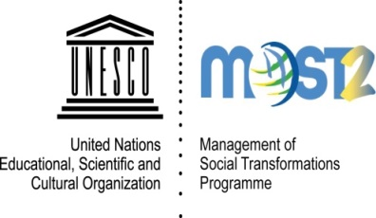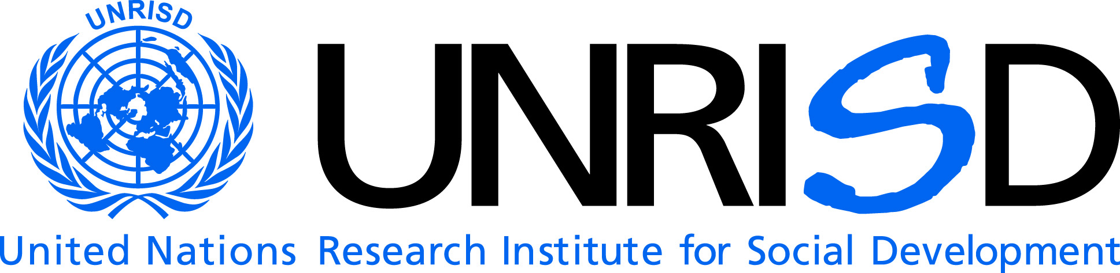

Reducing inequalities: a key to social development in the contemporary word
Friday 6 February from 1.15 pm to 2.30 pm
Moderator: Mr. Sergei Zelenev, Executive Director,International Council on Social Welfare
Speakers:
Representative of Her Excellency, Ms. Alicia Kirchner, President of the MOST Intergovernmental Council and Minister of Social Development, Argentina
Representative of Her ExcellencyMs. Betty Tola, Minister of Economic and Social Inclusion, Government of Ecuador and President of the LatinAmerican Forum of Ministers of Social Development
Reducing inequalities: Outcome of the X MOST Forum of Ministers of Social Development for Latin America, October, 2014, Quito, Ecuador
Ms. Sarah Cook, Director,UN Research Institute for Social Development (UNRISD)
Meeting the challenge of inequality: The role of transformative social policy
Ms. Daniela Bas, Director, Division for Social Policy and Development, UNDESA
The role of social inclusion as a policy response: Reducing inequalities in the context of the post-2015 agenda
Ms.Cecilie Golden, Programme Specialist, UNESCO’s MOST Programme
Strenghtening the social and human sciences knowledgebase for social justice and development including through the MOST Regional Forums of Ministers of Social Development

Commentator: Professor Lynne Healy, Professor at the University of Connecticut and the Representative of the International Association of the Schools of Social Work to the UN
During the 53rd session of CSOCD, UNESCO Management of Social Transformations Programme (MOST), DSPD/UNDESA, and UNRISD are convening this side event. The high-level speakers will contribute to the discussionon why tackling inequalities is essential for progress in social development in today’s world, providing social science findings and policy recommendations.
Inequality that exists in various forms in all countries is widely recognized as one of the key factors of disempowerment, preventing people from realising their potential in full.
As indicated in the Note by the Secretariat (E/CN/5/2015/6), on ‘’Emerging issues: contributions of social development to the transition from the Millennium Goals to the sustainable development goals, “Seven out of ten of the world’s people live in countries where income inequality has risen’’. As indicated by Under-Secretary General for Economic and Social Affairs, UNDESA, Mr. Wu Hongbo, during the last session of the CSD "Inequalities undermine poverty reduction, economic growth and social mobility (Report on the World Social Situation 2013 ‘’Inequality matters)".
In the same vein, the report of the Secretary-General ‘’Rethinking and strengthening social development in the contemporary world’’ (E/CN.5/2015/3) notes that ‘’In a general context of growing inequalities, exclusion among social groups remains significant’’.
In these both documents the need for social science is emphasized as an important element in the formulation, implementation, monitoring and evaluation of social policy policies, as they bring relevant inputs to the social policy making.
In the Synthesis Report of the Secretary-General on the Post-2015 Agenda issued in December 2014, six essential elements for delivering on the sustainable development agenda are proposed, among them are ‘’Dignity: to end poverty and fight inequalities’’ and ‘’Justice: to promote safe and peaceful societies, and strong institutions’’. Both of the elements are of high relevance to the MOST Programme, UNDESA and UNRISD.
The representative of Her Excellency Ms. Betty Tola, Minister of Economic and Social Inclusion, Ecuador and President of the Forum of Ministers of Social Development for Latin America, will present the outcome of the10th Forum of Ministers of Social Development for Latin-America, hosted by the Government of Ecuador, in October 2014, and organized in co-operation with UNESCO’s MOSTProgrammedwhich focused mainly on overcoming inequalities. In the outcome Quito Declarationit was recognized that ‘’over the past few years, the reduction of inequality has been the core goal of the public actions of governments and is a reality in most of the region’s countries’’. The initiatives and recommendations put forward by the meeting to reduce inequalities will be also discussed.
The participants from the UN and civil society organizations will discuss possible steps aimed at moderating inequalities in global development.

Webpages:
http://www.unesco.org/new/es/social-and-human-sciences/themes/most-programme/forums/forums-of-ministers/latin-america/

http://www.unrisd.org

http://undesadspd.org/

