Second regional multi-stakeholder consultation

Financing access to basic utilities for all
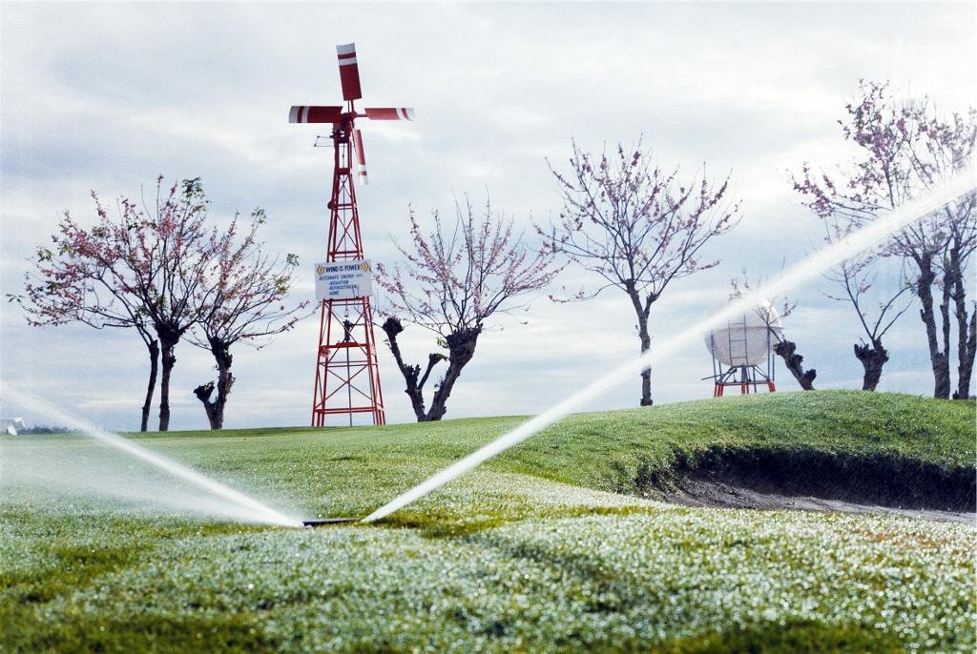

Meeting report

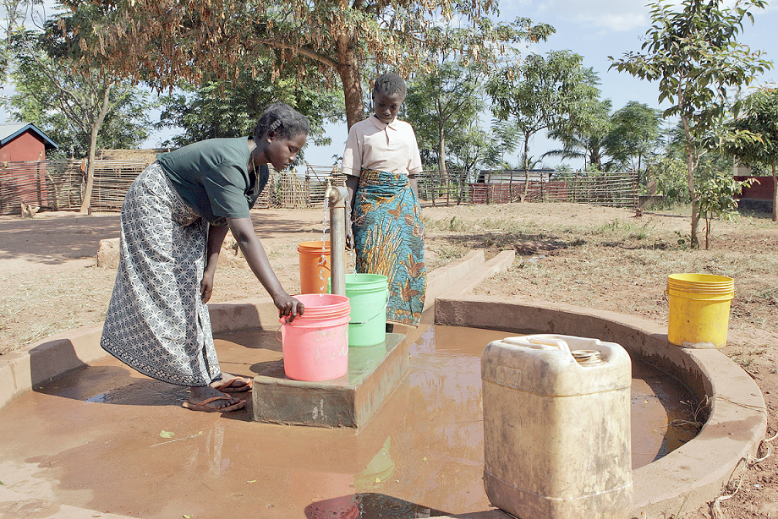

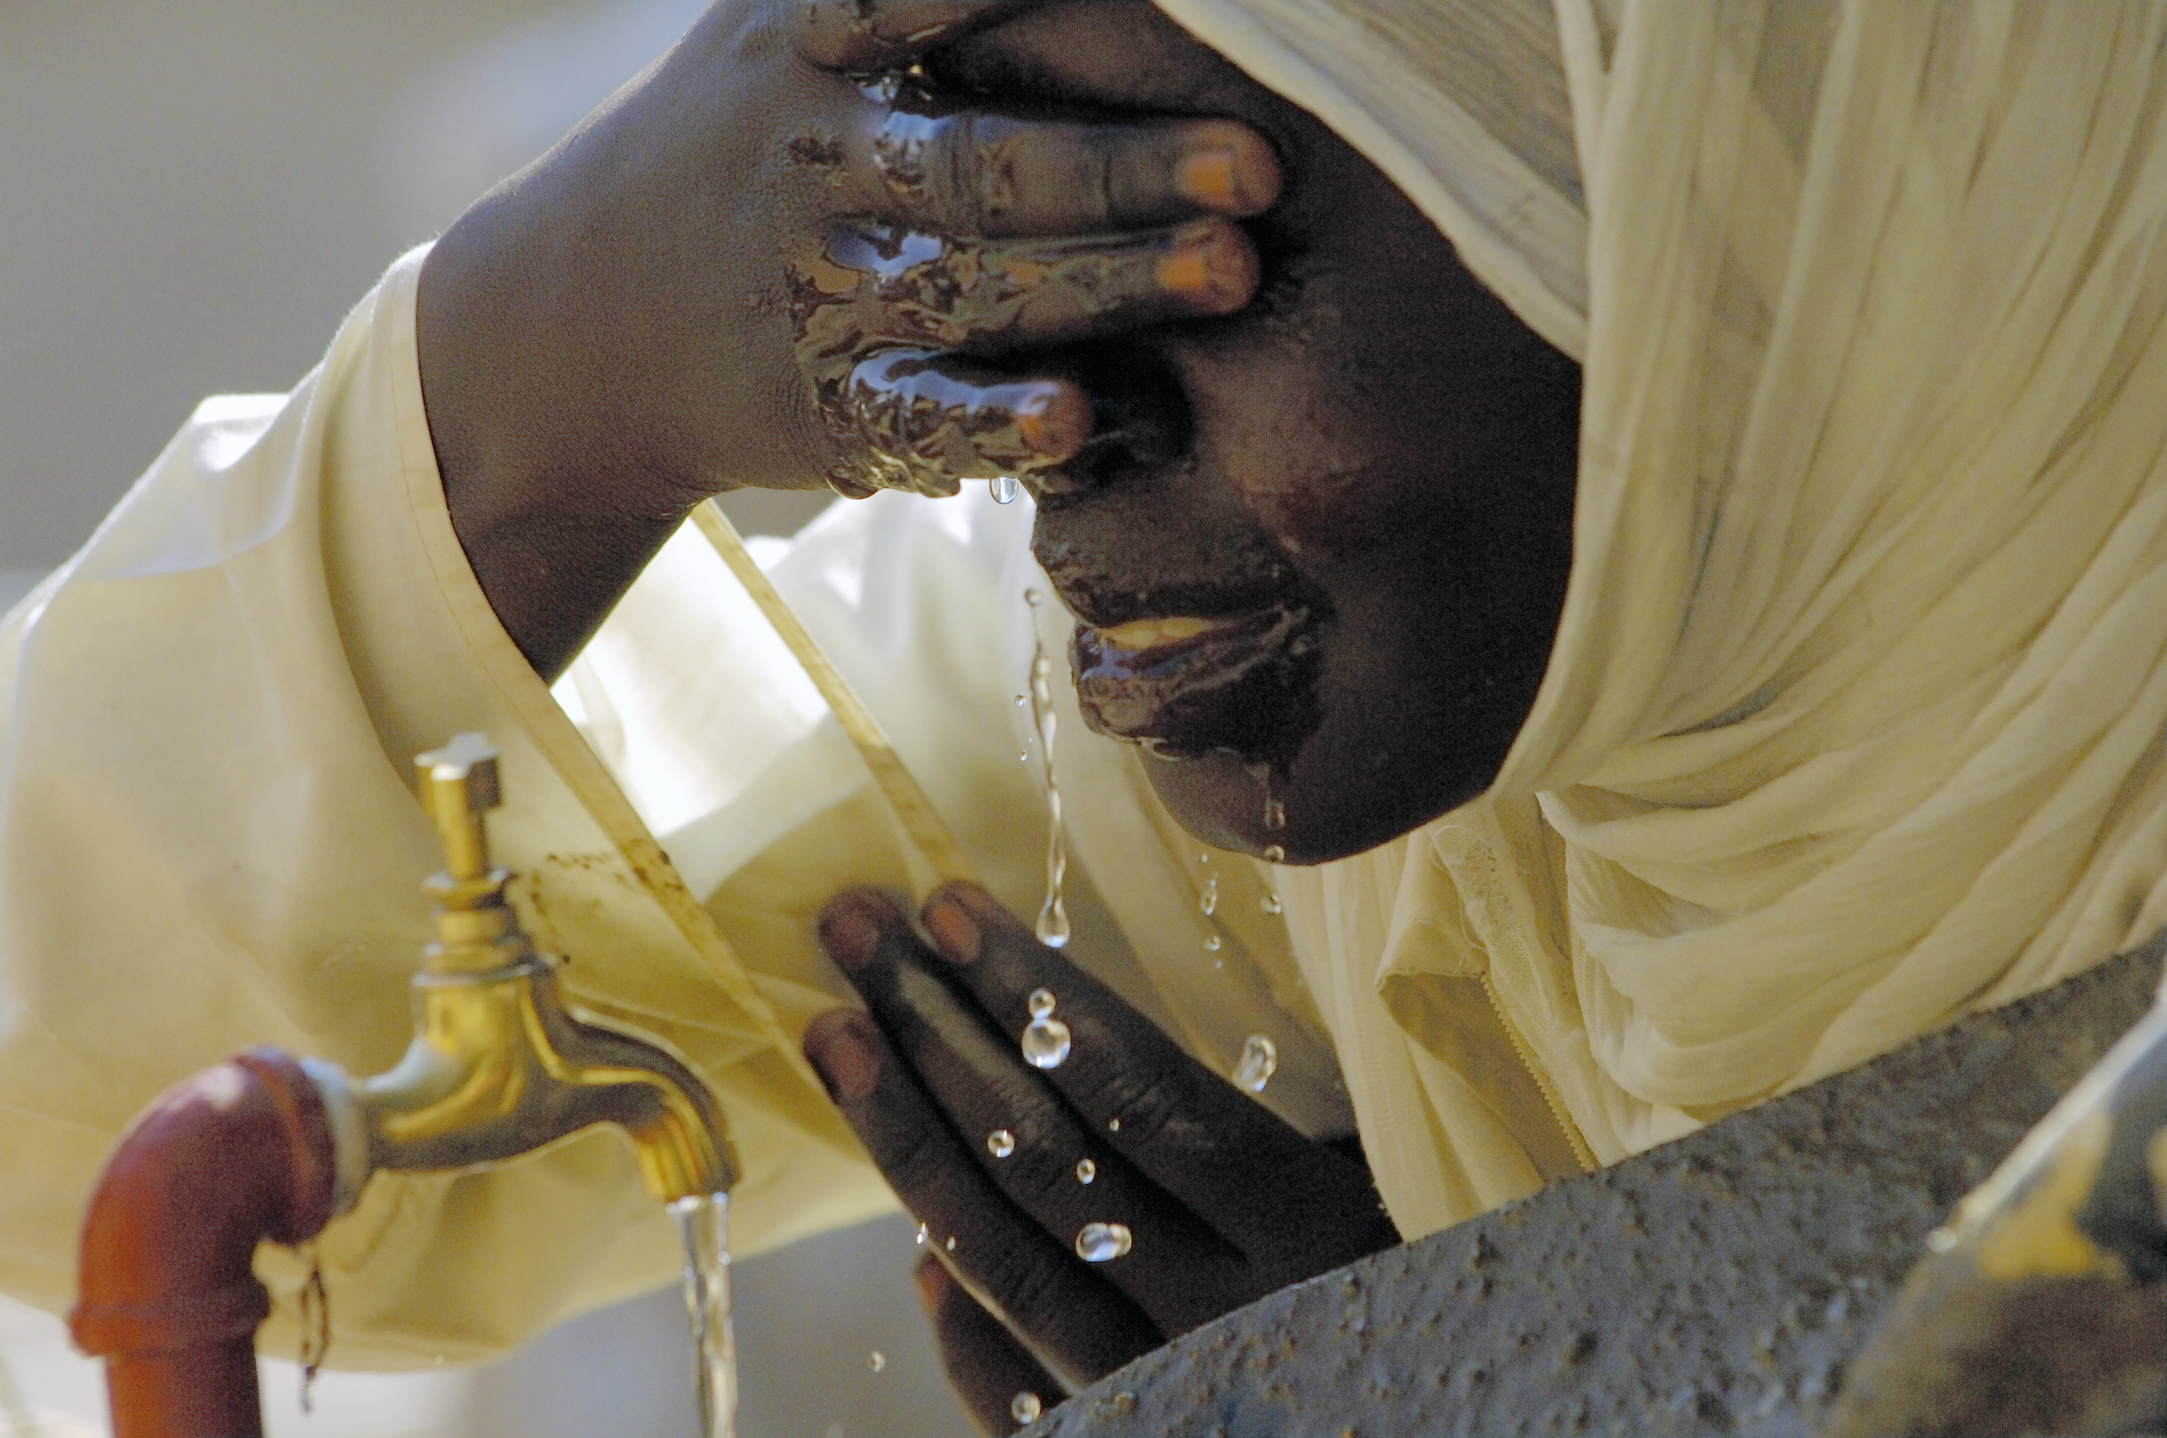

Lusaka, Zambia
23-25 April 2007

Second regional multi-stakeholder consultation

Financing access to basic utilities for all

Lusaka, Zambia, 23-25 April 2007

Meeting report

CONTENTS
Overview 4
Introduction 5
1. Mobilizing finance: Stable and predictable financing mechanisms for utility providers at all levels 8
The Devolution Trust Fund 8
The experience of the African Development Bank in financing water 10
2. Ensuring sustainable access for the poor through internal revenue generation – electricity 14
Principle conditions for ensuring sustainability in the African context 14
Lessons learned by ZESCO, Zambia's largest power utility 15
3. Ensuring sustainable access for the poor through internal revenue generation – water and sanitation 17
The experience of the Zambian National Water Supply and Sanitation Council (NWASCO) in regulating utility providers 17
The” new” and the “old” National Water and Sewerage Corporation of Uganda 19
Increasing government revenue-taxation and infrastructure investment 22
4. Macroeconomic factors to be taken into account 24
Aid inflows 24
Financial market liberalization and policy space 25
Risks 25
Monetary and fiscal policies 25

Overview

The consultation was organized by the Friedrich Ebert Foundation in collaboration with the Financing for Development Office of the United Nations Department of Economic and Social Affairs and the UNDP International Poverty Centre. It was held in the context of the Follow-up process of the International Conference on Financing for Development held in March 2002 in Monterrey, Mexico and in accordance with a mandate of the General Assembly given to the Financing for Development Office to organize multi-stakeholder consultations in collaboration with experts from the public and private sectors, academia and civil society. These consultations are aimed at better enabling member countries to implement their commitments as agreed in the Monterrey Consensus.
The event in Lusaka gathered around 45 African experts from central and municipal governments, utility providers, intergovernmental institutions, civil society, private sector, trade unions and academia. The first two days of the discussion (23-24 April) addressed long-term financing mechanisms and cost recovery strategies for providing water and electricity to the poor with a focus on Sub-Saharan Africa. The discussion covered a wide range of topics and case studies, including challenges of the Zambian Devolution Trust Fund in extending basic utilities to the poor, the experience of the African Development Bank in devising financing mechanisms for water investment, lessons learned by Zambia's largest power utility ZESCO, the experience of the Zambian National Water Supply and Sanitation Council in regulating utility providers, efficiency improvements at the National Water and Sewerage Corporation of Uganda, as well as strategies to increase government revenue through taxation. The debate also focused on macroeconomic and social factors to be taken into account in developing long- term financing strategies for basic utilities, including implications of aid inflows, effects of financial liberalization, different types of risks, the importance of policy space and the role of fiscal and monetary policies. On the third day of the meeting (25 April), participants presented their findings and outcomes to high-level government representatives, the broader public and media in an open plenary session.

Introduction
In their opening remarks, speakers highlighted the failure of privatization policies to ensure stable and predictable financing mechanisms for utility providers in Africa. Since the mid-1970s, investment in utilities and infrastructure has declined because of tighter fiscal restrictions and a decline in tax revenue. Moreover, there was less financial support of donors presumably due to poor public sector performance. Tied aid and aid conditionalities put another constraint on public spending. At the same time, there was limited private investor interest due to poor profit prospects and high costs of private finance. Yet, privatization was advocated as a new remedy to overcome a lack of infrastructure financing and public investments were scaled down further as they were believed to “crowd out” potential private investors. As a result of a lack of investment into utilities, public support for many government programmes has decreased.
Many speakers stressed that these privatization policies did not achieve the envisioned results. Others, however, emphasized that the role of the private sector should not be dismissed entirely as situations existed where it could provide important supplementary finance. Participants agreed that utilities and infrastructure are weak in most developing countries and still suffer from a lack of investment, delivery fragmentation, spatial decentralization, as well as inadequate and inappropriate regulation. Regulation is often based on unrealistic competition policy ignoring economies of scale and small market size). The challenge would lie in creating a regulatory environment that limits opportunities of abuse but maintains sufficient incentives for investment.
Speakers pointed to the limits of sectoral policies aimed at singling out potentially profitable segments for privatization. This type of policy has often led to further fragmentation and a loss of public control of vital segments and units of public service provision. Moreover, unprofitable segments have lost cross-subsidies and expertise. It was further emphasized that privatization policies put greater emphasis on cost recovery through payment collection than on improved service provision and delivery. This focus on improved financial performance has had adverse social implications as it further marginalized poor and rural areas. Overall, private sector utilities provision in Africa was disappointing and skewed by country and sector.
The tendency has recently gone away from long-term lease and concession contracts to management contracts (which may still lead to privatization, eventually) as management contracts usually involve less private sector risks. However, there is still considerable international donor support for privatization aimed at encouraging reluctant private investors to provide utilities and infrastructure. In this regard, it was mentioned that improved financial performance of privatized utilities seems to be mainly due to large financial contributions of governments following HIPC debt write-offs. Moreover, the financial environment has changed significantly for Africa within the last decade. Commodity prices have risen and new donors and investors, such as China have emerged while the trend of declining Official Development Assistance (ODA) has been reversed after the International Conference on Financing for Development (March 2002). It was highlighted, however, that ODA conditionalities of old donors have increased in most recent years.
To ensure that Africa will not keep on lagging behind in the achievement of the Millennium Development Goals, more public investment in utilities and infrastructure is needed urgently. The state has to play a crucial role in this endeavour as it remains the principal provider of utilities, especially in low income countries. Yet, national and regional balance sheets remain inadequate. The overall focus should be put on finding funds for innovative and least cost options that aim at universal, affordable and sustainable utility provision for all. Participants agreed that the question of how to tackle this challenge should be the focus of the consultation over the next two days.

1. Mobilizing finance: Stable and predictable financing mechanisms for utility providers at all levels

The Devolution Trust Fund

This session highlighted Africa’s experience in raising finance at the subnational level. Participants discussed Zambia’s Devolution Trust Fund, which was set up to improve access to water and sanitation to the poor. In 1994, the Zambian Ministry of Energy and Water Development (MEWD) introduced the National Water Policy (NWP), “a holistic (integrated) approach to water management aimed at promoting sustainable water resources development”. This programme had to tackle a myriad of challenges, including low capital investments into the water sector, dilapidated infrastructure, low government spending on water, insufficient cost recovery for capital investments (low tariffs and payment), limited skilled personnel and general difficulties accessing finance from donor and domestic sources. As a response to these issues, the National Water Supply and Sanitation Council (NWASCO), which serves as the regulator of the water supply and sanitation service providers, established the Devolution Trust Fund (DTF). The DTF aims to strengthen the efforts of commercial utilities in service delivery in per-urban areas. It is run by a fulltime DTF Manager and two more officers and managed by a management committee. Its funding is through government grants as well as external support agencies subject to the approval of the Minister as is provided in the Water Supply and Sanitation Act. The major beneficiaries of the DTF are commercial utilities. However, water supply and sanitation improvements projects can also be financed by donors or non-governmental organisations (NGOs) if these projects are monitored by the DTF. The DTF consists of two separate funds, the General Fund (GF) and the Performance Enhancement Fund (PEF). The purpose of the GF is to assist CUs in extending water and sanitation services to the urban poor. All commercial utilities are eligible applicants (unless explicitly excluded) and target project types focus on water supply, sanitation, capacity building or any combination thereof. The GF focuses on peri-urban or low cost areas. The project volume moves within specified thresholds. The PEF, on the other hand, directs its support towards initiatives by a commercial utility that aims at enhancing its financial viability. Eligible applicants are those with proven efforts to improve access to water and sanitation for the urban poor within the past 12 months and with a track record of well-implemented previous DTF projects. Qualified projects are those that focus on improving financial viability of the utility; i.e. reducing operational costs and/or increasing revenues. Committed DTF funds for the period of 2005 to 2010 currently total 9,116,667 Euro, of which 416,667 Euro have been pledged by the Republic of Zambia, 3 million Euro by KfW, 1.6 million Euro by Danida and 4.1 million Euro by the ACP-EU Water Facility.
So far, 120000 people have benefited from six pilot projects that had been completed from 2003 to 2005 at a combined cost of US$450,000. These projects included the construction of water kiosks, which are stationary vending locations, staffed by attendants that distribute water by the container. Nineteen kiosks in the Nkwazi settlement in Ndola and 16 kiosks in Mongu Peri urban areas were constructed under the first phase of funding. Under the second phase, the DTF helped finance 8 kiosks in Chipulukusu settlement in Ndola and 8 kiosks in Kawama and settlements in Chililabombwe. In Ndola alone, a minimum of 30,000 people have gained access to clean water from these kiosks. However, participants recognized a sizable funding gap of at least 2,670,000 Euros in order to bring water to an additional 2.85 Million people in Zambia’s peri-urban areas by 2015.

The experience of the African Development Bank in financing water

The debate then turned to the key findings of research undertaken by the African Development Bank on financing mechanisms for water sector investment in Africa. Participants identified insufficient financing levels, poor governance and inadequate capacity as key constraints for investing into utilities. The potential of market-based finance was seen as limited in Africa due to high capital costs with long payback periods, a low rate of return for water investments relative to other infrastructure (e.g. power, telecommunications), contract and regulatory risk and sub-sovereign risk. In response to these challenges, the African Development Bank has introduced a set of financial products, which are made available through two main lending windows geared towards the public sector and the private sector. The public sector window is further divided in two sub windows for lending on commercial terms to middle income countries through the African Development Bank and for lending on concessionary terms to poorer countries through the African Development Fund. For countries that can borrow both from the ADB window as well as the private sector window the ADB the range of financial products available includes direct loans, lines of credit, guarantees, equity participations, risk management products to hedge risks including climatic risks and grant resources.
The ADB has an additional dedicated window, the AWF (African Water Facility), which provided grant funding to a broad range of stakeholders in the water sector, including central or local African Governments, African municipalities, NGOs and community-based organizations, as well as regional, sub-regional and sectoral organizations (e.g. Regional Economic Organizations, River Basin Organizations etc.). However, the products on offer through the ADF window are limited to loans and grants and demand for them has been low. Due to the constraints identified by participants above, the costs of lending to water utility projects are high. One of the strategies discussed to lower lending costs was to lend directly to sub-sovereign entities (such as a municipality-owned water utility) in local currency. Moreover, participants agreed that more attention should be put on creating project development and financing facilities to hedge risk and allow for longer term financing mechanisms for water sector. Pooled financing arrangements could be an interesting option because of the variation amongst and between countries in Africa. Speakers saw potential to use intermediaries to pool risk, perhaps at a regional (Sub-Saharan Africa), or sub-regional (e.g. the Southern African Development Community) level. At the same time, it was suggested to put emphasis on capacity building and improving the risk profile of utilities. Multilateral development banks (MDBs) could help by increasing efforts to provide knowledge management and facilitation for the water utility financing, increasing flexibility to operate in local currencies for debt and risk mitigation activities and working towards the use grant financing to support partial risk guarantees for the water sector. It was recommended that MDBs cooperate to identify where existing and planned lines of credit can be earmarked for water utility business. In addition, participants suggested that MDBs target their lending towards municipal strengthening and bond market development in select middle income countries. Further support to microfinance institutions as part of a country strategy for financing small utility operators was also seen as worth exploring.
During the last part of this session speakers highlighted the nature of the financial sector in Africa and its potential in providing financing mechanisms for infrastructure investment. It was mentioned that financial policy and reform design depends on whether the country was a post-conflict country, a sparsely populated country, a small country, an oil rich country or a country with a “critical mass”. It was suggested that African financial systems have experienced three phases over the last 20 years. The first phase had been characterized by the dissolution of financial repression. This period was associated with structural adjustment policies that called for removing directed credit policies and price and interest rate controls. The second phase was characterized by privatisation, capital market reforms, and the establishment of securities exchanges. Most of Africa now passes through the third phase of financial reform, which features regionalisation and internationalisation, pension fund reform, microfinance movement, and the introduction of new technology platforms. However, financial development in Africa continues to face severe constraints related to small the scale of many economies, large informal sectors, governance issues, external shocks and capital flight.
The discussion then turned to the challenges of finding long term funding instruments for utilities with maturities of 5,10, 15 or even 20 years. In this regard, discussants highlighted that African utilities are compelled to operate under sub economic conditions. Many participants saw the setting of tariffs not as a function of sustainability but often as driven by political dynamics. Moreover, challenges persisted related to accounting standards. Financial statements for utilities were not often published or released. This lack of transparency would create credibility problems with potential investors. In addition, the financial relationship with the central government was seen as complex and often detrimental to the utility. In order to increase the availability of long-term funding for utilities, participants recommended promoting pension funds and other institutional investors, securities markets, as well as infrastructure bonds with special features. In addition, it was seen as critical to build confidence and absorptive capacity and to stabilize wholesale financial markets.

2. Ensuring sustainable access for the poor through internal revenue generation – electricity

Principle conditions for ensuring sustainability in the African context

The first part of this session focused on basic strategies to ensure sustainable access of the poor to electricity in the African context. Participants agreed that sustainable access to basic utilities for all was critical to the achievement of the MDGs. Speakers stressed the positive impact access to basic utilities has on health, education and gender equality. A fundamental question posed in the discussion was whether basic utilities for the poor should be viewed as commercial commodities. Most participants agreed that providing utilities, in particular for the poor, should not be viewed as an entirely commercial service that follows market rules. Full cost recovery was not seen as a realistic goal when extending services to the poor, at least not in the short or medium run. Hence, the funding of basic utilities needed to draw on other domestic resources such as tax revenue and cross-subsidies. Therefore, many participants emphasized that the main responsibility in funding utilities would lie with the municipal government and central government. Speakers further agreed that it was crucial to identify the real needs of the poor through participatory approaches (e.g., consultations, meetings and in-kind contributions of beneficiaries). Once the needs were properly identified, the most adequate and cost efficient electricity supply option should be selected (e.g., extension of transmission line, solar system (PV), micro hydro, wind energy, biomass, etc.). In this regard, it was also suggested that the purchase of materials needed for enhancing access to electricity for the poor should be tax exempt. Moreover, the increased use of local materials (e.g., wood poles instead of steel poles, etc.) and local labor could also increase the sustainability of services and minimize costs. Speakers recognized that there was a general trade-off between minimizing costs and the choice of the technology. However, although investing into the latest technology may be expensive, it could significantly lower maintenance costs and improve efficiency in the long run. Pooling of efforts in the form of forming associations and cooperatives and closer cooperation between municipalities and NGOs could also increase efficiency and widen the funding base.

Lessons learned by ZESCO, Zambia's largest power utility

The second part of this session focused on the experience of ZESCO, Zambia's largest power utility, in extending access to electricity to the poor. Speakers first highlighted the difference between individual and community access (e.g. in schools, clinics, and community centres). Electrification standards often represent constraints when it comes to extending access to poor individuals. For instance, thatched houses or mud houses can not be electrified. While on average 23% of individuals in Zambia have access to electricity, there is a vast disparity between the rural (2%) and the urban (44%) population. A sizable country (752,000 sq. km) with a population of only 10812000 (UN estimate, 2003), Zambia has to face relatively high costs per connection (around $1000).
Moreover, it is a least developed country with increasing but still low per capita income. Some speakers also underscored persisting difficulties in payment collection. Possible strategies to meet these challenges should focus on accelerating national development through pro-poor policies to increase the capacity to pay. However, extending electricity itself was seen as a growth –enhancing and pro poor policy as it supported critical industries, such as mining, agriculture, tourism and services (education, hospital, etc). In addition, electricity is crucial in supporting small-scale income generating industries. However, electricity costs, including connection, operations and maintenance costs have not been fully recovered in Zambia. ZECSO tariffs are currently the lowest in the region at 3.1Cents/kWh. Yet, revenues should actually exceed cost recovery as a margin was needed to finance urgently needed investments in generation and transmission of electricity in Zambia and old loans need to be repaid. Speakers pointed out that developed countries have been subsidizing electricity by way of grants or tax waivers and consumption support through welfare payments. Zambia, on the other hand does not have welfare payouts, only lifeline tariffs. Yet, many poor households are unable to obtain electricity service connections at the lifeline level due to infrastructure constraints.
Participants reiterated the potential of cross-subsidies, by which one customer category pays a tariff above the cost level so it could support lower-income categories. Additional government revenues have to be allocated to the electricity sector. If there is insufficient support to the electricity sector all other sectors requiring public investment could be adversely affected. Many participants view the role of mines and industrial customers very critically. Current electricity tariffs of mines average 2.1 cents with real costs of 4.2 cents. This calculation has been based on low commodity prices in the past. However, as commodity prices have risen this tariff should be reevaluated. Participants stressed that the potential new revenues that would result from a tariff increase in the mining sector could be used to finance electricity for the poor. Other recommendations to increase access to electricity to the poor included promoting the use of gas for cooking, as well as to equip all new houses with solar panels for heating. One participant suggested dropping lifeline units to a lower standard. This proposal turned out to be controversial. It was criticized as too hard on the poor and targeting the wrong segment of the population. Finally, participants reiterated the need to place increased emphasis on the rural population. Moreover, if the government vision of giving access to electricity to 30% of the population by 2010 is to be achieved more efforts should go into exploring the potential of innovative off-grid solutions.

3. Ensuring sustainable access for the poor through internal revenue generation – water and sanitation

The experience of the Zambian National Water Supply and Sanitation Council (NWASCO) in regulating utility providers

NWASCO, which was established by an Act of Parliament in 1997, is a regulatory authority that issues operating licenses to the currently ten commercial utilities (CUs), thirteen local authorities and six private water providers running water supply and sanitation services in Zambia. The regulator has been established as part of a new National Water Policy based on seven sector principles These included the separation of water resource management from water supply and sanitation, the separation of regulatory and executive functions within the water supply and sanitation sector, the devolution of authority to local authorities and private enterprises, full cost recovery in the long run, human resource development leading to more effective institutions, technologies appropriate to local conditions and increased funding by the Government of the Republic of Zambia (GRZ). Participants highlighted NWASCO’s independence. While it reported to the Ministry of Energy and Water Development it was a statutory and not a ministerial body. Costs were relatively low as the agency had a lean structure with a total staff of 15, which is supplemented by Water Watch Groups and part time inspectors that monitor the quality of services delivered. NWASCO’s expenditures were covered by a fee collected from the providers (2% of their turnover).
The fact that employee’s salaries were competitive with the private sector was seen as another factor supporting its independent status. Speakers highlighted various mechanisms through which NWASCO’s attempted to improve service delivery to the poor. These included the abovementioned DTF, low regulated tariffs, revenues from consumer taxes and cross-subsidies between towns and customer categories. Moreover, NWASCO would demand minimum service level guarantees, business and investment plans, raise block tariffs and insisted on metering so large volume consumers would pay the full cost. Before tariffs were approved the utility had to undergo a review performance as to their financial sustainability. Most speakers agreed that efficiency improvements of utilities did not automatically translate into improved access for the urban poor. For sustained performance improvement of utilities, effective regulation and monitoring was seen as a key factor.

The” new” and the “old” National Water and Sewerage Corporation of Uganda

This session highlighted the experience of the Ugandan National Water and Sewerage Corporation (NWSC) in optimizing revenues through cost efficiency –enhancing measures. The operational efficiency of the old NWSC (as at 1998) was low. There were many unviable towns being served, high arrears, an expensive labour force, inadequate and costly welfare schemes, a lack of performance incentives for area managers and staff and rampant water leakages and sewage spillages. Collection efficiency was low at around 60% and service interruptions in several towns would range from 15-21 hours. As a result NWSC was running a monthly deficit of about Ushs 348M (US$ 300,000) despite a high average tariff of Ush 1100/m3 (US$ 1.00/m3) with an overall debt burden of US$100 million.
Subsequent cost recovery interventions focused on the policy level through a change of the board and a change in strategy as well as on operational improvements through a comprehensive management reform. A critical step for optimizing revenue flows was to restore customer confidence through training in customer care, the establishment of customer care centres, conducting of customer surveys and amnesty for illegal water use and better territorial management. Cost containment included downsizing of staff from 1,850 in 1999 to 850 in 2001. While some participants viewed this measure as too drastic, others highlighted that by 2006 staff had increased again to 1200, which can be interpreted as an indicator of good management and financial sustainability. There was also a reduction in administration and overhead costs (vehicle maintenance, medical, travel and illicit activities). Moreover, a stricter appraisal of capital projects was ensured. A simplification, rationalisation and indexation of tariffs included lowering the average tariff to US $50cts, a reduction in connection fees by 50%, a reduction in reconnection fees by 75%, the elimination of a minimum charge and the introduction of a minimal service charge (minimal). As a result of the improved financial situation, more than 1,370 km of new water mains, new stand posts (an average of 300 per annum) were constructed in peri-urban areas. Cross-subsidies were applied across customer groups and across areas by application of a uniform tariff.
The water sector reform was implemented within the context of performance contracts to ensure continuous performance improvements, a Poverty Eradication Action Plan (PEAP) and a Sector Wide Approach to Planning (SWAPs). Critical ingredients were large upfront infrastructure investments (Water Works & Sewerage systems, big transmission mains, etc), social mission activities including reaching out to the poor, the take over of non-viable towns and agreed debt write offs. This strategy has lead to significant operating efficiency gains from 1998 to 2006, such as an increased service coverage (48% to 70%), a higher number of total connections (50,826 to 152,046), more metered connections (217 to 149,963), a larger number of new connections per year (3,317 to about 28,521 p.a.) and lower number of staff per 1,000 connections (36 to 7 in 2006). Unaccounted for water was reduced from 51% to 29.3% (in Kampala from 55% to 35.1% and other areas from 43% to 15.2%). In addition, collection efficiency had increased from 60% in 1998 to 95% in 2006 leading to a much higher operating profit. Based on these positive experiences, NWSC’s has offered advisory services on organizational behavior change, contract design and incentive systems to other utilities and institutions within and outside Africa. In concluding, it was stressed that there was a need for a multi pronged approach to finance the poor. Improved operational efficiency was seen as a prerequisite for improved financial performance and a tariff restructuring a necessity as a short term intervention.
Full cost recovery, however, at least in the short and medium term was called a “myth”, especially in least developed countries. Participants cautioned against disconnecting users from their services upon non-payment. The experience of Uganda had shown that this was an unnecessarily drastic and ineffective measure. In order to service the poor in a sustainable fashion and to finance big infrastructure projects targeted subsidies by the state or official development assistance was necessary. At the same time, utilities were urged not to be complacent about internal financing of investments.

Increasing government revenue-taxation and infrastructure investment

During this section participants discussed two Zambian government development plans, entitled vision 2030 and the Fifth National Development Plan (FNDP) 2006 – 2010, which emphasize infrastructure development. The main challenge spelled out in the plan is resource mobilisation both domestically and internationally. So far, most big infrastructure projects have largely been financed by borrowing from multilateral or international institutions. Participants recalled the main funding sources a government could draw from such as tax revenue (direct taxes, including income tax, corporate tax, withholding taxes, and indirect taxes, including VAT, import taxes, excise duties), non-tax revenue (fees, fines, levies and others), grants from cooperating partners (budget support and project grants), domestic financing (bank and non bank borrowing)and foreign financing (project and programme loans). These resources can be spend as recurrent expenditure (personal emoluments and operations of the government) and capital expenditure (fixed assets such as infrastructure (roads, railways, dams, building, power stations, water supply plants) and movable assets (motor vehicles, equipment, etc.)).In Zambia, domestic resources have proven to be inadequate to finance major infrastructural projects. As a result, the government has relied on foreign borrowing and grants.
In additions, speakers discussed some new ideas or innovations for increasing funding for infrastructure, including the earmarking of some domestic revenues for infrastructure i.e. imposing an excise duty (fuel levy) for road maintenance or on electricity for rural electrification. Other revenue raising alternatives mentioned included public private partnerships (PPP), BOT (build operate transfer) arrangements, private sector investment and user charges. However, many participants reiterated the failure of the private sector to invest into utilities in Africa and concluded that this sector was not a reliable source of finance. At the same time, user charges had limited revenue potential, especially when it came to charging the poor. A question was posed whether infrastructure projects should be exempt from taxation. It was mentioned that in practice, Zambian infrastructure projects financed by partners co-operating with the government are tax exempt. Different views persisted whether privately undertaken infrastructure projects should also be exempt from tax. Many participants cautioned that tax exemptions might have distortionary effects and will reduce revenue.
Some speakers recommended that tax policy and administration must be tailored in such a way that they yield adequate resources in fair and equitable manner. This was seen as a tremendous challenge that was exacerbated by transfer pricing, tax sparing, and smuggling. Many participants saw it as a challenge to find a clear conceptual link between infrastructure finance and taxation. One obvious connection was seen in the fact that better provision of public services could increase the willingness to pay taxes among the population, in particular the poor.

4. Macroeconomic factors to be taken into account

Aid inflows

The section focused on macroeconomic factors to be taken into account in funding utilities. Surges in aid inflows could lead to exchange rate appreciation and loss in competitiveness of the export sector. However, this was seen as a non-issue for most developing countries if these inflows were properly managed by the government and central bank. Ideally, foreign exchange inflows should be invested into non-competitive imports that improve the productive capacity of the recipient country. Participants further criticized that aid inflows were often pro-cyclical, which would aggravate downturns of the recipient economy. It was also highlighted, that the recent evaluation of Poverty Reduction Growth Facility- countries in Sub-Saharan Africa by IMF’s Independent Evaluation Office has concluded that only 28% of aid has been spent. One possible reason for this could be IMF conditionalities based on exaggerated concerns that too much public spending would exert inflationary pressures on the economy. Moreover, inflows of ODA need to be more predictable and ideally should be channeled through national budgets on a medium-term basis.

Financial market liberalization and policy space

Financial market liberalization has further increased the pro-cyclicality of capital inflows and has led to a net transfer of real financial resources from the developing to the developed world. Speakers also stressed the critical role of policy space. Poor countries should be able to pursue policies and strategies that support development by maintaining adequate fiscal space, by promoting investment and employment and through exchange-rate targeting for export promotion. Moreover, it was suggested that the central bank should revert to its historical role as a development supporting institutions.

Risks
Another section of this session focused on risk issues. Recommendations focused on mitigating exchange rate risks through managed floating rates rather than “corner solutions” and lowering interest rate risks through bonds, hedging and other options. There appeared to be agreement that moderate inflation rates in the region of 5-7% could be seen as acceptable and would not necessarily result in macroeconomic instability.

Monetary and fiscal policies

Finally, participants discussed the role of monetary and fiscal policies. As regards inflation targeting, it was emphasized that macroeconomic stabilization should not only be about consumer prices. Other indicators such as employment and exchange-rate targeting should be included as well. It was suggested that exchange-rate policies should aim for undervalued, not overvalued exchange rates. Encouraging exports and discouraging imports would help a developing country maintain a healthy trade balance in an open economy setting. A managed floating rate would help minimize exchange-rate instability. Interest rate policy had to be geared towards maintaining a positive real interest rate. It was pointed out that there was no empirical evidence for a positive correlation between interest rates and savings. Rather, where investment leads, savings and finance would follow. Currently, the share of government budget devoted to infrastructure finances was in the single digits in most African countries and much more of it was needed in relative and absolute terms to extend basic utilities to all.

This report is based on the salient features of presentations and discussions that emerged during the meeting. The views expressed do not necessarily reflect the position of the United Nations or of any other institution represented at the meeting. Comments and suggestions on the text should be addressed to Daniel Platz (e-mail: platz@un.org). More details on the meeting, including the list of participants, can be found at: http://www.un.org/esa/ffd/Multi-StakeholderConsultations/NGOs/indexutilities.htm. UN photographs by Fred Noy, Evan Schneider, Noel Gomez (from left to right).
See GA resolution 60/188 of 22 December 2005.
See website of the Zambian Ministry of Energy and Water Development (MEWD), Department of Water Affairs (DWA), at http://iwarema.gim.eu/users/mewd.html.
Water kiosks differ from community standposts. At water kiosks water is generally sold and not free as is the case for community standposts. Water sold in kiosks may come from a piped network, a well or a surface water source.
See GRZ (1994). National Water Policy. Lusaka, Ministry of Energy and Water Development.
These reform elements included a “100 Days programme to improve services”, “Service and Revenue Enhancement Programme (SEREP)”, “Area Performance Contracts (APC’s)”,” Internally Delegated Area Management Contracts (IDAMC’s)”,” One Minute Management Concept (OMM)”, “CHECKERS system”. For details see www.nwsc.co.ug
It was noted that NWSC increasingly favours the use of private yard connections as alternatives to public stand posts or kiosks, as the latter had experienced low rates of payment. As opposed to standposts, yard connections are private and water can be distributed through on-selling to neighbours.
One of the presentations made during this session (Terry McKinley-“The macroeconomics of financing basic utilities for all”) was already given at a previous multi-stakeholder consultation on the same topic in Brasilia, Brazil (11-13 December 2006). Salient features of that presentation are included in the corresponding meeting report, which is accessible online.

