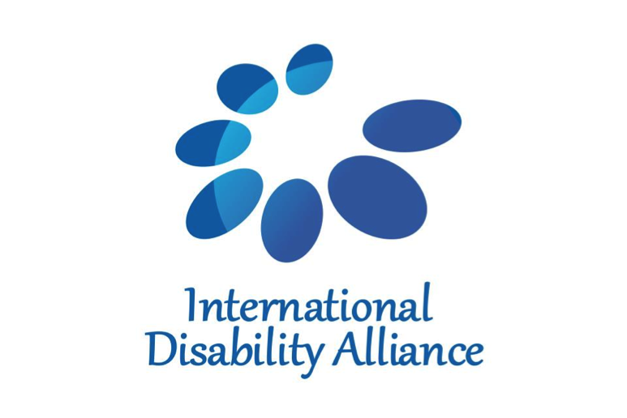

Mr. Vladimir Cuk

Executive Director
International Disability Alliance

Distinguished Excellences, Ministers, Ladies and Gentlemen,
It is a great honour for me to speak to you today on behalf of persons with disabilities and their families.
I would like to start by thanking Member States and the UN system for working together with us, the People, on designing the post-2015 development agenda. The conversation on shaping the new framework has been one of the most inclusive efforts in the UN history.
Allow me to continue by applauding the UN for adopting this important development framework. Equality is essential to sustainable development and key to creating an inclusive society for all, including persons with disabilities. We welcome that the new Agenda dedicates an entire goal to reducing inequality within and among countries, in which persons with disabilities have been explicitly included.
For persons with disabilities and their families, this is one of the greatest achievements of the new Agenda, because inequality goes beyond the problem of lack of access to buildings, development programs or services.
To address inequalities, we must connect the new Agenda with the Convention on the Rights of Persons with Disabilities (or the UN CRPD). The new Agenda makes the commitment to empower persons with disabilities, under a number of goals and targets that are also named in the UN CRPD. Therefore we recommend that the UN CRPD should serve as a guiding document for implementing the new Agenda. To achieve this, persons with disabilities must be included in planning, implementation, and monitoring processes. We are convinced that a human rights based, participatory, non-discriminatory approach and equity should be central now, towards 2030 and beyond.
Persons with disabilities would like to embrace this vision of the 21st century. As the Executive Director of the International Disability Alliance, the world’s largest network of global and regional organizations of persons with disabilities and their families, I have hope that the Agenda 2030 has opened doors for us to participate, to be included and to be recognized as active contributing members of society without any discrimination or fear of being left out or left behind. Not only today, but also in the future toward 2030 and beyond. The fact that the International Disability Alliance is here today, representing persons with disabilities and their families worldwide, is proof of this inclusive approach – and for this we thank you. Simultaneously, I would like to promise that we, persons with disabilities, are ready to help the United Nations and its Member States build a sustainable world without poverty and discrimination.
--
September 25th, 2015
United Nations Sustainable Development Summit 2015
Interactive Dialogue 2 - Tackling inequalities, empowering women and girls and leaving no one behind

International Disability Alliance
150 route de Ferney, PO Box 2100, CH 1211 Geneva 2, Switzerland
205 East 42nd Street, New York, NY 10167, USA

info@ida-secretariat.org
www.internationaldisabilityalliance.org
@IDA_CRPD_Forum

