Baseline review on mainstreaming the rights of persons with disabilities into UN Country Level Programming

Department of Economic and Social Affairs
Secretariat for the Convention on the Rights of Persons with Disabilities


United Nations
New York, 2010
Table of Contents

Acronyms iv

Executive Summary v

1. Overview 1
  - Background to the baseline review
  - Methodology

2. Reflection of disability issues in key UNCT strategic
planning documents: quantitative analysis 5
2.1 Reflection of disability issues in CCA/UNDAFs
2.2 Regional breakdown of reflection of disability issues in
CCA/UNDAFs
2.3 Trends over time
2.4 Resident Coordinator reports
2.5 MDG reports

3. Reflection of disability issues in key UNCT strategic
planning documents: qualitative analysis 12
3.1 Ways of mainstreaming disability issues in CCA/UNDAFs
3.2 Specific programming on disability issues in CCA/UNDAFs
3.3 Type of work over time

4. Challenges to mainstreaming disability perspectives 19
4.1 Data relevant to building the evidence base for social and
economic arguments for promoting disability rights
4.2 Breakdown of challenges to mainstreaming disability
perspectives

5. Recommendations 28
5.1 Establishing the baseline and measuring progress
5.2 Minimum standards and accountability mechanisms
5.3 Capacity development and roll-out of the draft Guidance Note

Figures

Figure 1: Breakdown of CCA/UNDAFs by year 5
Figure 2: Type of reference, UNDAFs 6
Figure 3: Type of reference, CCAs 6
Figure 4: Time trends for type of reference for all regions 8
Figure 5: Time trend for type of reference, all regions 9
Figure 5a: Time trends in RC Annual Reports by type of work 10
Figure 6: Type of reference, MDG reports 11
Figure 7: Breakdown of mainstreaming activities by type, total
sample 13
Figure 8: Type of work, all regions 14
Figure 9: Time trend for type of work, all regions 16

Tables
Table 1: References to disability issues in CCA/UNDAFs by
region 7
Table 2: Improving access to employment, education or other
services: country breakdown 14
Table 3: Data on persons with disabilities from CCA/UNDAFs 19
Table 4: Evidence on persons with disabilities from the CCAs
reviewed 23

Boxes
Box 1: CCA Good practice – China 16
Box 2: UNDAF Good practice: The Maldives 2008-2012 18

Annexes (issued as a separate document)
Annex 1: Methodological details
Annex 2: References to disability issues for CCA/UNDAFs reviewed
Annex 3: References to disability issues for RC reports reviewed
Annex 4: Performance indicators for mainstreaming disability issues
Annex 5: Training courses on the rights of persons with disabilities
Acronyms

CCA Common Country Assessment
CEB Chief Executives Board for Coordination
CIS Commonwealth of Independent States
CRPD Convention on the Rights of Persons with Disabilities
DPO Disabled People’s Organisation
DOCO Development Operations Coordination Office
GPDD Global Partnership for Disability and Development
IASG Inter-Agency Support Group
LAC Latin America and Caribbean
MDG Millennium Development Goal
Q&A Question and answer
RC Resident Coordinator
RD Regional Director
UNCT United Nations Country Team
UNDAF United Nations Development Assistance Framework
Executive Summary

The Department for Economic and Social Affairs commissioned this baseline review to contribute to the work of the Inter-Agency Support Group (IASG) for the Convention on the Rights of Persons (CRPD) and to promote mainstreaming of the rights of persons with disabilities in key UN Country Team (UNCT) planning and reporting documents. The purpose of the baseline is to determine the current state of mainstreaming of disability issues in UNCT planning and reporting documents, assess gaps in capacity and how these might be filled, and identify areas of training for UNCTs.

Planned users of this report are: UNCTs, which are mandated with supporting implementation of the CRPD and require details about the global context of UN work on disability issues; policy level staff in governments and civil society involved in making policy for persons with disabilities, who need an improved understanding of the extent of UN programming on disability issues, as well as capacity gaps; UN Regional and HQ offices which need to be able to support UNCTs in their work on disability issues; and civil society groups, which wish to advocate for greater attention to disability issues.

Ninety four CCAs between 1997 and 2010, and 97 UNDAFs between 2001 and 2010, were reviewed for reflection of disability issues using a six point typology for the type of reference, and a 12 point typology for type of work carried out. 119 RC reports from 2005, and 120 from 2008 were assessed, to determine if there had been changes in language and focus after the adoption of the CRPD, using the same two part typology. An IASG review of 80 MDG reports to determine their reflection of disability issues was supplemented by a review of a further 16 reports to determine if the type of language used in the MDG reports had become more rights-based after the adoption of the CRPD.

Results of this review should be read in the context of the recent entering into force of the CRPD in May 2008. While the normative framework is now well established, countries are only beginning to implement the CRPD on the ground.

Reflection of disability issues in key UNCT strategic planning documents: quantitative analysis
Ninety five per cent of CCAs and 81 per cent of UNDAFs included some reference to disability issues. This can be considered a solid starting point for improved mainstreaming. There were about 67 per cent more individual references to disability issues in the CCAs than the UNDAFs. Sixty six per cent of UNDAFs include references to persons with disability as one of a number of “vulnerable” groups, which can be considered only partial mainstreaming. Ten per cent of UNDAFs include disability issues as a stand alone in the text, and a further 5 per cent include disability issues as a stand alone in results statements/indicators. The last figure suggests there is specific, but limited, programming taking place.

With the adoption of the CPRD in December 2006, increased references to disability issues would be expected. Also, with the UN’s move to “Delivering as One” more joint work at country level on disability issues would be expected. Neither of these trends is evident in the CCAs and UNDAFs reviewed. References to disability issues as a stand alone in the text and results statements and indicators have decreased over time.

The review of Resident Coordinator reports reveals an increase in references to disability issues between 2005 and 2008, from one reference about every six reports to one reference every 2.4 reports. The kinds of references were similar between the two years, the majority being as a stand alone in results statements/indicators. For MDG reports there is less reference to persons with disabilities than in the UNDAFs.

For all key UN country level planning/reporting documents the main form of “mainstreaming” of disability issues is through including persons with disabilities in a listing of vulnerable groups. The challenge is to promote a greater depth of mainstreaming and more programming on persons with disabilities. Evidence also suggests that CCAs are increasingly not being completed, and the main focus of the IASG should be on mainstreaming in UNDAFs.

Reflection of disability issues in key UNCT strategic planning documents: qualitative analysis
There were four main types of reference to persons with disabilities - mainly as victims (38 per cent of references); through description and data (23 per cent); rights based approaches (20 per cent); and references dealing with the CRPD and/or national level legislation (19 per cent).

In terms of type of work carried out by UNCTs, education, social protection and employment were well represented, while others have a limited number of UNCTs focusing on them, such as health care and housing/shelter. The question arises as to whether the focus on three main areas is excluding other areas of work that may be more appropriate for UNCTs.

Capacity development of government made up 11 per cent of work, and capacity development of disability organisations or persons with disabilities 2 per cent. Given the capacity development mandate of the UN, it might have been expected that there would have been greater attention to capacity development. Attention to promotion of the CPRD was also fairly limited, with seven references found, or 8 per cent of the total. There does not appear to have been an increased focus on human rights programming as a result of the CRPD.

Challenges to mainstreaming disability perspectives
Lack of adequate data
In terms of the content of key UN planning documents, data on persons with disabilities is not prevalent in CCA/UNDAFs, with some 8 per cent of the sample including reference to this. Lack of adequate data has been highlighted as a major constraint to mainstreaming disability perspectives.

Accessibility
In terms of programming to mainstreaming disability perspectives, the CCA/UNDAFs include a significant amount of qualitative information on constraints to fulfilment of the rights of persons with disabilities, including lack of adequate government policy, limited provision of services, lack of access to or exclusion from services, lack of access to rights, social discrimination, and high levels of poverty and unemployment. The majority of references related to lack of access to services, in particular education, and discrimination, including within the family. There were no issues specific to any one region, rather the issues cut across all geographical boundaries.

Notable gaps in the CCAs in terms of potential challenges to mainstreaming of disability issues were: limited attention to capacity gaps and strengthening the capacity of Member States, civil society and the UN system; limited information concerning the intersection of disability and gender issues; and little information on the rural or urban implications of disability.

Recommendations
1. Establishing the baseline and measuring progress
Follow-up reports to this baseline to measure progress should be planned every 2-3 years. It will be important to use the same methodology as that employed in this baseline to ensure methodological consistency. It is recommended that for CCA/UNDAFs the averages presented in this report should be taken as a baseline. In the next review, all CCA/UNDAFs not covered in this report post-2010 would be included. For the RC and MDG reports, the latest year can be used as a follow-up. A similar qualitative assessment as in this report can also be carried out analysing the kinds of references used. The IASG should consider preparing a synthesis of RC Annual Reports similar to that produced on gender equality.

2. Minimum standards and accountability mechanisms
Development of minimum standards which clearly set out the expectations on UNCTs have proven useful both as guidance for UNCTs and to support increased accountability.
Section 5 and Annex 4 offer suggestions as to areas that could be included in a Scorecard on mainstreaming the rights of persons with disabilities. It is recommended that the IASG discuss with the UNDG Task Team on Gender Equality and the Empowerment of Women the possibility of including the suggested standards on a pilot basis during implementation in-country of the UNCT Performance Indicators.

3. Capacity development and roll-out of the draft Guidance Note
The first step in any capacity development process should be a capacity assessment. This could be through a dedicated questionnaire to UNCTs, but would preferably fit in with other ongoing capacity assessment activities being managed by DOCO.

The IASG has developed a rollout strategy for the Guidance Note, including: communication and advocacy; a training package; country technical support and backstopping; and knowledge management. Under communication and advocacy, and given the experience of piloting other similar guidance material, it is recommended that feed-back be solicited in three different regions and contexts over the period of a year in UNDAF roll-out countries, where the Guidance Note can be used in practice during the development of an UNDAF. The key to testing the Guidance Note is to have a “champion”, i.e. someone who is willing to follow the testing process through and ensure that it remains a UNCT or Theme Group priority. Testing of the draft Guidance Note should also include assessing the best format for intended users.

There are a number of potential areas for ensuring use of the Guidance Note in UNCT training. The first is through ongoing UNCT e-learning on common country programme processes. The UN Common Learning Package on HRBA also refers to disability issues only in passing and there is potential for including more systematic references in this training tool.

4. Improving the quality of data
One requirement in the CCA/UNDAF Guidelines could be to include data on persons with disabilities – for example, the estimated numbers of persons with disabilities, broken down by sex. This would also promote greater capacity development of governments for data collection and analysis. Given the general lack of adequate data, a key step for UNCTs would be to support the capacity of governments and other counterparts to collect and analyse data. This is recommended by both the Secretary General’s report on the MDGs and the IASG Strategy and Action Plan.

5.5 Access and developing disability related policies
The issue of lack of access to key services by persons with disability can be dealt with in the first instance by development of disability related policies. This could be in two stages. Firstly, UN agencies themselves need to have disability policies in place, similar to their gender equality policies, setting out their commitments to the rights of persons with disabilities. Experience with gender mainstreaming has shown that for policies to be effective they need to be complemented by an action plan, setting out:

i. an implementation plan
ii. time frame
iii. resources needed for implementation
iv. accountability of different levels of staff (from senior management down).

The second stage would be to support the development of policies by Member States. A review of the 40 policies currently in existence and guidance for policy development is given in the Handbook for Parliamentarians on Convention on the Rights of Persons with Disabilities and its Optional Protocol.

In addition greater attention should be given by UNCT to developing Joint Programmes on disability. Currently inter-agency guidance on joint programmes does not appear to include any references to disability issues; introducing examples and other information into inter-agency guidance material would be a step forward. This baseline review has demonstrated that very few UNCTs have attempted joint programmes on the rights of persons with disabilities. Such joint programmes should be trialled by select UNCTs to set up a model that can by used by the UN system as a whole.

1. Overview
1.1 Background to the baseline review.
The Convention on the Rights of Persons with Disabilities (CRPD) was adopted by the United Nations General Assembly in December 2006 and came into force in May 2008. The Convention provides the normative framework for work on disability by States Parties, the UN system, and counterparts. Central to the CRPD is a focus on the rights of persons with disabilities, as noted in Article 4: “States Parties undertake to ensure and promote the full realization of all human rights and fundamental freedoms for all persons with disabilities without discrimination of any kind on the basis of disability.” The CRPD also marks a paradigm shift in attitudes and approaches to persons with disabilities. It views persons with disabilities not as objects of charity or medical treatment, but rather as subjects with rights, who are capable of claiming those rights and making decisions based on free and informed consent, as well as being active members of society. As a culmination of decades of work by the UN, the Convention sets out the duty and obligations of all parties through a human rights lens.

Disability is an extensive but often hidden phenomenon. It is estimated that 10 to 12 per cent of the world’s population - between 670 to 800 million people - has a disability. About 80 per cent of all persons with disabilities live in developing countries. Stigmatization and exclusion from education, transport, cultural and civic activities, healthcare and employment, result in putting persons with disabilities at high risk of poverty, with the consequence that some 20 per cent of the world’s poorest have a disability. Women and children with disabilities often experience multiple barriers to social participation.

Given that persons with disabilities represent such a significant portion of the population, and are more likely to live in poverty than their peers without disabilities, ensuring that they are integrated into all development activities is essential to achieving the Millennium Development Goals (MDGs). There is strong evidence to suggest that the MDGs cannot be achieved without intensive programming on disability issues.

An Inter-Agency Support Group (IASG) for the CRPD, as called for by the UN System Chief Executives Board for Coordination (CEB), was established to serve as a mechanism for international cooperation in support of the promotion and implementation of the CRPD and its Optional Protocol at the country level. The IASG is responsible for supporting capacity development of UN Country Teams (UNCTs) in this area, and has been involved with the production of a draft Guidance Note on mainstreaming the rights of persons with disabilities. Development of this baseline went hand in hand with development of the IASG draft Guidance Note.

The purpose of this baseline is to:

- Determine the current state of mainstreaming of disability issues through a review of key UNCT planning and reporting documents, and against which progress of future interventions to mainstream disability at the country level can be assessed.

- Assess gaps in capacity and how these gaps might be filled.

- Identify areas of training that will be useful to further build the capacity of UN Country Teams to facilitate member states in undertaking disability focused activities.

1.2 Methodology
The baseline drew on the experience of previous reviews of gender mainstreaming throughout the UN and elsewhere, in particular the review of gender mainstreaming carried out by the UN Division for the Advancement of Women, development of the UNCT Performance Indicators for Gender Equality and the Empowerment of Women, and development of the draft standards for the UN System-Wide Policy and Strategy on Gender Equality and the Empowerment of Women. . This has revealed that the quality of attention to gender equality is as important as the number of times that gender issues are mentioned. For example, reviews in the early 2000s of the UN Secretariat and individual entity Programme Budgets focused on ensuring that gender equality perspectives were included in these strategic planning documents. Ten years later it was recognized that what was required was not only greater attention to gender equality perspectives, but also improved gender analysis supporting this. This baseline review learnt from this process and examined both the quantity and quality of references. Particular attention was given as to whether there has been increased attention to disability issues over the last ten years, but also whether there has been a more rights based approach since the adoption of the CRPD. It could be hypothesized that with the adoption of the CRPD there should be greater attention to disability issues, as well as greater attention from a rights based perspective. A greater rights based perspective could also be expected from the adoption of the Human Rights Based Approach across the UN, and as reflected in the Common Country Assessment/United Nations Development Assistance Framework (CCA/UNDAF) Guidelines.

The baseline review involved assessment of the following UNCT documents:

The latest CCAs and UNDAFs were reviewed for each country producing these. Ninety four CCAs between 1997 and 2010, and 97 UNDAFs between 2001 and 2010, were reviewed for reflection of disability issues using a six point typology for the type of reference, and a 12 point typology for type of work being carried out. These typologies were developed with a view to allowing assessment of progress over time. The typologies are provided below:

Type of reference
0 = no reference
1 = disability included in a listing of vulnerable groups e.g. (women, children)
2 = disability included as a stand alone in text
3 = disability included as a stand alone in results statements and/or indicators
4 = joint programme on disability
5 = other

Type of work
A = promotion of Convention
B = advocacy and attitude change
C = national planning and policy development
D = capacity development of government
E = capacity development of disability organisations or persons with disabilities
F = anti-discrimination, justice and human rights
G = data and information collection and analysis
H = affected by conflict and natural disasters
I = improving access to employment, education or other services
J = bringing down the physical barriers to persons with disabilities
K = improving access to information
L = other

“Type of reference” was developed from previous work assessing gender mainstreaming in UN programme budget documents. While inclusion of disability issues in a listing of vulnerable groups could be considered a move towards mainstreaming, inclusion as a stand alone in the text and results statements and indicators are better signals that disability issues are being mainstreamed. “Type of work” was adapted from a similar typology used by UNDP. Using these typologies facilitated an assessment of reflection of disability issues in CCA/UNDAFs over time and by focus. Details of references to disability issues for all CCA/UNDAFs reviewed can be found in Annex 2.

Resident Coordinator (RC) reports were reviewed for attention to disability issues. One hundred and nineteen RC reports from 2005 and 120 from 2008 were assessed, to determine if there had been changes in language and focus of the RC reports after the adoption of the CRPD. The same typology was used as above. Details of references to disability issues in RC reports can be found in Annex 3.

In addition, the IASG had previously carried out a review of 80 MDG reports to determine their reflection of disability issues. This was supplemented by a review of a further 16 reports to determine if the type of language used in the MDG reports had become more rights-based after the adoption of the CRPD.

This baseline report is organized as follows. Section two sets out reflection of disability issues in key UNCT strategic planning documents from a quantitative perspective, focusing on CCA/UNDAFs globally and by region, trends over time, Resident Coordinator and MDG reports. Section three involves qualitative analysis, focusing specifically on CCA/UNDAFs. Section four examines data on disability issues, and challenges to mainstreaming disability perspectives. Section five presents recommendations on measuring future progress, developing minimum standards and accountability mechanisms, and rolling out the draft IASG Guidance Note.
2. Reflection of disability issues in key UNCT strategic planning documents: quantitative analysis

2.1 Reflection of disability issues in CCA/UNDAFs
The breakdown of CCA/UNDAFs reviewed by year is given in Figure 1:
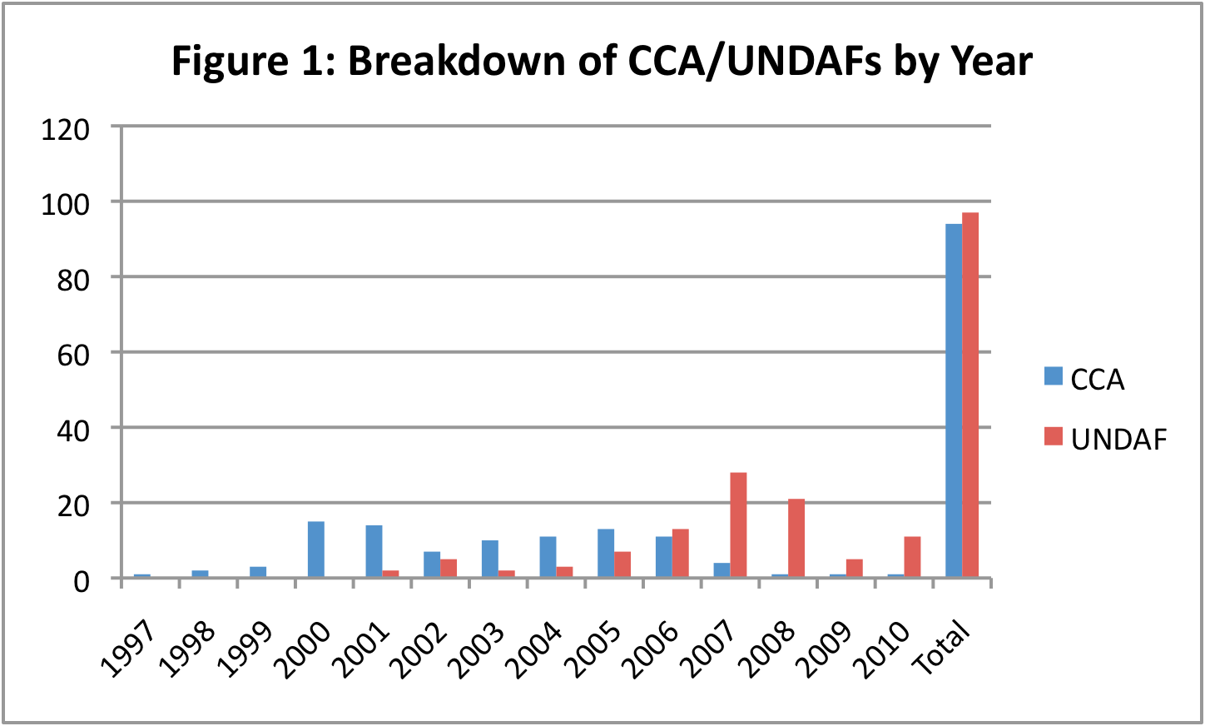
As is evident from Figure 1, most CCAs in the sample were produced between 2000 and 2006 (80 CCAs, or 87 per cent of the sample), and most UNDAFs in the sample were produced between 2005 and 2010 (85 UNDAFs, or 88 per cent of the sample). Figure 1 suggests that CCAs are increasingly not being completed, and that the main focus of the IASG should be on mainstreaming in UNDAFs.

As most of the CCAs reviewed were from an earlier period than the UNDAFs, a separate analysis was carried out by type of reference in CCAs and UNDAFs. This is illustrated in Figures 2 and 3. Ninety five per cent of CCAs and 81 per cent of UNDAFs included some reference to disability issues. This can be considered a solid starting point for improved mainstreaming.

There were a higher number of individual references to disability issues in the CCAs, about 67 per cent more. This suggests that analysis in CCAs is often not translated into the UNDAF. In a higher percentage of CCAs disability issues are included as a stand alone in the text – 34 per cent, as opposed to 10 per cent in the UNDAFs. Sixty six per cent of UNDAFs include references to persons with disabilities as one of a number of “vulnerable” groups, which can be considered only partial mainstreaming. Only 10 per cent of UNDAFs include disability issues as a stand alone in the text, and a further 5 per cent include disability issues as a stand alone in results statements and indicators. The last figure, and the regional breakdown below, suggests there is specific, but relatively limited, programming on disability issues taking place across UNCTs. This means that where disability issues are identified in the CCA, or in the preamble in the UNDAF, this is usually not translating into programming. This finding is corroborated by the lack of joint programmes – only one joint programme was identified, in Asia. The specifics of programming are discussed in more detail below.

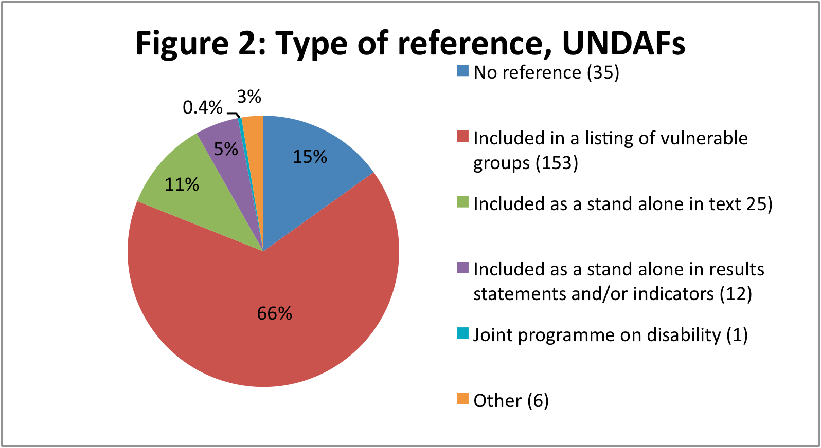

Note: figures in parentheses refer to the number of references

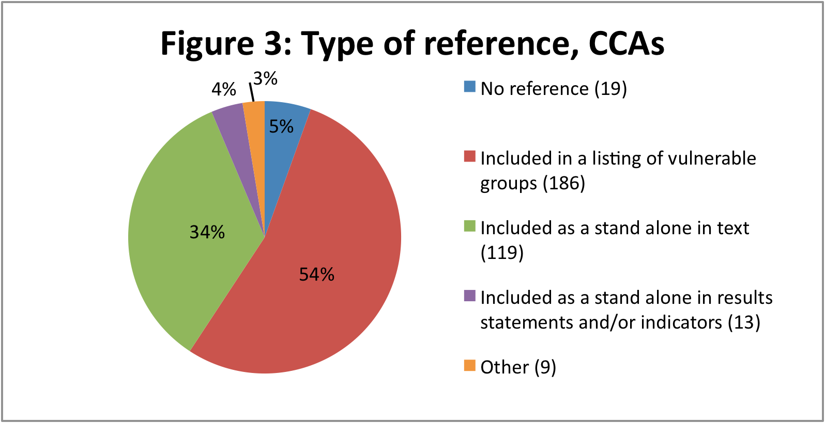

Note: figures in parentheses refer to the number of references

2.2 Regional breakdown of reflection of disability issues in CCA/UNDAFs
Table 1 presents a breakdown of type of reference by region. The Table illustrates that there are similar trends across the regions. The majority of references in all regions are to disabled persons being included in a listing with other “vulnerable” groups. Stand-alone references are the second most numerous.

Table 1: References to disability issues in CCA/UNDAFs by region (0-5 = %)
 | #UNDAF | #CCA | 0 (%) | 1 (%) | 2 (%) | 3 (%) | 4 (%) | 5 (%) | # refs  1-5
Africa | 28 | 27 | 15 | 61 | 19 | 3 | 0 | 2 | 112
Arab States | 9 | 9 | 21 | 52 | 22 | 3 | 0 | 5 | 33
Asia | 21 | 18 | 9 | 64 | 21 | 1 | 1 | 4 | 78
Europe | 16 | 21 | 2 | 61 | 29 | 6 | 0 | 2 | 204
LAC | 23 | 20 | 15 | 52 | 25 | 6 | 0 | 2 | 93
0 = no reference; 1 = disability included in a listing of vulnerable groups e.g. (women, children); 2 = disability included as a stand alone in text; 3 = disability included as a stand alone in results statements and/or indicators; 4 = joint programme on disability; 5 = other

Greater attention to disability issues in Europe and the CIS countries stands out, both in terms of almost all CCA/UNDAFs making some reference to disability issues, and the number of references per CCA/UNDAF. Otherwise, there are few differences between the other four regions, suggesting that there are generic patterns at work constraining mainstreaming of disability issues. Dividing the total number of references by the number of CCA/UNDAFs gives the following:

Africa: 2
Arab States: 1.8
Asia: 2
Europe and CIS: 5.5
LAC: 2.2

There was an overlap between the analysis in the CCA and the UNDAF vis-à-vis disability issues in 13 countries (Botswana, Ghana, Liberia, Lebanon, Bangladesh, China, Lao PDR, Nepal, Thailand, Moldova, Mexico and Nicaragua). In two of these countries (Ghana and Nepal) the UNDAF referred directly back to the CCA. In the majority of cases there was no connection between the CCA and UNDAF for a particular country in terms of disability issues.

2.3 Trends over time
With the adoption of the CPRD in December 2006 and its coming into force in May 2008, increased references to disability issues in the CCA/UNDAF would be expected. Also, with the UN’s move to “Delivering as One” it would have been expected that there would have been more joint work at country level on disability issues. Neither of these trends is evident in the CCAs and UNDAFs reviewed. Figure 4 presents time trends for type of reference for all regions.

Figure 4: Time trends for type of reference for all regions (adjusted by number of reports per year)
Figure 4 illustrates that the number of CCA/UNDAFs with reference to disability issues has remained fairly constant over the last decade, with the highest point being before the adoption of the CRPD, in 2002-2004. This is because this is the period where references in CCAs were most common. References to disability issues as a stand alone in the text and results statements and indicators has also decreased over time, which suggests there is less mainstreaming taking place than before the CRPD; and there has been no increase in the number of joint programmes.

2.4 Resident Coordinator reports
One hundred and nineteen Resident Coordinator (RC) reports from 2005 and 120 from 2008 (the latest year posted on the DOCO website) were reviewed to determine the extent to which they reflected disability issues, and also to determine if there had been any significant changes between the two years (i.e. the “pre” and “post” CRPD periods). The review was carried out using the same typology of type of work and type of reference as for the CCA/UNDAFs. While the RC reports are built on the UNDAF, some planned UNDAF activities are not carried out, so the RC reports are a more accurate picture of outputs achieved.

Figure 5 illustrates the time trends in references to disability issues between 2005 and 2008 (the numbers to the left of the chart are numbers of references).

The figure reveals that there has been an increase in references to disability issues, if from a modest start. In 2005 there were 23 references. The increase is from one reference about every six reports to one reference every 2.4 reports. The kinds of references were similar between the two years, with the majority being as a stand alone in results statements and indicators. The content of these references is discussed further below in Section 3.

Since 2004 a review of RC reports has been carried out from a gender equality perspective. Findings from the gender equality synthesis are subsequently reflected in the overall synthesis of RC Annual Reports, where there is a dedicated section on gender equality. The review of 2008 RC reports included assessment against six criteria which mainly focus on UNCT internal processes:

- GE (gender equality) in UNDAF framework
- GE in national development processes
- GE capacity building of staff
- Existence of joint initiatives
- Existence of gender theme groups
- GE in UNCT workplan outcomes

A review is also carried out of UNCT initiatives on gender equality by area of support (see below), similar to the review of type of work in CCA/UNDAFs in this baseline. The criteria used in the gender equality synthesis review are: sex-disaggregated data; education; HIV/AIDS; CEDAW/Beijing Platform; national women’s machinery; reproductive health and maternal mortality; and violence against women. A similar section on the rights of persons with disabilities in the overall synthesis of RC Annual Reports could be included.

Figure 5a below sets out the breakdown of references in the RC Annual Reports by type of work.

Figure 5a: Time trends in RC Annual Reports by type of work

Based on this baseline report, the IASG should consider preparing a similar report on disability issues as part of the synthesising of RC Annual Reports. Similar criteria might be used; however, currently almost all of the references disability issues in RC Annual Reports are to types of work carried out, rather than to internal UNCT processes related to disability issues, so the only one of the six criteria from gender equality reporting in the six bullet points above which is evident in relation to reporting on disability issues relates to national development processes.

2.5 MDG reports
As noted, the IASG undertook a review of 80 MDG reports published between 2003 and 2009, for reflection of disability issues, which was reported on by the Secretary-General in 2009. The findings from the review of CCA/UNDAFs and RC reports are similar to those in the IASG review of MDGs. The latter found (p. 2):

…disability is largely invisible in the implementation, monitoring and evaluation of the Millennium Development Goals. …. periodic reviews of the Millennium Development Goals that are under way within the United Nations do not include reference to disability issues or persons with disabilities.

A total of 42 [MDG] reports (52 per cent) made some reference to disability or persons with disabilities. These references included causes of disability, issues of concerns or challenges, and initiatives. Of those 42 reports, 16 included a reference to one or more initiatives specifically directed towards persons with disabilities. Twenty-eight reports mentioned disability in reference to “vulnerable” or “marginalized” groups or population “in need of special attention”. …. Other references were more specific to disability and persons with disabilities. None of the references provided detailed information nor elaborated on the issues or programmes concerned.

Most references to disability were related to social protection and safety nets (Goal 1), and education (Goal 2). Two reports contained data which show that the participation of persons with disabilities in gainful employment is very low. When they work, persons with disabilities receive remuneration that is significantly lower than that of non-disabled workers and in very few instances are work conditions adapted to the needs of persons with disabilities.

A breakdown of references to disability using the typologies used for CCA/UNDAFs and RC reports is shown in Figure 6. The figure shows that, in comparison to CCA/UNDAFs, there is a higher level of lack of reference to persons with disabilities in the MDG reports. The highest percentage is again to persons with disabilities included in a listing of vulnerable groups. However, there is a higher percentage of references to disability issues as a stand alone in the text than for UNDAFs.

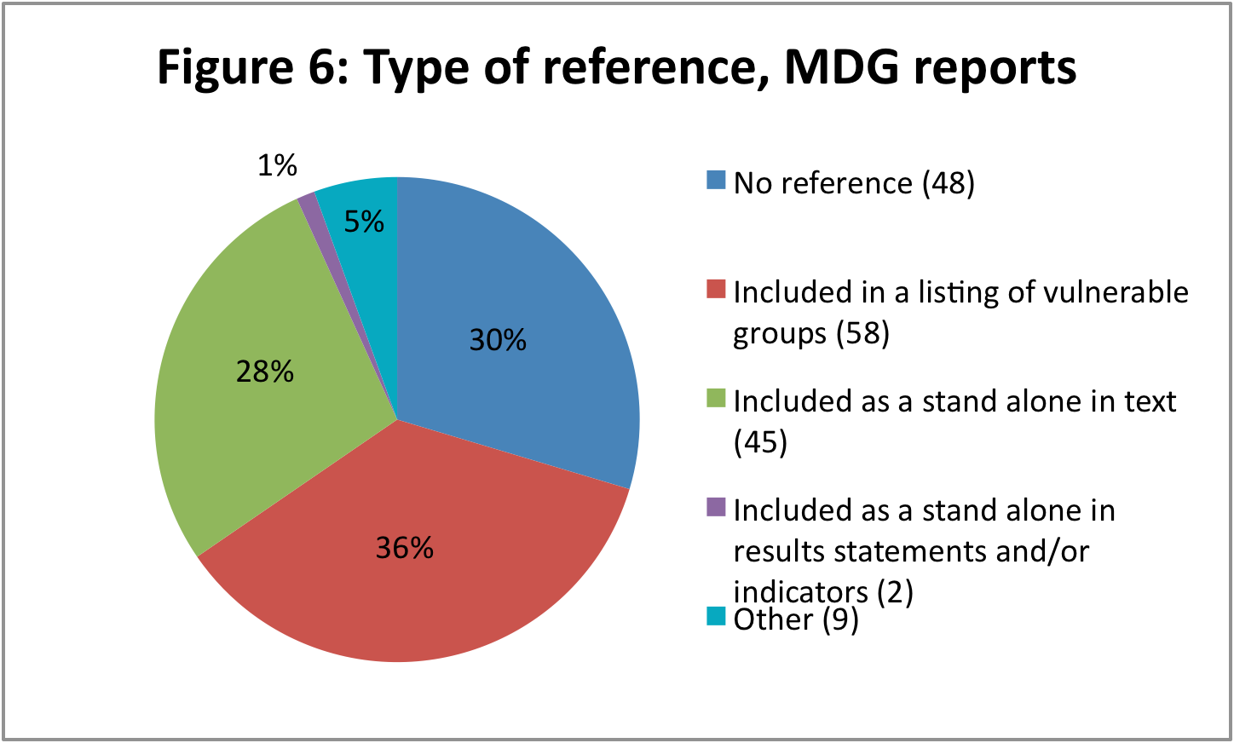

Overall it can be concluded that for all key UN country level planning and reporting documents the main form of “mainstreaming” of disability issues at present is through including persons with disabilities in a listing of vulnerable groups. The challenge is to promote a greater depth of mainstreaming and more programming on persons with disabilities.

3. Reflection of disability issues in key UNCT strategic planning documents: qualitative analysis

3.1 Ways of mainstreaming disability issues in CCA/UNDAFs
As noted, the main reference to persons with disabilities is in an undifferentiated format, that is as part of a list of vulnerable groups. This makes it difficult to ascertain any specifics concerning persons with disabilities. A qualitative review of the language used in the CCA/UNDAFs, for CCA/UNDAFs where there is more substantive mainstreaming of disability issues than as a list of vulnerable groups, suggests that there are four main ways of mainstreaming disability issues:

A. Persons with disabilities mainly as victims, e.g. the Guinea Bissau CCA from 2006

People with disabilities do not enjoy any protection or special assistance. They represent a heavy burden on their families and suffer tacit or open neglect or abuse that may be accepted and supported by family and society in general. The disabled are often seen as the consequence of a curse and nobody, not even the authorities, attends to them. Thus, there are no specialized training institutions for the disabled, except a private school for the blind. The financial resources to assist people with disabilities to integrate are insufficient. The war disabled, especially those of the conflict of 1998-99, have not always had the assistance needed to treat their disabilities.

B. Description and data. The CCA/UNDAFs provide the number of persons with disabilities or sub-groups. For example, the Ghana CCA from 2004:

An estimated two million persons live with disabilities in Ghana. According to the 2000 National Disability Project Document prepared by the Ministry of Manpower Development and Employment (MMDE), the major forms of disabilities are disability in seeing and moving (63%), learning, and hearing/speaking. The Volta, Western, Central, and Greater Accra regions record the highest rates of disability, ranging between 18% and 22%. More females (15.2%) live with disabilities than males (13.4%).

C. Rights based approaches, for example the Liberia CCA from 2006:

The disabled often find themselves excluded from positions of political or economic influence, making it so much more difficult to address such disparities through effective policy interventions.

And the Bangladesh CCA from 2005:

Children with disabilities face multiple difficulties in accessing the fundamental rights guaranteed under the law. National policy regarding the disabled appears to be almost entirely adult-oriented. There is no formal definition of childhood (or adult disability) in Bangladesh. The rights of the disabled are not ensured by the Constitution, and there is no legislation to ensure the rights of disabled children.

D. References dealing with the CRPD or national level legislation, for example the Lebanon CCA from 2007:

Lebanon has not yet signed or ratified the Convention on the Rights of Persons with Disabilities and its Optional Protocol which provide important guidelines and principles for the protection of persons with disabilities and the full exercise of their rights. Law 220/2000 on persons with special needs has a number of important provisions, but has yet to be comprehensively implemented on the ground, due in part to the lack of sufficient allocation within the public budget to meet the financial requirements for this implementation.

Lebanese laws have not yet mainstreamed the needs of persons with disabilities, a crucial requirement if persons with special needs are to fully enjoy their human rights, and financial resources are not allocated for adequate implementation.

Figure 7 illustrates the breakdown of mainstreaming activities by the four types of reference, after the 63 references in the CCA/UNDAFs that do not fit into any of these categories have been removed. As can be seen from the figure, the most common reference was to persons with disabilities as victims. However, rights based references and references to supporting the CPRD or national legislation together made up 43% of references. References to national level legislation made up 16 per cent, and to supporting the CPRD three per cent.

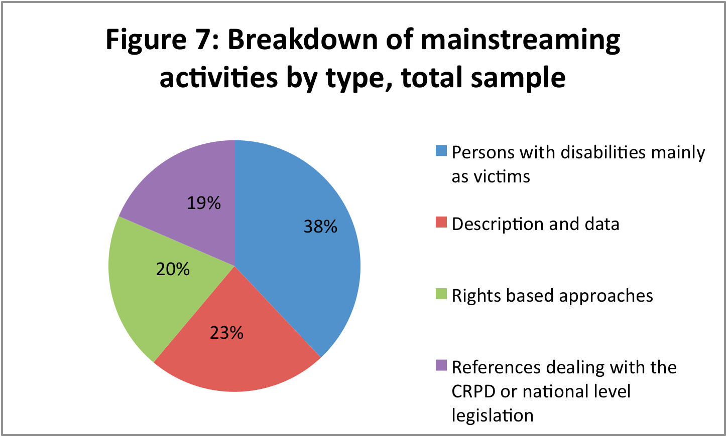

3.2 Specific programming on disability issues in CCA/UNDAFs
An analysis was carried out of the type of work references in CCAs and UNDAFs using the typology outlined above. An overview for all reports is provided in Figure 8.

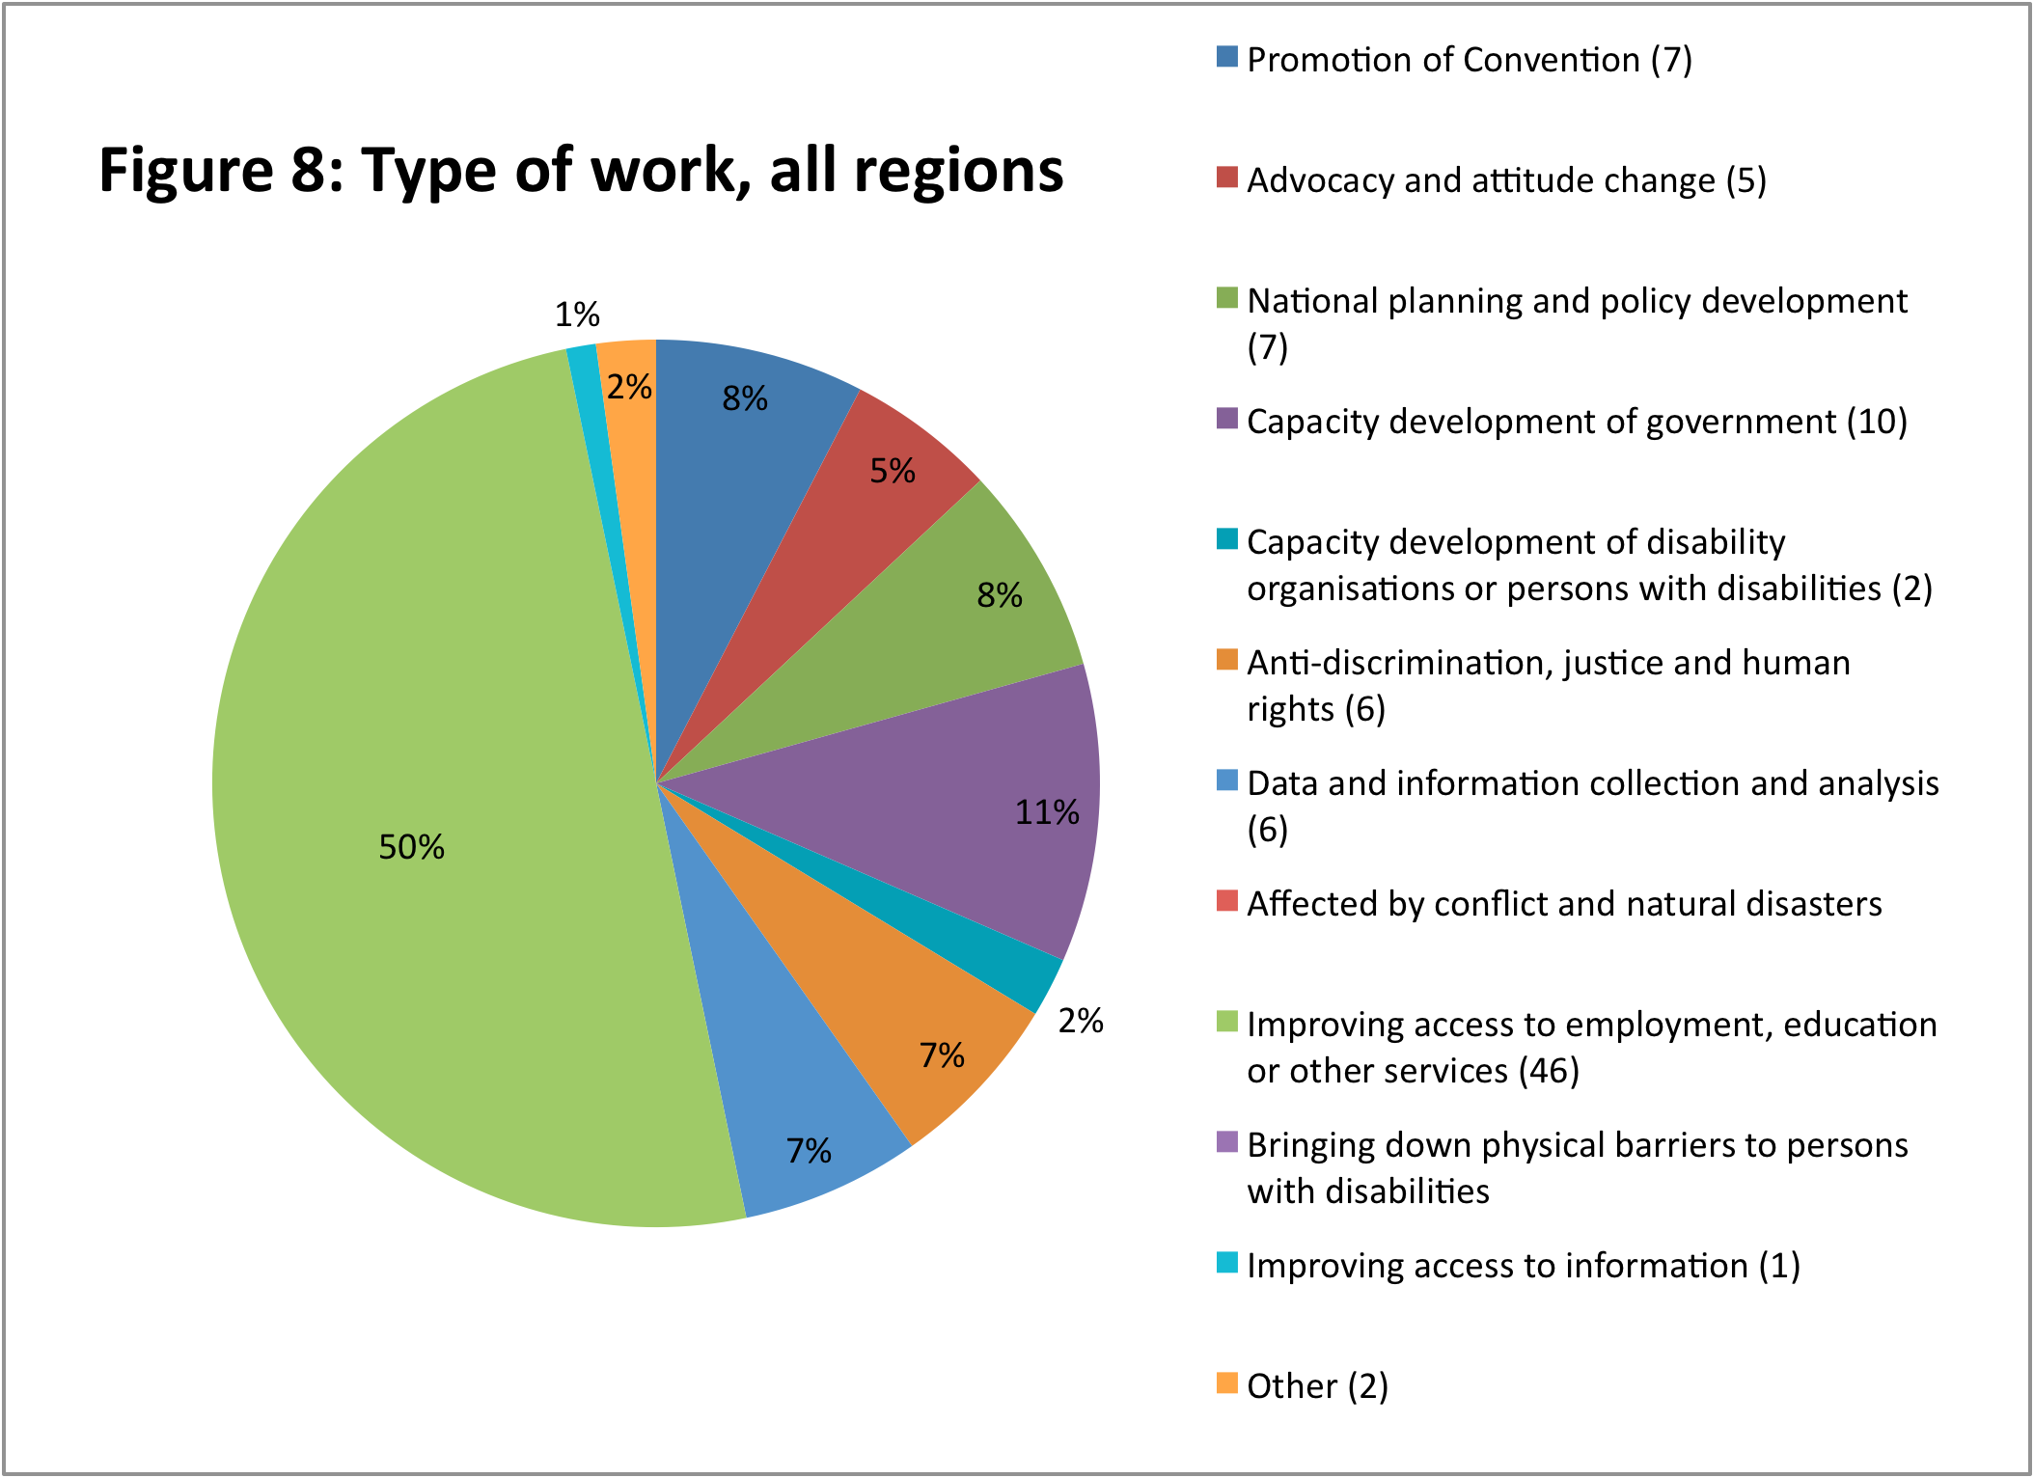
Ninety two references to actual activities to be carried out and results to be achieved were found in the CCAs and UNDAFs reviewed. Of these, 49 per cent related to improving access to employment, education and other services. Capacity development of government made up a further 11 per cent of work, and capacity development of disability organisations or persons with disabilities 2 per cent. Given the capacity development mandate of the UN, it might have been expected that there would have been greater attention to capacity development interventions. Only twelve such interventions were found in the CCAs and UNDAFs reviewed. Attention to promotion of the CPRD was also fairly limited, with 7 references found, or 8 per cent of the total.

A more in-depth analysis of “Improving access to employment, education or other services” reveals that access to education is the main focus of the majority of UNCTs – full details are given in Table 2:

Table 2: Improving access to employment, education or other services: country breakdown

Type of work | Countries involved
Education | Ghana, Tanzania, Lao PDR, Maldives, Georgia, Macedonia, Moldova, Romania, Serbia and Montenegro, Tajikistan, Uzbekistan, Brazil, Jamaica
Social protection | Sri Lanka, Georgia, Kazakhstan, Romania, Serbia and Montenegro, Tajikistan, Uzbekistan, Jamaica, Nicaragua
Employment | Benin, Malawi, Lao PDR, Mongolia, Moldova, Uzbekistan, Brazil, Mexico
Health care | Armenia, Brazil, Jamaica
Nutrition | Bangladesh, Armenia
Access to land | Gabon
Housing/shelter | Jamaica

Some areas are represented more than others, particularly education, social protection and employment, while others have a limited number of UNCTs focusing on them, such as health care and housing/shelter. In terms of capacity development, CCA/UNDAFs were quite general, noting for example “develop capacity of government to collect and analyse disability statistics”, and no particular trends could be found. The question arises as to whether the focus on three main areas is excluding other areas of work that may be more appropriate for UNCTs.

The Secretary-General’s report of 2009 on the MDGs notes similarly a focus on education (p. 14): “Initiatives mentioned in the reports are related to inclusive education, health care and rehabilitation, pensions and cash benefits. Examples of initiatives specific to persons with disabilities include: a disability survey in 2002 (Maldives, 2007); a registry of persons with disabilities (Chile, 2005); a Prevention Programme for Disabled Persons (Croatia, 2005); a Service of Personal Assistants to Persons with Disabilities programme (to encourage persons with disabilities to become active and to work) (Serbia, 2005); policy for persons with disabilities; incorporating disability reduction targets in the National Health-Care Policy (Liberia, 2004); taking steps towards inclusive education (Bahrain, 2007; Chile, 2005; Fiji, 2003; Kazakhstan, 2005; Kenya, 2005; Serbia, 2005; Thailand, 2008 and the United Republic of Tanzania, 2006); and a conference on the rights of persons with disabilities (Brazil, 2007). One report mentioned that the poverty reduction strategy emphasizes the urgent need to devote special attention to vulnerable populations, including persons with disabilities (Serbia, 2005).”

This baseline review attempted to extend the IASG’s earlier analysis by assessing whether the language used to discuss disability issues had changed from the pre-CRPD to the post-CRPD period. It did this by examining 19 MDG reports for countries which had an earlier or later report than the one included in the IASG’s sample. However, only two of these 19 reports (for Bhutan and Chile) included a reference to disability issues, so it was not possible to carry out this analysis.

3.3 Type of work over time
Figure 9 highlights trends over time for all references in CCA/UNDAFs to type of work for all regions.

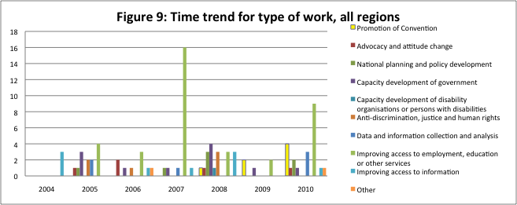
There is an upward trend in references to type of work over the period examined. For 2004-2006 (i.e. the pre-CRPD years) there were an average of 24 references in 19 CCA/UNDAFs . For 2007-2010 there were 64 references in 27 CCA/UNDAFs. As expected, there is an increase in focus on promotion of the CRPD since 2007,; adjusted for the number of reports references have almost doubled. However, there does not appear to have been an increased focus on human rights programming as a result of the CRPD.

A number of cases of good practice in mainstreaming disability in CCA/UNDAFs were found in this review, including the following cases from China and the Maldives, highlighted in Boxes 1 and 2.

Box 1: CCA Good practice - China

This CCA can be considered good practice because it:

- Sets out basic data on persons with disabilities and the consequences of this, including how disability interacts with gender discrimination;

- Focuses on national policy and standards and improving these;

- Takes a rights based approach noting the discrimination faced by persons with disabilities and focusing on their empowerment;

- Focuses on strengthening data collection

- Sets out the priority areas for international cooperation which should be picked up in an UNDAF, with a focus on capacity development of national institutions

- Includes a focus on international legislation (in this case promoting the development of the CRPD)

Relevant sections from the CCA are highlighted below:

Efforts have been made to develop ways to extend social insurance to rural migrant workers in some major localities, and China has adopted preferential policies to promote the employment of disabled people. But the removal of traditional safety nets and the rise in user fees for education, health care, childcare, and other social services have strained household economies, especially for the poorest and most vulnerable.

These changes have had a negative consequence on the situation of disabled persons, particularly the disabled poor and disabled children. There are around 60 million disabled people in China, mainly categorized as physically deformed, blind, deaf/dumbness, and mentally deficient. Disability restricts access to education and employment and tends to cause socio-economic exclusion. Among the disabled, the risks of becoming poor are higher than among others, and may lead households with disabled people into poverty. More than one-third of China's 30 million rural poor are disabled, and 60% of them are illiterate. Most demand for rehabilitation of the disabled are not easy to be satisfied and living conditions of disabled persons are far below the average level. This gap is likely widened further in the future. Primary education enrolment rate for blind children is comparatively low at 59%. Some girls with disabilities are doubly discriminated. Although much progress has been made in promoting the rights of disabled children, many continue to face deeply rooted discrimination and to have limited access to education, health, and other basic services.

It is imperative to address this special vulnerable group's needs so they can enjoy equitable access to the benefits of development. National support in this regard can be strengthened in a number of ways: by improving policies and legislation to establish a sound enabling environment; by strengthening the capacity of monitoring and evaluation through the establishment of monitoring systems, surveys, and assessments; by empowering the disabled to be active agents for development and social participation; and by mobilizing various social forces to support the disabled.

Although progress towards the protection and empowerment of the disabled has been made, several significant challenges remain. First, the current Law on Protecting Disabled Persons' Rights was promulgated in 1990. The NPC's Committee on Internal and Legal Affairs included the revision of this Law in the current Five-year legislation plan to ensure that the Law could better fit the new socio-economic situation in China. A more participatory consultation process could be adopted during the legislative revision process to solicit inputs from different sectors, both nationally and internationally. Second, to date there have been 12 different sets of standards reflecting degree of disability in China. Lack of coherence among these different standards hinders coordinated policymaking in various sectors to help disabled persons get equal access to employment, education, justice, and mainstreaming into the social life. It becomes an urgent task for the government to integrate the standards with international practices and to use these standards as a guideline for future policymaking and legislation.

Monitoring of disabled persons' situation in China is weak, however, particularly at the county and township levels. Strengthening local monitoring capacity through support in designing surveys, establishing indicators, and creating additional survey instruments is required for future policymaking.

Priority areas of international cooperation: Protection of vulnerable people: Developing a social risk management framework to protect vulnerable groups; enhancing the knowledge base in the area of child protection; revising the Disabled People's Right Protection Law; establishing integrated standards of disability; and enhancing monitoring and evaluation capacity for the disabled. Emphasis should be placed on capacity building for institutions responsible for the disabled, including training of rights-protection workers, social workers, mass organizations and volunteers, particularly in the western region to support the disabled persons' poverty reduction and mainstreaming into society.

China has joined other countries to push for a new international convention on the rights of people with disabilities under the auspices of the United Nations.

Box 2: UNDAF Good practice: The Maldives 2008-2012

The Maldives UNDAF includes in its results framework a measurable focus on persons with disabilities, and involves mainstreaming through Special Needs Education facilitators being available to all schools. The output is also included in the UNDAF monitoring and evaluation
plan. Details from the UNDAF are included below.

UNDAF Outcome |  | By 2010, the most vulnerable and marginalized sections of the society in the Maldives will enjoy better health status, improved access to quality education, enhanced social protection, income and employment opportunities.
Country Programme Outcomes | Country Programme Outputs |  | Key Partners  Internal External
2. All children aged three to sixteen and every child attending school have improved access to quality education and universal primary education enrolment is sustained. | 2.1 Children aged three to twelve with special needs have access to schools that progressively meet their needs and have Special Needs Education facilitators available to all schools. |  | MOE, MHEESS, CSO, MOH, MOGF | UNICEF,  UNESCO,  WHO

4. Challenges to mainstreaming disability perspectives
4.1 Data relevant to building the evidence base for social and economic arguments for promoting disability rights
The 2010 Secretary-General’s Report on the MDGs and Persons with Disabilities noted:

Data on disability are still a challenge for global monitoring because global figures on persons with disabilities are not yet readily available and baseline data for many development issues are scarce or non-existent. Despite progress made, the paucity of data on disability as well as a wide variance of definitions, standards and methodologies used to identify the conditions of persons with and without disabilities remain an obstacle to the effective formulation of disability-inclusive policies and programmes as well as in the monitoring and evaluation of progress in MDGs. … There is an urgent need for improved statistical data concerning the situation of persons with disabilities in crisis to develop benchmarks for including disability in the crisis-related responses and also to ensure equalization of distribution of the benefits produced by increased attention to food/energy security and related pro-poor policies.

Thirteen CCAs and two UNDAFs included data on persons with disabilities, as set out in Table 3. Data on persons with disabilities is not therefore prevalent in CCA/UNDAFs, with some 8 per cent of the sample including reference to this. Figures in the Table vary quite widely. For example, the Egypt CCA of 2005 noted 0.42 percent of the population as having a disability, the Angola CCA of 2002 found that 1.3 per cent of children aged 0-17 have some form of disability, whereas the Bangladesh CCA of 2005 came up with a figure of approximately 14 per cent. Some of the CCA/UNDAFs provide an absolute figure for persons with disabilities, rather than as a percentage of the total population. Different definitions, survey techniques, and time periods are likely to account for some of the variance in these findings.

As consistency in data collection increases with time, one requirement in the CCA/UNDAF Guidelines could be to include data on persons with disabilities – for example, the estimated numbers of persons with disabilities, broken down by sex. UNCTs can consider supporting the capacity of national partners in collection and analysis of data on persons with disabilities. This could be through ongoing support to the Census Office or equivalent to ensure consistency with international data norms, and as part of work on tracking the MDGs. Data on persons with disabilities should also be integrated into existing monitoring and evaluation frameworks for the MDGs and other internationally agreed development goals.

Table 3: Data on persons with disabilities from CCA/UNDAFs
UNDAF | Findings
Angola CCA 2002 | The 1996 MICS found that 1.3% of children aged 0-17 have some form of disability. Paralysis of the limbs is the most common form of disability (34% of cases), followed by problems of deafness and dumbness (16%). Disabilities result from illness in 42% of cases (including polio, a cause of paralysis), from congenital causes (29% of cases), and from war, landmines and other accidents (together accounting for 23% of cases).
Eritrea CCA 2001 | A 1992 study identified approximately 42,000 disabled people of whom 6,900 were children. Of the children, 1,500 were blind, 1,700 deaf, 1,400 were amputees, 1,400 were lame crippled or otherwise deformed and 500 were mentally retarded.
Ghana CCA 2004 | An estimated two million persons live with disabilities in Ghana. According to the 2000 National Disability Project Document prepared by the Ministry of Manpower Development and Employment (MMDE), the major forms of disabilities are disability in seeing and moving (63%), learning, and hearing/speaking. The Volta, Western, Central, and Greater Accra regions record the highest rates of disability, ranging between 18% and 22%. More females (15.2%) live with disabilities than males (13.4%).
Liberia CCA 2006 | It is difficult to attach exact figures to the number of people in Liberia living with disabilities – although a recent survey shows 14 per cent of rural households in Nimba County living with a chronically ill or disabled person (9 per cent rural average).
Tanzania UNDAF 2007-2010 | There is a marked difference in years of schooling between disabled and non-disabled children. At the age of 17, children with disabilities have missed 4 years of primary education compared to 1.7 years among children without disabilities
Egypt CCA 2005 | In 1996 the number of people living with disabilities was 284,188, or 0.42% of the population; this figure includes people with mental disabilities. About 22% of people with disabilities in Egypt are under 15 years, thus specialized childcare and educational institutions are of major importance. Children with physical and mental disabilities experience significant problems in schooling, and the 2000 Demographic and Health Survey indicated that of 60,000 children, only 5% were enrolled in primary education.
Lebanon CCA 2007 | In 2006, the labor force of the persons with disabilities was estimated at about 27,000, but only 7,052 were actually working.  Disability is an emerging health concern in Lebanon. The prevalence of disability among the general population is estimated at 4.3 percent, with around 1.8 percent suffering from severe disabilities. The number of persons with disabilities in Lebanon has significantly increased because of war, and also other reasons, such as road traffic accidents and genetic disorders as a result of inter-marriage among relatives, which contribute to childhood disability. Around 15 percent of the injured during the July 2006 war will be permanently persons with disabilities.
Afghanistan CCA 2004 | People with disabilities are currently estimated to comprise from nearly 3 to 5 percent of the Afghan population, although the actual figures are likely to be much higher.
Bangladesh CCA 2005 | According to the National Forum of Organisations Working With the Disabled, approximately 14 percent of the country's population has some form of disability.  The rate of disability is higher in boys than in girls. According to the Health and Demographic Survey (2000) conducted by the Bureau of Statistics, 7.38 males per 1000 population were found to have disabilities compared to 4.66 per 1000 for females with disabilities. In the absence of reliable data on the number of children with disabilities, it is guesstimated that nearly 340,000 children suffer from some form of disability.
Cambodia CCA 1998 | Another vulnerable group in the labour market is the disabled workers. While Cambodians with disabilities are estimated to make up 2.2 percent or 203,000 of the total population, there is no data indicating how many of these that are part of the labour force or unemployed
China CCA 2004 | People with disabilities and minority people tend to be over-represented among the rural poor in [the remote up-land areas of Western China].  There are around 60 million disabled people in China, mainly categorized as physically deformed, blind, deaf/dumbness, and mentally deficient. More than one-third of China's 30 million rural poor are disabled, and 60% of them are illiterate. Primary education enrolment rate for blind children is comparatively low at 59%. Some girls with disabilities are doubly discriminated.
Nepal CCA 2007 | Although an estimated 10% of Nepalis live with some form of disability, less than 4% of all people with disabilities have access to any form of rehabilitation services.
Thailand CCA 2005 | Another group likely to be poor are persons with disabilities. According to a survey by the National Statistical Office in 2001, the majority lived in the rural areas and had little or no education; fewer than half were employed and they usually earned significantly less than other employees. Registered persons with disabilities, who constitute around one-third of the total, are entitled to State assistance. Those who cannot work receive 500 baht per month.  Low enrolment of children with disabilities – According to a 2001 survey by the Public Health Research Institute, around 6 million people in Thailand have a disability – 10% of the population – with a slightly higher proportion in the North-east and the North. Estimates of the proportion of disabled children attending school range from 10% to 23%.
Moldova CCA 2006 | The Ministry of Education, Youth and Sport estimates that about 16,000 children of school age have disabilities or impairments of different kinds. The majority of these children do not attend school whilst an estimated 5,000 are enrolled in special residential schools. In 2004, there were 146,000 adults with disabilities and of these only 14% were working. There are 16 300 people with disabilities between the ages of 16 and 30
Panama UNDAF 2007-2011 | According to the 2000 Population Census, the total number of people with disabilities amounts to 52.197, of which 56% are men and 44% female. Similarly, of the total of 10,672 children registered disabled, 56% are boys and 44% girls. The types of disabilities reported are blindness, deafness, mental retardation, cerebral palsy, physical disabilities and other unspecified.

4.2 Breakdown of challenges to mainstreaming disability perspectives
The Secretary-General’s report on mainstreaming of disabilities within MDG reports found:

Most references to disability were related to social protection and safety nets (Goal 1), and education (Goal 2). Two reports contained data which show that the participation of persons with disabilities in gainful employment is very low….Although the problems of unemployment and unequal pay are prevalent throughout the world, the lack of reference to these issues in other country reports could be a reflection of the generally low priority given to the employment of persons with disabilities.

In the area of education, issues and challenges include access to adequate education for persons with sensory, physical and developmental disabilities; weak identification and assessment mechanisms of children with disabilities to ensure adequate education; and difficulty and high cost of providing primary education to those with disabilities in geographically dispersed areas.

One reference to gender perspectives (Goal 3) was made in relation to women as caregivers of persons with disabilities, while another report stressed the need to understand how gender equality was affected by different factors, such as disability. The only initiative mentioned specific to women with disabilities was a one-time financial assistance for women with disabilities.

References to access to obstetric, prenatal and post-natal care for women and children (Goals 4 and 5) were made only in the context of how the lack of adequate access is a cause of disability, but no reference was made to access to this care by women and children with disabilities….

One report made reference to the vulnerability of persons with disabilities to the effects of HIV/AIDS (Goal 6), owing, perhaps, to the lack of preventive education, given the presumptions made about the absence of sexual activity among persons with disabilities, or to the lack of accessibility to information and adequate services and treatment. Another report mentioned the impact of environmental degradation on persons with disabilities (Goal 7), as it adds additional barriers and difficulties to their everyday living situation.

There were similar findings from the CCA/UNDAFs reviewed for this baseline. The CCA/UNDAFs include a significant amount of qualitative information on constraints to fulfilment of the rights of persons with disabilities. Table 4 presents this information by country from 16 CCAs which included substantive information on constraints to mainstreaming (there were no UNDAFs found which included such information). A summary of focus areas from the CCA/UNDAFs is as follows:

- lack of adequate government policy and/or standards to promote the rights of persons with disabilities (Liberia, Lebanon, China, Moldova)

- limited provision of relevant services and inadequate allocation of financial resources (Malawi, Guinea-Bissau, Egypt, Mongolia, Kazakhstan, Moldova)

- lack of access to or exclusion from services (Ghana, Liberia, Egypt, Lebanon, Afghanistan, China, Lao PDR, Mongolia, Nepal, Bosnia and Herzegovina, Moldova)

- lack of access to rights (Bangladesh, Lebanon, Bolivia)

- social discrimination and discrimination within the family (Guinea-Bissau, Lebanon, Bangladesh, China, Mongolia, Nepal, Kazakhstan, Moldova)

- high levels of unemployment of persons with disabilities (Lebanon, Afghanistan)

- links between disability and poverty (China, Lao PDR, Bosnia and Herzegovina)

- role played by civil society in providing services (Moldova, Egypt, Lebanon, Nepal)

As can be seen from the points above, there were no issues that were specific to any one region, rather the issues cut across all geographical boundaries. There were several gaps in the CCAs. Firstly, there is limited attention to capacity gaps and strengthening the capacity of Member States, civil society and the UN system. Only the China CCA referred to this: “Strengthening local monitoring capacity through support in designing surveys, establishing indicators, and creating additional survey instruments is required for future policymaking.” One would expect to see a greater emphasis on capacity development in the future, in particular given the focus of this in the IASG draft Guidance Note on mainstreaming the rights of persons with disabilities. Secondly, there was limited information concerning the intersection of disability and gender issues - corroborated by the Secretary-General’s Report quoted above. Thirdly there was little information on the rural or urban implications of disability.

The majority of references in the CCAs related to lack of access to services, in particular education. Discrimination, including within the family, is another key theme. Because of this strong focus on the exclusion of persons with disabilities from the mainstream, there is a subsequent recognition of the need to be more inclusive in terms of mainstreaming. For example the Moldova CCA notes: “In the last years attempts have been made to integrate children with special education needs into the general educational system. However, directors and teachers in ordinary schools are reluctant to accept children with disabilities and have received no training on how to teach them.” Similarly the Mongolia CCA comments: “Disabled children are often kept out of the educational mainstream both by their parents and an educational system which has not been able to realise a greater degree of inclusiveness. This discrimination early in life carries on into adult years where access to employment and active participation in social affairs is hampered.”

Table 4: Evidence on persons with disabilities from the CCAs reviewed
CCA | Evidence on persons with disabilities
Ghana 2004 | Generally, people with disabilities (PWD) have limited access to basic social services and essential specialized care.  Provision of special services is also very limited in scope. For example, just 3,362 children with disabilities (less than 2% of the affected population) were provided with such special services in 2003. Only 10% of visually impaired children received assistance through special needs institutions.
Guinea-Bissau 2006 | People with disabilities do not enjoy any protection or special assistance. They represent a heavy burden on their families and suffer tacit or open neglect or abuse that may be accepted and supported by family and society in general. The disabled are often seen as the consequence of a curse and nobody, not even the authorities, attends to them. Thus, there are no specialized training institutions for the disabled, except a private school for the blind. The financial resources to assist people with disabilities to integrate are insufficient. The war disabled, especially those of the conflict of 1998-99, have not always had the assistance needed to treat their disabilities.
Liberia 2006 | The challenge of people living with disabilities has yet to be adequately addressed by the Government. This will require specific attention to issues of access as well as appropriate policies to promote inclusion.
Malawi 2001 | In the area of primary education, the following key issues need to be addressed: inadequate provisions for special needs education
Egypt 2005 | The health care system in Egypt is not geared to the early detection of physical and mental disabilities, and families looking after someone living with a disability face difficulties in getting appropriate health services, particularly in rural areas.  Though the civil society response to people living with disabilities is weak, there are a number of NGOs which have several programs targeting children with special needs, such as the Coptic Evangelical Organization for Social Services, Caritas Egypt, the Integrated Care Association as well as the Red Crescent Association. In all these respects there is a need to create mechanisms for monitoring the quality assurance of all care institutions, especially those that serve children with disabilities.
Lebanon 2007 | Lebanese laws have not yet mainstreamed the needs of persons with disabilities, a crucial requirement if persons with special needs are to fully enjoy their human rights, and financial resources are not allocated for adequate implementation. For example, persons with disabilities usually have difficulties accessing many public and private institutions, including schools. Educational institutions at all levels are not equipped with special curricula, tools and human resources to address the needs of students with disabilities. No support or referral systems exist to facilitate the job search for this category. The electoral law does not recognize the need for equipping polling stations for the persons with disabilities. Discrimination in treatment and access to resources, and abuse are practices that infringe on the rights of the persons with disabilities. In addition to the Ministry of Social Affairs, it is dedicated NGOs that usually follow up on the needs and rights of the persons with disabilities.  Employment objectives for the persons with disabilities have not yet been reached. According to Law 220/2000, employers in both the private and public sectors should recruit persons with disabilities at the rate of 3 percent of the total number of their employees. In 2006, the labor force of the persons with disabilities was estimated at about 27,000,but only 7,052 were actually working. This is mainly due to limited access to education and vocational training, limited appropriate physical infrastructure in the workplace, and non-implementation of relevant legislation. Employers’ attitude and the rules of the market vis-à-vis qualifications of the labour force also hinder the employment of this group.  In 2004, half of the persons with disabilities reported not having received any health care in the previous year despite the establishment of a special program for medical and social assistance to the persons with disabilities at the Ministry of Social Affairs.
Afghanistan 2004 | Because more than 8 to 10 people with disabilities are unemployed, most rely on the beneficence of their families; few opportunities exist for training or retraining for employment. Children with disabilities are subject to severe inequities and have limited access to educational opportunities.
Bangladesh 2005 | The law provides for equal treatment and freedom from discrimination for persons with disabilities; however, in practice, persons with disabilities face social and economic discrimination. The Bangladesh Persons with Disability Welfare Act provides for equal rights for disabled persons. The Act focuses on prevention of disability, treatment, education, rehabilitation and employment, transport accessibility and advocacy for the disabled.  According to the National Forum of Organisations Working With the Disabled, approximately 14 percent of the country's population has some form of disability. The economic condition of most families limits their ability to assist with the special needs of the disabled, and superstition and fear of persons with disabilities sometimes results in their isolation. Government facilities for treating persons with mental handicaps are inadequate. A few private initiatives exist in the areas of medical and  vocational rehabilitation, as well as employment of persons with disabilities.  Children with disabilities face multiple difficulties in accessing the fundamental rights guaranteed under the law. National policy regarding the disabled appears to be almost entirely adult-oriented. There is no formal definition of childhood (or adult disability) in Bangladesh. The rights of the disabled are not ensured by the Constitution, and there is no legislation to ensure the rights of disabled children.
China 2004 | Disability restricts access to education and employment and tends to cause socio-economic exclusion. Among the disabled, the risks of becoming poor are higher than among others, and may lead households with disabled people into poverty.  Although much progress has been made in promoting the rights of disabled children, many continue to face deeply rooted discrimination and to have limited access to education, health, and other basic services.
Lao PDR (no year) | In addition, children with disabilities are often denied access to education, trapping them in a cycle of poverty and disadvantage.
Mongolia 2001 | People with disabilities are particularly vulnerable in the labour market and in access to services. Disabled children are often kept out of the educational mainstream both by their parents and an educational system which has not been able to realise a greater degree of inclusiveness. This discrimination early in life carries on into adult years where access to employment and active participation in social affairs is hampered.  Children with disabilities are similarly lacking adequate learning opportunities. Statistics in this area vary widely and none are reliable. A new policy in 1998 started the implementation of integrated training of disabled children in regular schools. While this policy has only been implemented in certain areas the number of special schools have already been reduced from 14 to 5 since 1990, leaving a number of disabled children without access to basic education.
Nepal 2007 | Although an estimated 10% of Nepalis live with some form of disability, less than 4% of all people with disabilities have access to any form of rehabilitation services. Although there are government and non-government institutions mandated to assist them, and legislation is in place to protect their rights to transportation, employment, education and other state services, interventions have been inadequate and have only had limited coverage. People with disabilities are subjected to discrimination; the predominant Hindu belief being that disability is a punishment for sins committed in a past life.
Bosnia and Herzegovina 2008 | Persons with disabilities, who face significant vulnerability to poverty as well as high levels of exclusion from education and health services.  Despite efforts to improve the status of persons with disabilities the indicators on educational attendance, access to employment and adequate social services remain low.
Kazakhstan 2003 | The “defectology” model – a legacy from Soviet times – prevails in the treatment of children with disabilities. This model considers disability as an "illness" to be "cured" and sees institutionalisation for life as the only option for children with a permanent disability. The “defect” assessment process is not very transparent, and even emotional problems or minor speech impediments may be considered 'defects'. There is no particular effort to undertake an assessment of a child’s capacities.  Boarding establishments cater for children with sight, hearing, or speech defects. Children with other physical disabilities are integrated into mainstream education, unless the disability involves a lack of mobility, in which case the children remain at home with little support from the state. The absence of alternatives to institutional care compounds the problems faced by parents in caring for their disabled children.
Moldova 2006 | Many of these initiatives have stopped due to funding shortfalls, shortage of trained teachers, and lack of support among school administrators, parents and teachers. The situation of children with special needs is very difficult, and state budget allocations are insufficient to sustain existing programmes.  They become excluded from society because most public spaces and buildings are not accessible to persons with disabilities. The general attitude of society is that these children are best cared for in institutional settings  The rights and needs of 146,000 disabled citizens are not properly addressed, which leads to exclusion of this vulnerable population group from the economic and social life of the country. Despite the adoption of the National Program for Protection, Rehabilitation and Social Integration of handicapped people for 2000- 2005, there is no coherent social policy regarding the integration of disabled people in the job market, or provision for their orientation and training. Employers are not motivated to provide jobs and special work conditions for people with disabilities. Physical access to public services such as clinics and buses is another concern.  In the last years attempts have been made to integrate children with special education needs into the general educational system. However, directors and teachers in ordinary schools are reluctant to accept children with disabilities and have received no training on how to teach them. Also, parents are hesitant to place children with disabilities in ordinary schools for fear of stigmatization. Lack of early identification of disabilities, poor rehabilitation support and little co-operation between health professionals, social workers and schools contributes to this situation of discrimination, all in contradiction of the Dakar Action Framework. The CRC committee also noted too few efforts to integrate these children into mainstream education and society.  The Law on Social Assistance, adopted in 2003, stipulates the creation of social worker positions in every territorial and administrative unit. To date, none have been hired, due to budget constraints. NGOs render a variety of services for the disabled including: day care centres for children and youth, placement centres, temporary shelters, transportation and home assistance services, on-the-job reintegration services, psychosocial  assistance services. However, these services are sporadic, and receive little or no public funding. Most families face tremendous difficulties in caring for their disabled family members in their homes. Therefore disabled children face higher risks of abandonment for financial and social reasons. Many disabled children are committed to residential institutions with little hope of reintegration with their families.
Bolivia 2006 | With regard to the rights of senior citizens and persons with disabilities, policies have been designed to support them such as Free BONOSOL and Old Age Security and disability plan. However, there is still a low enforceability of rights of these groups and mechanisms to promote compliance.

5. Recommendations
5.1 Establishing the baseline and measuring progress
This baseline report has established the state of the art with reference to mainstreaming the rights of persons with disabilities in key UNCT planning and reporting documents. Follow-up reports to measure progress should be planned for every 2-3 years. It will be important to use the same methodology as that employed in this baseline report to ensure methodological consistency. Sampling is not an issue as all CCA/UNDAFs, RC and MDG reports would be reviewed. Follow-ups to the baseline using the same methodology would require about 20 days of work.

The question arises as to which year/s should be taken as the actual baseline against which to measure progress. It is recommended that for CCA/UNDAFs the averages presented in this report should be taken as a baseline. The reasons for this are:

- The 11 years covered in this report are broadly representative;

- A single year would give a distorted picture because of year-to-year variance;

- An average of years since the CPRD came into force would not allow an assessment of future CCAs, as there have been few CCAs since 2006.

So, in the next assessment, all CCA/UNDAFs not covered in this report post-2010 would be included. For the RC and MDG reports, the latest year can be used as a follow-up. The IASG should consider preparing a synthesis of RC Annual Reports similar to that produced on gender equality.

Follow-up should be against the following figures and tables in this report:

- Type of reference, UNDAFs
- Type of reference, CCAs
- References to disability issues in CCA/UNDAFs by region
- time trends for type of reference for all regions
- RC reports, time trend for type of reference, all regions
- MDG reports, type of reference
- CCA/UNDAFs, type of work, all regions
- Time trend by type of work for CCA/UNDAFs, all regions

A similar qualitative assessment as in this report can also be carried out analysing the kinds of references used.

5.2 Minimum standards and accountability mechanisms
Establishing a baseline and measuring progress against this raises the question as to whether minimum standards should be set for mainstreaming of disability issues into CCA/UNDAFs, in a similar way to the UNCT Performance Indicators for Gender Equality and Women’s Empowerment (UNCT Performance Indicators), which were rolled out by the UNDG in August 2008, and have been used to set minimum standards and support accountability for gender mainstreaming.

UNCTs have a large number of cross-cutting themes to which they need to pay attention, and are expected to have adequate capacity in each of these. While in theory these cross-cutting themes are complementary, in practice they often compete in terms of allocation of UNCT time and resources. While UNCT accountability mechanisms have been strengthened in the last few years, there are few negative or positive incentives and performance assessment is largely qualitative, based on a set of competencies for RCs and a “One80” self assessment also revolves around a set of competencies. Competencies are “technical” rather than cross-cutting, and it would not appear to be effective to attempt to include disability issues in RC competencies. In discussions with DOCO, the UNDG Task Team on Gender Equality and the Empowerment of Women did include gender mainstreaming in the RC competency framework in 2008, but this was removed in 2009.

Experience has shown that in the context of several cross-cutting themes and accountability structures that could be strengthened, development of minimum standards which clearly set out the expectations on UNCTs have proven to be useful both as guidance for UNCTs and to support increased accountability. The UNCT Performance Indicators were developed from the various UN mandates on gender mainstreaming and gender equality, and included direction from the CCA/UNDAF Guidelines where gender mainstreaming is one of the priority areas. In other words, there was already a set of “minimum standards” in place at the time of developing the UNCT Performance Indicators that could be adapted for accountability purposes. The CRPD does not set minimum standards for UNCTs as such, and the CCA/UNDAF Guidelines are less specific about persons with disabilities than for gender mainstreaming, mainly focusing on the need to gather disability-disaggregated data. However, Article 32 of the CRPD provides a mandate to UNCTs by noting in relation to international cooperation:

1. States Parties recognize the importance of international cooperation and its promotion, in support of national efforts for the realization of the purpose and objectives of the present Convention, and will undertake appropriate and effective measures in this regard, between and among States and, as appropriate, in partnership with relevant international and regional organizations and civil society, in particular organizations of persons with disabilities. Such measures could include, inter alia:
(a) Ensuring that international cooperation, including international development programmes, is inclusive of and accessible to persons with disabilities;
(b) Facilitating and supporting capacity-building, including through the exchange and sharing of information, experiences, training programmes and best practices;
(c) Facilitating cooperation in research and access to scientific and technical knowledge;
(d) Providing, as appropriate, technical and economic assistance, including by facilitating access to and sharing of accessible and assistive technologies, and through the transfer of technologies.

The Scorecard in Annex 4, based on the format and rating system of the UNCT Performance Indicators, and cross-referenced with the draft IASG draft Guidance Note, offers suggestions as to areas that could be included in a Scorecard on mainstreaming the rights of persons with disabilities. It is recommended that the IASG discuss with the UNDG Task Force on Gender Equality and the Empowerment of Women, chaired by UNIFEM, the possibility of including the following on a pilot basis during implementation in-country of the UNCT Performance Indicators. If an additional section could be added to the UNCT Performance Indicators this would achieve economies of scale (as the implementation of the Performance Indicators already involves a review of the CCA/UNDAF and other UNCT planning documents) and would be preferable to adding a separate planning and accountability mechanism. Sections 3, 4, 5 and 7 in Annex 4 below have been adapted from the UNCT Performance Indicators.

It is important not to be too directive about how often programming on the rights of persons with disabilities should appear in results statements and indicators, but if the Scorecard is used then there should be a change over time towards more references to persons with disabilities as a stand alone in text and results statements and indicators, and more focus on a rights based approach, with a decrease in the number of references to persons with disabilities among a group of “vulnerable” populations.

5.3 Capacity development and roll-out of the draft Guidance Note
The first step in any capacity development process should be a capacity assessment. This could be through a dedicated questionnaire to UNCTs, but would preferably fit in with other ongoing capacity assessment activities being managed by DOCO. For example support to the Arab States region for 2010 included support in capacity assessments for UNDAF roll-out countries:

As the Chair of the UNDG has noted in her letter to the Resident Coordinators and UNCTs of 21 October 2009 (attached for ease of reference), “Even the most strategic UNDAF will a lost opportunity if the right capacities are not lined up to deliver the goals and targets set”. The Chair of the UNDG has, therefore, asked each UN Country Team to review its current capacity mix as it develops or repositions its UNDAF. UNDAF roll out countries are, therefore, expected to conduct a review of their capacities at the time of assessing their comparative advantage and priorities and subsequently after the finalization of the new UNDAFs, to determine and bridge any capacity gaps for UNDAF implementation. It is suggested that the capacity reviews are light exercises. The lessons learned and methodology from the pilot countries on capacity assessments are available for consideration and adaptation, as relevant, by UNCTs. UN DOCO will identify possible UNDG or other resource persons and could provide limited financial support in this regard.

The IASG has developed a rollout strategy for the Guidance Note, including: communication and advocacy; a training package; country technical support and backstopping; and knowledge management . Under communication and advocacy, and given the experience of piloting other similar guidance material, it is recommended that feed-back be solicited in three different regions and contexts over the period of a year in UNDAF roll-out countries, where the Guidance Note can be used in practice during the development of an UNDAF. The contexts could be levels of UNCT activity around programming on the rights of persons with disabilities, or depth of government or civil society involvement in disability related work. This testing should involve governments and DPOs to the extent feasible. Whatever context is chosen, the key to piloting is that it needs a “champion”, i.e. someone who is willing to follow the piloting process through and ensure that it remains a UNCT or Theme Group priority. This testing of the Guidance Note can be done on a voluntary basis by interested agencies.

Testing of the draft Guidance Note should also include “market research” into the format in which intended users want to receive the information in the Guidance Note. A number of UN evaluations have demonstrated that guidance material from HQ is often not used by UNCTs as intended, and in some cases not used at all. As part of the market research, the IASG should assess the experience of the roll-out of other comparable guidance material (e.g. Integrating Disaster Risk Reduction into the CCA/UNDAF. A Guide for UN Country Teams; and United Nations Development Group Guidelines on Indigenous Peoples’ Issues).

UNCT staff are likely to have different learning needs and interests, and it will be important to meet those needs and interests. Some staff are likely to prefer workshops or face to face learning, and others internet learning, through social media, audio presentations, and/or self-help modules. Providing UNCTs with a hard or electronic copy of the Guidance Note and expecting them to use the note is likely to meet with a limited response.

There are a number of potential areas for ensuring use of the draft Guidance Note and related material in UNCT training. The first is through ongoing UNCT e-learning - http://www.unssc.org/lk/multilanguage/ - on common country programme processes, offered by the UN System Staff College. This consists of two sets of modules, the first on UNCT and CCA/UNDAF processes, and the second on cross-cutting themes. There are brief referenced to the rights of persons with disabilities and the CRPD in the introductory module and the modules on the Human Rights Based Approach and Gender Equality, there is scope for more thorough reflection of disability issues in these modules. The UN Common Learning Package on HRBA also refers to disability issues only in passing and there is potential for including more systematic references in this training tool.

Further details training courses on the rights of persons with disabilities can be found in Annex 5.

5.4 Improving the quality of data
Given the general lack of adequate data on persons with disabilities, a key step for UNCTs would be to support the capacity of governments and other counterparts to collect and analyse data. There is increased work in this area in relation to gender mainstreaming upon which UNCTs could build, by tying collection of data on persons with disabilities to collection of data on gender issues. One requirement in the CCA/UNDAF Guidelines could be to include data on persons with disabilities – for example, the estimated numbers of persons with disabilities, broken down by sex. This would also promote greater capacity development of governments for data collection and analysis

The 2009 Secretary-General’s report recommends the following:

Encourage Governments to use the current 2010 census round, in which country population censuses will be conducted within the next three to five years, to fill some of the information and data gaps regarding the living conditions for persons with disabilities.

The IASG Strategy and Action Plan for implementing the CPRD also recommends greater attention to data gathering and analysis including one objective:

Support national authorities in their efforts to collect appropriate and comparable data and information, including sex- and age-disaggregated statistical and research data.

5.5 Access and developing disability related policies
The issue of lack of access to key services by persons with disability can be dealt with in the first instance by development of disability related policies. This could be in two stages. Firstly, UN agencies themselves need to have disability policies in place, similar to their gender equality policies, setting out their commitments to the rights of persons with disabilities. Experience with gender mainstreaming has shown that for policies to be effective they need to be complemented by an action plan, setting out:

i. an implementation plan
ii. time frame
iii. resources needed for implementation
iv. accountability of different levels of staff (from senior management down).

The IASG Strategy and Plan of Action (ibid) for Implementation of the CRPD includes a focus on implementation of policies, as follows:

Implement comprehensive, system-wide and agency -specific policies, so as to give effect to the principles, substantive rights and provisions of the Convention, and assist States, when requested, to do likewise.

Objectives:
  - With an age and gender-specific approach, develop where necessary and adhere to Standards and Guidelines related to (internal) physical accessibility, human resources including promotion of employment opportunities of men and women with disabilities, information, communication (website, docs) and procurement in order to ensure the full and equal participation of persons with disabilities.
  - Develop inter-agency and internal policies, ensuring a gender and age-specific approach, on CRPD and implement them internally and in relation with external partners.
  - Assist States in the formulation of policies, through participatory processes and mainstreaming a gender and age perspective, aimed at ensuring the equal rights and fundamental freedoms of persons with disabilities and the implementation of CRPD.
The second stage would be to support the development of policies by Member States. A review of the 40 policies currently in existence, and guidance for policy development, is given in the Handbook for Parliamentarians on Convention on the Rights of Persons with Disabilities and its Optional Protocol.

In addition greater attention should be given by UNCT to developing Joint Programmes on disability. Currently inter-agency guidance on joint programmes does not appear to include any references to disability issues; introducing examples and other information into inter-agency guidance material would be a step forward. This baseline review has demonstrated that very few UNCTs have attempted joint programmes on the rights of persons with disabilities. Such joint programmes should be trialled by select UNCTs to set up a model that can by used by the UN system as a whole.

http://www.un.org/disabilities/convention/conventionfull.shtml
Mainstreaming the rights of persons with disabilities in United Nations country level programming at country level. A Draft Guidance for United Nations Country Teams and Implementing Partners. Draft.
Further details on the methodology used can be found in Annex 1.
IAMWGE (2002) “Gender Mainstreaming in the Programme Budget Process: Workshop Report”. New York: Inter-Agency Meeting on Women and Gender Equality. http://www.un.org/womenwatch/ianwge/taskforces/tfprogbudgproc.htm; UNCT Performance Indicators http://www.undg.org/index.cfm?P=222; OSAGI (2010) “Development of an Action Plan for the System-Wide Policy on Gender Equality and the Empowerment of Women”. Mimeo.
UNDG (2010) How to prepare and UNDAF. New York: UNDG http://www.undg.org/docs/11096/How-to-Prepare-an-UNDAF-%28Part-I%29.pdf
UN Inter-Agency Meeting on Women and Gender Equality (2003) Mainstreaming Gender Processes in Programme Budget Processes within the UN. New York: mimeo.
UNDP (nd) “Typology of UNDP Country Level Actions in Support of Persons Living with Disabilities.” mimeo.
UN General Assembly (2009) Realizing the Millennium Development Goals for persons with disabilities through the implementation of the World Programme of Action concerning Disabled Persons and the Convention on the Rights of Persons with Disabilities Report of the Secretary-General. A/64/180.
The total number of individual references were as follows: UNDAFs: 232. CCAs: 346.
A World Bank study (2008: 8) also found that: “fewer than 10 percent of countries with a PA [poverty assessment] reported statistics on poverty broken down by the presence of a disability (Type I), and all of these were in one region of the world, namely ECA [Europe and Central Asia].”
UNDG (2009) Synthesis of Resident Coordinator Annual Reports 2008. Gender Equality. New York: UNDG.
UNDG (2009a) Synthesis of Resident Coordinators Annual Reports. Contributing to Development Effectiveness. New York: UNDG.
UN General Assembly (2009) Realizing the Millennium Development Goals for persons with disabilities through the implementation of the World Programme of Action concerning Disabled Persons and the Convention on the Rights of Persons with Disabilities Report of the Secretary-General. A/64/180.
UN General Assembly (2010) Keeping the Promise: Realizing MDGs for Persons with Disabilities Towards 2015 and Beyond. Report of the Secretary-General.
There is an ongoing attempt coordinated by the UN to include questions on disability in censuses through the Washington Group on Disability Statistics. The purpose of this group is the promotion and coordination of international cooperation in the area of health statistics by focusing on disability measures suitable for censuses and national surveys, in order to provide basic necessary information on disability globally to inform policy on equalization of opportunities. http://unstats.un.org/unsd/methods/citygroup/washington.htm
ibid.: pp 4-5.
Mainstreaming the rights of persons with disabilities in United Nations country level programming at country level. A Draft Guidance for United Nations Country Teams and Implementing Partners. Draft.
http://arabstates.undp.org/subpage.php?spid=1&sscid=119
E.g. UNIFEM RBM Guidance, the UNCT Performance Indicators, and the UNEG Guidance on Evaluating from a Human Rights and Gender Equality perspective.
http://www.undg.org/index.cfm?P=1093; http://www2.ohchr.org/english/issues/indigenous/docs/guidelines.pdf
Rao, A. (2010) “Strengthening Gender Equality in United Nations Development Frameworks”. Paper for the UNDG Task Team on Gender Equality and the Empowerment of Women, draft.
UN General Assembly (2009) Realizing the Millennium Development Goals for persons with disabilities through the implementation of the World Programme of Action concerning Disabled Persons and the Convention on the Rights of Persons with Disabilities Report of the Secretary-General. A/64/180.
United Nations Inter-Agency Support Group for the Convention on the Rights of Persons with Disabilities and its Optional Protocol. Strategy and Plan of Action. New York: mimeo.
A search of agency disability policies revealed two policies, USAID in 1997 - http://pdf.usaid.gov/pdf_docs/PDABQ631.pdf; and a UNICEF policy from 1980 http://www.disabilityworld.org/06-08_03/children/unicef.shtml
OSAGI (2010) Draft standards for the CEB Policy and Strategy on Gender Equality and the Empowerment of Women. New York: OSAGI, mimeo.
http://www.un.org/disabilities/documents/toolaction/ipuhb.pdf

