**UN Enable Newsletter**

December 2017 – January 2018

The UN Enable Newsletter is prepared by the Secretariat for the Convention on the Rights of Persons with Disabilities (DSPD/DESA) with input from UN offices, agencies, funds and programmes, as well as from civil society organizations, including organizations of persons with disabilities. It is also available online at: [www.un.org/disabilities](http://www.un.org/disabilities).

**In this issue:**

- Status of the CRPD

- In the Spotlight

- News from UN Headquarters

- News from other UN entities

- Calendar of international disability events

- Other news

**STATUS OF THE CRPD**

**175** ratifications/accessions and **160** signatories to the CRPD

**92** ratifications/accessions and **92** signatories to its Optional Protocol (OP)

More on the CRPD at: <http://bit.ly/UN_crpd>

**The 11th Session of the Conference of States Parties: theme “Leaving no one behind through the full implementation of the CRPD”**

The 11th session of the Conference of States Parties to the Convention on the Rights of persons with disabilities will take place in New York from **12 to 14 June 2018**. The session will have an overarching theme of “Leaving no one behind through the full implementation of the CRPD” and the following sub-themes for which three thematic roundtable discussions will be organized:1) National fiscal space, public-private partnerships and international cooperation for strengthening the implementation of the CRPD; 2) women and girls with disabilities; 3) political participation and equal recognition before the law. In addition, a cross-cutting topic on “promoting high-quality disability statistics and disaggregation of data by disability for the full realization of the rights of persons with disabilities” will be included all three round tables. The session will also feature an election of 9 members of the CRPD Committee. More information will be available online at UN ENABLE website: <http://bit.ly/2xR9Evq>

**In the Spotlight**

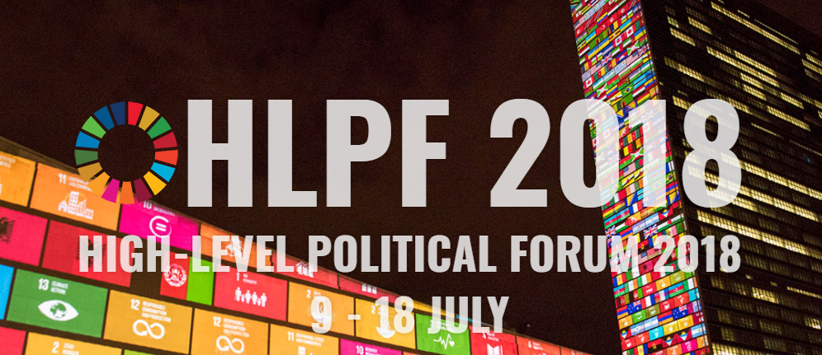

*Photo 1: High-Level Political Forum 2018, 9-18 July*

The meeting of the high-level political forum on sustainable development in 2018 convened under the auspices of the Economic and Social Council will be held from **Monday, 9 July, to Wednesday, 18 July 2018**; including the three-day ministerial meeting of the forum from **Monday, 16 July, to Wednesday, 18 July 2018**.

The theme will be "**Transformation towards sustainable and resilient societies**". The set of goals to be reviewed in depth will be the following, including Goal 17. Strengthen the means of implementation and revitalize the Global Partnership for Sustainable Development, that will be considered each year:

* Goal 6. Ensure availability and sustainable management of water and sanitation for all
* Goal 7. Ensure access to affordable, reliable, sustainable and modern energy for all
* Goal 11. Make cities and human settlements inclusive, safe, resilient and sustainable
* Goal 12. Ensure sustainable consumption and production patterns
* Goal 15. Protect, restore and promote sustainable use of terrestrial ecosystems, sustainably manage forests, combat desertification, and halt and reverse land degradation and halt biodiversity loss

More information on HLPF 2018 can be found at: <https://sustainabledevelopment.un.org/hlpf/2018>

## NEWS FROM UN HEADQUARTERS

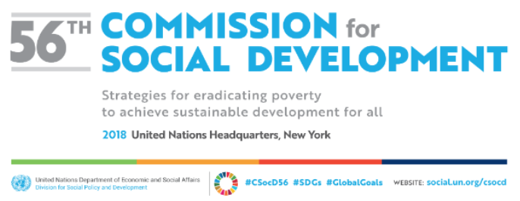

*Photo 2: The fifty-sixth session of the Commission for Social Development (CSocD56). #CSOCD56, #SDGs, #GlobalGoals, website: social.un.org/csocd*

The [fifty-sixth session of the Commission for Social Development (CSocD56)](https://www.un.org/development/desa/dspd/united-nations-commission-for-social-development-csocd-social-policy-and-development-division/csocd56.html) is being convened in Conference Room 4 at the United Nations Headquarters in New York from 29 January to 7 February 2018. The priority theme this year is **“Strategies for eradicating poverty to achieve sustainable development for all”**. The CSocD56 features four high-level panel discussions, including one on disability with a theme “Towards inclusive, resilient and sustainable development: an evidence-based approach to the mainstreaming of disability in the implementation, monitoring and evaluation of the Agenda 2030”, which was held on Wednesday 31 January 2018. The concept note is available at: <http://bit.ly/2EnwU7v> ; The video of the session can be viewed from <http://bit.ly/2GE8qHN> .

During the Commission, the side event on “Persons with Disabilities: Realising Equal Rights and Inclusive Development” was convened by China and European Union on 31 January. Detail of the event is available at: <http://bit.ly/2DXYjji>

**Disability statistics and data: The UN Statistical Commission**

UNDESA will organize a panel discussion on disability statistics and data during the 49th Session of the UN Statistical Commission in New York, which will be held from 6th to 9th March 2018.Detail will be available at: <https://unstats.un.org/unsd/statcom/49th-session/>

**New resolution: International Day on Sign Languages**

The UN General Assembly proclaimed 23 September as the International Day of Sign Languages through its resolution (A/RES/72/161) with a view to raise awareness of the importance of sign language in the full realization of the human rights of people who are deaf. This Day will first be observed from 2018. The resolution can be downloaded at: <http://www.un.org/en/ga/search/view_doc.asp?symbol=A/RES/72/161>

***NEWS FROM OTHER UN ENTITIES***

**OHCHR: The 19th session of the Committee on the Rights of Persons with Disabilities (CRPD), 14 February to 9 March 2018 in Geneva, Switzerland.**

The Committee will examine the implementation of the Convention in the following countries: Haiti, Oman, Sudan, Nepal, Slovenia, Seychelles and the Russian Federation. The Committee will hold an annual public interactive dialogue with National Human Rights Institutions and National Monitoring Frameworks of the Convention on 23 March. It will also have interactive dialogues with UN agencies, organizations of persons with disabilities and other stakeholders. The Committee will further discuss a draft general comment on the right to equality and non-discrimination. The accreditation for participating in the session is open and available on the Committee’s webpage: <http://www.ohchr.org/EN/HRBodies/CRPD/Pages/CRPDIndex.aspx>

**UNESCAP: High-level Conference adopted a regional Action Plan**

The High-level Intergovernmental Meeting on the Midpoint Review of the Asian and Pacific Decade of Persons with Disabilities, 2013-2022 reviewed the progress made in the implementation of the Incheon Strategy to "Make the Right Real" for Persons with Disabilities in Asia and the Pacific, and adopted by consensus an outcome document entitled ‘Beijing Declaration, including the Action Plan to Accelerate the Implementation of the Incheon Strategy’ to further the implementation of the regional framework as well as that of the 2030 Agenda and the CRPD. The Conference, with the support of the Chinese Government, took place in Beijing from 27 November to 1 December 2017 and was well attended by high-level officials from Asian countries. More details about the Conference including its outcome at: <http://bit.ly/2DOkubF> ; the outcome document can be downloaded at: <http://bit.ly/2nnn9z5>

At the margins of the High-level Intergovernmental Meeting on the Midpoint Review of the Asian and Pacific Decade of Persons with Disabilities 2013-2022, a panel discussion entitled “**Language Matters: Sign Languages and Linguistics Rights as Core Components of Inclusive Development**” was held on 27th November 2017. World Federation of the Deaf Regional Secretariat for Asia (WFD RSA), UN Educational, Scientific and Cultural Organization (UNESCO), and the Nippon Foundation (TNF) co-organized the event. The discussion highlighted good examples of legal recognition of sign languages in Japan, New Zealand, and South Korea, and introduced a regional research program on Sign Linguistics[, the Asia Pacific Sign Linguistics Research and Training Program (APSL)](http://www.cslds.org/apsl/about.php). About 70 participants attended the event. Detail of the event can be found at: <http://bit.ly/2DMVHVx>

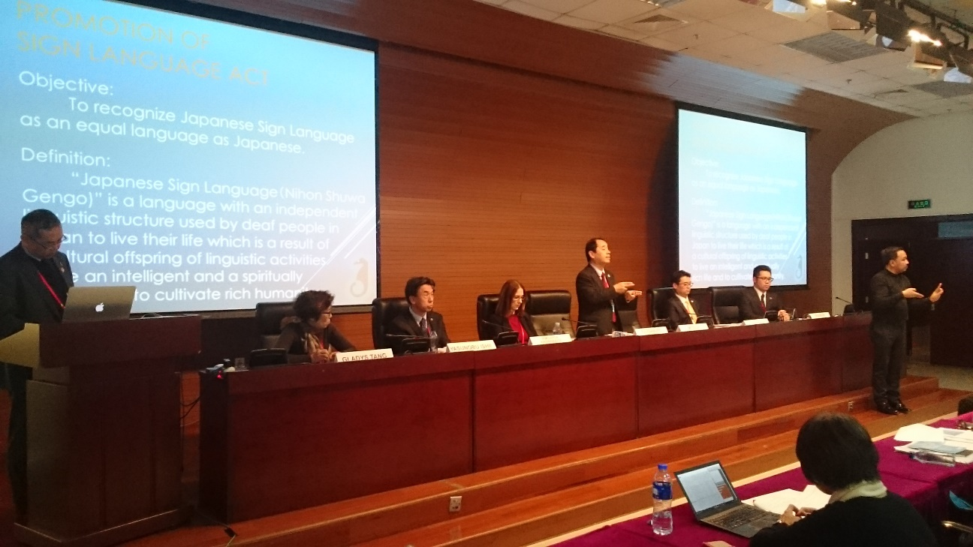

*Photo 3: President of Japanese Federation of the Deaf making his presentation at the side event, credit: Japanese Federation of the Deaf*

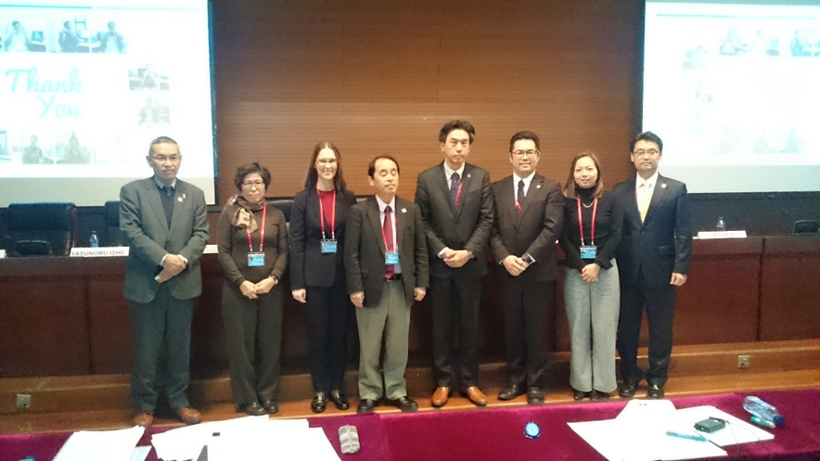

*Photo 4: Panelists and moderator at the side event, credit: Japanese Federation of the Deaf*

**UNDP: Issue Brief for Asia-Pacific on the Marrakesh Treaty to Facilitate Access to Published Works for Persons with Print Disabilities for Inclusive, Equitable and Sustainable Development**

This Issue Brief provides a concise summary of issues related to the Marrakesh Treaty to Facilitate Access to Published Works for Persons Who Are Blind, Visually Impaired, or Otherwise Print Disabled. It describes the key benefits and calls for countries in the Asia-Pacific region to implement the Treaty and bring more equitable access to information and knowledge for persons who are blind, visually impaired or otherwise print disabled. Joining and implementing the Marrakesh Treaty will significantly contribute to achieving many Sustainable Development Goals, which are guided by the principle of ‘leaving no one behind’. The Issue Brief is available in accessible formats at: <http://bit.ly/2DGG8un>

**UNDP: Justice in sight: Legal information booklet printed in Braille**

In keeping with the call of the SDGs to "leave no one behind" and to ensure more inclusive access to the justice system, the first Braille version of a booklet on court and judicial proceedings was recently released in Nepal. Developed by UNDP's Strengthening the Rule of Law and Human Rights Protection System in Nepal (RoLHR) and the Access to Justice Commission of the Supreme Court of Nepal, the booklet was intended to enable visually-challenged persons to gain access to basic information about court procedures and other related activities. A pdf version of the original document can be downloaded at: <http://bit.ly/2zkLBFm>

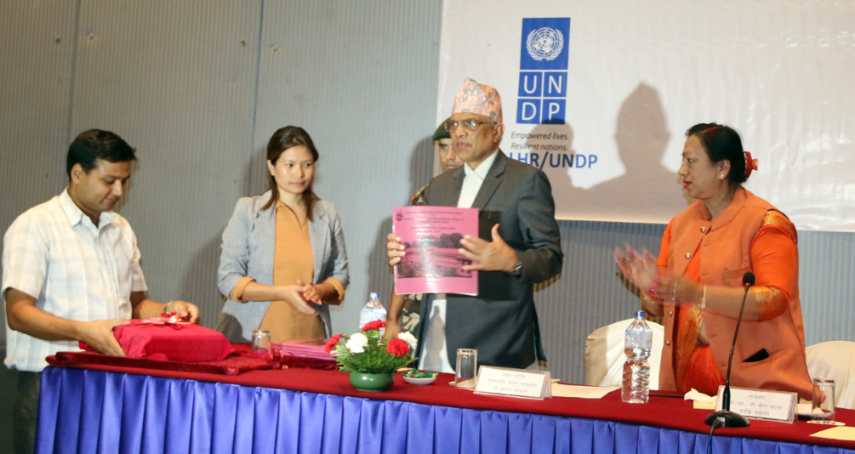

*Photo 5: The launch event of the Braille version of a booklet on court and judicial proceedings in Nepal, credit: UNDP Nepal*

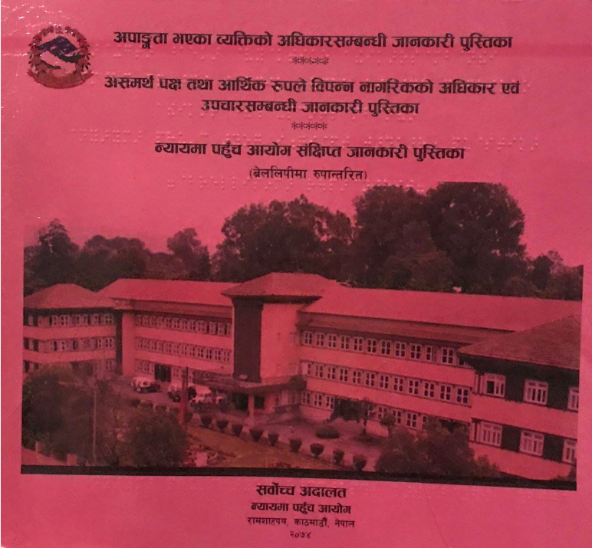

*Photo 6: Braille version of a booklet on court and judicial proceedings in Nepal, credit: UNDP Nepal*

**UN WOMEN: Spotlight on women and girls with disabilities on the International Day of Persons with Disabilities**

In connection with the International Day of Persons with Disabilities, 3 December 2017, UN Women highlighted stories from the field, and the adoption of General Assembly resolution with a focus on the situation of women and girls with disabilities. Also, on 3 December, the Executive Director’s blog series spotlighted Violence against women and girls with disabilities. For more information see:

<http://bit.ly/2DLUYDV> and <http://bit.ly/2BBzoMN>

**UN Women’s "We have abilities, we want possibilities!" initiative**

UN Women’s "We have abilities, we want possibilities!" initiative aims to strengthen the leadership skills of women with disabilities in the Republic of Moldova. The initiative ran from June to October 2017 and was part of the UN “Women in Politics” Programme, financed by the Government of Sweden. In From where I stand: “I am different, but that doesn’t mean that I should be condemned”, Olga Berdeu, a woman with disabilities that participated in the initiative shares her experience. For more information see: <http://bit.ly/2kW4et8>

**UNESCO Chair announced the launch the Love Diversity Initiative**

The UNESCO Chair and the Global Partnership of Children with Disabilities (GPcwd) launched the Love Diversity Initiative, #LoveDiversity, which is a photo shoot event celebrating diversity and physical activity that gathers photos and videos of people with and without disabilities, people from diverse backgrounds, age and gender participating in fun physical activities together. The UNESCO Chair in Inclusive PE, Sport, Recreation and Fitness would like to use this footage to advocate for inclusion of all across all areas of society. Everybody is welcome! For more detail, visit: [http://unescoittralee.com/projects/love-diversity/](https://unescoittralee.us9.list-manage.com/track/click?u=8ae1a3eac21f70cf144c637a9&id=822ab7dd25&e=11a65f4fe7)

**WHO: Improving access to assistive technology**

WHO held the 142nd session of the Executive Board from 22-27 January 2018 in Geneva, Switzerland. The Executive Board considered a resolution on Improving Access to Assistive Technology ([EB 142. R6](http://apps.who.int/gb/ebwha/pdf_files/EB142/B142_R6-en.pdf)), which recognized that assistive technology enables and promotes the inclusion, participation and engagement of persons with disabilities, among other stakeholders in all areas of society. The resolution also calls for actions to improve access to assistive technology.

**CALENDAR OF INTERNATIONAL DISABILITY EVENTS**

Please send us information on major international disability events, for possible inclusion in the list below, to [enable@un.org](mailto:enable@un.org). Now also available on the UN Enable website at: <http://bit.ly/1syHQs2>

**31 January - 2 February 2018: Global Action on Disability Network, Helsinki, Finland.**

The Ministry for Foreign Affairs of Finland (FORMIN) & the Abilis Foundation, will host the next GLAD Network meeting in Helsinki, Finland, from 31 January to 2 February 2018. The meeting will be co-chaired by the Australian Department

for Foreign Affairs and Trade (DFAT) and the International Disability Alliance (IDA). The event includes both a high level (ministerial segment) and substantive discussions to progress international cooperation in disability-inclusive development and humanitarian action. Learn more about the GLAD network at: <http://www.internationaldisabilityalliance.org/glad>

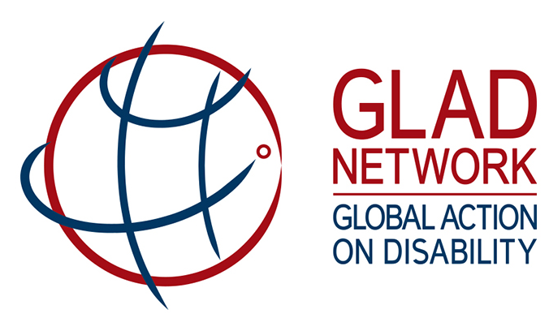

*Photo 7: GLAD Network, Global Action on Disability*

**7 - 13 February 2018: The 9th session of the World Urban Forum (WUF9), Kuala Lumpur, Malaysia**

WUF9 will be the first session to focus on the implementation of the New Urban Agenda adopted in the United Nations Conference on Housing and Sustainable Urban Development (Habitat III). A side event on ‘Implementing Universal Accessibility at the Local Level – Practical Actions for Realizing an Inclusive New Urban Agenda” will be held on **11 February from 5-6pm**. Detail of the side event can be found at: <http://bit.ly/2GvyZip>

**13 February 2018: Annual Disability Statistics Compedium Event, Washington, D.C., USA**

Join the Rehabilitation Research and Training Center on Disability Statistics and Demographics (StatsRRTC) for the release of the 2017 Annual Disability Statistics Compendium. The Compendium is a web-based tool that pools disability statistics published by various federal agencies together in one place. When working on legislative and other matters relating to persons with disabilities, the Compendium will make finding and using disability statistics easier. See more detail at: <http://bit.ly/2nsZcWn>

**21 - 23 February 2018: Zero Project Conference 2018 on Accessibility, Vienna, Austria**

The Zero Project Conference 2018, centered around the solutions and methodologies they offer, will seek to connect invitees from many different sectors of society so that they can share and discuss ideas and concepts that really work. And, thereby, in a joint effort, help support the implementation of the UN Convention on the Rights of Persons with Disabilities, worldwide. The Zero Project, part of the Essl Foundation, has announced [the Innovative Practices and Innovative Policies 2018](https://zeroproject.org/practice-type/innovative-practices-2018-on-accessibility/) ahead of the annual Conference at the United Nations in Vienna. The 93 awardees, from all around the globe will present their work to experts and leaders in the field of accessibility across three days. For detail, visit: <https://conference.zeroproject.org/>

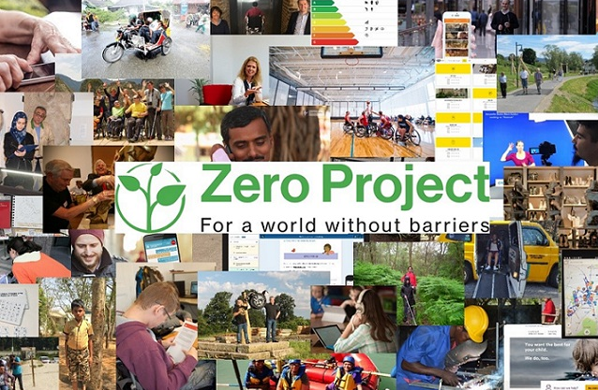

*Photo 8: Collage of Zero Project’s awardees on accessibility*

**5 - 9 March 2018: The Second Gender and Disability Forum and Regional Roundtable, Humanity & Inclusion (former Handicap International), Nairobi, Kenya**

The Making it Work (MIW) Gender and Disability project is organizing its Forum to address violence against women and girls with disabilities. Nine good practice holders (DPOs and Women’s Organizations) from Cameroon, Kenya, Malawi, Nigeria, Rwanda and Uganda will share their experiences, and learn from each other and from international experts. A roundtable “Better addressing the intersectionality of gender and disability in Africa - Regional opportunities” will take place with major DPOs, NGOs and UN agencies on **9th of March**, co-chaired by Ms. Fatma Wangare and Ms. Yetnebersh Nigussie. Contact: [s.pecourt@hi.org](mailto:s.pecourt@hi.org)

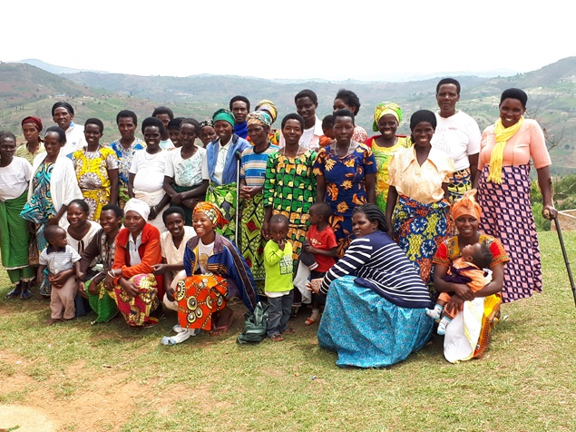

*Photo 9: Humanity & Inclusion (former Handicap International), Rwanda UNABU, credit: Pecourt, Humanity & Inclusion*

**21 March 2018: The World Down Syndrome Day**

A global awareness day which has been officially observed by the United Nations since 2012. For more detail, visit: <https://worlddownsyndromeday.org/>

**2 April 2018: The World Autism Awareness Day**

The United Nations General Assembly unanimously declared 2 April as World Autism Awareness Day (A/RES/62/139) to highlight the need to help improve the quality of life of those with autism so they can lead full and meaningful lives as an integral part of society. Commemorations will be held at the UNHQ in New York. Detail will be available at: <http://www.un.org/en/events/autismday/index.shtml>

**11 - 13 June 2018: The 7th M-Enabling Summit in Washington, D.C.**

The M-Enabling Summit Conference and Showcase is an annual meeting for all who create and contribute to accessible ICT products, services and consumer technologies. With its 2018 theme of “Accessible and Assistive Technologies Innovations: New Frontiers for Independent Living”, the 2018 M-Enabling Summit will provide a platform for empowering technologies and focus on next-generation innovations and breakthroughs for users of all abilities. It also includes the International Association of Accessibility Professionals (IAAP) Annual Conference. For registration and more details, visit <http://m-enabling.com/>

**25 - 27 July 2018: Down Syndrome International’s World Down Syndrome Congress, in Glasgow, UK.**

The Congress brings together people who have Down syndrome, their families, carers and others who have an interest in their lives, to look at new or emerging research and good practice, as well as to hear exciting developments in the lives of people with Down syndrome. Registration open at <http://wdsc2018.co.uk/>

**23 – 27 July 2019 XVIII World Congress of the World Federation of the Deaf, Paris, France**

The Congress theme, "Sign Language Rights for All" as the overarching theme of the XVIII World Congress of the World Federation of the Deaf highlights that full enjoyment of linguistic rights is vital in facilitating the full inclusion of the Deaf Community within society. For more information, visit: <https://www.wfdcongress2019.org/>

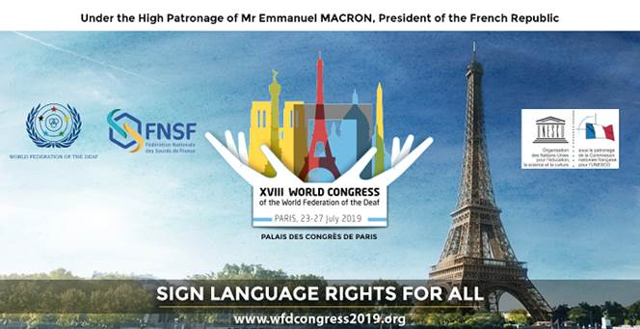

*Photo 10: Flyer of the XVIII World Congress of the World Federation of the Deaf, Paris, 23 – 27 July 2019*

**OTHER NEWS**

(DISCLAIMER: The information below is provided by other stakeholders for informational purposes only. This does not constitute endorsement of, or an approval by, the United Nations of any of the products, services, or opinions of the organization or individual. The United Nations bears no responsibility for the accuracy, legality or content of their statements and opinions.)

**EU Agency for Fundamental Rights reports on deinstitutionalisation**

In October 2017, the EU Agency for Fundamental Rights (FRA) published three reports on the theme ‘From institutions to community living’. The reports explore different aspects of the move away from institutions towards independent and community living: [deinstitutionalisation plans and commitments](http://fra.europa.eu/en/publication/2017/independent-living-structures); [funding](http://fra.europa.eu/en/publication/2017/independent-living-funding); and the [impact this is having on people with disabilities](http://fra.europa.eu/en/publication/2017/independent-living-outcomes). The findings show the need for systematic changes in the way in which support for people with disabilities is organised and funded.

**Rehabilitation International unveils two funds in support of disability and rehabilitation**

Rehabilitation International (RI) launched two funds to support global work on disability and rehabilitation. The Global Disability Development Fund (GDDF) will assist RI members and other groups working in partnership with RI to pursue activities in the fields of rehabilitation, education and employment, poverty alleviation, rights protection, assistive devices, accessibility, data collection and other initiatives relative to the implementation of the CRPD, the 2030 Agenda for Sustainable Development and RI’s 2017-2021 Strategic Plan. All projects to be funded must be directly related to persons with disabilities. Another fund is the Africa Fund (AF) that supports projects in disability and rehabilitation in Africa. For more information, visit: <http://bit.ly/2rSlhD0>

**The Stakeholder Group of Persons with Disabilities:** **Case Study on the Engagement of Organizations of Persons with Disabilities (DPOs) in Voluntary National Reviews, HLPF**

[The Stakeholder Group of Persons with Disabilities](https://sustainabledevelopment.un.org/majorgroups/personswithdisabilities), composed of various DPOs, issued a publication entitled “Case Study on the Engagement of Organizations of Persons with Disabilities (DPOs) in Voluntary National Reviews”. This is a comprehensive document on the High-level Political Forum and DPO participation in the Voluntary National Review process. The report showcases the national-level DPOs’ work carried out in different regions as well as best practices and challenges, and serves as a case study for all. This case study features the volunteering countries of Argentina, Bangladesh, Denmark, El Salvador, Ethiopia, India, Indonesia, Italy, Kenya, Nigeria, Peru, Sweden and Togo. The report can be downloaded at: <http://bit.ly/2saV6TV>

**Women Enabled International’s accountABILITY Toolkit**

Women Enabled International’s toolkit, “A Guide to Using U.N. Human Rights Mechanisms to Advance the Rights of Women and Girls with Disabilities” seeks to empower women and girls with disabilities and organizations working on their behalf to make use of the available U.N. human rights mechanisms. For more information, visit: <https://www.womenenabled.org/atk.html>

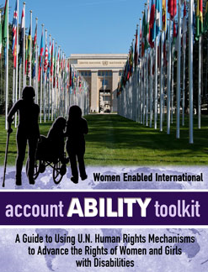

*Photo 11: A flyer of the Women Enabled International's acoutABILITY toolkit, A guide to using UN Human Rights Mechanisms to Advance the Rights of Women and Girls with Disabilities*

**Enabling a Global Human Rights Movement for Women and Girls with Disabilities**

Women Enabled International (WEI) produced a comprehensive mapping report of the field of advocates for the rights of women and girls with disabilities globally. This Report helps achieve greater collective impact by providing data, analysis and infographics of the leaders, venues, and locations where women's disability rights advocates and organizations are especially active, where the gaps are, and where there are opportunities for collaboration. Detail of the report can be found at: <https://womenenabled.org/mapping.html>

**Regional Women’s Institute on Leadership & Disability (WILD) – Asia**

Sixteen women with disabilities from China, India, Nepal, and Sri Lanka will be selected to participate in an eight-day WILD program in Sri Lanka, 23 - 30 May, 2018, to exchange experiences, explore strategies, strengthen a regional network of support, and create collaborative plans to promote inclusion of women with disabilities in community development efforts. Deadline for application: 5 February 2018. Application available in English and Chinese at: <http://www.miusa.org/news/2017/regional-wild-asia>

**Nippon Foundation: Japan's latest Public Sign Language Phone**

Japan's first Public Sign Language Phones (Video Relay Service booth) were activated at Haneda Airport in Tokyo on the International day of Persons with Disability, on 3 December 2017. Video Relay Service (VRS) is a video telecommunication service that allows Deaf individuals to communicate over video telephones with hearing people in real-time, via a sign language interpreter. Two VRS booths were set up by The Nippon Foundation and services are provided as free of charge for Deaf individuals who use Japanese Sign Language. More information can be found at: <http://bit.ly/2nkMeuk>

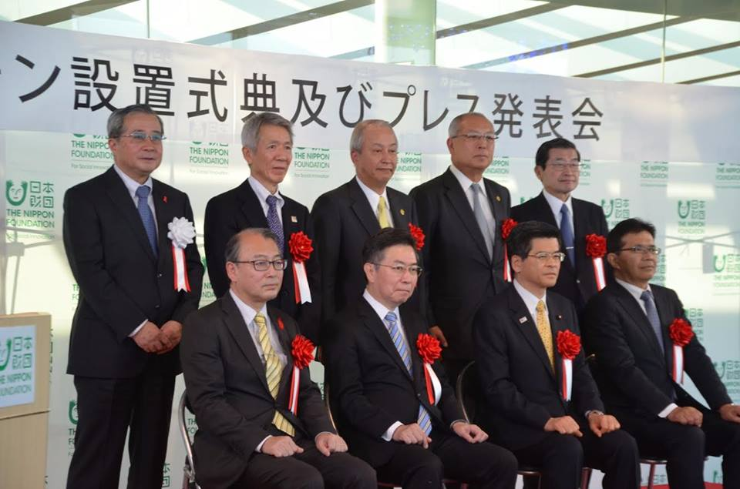

*Photo 12: Press conference of the launch of the public sign language phones, credit: Nippon Foundation*

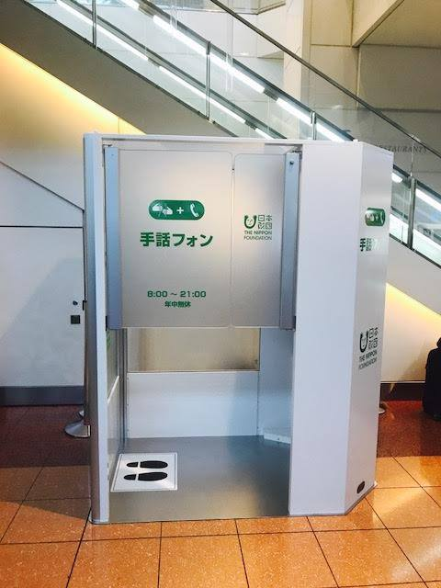

*Photo 13: The public sign language phone at Haneda Airport in Japan, credit: Nippon Foundation*

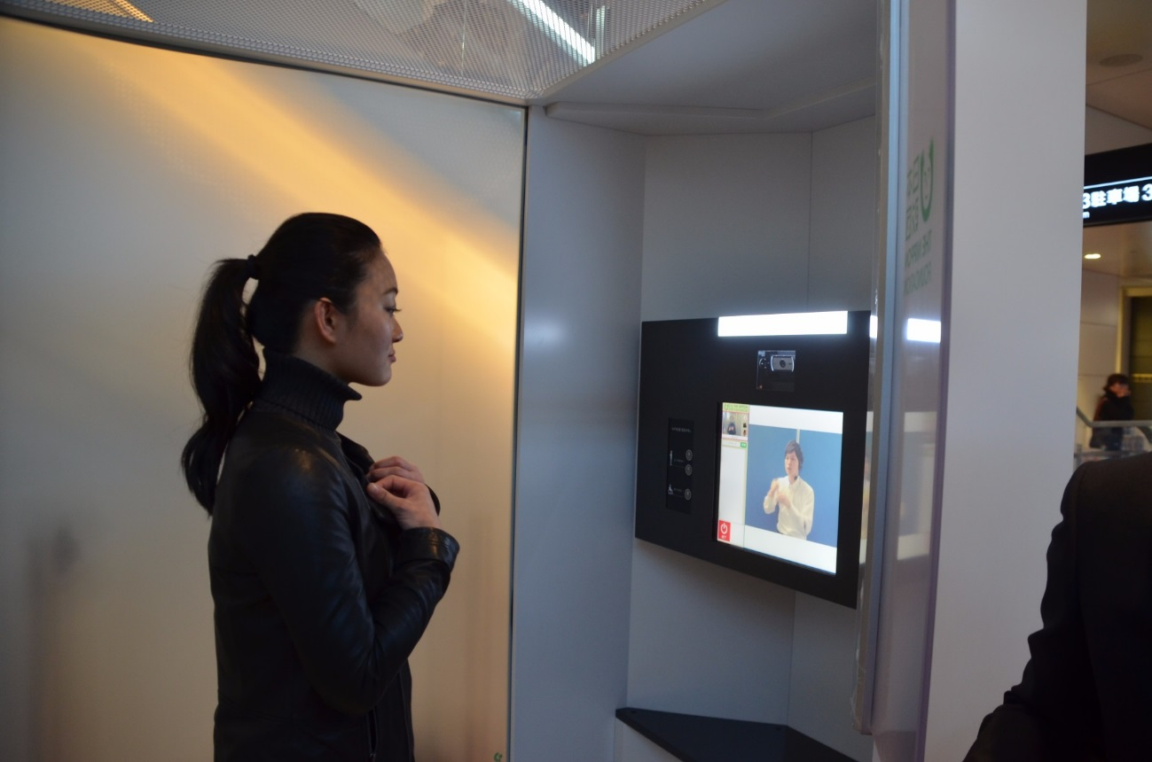

*Photo 14: Demonstrating the public sign language phone booth at Haneda Airport in Japan, credit: Nippon Foundation*

**Call for inputs:**

**All Children Reading launched Sign on For Literacy - Submission deadline -**

**16 February, 2018**

Sign On For Literacy competition is organised by All Children Reading partnered with USAID, World Vision and the Australian Government, in collaboration with the WFD, Nyle DiMarco Foundation and Deaf Child Worldwide. This competition seeks technology-based innovations to increase access to sign languages and literacy interventions for deaf children. These innovations will assist parents, educators, communities, and governments in enhancing early childhood development outcomes, improving access to local sign languages, and increasing literacy outcomes of deaf children. The submission deadline is **16 February 2018**. For more detail, visit: <http://bit.ly/2hyiyXD> ; Available in International Signs at: <http://bit.ly/2FwfcOm>

**GAATES: International Certification of Accessibility Consultants**

GAATES’ International Certification of Accessibility Consultants - Build Environment (ICAC-BE) program, launched in November 2017, has accepted the first candidates' credentials for review by the Expert Panel at the end of January 2018. The Expert Panel will review quarterly. The next review is scheduled at the end of March 2018. The ICAC-BE program is currently accepting applications from qualified candidates. Be recognized as a leader in the field for accessibility! Details of the program and application criteria are available at <http://gaates.org/certification/> Inquiries can be sent to [certification@gaates.org](mailto:certification@gaates.org). Press release available on Global Accessibility News: <http://bit.ly/2rSVOcJ>

**CONTACT INFORMATION**

Secretariat for the Convention on the Rights of Persons with Disabilities

Division for Social Policy and Development (DSPD)

Department of Economic and Social Affairs (DESA)

United Nations Headquarters, New York, NY 10017, USA

### BE INFORMED! GET INVOLVED!

Facebook: [www.facebook.com/pages/United-Nations-Enable/196545623691523](http://www.facebook.com/pages/United-Nations-Enable/196545623691523)

Twitter: <http://twitter.com/UN_Enable>

Website: [www.un.org/disabilities](http://www.un.org/disabilities)

Email: [enable@un.org](mailto:enable@un.org)

**Call for volunteers to translate the UN Enable newsletter in other languages**

Volunteer your time to translate the UN Enable newsletter in an official UN language or your own local language. We are looking for volunteers to translate the newsletter in to the UN official languages of **Chinese** and **Russian**.

(<http://bit.ly/enablenewslettervolunteer>)

**Call for photos for future inputs**

We will continue working to improve the design of our newsletter while ensuring the accessibility. We welcome your feedback.

---

**To subscribe:** <http://bit.ly/unenablenewsletter>