**UN Enable Newsletter**

Aug-Sep 2017

The UN Enable Newsletter is prepared by the Secretariat for the Convention on the Rights of Persons with Disabilities (DSPD/DESA) with input from UN offices, agencies, funds and programmes, as well as from civil society organizations, including organizations of persons with disabilities. It is also available online at: [www.un.org/disabilities](http://www.un.org/disabilities).

**In this issue:**

- Status of the CRPD

- In the Spotlight

- News from UN Headquarters

- News from other UN entities

- Calendar of international disability events

- Other news

**STATUS OF THE CRPD**

**174** ratifications/accessions and **160** signatories to the CRPD

**92** ratifications/accessions and **92** signatories to its Optional Protocol (OP)

More on the CRPD at: <http://bit.ly/UN_crpd>

## IN THE SPOTLIGHT

## International Day of Persons with Disabilities, 3 December 2017

The theme for the International Day of Persons with Disabilities (IDPD) 2017 is “Transformation towards sustainable and resilient society for all”. This theme focuses on the enabling conditions for the transformative changes towards inclusive society for persons with disabilities, as envisaged in the 2030 Agenda for Sustainable Development and the CRPD. Details can be found at: <https://www.un.org/development/desa/disabilities/international-day-of-persons-with-disabilities-3-december/idpd2017.html>

### Share your IDPD event on the UN ENABLE website

Let us know how you will be commemorating IDPD 2017 in your community and we will post the information and link to your event on the UN Enable website. ([enable@un.org](mailto:enable@un.org); max. 50 words)

## NEWS FROM UN HEADQUARTERS

**Upcoming meetings of the Third Committee of the UN General Assembly: Discussion on Women and Girls with Disabilities and the status of the Convention**

The General Assembly of the United Nations at its 72nd session will discuss issues concerning women and girls with disabilities through its Third Committee and will consider a resolution to advance their rights and inclusion. In support for the Third Committee, the Secretary-General issued the report entitled “Situation of women and girls with disabilities and the Status of the Convention on the Rights of Persons with Disabilities and the Optional Protocol thereto” (A/72/227), which provides an overview of the situation of women and girls with disabilities and presents the ongoing efforts and progress made by Governments, the entities of the United Nations system and civil society organizations in advancing the rights and status of women and girls with disabilities. The report also provides an update on the status of the Convention on the Rights of Persons with Disabilities and the Optional Protocol thereto. It concludes with recommendations for the further inclusion of women and girls with disabilities in the implementation of the Convention and the 2030 Agenda for Sustainable Development.

Full document can be downloaded at: <https://www.un.org/development/desa/disabilities/resources/general-assembly.html>

**2030 Agenda follow-up: Deputy Secretary-General underscored the need to address the persistent inequality challenge faced persons with disabilities**

On 8 September, Ms. Amina J. Mohammed, Deputy Secretary-General of the United Nations, made remarks at the informal meeting convened by the President of the 71st session of the General Assembly on the status of the implementation of the Sustainable Development Goals. The Deputy Secretary-General stated that while there were progress made towards the implementation of the SDGs, the assessment clearly shows that the pace of progress is insufficient to fully meet the ambitious goals.  Ms. Mohammed underscored that “Inequality remains a significant challenge, both within and among countries. Children and youth, women and girls, indigenous people, older people, rural workers, people with disabilities, migrants and people affected by conflict remain vulnerable, deprived of their rights and opportunities. Everyday, they must be empowered if we are to be true to our commitment to leave no one behind.”

For a copy of the full statement, please click the link: <https://www.un.org/sg/en/content/dsg/statement/2017-09-08/deputy-secretary-generals-remarks-sustainable-development-goals>

**2030 Agenda follow-up: Disability in the 2017 HLPF Ministerial Declaration**

The 2017 High-Level Political Forum on Sustainable Development (HLPF), convened under the auspices of the Economic and Social Council, took place from 10 to 19 July 2017, and concluded in New York on 19 July by adopting its Ministerial Declaration. Disability has been given 5 specific references in the Ministerial Declaration this year, including in the context of eradicating poverty and promoting prosperity; multiple and intersecting forms of discrimination, especially faced by women and girls with disabilities; improved and coordinated collection, analysis, dissemination and us of statistics and disaggregated data; as well as localizing and communicating the SDGs to all stakeholders including persons with disabilities.

Full text of the Declaration can be found at the UN ENABLE website link: <https://www.un.org/development/desa/disabilities/news/dspd/2017-hlpf.html>

**Call for participation: Rate the accessibility of places in your own community for the 2018 UN Flagship Report on disability and development**

Accessibility apps crowdsource and share information about accessibility in public places and are thus useful tools to assist persons with disabilities and in providing an overview of accessibility. Promoting accessibility is mandate by the UN covered in the articles 9.1(b), 9.2(b), (f), (g), (h) of CRPD and in SDG targets 4.a, 11.2 and 11.7. The UN Flagship Report on Disability and Development | 2018 - *Realizing the SDGs by, for and with persons with disabilities*, which will be released in 2018, will explore the information available in these apps to provide guidance on accessibility policy making.

Participate in this effort by rating the public places in your own community at: <http://www.axsmap.com/>, <https://wheelmap.org> and <https://www.jaccede.com>. These apps were developed by nonprofit organizations, and the last two apps are available in languages other than English.

***NEWS FROM OTHER UN ENTITIES***

**UNAIDS: Reference Report on Disability and HIV**

UNAIDS has made available a new Reference Report titled Disability and HIV on their website. This report highlights existing key evidence on the relationship between disability and HIV. It discusses the concrete steps needed for a person-centred, disability-inclusive HIV response that allows for increased participation of people with disabilities and integrates rehabilitation within the continuum of HIV care.

The report is available at: <http://www.unaids.org/en/resources/documents/2017/jc2905_disability-and-hiv>

**UN Women: Virtual Knowledge Centre to End Violence Against Women: Addressing violence against women and girls with disabilities**

The online platform provides practical information and tools to support activities to end violence against women and girls, including: step-by-step programming guidance; resources for implementation in the Tools Section; search for expert organizations in the Sources of Expertise Section; events & training sessions in the Calendar Section; ongoing programmes in the Leading Initiatives Section; and ask for programming help in the FAQs Section.

Tools and resources to address violence against women and girls with disabilities can be found at the website: http://www.endvawnow.org/en/

**UN Women’s Strategic Plan 2018-2021**

UN Women’s new Strategic Plan will contribute to women with disabilities reaching decision-making positions; gender responsive national and local plans, strategies, policies and budgets, including support to disability programming; and more and better quality and disaggregated data and statistics, including for those in vulnerable situations. UN-Women will continue to strengthen its relationship with women’s organizations and networks, including disability organizations. The Strategic Plan has four inter-connected outcomes: women lead, participate in and benefit equally from governance systems; have income security, decent work and economic autonomy; live free from violence; and contribute to building sustainable peace and resilience, and benefit equally from crisis prevention and humanitarian action.

See Strategic Plan and Annexes at: <http://www.unwomen.org/en/executive-board/documents/second-regular-session-2017>

**ITU: Accessible Americas IV: ICTs for ALL**

Since 2014 the International Telecommunication Union (ITU) has been annually organizing the Accessible Americas events. Its main focus is to raise awareness among governments in regards to the necessary measures to protect the rights and dignity of persons with disabilities and to strengthen national and regional cooperation to make the Americas region more inclusive. This year, Accessible Americas IV will take place in San Jose, Costa Rica, from 21 to 23 November 2017, bringing to the discussions challenges and difficulties faced by other vulnerable groups and to share the good practices.

For more information please visit the website (<http://www.itu.int/en/ITU-D/Regional-Presence/Americas/Pages/EVENTS/2017/16948.aspx>); or contact Vera Zanetti (vera.zanetti@itu.int).

**CALENDAR OF INTERNATIONAL DISABILITY EVENTS**

Please send us information on major international disability events, for possible inclusion in the list below, to [enable@un.org](mailto:enable@un.org). Now also available on the UN Enable website at: <https://www.un.org/development/desa/disabilities/calendar.html>.

**18 and 24 September 2017: World Federation of the Deaf - International Week of the Deaf 2017** will take place between in tandem with the theme, ‘Full Inclusion with Sign Language’. IWD 2017 stresses the importance of sign language – without actual recognition, facilitation and promotion of it, goals of the CRPD and 2030 Agenda cannot be fully achieved. More information about #IWD2017 will be announced sometime soon.

**8 October 2017: Together for an #accessible world, at Hilton Hotel in Buenos Aires, Argentina.** The event will bring together ITU Members and related stakeholders from all regions to share their views, challenges and success stories to jointly pave the way forward towards a global implementation process for an inclusive society. Many countries have already started fostering ICT accessibility by creating ICT accessibility policy frameworks on public ICT access, mobile communications, TV/video programming, public procurement of accessible ICT and accessible government websites. The session will provide practical guidance, recommendations and partnership opportunities to facilitate and promote the work on ICT accessibility for persons with disabilities, including age related disabilities.

Additional details can be found on the following website http://www.itu.int/go/WTDC17-PreEvents. For more information please contact digital.inclusion@itu.int

**9 to 11 October 2017: Pacific Rim International Conference on Disability and Diversity, Hawaii, USA** will gather voices from “diverse” perspective across numerous areas, including: persons representing all disability areas; family members and supporters across all disability and diversity areas, to exchange and discuss responsiveness to diverse cultural and language differences; evidence of researchers and academics studying diversity and disability; stories of persons providing powerful lessons; examples of program providers; and action plans to meet human and social needs in a globalized world.

Detail of the Conference can be found at: <http://www.pacrim.hawaii.edu/>

**27 September 2017: The World Tourism Day 2017, Doha, Qatar**

Detail of the World Tourism Day can be found at: <http://www2.unwto.org/home-wtd-2017>

**8–10 November 2017: 3rd International Conference of the World Federation of the Deaf, Budapest, Hungary**

Detail of the Conference can be found at: <http://wfdbudapest2017.com/>; Email: [golob@congressline.hu](mailto:golob@congressline.hu)

**27 November- 1 December 2017: UNESCAP High-level Intergovernmental Meeting on the Midpoint Review of the Asian and Pacific Decade of Persons with Disabilities, Beijing China**

Details can be found at: <http://www.unescap.org/events/high-level-intergovernmental-meeting-midpoint-review-asian-and-pacific-decade-persons>

**29 January-7 February 2018: 56th Commission for Social Development**

The 56th session of the Commission will take place in New York. A panel discussion on disability and development will be convened. More background and updates on the programme of activities will be available in the forthcoming session.

**7- 12 February 2018: 9th World Urban Forum, Kuala Lumpur, Malaysia**

Detail of the Forum can be found at: https://unhabitat.org/kuala-lumpur-to-host-world-urban-forum-in-2018/

**21-23 February 2018: Zero Project Conference 2018 On Accessibility in Vienna, Austria,** will gather 500 decision makers and opinion leaders worldwide; highlight more than 50 Innovative Policies and Innovative Practices, and involve leading experts from all over the world in the discussion of the most relevant solutions to work for the common goal for the implementation of the UN CRPD. More information about the Zero Project can be found at: <https://zeroproject.org/>

**9-18 March 2018: International Paralympic Winter Games, Pyeong Chang, Republic of Korea**

Detail of the Paralympic can be found at: https://www.pyeongchang2018.com/en/paralympics/index

**12-14 June 2018: 11th session of the Conference of States Parties to the Convention on the Rights of Persons with Disabilities, United Nations headquarters in New York.** More information will be available at: https://www.un.org/development/desa/disabilities/conference-of-states-parties-to-the-convention-on-the-rights-of-persons-with-disabilities-2/cosp11.html

**OTHER NEWS**

(DISCLAIMER: The information below is provided by other stakeholders for informational purposes only. This does not constitute endorsement of, or an approval by, the United Nations of any of the products, services, or opinions of the organization or individual. The United Nations bears no responsibility for the accuracy, legality or content of their statements and opinions.)

**Ending Poverty for Persons with Disabilities**

In June 2017 at the High-level Political Forum (HLPF), 44 countries presented their progress towards the Sustainable Development Goals(SDGs). It has been almost two years since the UN agreed on 17 goals and set forth an agenda for people, planet, and prosperity. Disability rights advocates talked about what the UN deliberations means to people’s lives on the ground. Read interviews with DPO leaders about what it means to live a life free from extreme poverty.

Link: <http://disabilityrightsfund.org/our-impact/insights/ending-poverty-persons-disabilities/>

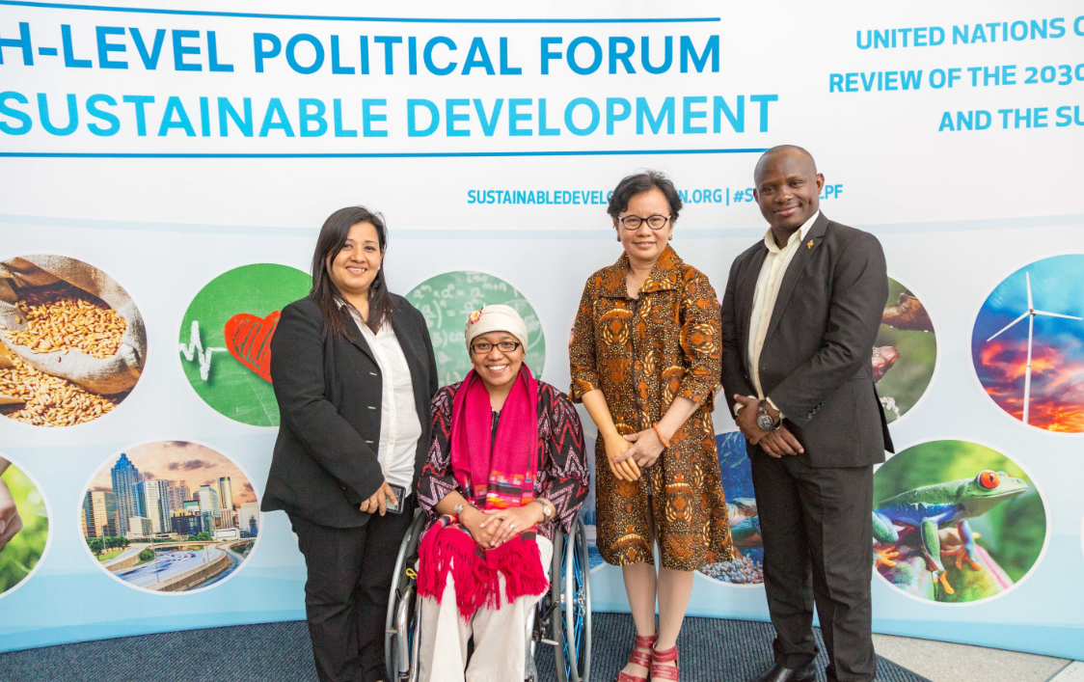

Photo caption: (From left to right) Pratima Gurung, Risna Utami, Maulani Rotinsulu, Ambrose Murangira at the UN High Level Political Forum. Photo credit: Andy Isaacson

**Office Manager’s training for Pacific DPOs**

The Pacific Disability Forum (PDF) conducted training for 14 Office Managers from Disabled People’s Organisations (DPOs) in the Cook Islands, Fiji, Kiribati, Papua New Guinea, Republic of Marshall Islands, Samoa, Solomon Islands, Tonga, Tuvalu and Vanuatu in Nadi, Fiji from the 14 to 16 August 2017. The training focused on building the capacity of DPOs office managers on good governance, outcomes based reporting, financial management and grant management. PDF focusses on institutional strengthening of Pacific DPO members to ensure organisational sustainability and efficiency. PDF acknowledges core funding support from the Australian Government Department of Foreign Affairs and Trade.

For more information please email Simione Bula at infor@pacificdisability.org or phone on +679 8912653

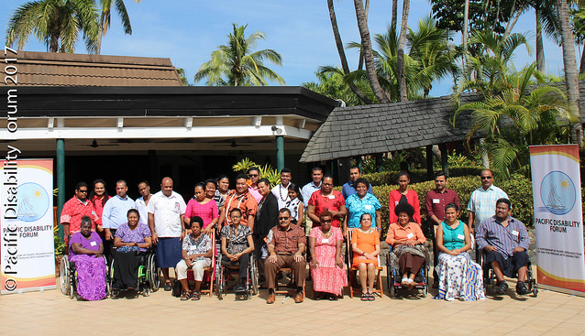

Photo caption: Group Photo of the Pacific DPO Office Manager’s with the staff members of the Pacific Disability Forum Secretariat

**Enhancing the Relationship between the Disability Movement and People Affected by Leprosy**

With an aim at strengthening the 2030 Agenda pledged to ‘Leave no one Behind’, Disabled People's International (DPI) and The Nippon Foundation (TNF) have entered into a partnership to undertake Phase 2 of the project on 'Enhancing the Relationship between the Disability Movement and People Affected by Leprosy'. The main objective of this project will be to bridge the gap between the Disability and the Leprosy sector by integrating persons affected by Leprosy, particularly in countries with higher prevalence of Leprosy, into the larger disability movement and to help them align their advocacy initiatives. The project will further seek to create platforms for persons affected by Leprosy to voice the stigma and discrimination faced by them at international disability events.  
  
For more information please visit the DPI website: <http://www.disabledpeoplesinternational.org/and> the TNF website: <http://www.nippon-foundation.or.jp/en/>

**Supporting Inclusive Movements: Funding the Rights of Women with Disabilities**

Leading advocates and women’s rights donors agree that much more can and needs to be done to include women with disabilities in women’s rights activism, agenda setting, and funding. This brief explores funding at the intersection of women’s rights and disability rights and offers steps donors can take to ensure that their grant-making is more inclusive of women with disabilities and to support this emerging movement.

Link: <http://disabilityrightsfund.org/wp-content/uploads/2015/11/Supporting_inclusive_movements_web.pdf>

Accessible word doc: <http://disabilityrightsfund.org/for-donors/donor-guide-to-inclusion/>

**First Seminar on Inclusive ICTs in Dominican Republic**

The Global Initiative for Inclusive ICTs (G3ict), jointly with the National Council on Disability (CONADIS) of the Dominican Republic, hosted the "First Seminar on Inclusive Information and Communication Technologies (ICTs)" on August 29-30 in Santo Domingo to promote accessible technologies, in line with the CRPD, in different areas of the Dominican society.  Part of a global series of training programs delivered by G3ict worldwide, the event facilitated the exchange of information and collaboration among key decision-makers in government, organizations of persons with disabilities, businesses, education, and research, in the context of the government-led campaign “República Digital”. Contact Francesca Cesa Bianchi [fcesabianchi@g3ict.org](mailto:fcesabianchi@g3ict.org)

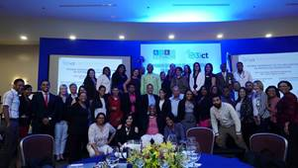

Photo Caption: A group photo of Inclusive ICTs Seminar participants in Dominican Republic

**New Easy Read Publication - Hear my voice – people with disabilities and older people in Tanzania tell their stories**

This new Easy Read publication tells the stories of persons with disabilities and older persons living in Tanzania. It explores the barriers that persons with disabilities and older persons face in accessing education, health care and work, the abuse and exclusion they experience, and what they want to change.

More information and detailed reports from the research are available on the website (<https://www.sightsavers.org/wp-content/uploads/2017/08/JN_0392_VOTM_EasyReadReport_V09.pdf>; https://www.sightsavers.org/voices-of-the-marginalised/). For any questions, contact Hannah Loryman ([hloryman@sigthsavers.org](mailto:hloryman@sigthsavers.org))

**CONTACT INFORMATION**

Secretariat for the Convention on the Rights of Persons with Disabilities

Division for Social Policy and Development (DSPD)

Department of Economic and Social Affairs (DESA)

United Nations Headquarters, New York, NY 10017, USA

### BE INFORMED! GET INVOLVED!

Facebook: [www.facebook.com/pages/United-Nations-Enable/196545623691523](http://www.facebook.com/pages/United-Nations-Enable/196545623691523)

Twitter: <http://twitter.com/UN_Enable>

Website: [www.un.org/disabilities](http://www.un.org/disabilities)

Email: [enable@un.org](mailto:enable@un.org)

**Call for volunteers to translate the UN Enable newsletter in other languages**

Volunteer your time to translate the UN Enable newsletter in an official UN language or your own local language. We are looking for volunteers to translate the newsletter in to the UN official languages of **Chinese** and **Russian**.

(<http://bit.ly/enablenewslettervolunteer>)

**Call for photos for future inputs**

We will continue working to improve the design of our newsletter while ensuring the accessibility. We welcome your feedback.

---

**To subscribe:** <http://bit.ly/unenablenewsletter>

**To unsubscribe:** [http://esamail.un.org/u?id=%%memberidchar%%&o=%%outmail.messageid%%&n=T&e=%%emailaddr%%&l=enable_news](http://esamail.un.org/u?id=%25%25memberidchar%25%25&o=%25%25outmail.messageid%25%25&n=T&e=%25%25emailaddr%25%25&l=enable_news)