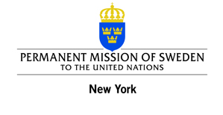

Film screening at the United Nations

ReelAbilities: NY Disabilities Film Festival

“The Importance of Tying Your Own Shoes”
(Lena Koppel, Sweden, 2011, 100 minutes)
When Alex gets a job as the leader of a local theater group
for people with disabilities his outlook on life begins to change.

See trailer here: http://www.youtube.com/watch?v=sxV-A64PXSY

Non-UN persons register here: http://tinyurl.com/bsuckz4 or

Call ReelAbilities Box Office at 646-505-5708.

11 March 2013

6.30 to 8.30 p.m., Conference Room 4

United Nations Headquarters

Sponsored by the

Permanent Mission of Sweden to the United Nations

and organized by the

United Nations

Department of Public Information

Department of Economic and Social Affairs

www.NY.Reelabilities.org

http://www.un.org/disabilities

