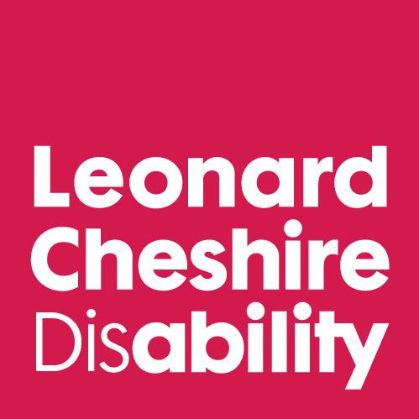
International Day of Persons with Disabilities
Message of Inclusion

Clare Pelham
Chief Executive, Leonard Cheshire Disability

Excellencies, representatives of member states, distinguished delegates, ladies and gentlemen.

Thank you for inviting me, as a representative of Leonard Cheshire Disability, here today. I am honoured to be here.

I hope you enjoyed the video of young people you have just seen. Through these young people you see what our future could be – how bright, how engaged, how determined – and how much of a difference these young people can make.

How terrible would it be if these young people did not realise their full potential? If they did not have the opportunities they could have because we did not hear their voice and we did not change the world?

These young people – Leroy and Aswini, Ashura and Sarah – are the lucky ones. There are so many young persons with disabilities around the world who face doors which are locked, and barriers too high for them to climb alone.

I do hope that you enjoyed the video. Because I want to say something now that may not be very enjoyable to hear. We are in danger of letting these young people down. All of us here in this room and many more worldwide may let these young people down. And it’s not because our hearts are not in the right place.

I was privileged to be here in September and I was delighted to hear how positive and how constructive discussions were. I was thrilled to hear a concerted voice saying ‘we must not forget disabled people. We must leave no one behind’.

And the Outcomes Document says many important and valuable things, and gives some clear actions which must be taken. At Leonard Cheshire we are working to make these happen. We are supporting thousands of children with disabilities to go to school, and for their communities to accept and support their inclusion.

Over 1,000 Leonard Cheshire Young Voices have campaigned for progress in many of the actions in the Outcome Document. For example, in Sierra Leone they have made buildings and buses accessible. In Tanzania they have successfully persuaded the Minister to create a committee to monitor the implementation of the Convention on the Rights of Persons with disabilities. In China they have improved accessibility at the Forbidden City in Beijing with the installation of ramps and lifts.

But we can not do this alone. No-one can do this alone.

We are all largely agreed on what we believe must happen. What is important now is how we get there.

There were many fine words spoken here in September. And there will be today. But words are not enough, we must also act. We can not achieve development goals either now or in the future if one billion disabled people are not included.

And that is how we may let these young people down. Someone wise once said “to fail to plan, is to plan to fail”. So, I ask now, where is our plan for the inclusion of disability in the post-2015 agenda? Who is writing it? When do we see the first draft?

These seem rather dull questions for an inspiring occasion like today. But unless we have answers to them soon – very soon – unless the global disability community is fully included in crafting the gaols of the post-2015 architecture – there is every chance that people with disabilities will be forgotten once and for all.

Today is a very special day. The day when more than ever we encourage the world to remember that however far we may go together, if persons with disabilities are not included we will never even get close to reaching our destination.

I call upon the UN to be a role model for inclusion. To demonstrate to the world how you construct an agenda for post-2015 where the interests of disabled people are front and centre. Fully included. As they should be. Let us change the world to include people with disabilities.

And please, Mr Secretary General, let us start with ourselves.

