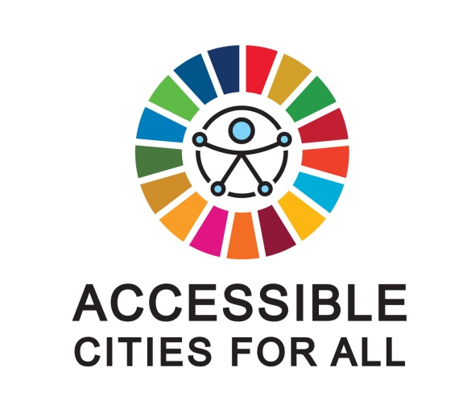

“Accessible Cities for All”
International Day of Persons with Disabilities 2016
10-Year Anniversary of the adoption of the
Convention of the Rights of Persons with Disabilities

6:30-8:00pm, Friday, 2 December 2016
ECOSOC Chamber, United Nations Headquarters

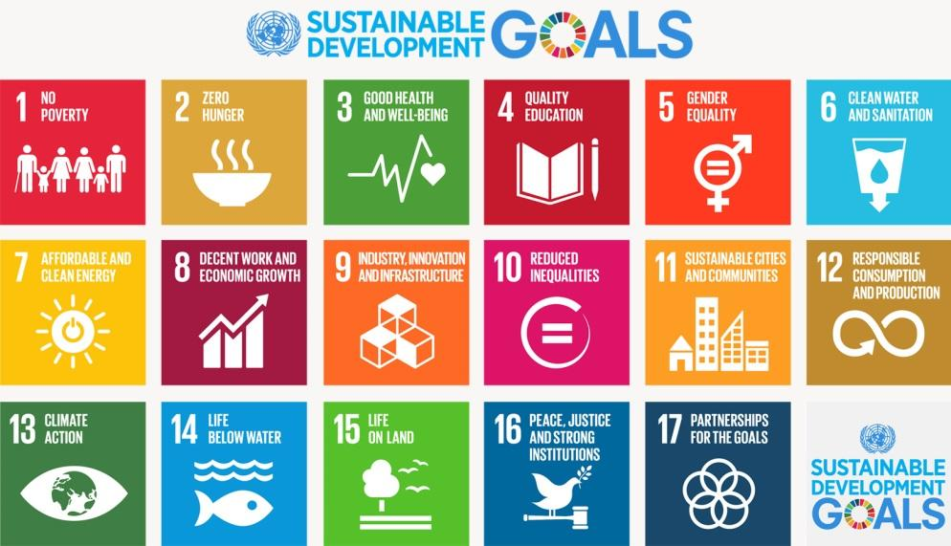

Working Title: “Accessible Cities for All”
Date: 6:30-8:00pm, Friday, 2 December 2016
Venue: ECOSOC Chamber, UN Headquarters, New York, NY, 10017
Initiative of: DSPD/UNDESA, New York City Mayor’s Office for People with Disabilities,
Partners: Permanent Missions of: Australia, Bangladesh, Bulgaria, Colombia, Ecuador, Italy, Jamaica, Philippines, Poland, Republic of Korea and Singapore.
In collaboration with: United Nations Department of Public Information
OVERVIEW
In commemoration of the 10th anniversary of the adoption of the Convention on the Rights of Persons with Disabilities and coinciding with the International Day of Persons with Disabilities, a special event is being organized to honour and raise awareness for the importance of accessible, inclusive and sustainable cities built for people of all abilities.
Building upon the momentum of the upcoming adoption of the New Urban Agenda (Habitat III), the event aims to draw attention to the importance of accessibility and inclusion for ensuring sustainability in cities and societies around the world, and for ensuring that implementation of the Sustainable Development Goals leaves no one behind. The event is a call to action for city leaders to make universal accessibility a priority.
GUESTS/ATTENDEES/PRESENTERS
Interspersed between creative performances promoting the international normative framework on disability, distinguished guests will highlight examples of cross-sectoral partnerships and best practices for ensuring urban accessibility, inclusiveness, and sustainability. Mayors, innovators and UN representatives will share achievements and aspirations to help ensure a future in which no person is left behind.
EVENT OUTCOME
This event will provide a platform for key decision-makers and advocates to share highlights from creative and collaborative discussions on how to make cities more inclusive and sustainable. Presenters, performers, and attendees will have the opportunity to connect, network and build partnerships towards meeting the international commitments to disability-inclusive development, including those found in the Sustainable Development Goals and the New Urban Agenda (Habitat III).
BACKGROUND
2016 marks the 10th anniversary of the adoption of the Convention on the Rights of Persons with Disabilities, a landmark international instrument aimed at ensuring the full inclusion of persons with disabilities in all aspects of social, economic, political and cultural life. 2016 also marks one year since the adoption of the 2030 Sustainable Development Goals, and the commitment of world leaders to achieve inclusive and sustainable development that leaves no one behind.
By 2050, the world’s urban population is expected to nearly double. Where do persons with disabilities fit within this urbanization trend? Are their needs effectively accounted for or are cities leaving them behind?
The commitment to accessibility is clear, but implementation is nascent. In an effort to build on the growing momentum towards universal accessibility, this event will bring together top decision makers and practitioners to share their good practices for implementing accessibility and celebrate their successes in reducing inequality and promoting inclusive development.
Having the 9th session of the Conference of State Parties to the Convention in June 2016 as a starting point and running through the International Day of Persons with Disabilities on the 3rd of December, communication efforts by the Division for Social Policy and Development in the United Nations Department of Economic and Social Affairs – with the support of the Social Media team in the Strategic Communications Section of the Department of Public Information – will give special attention to the role and contributions of accessibility and inclusion in the lives of persons with disabilities.

PROPOSED EVENT PROGRAMME
“ACCESSIBLE CITIES FOR ALL”
In commemoration of the 10th anniversary of the adoption of the Convention on the Rights of Persons with Disabilities and coinciding with the International Day of Persons with Disabilities

6:30-8:00pm, 2 December 2016
ECOSOC Chamber, United Nations

6:30 p.m. | Joint welcome message:  Message by Mr. Ban Ki-moon, Secretary-General, United Nations, delivered by Mr. Lenni Montiel, Assistant Secretary-General for Economic Development, Department of Economic and Social Affairs, United Nations  Mr. Richard Buery, Deputy Mayor of New York City For Strategic Policy Initiatives (TBC)
6:36 p.m. | Performance by Special Olympics Korea Ensemble
6:48 p.m. | Message by Ms. Yuriko Koike, Governor, Tokyo Metropolitan Government
6:52 p.m. | Statement by Ms. Cristina Gallach, Under Secretary-General for Communications and Public Information, United Nations
6:55 p.m. | Statement and performance by violinist Midori, United Nations Messenger of Peace
7:10 p.m. | Statement by:  Ms. Daniela Bas, Director, Division for Social Policy and Development, Department of Economic and Social Affairs, United Nations  Mr. Victor Calise, Commissioner, New York City Mayor’s Office for People with Disabilities
7:16 p.m. | Video on the anniversary of the Convention on the Rights of Persons with Disabilities featuring Mr. Jan Eliasson, Deputy Secretary-General, United Nations
7:19 p.m. | Performance by UN Staff Recreation Council Symphony Orchestra
7:28 p.m. | Video: “An Accessible and Inclusive World for All”
7:33 p.m. | Performance by Theater Breaking Through Barriers (Off-Broadway actors with and without disabilities)
7:45 p.m. | Statement by Mohammad Al-Tarawneh, UN Goodwill Ambassador for Peace and Development, and Special Advisor to the UN Special Rapporteur on Disability (TBC)
7:47 p.m. | Message by Mr. Stevie Wonder, United Nations Messenger of Peace
7:50 p.m. | END

