**The Secretariat for the Convention on the Rights of Persons with Disabilities, Division for Social Policy and Development of the Department of Economic and Social Affairs invites you to the 2014 International Day of Persons with Disabilities, under the theme**

# Sustainable Development: The Promise of Technology Programme

**Tuesday 2 December**

10:00-1:00 Accessible Technologies for Persons with Disabilities: Crossing the Digital Divide

CR8* Co-sponsored by the Permanent Missions of Singapore and Morocco to the United Nations

1:15-2:30 Mental Well-Being and Disability: Toward Accessible and Inclusive Sustainable Development Goals  
CR8 Co-organized by United Nations University International Institute for Global Health, The World Bank Tokyo Development Learning Center, and UN DESA, and co-sponsored by the Permanent Missions of Argentina   
 and Bangladesh to the United Nations

3:00-6:00 Creating Enabling Work Environments

CR8 **C**o-sponsored by the Permanent Mission of Germany to the United Nations

6:30-8:00 Film screening: “We Stand Alone”

CR4Co-organized by DESA and DPI and by Gbowee Peace Foundation Africa and Liberated People

**Wednesday 3 December**

10:00-11:30 Opening of IDPD: Disability-inclusive Sustainable Development: The promise of technology

CR4 First segment: Opening session

Co-sponsored by the Permanent Missions of Republic of Korea, the Philippines, Brazil, Spain, and the United Republic of Tanzania to the United Nations and United Nations Educational Scientific and Cultural Organization (UNESCO)

11:30-01:00 Second segment: Disability-inclusive Sustainable Development Goals

CR4 Co-sponsored by Permanent Mission of Australia

1:15-2:30 The Promise of Technology: Disability-Inclusive Disaster Risk Reduction and Humanitarian Action

CR4 *Co-organized by DESA and the Nippon Foundation, co-sponsored by the Permanent Mission of Japan*

3:00-4:00 Book Launch: Disability, Education and Employment in Developing Countries: From Charity to Investment

CRE *Co-organized by Japan International Cooperation Agency (JICA), UNDP, United Nations University (UNU) and UN DESA*

3:00-6:00 United Nations Enable Film Festival

CR4*Co-organized by UN DESA and UNESCO*

From 6.30 Reception and Musical performance by a group of Korean musicians with Intellectual Disabilities and Autism

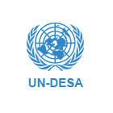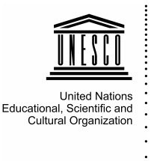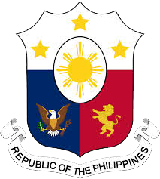*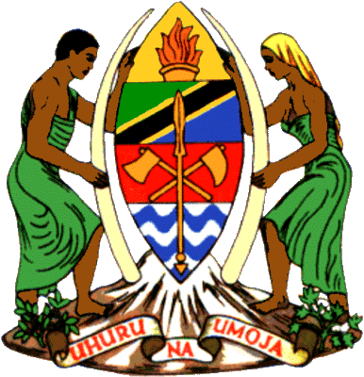http://www.mofa.go.kr/ENG/image/common/mofa_logo_top.png**The Permanent Mission of the Republic of Korea to the United Nations*

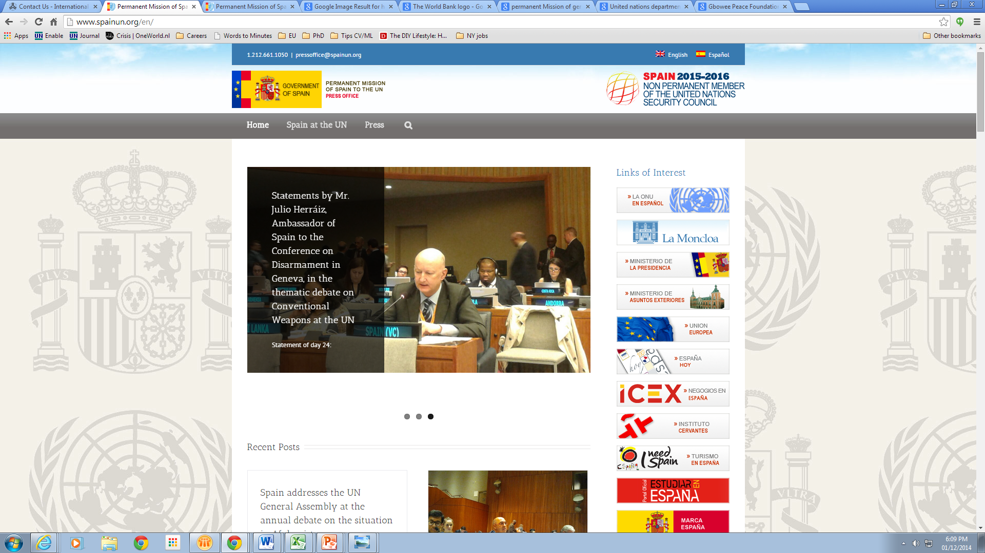

**Co-sponsored by the Permanent Missions of Brazil, Philippines, Republic of Korea,   
Spain, and United Republic of Tanzania to the United Nations and UNESCO**

# *\*For more information or for queries, please visit* [*www.un.org/disabilities*](http://www.un.org/disabilities) *or email:* [*enable@un.org*](mailto:enable@un.org)*.* All events will take place in the General Assembly Building, except for the reception.