***61st Session of the Commission on the Status of Women***

***Parallel Event***

**Intersectionality of Gender, Disability and Indigenous Identity: Experiences in Cross-Movement Collaboration to Empower Indigenous Women with Disabilities**

**Wednesday March 15, 10:30 AM to 12:00 PM**

**Location:** Armenian Cultural Center **Room:** Yerevan Hall

**Address**: 630 2nd Ave, New York, NY 10016

***Olga Montufar***

Indigenous Persons with Disabilities Global Network

***Krishanti Dharmaraj***, Executive Director Center for Women’s Global Leadership



*With International Sign Language and*

*captioning*

***Chanda Thapa Magar,*** Indigenous Women’s Programme Asia Indigenous Peoples Pact (*to be confirmed)*

***Maribel Derjani-Bayeh***, Policy Specialist UNWOMEN

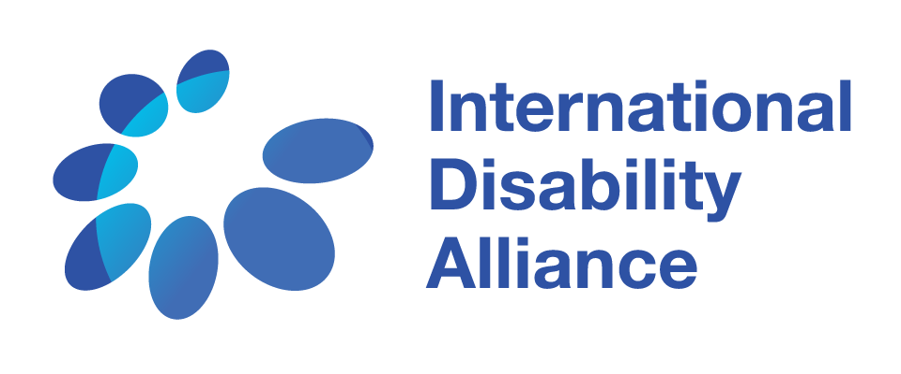***Megan Smith***, 2030 Agenda Liaison Coordinator International Disability Alliance

**Experiences in Cross-Movement Collaboration**

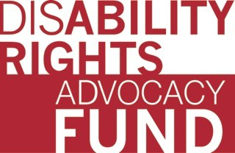Indigenous women with disabilities and their allies present global advocacy experiences to promote the **rights of indigenous women and girls with disabilities** and explore:

* Why is it important to work together to address the rights of **marginalized women and girls**?
* What collaborative good practices can we employ to **tackle discrimination**? What are the challenges?
* What are the strategies for cross movement collaboration with the **global women’s movement** to fight for the inclusion of all women?
* How do we combine our efforts **to end violence, exploitation, and human rights abuses** against all women, including indigenous women with disabilities?

 Lisa Adams [ladams@disabilityrightsfund.org](mailto:ladams@disabilityrightsfund.org)

**Disability Rights Advocacy Fund drafund.org**