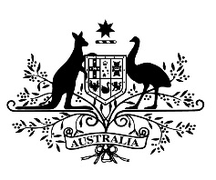
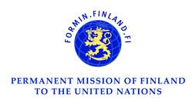
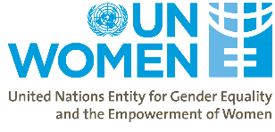

61st Session of the Commission on the Status of Women
Side Event

“Working to improve our own futures”: Strengthening networks of women with disabilities in humanitarian action

Monday 20th March, 1:15pm – 2:30pm
Conference Room B, United Nations Headquarters

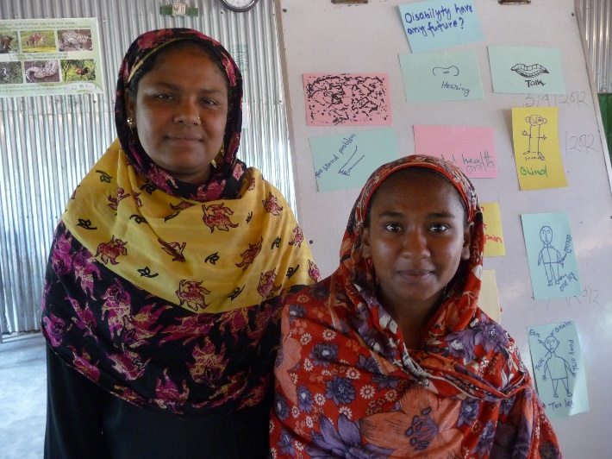
Organizations of women with disabilities can play a critical role in reaching women and girls with disabilities affected by crisis and conflict. Such work can bridge the development – humanitarian divide in an emergency and strengthen community resilience in protracted crisis. This side event will explore the roles and responsibilities of governments, international bodies, and civil society in strengthening the capacity of these organizations, including strategies to foster the economic empowerment and independence of organizations of women with disabilities.
Moderated by: Donald Steinberg – Current president and CEO of World Learning, past Deputy Administrator to USAID and former US Ambassador.

Remarks by:
- Ambassador Kai Sauer, Permanent Representative of Finland to the UN
- Ms. Sarah Goulding, Assistant Secretary of the Gender Equality Branch, Department of Foreign Affairs and Trade, Government of Australia
- Mr. A.H. Monjurul Kabir, Programme Advisor/Head of Section, Asia and the Pacific, Programme Division, UN Women
- Ms. Rama Dhakal, a member of the South Asian Disability Forum
- Ms. Sarah Costa, Executive Director, Women’s Refugee Commission

For more information, please contact Emma Pearce at: EmmaP@wrcommission.org

