
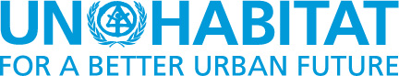

UN DESA/DSPD Forum
Disability and development – Disability Inclusion and Accessible Urban Development
Nairobi, 28-30 October 2015
Case studies

This is an unofficial, unedited compilation of exemplar case studies received by UN-DESA, from experts participating in the DESA/DSPD Forum

Country | Name of the organisation/ Government entity | Title, Initiative / Summary | Appendix
Brazil | RIOinclui – Obra Social da Cidade do Rio de Janeiro | RIOinclui  Offers accessible housing for children and youths with disabilities living in poor conditions in the city of Rio de Janeiro. | Appendix 1
Canada, International | Inclusive Design Research Centre, AXS Map | AXS Map Mapathons and Aha! Accessible Places and Inclusive Design Workshops  Workshops to raise awareness about the accessibility of businesses, public spaces and other places within a community, educate business owners and property owners. | Appendix 2
Canada | Province of Ontario | Accessibility for Ontarian with Disabilities Act (AODA) Information and Communication, Employment, Transportation, Design of Public Spaces (Built Environment)  Removing barriers to improve the quality of life for people of all ages and abilities in the province of Ontario. | Appendix 3
Canada, International | Inclusive Design Research Centre and Raising the Floor International | AccessForAll: Platform for Economic Inclusion  To enable the participation of people with disabilities in the full economic ecosystem.  To connect consumers at the margins with producers and suppliers at the margins for mutual benefit. To prompt filling the gaps in the supply chains and create a supply chain that responds to diverse demands thereby addressing the needs of consumers that are outliers, To reduce disparity. | Appendix 4
Colombia | Observatory of Disability in a Capital | Disability and Society Class  Undertakes different social sceneries for analyse, discuss and propose mechanisms of action to think possible improve the quality of life of persons with disabilities. | Appendix 5
Ecuador | Technical Secretary for the Inclusive Management on Disabilities of the Vice-Presidency of the Republic of Ecuador (SETEDIS) | Ecuador Lives Inclusion (Ecuador Vive la Inclusión); Ecuadorian Methodology for Development Universal Accessibility Plans  Promote the adoption and adaptation of universal accessibility norms. Implement accessibility adjustments by building capacity within national and local governments, civil society and private sector, and by developing technical tools as essential factors to bridge and achieve inclusion. | Appendix 6
Ethiopia | Ethiopian Center for Disability and Development (ECDD) | Guide to Accessible Ethiopia: promoting accessibility in Ethiopia  The aim of the project was to educate, promote and facilitate accessible design and building modifications by providing technical information. | Appendix 7
Ethiopia | Ethiopian Centre for Disability and Development (ECDD) (NGO) | Promoting Accessibility in Ethiopia; The audit and publication of information accessibility of towns in Ethiopia  Survey to measure the level of accessibility of services and facilities. | Appendix 8
Ethiopia, Zambia, Uganda, South Africa, Sierra Leone | African Child Policy Forum (ACPF) | Disability Awareness Creation: Towards an inclusive Africa  Report that analyses the accessibility of public and private service facilities in five African cities, namely Addis Ababa, Freetown, Lusaka, Kampala and Johannesburg. | Appendix 9
Germany | Sozialhelden e.V. | Wheelmap - Interactive city map for wheelchair accessibility  An online map which indicates whether or not a location is wheelchair accessible | Appendix 10
Hong Kong SAR, China | Labour and Welfare Bureau, The Government of the Hong Kong SAR | Accessibility and Retrofitting to Public Premises in Hong Kong  Report on improvement of accessibility, connectivity and interface with surrounding environment and user-friendly management practices for publicly accessible premises. | Appendix 11
India | Samarthyam, National Centre for Accessible Environments | Promotion of user-friendly Public Transport Systems - Buses & Bus Shelters  Research Study to document the existing infrastructure, provide user groups perspective, evaluate and assess the public transportation services in Delhi. | Appendix 12
International | The Global Alliance on Accessible Environments and Technologies (GAATES) | A Global Snapshot of Transport Needs and Priorities  A survey about available public transport. | Appendix 13
International | Associates for International Management Services | Universal accessibility in the context of development: issues and options  Universal accessibility in the context of development in contrast to regulatory-specific approaches to environmental accessibility. | Appendix 14
Ireland | National Disability Authority – Centre for Excellence in Universal Design | Shared Space, Shared Surfaces and Home Zones from a Universal Design Approach for the Urban Environment in Ireland  Research report investigating national and international ideas on how Universal Design is considered in the creation of Shared Spaces, Shared Surfaces and Home Zones in the Irish Urban context. | Appendix 15
Ireland | Centre for Excellence in Universal Design | Universal Design for Customer Communications To promote universal design as good design in customer communications that benefits a wide range of customers, but also results in a positive return on investment for businesses. | Appendix 16
Malaysia | Kuala Lumpur City Hall | Covered pedestrian & At-Grade In The City Kuala Lumpur  Barrier free and friendly pedestrian network, linkages to transportation hub, nodes, heritages areas and iconic buildings. | Appendix 17
Mexico | Government of Mexico, City Department of Environment of Mexico City | Metro Tezozómoc Pocket Park  Initiative of the Government of Mexico City to create a new public space as a result of public policies for social inclusion. It responds to an urban regeneration project by transforming an unused piece of land to a better public space. The pocket park intended to promote recreation, mobility, culture, social interaction and fun for all citizens in order to have a more inclusive city. | Appendix 18
Nepal | Kathmandu Metropolitan City (KMC) | Project/Programme title: Kathmandu Sustainable Urban Transport Project  Improving walkability in the city centre, in a corridor of approx. 15km | Appendix 19
Nigeria | Human and Organizational Resources Development Centre (HORDC) | Advocacy for inclusive Disability Laws, Policies and Programmes in Nigeria; Lagos State Urban Transport Project (LUTP)  Promoting, enhancing and sustaining the inclusion and accessibility of PWDs in all sectors of the society through inclusive laws, policies and programmes in line with the CRPD. | Appendix 20
Philippines | SM Shoemart | Experience from the Philippines: example of SM Shoemart, an inclusive business | Appendix 21
Qatar | Tawasol | The Development of an Arabic Symbol Dictionary; Development of Arabic Symbol Dictionary  The project aims to ensure that those with speech and language disorders and literacy difficulties in the State of Qatar have access to the communication resources they require to gain a voice and work towards greater personal autonomy. | Appendix 22
Qatar | Mada | Development of Arabic Assistive Technologies  The project aimed to ensure that people with a disability in the State of Qatar has access to technology and digital content to facilitate inclusion within society and were able to achieve their aspirations. | Appendix 23
Singapore | Building and Construction Authority (BCA) | Accessibility Master Plan to create a User-Friendly Built Environment  Accessible and universally design built environment. | Appendix 24
South Africa | Department of Transport, Public Transport Branch | Integrated Public Transport Networks: Johannesburg, Cape Town, Tshwane and Johannesburg; Operating network  Creating accessible, safe, affordable, efficient and integrated public transport. | Appendix 25
Uganda | Department of Elderly and Disability Affairs, Ministry of Gender, Labour and Social Development. | National Accessibility Standards  Accessible ramps in schools and new public and Private buildings. | Appendix 26
USA | The Federal Transit Administration and the U.S. Department of Housing and Urban Development | Realizing the Potential: Expanding Housing Opportunities Near Transit:  Study to better understand the proactive strategies being undertaken to create and preserve affordable housing near transit.  Green Infrastructure and the Sustainable Communities Initiative:  Report sharing green infrastructure best practices and output. | Appendix 27
USA | Livable New York | Advisory Workgroup Report  Helping municipalities’ better plan for the housing and community needs. | Appendix 28
USA | U.S. Urban Development Standards of Accessibility | Fair Housing Act | Appendix 29
USA | New York City Department of Transportation | Public Plaza: Inclusive Public Spaces; Madison Square Plaza Project  Understanding the complications with the built plazas and identify actionable remedies to those complications. | Appendix 30
USA | Coalition for a Livable Future (CLF) | Regional Equity Atlas (REA)  Assessing how different neighborhoods and populations are able to access the essential resources needed to meet their basic needs and advance their health and well-being. | Appendix 31

Country: Brazil
Name of Organistaion/Government entity: RIOinclui – Obra Social da Cidade do Rio de Janeiro
Project/Programme title: RIOinclui

Initiative selected as good practice example: Combining architecture, universal design and social work, RIOinclui offers accessible housing for children and youths with disabilities living in poor conditions in the city of Rio de Janeiro. A full network of local support is provided.

Thematic area of good practice example: Construction works for accessibility, capacity building, social work

Specific location: Rio de Janeiro, Brazil

Duration of project/programme: started in 2010

Beneficiaries of good practice example: Children and youths with disabilities

Implementing agency/agencies: RIOinclui – Obra Social da Cidade do

Brief background to the project: Persons with disability often have lower incomes, their families have higher expenses to cover, and many hardly ever leave home. Their homes do not offer any kind of mobility and their day-to-day life is compromised by limited mobility.

Overall objectives of the project/programme: Combining architecture, universal design and social work, RIOinclui provides accessible housing for children and youths with disabilities living in poor conditions in the city of Rio de Janeiro. Targeting physical and social mobility at the same time, the project goes beyond architectural interventions: reasonable accommodation for the beneficiaries and their care-givers is created. The whole family is empowered to benefit from statutory social welfare; a network of local support is provided.

Process/strategy to implement the project/programme: The Project is already implemented. At the end of 2013, 64 houses were built.

Changes achieved: With this project it was possible to give children and youths with disabilities living in poor conditions more perspectives and fulfil their basic necessities. For example leaving their home and therefor allowing them access to the community and going to school.

Country: International, Canada
Name of Organisation/Government entity: Inclusive Design Research Centre, AXS Map
Project/Programme title: AXS Map Mapathons and Aha! Workshops

Initiative selected as good practice example: Mapathon of Accessible Places and Inclusive Design Workshops www.axsmap.com and http://aha.idrc.ocadu.ca/

Thematic area of good practice example: Wayfinding, Education and Awareness, Community Engagement, Youth Engagement, Crowdsourcing

Specific location: Multiple locations globally, see www.axsmap.com

Duration of project/programme: 2012 to present and ongoing.

Beneficiaries of good practice example: Persons with disabilities, businesses, public venues, youth, community members, tourists and travellers

Implementing agency/agencies: Inclusive Design Research Centre, AXS map, school boards, community organizations

Source of funds: Ontario Government

Brief background to the project and Process/strategy to implement the project/programme:
A first step to creating accessible urban spaces is general awareness of accessibility principles and an understanding of the benefits of inclusive design within a community. Children and youth are ideal ambassadors for inclusion and accessibility. Engaging youth in spreading information about accessibility and gathering information about the location of accessible venues has multiple benefits: it seeds a culture shift within a community, maps out accessible businesses and venues for persons with disabilities, provides incentives for businesses that make accessibility improvements, educates business owners and encourages continuous improvement on the part of property owners and managers.

AXS Map is a web and mobile map application and crowd sourced accessibility database that invites community members to share reviews on the accessibility of businesses and places. The online and mobile interactive map application can be used to find businesses and venues that meet accessibility requirements for persons with disabilities and individuals that accompany them, including travellers. The online database is populated in part through community events called “Mapathons”, in which teams canvas neighbourhoods to identify the accessibility of all businesses and public spaces within a community. These teams include persons with disabilities and school children. The Mapathons have been used as experiential learning opportunities for school children in grades 4 through high school. Open, experiential curriculum units in math, social science, law, urban planning, communication and geography have been developed, using the Mapathons as a learning activity (e.g., learning radius and geometry by measuring turning angle and rise and run of ramps).
The Mapathon community events are accompanied by free workshops that educate business owners and property managers in the benefits of inclusive design and in strategies to make their businesses more accessible and inclusive of diverse customers. Business owners are provided with certificates that designate the accessibility level reached. Exemplary businesses are highlighted on the AXS Map site.

Overall objectives of the project/programme:
The objectives of the project are:
- To provide persons with disabilities with information about the accessibility of businesses, public spaces and other places within a community.
- To educate business owners and property owners regarding the benefits of inclusive design and strategies for making businesses accessible.
- To provide incentives for continuous improvement of accessibility within a community.
- To seed awareness of accessibility in school children, thereby encouraging a culture shift.
- To connect communities globally in the collective effort of inclusive design of urban spaces.

Changes achieved:
Over 100,000 businesses have been mapped around the globe.
Open educational resources in geography, math, law, social sciences, communication, architecture, and other subjects have been developed using Mapathons as a learning activity.

How change was monitored and evaluated:
Data analytics and usage metrics gathered on the AXS Maps site, as well as qualitative and anecdotal data gathered during Mapathons are being used to monitor and evaluate outcomes.

Shortcomings and persistent challenges identified in the implementation of the project/programme: While the program addresses the accessibility of businesses and public spaces, the accessibility of the urban infrastructure (sidewalks, roads, etc.) can continue to cause barriers to access. The Mapathons reveal that there are many misconceptions about accessibility and persons with disabilities. There appears to be a common resistance to accessibility compliance where there are building codes and laws related to accessibility. This resistance is supported by erroneous information about cost and incidence of disability.

Other lessons learned:
School children are ideal ambassadors for inclusive design. Once young people understand the challenge, they frequently assume that everyone must make communities accessible and will bridge no excuse for not continuously improving accessibility. In talking to businesses they are persuasive and disarming educators and see accessibility as a non-optional common goal.

Engaging the larger community in researching and rating accessibility creates community investment in the effort and leverages diverse perspectives and collective creativity in improving accessibility. Linking communities globally in a common map and database elicits community pride.

Country: Canada
Name of Organisation/Government entity: Province of Ontario
Project/Programme title: Accessibility for Ontarian with Disabilities Act (AODA)

Initiative selected as good practice example: City of London, Ontario, Canada

Thematic area of good practice example: Information and Communication, Employment, Transportation, Design of Public Spaces (Built Environment)

Specific location: City of London, Ontario, Canada

Duration of project/programme: from 2005 to 2025

Beneficiaries of good practice example: Persons of all abilities

Implementing agency/agencies: Corporation of the City of London, Ontario and its various departments

Source of funds: Municipal tax base

Brief background to the project: The Ontarian government enacted the Accessibility for Ontarians with Disabilities Act in 2005. It sets out a clear goal and timeframe to make Ontario accessible by 2025. It requires all municipalities to prepare a five year accessibility plan and to report annually on progress. “Large” organizations (50 or more employees) must comply by January 1, 2016. “Small” (less than 50 employees) organizations have until January 1, 2017.

Overall objectives of the project/programme: Removing barriers to improve the quality of life for people of all ages and abilities in the province of Ontario.

Process/strategy to implement the project/programme: The provincial government mandated changes for all to comply. Need to file implementation plan and report back every 3 years on progress. Accessibility plan to be revised every 5 years by companies or organizations with more than 50 employees (https://www.osler.com/uploadedFiles/AODA-Compliance-Checklist.pdf)

Changes achieved: City of London Accessibility Committee released its annual progress report in 2014
See: https://www.london.ca/city hall/accessibility/Documents/2014%20AODA%20Status%20Update.pdf, and
https://www.london.ca/city-hall/accessibility/Documents/FADS_2007_final.pdf

A brief summary follows:
- In 2013 the City of London’s Integrated Accessibility Policy and Multi-year Accessibility Plan was passed by Council. Its Purchasing and Supplies Bylaw was amended to incorporate the accessibility in its purchasing process. In the same year, the City launched its accessible web site in accordance with Web Content Accessibility Guidelines (WCAG) 2.0. By January 1, 2014, public or private sector organizations with 50 or more employees must ensure that any new website or web content must conform to WCAG 2.0 Level, and by January 1, 2021, to WCAG 2.0 Level AA.
- The City met the requirements of the 2008 Accessibility Standards for Customer Service in 2010, e.g. better signage; accessible counter retrofit; sensitivity training for all new employees and refresher courses for existing staff.
- In 2014, there were 91 audible pedestrian signals in the city.
- Zoning and parking by-laws were amended in 2014 to reflect the new parking standards and the size of accessible parking stalls.
- The City of London’s Facilities Accessible Design Standards has inspired over 50 cities and organizations to follow suit e.g. City of Winnipeg, Manitoba; City of Windsor, Hamilton, and Niagara Region, Ontario, as well as organizations such as the Essex County Accessibility Advisory Committee, New Jersey, USA; Le Phenix (NGO to represent Franco-Ontarian handicapped persons, based in Alfred, Ontario).
- Instituted a Diversity, Race Relations and Inclusivity Award since 2013 to “promote public awareness of and encourage ongoing initiatives on diversity, anti-racism”.

How change was monitored and evaluated:
City of London’s Accessibility Plan Coordinator acts as a resource for all service areas and facilitates the compliance of AODA.
In 2013, an Accessibility Implementation and Compliance Advisory Committee was formed but abandoned in 2014. Now all oversight of AODA matters is handled by the City’s Operations and Management Team comprising representatives from all service areas and oversees the AODA budget.
The Accessibility Directorate of Ontario (represented by the “Director”) can impose fines on organizations for failure to file an Accessibility Report. Its decisions can be contested at the License Appeal Tribunal.
See http://www.canadianlawyermag.com/5055/Not-compliant-with-AODA-Ignore-compliance-audit-notice-at-your-peril.html
http://www.auditor.on.ca/en/accessibility_achievementpolicy_en.htm
http://www.rubinthomlinson.com/blog/aoda-compliance-audits-and-websites/

Shortcomings and persistent challenges identified in the implementation of the project/programme:
- Long time frame: 20 years, hard to keep up momentum, may result in loss of institutional continuity and memory.
- Looks good on paper, could be hard to apply due to institutional barriers (provincial vs municipal and private sector).
- e.g. Budget cuts on paratransit services despite provincial law mandating services to be available. (http://www.ontario.ca/laws/regulation/r11191#BK49).
- There is insufficient “carrot or stick” to the Act. No incentive or reward granted. Penalties are relatively small compared to ADA (CDN $500-$15K as compared to the ADA US$55K-75K, subsequent violation US$150K) http://www.canadianlawyermag.com/5055/Not-compliant-with-AODA-Ignore-compliance-audit-notice-at-your-peril.html
http://www.aoda.ca/aoda-administrative-monetary-penalties-scheme-%E2%80%93-three-strikes-you%E2%80%99re-out/
- So far, there is no reported indication that the Government has levied fines, or conducted spot audits, or sent inspectors into any private sector organizations. In the case of private organizations with 20 or more employees, they are supposed to file a compliance report with the government by December 31, 2012. See http://www.aoda.ca/the-latest-in-our-campaign-to-get-the-wynne-government-to-at-last-keep-its-promise-to-effectively-enforce-the-accessibility-for-ontarians-with-disabilities-act/
- Social-cultural and generational issues on transport not well covered.
- Mental health issues not well understood or covered.
- Residential properties not covered, recreation and playgrounds not well covered.
- Multiple disabilities not well covered.
- Need to balance the requirements of the various stakeholders (government, industry/operator and the user), for example, Dean Mayo Moran’s Review of AODA Implementation and Enforcement: Written Submission on the lack of harmonization associated cost and budget, training and education, compliance and enforcement.
http://www.karlencommunications.com/adobe/ReviewOfAODA2014WrittenSubmissionMcCall.pdf
- Rural municipalities and native reserves transport needs not well covered.

Other lessons learned:
- Information material should be made available or disseminated in accessible formats for all (mobility, sensory and cognitive) groups with disabilities.
- Accessibility provisions should be planned with the users, and not imposed on them.
- Institutional barriers need to be overcome.
- Independent and effective enforcement and complaint mechanism need to be in place.

Country: International, Canada
Name of Organisation/Government entity: Inclusive Design Research Centre and Raising the Floor International
Project/Programme title: AccessForAll

Initiative selected as good practice example: Platform for Economic Inclusion

Thematic area of good practice example: Flexible economy, sharing economy, crowdsourcing, smart cities, digital inclusion

Specific location: Multiple locations, across Europe, North America and South America

Duration of project/programme: Multiple projects since 1998

Beneficiaries of good practice example:
1. Anyone facing barriers to participation in economy and digitally mediated practices and systems. 2. Consumers whose needs are not met by mass production and markets.
3. Producers and suppliers who face barriers to market entry.

Implementing agency/agencies: Libraries, schools, government services, community access points, open education initiatives.

Source of funds: Multiple sources, including Canadian and US governments, European Commission as well as William and Flora Hewlett Foundation and Andrew W. Mellon Foundation.

Brief background to the project and Process/strategy to implement the project/programme:
AccessForAll aims to achieve digital inclusion through dynamically matching each individual’s unique needs and preferences with the resources, services, interfaces, or environments available by pooling resources, using digital transformation, and connecting to suppliers and producers who may also face barriers.

It is built on the recognition that users are diverse; that the delineation between people who are disabled and non-disabled is arbitrary, not absolute; that people with disabilities are one of the most heterogeneous groups and do not fit neatly into diagnostic categories; that those categories can yield misleading information; and that the diagnostic category may only be a small factor in his or her needs and preferences. As such, both disability and accessibility are seen as relative conditions or traits. The purpose of AccessForAll is to enable systems that deliver user experiences, resource configurations, products and services that match the unique needs and preferences of each individual, whether or not disability is part of the context.

AccessForAll supports the premise that digital systems and networked communities make it possible to provide a one-size-fits-one solution.
The Global Public Inclusive Infrastructure (GPII) uses globally linked cloud infrastructure to deliver this individualized solution anywhere, anytime, on any device or platform. To deliver this functionality requires a set of broad conditions or functions. Among them:
- A means for supporting the individual in discovering accurate and current information about their individual needs and preferences in a given context, while fulfilling a given goal, and declaring this information in a common language that can be understood by technical systems and services;
- A way to securely and privately store this information and communicate the relevant information to the right services when needed;
- A variety of mechanisms for finding, transforming/adapting, augmenting or substituting user experiences and resources to match the individual needs and preferences anywhere, anytime, on any device or platform, and delivering these to the individual,
- A means for addressing gaps in available systems or resources; and
- A process for the user and their support team to provide feedback or review the success of the match, to both help to refine the matching process and refine their personal needs and preference profile or statement.

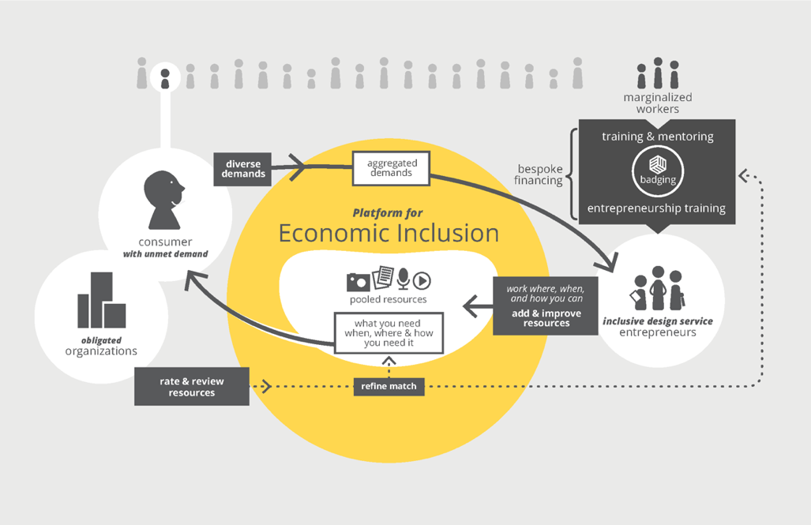
Figure 1: The Platform for Economic Inclusion illustrating the points above.

History of AccessForAll
Web4All
AccessForAll has its origins in the Web4All project (1999-2004; http://web4All.ca) implemented in Canada through a partnership between the Canadian Government and the Adaptive Technology Resource Centre at the University of Toronto (now the IDRC at OCAD University). The objective of Web4All was to make it possible for any user to instantly reconfigure any multi-user community access point (internet workstation) to match their personal requirements. This was achieved through a small needs and preference file that could be stored on a smart card (e.g., Bell calling card, library card, or bank card) or USB stick. The user was guided in specifying their personal needs and preferences through a needs and preference wizard. Web4All relied upon a small open source program and a set of solutions loaded onto each workstation.
TILE
The AccessForAll approach was next implemented in the education domain through a project called TILE (2002-2005; The Inclusive Learning Exchange, http://inclusivelearning.ca). TILE enabled learners to discover and declare their personal needs and preferences, the TILE server then delivered a learning resource or learning object that matched those needs and preferences. TILE leveraged the existence of federated learning object repositories with diverse learning resources that could address the spectrum of learner needs.
IMS Global Learning Consortium
The successful use of the AccessForAll approach is dependent on an interoperable, extensible common language for describing personal needs and preferences and an extensible common language for labelling resources to match those needs and preferences. To achieve this interoperability Prof. Treviranus brought the AccessForAll concept to the IMS Global Learning Consortium Accessibility working group with the support of WGBH SALT funding in 2002. The AccessForAll specification became an IMS recommendation in 2004 (http://www.imsglobal.org/accessibility/accmdv1p0/imsaccmd_oviewv1p0.html). The IMS Accessibility Working Group has since developed several versions of AccessForAll.
International Standards Organization (ISO) Standard
In 2004 Canada sponsored the adoption of AccessForAll as an ISO multi-part standard. ISO 24751 became a standard in 2008 (available via http://standards.iso.org/ittf/PubliclyAvailableStandards/index.html).
In 2009, the Raising the Floor Consortium formed to work on development of the GPII, which included cloud-based auto-personalization. It chose Access4All as the basis for the auto-personalization and in 2010 submitted a proposal to the European Commission to advance auto-personalization using Access4all under the project title Cloud4all. This project is working with the ISO Standards group to evolve ISO 24751 into a registry standard for AccessForAll terms, with a registry to be maintained by Raising The Floor International. There is an agreement between IMS and ISO to maintain the compatibility of the standard and specification.
Implementations
The FLOE project (2010-current; http://floeproject.org) is one of the most mature implementations of AccessForAll in the learning domain, leveraging the diversity of Open Education Resources to match the individual needs and preferences of learners.

An implementation begun in 2014 will implement GPII which includes Access4all in Libraries.
And a new project has been launched to implement GPII including Access4all in high schools, community colleges, American Job Centers, homes and companies (employers).

Overall objectives of the project/programme:
- To enable the participation of people with disabilities in the full economic ecosystem.
- To connect consumers at the margins with producers and suppliers at the margins for mutual benefit.
- To prompt filling the gaps in the supply chains and create a supply chain that responds to diverse demands thereby addressing the needs of consumers that are outliers.
- To reduce disparity.

Changes achieved:
Among the changes achieved are:
- a portable preference file that can be carried from system to system and automatically matched so that individuals with alternative access needs don’t need to explain or justify requirements,
- a growing pool of open source supports for creating accessible products and services
- educational resources that are matched to individual learner needs
- the removal of barriers to digital literacy
- a platform for a more inclusive city

How change was monitored and evaluated:
The platform acts as a dynamic research engine. Each participant provides feedback and can monitor success criteria. People with disabilities can measure the effectiveness of services and products provided through the platform and use this data to refine their understanding of their requirements to refine their request and the match provided by the platform. This data can be made anonymous and aggregated to identify gaps in services and provide policy guidance.

Shortcomings and persistent challenges identified in the implementation of the project/programme:
The primary challenges are a lack of understanding of the approach to accessibility and the application of emerging economic models based on networks. The accessibility community globally is very invested in deficit models and categories of disability for advocacy. Funding and legislation is built upon this framework and it seems risky to deconstruct this. The notion that every individual is different and disability is not the focus but just one facet of access is not readily accepted. Governments are very invested in a job model and are less supportive of flexible economies. The private sector is built on the notion of mass production, pushing products and not by consumer initiated demands. These are all shifting but some of the current projects may have been a little “before their time.”

Other lessons learned:
The feedback loops inherent in the platform can act as a means of amassing evidence to guide policy and support funding. This addresses the current bias against diverse beneficiaries and diverse measures in evidence-based decision making.

Links:
Floe Project: http://floeproject.org
Raising the Floor: http://raisingthefloor.org/who-we-are/our-approach/
GPII: http://gpii.net
Web4All: http://web4all.ca
Prosperity4All: http://www.prosperity4all.eu

Country: COLOMBIA
Name of Organisation/Government entity: UNIVERSIDAD DEL ROSARIO
Project/Programme title: DISABILITY AND SOCIETY CLASS

Initiative selected as good practice example:

Thematic area of good practice example: OBSERVATORY OF DISABILITY IN A CAPITAL

Specific location: BOGOTÁ-COLOMBIA

Duration of project/programme: The Disability and society class started from 2001 until now, uninterrupted.

Beneficiaries of good practice example: University students of health and social sciences, civil society, organizations of persons with disabilities, public or private representatives through forums or participation in worktables national or international.

Implementing agency/agencies:

Source of funds: UNIVERSIDAD DEL ROSARIO

Brief background to the project: The Disability and Society class undertakes different social sceneries for analyse, discuss and propose mechanisms of action to think possible improve the quality of life of persons with disabilities and its influence of

During these years, the class has taken special issues about disability like a social perspective, need to change the healthcare approaches towards human rights, the responsibility of use of the language like a social determinant of the forms like the societies

Overall objectives of the project/programme:
- Identify the historical evolution of the concept of disability, myths and social realities.
- Understand how imaginaries and social representations have an impact on the understanding of disability
- Explain the diverse theoretical and conceptual approaches that address the concept of disability
- To identify policy relating to national and international level and influence on policies, plans, programs or projects related to disability
- Analyze social situations relating to the participation of persons with disabilities, access to education, access to employment, access to public spaces, access to public transport, access to tourist sites, among others, through a comparative analysis with public policies.

Process/strategy to implement the project/programme:
- Link different perspective on disability starting from self-perception of the participants, breaking paradigms, is the first unit and work through a pedagogical workshop (own creation). With this, the participants recognize the influence of thoughts in the disability comprehension and the social consequences that could impact the approaches that are built national policies, plans or programs.
- Depth study of the Convention of Human Rights for persons with Disabilities, like a mirror to reflect the national situation in regard of change of policies, national development plan, among others for determine the gaps and challenges to do.
- Involve real situations of persons with disabilities through case studies, for example Constitutional Court Sentences.
- Open dialogues with persons with disabilities, organizations and families.

Changes achieved:
- Positive perception of the participants about their responsibilities in disability, is not an issue to behoove a one sector if not depend of all, like professional, like citizen, like a public or private server among others.
- Be part of an institutional commission for design a policy about Inclusion in higher education.

How change was monitored and evaluated:
- The class planning is founded in a critical review of the context both nationally and internationally.
- The participants can to development field work, contrasting different situations that involve the lives of persons with disabilities, if the can access to education, if they can access to public transportation, if does exist facilities to make tourism among others, and propose alternatives to change, or give recommendations to different sectors.
- The participants evaluate the impact of the class into their academical formation.

Shortcomings and persistent challenges identified in the implementation of the project/programme:
- Can involve more decision makers for implementing transformations with the vision that the quality of life for persons with disabilities impacts positively the social development of any nation, reducing the poverty, increasing the access to public services and linked different sectors that share common aims.
- The start point is not more economical resources, first of all is important start of positive willingness towards inclusive societies (societies for all), universal design, reasonable adjustments, where could be creating possibilities to habit, occupy and be in common spaces (home, school, places of entertainment, transportations, among others).

Other lessons learned:
- Disability is a reality that appears to all societes and is important trascend to gain participation, visibility, and recognition of the persons with disabilities.
- Is very important articulate the realities of the disabilities and its relation with the Sustainable Development Goals.
- Transportation and tourism are good forms that a country or city express its commitment with make possible that persons with disabilities can appropriate of their territories or can access to others with confidence and guarantee of recognition.

Country: Ecuador
Name of Organistaion/Government entity: Technical Secretary for the Inclusive Management on Disabilities of the Vice-Presidency of the Republic of Ecuador (SETEDIS)
Project/Programme title: Ecuador Lives Inclusion (Ecuador Vive la Inclusión)

Initiative selected as good practice example: Ecuadorian Methodology for Development Universal Accessibility Plans

Thematic area of good practice example: National and local experience on planning and building accessible and inclusive cities: Infrastructure, housing and public spaces

Specific location: National (24 provinces)

Duration of project/programme: 2013 – ongoing

Beneficiaries of good practice example:

350.000 Pregnant Women
1.500.000 Children under five years old
1.229.089 older adult
374.251 Persons with disabilities

Implementing agency/agencies: Technical Secretary for the Inclusive Management on Disabilities of the Vice-Presidency of the Republic of Ecuador (SETEDIS)

Source of funds: Government of the Republic of Ecuador

Brief background to the project:
The Technical Secretariat for the Inclusive Management on Disabilities was created in 2013 to coordinate the transfer of programs and projects from the Misión Solidaria Manuela Espejo to the guiding ministries; following Executive Directive No. 547, enacted January 14, 2015, this was transformed into the Technical Secretariat for the Inclusive Management on Disabilities.
Among its roles are the coordination of cross-sector implementation of public policy in matters concerning disabilities such as development and enactment of policy, plans, and programs to raise awareness about persons with disabilities within the initiative of Participatory and Productive Inclusion and Universal Access under the national program Ecuador Lives Inclusion (Programa Ecuador Vive la Inclusion).
Social inclusion requires a systematic approach in which universal design plays a key role. The Ecuadorian Government is deploying efforts on achieving inclusion, for which the Technical Secretariat of Disabilities, SETEDIS, is working on the topic of "Universal Accessibility" (UA) as a strategic and priority project, which while having a greater impact on persons with disabilities, children, pregnant women, and the elderly, also has a positive impact for all population.
During the second semester of 2013, SETEDIS started its activities on UA, and detected several issues about public policies, effectively planning projects, defining priorities and establishing realistic goals; all these mainly due to the lack of national information, indicators and methodologies.
This scenario promoted the creation of an innovative methodology to assess and measure UA, which facilitated developing accessibility plans and prioritizing their implementation.
Overall objectives of the project/programme:

- Promote the adoption and adaptation of universal accessibility norms.
- Implement accessibility adjustments by building capacity within national and local governments, civil society and private sector, and by developing technical tools as essential factors to bridge and achieve inclusion.

Process/strategy to implement the project/programme:
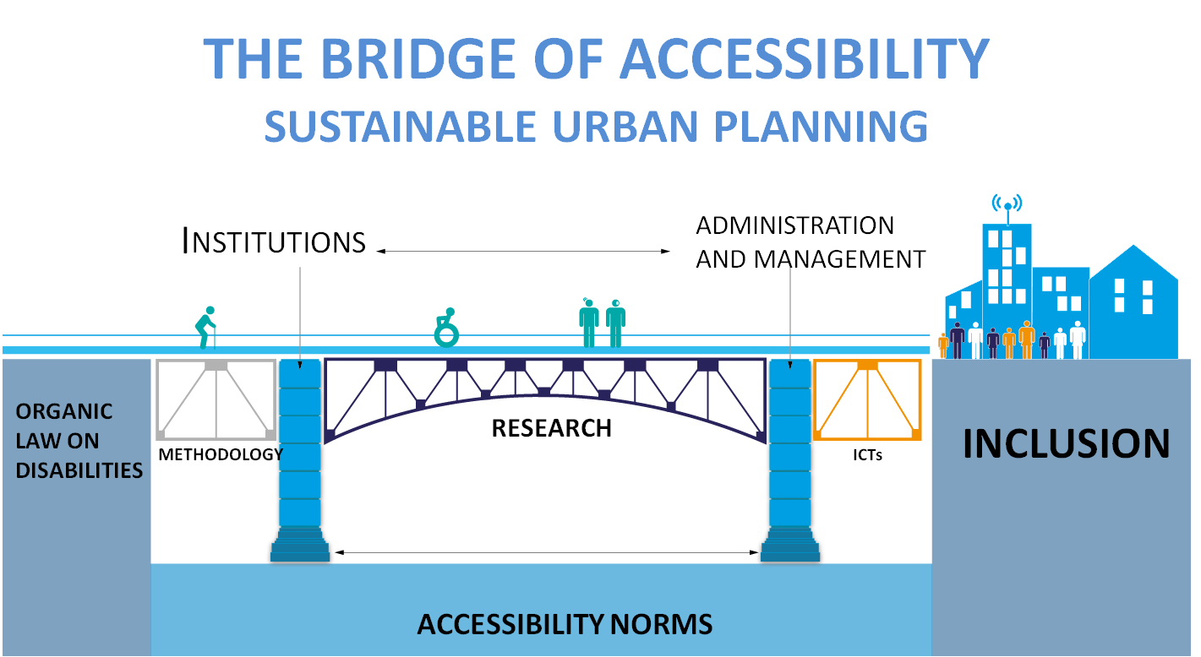

Treatment of persons with disabilities changed radically with the adoption of Ecuador’s new constitution in 2008. Since then, work had been done to provide persons with disabilities with equal opportunities and to improve their living conditions. In addition, the Organic Law on Disability was adopted in 2012, and other national plans and legislation further promoted and protected their rights.
In terms of legislation, Ecuador has taken its greatest step on advocating the Rights of Persons with Disabilities. In practice, however, an effective inclusion of persons with disabilities required a bridge where national and local governments, civil society in particular Disable People Organizations (DPOs), and the private sector, join together in the implementation of Universal Accessibility.
The first step was the adoption and adaptation of universal accessibility norms. By the year 2013, the accessibility regulations covered only the physical standards. In late 2013, 16 norms and standards were introduced in Ecuador, including aspects of information, communication, transport, technology.
The second step was to address the lack of knowledge about the topic as well as the absence of qualified professionals, which constitute a major obstacle for the advancement in accessibility at a national scope. As a response, SETEDIS created a methodology and an index on accessibility, and built capacity in urban planning and design professionals.
At the present, complementary initiatives are being developed, which are axed in a cross-sector implementation strategy of public policy, to name a few:

- Incorporate Universal Accessibility and Universal Design into professional curricula.
- Provide technical assistance to Decentralized Autonomous Governments on the design and adoption of Ordinances.
- Incorporate a chapter on Universal Accessibility into the Ecuadorian Building Standard (NEC), mandatory regulations for the building industry.
- Create an Accessibility recognition seal.
- Accessibility principles in the e-government project law.

Changes achieved:
The general results expose a worrying actual scenario in matters of inclusion; also, it is proved that the methodology could be applied on further studies of universal design with minimum adaptations.
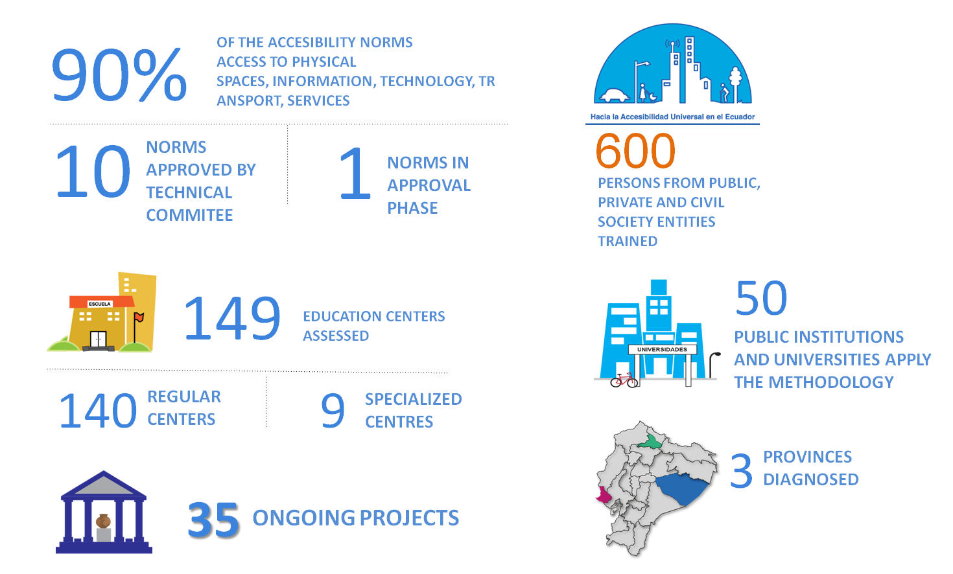
Some of the main achievements are:

Universal access is an issue that cuts across disabilities and sectors, and therefore, constitutes the very basis of empowerment of people with disabilities. Ecuadorian Universal Accessibility strategy is in line with Participative Inclusion, which has developed 140 intersectorial networks of territorial coordination.
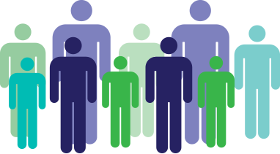
Circuits count with a Strategy of Inclusive Community Development
Persons participated in the process
90
64.000
Intersectoral Networks of Territorial Coordination
140
Public and Private Institutions are Part of the Network
500
How change was monitored and evaluated:

The application of the methodology allowed gathering national data on universal accessibility. It constitutes the base line for upcoming evaluations in the implementation of universal adjustment.
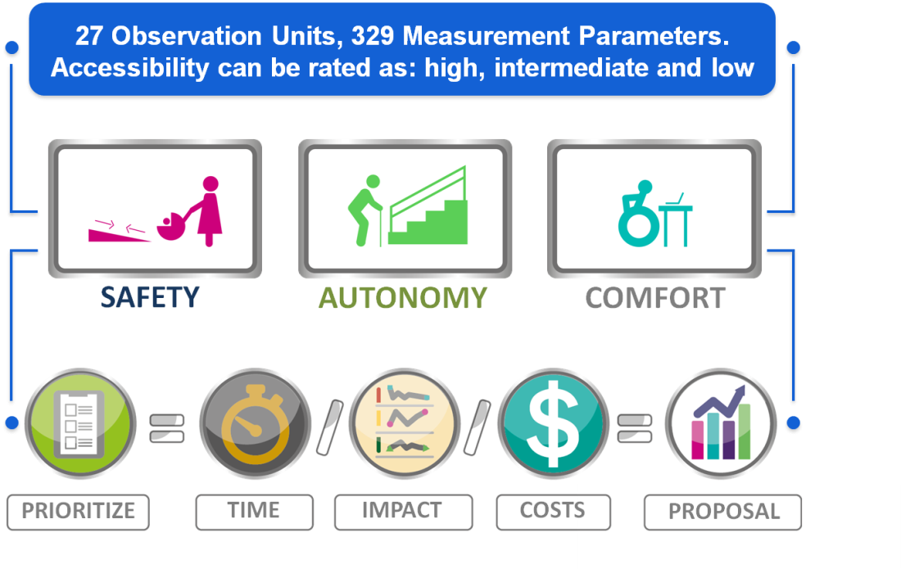
The methodology includes an index and three core indicators: safety, autonomy, and comfort. During 2014, the methodology with its index was tested and validated in two studies, one in hundred forty nine (149) public schools and a diagnosis of accessibility in three (3) provinces of Ecuador. Both studies were carried out as participative process which took into account users' experiences and opinions.

A Principal Components Analysis (PCA) was applied to obtain values and vectors of the sampling covariance matrix, resulted from the main data matrix. PCA determines the Ecuadorian accessibility index as follows:
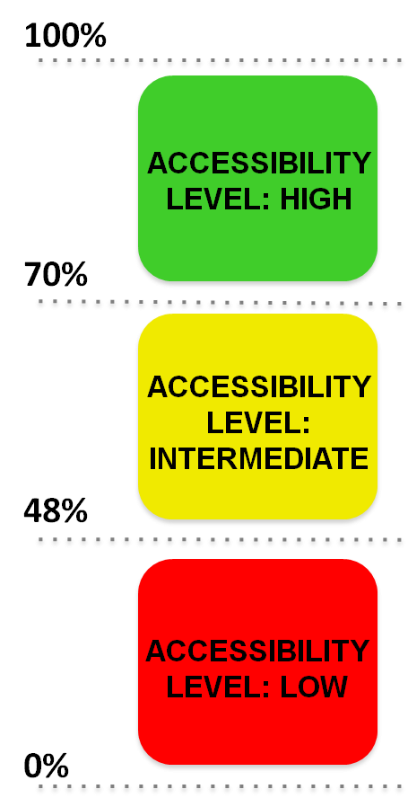


47%
LOW
GENERAL ACCESSIBILITY LEVEL IN ECUADOR

Shortcomings and persistent challenges identified in the implementation of the project/programme:
As a result of the methodology and the studies we have: prioritizing resources to make accessibility adjustments in public schools by the Ministry of Education; the creation of a governmental free service for assessing public and private entities on developing and implementing their own “accessibility plans”, among others.
The main challenge identified is “the mirage of the wheelchair ramp”, universal accessibility is often reduced to describe facilities or amenities to assist people with impaired mobility.
The implementation of accessibility adjustments and their proper maintenance requires the development of an accessibility management system by the Decentralized Autonomous Governments and political decision to mobilize adequate funds.

Country: Ethiopia
Name of Organisation: Ethiopian Center for Disability and Development (ECDD)
Project title: Guide to Accessible Ethiopia: promoting accessibility in Ethiopia

Initiative selected as good practice example: Yes

Thematic area of good practice example: Promoting urban accessibility

Specific location: Addis Ababa and 12 secondary towns in Ethiopia

Duration of project: 2013-14

Beneficiaries of good practice example: Residents and visitors with disabilities

Implementing organization: ECDD

Source of funds: Light for the World (LFTW) - Austria

Brief background to the project: The ECDD-LFTW project assessed the accessibility of selected public buildings and services in Ethiopian towns for persons with disabilities, including hotels, guest houses, restaurants, shopping places, medical services, tour and travel services, museums, and recreational centers among other establishments. ECDD surveyors collected information on the accessibility of facilities and services for persons with physical, visual and hearing disabilities living in Addis Ababa and in 12 secondary towns of the country, including Adama, Bishoftu and Jimma in Oromia Regional State, Hawassa and Arba Minch in Southern Nations, Nationalities and Peoples’ Regional State, Axum and Mekele in Tigray Regional State, Bahir Dar, Gondar, and Lalibela in Amhara Regional State, and the cities of Dire Dawa and Harar in eastern Ethiopia. Six separate Regional Guides to accessible facilities and services in Addis Ababa and the 12 towns, as well as a combined “Guide to Accessible Ethiopia” were prepared and made available to the public.
Overall objectives of the project: To educate, promote and facilitate accessible design and building modifications by providing technical information. Persons with physical, visual, hearing or other impairments are citizens, consumers, students and workers just like everyone else. They need, deserve and have a right to access services and opportunities available to everyone. By building inaccessible buildings and maintaining physical barriers, cities continue to exclude and discriminate against persons with disabilities. By doing so, society loses the contribution of its disabled members. The World Bank estimates the annual loss of GDP globally, due to the exclusion of persons with disabilities from economic activities at over US$1 trillion.
An accessible infrastructure not only benefits people with disabilities but a wide range of people such as elders who have difficulties in walking, pregnant women and young mothers carrying babies, people with cardiac problems, persons carrying heavy loads, and people with temporary impairments such as a broken leg. Anyone can or will join one of these categories sooner or later in life, thus accessibility and inclusion concern a much larger public than only persons with disabilities.
Buildings, sidewalks, parks, recreational areas and other structures and spaces should be designed or adapted in a way that meets the needs of as many people as possible, including persons with disabilities. It is much easier to consider accessible designs at the beginning of a project because if taken into account during the conception phase accessible design considerations represent only 2%, often less, of the total cost of a structure.
Process to implement the project: ECDD recruited and trained persons with disabilities as surveyors in each city/town, who then surveyed target businesses and organizations using a survey checklist. The collected data was then tabulated and written up in the form of city/town Guides, which were then printed and distributed. The Guides were also made available on the ECDD website.
Changes achieved: Several surveyed establishments made accessibility modifications, particularly the installation of ramps and accessible toilets, as a result of the project.
How change was monitored and evaluated: Establishments wishing to undertake accessibility modifications usually contacted ECDD for technical guidance.
Shortcomings and persistent challenges identified in the implementation of the project: During the course of the project literally hundreds of new buildings were constructed in Addis Ababa and in the 12 secondary towns, making it impossible for the Surveyors to keep up and to ensure the Guides were up to date.
Other lessons learned: Producing a current access guide to buildings and services in dynamic urban areas of Ethiopia proved to be a time-consuming and eventually impossible task, despite the utility of the guide to residents and visitors with disabilities.

Country: Ethiopia
Name of Organisation/Government entity: Ethiopian Center for Disability and Development (ECDD) (NGO)
Project/Programme title: Promoting Accessibility in Ethiopia
Initiative selected as good practice example: The audit and publication of information accessibility of towns in Ethiopia.
Thematic area of good practice example: Inclusive Urban development
Specific location: Addis Ababa and other major twelve towns in Ethiopia
Duration of project/programme: 2009-2015
Beneficiaries of good practice example: Residents with disabilities in the respective towns, Organizations intending to organize programs in those towns and tourists with different kinds of disabilities.
Implementing agency/agencies: Ethiopian Center for Disability and Development (ECDD)
Source of funds: Light for the World Austria

Brief background to the project:

In 2008 the UN has held a consultation meeting in Addis on the UNCRPD. Persons with disabilities flying to Addis had no information as to where to stay in hotels and where to go for any medical or social need. Then, Light for the World and ECDD jointly discussed about the need to provide information of services and facilities in urban areas. Addis Ababa, being the capital of the African Union, it was a reality that more than 200 visiting persons with disabilities pay visit for a number of reasons. Moreover, such information was believed to help residents with disabilities to fully access services and opportunities in place.
Accordingly, the first phase was done in Addis Ababa by surveying different facilities and services and publication of “guide to Accessible Addis” prepared in 2010. This experience led to another nationwide practice of surveying facilities and services in other 12 major towns in Ethiopia and the publication was released in 2015. Both publications are going to be accessible for the public online since September 2015. This practice closely worked with the Ministry of Urban Works Construction and Development and came up with one guideline for the building code pertaining to accessibility of buildings. Furthermore, Architects and urban planners as well as Medias worked with the organization very closely and came up with workable designs to implement the universal design in Ethiopia. A number of business facilities have constructed ramps to their entrances, introduced Braille Menu and trained their receptionists in sign language as an alternative way of communication.

Overall objectives of the project/programme: To provide information for tourists and residents with disabilities living in urban settings on the accessibility level of facilities and services, sensitizing architects, building owners and urban planners on the need to make their services and facilities accessible and influence policy making entities come up with the required legal framework to insure accessibility were the three major objectives of the project.

Process/strategy to implement the project/programme: The project trained 24 persons with disabilities as surveyors and hired them to do the surveys. Prior to that, a tool was developed to measure the level of accessibility of services and facilities. The surveyors in the respective towns as auditors and advisors to assess and improve the accessibility of assessed services and facilities. A half day information seminar was organized involving architects, urban planners and building owners in each town to increase the level of awareness they have on the UNCRPD and key accessibility standards. As a result of those seminars and surveys a model reconstruction or modification of buildings to make them accessible was held on a cost sharing basis. The modifications made were as models to the towns and accordingly limited to schools in order to increase the level of inclusive education to children with disabilities which is one of the major thematic interventions of ECDD. Then the information collected by the surveyors was used as input to publish the “Guide to Accessible Ethiopia” book providing information about the accessibility of services and facilities in the 12 major towns and Addis Ababa.

Changes achieved: Building owners have got the awareness on the need to make their services accessible and have made necessary modifications with their own costs; The government has enacted regulation for the building code with a heavy input from this project and is in process to form an executing body to the code; Architects and urban planners are widely discussing about the issue and making a mandatory requirement for new buildings.

How change was monitored and evaluated: Surveyors with disabilities come from the areas where the accessibility audit was done and had the chance to be availed for surprise visits. Moreover, different media programs were organized and building owners had the chance to challenge or confirm their level by phoning in to the radio programs. ECDD plans to have a formal impact survey after one year. Shortcomings and persistent challenges identified in the implementation of the project/programme: The surveyors with disabilities lack the required drawing and surveying skills and their performance varied; Some building owners were not willing to make their premises audited due to hear of shame and blame; Too much information was collected and took time more than anticipated to sort out the relevant ones.

Other lessons learned: Many building owners do not think of persons with disabilities as customers. So, they build ramps for suitcases, but not for PWDs. Persons with disabilities are the best surveyors of accessibility. They test the services themselves and continue to serve even after project phase out as they live with the disabilities they have. Business owners are careful about their reputations and as a result they make modifications and came back to the medias. Medias are important tools to influence changes.

Country: Ethiopia, Zambia, Uganda, South Africa, Sierra Leone
Name of Organisation/Government entity: African Child Policy Forum (ACPF) is an independent, not for profit, pan-African institution for policy research and dialogue on the African child.

Project/Programme title: Disability Awareness Creation: Towards an inclusive Africa

Initiative selected as good practice example: The case study presented here is informed by a study report that analyses the accessibility of public and private service facilities in five African cities, namely Addis Ababa, Freetown, Lusaka, Kampala and Johannesburg to persons with disabilities.

The study focused on board issues of accessibility, taking account:

-The built environment and public spaces
-Transport networks
-Education
-Health services
- Other public services
- Information and communication technologies
-Recreation and play facilities
-Employment

Methodology

Qualitative research was selected as the primary means of gathering information and knowledge about the study cities, in order to provide platforms for the broadest representation from across the spectrum of stakeholders involved in the accessibility debate. Primary research was carried out in Johannesburg, Freetown, Kampala and Lusaka during 2011; and in Addis Ababa during September 2011. A series of face-to-face interviews with key stakeholders was undertaken in each study city. The study was updated in 2014.

Thematic area of good practice example: Access to court space for people with disabilities Germiston in South Africa and ensuring access to school in Mpumalanga Province, South Africa
Specific location: Germiston and Mpumalanga, South Africa

Year: 2003 and 2010.

Beneficiaries of good practice example: Persons with physical disabilities

Success case 1: Ensuring access to court space for people with disabilities
Background:
Esthe Muller is a South African lawyer and also a wheelchair user. When she and other people with disabilities were unable to access her local court house because of the presence of steps, she brought a case in 2003 under the "Promotion of Equality and Prevention of Unfair Discrimination Act" of 2000. Her case was supported by the South African Human Rights Commission and was brought against the Justice Department and the Department of Public Works.

Because of the inaccessibility of the court houses, Ms. Muller had to be carried up the stairs to enter the courthouse. On another occasion, the court had to postpone her cases because she could not get into the room. "It's embarrassing for my client to have his lawyer carried into court. It's also embarrassing for me," she said.
Result achieved:
In September 2004, the South African Equality Court reached a final settlement in the case. The two government departments admitted that they had failed to provide proper wheelchair access. They also admitted that their failure was a form of unfair discrimination against Ms. Muller and other people with similar accessibility needs, and they apologized for this. The departments committed to a plan to ensure that all court buildings throughout the country will be made accessible within three years. At least one courtroom and one toilet in each building will have to be accessible to people with disabilities. The plan requires specific actions to be taken by specific dates, and the departments will report on their progress to the Equality Court. In the meantime, inaccessible courthouses will need to find other ways to make sure
that people with disabilities can access their facilities. For example, some have constructed "makeshift" courtrooms, and in other instances judges and magistrates have moved their proceedings to more accessible spaces.

Agencies involved: The equality courts in Germiston and South African constitutional court

Equality courts: is a special courts created under the Promotion of Equality and Prevention of Unfair Discrimination Act of 2000 (PEPUDA) to be accessible to all South Africans. These courts hear only cases relating to unfair discrimination, harassment, and hate speech.

Constitutional court of South Africa: is a supreme constitutional court established by the Constitution of South Africa. It was originally the final appellate court for constitutional matters. Since the enactment of the Superior Courts Act in 2013, the Constitutional Court has jurisdiction to hear any matter if it is in the interests of justice for it to do so.

Success case 2: Ensuring access to school in Mpumalanga Province, South Africa

Background:
Lettie Hazel Oartman v St Thomas Aquinas Private School and Bernard Langton

The St. Thomas Aquinas private school had refused to re-admit a former learner with disability on the basis of her physical disability. The student, who was a wheelchair user, had withdrawn from the school due to accessibility challenges in the school environment.

Result achieved:

The Witbank Equality Court in Mpumalanga Province found that the refusal to re-admit the student with a disability constituted unfair discrimination on the basis of disability contrary to the constitutional and the Equality Act (Promotion of Equality and Prohibition of Unfair Discrimination Act).

Hence, the court ordered the private schooling institution to take reasonable steps to remove all obstacles so that the learner should have wheelchair access to classrooms and other facilities.

Other lessons learned:

The evidence from the five countries and cities illustrated that the process of UNCRPD implementation has commenced, and that that process appears to be inevitable and irreversible. Political will for reform is apparent in all the study countries. Governments must act to implement the positive policy frameworks they are creating. Individuals and groups of people living with disabilities must be prepared to challenge and call government, public and private institutions to account. The international donor community must prioritise and include the needs of people with disabilities in its support for programmes to achieve the Sustainable Development Goals.

Country: Germany
Name of Organization/Government entity: Sozialhelden e.V.
Project/Programme title: Wheelmap - Interactive city map for wheelchair accessibility

Initiative selected as good practice example: Wheelmap.org is an online map which indicates whether or not a location is wheelchair accessible. It works like Wikipedia – many people help to collect and update information about the accessibility of places in the city.

Thematic area of good practice example: Online map indicating wheelchair accessibility

Specific location: Berlin, Germany; available worldwide, translated into 23 languages

Duration of project/programme: started in 2008

Beneficiaries of good practice example: Persons with mobility impairments

Implementing agency/agencies: Sozialhelden e.V.

Source of funds: donors

Brief background to the project: Barriers in public places constantly prevent persons with mobility impairments from free movement and participation. A narrow doorway here, a step there – that’s all it takes. To make things w2orse, information on the accessibility of public places is poorly available. Hence, persons with mobility impairments are excluded from public transport, gastronomy, shopping etc.

Overall objectives of the project/programme: Wheelmap.org is a global tool that can be used by everyone everywhere. It is available on the internet and as an app for iPhone and Android. The information provided empowers persons with mobility impairments to plan their day more efficiently, increase their mobility and participate more easily in society. The collected data is also a great tool to raise awareness and set the political agenda by showing what has been achieved and what still needs to be done. Wheelmap.org thus contributes to building more inclusive environments and societies.

Process/strategy to implement the project/programme: The Project is already implemented, available worldwide and translated into 23 languages.

Changes achieved: Due to this app, so far 360,000 locations are marked by contributors. And there are about 300 new entries every day. Not only describes the app the wheelchair accessibility of a certain place. But also gives the app owners of these buildings the chance to make their buildings more accessible.

Country: Hong Kong SAR, China
Name of Organisation/Government entity: Labour and Welfare Bureau, The Government of the Hong Kong SAR
Project/Programme title: Accessibility and Retrofitting to Public Premises in Hong Kong

Initiative selected as good practice example: Released on 7 June 2010, the Equal Opportunities Commission Hong Kong (EOC) Report made recommendations on the improvement of accessibility, connectivity and interface with surrounding environment and user-friendly management practices for publicly accessible premises.

Thematic area of good practice example: Upon availability of additional funding starting from 2011 – 12 and the appointment of additional works contractors in October 2011, the works departments including the Architectural Services Department (ArchSD), the Highways Department (HyD) and the Civil Engineering and Development Department have stepped up their efforts in taking forward the retrofitting programme.

As at 31 December 2011, among all Class A items, site survey at 3,235 premises/facilities were completed (100%) and both site survey and feasibility study were completed at 3,208 premises/facilities (99%), while works at 1,434 premises/facilities (44%) have commenced.

For Class B items, site survey at 183 premises/facilities were completed (47%) and both site survey and feasibility study were completed at 126 premises/facilities (33%).

Having regard to the complexity and extent of upgrading and retrofitting works, and the site and operational constraints, ArchSD has broadly categorised their improvement works into three groups:

(a) High Level of Complexity
(b) Medium Level of Complexity
(c) Low Level of Complexity

Specific location: The 18 districts of the City of Hong Kong

Duration of project/programme: 2011 - 2017

Beneficiaries of good practice example: People with disabilities, the elderly and the general public at large

Implementing agency/agencies: The works departments of the Hong Kong SAR Government including the Architectural Services Department (ArchSD), the Highways Department (HyD) and the Civil Engineering and Development Department, in collaboration with the managing departments of these premises and facilities.

Source of funds: Hong Kong SAR Government, Finance Committee of the Legislative Council

Brief background to the project: In response to the Equal Opportunities Commission (EOC) Report, the Government set up a Task Force to examine not only the Government and Housing Authority (HA) premises identified by EOC, but also about 3 900 premises and facilities under the management of the Government departments and HA which have a frequent public interface, and made prompt response and follow-up action to the recommendations of removing the physical barriers and to providing access to these premises for people with disabilities.

Overall objectives of the project/programme: It is the Government’s established policy objective to provide a barrier-free environment for persons with disabilities with a view to enabling them to gain access to public and private premises and make use of the facilities on an equal basis with others, thereby facilitating them to live independently and integrate into society.

Process/strategy to implement the project/programme: For the retrofitting programme devised by HA to improve accessibility of 235 premises/facilities under its management (which covers public housing estates, commercial centres, carparks and factory buildings), most of the improvement works were implemented by 30 June 2012. To strike a balance between the progress of improvement works and service interruption and nuisances to tenants, HA had scheduled some of the improvement works for completion by 30 June 2014. To tie in with HA’s lift modernisation programme, a small proportion of the improvement works will be completed by 2016-17. In brief, site preparation for all premises/facilities have been completed, while works have commenced at 185 premises/facilities.

Meanwhile, HyD continue to accelerate its retrofitting programme for the provision of barrier-free access (lift or ramp) at public footbridges, subways or elevated walkway structures that are without such access or alternative at-grade crossings, where technically feasible. Up to now, out of a total of 295 such facilities, HyD has completed investigation of 123 facilities, of which 67 were found feasible for lift/ramp retrofitting works. Amongst these 67 facilities, the retrofitting works for 25 have already been completed and the retrofitting works for 9 are in progress or under active planning.

As regards the remaining footbridges, subways or elevated walkway structures, HyD has already commenced planning and investigation for retrofitting works. In order to further shorten the time of project delivery, retrofitting works for all remaining feasible items would be taken forward in phases with the majority of works scheduled for completion by around 2016-17 and the rest (e.g. those involving public objections or are technically complex) by around 2017-18.

The Administration has already obtained funding approval of about HK$292 million (US$38 million) from the Finance Committee of the Legislative Council for the design of barrier-free facilities at about 180 public pedestrian footbridges and subways, as well as the first phase of retrofitting works (involving 10 facilities). For the remaining retrofitting works, the Administration intends to seek funding from the Legislative Council in several batches as soon as the design works have been completed.

Changes achieved: The major access retrofitting and improvement programme covers about 3,700 Government premises and facilities.

How change was monitored and evaluated: Hong Kong Government work closely with EOC, the Rehabilitation Advisory Committee, the rehabilitation sector and the community in building towards a barrier-free and inclusive society. The Government has undertaken to provide, starting from April 2011, a quarterly progress report of the retrofitting programme for upgrading the barrier-free facilities in existing Government and HA premises and facilities.
Shortcomings and persistent challenges identified in the implementation of the project/programme: Professional and Qualified Access Consultants should be engaged to provide advice on the design and implementation of the programme. The designs of universal accessible facilities should not be left to unqualified and untrained architectural generalists or works contractors to propose and implement.

Professional and Qualified Access Consultants must be engaged at the outset of the programme working with the disabled community.

Other lessons learned: Access Co-ordinators and Access Officers

To dovetail with the appointment of Access Co-ordinators (ACs) and Access Officers (AOs) in Government bureaux and departments in April 2011, the Government has launched a series of training, including seminars and pilot workshops, in collaboration with EOC for ACs and AOs since early 2011.

Web-based training package and new training video clips produced in collaboration with EOC have also been uploaded onto the government network to further enhance the awareness of accessibility in the civil service. Also, departments having frequent interface with the public in their service delivery (such as the Hong Kong Post, Transport Department, Hong Kong Police Force, Food and Environmental Hygiene Department, Housing Department, Leisure and Cultural Services Department etc.) continue to organise, in collaboration with the EOC and the Civil Service Training and Development Institute (CSTDI), tailored-made accessibility seminars/workshops for their frontline staff.

Furthermore, the Labour and Welfare Bureau and CSTDI, in collaboration with the Hong Kong Council of Social Service, organized the first series of sign language training workshops for frontline staff of government departments in August 2011 to enhance their knowledge in basic sign language and awareness of the deaf culture, thereby facilitating the hearing impaired in their access to government services. Another round of workshops was rolled out in February 2012.

Country: India
Name of Organistaion/Government entity: Samarthyam, National Centre for Accessible Environments
Project/Programme title: Promotion of user-friendly Public Transport Systems - Buses & Bus Shelters
Initiative selected as good practice example:
Thematic area of good practice example:
Specific location: New Delhi
Duration of project/programme: 2005- ongoing (Operational)
Beneficiaries of good practice example: Primary: Persons with disabilities
Secondary: Families/carers of persons with disabilities and everyone else
Implementing agency/agencies: Delhi Transport Corporation, New Delhi Municipal Corporation and Government of NCT, Delhi
Source of funds: Union Ministry for Social Justice & Empowerment and Government of NCT, Delhi
Brief background to the project:
Samarthyam, National Centre for Accessible Environments a disabled persons organization with a mission to promote ‘Mobility for All’ (including persons with disabilities) conducted a research study on “Promotion ofuser-friendly Public Transport Systems - Buses & Bus Shelters” in India to provide user groups’ perspective on existing bus shelters & Low Floor Buses (LFB) and upcoming Bus Rapid Transit System (BRTS) introduced by the Delhi Government.
During the course of research study on accessibility of buses and Bus Q Shelters (BQS) conducted in 2005 and second phase in 2010, Samarthyam had suggested to various concerned departments to make the bus shelters universally accessible. In 2006, the entire route of 620 buses (on which the Low Floor Buses are plying) i.e. from Hauz Khas terminus to Shivaji Stadium terminus has been selected for the same. Drawings and sketches with universal designs of BQS are being implemented by both DTC (225 BQS) and NDMC (197 BQS). During the Commonwealth Games more than 1100 bus shelters were planned with 1000 low floor buses. Samarthyam is monitoring the construction process and Delhi NCR and other adjoining cities have similar designs of accessible bus shelters. Samarthyam has stressed to provide kerb ramps and tactile tiles including Braille information signage in bus shelters.
Overall objectives of the project/programme:
The objective of the action oriented study was to document the existing infrastructure, provide user groups perspective, evaluate and assess the public transportation services in Delhi.

Process/strategy to implement the project/programme:
The existing buses, terminals, operations are full of obstacles, which induces fatigue; impinges on the right to freedom of movement, access to health and other social services. Transport Disadvantaged Persons such as senior citizens, persons with reduced mobility and persons with disabilities; constitute approx. 40 % of the population. Barriers to mobility discriminate against this group, preventing them from accessing activities that contribute to living a dignified and meaningful life.
Growth in the elderly population, allied with greater integration of persons with disabilities into daily life, has led to greater demand for transit service to meet their mobility needs. . Delhi has a population of 17 million wherein buses carry approximately 80 per cent of passengers, which constitute only 2-8 per cent of daily vehicular traffic. The projected growth presents an opportunity for new design options, for example, Low Floor Buses (LFB) and accessible Bus-Q-Shelters (BQS).
Samarthyam with a mission to promote universal accessibility to road based public transport, conducted a research study on “Promotion of User-friendly Public Transportation system – Buses and Bus Shelters” to provide user groups’ perspective on existing bus shelters & Low Floor Buses (LFB) and upcoming Bus Rapid Transit System (BRTS) introduced by the Delhi Government. It aimed to document the existing infrastructure, conduct access audit, evaluate and assess the public transportation services in Delhi.
Access audit team comprising persons with diverse disabilities, architect/engineer; conducted accessibility checks of bus terminuses/shelters, existing high chassis buses and the newly introduced LFB.
Information was collected by questionnaire from 100 persons with disabilities and interviews/opinion survey of 15 eminent transport planners from Indian Institute of Technology, Delhi (IITD), New Delhi Municipal Council (NDMC), School of Planning & Architecture and Delhi Transport Corporation (DTC). Persons with disabilities, architect and engineer also conducted accessibility checks of bus terminuses/shelters, existing high chassis buses and the newly introduced LFB by Delhi Government. The results of all the access audits and recommendations were compiled into a database, supplemented with photographs, illustration, sketches and drawings and shared with transportation experts and Government.
In order to obtain the desired outcomes, several initiatives were taken. Information from 100 Persons with disabilities was collected. Interviews /opinion surveys of eminent transport planners from IITD, NDMC, SPA, DTC, Persons with disabilities, architect and engineer were also conducted for accessibility checks of bus terminuses / shelters, existing high chassis buses and the newly introduced LFB by Delhi Government. The outcomes were shared with transport experts and Government. On the basis of analysis and results, Samarthyam designed a cost effective prototype of BQS at Hauz Khas Terminal, which was approved by the Minister for Transport on 19 March 2006.
The action oriented research study had led to ample scope of expansion, replicability and sustainability, which emphasized on both short and long term perspective planning. Union Ministry of Social Justice & Empowerment granted Rs. 10 million (2,40,000 US$) to build 25 BQS on the LFB route to DTC. NDMC awarded construction of 197 BQS on Buy-Operate-Transfer basis to J. C. Decaux advertising company. A joint inspection by NDMC, Samarthyam and J. C. Decaux of first BQS at Humayun Road has been conducted and construction process is in full swing.
Changes achieved:
The major outcome of the Research Study was a cost effective BQS based on the principles of universal design by Samarthyam. The Minister for Transport, Delhi approved the design and inaugurated the prototype at Hauz Khas Terminal on 19 March 2006. Samarthyam had suggested/advocated in various forums including the media that on the LFB route no. 620 all BQS shall be made accessible to all. Encouraged by the user-friendly prototype at Hauz Khas Terminal, the Union Ministry for Social Justice.
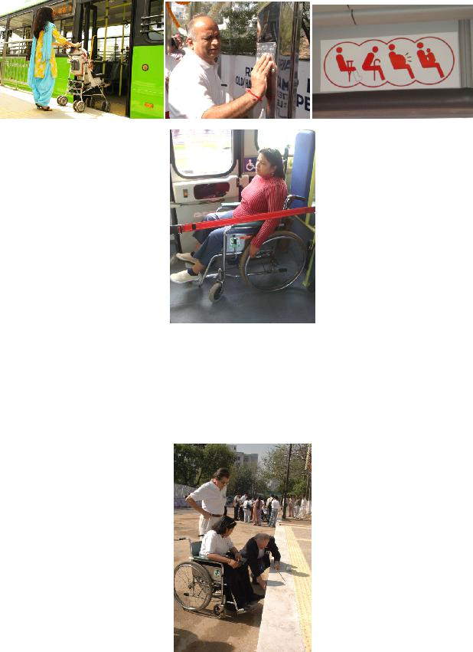
Empowerment, granted DTC Rs. 10 million (2,40,000 US$) to build 25 BQS on route no. 620. Samarthyam volunteered for facilitating and monitoring the construction process with the user group inputs and conducting feasibility field visits of all the BQS falling under DTC jurisdiction.
How change was monitored and evaluated:
Samarthyam approached DTC and NDMC with the BQS design, requesting the two agencies to construct a prototype in their respective jurisdiction including the Delhi Transport Department. The Minister for Transport, Delhi approved the design and issued instructions to make a model BQS at the Hauz Khas Terminal operated by DTC. Samarthyam facilitated the construction process and the Minister inaugurated the prototype on 19 March 2006, in the presence of international and national experts and participants of the first National Conference on Accessible Transportation “Mobility for All”
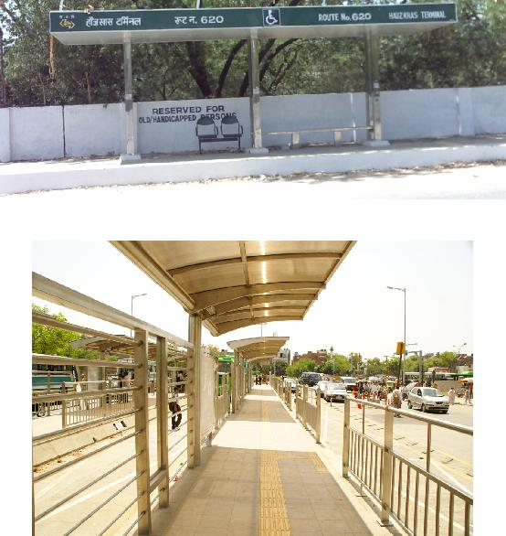
The prototype design comprised of bus shelter at a height of 380 mm, synchronizing with the chassis level of LFB, thus making it convenient for embarking and disembarking by all users. The BQS is equipped with ramps on both sides; tactile warning tiles for persons with vision impairment; Braille plate with route information; space for two wheel-chair users with access symbol painted on the ground; information signage; colour contrast and priority seats.
Prototype developed in 2006 Bus shelters, 2010- till date
Samarthyam is monitoring the construction process and Delhi NCR and other adjoining cities have similar designs of accessible bus shelters
Shortcomings and persistent challenges identified in the implementation of the project/programme:
Other lessons learned:
The introduction of LFB and the upcoming cost effective Bus Q Shelters in the NDMC, DTC and BRTS, with its inclusive and universal design is the result of partnership between the users, service providers and apeople-focused emphasis incorporated into transport planning. The growing service needs, the public responsibility, the varied advantages low floor buses offer to all public with the new BQS design; suggest their value as integral component of future accessible public transport system in both semi urban and urban areas. Samarthyam’s model of user-transport service provider consultation and cooperation proves to be successful towards making buses accessible for all.

A GLOBAL SNAPSHOT OF TRANSPORT NEEDS AND PRIORITIES
International
Abstract

The Global Alliance on Accessible Environments and Technologies (GAATES) carried out a survey in 2013 among its members worldwide.

Responses to the survey came from 39 countries in Africa, the Indian sub- continent, the Pacific Rim, South East Asia, North America, Europe, Latin America and Europe. The majority of respondents were people with personal experience of disability.

The survey asked about available public transport in the region in which people lived and invited them to identify the biggest problems affecting mobility. The major factor cited was inaccessible public transport vehicles followed by the attitude of drivers and other transport staff.

Priorities for change identified by respondents in many countries included a clear legal framework for accessibility and the means to monitor and enforce it. Understanding and commitment from elected officials and from transport professional were also cited by many. The survey respondents called, above all, for technical guidance on inclusive design solutions aimed at civil engineers, planners and other professionals.

The paper considers the findings of the survey and discusses ways to provide effective outreach to promote accessibility, particularly in developing countries.

Keywords: policy development, training, survey, developing countries, accessibility, knowledge

1. GAATES

The Global Alliance on Accessible Technologies and Environments (GAATES) is a not for profit international organisation dedicated to the promotion of accessibility of the built, transportation and virtual environments, as well as disability inclusive disaster risk reduction (DiDRR). GAATES is working to improve access for the estimated one billion people with disabilities around the world. People are marginalised by the lack of accessibility to the built environment, transport and related facilities, as well as lack of access to information and communications.

GAATES membership includes people with and without a disability, and from diverse cultural, educational and disciplinary backgrounds around the world. The majority of members have personal disability experience and many years of experience in the accessibility or advocacy fields

2. The Survey

In 2013 the GAATES Transportation Committee carried out an on-line survey of GAATES members around the world to determine what the biggest mobility problems are that people with disabilities face and what they feel that GAATES could most usefully do to address those problems.

The Survey was completed by 257 people from 39 countries (a full list of responding countries is at Annex A).

The chart below shows the breakdown of responses by Region.
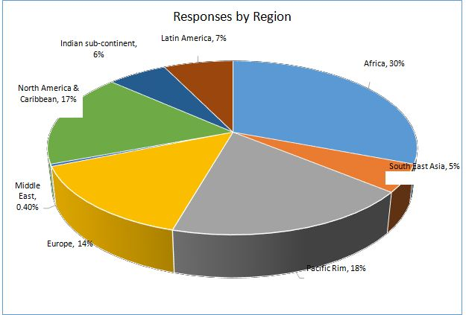
3. Findings

3.1 The respondents

76% of respondents said that they have personal experience of disability. Respondents were asked what type of area they lived in. 60% described their location as “mainly urban”, 28% described it as “suburban or township” and10% as “mainly rural”.

3.2 Available Public Transport
Respondents were asked to identify all the types of public transport that are commonly available where they live.

The chart below summarises the responses across all regions.
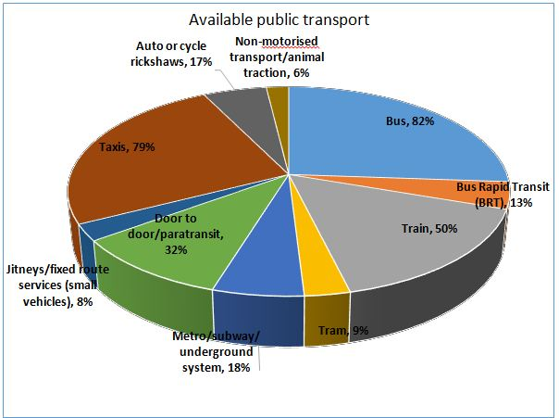

If the same analysis is run separately for the respondents from different regions of the world, there are obviously variations in the mix of available transport. Responses from the Indian sub-continent, for example, identified no availability of door to door or other fixed route services in small vehicles. They did, however identify high level usage of cycle or auto rickshaws and of taxis (77% of respondents).

Respondents from Africa indicated a greater usage of door to door/paratransit services (35% of respondents) and in addition a small number (6% of respondents) use non-motorised transport or animal traction. Other transport modes identified included motorbike, private car, Jeepney, ferry, trolleybus and donkey rickshaw.
Responses from Latin America showed the highest level of any region for BRT availability (32% of respondents) and a high level of access to metro/underground systems (53% of respondents).

3.3 Biggest mobility problems

The next question asked respondents to identify the three biggest problems affecting the mobility of people with disabilities in their country/region. The Chart below indicates the worldwide responses.

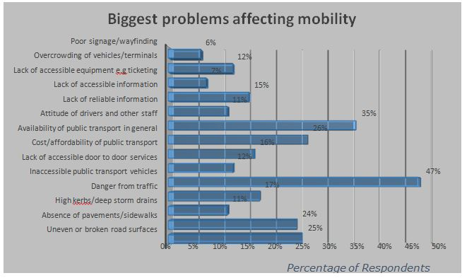
Additional comments from respondents in included:

- “Attitude, and lack of care for pwds” (Kenya)
- Inappropriate wheelchairs that cannot push over uneven ground to get to roads”. (South Africa)
- “Lack of last mile connectivity and lack of reliable public transport connecting all destinations.’ (India)
- “In theory, there is no limit, traveling on an equal basis is a right and any public service must provide alternatives when barriers still exist. In practice travellers with disabilities need to be determined and aware of their rights, but it is better and better. In Europe the process is launched and just needs to be performed.” (France)
- “Places reserved for wheelchair users are always taken by able bodied passengers.” (Mexico)
- “Communication challenges, particularly for those who are deaf”. (Zimbabwe).

3.4 Groups most affected

The next question asked whether some groups of people with disabilities were worse affected than others by the kind of problems identified in the previous question.

Respondents were asked to identify the three groups they thought had the biggest problems. The responses are summarised in the Chart below:
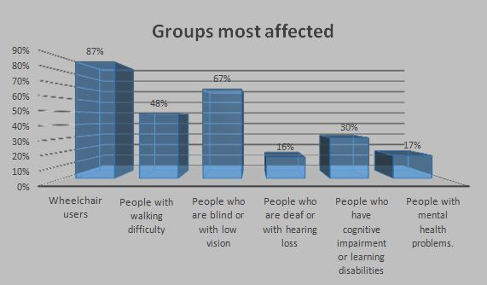

Other categories identified by respondents included:

- People of short stature (Kenya)
- People who are deaf/blind (Kenya)
- Older people who are unable to drive (New Zealand)
- People with autism (South Africa)
- People unable to speak (South Africa)
- People with multiple disabilities (USA)
- People with intermittent pain (USA)
- Upper limb amputees (Argentina)

3.5 What needs to change?
The next question asked respondents to identify the three most important changes that would enable people with disabilities to move around the streets and pavements/sidewalks and access public transport more easily.

- The most frequently identified (from many different countries) were:
- Better attitude and staff awareness/need for training;
- Legislative support and control mechanisms/enforcement and monitoring of access improvements;
- More attention to making the pedestrian environment accessible;
- More accessible public transport (buses in particular). Other issues identified include:
- “Public and professional awareness and commitment to make the city accessible”. (Malaysia)

- “Developing and enforcing public policies to provide for effective, progressive and consistent implementation of safe and accessible public transport.” (Mexico)
- “The Improvement of the transport system, proper consultations with PWD's in the initial planning phase and maximum use of the Technical Assistance Guidelines”. (South Africa)
- “To have good wheelchairs which they can use to walk on the sideways and to establish Physical rehabilitation centre”. (Somalia)
- “Policy formulation, budget allocation and implementation within a given time frame”. (Kenya).

3.6 What help is needed?

The last question asked what one initiative GAATES could most usefully take to help tackle the wide range of problems identified by respondents.

The breakdown of responses can be seen in the Chart below:
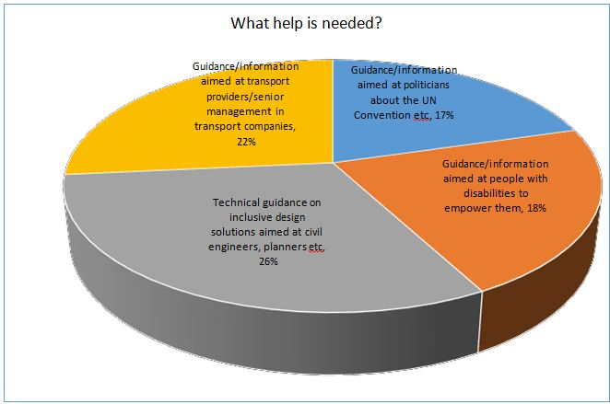
As the Chart indicates, there is no clear priority identified, with almost equal weighting given to each of the options which the survey had identified as being areas in which help is needed.

Additional comments from respondents addressing the direct question of what GAATES could do and offering more general observations on changes that are needed, included the following:

- “Empowering PwDs and include them to be members of the accessibility monitoring teams under state/independent institutions/mechanisms.” (Sri Lanka)

- “Integrating of Disability issues in ALL curriculum but preferably for teacher trainees (colleges, universities) so that this cascades to pupils/students and then to community at large. Economic empowerment to enhance self-reliability as in this will help them acquire adapted vehicles and other mobility devices.” (Kenya)
- “Persons with disabilities also need to be empowered to know how to address these challenges constructively.” (South Africa)
- “Information to the community in general to increase disability awareness and thus improve community understanding and thus empathy towards an individual with a disability. The community can then pressure government better than a lone specialised group.” (South Africa)
- “Awareness about inclusive design and universal design to general public to see the importance of these things that it's not only applicable to persons with disabilities but also for other groups of citizens such as the elderly.” (Thailand)
- “Small grants to organisations working for the disabled, in order to do trials in transporting the disable at low cost.” (India)

4 Drawing lessons from the findings

Although the survey responses span a wide cross section of the world’s populations from highly developed industrial nations to less developed areas, there are some clear common threads running through the responses which can be summarised as follows:
- Even in countries/regions where laws are in place and accessible public transport exists, there is intense frustration that laws are not implemented or enforced and that there are still significant gaps in accessibility;
- At the most basic local level, lack of suitable wheelchairs and barriers preventing access to streets and pavements/sidewalks are a huge problem;
- Everywhere in the world, lack of understanding and awareness of disability is a major problem. This applies to transport staff (drivers etc.); to those who design and plan transport and pedestrian infrastructure (engineers, architects etc.); politicians and government officials and the travelling public as a whole;
- Poor design of public transport and inability to travel spontaneously (without pre-booking) also affect many people.

5 Moving the agenda forward

There is already some excellent material addressing some or all of these issues (for example from Access Exchange International and the World Bank). However, it is clear that this material is not yet universally available to those who could use it to promote accessibility around the world.

An obvious first step – and one which GAATES is taking – is to try to broaden knowledge of and access to the information already available on the internet.

Some material has global relevance and should be disseminated as widely as possible. However, it is important to recognise that high tech, high cost solutions that work for some countries may be out of reach – and indeed inappropriate – for others.
It is also important to note that however good the material provided to those who want to push for change and to start to make a difference, unless Governmental structures and political positions are aligned, progress will remain limited.

6 Positioning accessibility in the global agenda

Accessibility should not be seen as a policy goal in isolation. It needs to be considered as part of the broader process of innovative thinking underway in many countries about sustainable development and the creation of liveable communities.

This would strengthen the position of accessibility as a non-negotiable part of policy making, planning and funding at international, national and regional levels.

7 United Nations Convention on the Rights of Persons with a Disability

The UN Convention on the Rights of Persons with a Disability (CRPD) is seen as a catalyst for change in this context, particularly in developing countries. The Convention, which has now been signed by 159 countries and ratified by 152 (many from the developing world), places an obligation on signatories to provide access to the physical environment and to transport. There is a clear stated link between access to transport and the ability of disabled people to use basic services including health, education and employment. There is some evidence of the UN Convention being successfully used to provide leverage to initiate or enforce access improvements at local level. At a broader level, the USA, for example, builds the Convention into their memoranda of understanding in working with other countries on disability and accessibility issues. The World Bank also regards the Convention as an important tool in building partnerships.

The UN Convention refers to “progressive realisation” of the goal of accessibility. In other words it must be seen not as a one off but as a step by step process. To get that process started, it is important to build up sufficient momentum among stakeholders, including disabled people, technical experts and policy makers to think innovatively and to implement change.

8 Developing coherent structures and processes

In organisational terms, many countries lack the administrative structures to implement a mandate for accessibility. There is also clear evidence of limited or no collaboration between different sectors and levels of government and agencies.

Lack of understanding and awareness about the need for accessibility also impacts on the quality of implementation and monitoring and often means an absence of enforcement even after laws have been passed.
One possible model to address this problem would be the creation of oversight boards at national or regional levels to represent the interests of stakeholders, including people with disabilities, and ensure correct and timely implementation and follow up.

Key to this process too is the engagement of disabled people from the drawing board through to realisation at every phase of the process. Establishing and formalising effective stakeholder engagement is fundamental to success. It is particularly important to ensure that stakeholder organisations are fully representative across the whole spectrum of disability issues and are well briefed on legal and other frameworks. The process by which they are established also needs to be robust so that there is continuity of input.

Progress in driving the accessibility agenda is often dependent on a small number of individuals with understanding and commitment. Successful though this can be in the short term, continuity over time can only be achieved through the establishment of processes and laws. A clear legal framework (both at the international level of the UN Convention and at more specific national and regional or local levels) is also essential, together with political commitment.

Another obstacle to coherent progress can be the multiplicity of agencies involved, often without clear strategic thinking or communication between them. While it is evident that disability and therefore accessibility are cross-sectoral issues, there needs to be co-ordination between the different parties to optimise progress. Some good examples of joint working include: the USA where Government Departments responsible for transport, housing and environmental protection are developing joint approaches to addressing need through establishing liveable communities; Norway which has brought all its relevant Government Departments together under the banner of Universal Design; and China which has formalised (in Shanghai for example) an annual process of consultation between city construction authorities and disabled and older people.

More effective and cost effective progress can also be made by developing detailed implementation strategies at national, regional and local levels, together with penalties for non-compliance. “Hearing” boards could be set up (again at national or regional levels) to address non-compliance by public and private transport providers and agencies. Local volunteer advisory boards of professionals and users to monitor progress can also be valuable.

9 Economic and Financial Issues

In financial terms, there is competition for national spending and accessibility is given a low priority by many cash strapped national, regional and local government agencies. The initial cost of achieving accessibility is often viewed as unaffordable, especially for developing countries, despite ratifying the UN Convention on the Rights of Persons with a Disability.
There is therefore an urgent need to re-think the economic and fiscal basis for accessibility.

A major step forward in making the case for routine investment in accessibility would be to re-position accessibility as a benefit rather than a cost. One means to address this problem could be to incorporate access to transport, in its fullest sense, within an official measure of economic progress.

Strong governance and a clear legal base are essential to successful funding of accessible transport and infrastructure. Understanding local culture, demonstrating improvement and introducing technical innovation are also important.

Tourism and international sporting events (e.g. Olympics/Paralympics) are also key global economic drivers which should be harnessed.

10 Marketing

The positioning of accessibility issues in the global consciousness is also important. There is currently little understanding in the population at large of the enormously detrimental impact that a lack of mobility can have on people’s lives. There needs to be greater momentum built up at international as well as (in many countries) at national level to raise accessibility up the political and public agendas.

11 Planning

Settlement patterns are changing. Since 2007 more than half the world’s population has lived in urban areas and by 2025 this will rise to 60%. Population growth may strain the fiscal capacity of urban areas to respond to new infrastructure needs.

There is too often a disconnect between the planning and political processes and the realities of daily living for those with mobility difficulties. In developed countries the growth of out of town retail and health facilities that can only be accessed by those with private cars is one such example.

One solution being explored in some countries is the concept of “ageing in place” which allows older people and those with disabilities to continue to live in their own communities by creating barrier free and accessible environments around them.

At the opposite end of the spectrum, rural poverty and isolation are still major factors and are disproportionately affecting older and disabled people. There are many countries and areas still without basic facilities such as paved roads and indeed without basic equipment such as wheelchairs.

12 Training

One key factor in addressing needs in both urban and rural environments is for transport and planning professionals as well as architects to be routinely trained in accessibility issues as a part of their basic curriculum. There are some good examples, such as Catalonia in Spain where university students must take credits in the Design for All concepts but this is still the exception rather than the rule in most countries.

As a result of this simple gap, opportunities are lost and expensive mistakes are made in planning and developing infrastructure which are often impossible to put right and may leave a negative impact for many years.

13 Research and Knowledge Transfer

As the GAATES survey revealed, a number of key gaps exist both in basic knowledge (particularly knowledge that is relevant to developing countries) and more generally in the application of that knowledge and its availability to practitioners.

For example, we still lack consistent and meaningful indicators of accessibility. There is a tendency to measure progress in terms of numbers of, for example, accessible buses or bus stops. This kind of indicator does not give enough information about the impact on the day to day mobility of disabled and older people.

An international forum for the exchange of knowledge and research data would be valuable, with an emphasis on helping developing countries to identify the right technology or approach for their particular situation. Such a forum , which GAATES is working to develop, could also have an important role in promoting and disseminating information on innovation in this field.

Some means, at international or national levels, to evaluate progress and to advise on next steps would be welcome. There are some examples of innovation in this field. One such is a recent joint project funded by the United National Development Programme (UNDP) and the Government of Malaysia which was intended to support the development of a fully accessible transport system for Penang State, as a pilot for the rest of Malaysia. The project focussed on access audits of public transport facilities, capacity building and awareness raising activities.

It is also interesting that while there are clear guidelines on the correct technique for installing access improvements, often there is no explanation of why they need to be done in a particular way. This has an adverse impact on the quality of installation and maintenance, for example, in areas such as tactile paving. This can be a factor in both developed and developing countries. A good example of tackling this problem comes from Shanghai where there is one “access checker” per square kilometre of the city whose job it is to identify barriers to access.

Developing countries tend to adopt standards drawn up either by international bodies or by developed countries even though they may sometimes be inappropriate or unaffordable. There is a need for further work to identify the “low hanging fruit” that could give developing countries a clear and affordable basis for sustainable accessibility. One obvious starting point would be basic improvements to the local pedestrian environment to create access for disabled and older people. Another is to consider simple low cost improvements such as the use of contrasting colour on step edges that can assist people with low vision.

There is also a need for stakeholder engagement in research. The example of “Citizens’ Science” committees and other kinds of community engagement could be useful as a means of focusing on the topics of greatest relevance to disabled and older people.

14 Design and Technology

There is a clear need to distinguish between solutions appropriate for developed and developing countries. The low floor bus is one such example. This is now almost universal in developed countries with very positive benefits but may not be the best solution in some developing country situations without paved roads or other basic infrastructure. High floor vehicles with access aids and smaller vehicles may be better solutions at least on a transitional basis.

Universal Design, which is based on the premise that products and environments should be usable by all people, to the greatest extent possible, without the need for adaptation or specialised design is a very valuable concept. However, it can only be applied where a culture of inclusion and accessibility has been established. Although the concept of Universal Design has been in existence for over 20 years, its take-up is still mostly at local or regional levels.

There is a particular need to find the means to support development of low cost products for developing countries. Accessible three wheeled scooters are one prime example which could not only provide low cost mobility for many but could also create employment through establishing manufacturing bases in developing countries. Although this market is too small in a single country to make an economic product, the combined market size of several countries could make it a commercially viable proposition.

13 Summary and Conclusions

The GAATES survey of key issues on transport accessibility has identifies a number of clear priorities as well as illustrating the difficulties that exist still in many developing countries in moving the accessibility agenda forward.
As this paper has demonstrated, it is not simply a matter of providing the right information and technical resources to those championing accessibility in their own communities – though this is certainly an important step. To make progress that is coherent and sustainable, there need to be fundamental shifts in attitude and understanding among politicians and economists as well as among practitioners in the transport field.

Neither the goal of accessibility, nor the means to achieve it are unattainable but there are still barriers - both attitudinal and physical - to break down before real progress can be made.

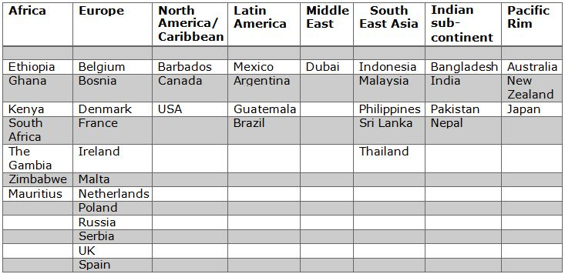
Annex A: Responses by Country

Universal accessibility in the context of development: issues and options∗
Associates for International Management Services
International

After more than 30 years of normative guidance on the central role of accessibility to the general systems of society in promoting equalization of opportunities for persons with disabilities, the question arises about why accessibility in the built environment, in transport and public accommodations and in information and communication technology is not yet the “new normal.” Rather, environmental accessibility is most often – but not always – a product of regulation, administrative guidance or judicial actions.
This note considers issues and options related to universal accessibility in the context of development in contrast to regulatory-specific approaches to environmental accessibility.
Universal accessibility refers to solutions that are intuitive to use, involve ease of effort and respond to needs, interests and capabilities of a wide-range of end users, equally – persons with disabilities and non-disabled persons alike. Universal accessibility solutions are efficient in that one set of designs or procedures are produced to respond to a wide-range of expected end-user needs, interests and capabilities; they generally involve end-user input on performance requirements and build on feedback on actual usage from diverse communities of interest. Universal accessibility solutions are cost-effective in that designs generally do not require costly retrofitting to respond to new accessibility requirements; end-user feedback contributes to solutions that deliver enhanced accessibility and usability as required.
Universal accessibility solutions build upon basic concepts and principles of “universal design” but may not always reflect a strict universal design construct. This distinction can be seen by recalling basic concepts of “universal design”:
(a) Equitable use: the design is useful and relevant to a wide group of end-users;
(b) Flexibility in use: the design accommodates a wide range of individual preferences and abilities;
(c) Simple and intuitive use: the design is easy to understand regardless of the knowledge, experience, language skills or concentration level of the end-user;
(d) Perceptive information: the design communicates information effectively to the user regardless of the ambient condition or the sensory abilities of the end-user;
(e) Tolerance for error: the design minimizes the hazards and adverse consequences of unintended actions by the end-user;
(f) Low physical effort: the design can be used easily, efficiently and comfortably with a minimum of fatigue;
(g) Size and space: the size and space for approach, reach, manipulation and use should be appropriate regardless of the body size, posture or mobility of the end-user.
While “universal designs” provide intuitive ease of use and allow for end-user error, they do not specifically address provision of accessibility for a diverse range of end-users as set forth in article 9 (Accessibility) of the Convention on the Rights of Persons with Disabilities.
This note does not intend to pursue argumentation over the meaning of words but aims to present options for promoting environmental accessibility in the context of urban – and rural – development. It is premised on the notion that environmental accessibility is a member of the set of global public goods and not a defined benefit for specific members of the population: once provided, none can be excluded from accessible environments for cause. The benefit that any one end-user can experience from accessible environments, urban infrastructure or information and communication technology does not diminish opportunities for others to enjoy the “ease and flexibility” of accessible environments.
In a brief, technical sense public goods are commodities and services that are: (1) non-rivalrous, which means extension of the good or service to others involves zero marginal cost; and consumption of a public good by any one consumer does not reduce quantities available to others; and (2) non-excludable, which means no one can be excluded from or affected by a public good. The joint consumption and zero marginal cost characteristics of public goods suggest that market mechanisms alone cannot provide a basis for efficient allocation of resources and introduce the need to construct social welfare functions to allocate public resources to serve collective purposes. Addressing environmental accessibility as an issue in provision of a global public good in the context of development would move budget debates from questions of how to – and who should - fund disability-specific infrastructure and services to decisions on how to maximize public welfare and levels of living within available resources for urban – and rural – development.
It is possible to cite a number of examples of universal accessibility good practice in daily life, from the mundane – small appliances – to essential technologies and public infrastructure. A number of factors have been identified with usable and accessible designs: for some it is a matter of building market share among under-served populations; it may represent a pre-emptive response to regulatory actions; there is the growing use of mobile access of information and communication technologies which require efficient and usable designs to capture and retain an extensive range of end-users; and population ageing is a positive and accelerating trend globally.
A mundane example of a universally accessible design can be found in digital rice cookers produced by the Toshiba Corporation: the user interface is in English – the working language of the Association of Southeast Asian Nations (ASEAN) – and in braille. The devices are on offer at Toshiba dealers and do not involve a special visit to service organization for the visually impaired; the braille option is a given not an extra charge.
Think about how many small appliances are universally accessible on the market now, and then think of opportunities of meeting under-served consumers for usable interface options.
In the field of technology, a major development is the decision by Internet browser software publishers to include – at no charge – the option to increase the size of content displayed. Previously, such a capacity was an extra-charge item for end-users who were unable to work with a conventional display.
Experience suggests, however, that accessible information and communication technology is always “under construction”: the rapid pace of developments in Internet-enabled services and content often can present challenges to end-users who may have limited sensory, physical or intellectual capacities. Often regulatory or administrative guidance is required to ensure content developers and service providers respond to recognised standards for accessible and usable information and communication goods and services, many of which have been developed by the World Wide Web Consortium (W3C).
Experience also suggests that designs providing accessible environments and facilities require both post-occupancy surveys to ensure that standards employed respond to actual end-user needs, and periodic monitoring in the light of changing technologies, end-user characteristics or service expansion. Two examples reflect these issues: the United Nations House in Beirut, which houses both the United Nations Regional Economic and Social Commission for Western Asia and a number of UN system representative offices was constructed in the late-twentieth century, along with the redevelopment of the Beirut Central Business District, as an accessible facility. However, post-occupancy surveys found areas, particularly for ease of entry and exit, where applicable standards did not produce accessible solutions for local users; retrofits were budgeted and implemented to meet actual end-user accessibility needs.
A second example from late-twentieth century urban infrastructure relates to the Skytrain system of Bangkok. At the time of design and construction, developers provided only limited access to Skytrain stations by lift; passengers with mobility issues and parents with children in strollers were at a severe disadvantage in using this quick and efficient transport system. Interested civil society organisations soon took the case of unequal access to the court system and recently won a judgement that Skytrain must provide ease of access at all current and planned stations – which is being done at considerable costs. At the initial design stage developers argued that the available budget did not allow for provision of lifts at all stations; a decision was made to provide lifts at a limited set of stations, mainly with high-levels of tourist traffic. In essence the Skytrain management of the time applied a classic corner solution to facility use and access rather than construct an appropriate welfare function that would maximize benefits for a wide range of potential end-users.
Universal accessibility is not a play on words but a framework for efficient solutions to accessibility in the context of urban development
Country:
Ireland
Name of Organistaion/Government entity:
National Disability Authority – Centre for Excellence in Universal Design.
Project/Programme title:
Shared Space, Shared Surfaces and Home Zones from a Universal Design Approach for the Urban Environment in Ireland
Initiative selected as good practice example:
Research report titled "Shared Space, Shared Surfaces and Home Zones from a Universal Design Approach for the Urban Environment in Ireland" which investigates national and international ideas on how Universal Design is considered in the creation of Shared Spaces, Shared Surfaces and Home Zones in the Irish Urban context.
This research was undertaken by TrinityHaus (Trinity College Dublin), on behalf of the National Disability Authority’s Centre for Excellence in Universal Design. This report sets out key evidence based findings and provides key recommendations in relation to the implementation of Shared Spaces, Shared Surfaces and Home Zones in Ireland.
The findings from the research have been organised under seven themes which have been explored indepth. These include:
- Evidence Base Decision Making.
- Legislation, design guidelines and enforcement.
- Education, Awareness and training.
- Consultation and planning.
- Design and appropriate locations.
- Economic Implications.
- Maintenance, management, durability and sustainability
Thematic area of good practice example:
Shared Space, Shared Surfaces and Home Zones from a Universal Design Approach for the Urban Environment
Specific location:
Ireland, several cities
Duration of project/programme:
Six months Research project
Beneficiaries of good practice example:
The whole society through research for developing better and improved public policies for urban design.
Implementing agency/agencies:
National Disability Authority – Centre for Excellence in Universal Design; TrintyHaus;
Source of funds:
Funded through the Government
Brief background to the project:
This research has been undertaken by TrinityHaus (Trinity College Dublin), on behalf of the National Disability Authority’s (NDA) Centre for Excellence in Universal Design (CEUD). The aim of the research was to engage with a wide range of stakeholders in a discussion about Shared Spaces, Shared Surfaces and Home Zones in the Irish context. The research seeks to explore contemporary national and international practices and thinking on Shared Spaces, Shared Surfaces and Home Zones and to investigate these concepts from a Universal Design approach in the Irish urban environment. This report sets out key evidence based findings and provides key recommendations in relation to the implementation of Shared Spaces, Shared Surfaces and Home Zones in Ireland.
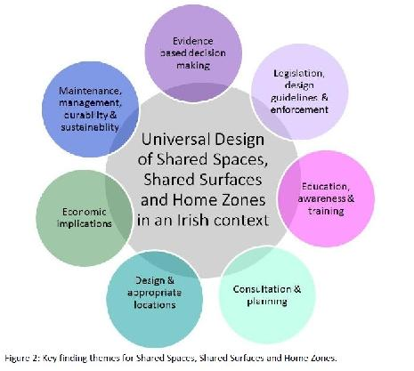
Overall objectives of the project/programme:
The aim of the research was to engage with a wide range of stakeholders in a discussion about Shared Spaces, Shared Surfaces and Home Zones in the Irish context. The research sought to explore contemporary national and international practices and thinking on Shared Spaces, Shared Surfaces and Home Zones and to investigate these concepts from a Universal Design approach in the Irish urban environment. The findings report sets out key evidence based findings and provides key recommendations in relation to the implementation of Shared Spaces, Shared Surfaces and Home Zones in Ireland.
Process/strategy to implement the project/programme:
This research project has been conducted over six months and has involved an extensive literature review of national and international best practice, guidelines, reports and peer reviewed journal papers in relation to Shared Space, Shared Surfaces and Home Zones. In addition to this, engagement with over twenty organisations, interviews with over thirty individuals, site visits and analysis of urban spaces and Home Zones, and two workshops has informed the research. Key urban issues, road design and end user concerns in have also been examined and these form the backdrop to Shared Space, Shared Surfaces and Home Zone concepts in the Irish context. Figure 1 below illustrates the process that has led to the key research findings and recommendations contained in this report.
Following the completion of the stakeholder interviews and having conducted a large part of the research, a draft report was prepared which outlined the key preliminary findings up to that point. This was circulated to all stakeholders prior to the second stakeholder workshop and was used as the basis to discuss all the findings with the stakeholders at the workshop. This document was subsequently amended to include all feedback and now forms a large part of this final report.
Changes achieved:
A series of recommendations under seven themes (Evidence Base Decision Making; Legislation, design guidelines and enforcement; Education, Awareness and training; Consultation and planning; Design and appropriate locations; Economic Implications; Maintenance, management, durability and sustainability) which provide good practice advice on the implementation of Shared Spaces, Shared Surfaces and Home Zones.
How change was monitored and evaluated:
Unknown.
Shortcomings and persistent challenges identified in the implementation of the project/programme: N/A.
Other lessons learned:
The research findings and key recommendations emphasise the current issues associated with shared space design in general and specific concerns expressed by key stakeholders in the Irish context. There is a belief held by many stakeholders that the standard of much urban design in Ireland to date was not of a sufficient quality, and this had some bearing on their opinion about the potential success of shared space design in Ireland.
While this report contains over sixty key research findings and twenty recommendations it is understood that these need to be prioritised and consideration given to shorter term achievements.
Many stakeholders, particularly those representing end-users had little awareness of shared space design and those that did tended to represent people with visual difficulties. These groups were therefore more aware of the potential difficulties presented by certain existing features of shared space design. However, all stakeholders were supportive of the core principles of shared space design which focus on increased pedestrian priority and the overall improvement of the street environment.
One of the main conclusions of this report finds that pilot studies are necessary immediately to inform end-users about the intentions of shared space design and to learn from direct onsite interactions between selected end-users, the public and local businesses and shared space designed pilot study schemes. Where local authorities are considering urban upgrade or trial pedestrianisation, this would provide an ideal opportunity for such pilot studies. Such pilot studies need to be informed by preliminary site selection criteria, draft design guidelines and an assessment methodology with an associated indicator suite to measure the impact of the alterations. These guidelines and assessment criteria need to be developed prior to the pilot study phase. Once the research has been completed a set of evidence based national guidelines can be created based on these preliminary guidelines.
Country:
Ireland
Name of Organistaion/Government entity:
Centre for Excellence in Universal Design
Project/Programme title:
Universal Design for Customer Communications
Initiative selected as good practice example:
http://universaldesign.ie/Products-Services/Customer-Engagement-in-Tourism-Services/
http://universaldesign.ie/Products-Services/Customer-Engagement-in-Energy-Services/

Thematic area of good practice example:
Tourism and Energy Supply Sector

Specific location:
Ireland

Duration of project/programme:
2009 – ongoing

Beneficiaries of good practice example:
Tourists, tourism service providers, energy suppliers, energy customers

Implementing agency/agencies:
Centre for Excellence in Universal Design, national standards Authority of Ireland, Fáilte Ireland, Commission for Energy Regulation

Source of funds:
Government (through CEUD)

Brief background to the project:
- Development of two national standards on Universal Design for customer communications (one for tourism, one for energy suppliers),
- development of a series of toolkits for use by these sectors to build capacity among companies and staff on universal design for communication,
- develop case studies (tourism sector only) to show the actual, real business benefits to businesses in making their communication products (e.g. website, brochures, menus easier for everyone to use),
- develop a certification scheme based on the standard to show compliance with regulatory obligations on UD (for energy sector only – under development.

Overall objectives of the project/programme:
To promote universal design as good design in customer communications that benefits a wide range of customers, but also results in a positive return on investment for businesses.

Process/strategy to implement the project/programme:
Engage with the tourism and energy supply sector through their regulatory body

Changes achieved:
Significant business benefits recorded by 4 tourism service providers who adopted the standard / toolkits

How change was monitored and evaluated:
Change being monitored in energy sector by regulator (CER)
Case studies documents 4 businesses in tourism sector – no ongoing monitoring – further training planned for early 2016 – 50+ tourism service providers

Shortcomings and persistent challenges identified in the implementation of the project/programme:
It will important that the certification scheme (under development) for the energy sector measures accurately the actual level of universal design of energy providers customer communications

Other lessons learned:
Actual business benefits realised in case studies:
• Use of the Face to Face Toolkit and prompt cards for frontline staff dealing with customers contributed to a prominent Irish hotel chain reaching an 85% customer satisfaction rating
• Use of the written Communication Toolkit to improve menu design resulted in a 12% increase in food sales per server in a family owned restaurant
• Having listened to customer feedback about their website a Dublin pub and music venue used some simple tips in the Web Communication Toolkit to improve their online booking facility resulting in a 100% increase in online bookings in a 12 month period.
• After following the advice in the Face to Face Toolkit Viking Splash, a Dublin-based tourism adventure expereince have significantly improved customer reviews resulting in a saving of €450 per week and increasing visitor numbers by 6%.

Country:
Malaysia
Name of Organization/Government entity:
Kuala Lumpur City Hall
Project/Programme title:
Covered pedestrian & At-Grade In The City Kuala Lumpur
Initiative selected as good practice example:
Barrier free and friendly pedestrian network, linkages to transportation hub, nodes, heritages areas and iconic buildings.
Thematic area of good practice example:
Barrier free and friendly pedestrian network
Specific location:
City Kuala Lumpur
Duration of project/programme:
2011-2015
Beneficiaries of good practice example:
General public
Implementing agency/agencies:
Kuala Lumpur City Hall
Source of funds:
Federal Government and Kuala Lumpur City Hall
Brief background to the project:
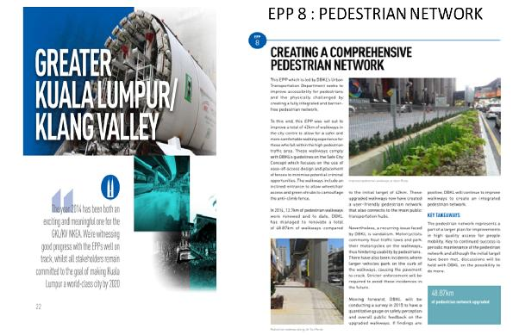
Overall objectives of the project/programme: barrier free and friendly pedestrian network
a.Process/strategy to implement the project/programme: construction in phases and task force committee
Changes achieved:
Barrier free and friendly pedestrian network, liveable city, continuous linkages between public transportation networks
How change was monitored and evaluated:
Task force committee and steering and monitoring periodic meeting from various agencies
Shortcomings and persistent challenges identified in the implementation of the project/programme:
a.Site constraint where location is in urban city centre
b.Existing underground utilities services
c.Collaboration between various agencies and all level of stakeholders
d.Control of traffics
e.Construction limitation and etc.
Other lessons learned:
a.Collaboration between various agencies to achieve national goals
b.Implementation of construction in urban city
c.Approach and concepts in creating comprehensive pedestrian networks

Country: Mexico
Name of Organistaion/Government entity:
Government of Mexico City
Department of Environment of Mexico City
Project/Programme title:
Metro Tezozómoc Pocket Park
Initiative selected as good practice example:
Initiative of the Government of Mexico City to create a new public space as a result of public policies for social inclusion. It responds to an urban regeneration project by transforming an unused piece of land to a better public space. The pocket park intended to promote recreation, mobility, culture, social interaction and fun for all citizens in order to have a more inclusive city.
Thematic area of good practice example:
Pocket park.
Specific location:
Corner of Eje 4 Ahuehuete and Av. Sauces, Colonia Pasteros, Delegación Azcapotzalco, México D.F., near Metro Tezozómoc station.
Duration of project/programme:
Design phase: two months.
Building phase: three months.
Beneficiaries of good practice example:
It benefits around twenty thousand people providing activities for all ages and abilities:
a)playground for children,
b)skate park for youths,
c)seating area and dancing fountain for families and communities to gather and socialize, including people with limited mobility.
Implementing agency/agencies:
Department of Environment of Mexico City
- Espacios Verdes Integrales S. A. (building construction company)
- For the inclusion project:
- Tecnósfera, S.C. (urban and landscape designers) Arq. Psj. Bruno Palomino Ramírez and Miriam Pamela Garduño Alvarado.
- Can Lah, S.C. (access consultant) Arq. Janett Jiménez Santos and Arq. Psj. Jennifer Miranda García.
Source of funds:
It was a mitigation measure whereby a private company had to environmentaly enhance a specific public space and thus, it had to be funded by the company itself.
Brief background to the project:
It was an unused plot with a concrete slab. Previously, it was used as a parking lot for the Metro transportation system and later abandoned with a fence around the land.
Overall objectives of the project/programme:
1. Recover unused land. The landscape design project of Metro Tezozómoc Pocket Park has an area of 1477.31 sqm. So far, it is the largest pocket park in Mexico City.
2. Activites for social interaction. The integration of users is sought by four guiding activities that unify the architectural space, forming clear and defined areas that highlight and enhance a space with a contemporary design creating a livable space. These created four areas:
- Central plaza: 550 sqm
- Dancing fountain: 60 sqm
- Skate park: 560 sqm
- Children play area with play components: 132 sqm
3. Visibility for safety. It aimed to have clear and unobstructed views throughout the pocket park. At any standing point inside the park its design sought a full visual domain of the space. In addition, 12 solar street lights were installed to fully illuminate the open space at night.
4. Use of universal design principles for social inclusion. Universal design principles were used for the built elements for a specific landscape feature. For exmaple, tactile walking surface indicators (TWSI) ,tactile-visual maps and handrails were installed.
5. Environment issues: Solar lighting. An automatic irrigation system was installed to provide water to the green areas of the pocket park with a minimal use of water, in order not to waste water. Trash bins were not considered to prevent people from throwing garbage from their homes in this project site, as it was previously used by persons walking on their way to the Metro station.
Process/strategy to implement the project/programme:
Negotiations were carried out between the local authority and the investor for the mitigation measure. Once the local authority selected the appropriate plot of land for intervention, the process started.
Since the beginning of the process, it was suggested that the Metro Tezozómoc Pocket Park should be inclusive to all people, establishing a program where all activities were linked together.
The building construction company hired Tecnósfera, S.C., the urban and landscape designers, to design something “different” from what previously had been done in the City. An analysis, diagnostic, zoning, architectural plans and the executive project were done. Since the design stage, universal design was considered in the project by hiring an access consultant. Can Lah, S.C. was involved in the design project. In order to comply with the TWSI building standard of Mexico City published in 2011, molds had to be made by the supplier. The installation critera followed the standard and the best practice approved by visual impaired people.
The building construction phase started with the building works, such as the walls, floor, ramps of the skate park, ramp to the play area and drainage. Street furniture, such as handrails, solar street lighting and seating benches were installed along with children´s play components and finally, vegetation.
The opening of the park had a political aspect. The major of Mexico City, the head of the Department of Environment of Mexico City and the local authority got interested on the project because of the concept of inclusion and the accessible building elements. It was the first park with TWSI and with tactile maps in Mexico City.
Changes achieved:
- The pocket park is a meeting point.
- Neighbours do not throw their garbage in the pocket park.
- Neighbours organize themselves to maintain the park clean. For example, they sweep the floor.
- The investor and building Construction Company changed their approach towards making inclusive projects in the future. The investor became aware that spending money is in the best interest of everyone.
- It opened a new approach to public space in the local government of Mexico City. After the whole process, the stakeholders believed that they had gained something good for the community.
How change was monitored and evaluated:
It was opened in September 2014 and it has not been monitored or evaluated formally. However, during the first 6 months, the community took care of the pocket park. For example, one of the play components (the chicken) broke and the neighbours themselves fixed it. Graffiti was painted on the tip of the play rocket and the neighbours erased it.
Shortcomings and persistent challenges identified in the implementation of the project/programme:
The main challenge was to include universal design principles and changes the traditional paradigms throughout the project with the different actors involved. Tecnósfera, S.C. (urban and landscape designers) had to push a lot to convince other stakeholders to make an inclusive pocket park with accessible building elements. The investor, for example, did not want to spend money on the TWSI guide route.
Finding a supplier for tactile maps was difficult. Stainless steel maps were selected as part of the design but no suppliers were found to do the job, so acrylic and aluminium were the materials finally used for it. At the end, Tecnósfera, S.C. had to donate the tactile maps and use recycled material to support the tactile maps. Searching for a tactile map provider was not an easy task.
Budget was not enough to buy other play components.
Other lessons learned:
The Metro Tezozómoc Pocket Park can be used as a model for the design and construction of other public spaces even though there is still room for improvement.

Country:
Nepal
Name of Organization/Government entity:
Kathmandu Metropolitan City (KMC)
Project/Programme title:
Kathmandu Sustainable Urban Transport Project
Initiative selected as good practice example:
Improving walkability in the city centre, in a corridor of approx. 15km
From the activist point of view this is one of the good example how the advocacy group can make big impact and how can work together with the government to improve the project’s quality. At the time, when we knew the ADB was going to fund the government for this project we organized the campaign and demanded to incorporate accessibility features. Most of government officers agreed to our demands and also said that it is not big deal for them to include that feature in the project; which might only add little cost. Apart from that, what is interesting to all of us is that they thanked for opening their eye and also suggested for continuous campaign, from time to time to sensitize them. This case suggest that in the developing countries where implementing provision of by-laws are weak, the watchdog role of advocacy group for positive change is essential, which further can help to improve the quality of the work and to establish the conditions for mutual understanding.
Thematic area of good practice example:
Improve pedestrian pathways in an urban area
Specific location:
Kathmandu city centre
Duration of project/programme:
Unknown
Beneficiaries of good practice example:
People with disability in the Kathmandu’s metropolitan area.
Implementing agency/agencies:
Main agency: The Ministry of Physical Infrastructure and Transport (MOPIT) Agencies involved:
Department of Roads (DOR),
Department of Transport Management (DOTM),
Metropolitan Traffic Police Division (MTPD),
Kathmandu Metropolitan City (KMC),
Department of Environment (DOENV) .
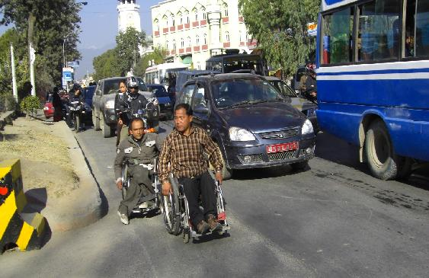
Fig: People with disability are forcing to use the main road due to lack of accessible pedestrian

Source of funds:
Asian Development Bank
Brief background to the project:
Situation of accessibility in urban area of Kathmandu is so bad that one can hardly imagine how the person with could move in such environment. The simple component of accessibility like curb ramp, tactile block, traffic light and safe zebra crossing zone which can be easily achieved with little bit more consideration if we think from beginning have long been neglected or overlooked. There are so many reason behind it but due to the lack of this simple things people with disability either being forced to constrain themselves in their limited surrounding or forced to risk their life in danger in main road.
The fundamental mobility right of people with disability as citizens has either been overlooked or neglected since long time. But from fast 10 years as Nepal practicing the open democratic system there are several of self-help group grown which are active and working very hard for their right. The disabled people organization (DPOs) are some of them which are advocating the accessibility time to time and organizing campaign in different ways. As result we can see some positive changes in urban environment to improve the access of person with disabilities. The current pedestrian improvement project funded by ADB (Asian Development Bank) and implemented by Kathmandu metropolitan city is one of the good example which is addressing the urban accessibility issues.
Fig 2: Members of DPOs protesting in municipality building for barrier free urban pedestrian

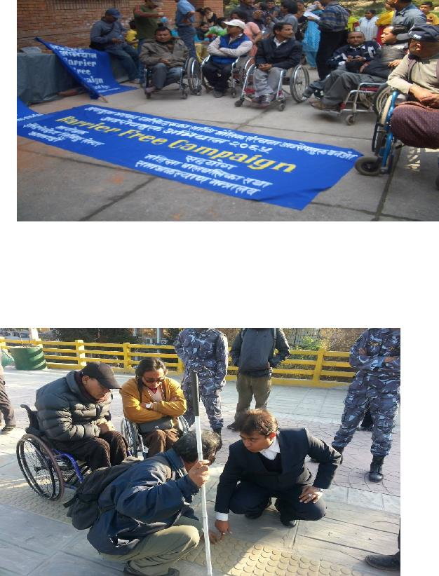
Fig 3: People with disabilities observing the effectiveness of it as user expert with project engineer
Overall objectives of the project/programme:
Overall objectives of the project/programme:
Improve the condition of pedestrian in Kathmandu valley by incorporating the accessible feature like curb ramp for wheelchair user and tactile block for visually impaired

Process/strategy to implement the project/programme:
In this on-going project people with disability are equally involved as user expert to insure the usability of the product.
Changes achieved:
Due to the result we can see some changes in pedestrian like tactile block and curb ramp and people with disabilities are comfortably using it and feel safe in while waking in urban area. 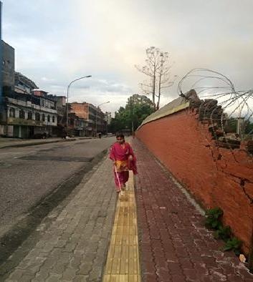Fig 4: Visually impaired person walking due to help of tactile block
How change was monitored and evaluated:
Shortcomings and persistent challenges identified in the implementation of the project/programme: Narrow road, vendor using the footpath, lack of awareness about the issues with disabilities, unskilled manpower who work on field
Other lessons learned:
1.Continues advocacy and awareness is essential to raise the issues of urban accessibility in society, and DPOs can play very important role to publicize the issues and to create moral pressure on the government
2.The use of person with disability and their group as user expert play very vital role to ensure the quality of work for it was aimed for
3. A clear cut easy to understand guidelines and mandatory provision by laws is need for the good implementation of the project
4.Sensitization programs or training is need both for government officer and technical persons
5.Sharing of success stories in public medias is need for replication and win the public appreciation

Country: Nigeria
Name of Organistaion/Government entity: Human and Organizational Resources Development Centre (HORDC)
Project/Programme title: Advocacy for inclusive Disability Laws, Policies and Programmes in Nigeria

Initiative selected as good practice example: Lagos State Urban Transport Project (LUTP)

Thematic area of good practice example: Accessible Public Transport System

Specific location: Lagos state, Southwest of Nigeria

Duration of project/programme: 6 years

Beneficiaries of good practice example:About 20 million inhabitants of Lagos state amongst whom are over 2 million persons with disabilities and unspecified population of elderly persons, pregnant women and children

Implementing agency/agencies:
- Disability Policy and Advocacy Initiative (DPAI)
- Joint National Association of Persons with Disabilities (JONAPWD) Lagos State Chapter
- Lagos State Office of Disability Affairs (LASODA)
- Lagos State Metropolitan Area Transport Authority (LAMATA)
- Lagos State Ministry of Works
- Lagos State Ministry of Physical Planning and Urban Development.

Source of funds:
- The initiative selected as “good practice example” has been funded through the World Bank, private sector investment and the annual budget of the state government.
- The 6-year Disability Policy Advocacy Project has been funded through the UK Government’s Department for International Development (DFID) under its State Accountability and Voice Initiative (SAVI) programme in Nigeria

Brief background to the project:
Although Nigeria signed and ratified the UNCRPD in 2010, the country is yet to fulfil its obligation to domesticate its provisions through a National Act of Parliament. As such, persons with disabilities (PWDs) suffered various forms of exclusions including lack of access to public infrastructures and facilities including roads, pedestrian bridges, public transport, public buildings, recreational and sport centres, public schools, housing, etc. The entire physical environment is virtually planned and developed with out any sensitivity to the accessibility needs of PWDs in Nigeria.
In Lagos state, Before 2010, Persons with disabilities are neither consulted nor participated in policy design, development, planning, implementation, monitoring and evaluation processes. Neither did There exist a dedicated Agency for the purpose of managing disability affairs as required by the UNCRPD.
On the 8th of March, 2010, In Lagos state, with support from DFID-SAVI, HORDC joined other Disabled People’s organizations (DPOs), mainstream civil society groups and passionate individuals to form an Advocacy Partnership for disability-inclusive laws, policies and programmes in Lagos state. The advocacy Partnership was formed with a view to influencing the enactment and implementation of disability laws, policies and programmes in Lagos state; and to replicate achievements in other parts of the country.

Overall objectives of the project/programme:
The advocacy project was designed with the broad objective of promoting, enhancing and sustaining the inclusion and accessibility of PWDs in all sectors of the society through inclusive laws, policies and programmes in line with the UNCRPD.

Process/strategy to implement the project/programme:
- The project adopted the partnership approach to advocacy. Through this approach, relevant agencies of government were targeted and constructively engaged as “partners” through information sharing; capacity-building and awareness raising. Civil society members of the partnership leveraged on the each other’s strength to engage relevant influencial policy-makers including legislators to achieve the project objectives.
- the social model of disability was adopted as the theoretical framework for the advocacy in line with the UNCRPD to guide development of advocacy and public awareness messages and to influence positive attitudinal change by policy-makers towards disability issues.
- The partnership adopted different advocacy strategies including advocacy visits, use of position papers and factsheets, policy reviews/impact assessments,media engagements, etc to identify policy gaps and profer relevant remedies.

Changes achieved:
- The first and most comprehensive state-level disability law in Nigeria, “Lagos State Special People’s Law” was enacted by the state government within 18 months of the advocacy between March, 2010 and June 2011.
- The first ever dedicated state-level Agency on disability in Nigeria, “Lagos State Office for Disability Affairs” was established on 9th July, 2012.
- The Lagos State Physical Planning and Urban Development Law was reviewed to effectively accommodate disability-inclusion and accessibility requirements including “ disability-accessible building code”
- For the first time in Nigeria, a State Government/Civil Society Partnership was formed as the Lagos state government norminated Desk Officers to represent it at CSO advocacy meetings and programmes. In addition, PWDs and DPOs are now regularly consulted and invited to participate in policy designs, planning and implementation processes.
- The implementation of relevant provisions of the disability law are being mainstreamed in key sectors in Lagos state including physical planning and urban development, works and infrastructure development, transport, housing, education, health and even the electoral process respectively.
- Specifically, the following inclusive and accessibility changes occurred in the physical and urban development of the state:
- entrances of all existing government buildings are being fitted with ramps, while new building are constructed with relevant physical accessibility provisions;
- all newly constructed roads are provided with accessible sidewalks fitted with ramps;
- newly constructed pedestrian bridges are fitted with ramps;
- parking lots are being designated for PWDs at appropriate and accessible locations in all government premises and public places;
- an intermodal urban transport with accessible shelters, buses, trains, jetties and airports are being designed, developed and implemented in Lagos state. At the moment,the Bus Rapid Transport scheme (BRT) is operated with accessible shelters and free bus rides for PWDs;
- The re-development of urban slums, remodelling of cities and towns, and the design and development of new cities in Lagos state (such as the Eko Antlantic City Project) are implemented with reasonable disability inclusion and accessibility requirements in line with the state’s disability laws;
- Public buildings and premises such as banks, hotels, shopping mulls,etc are also complying to inclusivity and accessibility requirements such as through fitting of ramps in their enterances and designation of parking lots.

How change was monitored and evaluated:
- The partnership monitor its activities through the indicators and targets set against its work plan objectives, and ouctomes;
- The partnership conducts annual budget monitoring and review with a view to tracking appropriation and expenditures on disability-based projects, programmes and policies;
- The partnership also conducts annual policy reviews and citizens impact assessments;

Shortcomings and persistent challenges identified in the implementation of the project/programme:
- The development and maintenance of an accurate disability data-base (DDB) is central to the implementation of any advocacy project and any inclusive and accessible urban development programme. Accordingly, the inability of the project to successfully push for the development of an accurate DDB and the seeming incapacitation of the state government to pursue this objective remain a key challenge to the effective inclusion of PWDs in the urban development programmes of Lagos state.
- Due to capacity gaps, there is a seeming lop-sidedness of the project’s impacts towards physical disabilities while other disability types (blind, deaf and intellectual disabilities) are not adequately captured in the design of projects. For instance, blind and deaf persons are still confronted with the challenges of accessing public information on signages, road signs and maps, public utility user guides, etc. Also, accessibility needs of blind and deaf persons on roads, public buildings, etc are yet to be achieved.
- Again, due to capacity and technology gaps, there is persistence in the challenge of accuracy and precision especially in measurements of accessibility features of infrastructures such as ramp slopes, wheelchair accessible door-ways, etc.
- The challenge of poor funding for disability projects have not been effectively overcome due to poor prioritization of disability issues. For instance, the use of accessible buses and trains are considered too “expensive” to acquire and maintain.
- DPOs and CSOs in Nigeria are mostly confronted with the challenges of funding and institutional capacities to sustain effective policy reviews, monitoring and evaluation, as well as massive public awareness.

Other lessons learned:
- It is observed that beyond the achievement of the enactment of a disability law and establishment of a disability agency in Lagos state, there is need to advocate for the review of the Lagos state longterm development planning instrument, “the State Development Plan” in which should be embedded a disability-inclusive and accessible Urban Development Master Plan.
- an inclusive and accessible urban development programme (especially in a country with high infrastructural deficit and highly disturted urban planning like Nigeria) is highly capital intensive. It will therefore require the setting-up of a “Special Fund” drawn from international development agencies, private sector and the budget of the state government.
- Similarly, from the Lagos state experience in Nigeria, it is observed that governments in poor countries may appear reluctant to expend so much to rebuild or remodel infrastructure and cities just to enhance inclusion and accessibility for PWDs. As such, beyond the conduct of advocacies, innovative and strategic approaches are required to identify cost effective methods of inclusive and accessible urban development in poor countries.

Case study on good practice in accessibility: Experience from the Philippines

Accessibility in the Philippines has been an issue which is in the center of the struggle of persons with disabilities who believe that this very basic right has for decades, been deliberately denied to them and was a major stumbling block in their ability to realize their fullest potentials as contributing members of their families and communities. The country’s urban areas have seen unprecedented levels of development during the last two decades. However, accessibility has remained among the areas that required attention until Filipinos with disabilities thought they needed to be more proactive in their demand that their right to access be recognized and respected.

One of the biggest business companies in the country is SM Shoemart which operates close to fifty (50) medium and up-scale malls in various cities. Persons with disabilities thought that if SM Shoemart can make its facilities inclusive and accessible to persons with disabilities, it can open the door for other business entities and even government, to recognize and appreciate the value of being inclusive. PWDs have reached out to SM and a partnership was forged and put into action.

Today, SM Shoemart has become a model of accessibility not only in the Philippines but in Asia and is proud about being so as part of fulfilling its so-called corporate social responsibility. It has created a department within the company which ensures that any SM mall that is constructed must adhere strictly into the standards set for by the concept of Universal Design. The company even took a step further in its desire to include persons with disabilities by ensuring that representatives of PWDs sit in its committee on accessibility. Regularly, staff of the company, down to the level of those who maintain restrooms and man elevators, undergo regular disability orientation and sensitivity trainings to make sure they understand what it means to be inclusive. These employees know exactly what the Wheelchair Sign implies: that people with less mobility including persons with disabilities, must have priority in using lifts/elevators and restrooms among the most basic of SM malls’ facilities.

A study conducted by the company revealed that business has been better in spite of tough competition in this field, as a result of SM shoemart’s corporate commitment to be inclusive. More families have been spending time in the malls, tagging along their members with disabilities and the elderly. More fun, family bonding, more shopping and dining and even watching movies by families has brought into SM’s business more revenues. As families spend more time together, their spending increased. Today, SM is so encouraged to be inclusive that it has created a program called SM Cares to provide additional services such as charging stations for wheelchairs and other assistive devices in a designated area in every SM Mall. The accessibility of SM malls is a model that has forced other public places to follow suit.

The Philippine Government has recently recognized and given an award to SM Shoemart for being a model in accessibility. Government has likewise encouraged other members of the business community in the Philippines to emulate the example set by SM. Being inclusive is finally recognized and appreciated as a good business practice. There is so much more that needs to be done to promote accessibility in the Philippines but the important initial steps have been made and things will only keep improving especially with persons with disabilities’ increased awareness and appreciation of accessibility as a basic right that has to be provided, realized and respected.

Country: Qatar
Name of Organization/Government entity: Tawasol
Project/Programme title: The Development of an Arabic Symbol Dictionary

Initiative selected as good practice example: Development of Arabic Symbol Dictionary

Thematic area of good practice example: Language and Cultural issues in ensuring Access

Specific location: Doha

Duration of project/programme: 3 years

Beneficiaries of good practice example: Arabic speakers with communication and/or literacy impairments

Implementing agency/agencies: Mada, Hamad Medical Corporation, University of Southampton
Source of funds: Qatar National Research Fund

Brief background to the project:

For individuals with special needs the development of communication and literacy skills is critical to a successful education and daily living support. An essential tool for these skills can be graphic symbol sets in which images or pictograms are used to convey meaning to enhance or replace speech and language as well as provide a support to text. However most symbols sets are derived from a language and cultural context making the task of cultural transference difficult, and leaving children with special needs unable to access the resources they need.

To address the challenge for Arabic speakers the Tawasol project has been established, a QNRF funded project to produce an Arabic Symbol Dictionary.

The symbol set is produced under creative commons license allowing unrestricted use by individuals, in schools and other organisations. The symbols with their lexical entries will support Modern Standard Arabic, Qatari Dialect and English. The project has completed two years to date with the final year starting in December.

Overall objectives of the project/programme:

The project aims to ensure that those with speech and language disorders and literacy difficulties in the State of Qatar have access to the communication resources they require to gain a voice and work towards greater personal autonomy

Process/strategy to implement the project/programme:
The project was established as a collaboration between three entities. A work plan was identified which sought to review existing symbol sets, identify core Arabic word lists, create a design specification for Arabic symbols, produce and distribute the symbols and establish resources to ensure uptake of the symbols during and after the project lifespan.
One of the interesting innovations in the project was a crowd sourced approach to the selection of symbols where consensus could not be achieved. This allowed a significantly wider group of Arabic speakers to provide input to the most appropriate means of communicating concepts. Voting sessions are available on both a face to face basis and online to facilitate the widest possibly engagement with stakeholders. Many of those voting on the symbols will become the professional users of the final product.
Changes achieved:

To date some 250 symbols have been approved for distribution, these have been aligned to Modern Standard Arabic, Qatari dialect and English. The design brief for Arabic symbols has been confirmed allowing for design rules to be created that will help in building a sustainable dictionary with options to add further vocabulary at the end of the project. The project is on track to complete well over 500 symbols by the end of the project funding.

How change was monitored and evaluated:

An international advisory board was created with the remit to review progress and ensure that the symbol dictionary was suitable for the objective. By engaging directly with a wide range of stakeholders, professionals and those with communication needs throughout the span of the project it has been possible to ensure that progress in the number of symbols and their relevance to users has been maintained.

Shortcomings and persistent challenges identified in the implementation of the project/programme:

The project has sought to address from the very beginning the need to design with distribution in mind. Online distribution will be critical, along with the need to work with existing symbol sets such as ARASAAC to maximise compatibility. Engagement with the manufacturers of software and devices that integrate symbols into communication devices has been considered essential to ensure that the dictionary content is presented in a way that makes implementation in solutions as seamless as possible.

Creative commons open licensing is designed to make the use of the symbols in as wide a range of applications as easy as possible.

Other lessons learned:

The importance of engaging professionals with a shared cultural experience to end users was essential in developing effective symbols and a core vocabulary. This shared identity helped to ensure the relevance of symbols and that the products would have a high degree of functional familiarity for people with a disability
Updates and discussions on the project can be found at http://access.ecs.soton.ac.uk/blog/symboldictionary/
Arabic Symbol Dictionary website http://www.tawasolsymbols.org

Country: Qatar
Name of Organization/Government entity: Mada
Project/Programme title: Development of Arabic Assistive Technologies

Initiative selected as good practice example: Development of Arabic Assistive Technologies

Thematic area of good practice example: Language and Cultural Transference

Specific location: Doha

Duration of project/programme: 5 years

Beneficiaries of good practice example: People with a disability including those with physical, visual, hearing, speech and intellectual challenges

Implementing agency/agencies: Mada with a range of partner organizations, each product owned by an individual IP owner

Source of funds: Ministry for Information and Communications Technology

Brief background to the project:

When the Mada centre opened in 2010 it was clear that little or no Arabic language access technology was available to support people with a disability, as a result Mada engaged in a process of establishing partnerships with a range of access technology organisations in the private and public sector to ensure that a range of products were localised and contextualised for the Arabic Language. The lack of such technology was a significant barrier to full participation in society and moreover to reduced opportunities for access to employment, education and daily life.

Overall objectives of the project/programme:

The project aimed to ensure that people with a disability in the State of Qatar has access to technology and digital content to facilitate inclusion within society and were able to achieve their aspirations

Process/strategy to implement the project/programme:

Mada established a call to action to AT developers in 2011. This was distributed and negotiated in partnership with the Assistive Technology Industry Association. In each of the years from 20011-2013 organisations were invited to submit proposals for funding to bring products to the Arabic market. Funding was approved subject to products being publically available and moreover that in return for the funding Mada obtained access to a agreed level of licenses for distribution within the state of Qatar. IP resided with the partner organisation allowing them to market, distribute their solution beyond Qatar, creating a sustainable market and business model.

Changes achieved:

35 products targeting the needs of people with physical disabilities, visual impairments, hearing impairments and learning difficulties including both dyslexia and autism were created. To date some 3500 products have been distributed within Qatar.

How change was monitored and evaluated:

The products were introduced over an extended period as they became available. All products went through a User Acceptance test before release, and were then provided following a process of personal assessment and recommendation with an AT professional at the Mada centre. This allowed the team to ensure that the correct solutions were made available, and moreover that impact and success were evaluated by the Mada team members.

Shortcomings and persistent challenges identified in the implementation of the project/programme:

There remain some underlying weaknesses in the Arabic assistive technical infrastructure. These included
- Lack of simple and accurate word prediction
- Lack of Language and culturally sensitive symbols
- Lack of low cost/ High Quality Text to speech
- Lack of Speech recognition

During the initiative the first two were addressed and whilst some progress was made on the others a satisfactory outcome was not yet finalised. Whilst working on these projects we were in addition able to identify progress on related issues such as Arabic OCR with Qatar National Library. This support the creation of accessible books and documents for Arabic speakers

Other lessons learned:

As a result of the model, Mada investigated similar issues that could be applied to the transfer and contextualisation of capacity building and knowledge transfer. A website was created at http://localisation.atbar.org/ which outlined the issues and solutions that need to be considered in creating assistive technologies for language communities

Country: Singapore

Name of Organisation/Government entity: Building and Construction Authority (BCA)

Project/Programme title: Accessibility Master Plan to create a User-Friendly Built Environment
Initiative selected as good practice example: It is a Programme which uses multi-levers and multiagencies effort to create an accessible and universally design built environment

Thematic area of good practice example: To raise the accessibility standards and drive the adoption
of Universal Design (UD) in the built environment.

Specific location: To target all places to be accessed by members of public

Duration of project/programme: 10 years

Beneficiaries of good practice example: Users and occupants of residential and public buildings and
Parks and Open spaces.

Implementing agency/agencies: BCA and other public agencies

Source of funds: Government

Brief background to the project:
Singapore, a city state with a current population of 5.54 million, underwent rapid urbanisation from the late 1950s, resulting in a high-rise, high-density built environment in the years that followed. At that time, the majority of the population was young and mobile. The need to provide for barrier free accessibility was not a critical concern compared to maximising land resources for the economic and housing needs of the growing population.

The issue of accessibility was visited in the 80s resulting in the legislation to provide barrier-free accessibility in buildings under the Building Control Act, 1989. Since 1990, a milestone year, all public buildings and communal areas of residential buildings with building plans that were submitted to the Building Authority for approval were required to provide barrier-free accessibility in accordance with the Code on Accessibility in buildings, 1990.

While the legislation and Code on Barrier-free Accessibility had been an important lever in ensuring all new buildings are accessible, there remains a large stock of buildings built before 1990 that were not barrier-free.

With a fast greying population, projected to have 1 in 5 or 20% to be 65 years and above in year 2030, planning for an inclusive and user-friendly built environment for the elderly and individuals with disabilities was imperative. The BCA Accessibility Master Plan was thus developed in 2006 to support and complement the Recommendations by the Ministerial Committee on Ageing Issues and the Enabling Master Plan to create an inclusive built environment.

Overall objectives of the project/programme:
The Accessibility Master Plan seeks to pursue an upstream goal of raising the accessibility standards and driving the adoption of Universal Design (UD) in the built environment. Barrier-free accessibility and UD will be instrumental to our continual efforts in building a liveable City for All Ages and in fulfilling our nation’s obligations under the UN Convention on the Rights of Persons with Disabilities.

Process/strategy to implement the project/programme:
The Accessibility Master Plan is a holistic framework that addresses both Barrier-free accessibility and adoption of UD in the built environment through a multi-lever, multi-pronged approach to deal with accessibility concerns in the past, present and future developments through 4 strategic thrusts.

In the efforts to make Singapore an inclusive and friendly environment, the close 3-P collaboration is key and highly effective in driving accessibility improvement and broadening the UD. Hence, all activities and initiatives involve the continual engagement between the Public, Private and People sectors.

Some of the initiatives implemented under the four Strategic Thrusts are as follows:
i) Mitigating Existing Challenges
a. 5-year Accessibility Upgrading Programme (2006-2011) to support and facilitate the upgrading of Key buildings and Key area by the public and private sectors. Orchard Road was chosen as one of the key areas for driving upgrading and improvement.
b. Capital incentive –S$40 million Accessibility Fund to co-pay up to 80% of the of upgrading existing buildings of the private sector with at least basic accessibility features

ii) Tackling Future Challenges Upstream
a. Raising the minimum standard of the Accessibility Code by a Review Committee that comprises representatives from the public, private and people sectors. The code on “Barrier-free accessibility in Buildings” was re-named “Code on accessibility in the Built Environment” in 2007 to reflect the enhanced scope. Some of the changes/enhances includes
• New requirement to ensure the inter-connectivity between buildings
• Places greater emphasis on UD Concepts and provisions that will benefit a wider spectrum of people - persons with physical and sensory impairment, older persons and family with young children.
• The requirement for all new residential units to make provision for the toilet to be easily retrofitted for use by persons with disabilities when need arises.

b. Promoting the adoption of Universal Design
• Published UD Codes for designers and developers.
• Organized UD Award (from 2006-2011) which recognizes buildings and stakeholders that adopt a user-centric philosophy in their design, operations and maintenance. It identifies and distinguishes developments that have gone beyond meeting minimum standards
• To “brand” UD, a voluntary UD Mark certification scheme in 2012 was initiated to replace UD Award. This scheme assesses projects at their design stage, facilitating the incorporation of UD at the start of their development. Once completed, the development or project will be assessed and awarded a display plaque, indicating one of the four Universal Design Mark ratings: Certified, Gold, GoldPLUS or Platinum.

iii) Maintaining Existing Accessible Features
a. To deal with misuse and removable of accessible features, the Building Control Act was amended in 2008 to ensure that building owners continue to maintain accessible features in their buildings approved under the Building Control Act
.
iv) Raising awareness and Capabilities of the Industry and Stakeholders
a. To raise public awareness to create demand and inculcate good social behavior in the use of accessible features, the outreach initiatives include:-
• The one–stop information Portal www.friendlybuilding.sg with a search feature to find the friendly buildings which help persons with disabilities confirm that the building is assessable before visit.
• Roving exhibitions and students competitions

b. To raise the capabilities of the industry,
• UD Assessor Course was put up for developers, project managers, builders who are keen to obtain UD Mark Certification
• Singapore Universal Design Week with programmes which span a week for both the professionals, students and general public
• Formed UD Club for practitioners to share and learn on UD
• Internship for tertiary education students

Changes achieved:
The implementation of the Accessibility Master Plan has resulted in progressive, observable improvements in barrier-free accessibility in the built environment and wider application of UD principles in new and existing buildings undergoing major alteration and additions.
• As at 2012, close to 100% of the public sector buildings are provided with at least basic accessibility features, an increase from about 50% at 2007.
• As at 2012, about 88% of the Orchard Road buildings have at least basic accessibility features, an increase from 41% at 2006.
• The Accessibility Fund has supported more than 140 buildings for upgrading.
• Since the launch in 2012, 94 UD Mark certification with 7 UD Mark Platinum were awarded.
• The “branding” of UD has promoted several developers to ask for “UD Mark platinum” in their design brief to the architects...
• The UD Mark Certification scheme was recognised as one of the innovative project by the “Zero Project” in 2014 in successfully encouraging building owners/developers to adopt UD voluntarily.

Other improvements made to the built environment includes:

Public Housings (more than 80% of the Singapore population live in public housing)
• New public housings are built in accordance with the Accessible Code and UD principles.
• The Housing and Development Board (HDB) has also provided upgrades to existing public housing and communal areas. These include lift upgrades to older flats, ensuring that estates are barrier free. Works include retrofitting estates with features such as ramps, railings, levelling of steps for enhanced accessibility, improved connectivity between building blocks, key precinct facilities and amenities; and linking access routes to traffic crossings and transportation nod Improvement in infra-structures by Land Transport Authority
• Upgraded all road related facilities within the 400m of Train stations
• 96% of our bus shelters are barrier-free and all bus interchanges have been upgraded to be barrier-free in preparation for all public buses and services to be wheel-accessible by 2020.
• More than 85% of our Train stations are provided with at least two barrier-free access routes
• Other initiatives include retrofitting lifts at overhead bridges at selected train stations, the Green Man+ scheme which allows senior citizens and persons with disabilities to enjoy longer crossing times at traffic junctions by tapping their concession cards at the traffic light poles. There is also the audible pedestrian signal installed at selected pedestrian crossings to assist visually-impaired pedestrians to cross the road safely.

How change was monitored and evaluated:

Under the 1st Accessibility Master plan, Orchard Road was selected for improvement. The Key steps are to monitor and evaluate Orchard are as follows:
1) Survey forms sent to building owners to carry out self-check and followed up with site Audit by BCA Staff.
2) Buildings are rated according to the level of accessibility and posted on the BCA Friendly Building Portal www.friendlybuilding.sg
3) For buildings that are not barrier-free, BCA staff will follow up with building owners to encourage them to upgrade with the support of Accessibility Fund. Every case was followed up periodically. Orchard Road Shopping Mall was surveyed in 2006 with only 41% of barrier-free buildings. By early 2012, the number of existing buildings with at least basic accessibility features has increased to 88%.

Shortcomings and persistent challenges identified in the implementation of the project/programme:
The key Challenges
1) For existing buildings
Most building owners are not keen to voluntarily upgrade their buildings to be barrier-free even with the offer of Accessibility Fund. Reasons cited included the loss of valuable saleable/rentable floor areas.
2) New Buildings
Need to continually encourage building owners to go beyond minimum Code Compliance for their new buildings to adopt UD concept.
3) Land scarce
Singapore is a land scarce country. To improve the ‘Walkability’ of public areas, particularly the road sidewalk, we have to overcome land constraints and look into the need to review the current planning perimeters. Greater effort and co-ordination among different agencies are needed to ensure each agency does not work in ‘silos’.
4) Flood
The change of new platform to mitigate flash flood remains a challenge to have barrier-free interconnectivity and comfortable entries to buildings.

Other lessons learned:
In the efforts to make Singapore an inclusive and friendly environment, the close 3-P (public, private and people) collaboration is key and highly effective in driving accessibility improvements and broadening the UD. The success of the programmes is not due to one single agency. It is the whole of government effort.
Country: South Africa
Name of Organistaion/Government entity: Department of Transport, Public Transport Branch
Project/Programme title: Integrated Public Transport Networks: Johannesburg, Cape Town, Tshwane and Johannesburg

Initiative selected as good practice example: Operating network

Thematic area of good practice example: Public Transport

Specific location: Gauteng and Western Cape Provinces, South Africa

Duration of project/programme: Differs between operating municipalities. Please see below.

Beneficiaries of good practice example: People with disabilities, elderly people, children, people accompanying children and pregnant women (accounting for around 60-65% of the South African population based on 2011 estimates).

All public transport users, as it is a safer, better integrated and more reliable form of public transport.

Implementing agency/agencies: Implementing municipalities, supported by the province and national department of transport.
Universal access consultants, appointed by municipalities provide project support directly to them.

Source of funds: National Grant: Public Transport Network Development, Provincial funding (Equitable share) and income generated by the system.

Duration of programme and changes achieved:

Municipality and bus system | Duration of programme | Changes achieved
Tshwane: A re Yeng | Operating since 2014, planning since 2009. | - 9.8 km of BRT trunk, 2.3km of mixed traffic trunk and feeder corridors. 37km of non-motorised transport network feeding about 17 stops with shelters, 441 flag and pole stops and 7 stations.  - 30 buses, universally accessible at the stations and selected stops. This is due to the parking problems in the city which means that the buses are unable to draw up alongside the kerb  - A Re Yeng carries 2,565 passengers per day using 30 buses. (May 2015)
Johannesburg: Rea Vaya | Operating since 2009, planning since 2003 | - 43.5 km of BRT trunk, 149.62km of mixed traffic trunk corridors and 317km and feeder km. 6.5km of non-motorised transport network feeding about xxx stops with shelters, 231 flag and pole stops and 48 stations.  - 277 buses, universally accessible at the stations only.  - Re Vaya carries 36,649 passengers per day using 277 buses. (June 2015)
Cape Town (TCT): My Citi | Operating since 2009, planning since 2007 | - 31.4 km of BRT trunk, 108km of mixed traffic trunk corridors and 317km of feeder km. 31km of non-motorised transport network feeding 363 stops with shelters, 222 flag and pole stops and 42 stations.  - 379 universally accessible buses  - TCT is in the process of costing universal access rollout from an infrastructure and operational perspective so as to determine the most appropriate process for implementation. This is alongside a universal access infrastructure audit as well as the restructuring of its door-to-door on-demand service, Dial-a-Ride.  - TCT signed a memorandum of action with the rail implementing agency, PRASA on 4 May 2015 aiming to integrate bus and rail services (ticket, interchanges, operations monitoring and management, improving land use densities.  - My Citi carries 78, 825 passengers per day using 379 buses. (February 2015)
George: GoGeorge | 8 months of operation (2015), planning since 2005 | - Network of trunk, community, inter-suburb and inter town routes covering 25 routes covering 5.8 million bus/km per year  - 95 vehicles in fleet with operations commencing in 2015  - Central bus terminus and depot and a remote depot  - The network operates in mixed traffic with universally accessible vehicles (boarding and alighting)  - GoGeorge carries 11,368 passengers per day, using 64 buses, 12m and 9m vehicles (June 2015)

Brief background to the project:

The Department of Transport (DoT) is one of the key government departments piloting a more economically viable and sustainable approach to the development of urban space through its
Integrated Public Transport Networks (IPTNs), monitored by the Public Transport Network Division (PTND). It is the only division in the Department responsible for a grant that actively promotes the progressive implementation of universal access as part of the grant conditions, which is in line with the United Nations Convention on the Rights of Persons with Disabilities (UNCRP).

The Public Transport Strategy 2007 and the Public Transport Network Grant support the progressive implementation of universal access in public transport and urban spaces, as the most realistic and affordable way of changing cities so that they are inclusive of every one. Both strategy and policy instrument propose that this approach is the most realistic and affordable way of changing urban transport and urban living so that everyone can participate in society in a meaningful way.

The National Land Transport Act identifies vulnerable groups who currently have difficulties using transport as special needs passengers. The national focus on these groups is in line with the universal design approach required by the United Nations Convention. Through the IPTNs, municipalities are demonstrating a reformed approach to urban planning which aims to be universally designed over time.

The principles of universal design, when applied to urban planning, support other government directives that encourage compact, pleasant, environmentally sustainable urban spaces with mixed-use residential and business nodes. They promote walking and cycling, as well as easy-to-use public transport for people who live outside the urban centre or who are unable to walk long distances.

The Integrated Urban Development Framework (COGTA: 2014) identifies levers that aim to create compact cities. Universal design has been highlighted in the report on vulnerable groups as a necessary approach. Although the IUDF is still in the initial stages, DoT is already working with the suggested approach on municipal transport networks.

The National Development Plan (National Planning Commission: 2011) identifies the need to create more compact cities and to re-organise public transport so that every person can be included in urban life. Without this South African cities cannot become viable economic centres of growth. In turn, without economically responsive urban hubs, it becomes harder to support isolated rural communities.

The method used by DoT on transport projects is to target new public transport interventions and apply relevant national minimum standards. It should be noted that these standards are not new, and some have been in existence for over 20 years. However, they have only been applied to urban public space since 2010 and only within the IPTNs.

By using this approach, DoT sets a new municipal standard within the IPTN. No dates are set for upgrading existing services, these are improved based on available funds. However the new intervention sets a very visible, identifiable and usable standard.

In this way, it is simple to price and plan the improvements required to existing transport services. Implementation of the upgrading of existing transport services is incremental, with a timetable negotiated with DoT.

The timetable is dependent on other municipal priorities and is implemented exponentially depending on available resources. This approach is reasonable. It is in line with other government legislation, such as the Promotion of Equality and Prevention of Unfair Discrimination Act 2000.

The approach that the Department of Transport uses is seen as a good practice example of the implementation of the UNCRDP.

Overall objectives of the project/programme: accessible, safe, affordable, efficient and integrated public transport that is:

- Effective in satisfying user needs
- Affordable
- Operating efficiently
- Reliable
- Of an acceptable standard
- Readily accessible
- Operated in conjunction with effective infrastructure provided at reasonable cost
- Safe
- Integrated between modes giving due consideration to the needs of users
- Effective in promoting integrated transport planning

Process/strategy to implement the project/programme: Public Transport Strategy, 2007

How change was (is) monitored and evaluated: Numbers of passengers using the system, number of passenger complaints resolved as a percentage of those received, reporting on the Universal Design Access Plan, which is part of the operational plan

Shortcomings and persistent challenges identified in the implementation of the project/programme:

- Operating difficulties: discord amongst operators of the current bus operating companies and previous and existing minibus taxi operators.
- Municipal capacity: no experience of planning and operating public transport of this nature.
- Geographical spread: South African cities creating economically unviable cities: this leads to problems implementing public transport (whether universally accessible or not) that is unable to run without state subsidy.
- Universal access: lack of understanding of the complexity of universal access at the outset of the project, particularly relating to vehicles and infrastructure.. Universal access standards are not thorough enough and not well-known enough
- Speed of delivery: Lack of historical implementation in universal access leads to slow pace of change
- Ethics: professional lack of responsibility from some service providers (of professional bodies – architects/engineers)
- Teamwork: lack of national and municipal teamwork around a common goal
- Silo thinking: tunnel vision of government departments at all levels of government – main UA focus on new road-based public transport only
- Unintended costs: mistakes made due to lack of knowledge, or lack of coordination between implementing departments
- Vested interests: costs driven up by over-charging
- Evaluation: different ways of measuring success, due to different unspoken goals
- Car-based focus: trying to please everyone means not meeting the needs of the priority group
(Other) lessons learned:

- Information on standards on all aspects of the travel chain is required by municipalities in the early planning stages so that the network plan is realistic
- Flexibility is required to find answers to problems for remote or rural areas where road structure is substandard and normal buses are too heavy
- No matter how much the municipality prepares, the initial year of operation is a steep learning curve
- Municipalities need access to training in running a new operational model for public transport which is unlike anything that South Africa has operated before.

Country: Uganda
Name of Organistaion/Government entity: Department of Elderly and Disability Affairs, Ministry of Gender, Labour and Social Development.
Project/Programme title: National Accessibility Standards

Initiative selected as good practice example: Accessible ramps in schools and new public and Private building

Thematic area of good practice example: Physical accessibility

Specific location: Kampala city and Wakiso district

Duration of project/programme: Two year

Beneficiaries of good practice example: Persons with Physical disabilities and all persons without disabilities

Implementing agency/agencies: Ministry of Gender, Labour and social Development and Uganda National action on physical disability.

Source of funds: DANIDA

Brief background to the project: Establish National accessibility standards and National Accessibility audit committee.

Overall objectives of the project/programme:

Process/strategy to implement the project/programme: Partnerships, research study and draft accessibility.

Changes achieved: The building control act, 2013 integrates the accessibility standards

How change was monitored and evaluated: The building control Act 2013 establishes a National Building Review Board and Building Committees to promote and ensure planned, decent and safe building structures that are developed in harmony with the environment and accessibility standards.

Shortcomings and persistent challenges identified in the implementation of the project/programme: Focuses on Physical accessibility standards and does not address the information and communication accessibility standards.

Realizing the Potential: Expanding Housing Opportunities Near Transit:
USA
The Federal Transit
This new national study funded by the Federal Transit Administration and the U.S. Department of Housing and Urban Development shows that location matters a great deal when it comes to reducing household costs. While families who live in auto-dependent neighborhoods spend an average of 25 percent of their household budget on transportation, families who live in transit-rich neighborhoods spend just 9 percent, the study says. The report examines five case study regions – Boston, Charlotte, Denver, Minneapolis, and Portland -- to better understand the proactive strategies being undertaken to create and preserve affordable housing near transit.
http://www.reconnectingamerica.org/resource-center/books-and-reports/2007/realizing-the-potential-expanding-housing-opportunities-near-transit-2/

Green Infrastructure and the Sustainable Communities Initiative:
Administration and the U.S. Department of Housing and Urban Development
USA
The incorporation of green infrastructure can be a cost-effective solution to help communities save taxpayer money on public infrastructure capital investment and maintenance costs, improve stormwater management and water quality, reduce combined sewer overflows (CSOs), and limit the impacts of flooding on homes and businesses. All of these efforts support communities to become more resilient to the effects of climate change and extreme weather events, while lowering future infrastructure costs and promoting community revitalization.
This report shares the green infrastructure best practices and outputs of HUD grantees under the HUD SCI grant programs as part of HUD’s commitment under the Green Infrastructure Collaborative. These profiles present a high-level snapshot of the grantees’ green infrastructure work and link to other resources with more detailed information on plans and projects.
http://portal.hud.gov/hudportal/documents/huddoc?id=greeninfrastructsci.pd
Advisory Workgroup Report: Livable New York:

Livable New York

USA

In response to changes in demographic, policy, environmental, and economic conditions, Livable New York is to helping municipalities better plan for the housing and community needs of the State's older people, younger people with disabilities, families, and caregivers. Under this initiative to create livable communities, municipalities will be provided with education, technical assistance, and training on understanding the impact of change, using community evaluation as a basis for resident-centered planning, and implementing successful and innovative models, strategies, and approaches related to the initiative's focus areas of housing options and development, universal design and accessibility, green building, mobility, transportation, etc.
http://www.aging.ny.gov/LivableNY/Documents/AdvisoryWorkgroupRecommendationsReport.pdf

FAIR HOUSING ACT

U.S. Urban Development Standards of Accessibility

USA

The Fair Housing Act protects people from discrimination when they are renting, buying, or securing financing for any housing. No one may take any of the following actions based on race, color, national origin, religion, sex, familial status or disability: refuse to rent or sell housing; refuse to negotiate for housing; make housing unavailable, set different terms, conditions or privileges for sale or rental of a dwelling, etc. Landlord’s may not refuse to let renters make reasonable modifications to the dwelling or common use areas, at the renter’s expense, if necessary for the disabled person to use the housing, or refuse to make reasonable accommodations in rules, policies, practices or services if necessary for the disabled person to use the housing.

http://portal.hud.gov/hudportal/HUD?src=/program_offices/fair_housing_equal_opp/FHLaws/yourrights

All privately and publicly owned housing with 4 or more units, regardless of whether they are rental or for sale units, must adhere to the accessibility requirements of the Fair Housing Act. All Federally assisted new construction housing developments with 5 or more units must design and construct 5 percent of the dwelling units, or at least one unit, whichever is greater, to be accessible for persons with mobility disabilities.
http://portal.hud.gov/hudportal/HUD?src=/program_offices/fair_housing_equal_opp/disabilities/accessibilityR

Country: USA
Name of Organisation/Government entity: New York City Department of Transportation
Project/Programme title: Public Plaza

Initiative selected as good practice example: Inclusive Public Spaces: Madison Square Plaza Project

Thematic area of good practice example: Plaza Furniture within the pedestrian right of way

Specific location: Madison Square Public Plaza on East 23rd Street, Manhattan, New York

Duration of project/programme: 1 year

Beneficiaries of good practice example: New Yorkers and NYC visitors with disabilities

Implementing agency/agencies: NYC DOT

Source of funds: New York City DOT Capital Funds

Brief background to the project:

NYC DOT works with selected not-for-profit organizations to create neighborhood plazas throughout the City to transform underused streets into vibrant, social public spaces. The NYC Plaza Program is a key part of the City's effort to ensure that all New Yorkers live within a 10-minute walk of quality open space.

DOT funds the design and construction of plazas and with community input through public visioning workshops, assists partners in developing a conceptual design appropriate to the neighborhood.

After restructuring the street use and building Madison Square plaza, DOT was approached by PASS (Pedestrians for Accessible and Safe Streets), an advocacy group for low vision and blind pedestrians in New York City. The team had concerns about the placement of round planters, granite blocks and detectible warning signs throughout the plaza.

Overall objectives of the project/programme:

The main objectives of this project were to work with special interest groups including PASS and other stakeholders to understand the complications with the built plazas and identify actionable remedies to those complications.

Process/strategy to implement the project/programme:

DOT, in close interactions with the NYC Mayor’s Office for People with Disabilities, an accessible design consultant and the PASS coalition, worked closely to identify areas of the plaza that presented difficulties for pedestrians with disabilities, especially low-vision and or blind pedestrians. Together, the group conducted several walkthroughs of the plaza and gathered data on concrete changes that would transform Madison Square plaza into an accessible space for all visitors.

Changes achieved:

From the data collected, the team was able to clear intersections of all furniture and added detectible warning signs at the crosswalks to enhance navigation. Existing granite blocks were strategically placed to help detect edges of the plaza. Planters and other street furniture were placed closer together to create consistent and clear boundaries within the plaza and prohibit permeability into active traffic.

How change was monitored and evaluated:

DOT’s plaza unit maintained an open dialogue with the Mayor’s Office for People with Disabilities and the PASS Coalition who has reported on the positive changes made to Madison Square plaza. The groups meet quarterly to discuss plazas and other subjects of interests.

Shortcomings and persistent challenges identified in the implementation of the project/programme:

DOT continues its search for sustainable detectible materials that could be used to easily identify plazas’ boundaries. A lack of national standards and guidelines for accessibility in outdoor spaces continues to be a struggle.

Other lessons learned:

From this project, DOT has learned the importance of actively seeking engagement of the disability community for all the work we do. We have established a quarterly meeting with the PASS Coalition and engage other stakeholders from the disability community for input in our projects. We also continue a close collaboration with the Mayor’s Office for People with Disabilities.

Country: United States of America
Name of Organisation/Government entity: Coalition for a Livable Future (CLF)
Project/Programme title: Regional Equity Atlas (REA)

Initiative selected as good practice example: raising awareness, advocacy, and planning tool

Thematic area of good practice example: identifying neighbourhood inequities

Specific location: Portland, Oregon, USA

Duration of project/programme: 2007-2015

Beneficiaries of good practice example: REA has been used by local NGOs and governments to identify areas of highest need, inform health and equity impact assessments, identify vulnerable populations, analyze potential sites for investment, and track performance measures. For example:

- A local faith-based NGO used the REA as part of a food security assessment. The analysis showed that one neighbourhood was amongst the poorest and most culturally diverse in the region, and had among the lowest levels of access to multiple resources (including food, sidewalks, and public transit). The REA, combined with community interviews and surveys, provided the NGO with a data-driven advocacy tool to inform policy-makers of disparities, and the need to prioritize community-informed investments in the neighbourhood.
- A county department used the REA as part of their planning and decision-making about where to locate future housing developments. County staff engaged developers and community members in using REA maps help identify criteria for an equity assessment. They also used REA maps to assess the benefits and drawbacks of a potential site for new affordable housing, showing the site's access to transit, educational facilities, healthy food options, and parks.
- A local NGO used the REA to analyze the demographics of a multi-ethnic neighbourhood where community leaders are working to develop a thriving business district. CLF worked with them to highlight the area’s needs, so they could make the case to policymakers and prioritize future services. For example, the maps showed that a large percentage of the residents in parts of the district are under age 18. This information has helped inform the NGO’s plan to offer programs such as child care services and education centers.
- CLF’s Equity Stories Project gathered videos, photographs, and personal narratives from people across the region who are impacted by the disparities shown in the REA. NGOs have used these stories to put a human face on local conditions and create more compelling cases for policy change. For example, a grassroots tenants’ rights organization used the video to capture the experiences of low-income refugees who are living in substandard housing with unhealthy conditions that make their families sick. The NGO uses the videos in support of a campaign to bring rental units up to code.

Implementing agency/agencies: Coalition for a Livable Future

Source of funds: Bullitt Foundation, Meyer Memorial Trust, Northwest Health Foundation, Robert Wood Johnson Foundation, and in-kind support from a local government, Metro, and university, Portland State University

Brief background to the project: Equity atlases provide a visual depiction of these disparities and enable us to understand how the benefits and burdens of growth and change are distributed across a region. Through the use of high-quality maps and data, equity atlases show where different demographic groups live; how well they are able to access key resources such as transit, quality education, affordable housing, jobs, food, clean air, and parks; and how these patterns affect their health and well-being.

The Regional Equity Atlas was launched in 2007 as a hard copy book of maps and analysis describing disparities in opportunity using various indicators across neighbourhoods and populations in Portland, Oregon. A web-based mapping tool was subsequently developed and launched in 2013, along with analysis and an outreach and education initiative.

By illuminating a community’s geography of opportunity, equity atlases can play a powerful role in supporting advocacy and policy change to promote greater equity.

The REA can be used to inform a wide range of planning, policy, and investment decisions, such as where to locate new housing, transit, parks, services, infrastructure, and other amenities, and where to most effectively target public and private investments.

Overall objectives of the project/programme: The REA assesses how well different neighbourhoods and populations are able to access the essential resources needed to meet their basic needs and advance their health and well-being.

Process/strategy to implement the project/programme: The REA was developed through an extensive, multi-year process. The process include planning, building a project team, engaging stakeholders, selecting indicators, developing the mapping platform, creating maps, developing interpretive materials and analysis, and outreach and education.

Changes achieved: The REA has transformed conversations around equity in the Portland metropolitan region and helped shape local advocacy and policymaking to address disparities. CLF and other local NGOs used the REA findings to secure changes in regional planning and investment decisions. Local governments have relied on the REA to shape their understanding of the region’s needs. Other regions and a national organization in the USA have been inspired by our example to develop other equity atlases.

How change was monitored and evaluated: The Coalition for a Livable Future used user surveys, interviews, tracking of partners’ use of the tool and the affect on outcomes, and tracking of government practices and media reports to assess shifts in policies, investments, and attitudes.

Shortcomings and persistent challenges identified in the implementation of the project/programme: The focus of the REA is not solely on persons with disabilities, rather it looks at the extent to which persons with different identity markers (race, gender, age, disability) are afforded access (or not) on an equal basis with others. While the Regional Equity Atlas has been good at identifying barriers in the built environment, some aspects of accessibility inequities were more difficult to map. One shortcoming is that there is a lack of information about the availability of support services for persons with disabilities, and there is a lack of information about some other elements of accessibility (especially with regard to information and communication technology). In some cases, imperfect proxies were used to gauge accessibility. For example, single story buildings and buildings with lifts (elevators) were deemed “accessible” according to the map, while of course, not all single story buildings are in fact built according to universal design principles and standards.

Other lessons learned: The REA has advanced systemic change by:
- Institutionalizing an equity lens within local government: The Portland metro area’s regional government is using Regional Equity Atlas 2.0 to help incorporate equity considerations into planning and decision-making related to regional growth management, regional transportation, and climate change mitigation strategies.
- Shaping investment priorities: The Portland Bureau of Transportation used Regional Equity Atlas 2.0 data to create a decision-making framework to determine how to prioritize investments in street lighting upgrades.
- Guiding system design: Multnomah County’s Schools Uniting Neighborhoods system is using Regional Equity Atlas 2.0 maps to assess shifting demographics in the county in order to guide the system’s planning and design of wraparound health, mental health, and social services to meet the needs of low-income families.
- Informing location decisions: The Washington County Women Infants and Children (WIC) program used Regional Equity Atlas 2.0 transit and demographic maps to inform the location of a new WIC office to ensure that low-income mothers and children have access to nutritious food.

ACPF (2014). Access Denied: Voices of persons with disabilities from Africa. The African Child Policy Forum (ACPF)
"Equality Court Victory for People with Disabilities." 24 Feb. 2004. South African Human Rights Commission.http://www.sahrc.org.za/sahrc_cms/publish/article_150.shtml; Reynolds, Dave. "Government sets date for all courts to be accessible." 15 September 2005. Inclusion Daily Express.http://www.inclusiondaily.com/archives/04/09/15/091504sacourtaccess.htm
Case No. 1 of 2010. Witbank Equality Court.; South African Human Rights Commission (2011). Annual International report. Pp 56-57.
∗ Prepared by Clinton E. Rapley, Director of Planning Services, Associates for International Management Services (Syracuse, NY 13224, USA). Note: Products and service marks are presented for reference only and do not constitute endorsement. Product and service names are the property of the respective owner or copy right holder. VER.: 2015-0915 World Programme of Action concerning Disabled Persons (A/37/351/Add.1 andAdd.1/Corr.1, annex).
Report. International Seminar on Environmental Accessibility, Beirut, 30 November - 3 December 1999 (United Nations document: E/ESCWA/HS/2000/1), p.4.
General Assembly resolution 61/106, annex.
See Paul A. Samuelson, “The Pure Theory of Public Expenditure,” The Review of Economics and Statistics, vol. 36, No. 4. (November 1954), pp. 387-389, available at http://links.jstor.org/sici?sici=0034-6535%28195411%2936%3A4%3C387%3ATPTOPE%3E2.0.CO%3B2-A. See also William D. Nordhaus, “Paul Samuelson and Global Public Goods,” in Michael Szenberg, Lall Ramrattan, and Aron A. Gottesman (eds.), Samuelsonian Economics and the Twenty-First Century (New York: Oxford University Press, 2006), pp. 88-98.
The World Wide Web Consortium is an international community that develops open standards to ensure the long-term growth of the Web: http://www.w3.org.
Deutsche Gesellschaft für Internationale Zusammenarbeit (GIZ). Governance Support Programme Review of the Draft South African Integrated Urban Development Framework with respect to inclusion of vulnerable population groups. 27 February 2015, updated: 16 March 2015

