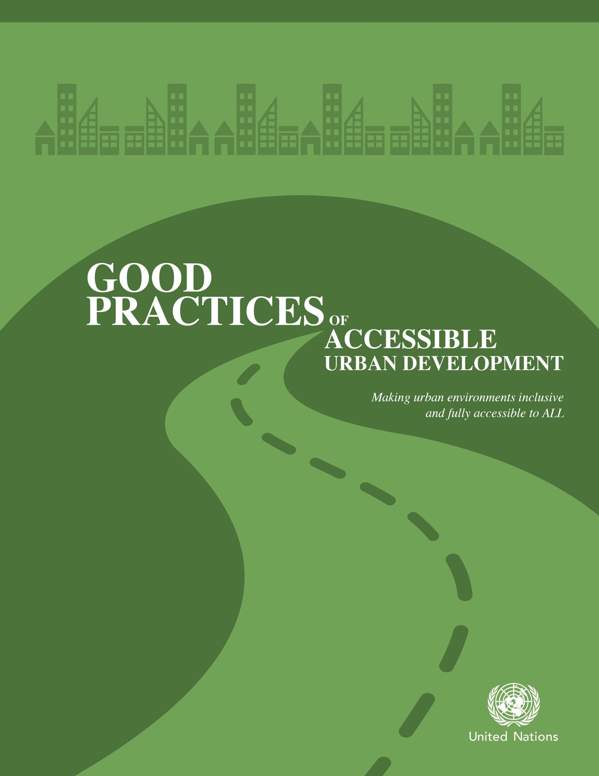

DEPARTMENT OF ECONOMIC AND SOCIAL AFFAIRS
The Department of Economic and Social Affairs of the United Nations Secretariat is a vital interface between global policies in the economic, social and environmental spheres, and national action. The Department works in three main interlinked areas: (i) it compiles, generates and analyses a wide range of economic, social and environmental data and information on which Member States of the United Nations draw to review common problems and to take stock of policy options; (ii) it facilitates the negotiations of Member States in many intergovernmental bodies on joint courses of action to address ongoing or emerging global challenges; and (iii) it advises interested governments on the ways and means of translating policy frameworks developed in United Nations conferences and summits into programmes at the country level and, through technical assistance, helps build national capacities.

NOTE
The designations employed and the presentation of the material in the present publication do not imply the expression of any opinion whatsoever on the part of the Secretariat of the United Nations concerning the legal status of any country or territory or of its authorities, or concerning the delimitations of its frontiers. The term “country” as used in the text of this review also refers, as appropriate, to territories or areas. The designations of country groups in the text and the tables are intended solely for statistical or analytical convenience and do not necessarily express a judgement about the stage reached by a particular country or area in the development process.

Mention of the names of firms and commercial products does not imply the endorsement of the United Nations.

ST/ESA/364
United Nations
Department of Economic and Social Affairs
http://www.un.org/disabilities

ACKNOWLEDGEMENTS
The present document was prepared by the Secretariat for the Convention on the Rights of Persons with Disabilities, Division for Social Policy and Development of the United Nations Department of Economic and Social Affairs (DESA), in close cooperation with the Essl Foundation.

Case studies contributions were provided by experts and their affiliated organizations from five regions of the world, especially the participants of the DESA and UN Habitat Forum on Disability Inclusion and Accessible Urban Development, which took place in Nairobi on 28-30 October 2015: Siam Imm Goh (Building and Construction Authority, Singapore), Joseph Kwan (UDA Consultant Ltd., Hong Kong Special Administrative Region, China), Steve Coe (Community Access Inc., Malaysia), Karen D. Schwartz and Youn Young Park (Centre on Disability Studies, Canada), Isabel Cristina Pessoa Gimenes (RIOinclui, Brazil), Guy Davies (Disability Solution, South Africa), Sunarman Sukamto (CBR DTC Solo City, Indonesia), Janett Jimenez-Santos (Can Lah. S.C, Mexico), Annette M. Williams (San Francisco Municipal Transportation Agency, United States of America), Jane Wilbur (WaterAid, Ethiopia), Elizabeth Franchini (Fondazione Banca del Monte Di Lucca, Italy), Michael Le Surf (Changing Places Consortium, United Kingdom), Gitte Fyrkov (Musholm Vacation, Sports and Conference Centre, Denmark), Quemuel Arroyo (New York City Department of Transportation, United States), Marnie Peters (Global Alliance on Accessible Technologies and Environments, GAATES), Yana Chicherina (Inclusive Employment and Social Partnership and Aziza Umarova, UNDP, Uzbekistan), Balmas Silvia (European Foundation Centre, Belgium), Jutta Treviranus (Inclusive Design Research Centre, Canada), Enrique Diego Bernardo (Empresa Municipal del Transportes de Madrid, Spain), Agathe Bogacz (Forum EineMitte fur Alle, Hamburg, Germany) and Or Cohen (Access Israel, Israel).

Valuable contributions, comments and inputs were also provided by Michael Fembek and his team (Essl Foundation), Clinton E. Rapley (Associates for International Management, Thailand and the United States) and Michael Szporluk (Independent Consultant on urban development issues, United States).

The authors and collaborators wish to extend their appreciation for the support from Marnie Peters (Global Alliance on Accessible Technologies and Environments, GAATES) and Thomas Richert (Access Exchange International, United States) during the preparation of this publication.

Team from the Secretariat for the Convention on the Rights of Persons with Disabilities, Division of Social Policy and Development, Department of Economic and Social Affairs of the United Nations (SCRPD/DSPD/DESA)
Akiko Ito, Guozhong Zhang, Maria Martinho, Robert Venne, Miranda Fajerman, Julie Pewitt, Talin Avades and Claire Odom.

Table of Contents
I. Introduction 6
Accessibility and inclusion of persons with disabilities in urban development 6
International policy frameworks requiring states to promote accessibility and disability inclusive development 7
Initiatives and progress made to promote accessible and inclusive development 8
The gains of accessibility 9
Recommendations on the way forward to advancing an accessible and inclusive New Urban Agenda for all 9
II. Criteria for selecting good practice case studies on promoting accessible urban development that is inclusive of persons with disabilities 12
III. Case studies 15
Part One: Housing and built environments 15
Case study 1: Accessibility Master Plan to create a user-friendly built environment (Singapore) 15
Case study 2: Accessibility and retrofitting to public premises (China, Hong Kong SAR) 19
Case study 3: Action plan towards Kuala Lumpur as an accessible city (Malaysia) 22
Case study 4: Supportive Housing for Persons with Disabilities (United States of America) 26
Case study 5: Liveable and Inclusive Communities for Seniors with Disabilities and All Citizens: Model and Tools for Actions (Canada) 28
Case study 6: RIOinclui: Combining architecture, universal design and social work, construction works for accessibility (Brazil) 30
Part Two: Transportation 32
Case study 7: Inclusive Public Transportation (South Africa) 32
Case study 8: Accessibility standard for public transportation (Indonesia) 36
Case study 9: Accessibility for people with disabilities to the Bus Rapid Transit system Metrobus (Mexico) 38
Case study 10: Multi-Modal Transportation Accessibility in San Francisco (United States) 42
Case study 11: Visual and acoustic information on public buses (Spain) 49
Part 3: Public spaces and public services including information and communication technology-based services 51
Case study 12: Including persons with disabilities in access to safe sanitation (Ethiopia) 51
Case study 13: Transforming an unused piece of land into an inclusive public space (Mexico) 54
Case study 14: City of Lucca – Becoming accessible (Italy) 58
Case study 15: Changing places (United Kingdom) 60
Case study 15: Accessible Musholm, a unique accessibility and universal designed Vacation – Sports - Conference Centre for people with physical, cognitive and communication disabilities (Denmark) 62
Case study 16: Public Plaza: Inclusive Public Spaces (United States) 64
Part Four: Strategies and innovations for promoting accessible urban development 66
Case study 18: Ecuador Lives Inclusion (Ecuador Vive la Inclusión) Technical Secretary for the Inclusive Management on Disabilities of the Vice-Presidency of the Republic of Ecuador (SETEDIS) 66
Case study 19: Supporting architects and urban planners to understand accessibility (The Global Alliance on Accessible Technologies and Environments, GAATES) 72
Case study 20: Accessibility, civic consciousness, employment and social support for people with disabilities (Uzbekistan) 74
Case study 21: League of accessible and historical cities (Italy, Denmark, France, Spain, Bulgaria) 78
Case study 22: Aha! (Accessibility Help & Advice), Mapathon of accessible places and inclusive customer service workshops (Canada) 81
Case study 23: The Forum “One Quarter for All” (Germany) 83
Case study 24: Help me help you: accessibility of public services (Israel) 85
IV. Final words 87
Promoting accessibility as a public good, building sustainable and inclusive urban development for all 87

Acknowledgements

The authors would like to extend special appreciation to the many contributors, especially those from the offices of UN-Habitat and the Secretary-General’s Special Envoy on Disability and Accessibility, for their inputs received for this section.

Introduction
“Persons with disabilities have a significant positive impact on society, and their contributions can be even greater if we remove barriers to their participation. With more than one billion of persons with disabilities in our world today, this is more important than ever.”

Ban Ki-Moon, United Nations Secretary-General, message on the occasion of the International Day of Persons with Disabilities,
3 December 2012

By 2050, it is expected that about 6.25 billion people, 15 per cent of whom are persons with disabilities, will be living in urban centres. Urbanization has the potential to be an engineer for achieving sustainable and inclusive development for all. The current lack of environmental accessibility faced by people with disabilities, in particular in many cities in the world, presents a major challenge. As the international community prepares for the Third Global Conference on Housing and Sustainable Urban Development (Habitat III), which will take place in Quito, Ecuador, in October 2016, it is an apt and a strategic opportunity to promote an accessible and inclusive Urban Agenda.

In fulfilling the promise of a sustainable and inclusive New Urban Agenda, the work of Habitat III would be greatly supported by promoting accessibility following universal design approaches and disability inclusion. This requires strong commitments in concrete terms including inclusive urban policy, regulatory norms and standards, universal design approach planning, allocation of necessary resources, and a broad-based partnership that involves and engages all community members, including persons with disabilities.

Accessibility and inclusion of persons with disabilities in urban development
Urbanization is currently one of the most important global trends of the 21st century. Urban environments, infrastructures, facilities and services, depending how they are planned and built, can impede or enable access, participation and inclusion of members of society.

For the 15 per cent of the world’s population who live with a disability, many of whom reside in urban areas, available evidence reveals a widespread lack of accessibility in built environments, from roads and housing, to public buildings and spaces. Evidence also reveals a lack of accessibility to basic urban services such as sanitation and water, health, education, transportation, emergency and disaster response, resilience building, and access to information and communications. These accessibility limitations greatly contribute to the disadvantages and marginalization faced by persons with disabilities, leading to disproportionate rates of poverty, deprivation and exclusion. These disadvantages also impede the realization of the 2030 Agenda for Sustainable Development and other internationally agreed development goals.

International policy frameworks requiring States to promote accessibility and disability inclusive development

The current international policy framework guiding disability-inclusive urban development is largely based on a number of instruments concerning persons with disabilities. The World Programme of Action Concerning Disabled Persons (1982) (A/RES/37/52) views accessibility as an essential means to further its goals of “full participation” and “equality”. The Standard Rules on the Equalization of Opportunity for Persons with Disabilities (1994) (A/RES/48/96) identifies “accessibility” of the physical environment and of information and communication as two “target areas” to ensure equalization of opportunities. The Convention on the Rights of Persons with Disabilities (2006) further strengthened the international normative framework for the advancement of the rights and the socio-economic development of persons with disabilities. Accessibility is defined in the Convention as a cross-cutting issue that enables persons with disabilities to live independently and participate fully in all aspects of life. The Convention has a stand-alone article on Accessibility – Article 9 – and a number of other provisions on detailed guidance on measures that States shall take to advance accessibility. These include Article 19 on living independently and being included in the community, Article 20 on personal mobility and Article 21 on freedom of expression and access to information.

Under the Convention on the Rights of Persons with Disabilities, States Parties have a general obligation: (i) “to undertake or promote research and development of universally designed goods, services, equipment and facilities, as defined in Article 2 of the Convention, which should require the minimum possible adaption and the least cost to meet the specific needs of a person with disabilities, to promote their availability and use, and to promote universal design in the development of standards and guidelines”;and (ii) “to enable persons with disabilities to live independently and participate fully in all aspects of life, States Parties shall take appropriate measures to ensure to persons with disabilities access, on an equal basis with others, to the physical environment, to transportation, to information and communications, including information and communications technologies and systems, and other facilities and services open or provided to the public, both in urban and in rural areas.”

In 2013, the United Nations High-level Meeting on Disability and Development and its action-oriented Outcome Document (A/RES/68/3) stressed the importance of ensuring accessibility for and inclusion of persons with disabilities in all aspects of development, and recommended giving due consideration to all persons with disabilities in the 2030 Agenda for Sustainable Development. The Outcome Document further called for actions to ensure accessibility, following the universal design approach, by removing barriers to the physical environment, transportation, employment, education, health, services, information and assistive devices, such as Information and Communications Technology (ICTs), including in remote or rural areas, to achieve the fullest potential throughout the whole life cycle of persons with disabilities (A/RES/68/3).

The commitment of the international community to advance accessibility and to mainstream disability in development was further strengthened and reflected in the recently adopted 2030 Agenda for Sustainable Development. Disability is specifically referenced in seven targets of the Sustainable Development Goals (SDGs) in the 2030 Agenda, including SDG 11 related to sustainable cities and communities, with targets on providing accessible transport systems and public spaces.

Initiatives and progress made to promote accessible and inclusive development
Worldwide, in the recent years, there have emerged many promising initiatives and good practices that have successfully promoted accessibility and the inclusion of persons with disabilities, their rights, aspirations and contributions in the context of urban development.

The commitment of the United Nations to promoting accessibility, inclusion and advancement of persons with disabilities in society and development is deeply rooted in its Charter and the pursuit of promoting economic and social progress and human rights for all. In 2013, the United Nations Secretary-General appointed as his Special Envoy on Disability and Accessibility Excellency Lenin Moreno, who has attached great importance to the promotion of accessibility and disability inclusion in development, including in the SDGs. United Nations system organizations are making progress in establishing internal policies aimed at promoting built environments, facilities and services that are accessible and inclusive for all.

The United Nations Department of Economic and Social Affairs (DESA) and UN-Habitat have been promoting accessibility and inclusion of persons with disabilities in contexts of sustainable and inclusive development. DESA organized a series of expert group meetings on accessibility in built environments (Washington D.C., 2010), on accessible ICTs, including in the situation of disasters reduction (Tokyo, 2012; Sendai 2015) and on humanitarian response actions (Istanbul, April 2016). Together with its Member States, United Nations entities and other major stakeholders, DESA and UN-Habitat have also organized DESA Forums on accessible and disability-inclusive urban development (New York, June 2016 and Nairobi October 2015), published analytical research and guidance on accessibility and development, and have facilitated and supported intergovernmental processes and bodies to advance accessibility.

The benefits of accessibility
Available evidence illustrates that urban infrastructures, facilities and services, if designed and built following accessibility or inclusive “universal design” principles from the initial stages of planning and design, bear almost no or only 1 per cent additional cost., Therefore, progressive realization of accessibility following universal design principles in urban development is not beyond reach for low-income countries. Cities that depend on a tourism economy are also likely to pay high opportunity costs for inaccessible infrastructure and services if they exclude tourists with disabilities, and older persons and parents with young children, who may experience accessibility limitations, who may otherwise visit these destinations. It is estimated that, in economic terms,
that by not adapting its inaccessible infrastructures the tourism industry would fail to capture
approximately 15- 20 percent of the global market share.

Basic economics posit that any barrier to participation – physical, technological, cultural or institutional – effects efficient allocation of resources, organization of production, exchanges, consumption, and distribution of benefits. This is of particular relevance in low-and middle-income economies where limited available resources need to be allocated in a way that maximizes utility and inclusion. Costs associated with the exclusion of a single group, namely persons with disabilities, from the labour force could lead to substantial losses, for example, of up to around 7 per cent of national GDP. The positive externality or spill-over effect of accessibility on a broad spectrum of the population at large should therefore not be overlooked.

For urban development to be sustainable and inclusive for all, it is essential for accessibility to be given serious consideration and proactively promoted in the discourse related to the upcoming Third United Nations Conference on Housing and Sustainable Development- (Habitat III) and its outcome New Urban Agenda. Accessibility is a matter of human rights, and it is also an economic and social development imperative in the achievement of the SDGs and other internationally agreed development goals.

Recommendations on the way forward to advancing the accessible and inclusive New Urban Agenda for all

In October 2016, Habitat III will design the New Urban Agenda, which is expected to focus on policies and strategies for effectively harnessing the power and forces behind urbanization. The New Urban Agenda will provide the international community with a distinct opportunity to transform current patterns of urbanization by fully incorporating accessibility and disability inclusion in urban development policy and practices.

With over 165 States parties who are already committed and obligated to advancing accessibility, and with the adoption of the 2030 Agenda for Sustainable Development, the UN Habitat III and the New Urban Agenda present a historical opportunity to further operationalize the SDGs, by promoting accessibility and the inclusion of persons with disabilities in achieving inclusive and sustainable urbanization for all. A truly inclusive New Urban Agenda also needs to actively include and engage persons with disabilities in its discourse and development.

The following findings and recommendations, which were adopted at a United Nations expert group meeting, may be helpful in informing the ongoing Habitat III discourses, developing the New Urban Agenda and furthering accessible and inclusive urban development.

- Promoting accessibility as a collective good and a key component in urban policy, design, planning and development is critical to the success of the New Urban Agenda
- Accessibility shall be actively promoted as a collective good that benefits all. Accessibility facilitates full and effective participation of all and should therefore be incorporated and actively promoted as an integral component of good policy to achieve inclusive and sustainable urban development. A city is only well designed if is well designed for all.

- For the over one billion persons with disabilities worldwide, accessibility is a precondition for their enjoyment of human rights and is a means for economic, social, cultural and political empowerment, participation and inclusion.

- An accessible and disability-inclusive urban development agenda can be realized everywhere. This requires strong commitments in concrete terms, which includes inclusive and disability-responsive urban policy frameworks, appropriate regulatory structures and standards, "design for all" approaches in planning and design, and predictable resource allocations. It also requires active and meaningful participation of persons with disabilities and their organizations, as rights-holders and as agents and beneficiaries of development during all stages of the urbanization process.

- Accessible housing and built infrastructures as key elements for sustainable and inclusive cities
- Integrated approaches to housing and the positioning of housing at the centre of inclusive urban development need to take account not only of environmental sustainability, diversity (including disability) and financial aspects, but also human rights.

- Universal design, as a concept and principle, should be reflected in designs and plans for new built environments and in renovations to buildings and facilities to ensure they are accessible for all.

- Building standards, laws and effective enforcement mechanisms are essential to ensure accessibility, availability, affordability and quality of housing and public services for all, including persons with disabilities.

- Accessible transportation, public spaces and public services
- Integrated transportation facilities and services not only provide accessibility for all, but are also reliable and affordable. They drive sustainable and inclusive growth and change.

- Inclusive transportation requires continuity of accessibility throughout travel chains, meaning all elements of a journey from the starting point to the final destination include accessible entranceways.

- Integrated urban policy and plans must identify and address gaps in accessibility in public spaces and from one built environment to another.

- Social equity requires that the costs of accessible transportation and basic public services shall not be borne fully by users who require services since these are essential to ensure opportunities for full and effective participation in social, economic, cultural and political life for persons with disabilities.

- Accessible information and communication technologies (ICTs) for building inclusive, resilient and smart cities and communities
- Governments should develop accessible ICTs, including mobile applications, government websites, public kiosks and automated teller machines, and should include accessible ICT services in their urban development plans.

- Due to the rapid pace of development and innovation in ICT products and services, assistive and adaptive devices and technologies are not always accessible, and the cost of many of these technologies limits access for persons with disabilities, particularly in low- and middle-income countries. Governments should promote and facilitate research, development and mainstreaming of accessible ICT products and services by including accessibility requirements in public procurement exercises for ICT products and services used by public organizations or their customers or staff.

- Many national telecommunication authorities have universal service goals that recognize affordability and access to networks as a right; consideration shall be accorded urgently to accessibility as a third universal service goal.

- Full and active participation of persons with disabilities and broad-based multi-stakeholder partnerships for advancing inclusive and accessible urban development
- The message of the SDGs to “leave no one behind” seeks to ensure that the targets are met for all peoples and segments of society, including persons with disabilities in cities.

- Achievement of a truly inclusive New Urban Agenda, where no one is left behind, requires a holistic and people-centred approach that informs, engages and involves persons with disabilities and their organizations in all aspects of urban development, in particular, access to adequate housing.

- The New Urban Agenda should further the advancement of accessibility for all with respect to the right to adequate housing, the built environment, public spaces, transportation, facilities, services and ICTs.

- A New Urban Agenda cannot be achieved unless it responds to the needs and rights of everyone, including the estimated one billion people with disabilities.

Criteria for selecting good practice case studies on promoting accessible urban development that is inclusive of persons with disabilities

“A city that is well designed is well designed for all. Accessibility, as a collective good that benefits all, should therefore be considered a central component of good policy to achieve inclusive and sustainable urban development.”

Recommendations from a group of experts at the UNDESA-UN Habitat Forum on Disability Inclusion and Accessible Urban Development, Nairobi, 28-30 October 2015.

This document is prepared in response to the request in paragraph 15(b) of the General Assembly Resolution 65/186, in which the Secretary-General was asked to “provide information on best practices at international, regional, sub-regional and national levels for including persons with disabilities in all aspects of development efforts”.

The document aims to: (i) use case studies from both developing and developed cities and countries to illustrate what constitutes best practices in successfully promoting accessibility and hence the inclusion of persons with disabilities in the urban development contexts, in alignment with the Convention on the Rights of Persons with Disabilities (CRPD) and the most recent normative frameworks, in particular, the 2030 Agenda for Sustainable Development; (ii) showcase key experiences and lessons learned from these case studies, for informing and contributing to the ongoing discourses leading to the United Nations Conference on Housing and Sustainable Human Settlements (Habitat III) and the outcome of the Conference “New Urban Agenda” as well as its implementation; and (iii) present specific recommendations and support initiatives and actions to advance inclusive urban development for all.

The case studies included in this document have been collected through key contacts and networks. In collecting these case studies, efforts were made to present good practices in different geographical regions and diverse thematic areas, with an emphasis on areas emanating from recent UN General Assembly resolutions highlighting the promotion of accessibility in housing, built environment, information and communication technologies, public spaces and public services, as well as relevant strategies including cooperation and partnership with multi-stakeholders for the effective promotion of accessibility (A/RES/68/3). This selection of case studies does not aim in any way to be exhaustive; it simply aims to offer a set of illustrative examples.

The section below outlines a set of criteria for assessing good practices in successfully promoting accessibility and inclusion of disability in the contexts of urban development. Good practices are understood here as: (i) well-documented initiatives with evidence of success in the creation of barrier-free environments, space, facility and services in different sectors of urban development; and (ii) initiatives that can be considered for replication, scaling up and further study.

The criteria for best practices listed below aim to provide a framework for assisting initial assessments of existing practices and to facilitate further discussion. They reflect an ideal situation: the case studies included here present experiences of working towards the best practices criteria without necessarily meeting all of them. In addition, given the topic and focus of the policy work and of the context, certain criteria will be more relevant to the scope of the programme or project.

These initial criteria are based on, above all: (i) the CRPD; (ii) recently adopted United Nations resolutions; (iii) General Comment No. 2 (accessibility) of the Committee on the Rights of Persons with Disabilities; (iv) the reports of the Expert Group on Mainstreaming Disability in MDG Policies, Processes and Mechanisms: Development for All; and (v) the gender mainstreaming experience. Some of the criteria are closely interlinked. For example, if participation is to be meaningful, it has to be accessible and non-discriminatory. Moreover, some of the criteria may serve as a means to the end of mainstreaming disability in a specific project or initiative, but they may also represent an end in themselves.

To satisfy the criteria for best practice, the example must:

- promote accessibility in one or more urban sectors, such as built environment, public space, transportation and information and communications, including ICTs, and public services;

- increase awareness and understanding of accessibility at the organizational, community and institutional level;

- be results-oriented and produce a measurable change that contributes to the creation or improvement of environmental accessibility in specific sectors that impact on the quality of life of persons with disabilities. This also implies having a robust monitoring and evaluation system that includes the collection of data;

- be appropriately resourced in terms of financial and human resources, hence, the importance for donors to emphasize accessibility and disability-inclusive matters and for NGOs to recognize it as a priority;

- be sustainable, socially, culturally, economically (i.e. be affordable), politically and environmentally;

- be replicable, i.e. show how the product and/or process can be reproduced or adapted in other countries and contexts. Replicability should be assessed taking into consideration context-specificity, since it is important to recognize that some practices in one country or context are not necessarily valid or transferable to the circumstances of another. The concept of “appropriateness” (i.e. suitable to other contexts) should therefore be introduced when talking about replication;

- involve effective partnerships that show the commitment of various organizations, which may include, inter alia, government, academia, media, the United Nations and NGOs. Inter-agency and inter-organizational efforts should be emphasized with the full involvement of Disabled People’s Organizations (DPOs) and local governments to assure ownership of the initiative.

Case studies

Part One: Housing and built environments

Case study 1: Accessibility Master Plan to create a user-friendly built environment (Singapore)

Name of organization/Government entity: Building and Construction Authority (BCA)

Thematic area of good practice example: Raising the accessibility standards and drive the adoption of universal design (UD) in the built environment.

Specific location: All places accessed by the public in Singapore.

Duration of project/programme: 10 years.

Beneficiaries of good practice example: Users and occupants of residential and public buildings and parks and open spaces.

Implementing agency/agencies: BCA and other public agencies.

Source of funds: Government

Brief background to the project: Singapore, a city state with a current population of 5.54 million, underwent rapid urbanization from the late 1950s, resulting in a high-rise, high-density built environment in the years that followed. At the early stage of nation building, the provision of accessibility was not a critical concern compared to maximizing land resources for the economic and housing needs of the growing population.

The issue of accessibility was discussed in the 1980s, which resulted in legislation to provide barrier-free accessibility in buildings under the Building Control Regulations, 1989. While the legislation has been an important lever in ensuring accessibility in new buildings, a large stock of buildings built before the legislation was not barrier-free.

With a fast ageing population, planning for a user-friendly built environment was imperative. The BCA Accessibility Master Plan was thus developed in 2006 to support and complement the Recommendations by the Ministerial Committee on Ageing Issues and the Enabling Master Plan to create an inclusive built environment.

Overall objectives of the project/programme: The project pursues an upstream goal of raising the accessibility standards and driving the adoption of Universal Design (UD) in the built environment. Accessibility and UD are instrumental to continual efforts in building a Liveable City for All Ages and in fulfilling our nation’s obligations under the United Nations Convention on the Rights of Persons with Disabilities.

Process/strategy to implement the project/programme: The Master Plan is a holistic framework that addresses both accessibility and UD adoption in the built environment with a multi-lever and multi-pronged approach to deal with accessibility concerns of the past, present and future developments through Four Strategic Thrusts.

Initiatives implemented under the Four Strategic Thrusts include:

- Removing existing barriers
- a five-year Accessibility Upgrading Programme (2006-2011) to support the upgrading of key buildings by the public and private sectors. A section of Orchard Road was chosen as one key area for driving accessibility;
- a capital incentive of 40 million Singaporean dollars of Accessibility Fund to share the cost of construction of basic accessibility features implemented by the private sector building owners.
- Tackling future challenges upstream
- Raising the minimum standard of the Accessibility Code to benefit a wider spectrum of people – persons with disabilities, older persons and young children.
- Promoting the adoption of UD
  - published UD Guides;
  - organized BCA UD Award (from 2006-2011) to recognize buildings and stakeholders that adopt a user-centric philosophy in their design;
- To “brand” UD with the launch of the BCA Universal Design Mark certification scheme in 2012.
- Maintaining Existing Accessible Features
- To deal with misuse and removal of accessible features, the Building Control Act was amended in 2008 to place a duty on the building owners to continue to maintain the accessible features in their buildings.
- Raising awareness and capabilities of the industry and stakeholders
- Outreach and education initiatives include:
- the Singapore Universal Design Week: a week-long programme of conferences, forums, workshops and exhibitions;
- a one-stop information portal, www.friendlybuilding.sg;
- “Find your friendly building” Apps;
- training programmes for building professionals and students;
- continuous encouragement of building owners to upgrade with the support of the Accessibility Fund.

Changes achieved: The project has led to progressive, observable improvements in accessibility and wider application of UD principles in new and existing buildings undergoing major alteration and additions.

- As of 2012, almost 100 per cent of government buildings frequented by the public were barrier-free, an increase from about 50 per cent in 2007.
- More than 90 per cent of the buildings along Orchard Road now have at least basic accessibility, an increase from 41 per cent in 2006.
- The BCA UD Mark Certification Scheme was recognized as an innovative project by the “Zero Project” in 2014 in successfully encouraging building owners/developers to voluntarily adopt UD.

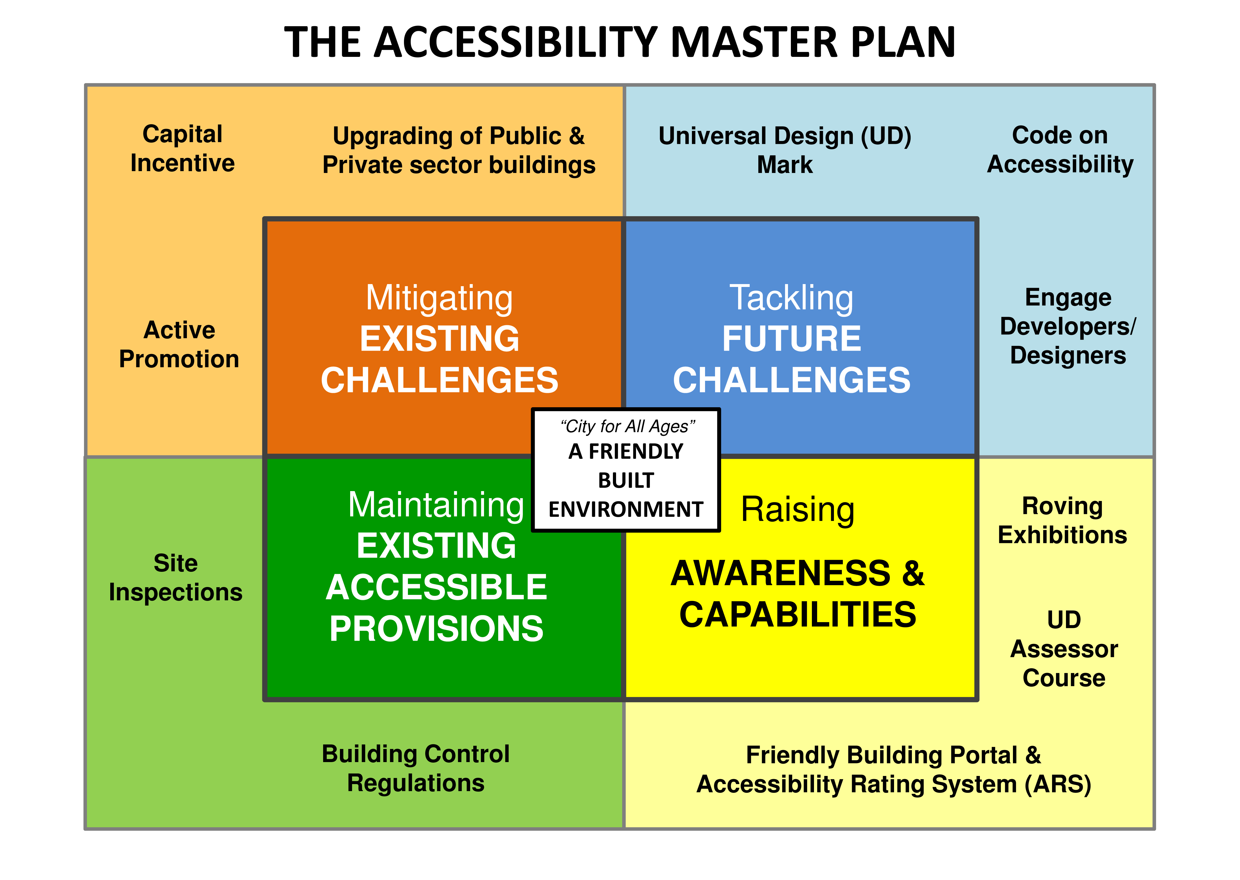

How change was monitored and evaluated:
Key steps for monitoring and evaluating the Orchard Road project are:

- Survey forms for building owners to carry out a self-check, followed up with a site audit by BCA.
- Buildings are rated according to the level of accessibility and the ratings are posted on the portal www.friendlybuilding.sg.
Shortcomings and persistent challenges identified in the implementation of the project/programme:
- Lack of a business justification
Building owners are not keen to voluntarily upgrade their buildings even with the support of Accessibility Fund, citing the lack of a business case and the loss of saleable/rentable floor areas.
- Land scarcity in Singapore
With high land cost, most developers are reluctant to go beyond Code compliance to incorporate UD in their buildings.
- Floods
The need for higher platform levels to mitigate flash flood remains a challenge to have barrier-free interconnectivity and entries into buildings.
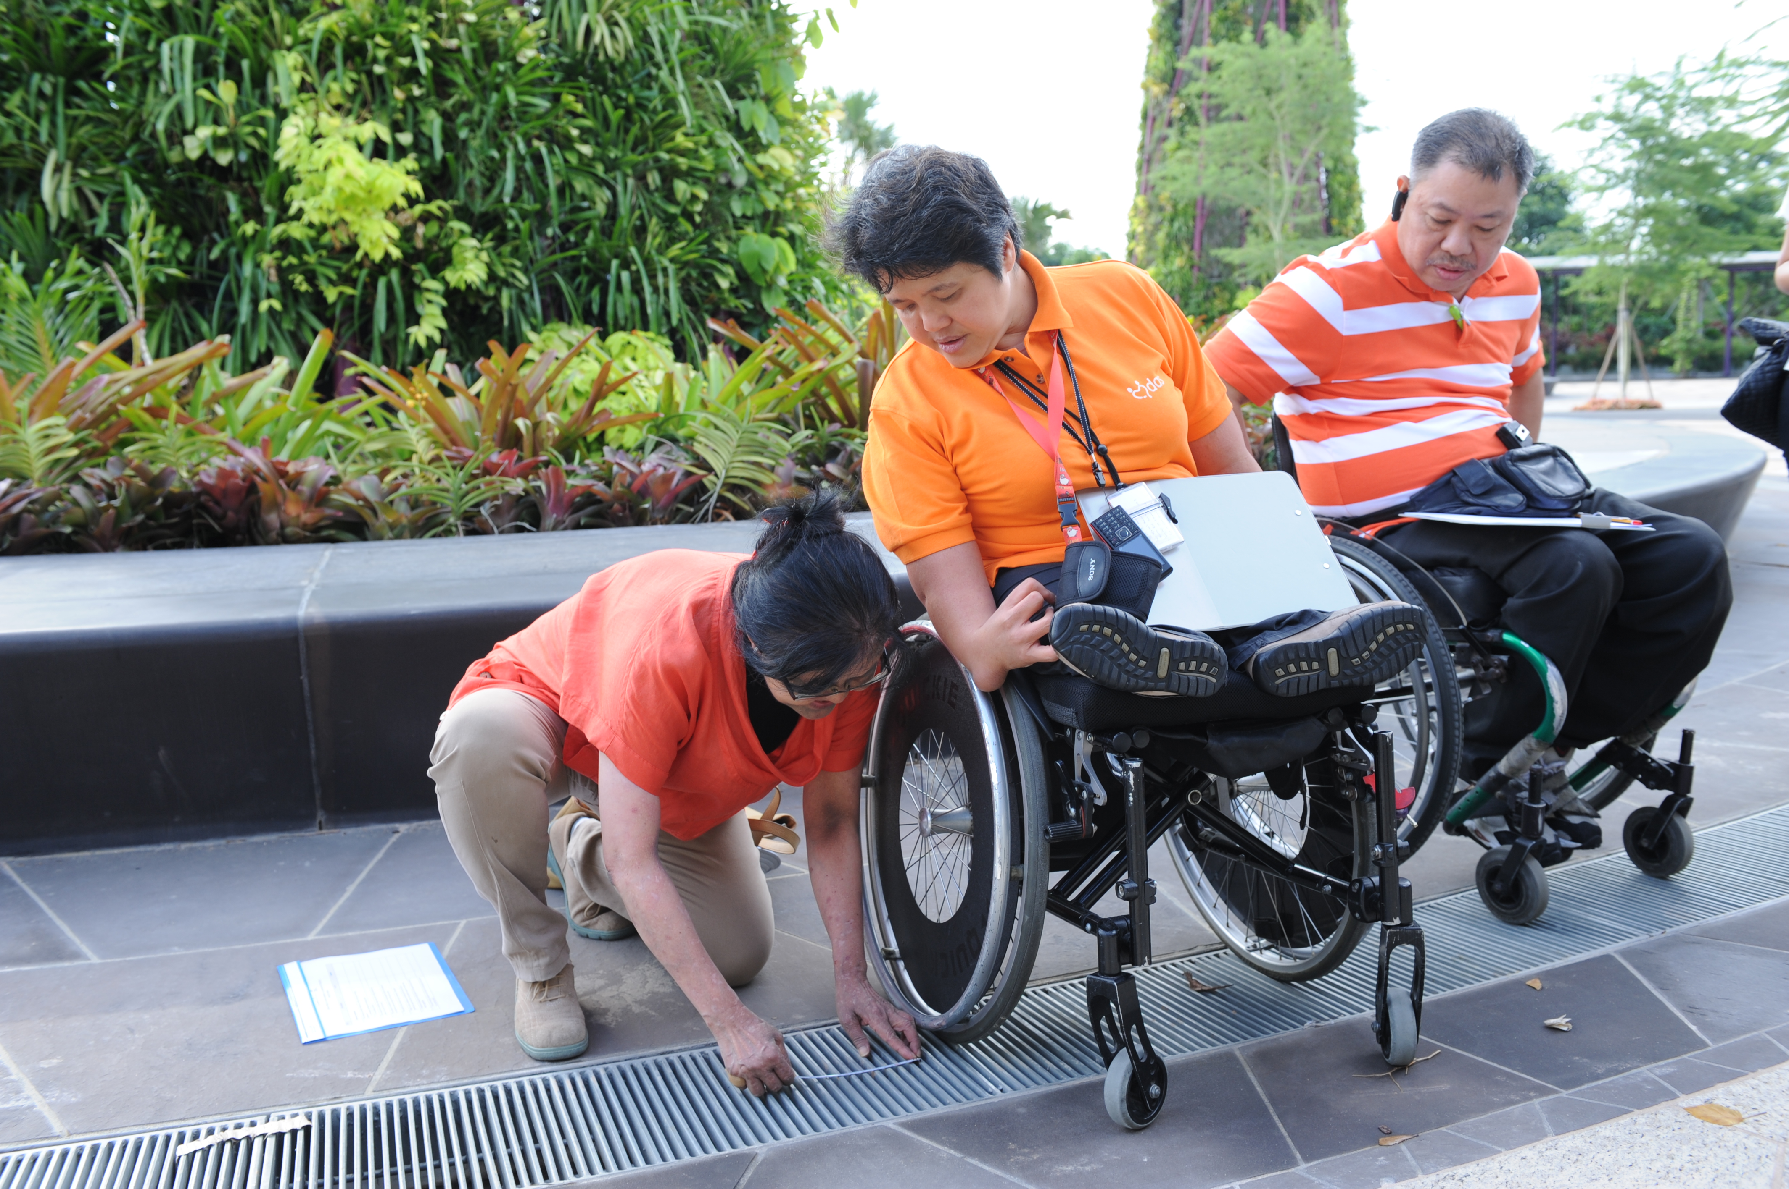

Other lessons learned: To create an inclusive environment, the close 3-P (the public, the private sector and people) collaboration is key in driving accessibility improvements and broadening the UD. It is a whole-of-government effort through continual engagement with the private sector and people.

Other improvements made to the built environment:

- The Housing and Development Board retrofitted the public housing estates to enhance accessibility, improved connectivity between building blocks, key precinct facilities and amenities, and linked access routes to traffic crossings.
- The Land Transport Authority improved the accessibility of train stations and road- related infrastructures in preparation for all public buses and services to be wheel-accessible by 2020.

Contact:
Ms. GOH Siam Imm
Building and Construction Authority
52 Jurong Gateway Road #10-01 - Singapore 608550
GOH_Siam_Imm@bca.gov.sg
www.bca.gov.sg
www.bca.gov.sg/friendlybuilding

Case study 2: Accessibility and retrofitting to public premises (China, Hong Kong SAR)

Name of organization/Government entity: Labour and Welfare Bureau, The Government of the China, Hong Kong SAR

Thematic area of good practice example: To retrofit existing government buildings and facilities to be user-friendly and accessible for all, including people with disabilities

Initiative selected as good practice example: The 2010 Report of the Equal Opportunities Commission Hong Kong (EOC) made recommendations on the improvement of accessibility, connectivity and interface with surrounding environment and user-friendly management practices for publicly accessible premises.

Specific location: The 18 districts of the city of Hong Kong

Duration of project/programme: 2011 – 2017

Beneficiaries of good practice example: Users and occupants of public buildings, facilities, parks and open spaces including people with disabilities, the elderly and the community at large

Implementing agency/agencies: The works departments of the Hong Kong SAR Government including the Architectural Services Department (ArchSD), the Highways Department (HyD) and the Civil Engineering and Development Department, in collaboration with the managing departments of these premises and facilities.

Source of funds: Hong Kong SAR Government

Brief background to the project: In response to the Equal Opportunities Commission (EOC) Report, the Government set up a Task Force to examine not only the government and its Housing Authority (HA) premises identified by EOC, but also around 3,900 premises and facilities under the management of the Government departments and HA that have a frequent public interface. The people responsible for the premises responded promptly and followed up on the recommendations of removing the physical barriers and providing access to these premises for people with disabilities.

Overall objectives of the project/programme: It is the Government’s established policy objective to provide a barrier-free environment for persons with disabilities with a view to enabling them to gain access to public and private premises and make use of the facilities on an equal basis with others, thereby facilitating them to live independently and integrate into society.

Process/strategy to implement the project/programme: For the retrofitting programme devised by HA to improve accessibility of 235 premises/facilities under its management, which covers public housing estates, commercial centres, carparks and factory buildings, most of the improvement works were implemented by 30 June 2012. To strike a balance between the progress of improvement works, service interruption and nuisances to tenants, HA had scheduled some of the improvement works for completion by 30 June 2014. To tie in with HA’s lift/elevator modernization programme, a small proportion of the improvement works will be completed by 2016-2017. In brief, site preparations for all premises/facilities have been completed, while works have commenced at 185 premises/facilities.

In addition, HyD continues to accelerate its retrofitting programme for the provision of barrier-free access (lift or ramp) at public footbridges, subways or elevated walkway structures that do not have such access or alternative at-grade crossings, where technically feasible. Up to now, out of a total of 295 such facilities, HyD has completed investigation of 123 facilities, of which 67 were found feasible for lift/ramp retrofitting works. Among these 67 facilities, the retrofitting works for 25 have already been completed, and the retrofitting works for nine others are in progress or under active planning.

As regards the remaining footbridges, subways and elevated walkway structures, HyD has already commenced planning and investigation for retrofitting works. In order to further shorten the time of project delivery, retrofitting works for all remaining feasible items will be taken forward in phases with the majority of works scheduled for completion by around 2016-2017 and the rest (e.g. those involving public objections or which are technically complex) by around 2017-2018.

The Administration has already obtained funding approval of about HK$292 million (US$38 million) from the Finance Committee of the Legislative Council for the design of barrier-free facilities at about 180 public pedestrian footbridges and subways, as well as the first phase of retrofitting works (involving ten facilities). For the remaining retrofitting works, the Administration intends to seek funding from the Legislative Council in several batches as soon as the design works have been completed.

Changes achieved: The major access retrofitting and improvement programme covers about 3,700 government premises and facilities.

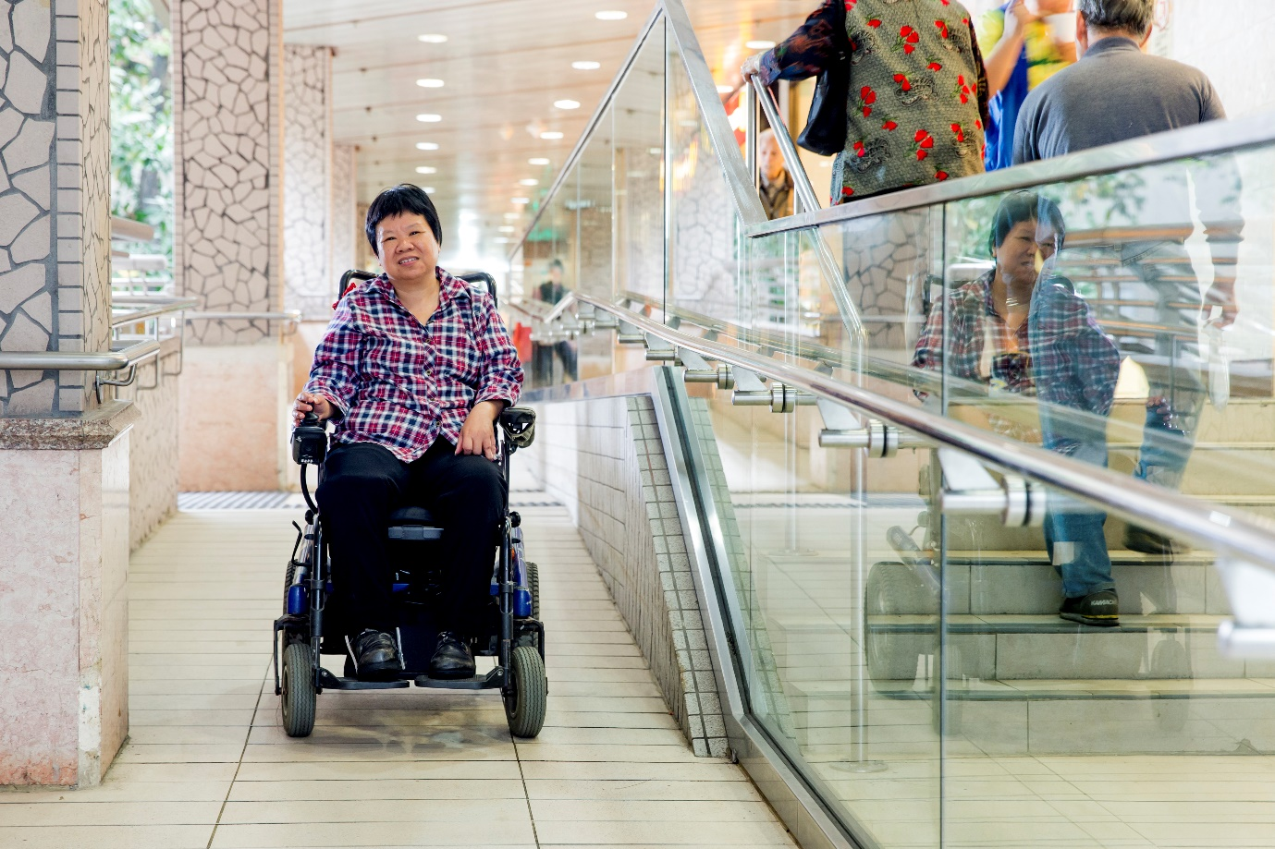

How change was monitored and evaluated: The Government of the Hong Kong Special Administrative Region worked closely with EOC, the Rehabilitation Advisory Committee, the rehabilitation sector and the community in building towards a barrier-free and inclusive society. Since April 2011, the Government has undertaken to provide, a quarterly progress report of the retrofitting programme for upgrading the barrier-free facilities in existing Government and HA premises and facilities.

Shortcomings and persistent challenges identified in the implementation of the project/programme: Professional and Qualified Access Consultants should be engaged, at the outset of any programmes and working with the disabled community, to provide advice on the design and implementation of the programme.

Other lessons learned: There is need to train Access Coordinators and Access Officers.

To dovetail with the appointment of Access Coordinators (ACs) and Access Officers (AOs) in Government bureaux and departments in April 2011, the Government has launched a series of training, including seminars and pilot workshops, in collaboration with EOC for ACs and AOs since early 2011.

A web-based training package and new training video clips produced in collaboration with EOC have also been uploaded onto the government network to further enhance the awareness of accessibility in the civil service. Also, departments that have frequent interface with the public in their service delivery (such as the Hong Kong Post, the Transport Department, the Hong Kong Police Force, the Food and Environmental Hygiene Department, the Housing Department, and the Leisure and Cultural Services Department) continue to organize, in collaboration with the EOC and the Civil Service Training and Development Institute (CSTDI), tailored-made accessibility seminars/workshops for their frontline staff.

Furthermore, the Labour and Welfare Bureau and CSTDI, in collaboration with the Hong Kong Council of Social Service, organized the first series of sign language training workshops for frontline staff of government departments in August 2011. The training aims to enhance their knowledge in basic sign language and awareness of the deaf culture, thereby facilitating the hearing impaired in their access to government services. Another round of workshops was rolled out in February 2012.

Contact:
Ar. Joseph Kwan MH
UDA Consultants Ltd.
Consultants in Universal Design & Accessibility
China, Hong Kong SAR
jkuda@netvigator.com

Case study 3: Action plan towards Kuala Lumpur as accessible city (Malaysia)

Name of organization/Government entity: Project Implementation and Building Maintenance Department

Thematic area of good practice example: Built environment

Specific location: Kuala Lumpur, Malaysia

Duration of project/programme: 2010

Beneficiaries of good practice example: Primarily persons with disabilities and the elderly

Implementing agency/agencies: Project Implementation and Building Maintenance Department

Source of funds: Kuala Lumpur City Hall and Federal Government

Brief background to the project: Kuala Lumpur’s Uniform Building By-law contains an obligation to respect accessibility standards. These standards apply to the access to public buildings, the access to outdoor spaces, escape routes and minimum design criteria for public toilets. In 2002, under the Biwako Millennium Framework: Towards an Inclusive, Barrier-free and Rights-based Society for Persons with Disabilities in Asia and the Pacific, the Malaysian government committed to achieve a 75 per cent barrier-free environment by 2012. In 2008, the country enacted the Persons with Disabilities Act, which contains accessibility provisions and a definition of Universal Design. In 2010, the city developed the Action Plan Towards Kuala Lumpur as Accessible City. Subsequently, in 2012, access to the physical environment, public transportation, knowledge, information and communication became goal number three of the Incheon Strategy to “Make the Right Real” for Persons with Disabilities in Asia and the Pacific.

In November 2012, Malaysia, together with other Member States of United Nations Economic and Social Commission for Asia and the Pacific (ESCAP), adopted the Ministerial Declaration on the Asian and Pacific Decade of Persons with Disabilities, 2013-2022 and the Incheon Strategy to Make the Rights Real for Persons with Disabilities in Asia and Pacific.

Overall objectives of the project/programme: The Action Plan towards Kuala Lumpur as Accessible City, which was developed in 2010, sets out an implementation framework including workshops, access auditing and a holistic focus on all three stages of the construction process: design, construction and post construction. It highlights three priority areas: legislation, enforcement and monitoring, and awareness raising. The core concepts are the continuum of access, approachability, accessibility and usability by applying Universal Design.

Process/strategy to implement the project/programme: All new developments in Kuala Lumpur are controlled under the issuance of Development Order (D.O.). Conditions applied in D.O. require that all developments comply to MS 1184 (2014) and MS 1183. In addition, all the Submitting Principal Persons (SPPs) are required to sign an undertaking as follows: "... I certify that all the accommodations to be constructed/provided are in compliance with Malaysian Standard 1183, 1184 and Disability Act 2008. I accept full responsibility accordingly."
Implementation is also supported by:

- Monitoring: During the construction, access auditors inspect the construction and have the possibility to issue a stop-work order. After the construction, follow-up inspections are carried out.

- Enforcement: Enforcement mechanisms comprise Access Officers, the Access Advisory Group, Access Inspectors, and Access Auditors. Access statements, inspections and audits are used to monitor and enforce accessibility standards.

- Awareness raising and training: Awareness-raising programmes create a constant dialogue, and offer workshops for professionals and pilot projects as benchmarking.

Changes achieved:

- A benchmark was created for all local authorities in Malaysia.

- BCA was the first local authority implement the Access Statement for Accessibility in public projects

- More than 100 access audits were carried out and nine training workshops held (3 times annually).

- 2,241 persons with disabilities (as of 31 December 2015) staying in Kuala Lumpur City Hall adapted public housing units.

- The pedestrian network, which consists of a 48.9 km long pedestrian walkway in the city of Kuala Lumpur, was upgraded in 2011-2014.

- More than 1 per cent of Kuala Lumpur City Hall’s employees are persons with disabilities.

- This initiative was highlighted in the newsletter of Access Exchange International.

- Access audit manual and guidelines were published.

- The Mayor’s Award was received for good practices.

- Collaborations were established with various agencies and universities in research studies and projects.

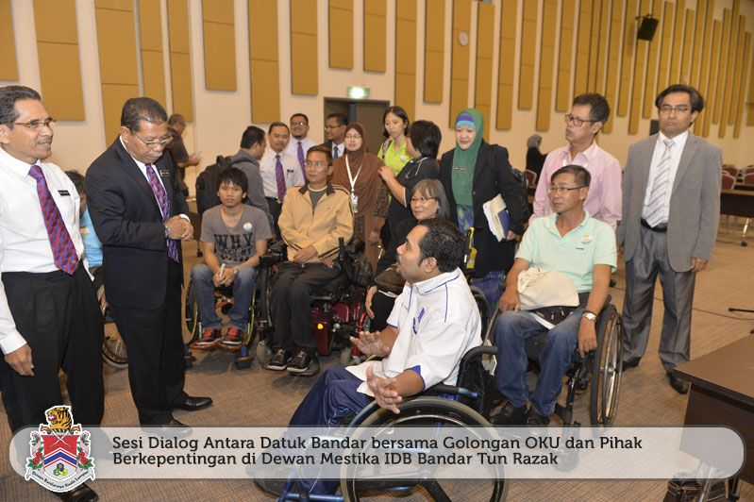

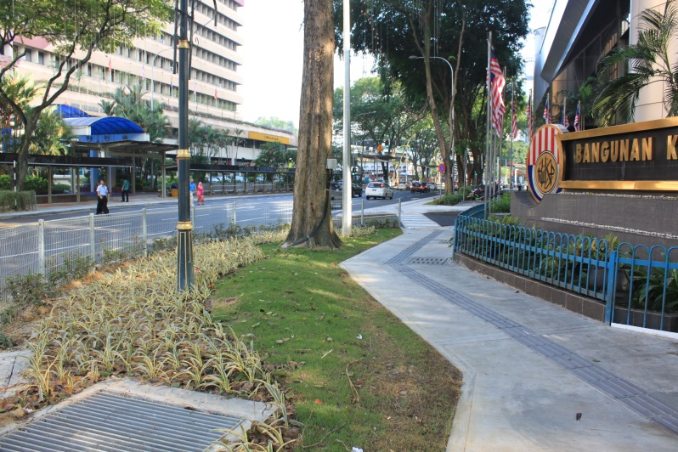

How change was monitored and evaluated: In 2010, Kuala Lumpur City Hall created a special Innovation and Building Standard Unit, which serves as a secretariat to set up guidelines, design methods of access, run courses, conduct access audits and perform upgrades, as well as enter into dialogue with persons with disabilities. It set up four enforcement mechanisms: Access Officers, the Access Advisory Group, 27 Access Inspectors and 27 Access Auditors (figures as of 2013). All audits are conducted with persons with disabilities. Awareness and training programmes on access audits are continuously carried out. Retrofitting and upgrading in renovation are encouraged, stakeholder dialogues are held, and pilot projects are carried out.

Shortcomings and persistent challenges identified in the implementation of the project/programme: Retrofitting projects and historical buildings will be a challenging task due to the constraint of sites and the complexity of the urban city of Kuala Lumpur.

Other lessons learned: Currently, Kuala Lumpur City Hall (KLCH) staff are working with the national standard-setting body. In 2013, the guidelines Using Universal Design in the Built Environment (MS 1184:2014) were published for public comment and were enforced in 2014. Thus, it became mandatory for all public and private service providers. KLCH plans to undertake a Barrier-Free City Master Plan, accessible tourism and a comprehensive accessibility mapping.

Contact:
Ch'ngGaik Bee @ Hjh.Dalilah Bee Abdullah
Deputy Director
Project Implementation and Building Maintenance Department
Kuala Lumpur City Hall
24 Floor, Menara DBKL 3, Bandar Wawasan,
Jalan Raja Abdullah, 50300 Kuala Lumpur.
Tel: +603 26176522 Fax: +603 26983854
cgb4444@yahoo.com.sg
0060-19-3298169
http://bengkeloku.webs.com

Case study 4: Supportive Housing for Persons with Disabilities (United States of America)

Name of project implementation: Community Access, Inc.

Thematic area of good practice example: Housing and Infrastructure

Specific location: New York, United States of America

Duration of project/programme: 1980 to present

Beneficiaries of good practice example: Persons living with mental illness, HIV/AIDS and addiction issues, who are often poor. Most have undergone years of hospitalization, homelessness and incarceration, and have experienced trauma in their lives.

Implementing agency/agencies: Community Access, Inc.

Source of funds: In the United States, federal, state and city funds and corporate equity investments finance the development of the housing. Government grants subsidize the rents, allowing tenants to pay only one-third of their income in rent. Government grants, foundations, and private philanthropy fund the support services.

Brief background to the project: Beginning in the 1980s, homelessness increased dramatically in New York and other major cities in the United States as patients were released from psychiatric hospitals without the services necessary to live in the community. Many of these patients ended up on the streets and in shelters, which created a major public health problem with significant costs to the public.

Overall objectives of the project/programme: Supportive housing is the evidence-based solution to homelessness and the institutionalization for persons with disabilities. By combining affordable rental housing with on-site professional and peer supports, people are able to live independently and become active participants in the community.

Process/strategy to implement the project/programme: Community Access develops affordable rental housing to help persons with mental illness live independently. With the help of support services in the buildings, formerly homeless people have a place to call home and are able to become active, and often employed, citizens. Community Access pioneered the housing model of integrating persons with psychiatric disabilities in low-income families, which has become the supportive housing model of the New York State Office of Mental Health and has been replicated throughout the nation. Other populations, including persons with HIV/AIDS, seniors, homeless families, veterans, and youth aging out of foster care have benefitted from supportive housing.

Changes achieved: No longer is homelessness managed solely through emergency services; it is now addressed through affordable housing with supportive services. State and federal budgets reflect a shift in investments from transitional shelters to supportive housing. The design of the supportive housing has also become more sustainable, active and energy-efficient.

How change was monitored and evaluated: Extensive evaluation through independent academic studies (e.g. University of Pennsylvania) and by the US Federal Government. Key results are better quality of life and cost savings to public systems.

Shortcomings and persistent challenges identified in the implementation of the project/programme: It is challenging to find the political will to address poverty issues as well as build affordable housing in high-cost cities. There is a stigma around mental illness, which creates resistance in many neighbourhoods.

Other lessons learned: Supportive housing reduces homelessness for people with disabilities and helps them reconnect with community and family. It has resulted in cost savings across public health and social services systems. Studies show that hospital emergency room visits, emergency detoxification services and incarceration rates have significantly declined. Supportive housing has been incorporated in all 50 states in the United States, and has been embraced by Australia and Canada.

Contact:
Mr. Steve Coe, CEO
scoe@communityaccess.org
Community Access Inc.
www.communityaccess.org

Case study 5: Liveable and Inclusive Communities for Seniors with Disabilities and All Citizens: Model and Tools for Actions (Canada)

Thematic area of the good practice example: Knowledge sharing, partnership building, community inclusion, ageing and disability

Specific location: Canada – British Columbia, Alberta, Manitoba and Ontario

Duration of the project: January 2010 – March 2012

Implementing agency/agencies: Canadian Centre on Disability Studies

Source of funds: Human Resource and Skills Development Canada (Office for Disability Issues)

Brief background to the project/programme: Since 2005, the Canadian Centre on Disability Studies (CCDS) has conducted a series of projects focusing on ageing and disability. Statistics have shown that as people age, they often age into disability, even if they did not identify as being someone with a disability when they were younger.

People with disabilities are living longer, and many now reach the age of seniors. Despite some common interests between these two population groups, the seniors’ community and the disability community, current policies and programmes for them are often planned and implemented in an isolated way, leading to the duplication of services and/or limiting benefits to a narrow range of community members (“siloed” thinking and planning). To address these concerns, CCDS has developed and continues to refine the Liveable and Inclusive Community (LIC) Concept Model and accompanying Planning and Evaluation Frameworks. The Model and Frameworks have been designed to help policy developers, project/programme planners and community members plan new initiatives and evaluate existing initiatives, with the ultimate goal of creating communities that are both liveable and inclusive.

Overall objectives of the project/programme and of the selected practice: Using the knowledge and experience of community participants, the overall objective is to increase the knowledge of policymakers, service providers and the community generally on how to create LICs; develop Planning and Evaluation Frameworks based on the LIC Concept Model that can be shared by the community and government, and applied to ensure better activity coordination, decision-making and distribution of resources for all community members, including people with disabilities; and provide guidelines for planning/evaluating initiatives (policies, practices and/or programmes) that lead to LICs.

Process/strategy used to implement the project/programme:

- Workshops are conducted in each region to encourage community participants to identify strategies and barriers to planning initiatives that contribute to LICs. Workshop participants are recruited by regional coordinators who have knowledge of their communities. They are drawn from both the seniors’ community and the disability community, planners and government representatives.

- With the involvement of government and community participants across Canada, the LIC Concept Model is being refined, and the Planning and Evaluation Frameworks are being developed.

- Government and community participant groups select an initiative of their choice and use the LIC Concept Model and Frameworks to plan for or evaluate that initiative.

Changes achieved: This project resulted in the increased capacity of government and community participants to: plan future initiatives that are inclusive (e.g. accessible housing, increasing accessibility of community public and private space); and to evaluate existing initiatives to determine how inclusive they actually are (e.g. affordable housing projects, zoning by-laws, income supports).

How change was monitored and evaluated: Changes are being monitored by analysing group progress and discussions. Also, there is self-reported evaluation of an increase in capacity to understand LICs, and to plan for and evaluate initiatives for inclusivity.

Shortcomings or persistent challenges identified in the implementation of the project/programme: The focus and scope of this project are specifically on people ageing with and into disability. A wider scope would have allowed more participants to have been involved in piloting the Concept Model and Frameworks, using broader initiatives. Moreover, there is a lack of involvement of more people in various levels of government who are responsible for formal planning processes within communities.

Other lessons learned: Given the significance of partnerships in this project, it is extremely important to foster good working relationships and value the input of all project stakeholders.

Contact:
Karen D. Schwartz, E-mail: research1@disabilitystudies.ca
Youn-Young Park, E-mail: research3@disabilitystudies.ca

Case study 6: RIOinclui: Combining architecture, universal design and social work, construction works for accessibility (Brazil)
Name of organization/Government entity: RIOinclui – Obra Social da Cidade do Rio de Janeiro

Thematic area of good practice example: Combining architecture, universal design and social work; construction works for accessibility; and capacity building and social work.

Specific location: Rio de Janeiro, Brazil.

Duration of the project/programme: start in 2010, ongoing-

Beneficiaries of good practice example: Children and youth with disabilities.

Implementing agency/agencies: RIOinclui – Obra Social da Cidade do Rio de Janeiro

Source of funds: Donations from physical and legal persons.

Brief background to the project: Persons with disabilities often have lower incomes; their families have higher expenses to cover; and many hardly ever leave home. Their homes do not promote mobility, and their day-to-day life is compromised by limited mobility.

Overall objectives of the project/programme: Combining architecture, universal design and social work, RIOinclui provides accessible housing for children and youths with disabilities living in poor conditions in the city of Rio de Janeiro. Targeting physical and social mobility at the same time, the project goes beyond architectural interventions: reasonable accommodation is created for the beneficiaries and their caregivers. The whole family is empowered to benefit from statutory social welfare; and a network of local support is provided.

Process/strategy to implement the project/programme: The Project is already implemented. At the end of 2013, 64 houses were built. RIOinclui – Obra Social da Cidade do Rio de Janeiro was furthermore accredited in 2012 at the Conference of State Parties to the United Nations Convention on the Rights of Persons with Disabilities (CRPD) and accepted as a contributing member of the Latin American Network of Non-Governmental Organizations of Persons with Disabilities and their Families (RIADIS). The project has reached 320 beneficiaries to date.

Changes achieved: With this project, it was possible to give more perspectives to children and youth with disabilities living in poor conditions and to fulfil their basic necessities. For example, the project gave them the mobility to go out and come back to their home, therefore giving them access to the community and the opportunity to go to school.

RIOinclui’s main focus areas are architecture and social service. For example, a house that was built in rugged terrain prevented a child with a severe motor disability (a wheelchair user) from leaving her home. The construction of a platform gave her access to the community and the opportunity to go to school. Technical knowledge of accessibility, from the nexus of architecture and social service, can be replicated in any work that seeks to guarantee human rights to persons with disabilities.

How change was monitored and evaluated: Through home visits conducted by social workers and architects and also through a local joint network (NGO partners).

Shortcomings and persistent challenges identified in the implementation of the project/programme: The greatest challenge will be to turn the programme into public policy, thus ensuring access to a greater number of users.

Other lessons learned: There is a need to go beyond the adequacy of housing conditions and to promote the empowerment of the family.

Contact:
Ms. Isabel Cristina Pessôa Gimenes
RIOinclui – Obra Social da Cidade do Rio de Janeiro, Rua São Clemente, 360 Botafogo, cep:22260-000, Brazil
gimenes.isabel@gmail.com
www.rioinclui.org.br

Part Two: Transportation

Case study 7: Inclusive Public Transportation (South Africa)

Name of organization/Government entity: Department of Transportation, Public Transportation Branch

Project/Programme title: Integrated Public Transport Networks: Johannesburg, Cape Town, Tshwane and Johannesburg

Thematic area of good practice example: Public Transport

Specific location: Gauteng and Western Cape Provinces, South Africa

Duration of project/programme: Differs between operating municipalities

Beneficiaries of good practice example: People with disabilities, the elderly, children, people accompanying children, and pregnant women (accounting for around 60-65 per cent of the South African population based on 2011 estimates). All public transport users, as it is a safer, better integrated and more reliable form of public transport.

Implementing agency/agencies: Implementing municipalities, supported by the province and national department of transport. Universal access consultants, appointed by municipalities provide project support directly to them.

Source of funds: National Grant: Public Transport Network Development (PTND), provincial funding (equitable share) and income generated by the system.

Brief background to the project: The Department of Transport (DoT) is one of the key government departments piloting a more economically viable and sustainable approach to the development of urban space through its Integrated Public Transport Networks (IPTNs), monitored by the PTND.

The Public Transport Strategy 2007 and the Public Transport Network Grant support the gradual implementation of universal access in public transport and urban spaces as the most realistic and affordable way of changing cities so that they are inclusive of every one.

The National Land Transport Act identifies vulnerable groups who currently have difficulties using transport as special needs passengers.
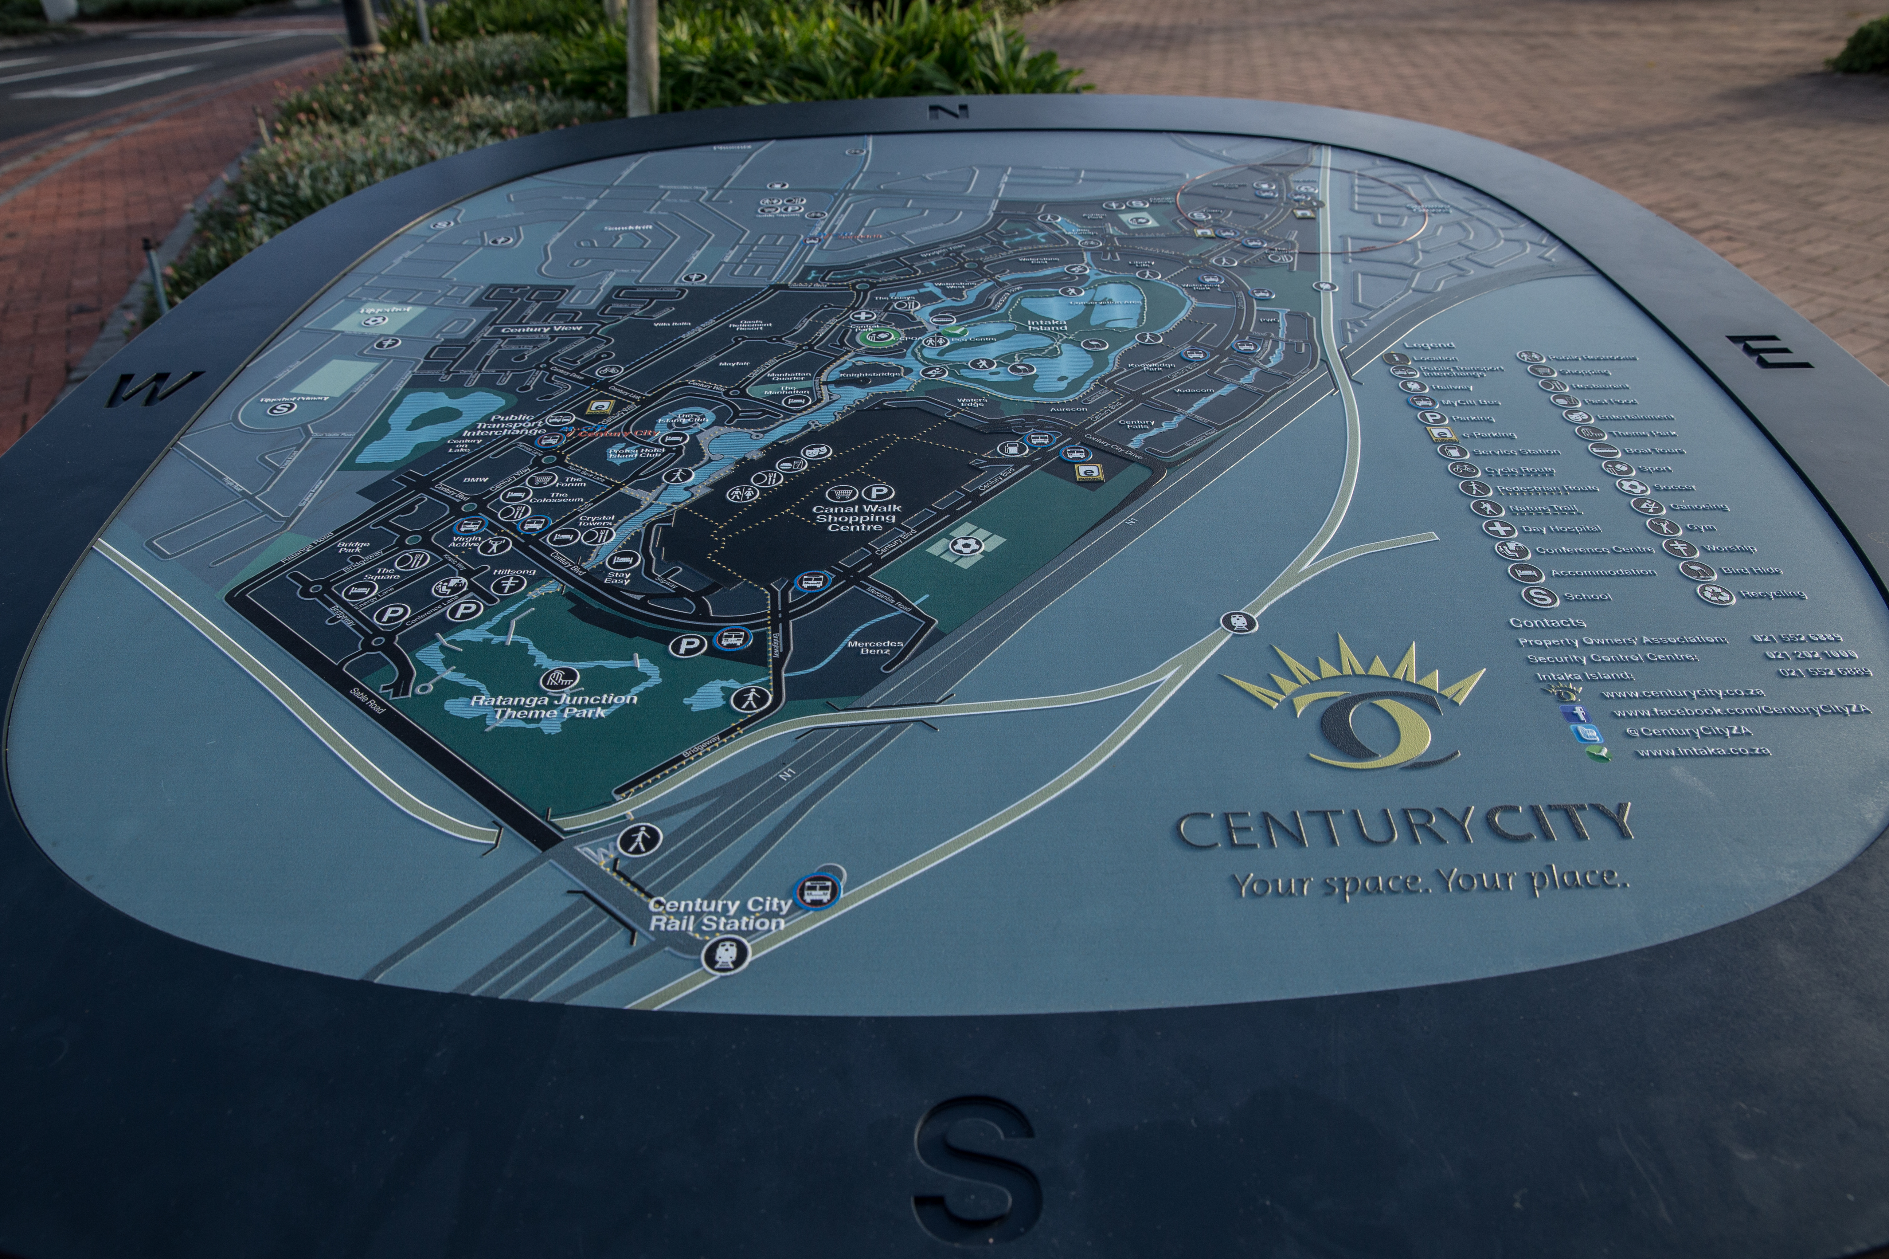

The principles of universal design, when applied to urban planning, support other government directives that encourage compact, pleasant, environmentally sustainable urban spaces with mixed-use residential and business nodes. They promote walking and cycling, as well as easy-to-use public transport for people who live outside the urban centre or who are unable to walk long distances.

The Integrated Urban Development Framework (IUDF) identifies levers that aim to create compact cities. Universal design has been highlighted in the report on vulnerable groups as a necessary approach. Although the IUDF is still in the initial stages, DoT is already working with the suggested approach on municipal transport networks.

The National Development Plan identifies the need to create more compact cities and to re-organize public transport so that every person can be included in urban life. The method used by the DoT on transport projects is to target new public transport interventions and apply relevant national minimum standards. It should be noted that these standards are not new, and some have been in existence for over 20 years. However, they have only been applied to urban public space since 2010 and only within the IPTNs.

By using this approach, the DoT sets a new municipal standard within the IPTN. No dates are set for upgrading services; they are upgraded based on available funds. However, the new intervention sets a very visible, identifiable and usable standard. In this way, it is simple to price and plan the improvements required to existing transport services. Implementation of the upgrading of existing transport services is incremental, with a timetable negotiated with the DoT.

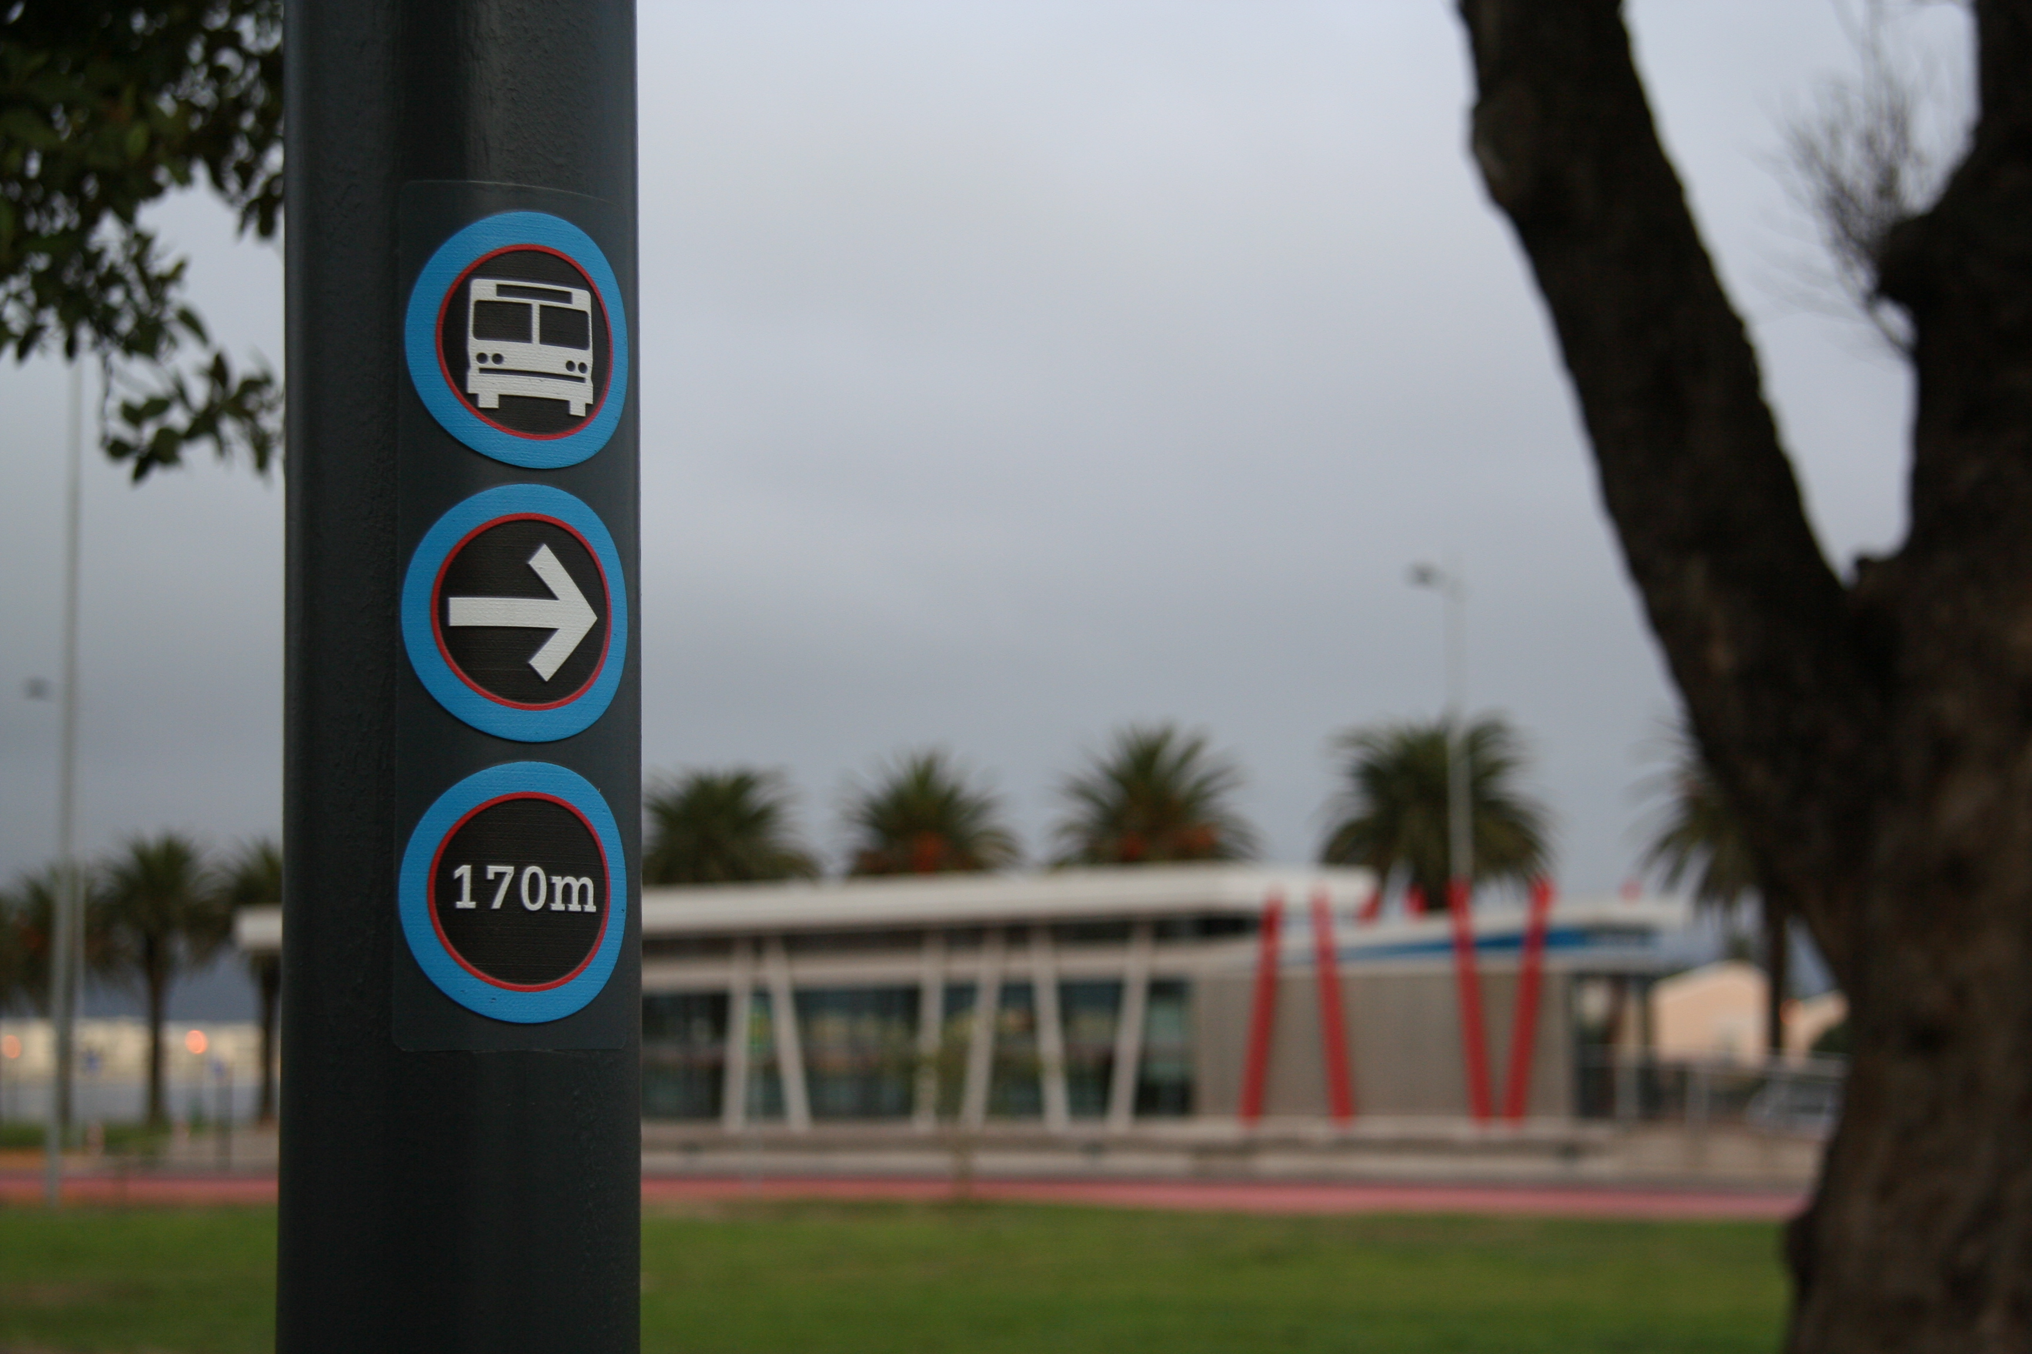

Overall objectives of the project/programme:
The project aims to be:
- effective in satisfying user needs;
- affordable;
- operating efficiently;
- reliable;
- of an acceptable standard;
- readily accessible;
- operated in conjunction with effective infrastructure provided at reasonable cost;
- safe;
- integrated between modes giving due consideration to the needs of users;
- effective in promoting integrated transport planning.

Process/strategy to implement the project/programme: Public Transport Strategy, 2007

Changes achieved: In Cape Town, the transport authority of the city, Transport for Cape Town (TCT) implemented MyCiti, a high-quality bus-based transit system operating since 2009, which has led to the following outcomes:

- There are 31.4 km of bus rapid transit trunk lines,108 km of mixed traffic trunk corridors and 317 km of feeder bus routes; 31 km of non-motorized transport network feeding 363 stops with shelters, 222 flag and pole stops, and 42 stations.
- There are 379 universally accessible buses.
- TCT is in the process of costing universal access rollout from an infrastructure and operational perspective so as to determine the most appropriate process for implementation. At the same time, a universal access infrastructure audit as well as the restructuring of its door-to-door, on-demand service, Dial-a-Ride, will be carried out.
- TCT signed a memorandum of action with the rail implementing agency, PRASA, on 4 May 2015, aiming to integrate bus and rail services (ticket, interchanges, operations monitoring and management).
- MyCiti carries 78, 825 passengers per day using 379 buses (February 2015).
- Since inception, MyCiTi has carried over 32.5 million passengers (April 2016).
- As of March 2016, there were 37 inter-connected routes serving 42 stations and 366 stops.
- MyCiti is experiencing steady expansion:
  - December 2015: 1.4 million passenger journeys
  - January 2016: 1.5 million passenger journeys
  - February 2016: 1.7 million passenger journeys.

How change was monitored and evaluated
Change was monitored and evaluated by determining the number of passengers using the system, the number of passenger complaints resolved as a percentage of those received, and by reporting on the Universal Design Access Plan, which is part of the operational plan.

Shortcomings and persistent challenges identified in the implementation of the project/programme:

- Operating difficulties: The is discord among operators of the current bus operating companies and previous and current minibus taxi operators.
- Municipal capacity: There is a lack of experience in planning and operating public transport of this nature.
- Geographical spread: South African cities have become economically unviable cities, which has led to problems in implementing public transport (whether universally accessible or not) that is unable to run without state subsidy.
- Universal access: There is a lack of understanding of the complexity of universal access at the outset of the project, particularly relating to vehicles and infrastructure. Universal access standards lack thoroughness and are inadequately known.
- Speed of delivery: There is lack of historical implementation in universal access leads to slow pace of change.
- Ethics: there is a professional lack of responsibility from some service providers (of professional bodies – architects/engineers).
- Teamwork: There is lack of national and municipal teamwork around a common goal.
- Unintended costs: Mistakes are made due to lack of knowledge and lack of coordination between implementing departments.
- Vested interests: Costs are driven up by over-charging.
- Evaluation: There are different ways of measuring success due to different unspoken goals.
- Due to trying to roll out multiple systems, certain specialist inputs are stretched, and not enough lessons learned have been able to be shared between projects.

Other lessons learned:

- Information on standards on all aspects of the travel chain is required by municipalities in the early planning stages so that the network plan is realistic.
- Flexibility is required to find answers to problems for remote or rural areas where road structure is substandard and normal buses are too heavy.
- No matter how much the municipality prepares, the initial year of operation is a steep learning curve.
- Municipalities need access to training in running a new model for operating public transport, which is unlike any model that South Africa has run before.
- The new systems have to be launched alongside increased policing to ensure that private vehicles do not abuse the infrastructure (driving in bus lanes, illegal parking in bus stops, or blocking walkways).
- The private sector become involved in the project, recognizing the benefits of having a Universally Accessible transport system providing a service to them and their tenants.
- In a recent development, the Rabie Group, owners of Century City, a mixed commercial and residential development, paid the full costs of designing and building the MyCiTi station on their property, and developed a new, accessible system of wayfinding that is being introduced across their property. These accessible maps and signs are a direct development of the accessible maps and signs used throughout the MyCiTi system, to ensure consistency for users, but tailored to reflect the site’s individual branding.

Contact:
Mr. Guy DAVIES
Disability Solutions (Pty) Ltd, 6 Non Pareille St, Paarl 7646, South Africa
disabilitysolutions@gmail.com
www.disabilitysolutions.co.za

Case study 8: Accessibility standard for public transportation (Indonesia)
Name of organization/Government entity: Department of Transportation, Information, and Communication, City of Solo (Surakarta), Indonesia

Thematic area of good practice example: Standard of Accessibility of Public Facilities in Transportation, Information, and Communication for persons with disabilities

Specific location: Solo (Surakarta), Indonesia

Duration of project/programme: Founded in 2006

Beneficiaries of good practice example: Persons with disabilities

Implementing agency/agencies: Department of Transportation, Information, and Communication

Source of funds: Public (local government) and Private (business sectors)

Brief background to the project: In general, Indonesia has comprehensive legislation regarding the rights of persons with disabilities as well as their access to different modes of transportation, e.g. Minister of Transportation Decree No. 71 of 1999. Similarly, the City of Solo has adopted a comprehensive disability law through Local Regulation No. 2 of 2008 on Equality of Persons with Disabilities as well as the subsequent Mayor Regulation No. 9 of 2013 on the implementation of the Local Regulation No. 2 of 2008. In addition, the city adopted two standards: the Standard of Public Building, and Public Facilities of 2006, which includes accessibility for persons with disabilities and which is managed by the City Space Management Office.

Overall objectives of the project/programme: Solo’s Standard of Accessibility of Public Transportation, Information and Communication of 2006 aims to improve accessibility, safety, and the dignity of people with disabilities and the elderly in the City of Solo, by promoting adequate measures that support self-sufficiency and well-being.

Process/strategy to implement the project/programme: Implementation of the Standard of Accessibility of Public Transportation, Information and Communication of 2006 began in 2008 and is carried out by the Department of Transportation, Information, and Communication of the local government. The provision on public transportation is enforced at the national level by the Ministerial Regulation on Technical Guidelines of Facilities and Accessibility in Buildings and Environment of 2006, while the part concerning information and communication exists only at Solo City level. In the event that Transportation Services do not implement the provisions, government officials intervene. Disabled persons organizations (DPOs) carry out on-the-spot evaluation, coordinate with stakeholders and obtain funds from sponsors or from the City’s Revenue and Expenditure Budget.

Changes achieved: Solo’s Standard provides a reference for development activities, which includes the technical planning and execution of constructions, thereby contributing to creating an accessible built environment. The Standard consists of a series of detailed plans on how to build accessible facilities. Concerning information and communication, all Solo government officials now receive, for example, free training in sign language. In addition, DPOs promote the availability of sign language interpreters in government offices, terminals, and railway stations, etc., and governmental offices are providing computers with screen readers. The Standard has been the trigger for the development of the Local Regulation No. 2 of 2008 on Equality of Persons with Disabilities.

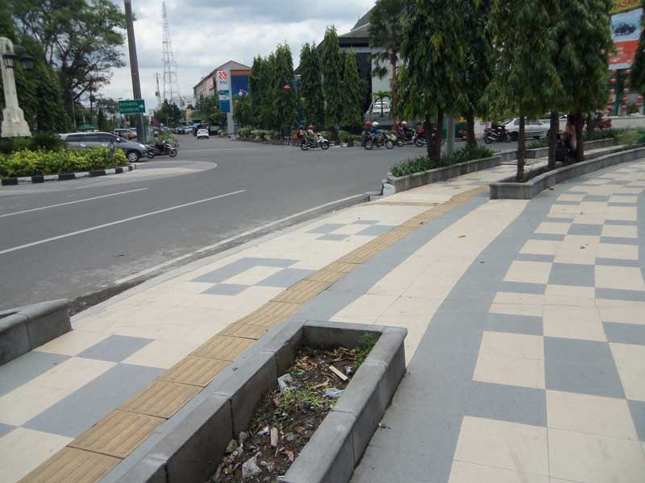

How change was monitored and evaluated: Monitoring can be carried out at any time by persons with disabilities and/or the relevant local government department, supported by civil society (including mass media). Evaluation has been performed at least once annually. (The annual comprehensive evaluation is organized by the local government, including accessibility aspects of development.)

Shortcomings and persistent challenges identified in the implementation of the project/programme: Problems with urban spaces, city parks and parking spaces persist. In addition, accessibility issues may clash with other poverty issues (e.g. beggars) or with space issues (e.g. rickshaw drivers). A major problem lies with priorities and cost-effectiveness. Information and communication have not yet been revised in easy or plain language.

Other lessons learned: Disability rights is a crosscutting issue that needs to be mainstreamed into all local government departments and other development actors, in both civil and business sectors. To realize disability rights, long-term advocacy is needed to involve and influence the local government system and structure to reasonably accommodate the rights of persons with disabilities.
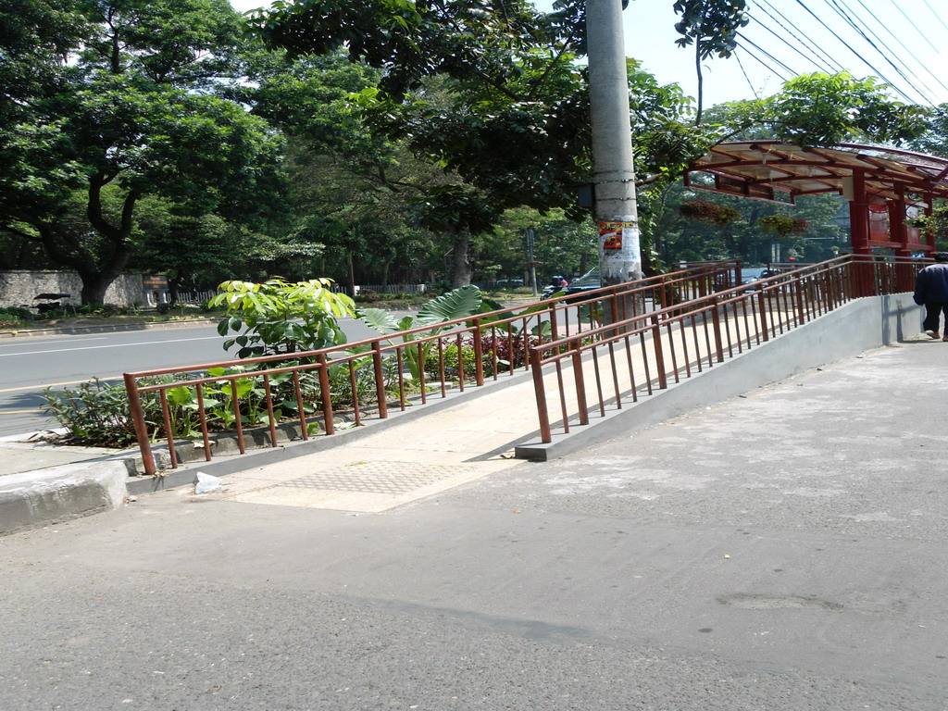
Contact:
Sunarman Sukamto
CBR DTC Solo, Jl. Mendungan RT. 001 RW. 005 No.: 29 Pabelan, Kartasura, Sukoharjo, Solo (57126)
Mobile/Cellular: +62 81 329 203 898
maman_shg@yahoo.com /mamansun@gmail.com
www.pprbmsolo.org

Case study 9: Accessibility for people with disabilities to the Bus Rapid Transit system Metrobus (Mexico)
Name of organization/Government entity: Mexico City Metrobus (Sistema de Corredores de Transporte Público de Pasajeros del Distrito Federal, Metrobús) is a decentralized body of the public administration and is under the Department of Mobility of the Government of Mexico City.

Thematic area of good practice example: Urban Frameworks – Accessible Public Transport

Specific location: Mexico City, Eje 3 Oriente, Avenida Ingeniero Eduardo Molina. From San Lazaro station (with modal transfer which intersects with rail lines) to Rio de los Remedios terminal station.

Duration of project/programme: Construction time of the line: 7 months.

Beneficiaries of a good practice example: The project helped all residents to travel in a more efficient, safe, rapid, convenient and effective way. Travel time along the corridor was reduced up to 40 per cent.

The project led to a better use of the public space, providing adequate space for different users and giving priority to pedestrians, public transportation and bicycles. It also improved the urban image of the neighbourhood.

The project benefitted people with disabilities as well as people with limited mobility, such as the elderly, people with baby strollers and children. The accessibility features support safety measures for all travellers.

Implementing agency/agencies: Department of Public Works, constructors; Metrobus, who operates the system; The social government agency that coordinated the groups of peoples with disabilities (transportation service users) and the accessibility consultant; the Institute of Transportation and Development Policy that served as a consultant in the design process; World Resources Institute (WRI) EMBARQ.

Source of funds: Federal and city funds

Brief background to the project: In 2002, EMBARQ, which is the WRI Centre for Sustainable Transport, signed an agreement with the Government of Mexico City to introduce the Programme for Sustainable Transport. The agreement aimed at improving mobility, accessibility and quality of life for residents, reducing travel time and improving the quality of existing services. This consisted in introducing a modern mass transit system, the Bus Rapid Transit (BRT) corridor. In addition to addressing the bus service issue, the BRT Metrobus project emerged in the context of the city’s efforts to reduce air pollution in Mexico City.

In 2008, Mexico ratified the Convention on the Rights of Persons with Disabilities. As a result, the local government integrated in its political agenda, accessibility to people with disabilities, including in transport and the update of building regulations.

In 2005, the first BRT system, Metrobus line 1, was opened, which provided limited accessibility features. The expansion of the system, influenced by the Convention, as well as by social and technical changes and political events, promoted the progressive evolution of the accessibility criteria. Metrobus line 5, which opened in 2013, was the first line that integrated the accessibility criteria with a better understanding of the relationship between stations, public space, operation and bus transfer.

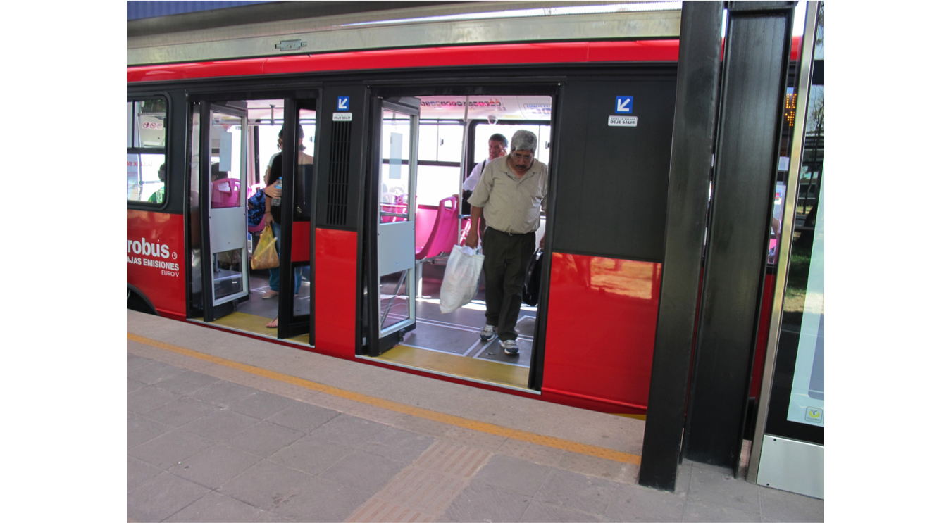

Overall objectives of the project/programme: The aim of the project was to provide a safe reliable service and easy access, taking into consideration people with disabilities.

Accessibility components considered were:

- In stations: enclosed stations with raised platforms for high-floor buses, ramps to station entrances, and accessible paths to bus doors, gratuity service with an accessible entrance gate, tactile walking surface indicators from the station entrance to the preferential boarding area, tactile signs, buttons to alert bus drivers to minimize the gap between the platform and bus floor, and accessible toilets.

- Buses: A dedicated bus lane with low emission buses, wheelchair access and spaces for wheelchair, audible and visual alarms on buses for closing doors, and preferential seats.

- Public space to station entrance: accessible sidewalks along the length of the BRT line corridor, accessible pedestrian crossings using traffic control to the median stations with audible signals for pedestrian traffic lights, and tactile warnings at curb ramps.

Process/strategy to implement the project/programme: The building authority checked over the architectural plans with an accessibility consultant looking at the accessibility standards of the local building regulations.

A government social agency was the coordinator of the groups of users with different types of disabilities. For example, a group of people with visual disabilities, who had previously acted as accessibility evaluators, were asked to test the tactile signage before their installation at the station. After installation, the group was asked to go to the station to ensure that their location was adequate in relation to the tactile warning surface.

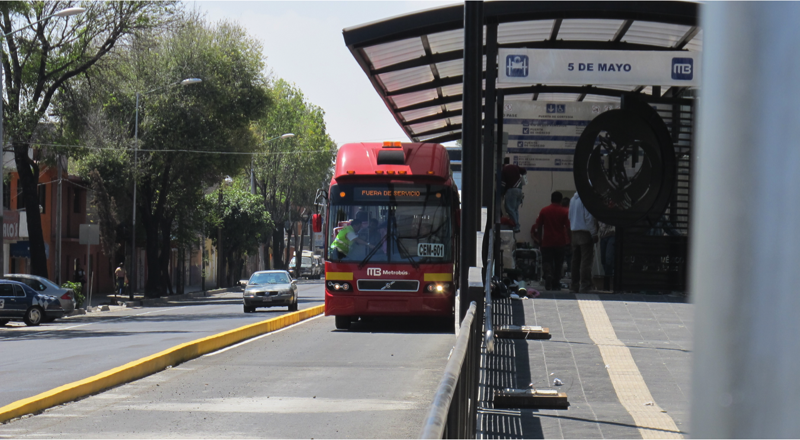

Changes achieved: Accessibility for persons with disabilities was improved compared to previous Metrobus lines. For persons with disabilities, the new accessibility features improve their mobility by giving them access to the public transport network and making the city more liveable for them.

How change was monitored and evaluated: There was a final walk tour with the disability group, and issues were raised on certain accessibility features. Travellers with disabilities can submit complaints to the Metrobus operator, which will contribute to assess if the system is functioning properly.

Shortcomings and persistent challenges identified in the implementation of the project/programme:

1. There were time constraints to finishing the construction work. As a result, there was no time to review in greater detail certain necessary accessibility features. For example, to ensure accessibility and safety in pedestrian crossing points, there was a lack of time to analyse and redesign intersections.

2. The response of the access consultants and the disability group was sometimes too late for the construction process.

3. There was a lack of suppliers who could address the accessibility requirements. For example, the tactile signage received several comments by the group of persons with visual disabilities, but the manufacturer could not meet the accessibility criteria, such as colour contrast or quality of the raised characters with the material requested (stainless steel).

4. At the time of construction, changes had to be made to the project because of unexpected situations. In addition, the work tends to be outsourced between two or more companies, which may not have the same detailed criteria.

5. Due to changes of government officials in charge of the building work for Metrobus projects, the accessibility criteria had to be re-addressed from the start, with briefings to show the progress made in previous lines.

- No technical accessibility guidelines for the Metrobus system are published that would allow to maintain the quality as well as the successful accessible growth system independent of political cycles.

Other lessons learned:

1. The operation of the Metrobus system must be assessed at an early stage to ensure accessibility to the premises.

2. The “last mile” is still a problem for people with disabilities, especially for wheelchair users to travel from home to the Metrobus stations.

3. Line or modal transfer needs to be addressed when building other Metrobus lines. This should include accessible pathways and signage.

4. Participation of users with disabilities is a key element for success; however, effective participation requires an accessibility consultant who can translate user requirements into technical language, which would facilitate the process for the constructors.

5. Government officials should make better informed decisions on mobility for people with disabilities. They should provide open and dynamic bridges of communication with persons with disabilities and all relevant stakeholders.

6. The technical accessibility guidelines for Metrobus must be flexible and kept up-to-date.

7. More efforts are needed by Metrobus.to improve current accessibility criteria.

Contact:
Janett Jimenez
Can Lah. S.C, Mexico
Email: jimesan@yahoo.com

Case study 10: Multi-Modal Transportation Accessibility in San Francisco (United States)
Name of organization/Government entity: San Francisco Municipal Transportation Agency (SFMTA)

Project/Programme title: Multi-Modal Transportation Accessibility

Thematic area of good practice example: Multi-modal access to a North American city

Specific location: All modes of transportation throughout the city of San Francisco, from pedestrian to vehicular modes

Duration of project/programme: Accessibility for persons with disabilities has been mandated in the United States since the Americans with Disabilities Act (ADA) was enacted in 1990; however, the city of San Francisco had initiated efforts to make its transportation system accessible for persons with disabilities decades before the ADA, and accessibility considerations, including efforts to exceed ADA requirements, are ongoing.

Beneficiaries of good practice example: All people travelling within the city of San Francisco benefit from the accessibility of the transportation system, both people with disabilities and members of the general public for whom travel is made easier by improvements such as curb cuts on sidewalks and ramps on buses.

Implementing agency/agencies: SFMTA and other public agencies

Source of funds: Government

Brief background to the project: The SFMTA is a department of the City and County of San Francisco, and is responsible for the management of all ground transportation in the city. The SFMTA plans, designs, builds, operates, regulates and maintains one of the most diverse transportation networks in the world. In addition to the four modes of transportation (transit, walking, bicycling and driving, which includes private vehicles, taxis, car-sharing, on-and off-street parking and commercial vehicles), the Agency directly oversees five transit modes (bus, trolley bus, light rail, historic streetcar and cable car). Also, the Agency oversees paratransit service, which serves individuals unable to use the fixed-route transit service.

The SFMTA’s public transit system, the San Francisco Municipal Railway (Muni), is the eighth largest transit system in the United States, with approximately 750,000 weekday boardings on fixed route modes, 510,000 annual paratransit van trips and 270,000 annual paratransit taxi trips. Walking and bicycling are common modes of transportation in the city. Nearly a fifth of the 4 million trips that San Franciscans and visitors take each day are entirely by foot, and there are an estimated 82,000 bicycle trips in San Francisco per day.

Overall objectives of the project/programme: The SFMTA, in partnership with other City and County agencies, works to make sure that all modes of transportation are accessible for persons with disabilities. At a minimum, this means ensuring compliance with the ADA requirements, but often the Agency aims to exceed the ADA requirements. SFMTA has four core values for the transportation network, one of which is “Social Equity and Access: Prioritize the most affordable and accessible modes.”

Process/strategy to implement the project/programme: The table below summarizes the existing accessibility features on each transportation mode, as well as SFMTA’s ongoing efforts to improve accessibility.

Changes achieved: The table summarizes the accessibility features implemented on each transportation mode.

How change was monitored and evaluated: One method that SFMTA uses to monitor and evaluate the accessibility of the transportation system is to solicit ongoing input from the community. The Multimodal Accessibility Advisory Committee (MAAC) is a group of seniors and customers with disabilities who regularly use SFMTA services and provide input on accessibility-related projects. The Paratransit Coordinating Council (PCC) is an advisory body for customers, service providers, social service agency representatives, and others to provide input on the paratransit program.

Another method that SFMTA uses to monitor accessibility is customer satisfaction surveys. In the annual Muni Customer Satisfaction Survey, when customers are asked to rank Muni’s performance in different areas, “accessibility for persons with disabilities” is consistently the highest ranked attribute. In the 2015 survey, 78 percent of respondents ranked accessibility for persons with disabilities as “excellent” or “good.”

Mode/Service | Existing Accessibility Features | Ongoing Efforts to Improve Accessibility
Muni Buses | - Wheelchair Lifts and Ramps. All buses are equipped with either mechanical lifts or wheelchair ramps.  - Securement Areas. All Muni buses have at least two wheelchair securement areas.  - Kneelers. Kneelers lower the front steps of accessible buses by several inches, making it easier for customers to board the bus, especially if boarding from the street.  - Priority Seating. Priority seating is provided for seniors and people with disabilities.  - Stanchions and straps. Vertical and horizontal poles for standing customers to hold on to for stability, as well as hanging straps and hand holds, are provided throughout the vehicle.  - Destination Signs. On most vehicles, digital signs on the front, sides and rear display the line name and destination. A recorded voice announces the same information to waiting passengers whenever the doors open.  - Automated Stop Announcements. On most vehicles, a recorded voice automatically announces the upcoming stops prior to arrival, digital signs simultaneously display the same information. | - When the San Francisco Municipal Transportation Agency (SFMTA) purchases new buses, Accessible Services staff and disability advisory groups provide input on the accessibility of the design.  - Accessible Services staff provide ongoing training to new Muni operators on how to use the accessible features of the vehicles and facilities, and how to provide the best possible service to persons with disabilities.
Muni Metro Light Rail System | - Overview. The Muni Metro light rail system features six lines. Downtown, the Metro runs underground, and all stops are accessible at high level. In the neighbourhoods, trains run at street level and accessible raised wayside platform stops are located at major destinations and transfer points.  - Priority seating. Priority seating is provided for seniors and customers with disabilities.  - Stairs can be raised or lowered. The stairwells on all Muni Light Rail Vehicles (LRVs) can be raised or lowered. For stations at high-level platforms, such as those in the underground stations and at some surface stations, level boarding is provided at all doors with the stairs in the raised position. For street level stops on the surface in some neighbourhoods, steps are lowered to provide access to curb height islands via stairs. At key surface stations, wheelchair accessibility is provided at mini-high wayside platforms using the raised steps.  - Dedicated Area for Mobility Devices. Each LRV is equipped with accessible seating areas.  - Underground Stations Wayfinding. All underground station entrances are easily identified by new sidewalk signage –  - Automated Announcements. In the underground stations, a digital voice announcement system announces the route designation and arrival time of approaching and arriving trains. Announcements of upcoming stations are made inside the train.  - Tactile Maps. Maps of the Metro system with Braille and raised characters are installed on the concourse and platforms levels of underground stations. | - SFMTA continues to conduct a stop analysis in order to prioritize potential new stop locations for accessible Muni Metro wayside platforms in the neighbourhoods. As locations are prioritized, feasibility determined, and funds secured, Muni-Metro accessible stops are added.  - When the SFMTA purchases new LRVs, Accessible Services staff and disability advisory groups provide input on the accessibility of the design.
Historic Streetcars | - Overview. Most of the historic streetcar stops on the Muni’s F-line include accessible wayside boarding platforms (i.e. elevated platforms that that are accessible via a ramp). In the core of downtown San Francisco, accessible stops are located at key locations only. Four of the stops that are accessible have mechanical lifts (i.e. wayside lifts) to raise the passenger to the level of the car floor.  - Stop request buttons and wheelchair stationing areas. SFMTA has three main types of historic streetcars. The most common type of vehicle, the President Conference Cars (PCCs), which ran in many American cities back in the mid-20th century, have been refurbished and modified to provide two wheelchair stationing areas with stop request buttons. The second type, the “Milan” from Milan, Italy, has access via a ramp to the rear door and plenty of space at the rear of the vehicle to position a wheelchair. The third type is a multitude of cars from around the world that have been modified to allow the use of ramp for access to the cars. | In the next few years, the Better Market Street project will update transit services on Market street. All stops on the F-Market Historic Streetcar line will be accessible, and at least three of the wayside lifts will be replaced with the easier-to-maintain and more reliable wayside platforms.
Travel Training | - Travel Training. Free Travel Training is available for individuals who would like to improve their transit skills or gain more experience using the Muni bus and rail system. | - SFMTA staff provide ongoing promotion of the travel training at senior and disabled community outreach events.
Paratransit Van Service | - Detailed Americans with Disabilities Act (ADA) regulations specify the requirements for complementary paratransit service, including service criteria, types of service options, operational performance, and other factors. San Francisco has two van services: SF Access, which provides pre-scheduled shared ride services to individuals based on reservations made 1 to 7 days in advance, and standing reservations. Group Van Services ,which provides pre-scheduled services to groups of disabled individuals going to one location like an Adult Day Health Center, Senior Center or a shared work site. | - Peer Escort Project. While not required by the ADA, SFMTA recently began to offer a peer escort programme, in which senior volunteers are provided a stipend to accompany and provide extra assistance to “attendant required” (“ATR”) paratransit riders, such as riders with dementia.
Paratransit Taxi Service | - Overview. Paratransit Taxi is a programme in which SFMTA provides a subsidy to persons who are ADA-eligible to purchase taxi rides. All taxis in San Francisco are required to participate in the SF Paratransit programme, and the rider calls the taxi provider directly to schedule the ride, just as a member of the general public would. This is not an ADA service, but many riders find that it better meets their transportation needs.  - Taxi Debit Card. In 2011, SFMTA replaced paper taxi vouchers with a taxi debit card programme. All taxi operators in the city have In-Taxi Equipment (ITE) that accepts SF Paratransit Taxi Debit Card payments. The taxi debit card programme allows for better trip and program monitoring and reduces opportunities for fraud.  - Ramp Taxi Incentive Program. SFMTA provides various incentives for drivers to pick up wheelchair customers, including financial incentives for each wheelchair trip provided (see Figure 1). | - Electronic taxi hailing (e-Hail) mobile application. SFMTA has partnered with Flywheel, a mobile application that allows users to electronically hail, track, and pay for taxi trips, to develop a customized version of their existing application, which will allow SF Paratransit taxi riders to electronically request and pay for their taxi trip using their smartphone (see Figure 2).
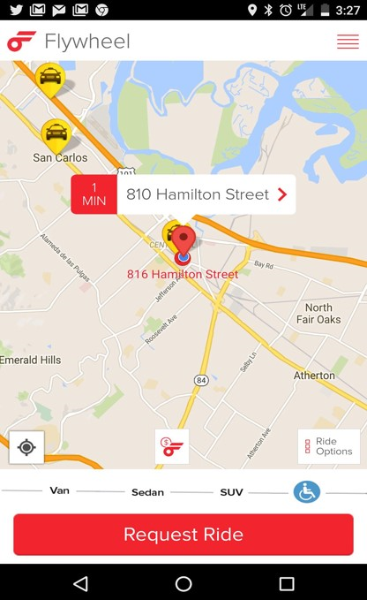
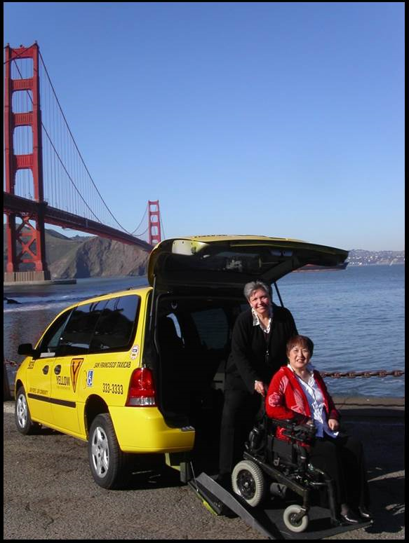
Shortcomings and persistent challenges identified in the implementation of the project/programme:

- Ramp Taxi Challenges – Ramp taxi vehicles are the least popular type of vehicle for both taxi companies and for drivers due to the higher fuel costs, maintenance costs and the purchase price of wheelchair-accessible vans. Consequently, it has always been more difficult to fill ramp taxi shifts and even more so, since the growth of Transportation Network Companies (TNCs) such as Uber and Lyft. To address this, SFMTA has introduced additional ramp taxi incentives, and is partnering with Flywheel to develop a mobile e-Hail application.
- Transportation Network Companies (TNCs) – With the recent proliferation of Transportation Network Companies (TNCs) such as Uber and Lyft, SFMTA, in its role of the taxi regulator for the City and County of San Francisco, has been working with the California Public Utilities Commission (CPUC), the regulator of the TNC industry, to in order to ensure that this new mode of on-demand transportation is regulated in such a way that it is accessible for persons with disabilities, including wheelchair users.

Other lessons learned: For countries with inaccessible infrastructure and transit vehicles, and limited financial resources, SFMTA’s accessibility solution for our Historic Streetcar Line may be particularly interesting. For passengers boarding and exiting at accessible wayside platforms along the Historic Streetcar line, SFMTA developed a highly affordable, low-tech, solution to bridge the gap between the streetcar and the wayside lifts and platforms. Rather than retrofitting the vehicle to install a mechanical ramp or lift, there is simply a bridge plate, essentially a piece of metal with a tactile warning surface and lips at the side, which is folded and stored vertically behind the operator’s seat. When needed, the operator manually places that bridge plate between the car and the platform to allow passengers to cross into the car.

Contact:
Ms. Annette Williams
Manager, Accessible Services Program
San Francisco Municipal Transportation Agency
One South Van Ness Avenue, Seventh Floor
San Francisco, CA 94103-5417
www.sfmta.com
annette.williams@sfmta.com

Case study 11: Visual and acoustic information on public buses (Spain)
Name of organization/Government entity: Empresa Municipal de Transportes de Madrid (EMT Madrid)

Thematic area of good practice example: Public Transport

Specific location: Madrid, Spain

Duration of project/programme: Several projects constantly evolving.

Beneficiaries of good practice example: Persons with visual or hearing impairments

Implementing agency/agencies: EMT Madrid

Source of funds: Public funds

Brief background to the project: Public transportation is not easily accessible for persons with visual and hearing impairments who would like to navigate the city in a safe and independent way. The use and further development of Information and Communications Technology (ICT) applications help to make public transportation more accessible. The aim of the project is to make the use of the public bus transportation easier for everyone, regardless of their physical, mental or sensory conditions.

Overall objectives of the project/programme: The project aims to enable the safe and independent use of public bus transportation for persons with visual or hearing impairments, also designed to assist persons with all physical, mental or sensory conditions. A new information technology has been developed and mobile applications introduced.

To facilitate the use of the bus service by persons with visual impairments, visual and acoustic information is provided both inside and outside the vehicle. It indicates the position of the bus, the line number, the direction, and information about the route once the bus arrives at the bus stop. The information panels at the bus stop include audio information that can be activated through a simple button or by activating Bluetooth on the mobile phone. A telephone service provides automatic information about the estimated time of arrival at each stop. The website has also been created in an accessible way.

Process/strategy to implement the project/programme: The company makes its own technological designs and makes public tenders for the implementation of fabrications, supplies and facilities.

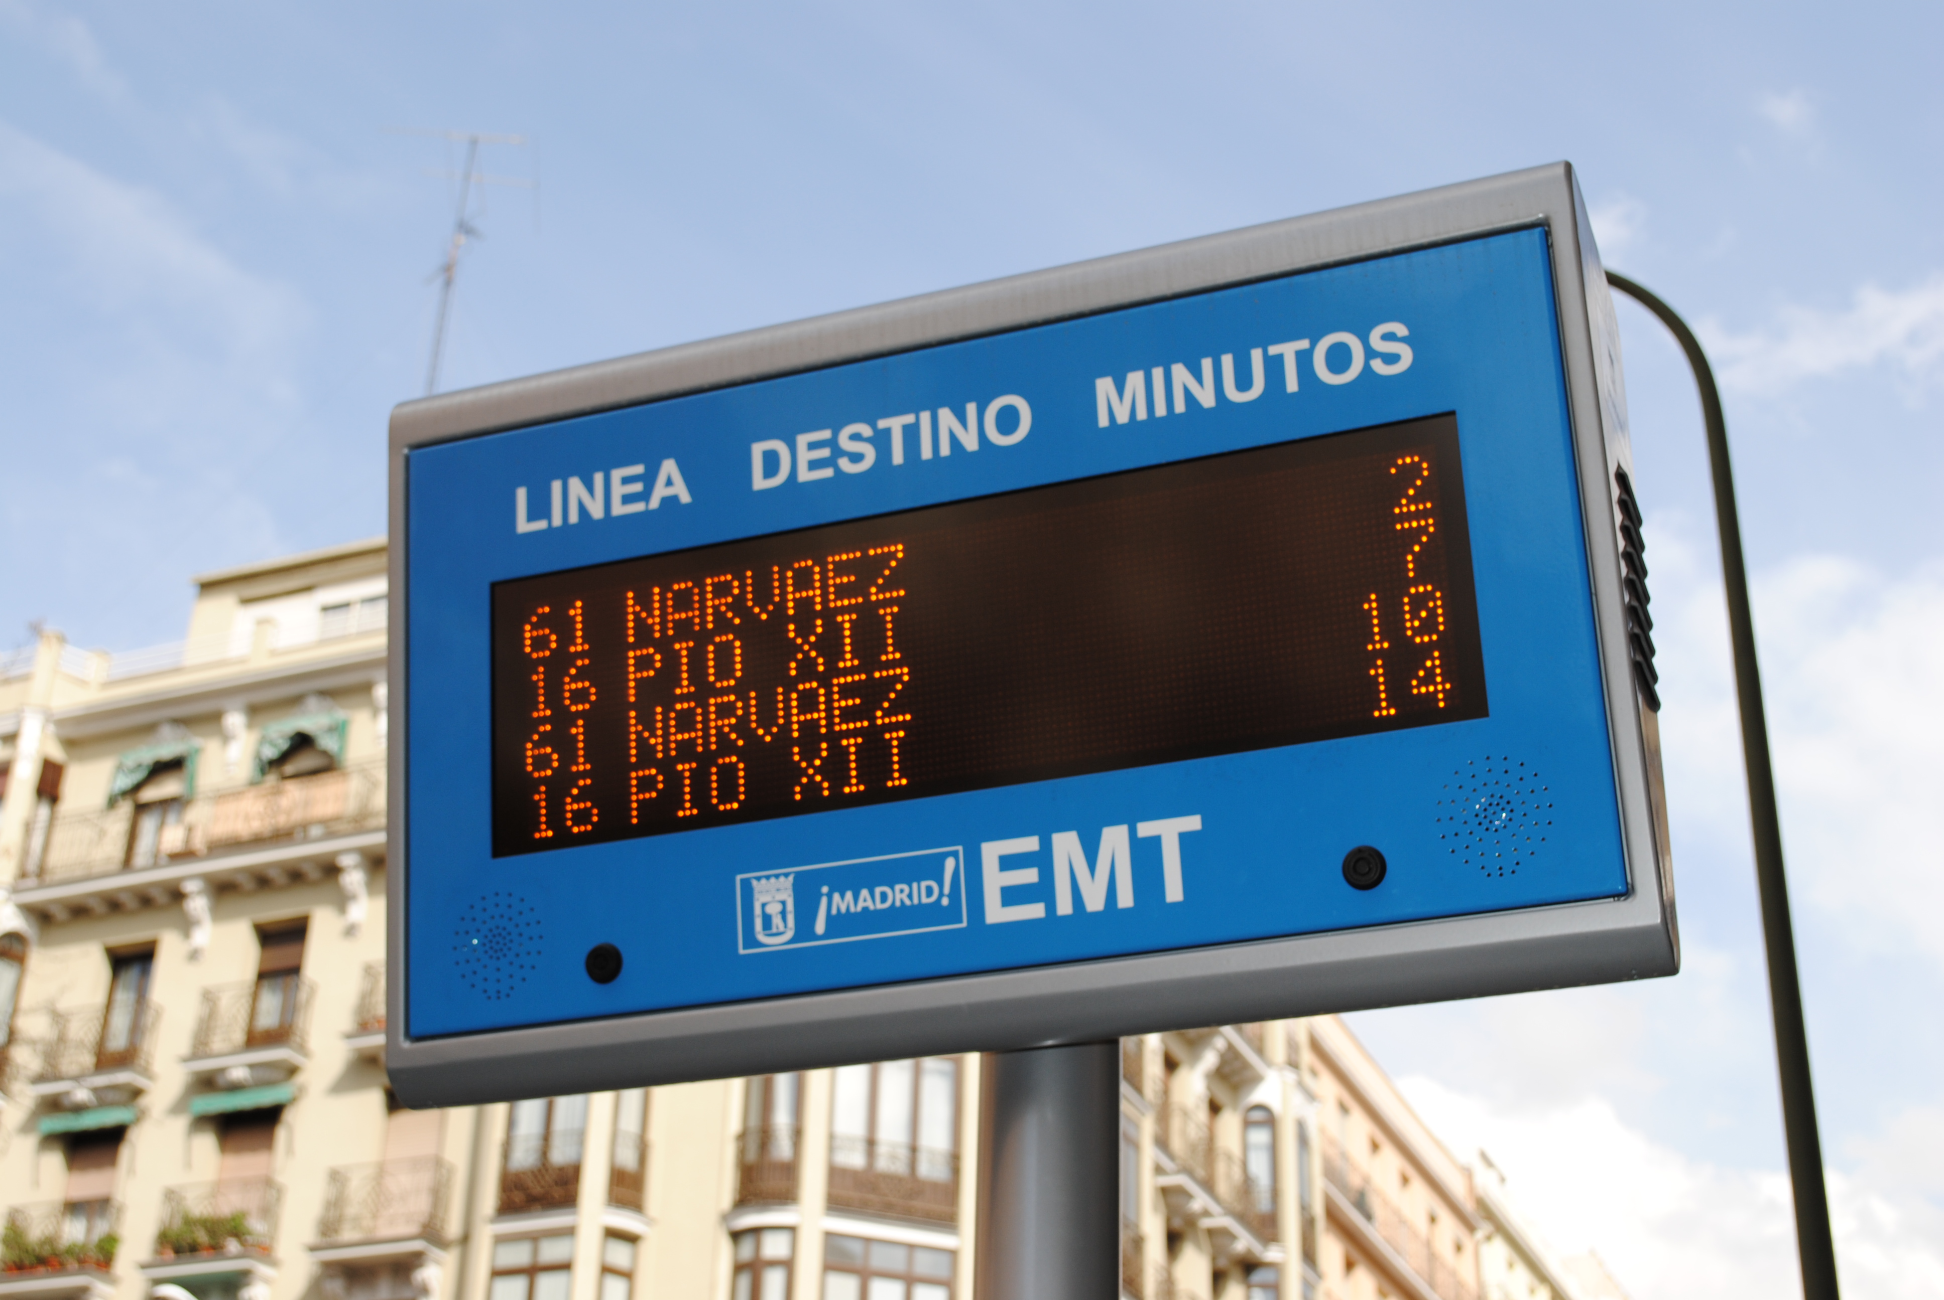

Changes achieved:
A series of actions that introduced the concepts of ICT have been implemented:
- visual and acoustic information systems installed inside and outside the bus and at bus stops;
- systems based on mobile phones, with voice recognition and synthesis;
- innovative mobile applications, such as a voice guidance system to use the bus.
- innovative Smart TV and wearables applications;
- an Open Data Platform in order to third parties can develop even more apps and functionalities.

How change was monitored and evaluated:
- 1,900 vehicles of EMT provide visual and audio information;
- 800 information panels at bus stops;
- Applications and Open Data Platform receive 30 million visits per month.

Shortcomings and persistent challenges identified in the implementation of the project/programme:
- Lack of integration with other apps and urban systems (traffic, parking, other public transport modes, etc.);
- needs to be constantly updated and aligned with new operating systems and devices;
- needs for enhanced collaboration with stakeholders and disability community.

Other lessons learned:
- Accessible mobility, the option to travel around Madrid on public transport, is a key factor for social participation and for gaining access to all the services available in the city.
- Accessible mobility is now a reality for everyone in Madrid as a result of an innovative above-ground urban transport network.

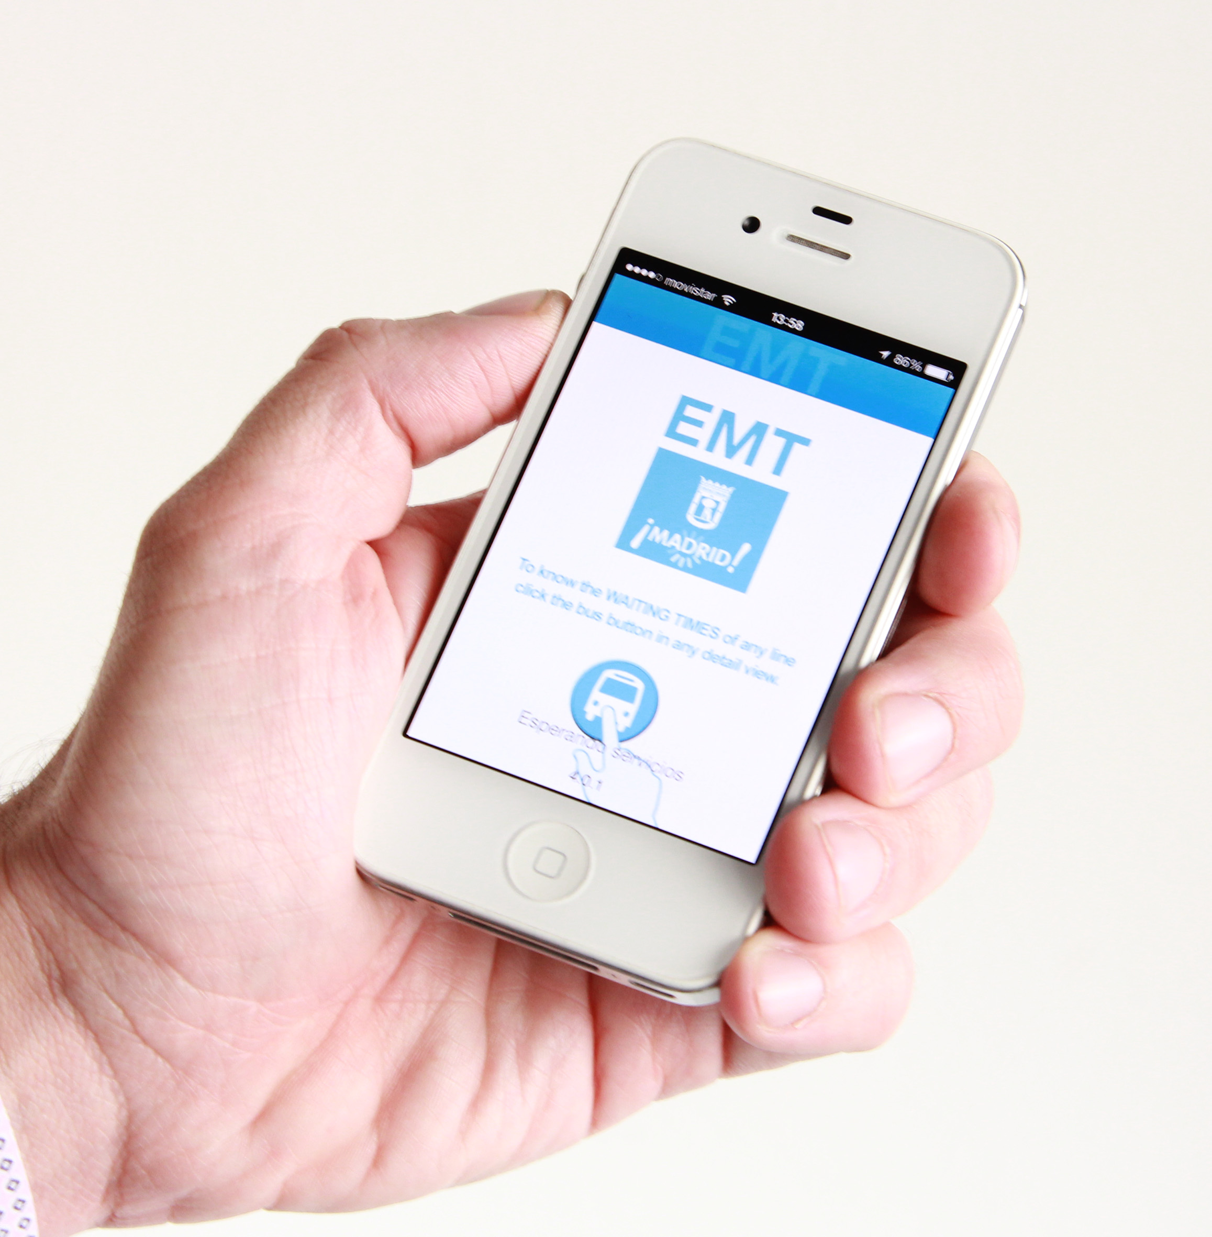
Contact:
Mr. Enrique DIEGO BERNARDO
Empresa Municipal de Transportes de Madrid C/ Cerro de la Plata, 4, 28007 Madrid, Spain
+34-91 40 68 849
enrique.diego@emtmadrid.es
www.emtmadrid.es

Part Three: Public spaces and public services including information and communication technology- (ICT) based services

Case study 12: Including persons with disabilities in access to safe sanitation: (Ethiopia)

Project/programme title: Including disabled people in access to safe sanitation: a case study from Ethiopia

Thematic area/s of good practice example: Access to sanitation and hygiene

Specific location: Ethiopia, Southern Nations Nationalities and People’s Region (SNNPR), Butajira town

Duration of project: February to September 2009

Beneficiaries of best practice example: People with physical and hearing impairments and non-disabled community members

Impairment/s targeted: People with mobility and hearing impairments

Implementing agency/agencies: WaterAid, Progynist (an Ethiopian women’s empowerment NGO, www.bds-ethiopia.net/progynist.html) and private sector contractors

Source of funds: WaterAid

Brief background to the project and to the selected practice: The Government of Ethiopia (GoE) has adopted a number of laws, policies and standards with a disability focus. In relation to the provision of basic Water, Sanitation and Hygiene (WASH) services, the most relevant guidelines are: Article 41.5 of the Constitution of the Federal Democratic Republic of Ethiopia (1995) and the National Programme of Action for Rehabilitation of Persons with Disabilities (1999). Ethiopia also aims to implement the Action Plan established for the African Decade of Persons with Disabilities (extended to December 2019). Despite the existence of these policies and frameworks, the GoE standard designs for WASH facilities in Ethiopia are not accessible to people with disabilities.

In 2006, WaterAid (WA) in Ethiopia conducted research into the barriers people with disabilities face when accessing safe WASH facilities. Informants were members of Fana, a disabled persons’ organization (DPO) with 62 members in Butajira town, SNNPR. A key research recommendation was to incorporate accessible designs within the WASH sector.

Overall objectives of the project/programme: In 2009, WA in Ethiopia piloted accessible sanitation and showers in a building administered by Fana as a small-scale pilot project. Key objectives of the project were: (i) to meet the sanitation and hygiene needs of the Fana members; (b) to raise the profile of disability issues within WASH in Ethiopia; (iii) to draw from lessons learned and encourage other actors (the government, development agencies, the private sector) to mainstream inclusive WASH in WA Ethiopia—this is the component selected as a best practice; and (iv) to generate learning for WA globally.

Process/strategy used to implement the project/programme: WA provided the funds and developed the pilot project in consultation with the Fana management committee, Progynist, and the local government. It also provided technical advice and support throughout the project. Progynist liaised with Fana members, local government officials and the private sector. The city’s Water and Sewerage Bureau assigned its employees with the task of installing a water supply for the Fana building, and the private sector constructed two accessible toilets and two accessible showers. The project has an income-generation component, since a fee is charged for using the showers for non-disabled community members. Two members of the Fana management committee participated in the design and implementation of the project, advising on construction, carrying out basic construction and managing the project once completed.

Changes achieved: The pilot project achieved changes in the following areas:
Awareness-raising: At the community level, achievements can be claimed in addressing attitudinal barriers as the project raised public awareness of disability issues. The Fana management committee also provides a service (toilets and showers) for non-disabled people, which shows that disabled people are capable of earning an income. In addition, the Fana management committee, who live in the Fana building, reported significant benefits from being in close proximity to the facilities. At the national level, WA raised the profile of disability within the WASH sector in Ethiopia by disseminating research and publications nationally and internationally through networks and the media.

Research: WA in Ethiopia was one of the first WA country programmes to pilot accessible toilets within its work. The WA team in Ethiopia has now committed to mainstreaming inclusive development within all areas of its programming, as is WA globally.

Policies: Lessons learned from the pilot project informed the WA Equity and Inclusion Framework that guides the implementation of the Equity and Inclusion Policy of WA. Rather than disability being a stand-alone topic or policy, it should be included in the WA Equity and Inclusion Framework. Of a total of 26 programmes, 15 WA country programmes now have a specific focus on disability in their country strategies.

Shortcomings or persistent challenges identified in the implementation of the project/programme: The best practice example could have been improved in the following ways:

- by undertaking mainstream inclusive development in all areas of work rather than targeting disabled groups as a stand-alone activity. Intervention should be designed to address environmental, social/attitudinal and institutional barriers;

- by conducting a stakeholder analysis that incorporates an assessment of power, age, gender and impairment during the project planning phase. Other aspects could be added, as appropriate; these could include ethnicity, religion and caste;

- by recognizing that full participation is unrealistic within resource constraints;

- by making empowerment more specific, measurable and achievable. Using the information gained from the stakeholder power analysis, activities could be developed to improve specific power relations.

Contact:
Jane Wilbur, Principles Officer, Equity, Inclusion and Rights, WaterAid.
E-mail: janewilbur@wateraid.org; tel: +44 20 7793 4567.
Mahider Tesfu, Senior Equity and Inclusion Officer, WaterAid in Ethiopia.
E-mail: mahidertesfu@WA.org; tel: +251 11661680

Case study 13: Transforming an unused piece of land into an inclusive public space (Mexico)

Name of organization/Government entity: Secretaría del Medio Ambiente del Gobierno del Distrito Federal (SEDEMA, Department of Environment of the Government of Mexico City)

Initiative selected as best practice sample: Reclaiming of public space by creating pocket parks through an inclusive approach since the early stage. Participation of the community on public spaces decisions and involvement of accessibility expertise.

Thematic area of good practice example: Inclusive urban spatial development. Urban regeneration to improve the quality of life in the neighbourhood. Design of public spaces considering community needs.

Specific location: Metro Tezozomoc Pocket Park, Corner of Eje 4 Ahuehuetes and Av. Sauces, Colonia Pasteros, Delegación Azcapotzalco, México City, near Tezozómoc Metro Station.

Duration of project/programme:
Design phase: two months
Construction phase: three months

Beneficiaries of good practice example: The park benefits around 18 thousand people living in the municipality, providing activities for different ages and for persons with disabilities:
- a playground for children;
- a skate park for youths;
- a seating area and dancing fountain for families and communities to gather and socialize, including people with limited mobility.

Implementing agency/agencies:
- SEDEMA
- Espacios Verdes Integrales S.A. (building construction company)
- Tecnósfera, S.C. (urban and landscape designers)
- Can Lah, S.C. (access consultant)

Source of funds: Due to a mitigation measure whereby a private company had to environmentally enhance a specific public space, the pocket park was funded by the company itself.

Brief background to the project: Azcapotzalco is one of Mexico City’s 16 municipalities and is a centre of industry. According to the National Institute of Statistic and Geography (INEGI), 37.4 per cent of the land of the demarcation is for industrial use. Housing in the municipality is varied. Most residential buildings are of two or three floors, and apartment buildings average five floors. Infrastructure is in a poor condition, mainly the asphalt, water networks, drainage and public lighting. Due to its industrial character, there is heavy vehicle traffic and there are few open spaces.

The land owned by the City in Azcapatzalco was an unused plot with a concrete slab. Previously, it was used as a parking lot and later abandoned with a fence around the land. The land is located at a block corner close to a station of the City Metro transportation system with an area of 1,477.31 m2.

Groups of skateboarders gathered around the area making it difficult for pedestrians to use the street and reach the Metro Station. The urban image of the area was run down with trash, abandoned vehicles and graffiti and was unsafe for passersby.

Overall objectives of the project/programme:
1. Reclaim unused land through the construction of the largest pocket park in Mexico City.

2. Activities to promote recreation, culture, social interaction and fun. The integration of users is sought through activities that define four areas that highlight and enhance a space with a contemporary design creating a friendly space for each activity:

- Central plaza with seating areas: 550 m².
- Dancing fountain accessible for wheelchair users: 60 m².
- Attractive ramps for the skate park: 560 m².
- Secure children play area with play components: 132 m².

3. Visibility for safety. The pocket park is designed in such a way that any standing point inside the park allows for full visibility of the surrounding space. In addition, lighting was designed to fully illuminate the open space at night.

4. Use of universal design as a concept and principle. Universal design principles were used for the design of the built elements for the landscape features; for example, the pedestrian ramp to the children play area, the tactile walking surface indicators (TWSI) indicating tactile routes, the tactile-visual maps for orientation, visual contrast for different elements, and handrails were all installed.

5. Environmental sustainability: Solar street lights were installed. To provide oxygen and increase permeable surfaces, 22 trees were planted in green areas. An automatic irrigation system was installed to provide watering the green areas of the pocket park with a minimal use of water.

Process/strategy to implement the project/programme: Negotiations were carried out between SEDEMA and the investor for the mitigation measure. Once decided on the intervention land area, the community was ask about their needs and encouraged to be involved in the process.

Since the beginning of the process, it was suggested that pocket park should be inclusive to all people, and that a programme should be established considering the different community needs in one space. One of the requirements was that even though there were areas with specific activities, the pocket park should link them together and make the park environmental sustainable by designing them with a low maintenance cost.

The building construction company hired the urban and landscape designers to design something original in the city. An analysis, diagnostic, zoning, architectural plans and the executive project were carried out. Since the design stage, universal design was considered in the project by hiring an access consultant. In order to comply with Mexico City’s 2011 TWSI building standard, molds had to be made by the supplier. The installation criteria followed the standard and the best practice approved by persons with visual impairments.

The construction phase started with the building works, such as the walls, floors, ramps of the skate park, a ramp to the play area and drainage. Street furniture such as handrails, solar street lighting and seating benches were installed together with children´s play components and, finally, vegetation.

The Major of Mexico City, the Head of the Department of Environment of Mexico City, the local authority and other government agencies presided over the opening ceremony. They became interested in the project because of the concept of inclusion and the accessible building elements. It was the first park with TWSI and with tactile maps in Mexico City.

Changes achieved:
The project achieved the following outcomes:

- Awareness was raised among different stakeholders that making inclusive spaces is in the best interest of everyone. There was a media release and local government report of the new pocket park. The pocket park gave an example of how to approach urban regeneration by reclaiming unused land and the implementation of policies for inclusion by creating inclusive public spaces.

- The investor and construction company became aware that spending money on accessibility features benefitted different users, and that this experience may inspire others in future projects to be inclusive. The urban and landscape designers became familiar with universal design principles and gained knowledge of local products and materials available for the accessibility features.

- The neighbours believed that something positive was gained for the community. Residents use the pocket park as a meeting point, particularly the group of skateboarders. Neighbours are involved in the maintenance of the pocket park and they keep the park clean by sweeping the floor and watch for people not to throw garbage in the street and pocket park.
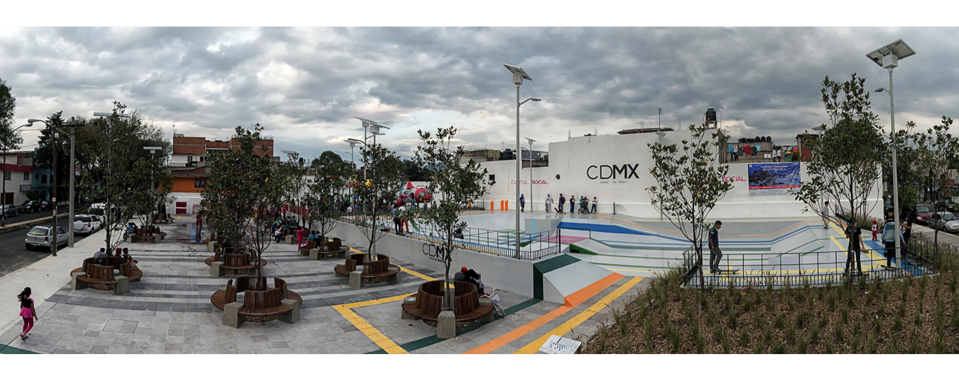
How change was monitored and evaluated: The pocket park was opened in September 2014 and it has not been formally monitored or evaluated. However, during the first six months, the community took care of the pocket park. For example, one of the play components (the chicken) broke, and the neighbours themselves fixed it. Graffiti was painted on the tip of the play rocket and the neighbours erased it. By observation, the park is used at different times of the day.

Shortcomings and persistent challenges identified in the implementation of the project/programme: The main challenge was to include universal design principles and change the traditional paradigms throughout the project with the different stakeholders involved. The urban and landscape designers had to convince others to make an inclusive pocket park with accessible building elements. For example, they convinced the investor to install the TWSI guide route.

Finding a supplier for tactile maps was not an easy task. Stainless steel maps were selected as part of the design but no suppliers were found to do the job, so acrylic and aluminium were the materials finally used for it. To lower the costs, recycled material was used to support the tactile maps. The budget was insufficient for buying other play components.

Organizing the neighbours took time, and support is still needed to keep them together so that they feel that the public space was created for them and belongs to them. It is also important to maintain the space in good condition.

Other lessons learned: Even though there is still room for improvement, the Metro Tezozómoc Pocket Park can be used as a model for the design and construction of other public spaces. Creating awareness about the need of inclusive spaces is the first step to achieve the objective, and involvement and participation of the community is essential.

Contact:
Janett Jimenez
Can Lah. S.C, Mexico
Email: jimesan@yahoo.com

Case study 14: City of Lucca – Becoming Accessible (Italy)
Name of organization/Government entity: Fondazione Banca del Monte di Lucca
Thematic area of good practice example: Accessibility in historical cities

Specific location: Lucca, Tuscany, Italy

Duration of project/programme: 2010-2016

Beneficiaries of good practice example: From the outset, the strength has been the involvement of people with disabilities. The Foundation strongly believes that it is impossible to even think about a project improving accessibility without first asking them what they would appreciate, but it is a project for all citizens and tourists.

Implementing agency/agencies: Fondazione Banca del Monte di Lucca

Source of funds: Foundation and private grants

Brief background to the project: Lucca is old historical city with a significant cultural heritage, and there is need to make it more accessible, to the extent possible, for all. There is an economic opportunity to increase tourism.

Overall objectives of the project/programme: An old historical city with a huge cultural heritage and the need to make it more accessible, to the extent possible, for all. An economic opportunity to increase tourism.

Process/strategy to implement the project/programme:
- Creating a solution that allows people to move and live better in their own town, to be part of events, to reach public spaces easily; and to raise awareness on disability issues, inclusion and respect.
- Studying a prototype with a public university to allow persons with visual impairments to visit the City Walls autonomously.
- Cooperating with disabled people to test new solutions for an historical town, such as Lucca.
- Exchanging ideas and peer learning from the other foundations and subjects involved in the European Project of the League (LHAC). Disseminating the experience and presenting replicable solutions.
- Involving persons with disabilities, in order to convey practical suggestions based on real needs.
- Creating more than 5 km of accessible routes, a path for visually impaired people on the City Walls (4.5 km). Creating a logo and an accessible website where all information are collected.
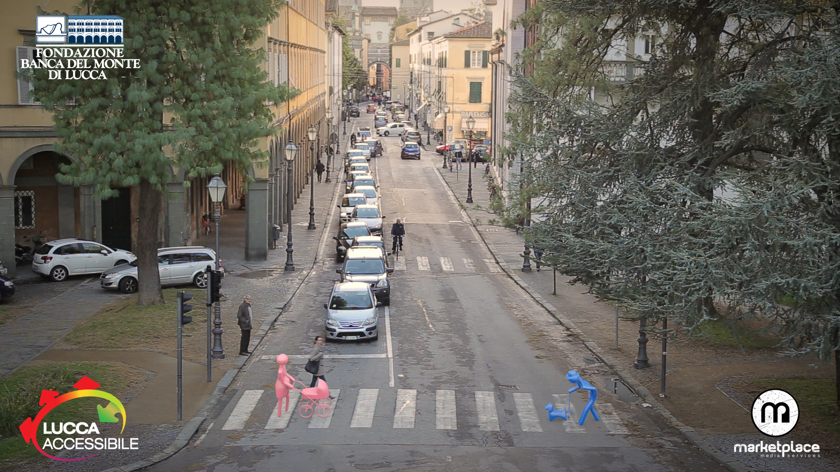

Changes achieved: At the European level, a practical guide was formulated with the experiences and solutions of this project. At the local level, an improvement on the awareness and a starting point for new future regulations. Awareness of disability issues was raised among the community has been an important by-product of the initiative and an important step on the road to inclusion.

How change was monitored and evaluated: It was evaluated by European bodies: www.lhac.eu/resources/toolip/doc/2015/07/23/evaluation-last-version-excel.pdf

Shortcomings and persistent challenges identified in the implementation of the project/programme: Awaiting the Accessibility Act as a milestone to pursue new objectives.

Other lessons learned: There are many good ideas for accessibility, but it is difficult to involve people to work together for a common goal and to communicate effectively. However, it is only by working together on disability issues that the environment and people can change, together.

Contact:
Elizabeth Franchini
elizabeth.franchini@fondazionebmlucca.it
Fondazione Banca del Monte di Lucca

Case study 15: Changing Places (United Kingdom)

Name of organization/Government entity: Changing Places Consortium
Thematic area of good practice example: Campaign to provide accessible toilets in public places

Specific location: United Kingdom

Duration of project/programme: Started in 2006 and is an ongoing project.

Beneficiaries of good practice example: Persons with disabilities

Implementing agency/agencies: Changing Places Consortium – Centre for Accessible Environments, Pamis, Mencap, and other experts in the field of learning disability.

Source of funds: Sponsorship via Aveso (www.aveso.co.uk)

Brief background to the project: Due to the lack of suitable toilets, persons with disabilities who need assistance cannot take part in many activities such as shopping and going to a park or a show. Without a suitable changing bench and hoist, many persons with disabilities have to be laid on unhygienic toilet floors.

Overall objectives of the project/programme: The Changing Places Consortium is campaigning to build more accessible toilets in all major public places, including city centres, shopping centres, arts venues, hospitals, motorway service stations, leisure complexes, large railway stations, airports etc. Changing Places toilets are different from standard accessible toilets because they include special equipment such as a height-adjustable changing bench and a hoist, offer adequate space in the changing area for up to two carers, and provide a centrally placed toilet with room on either side for the carers.

A Changing Places toilet provides equipment, space and facilities (including hoist and adult-sized changing bench) for persons with disabilities who need assistance and cannot use standard accessible toilets. Changing Places toilets should be provided in addition to standard accessible toilets.

Process/strategy to implement the project/programme: The Changing Places campaign has ensured that there are over 800 Changing Places toilets currently in the United Kingdom with the aim of having 1,000 by 2017/18. Individuals and companies may commit themselves to building a Changing Places toilet on their premises according to the provided standards and requirements. Their toilet will then be listed on the map of Changing Places, which allows beneficiaries to find locations with appropriate toilets. There are also mobile Changing Places toilets available to rent for large and small events.

Changes achieved:
- Currently over 800 Changing Places toilets in the United Kingdom
- Estimated equipment cost: GBP 12,000 – 15,000 incl. VAT

How change was monitored and evaluated: There are many examples of campaigning success and how Changing Places have changed people’s lives. Regular news stories are posted on the Changing Places’ website www.changing-places.org/news.aspx

Shortcomings and persistent challenges identified in the implementation of the project/programme: Main challenges are venues obtaining funding for Changing Places projects and the lack space available in some venues for Changing Places that meet the British Standard.

The consortium work with providers, architects, installers and campaigners to make sure that the best results are achieved and that the projects meet the British Standard when possible.

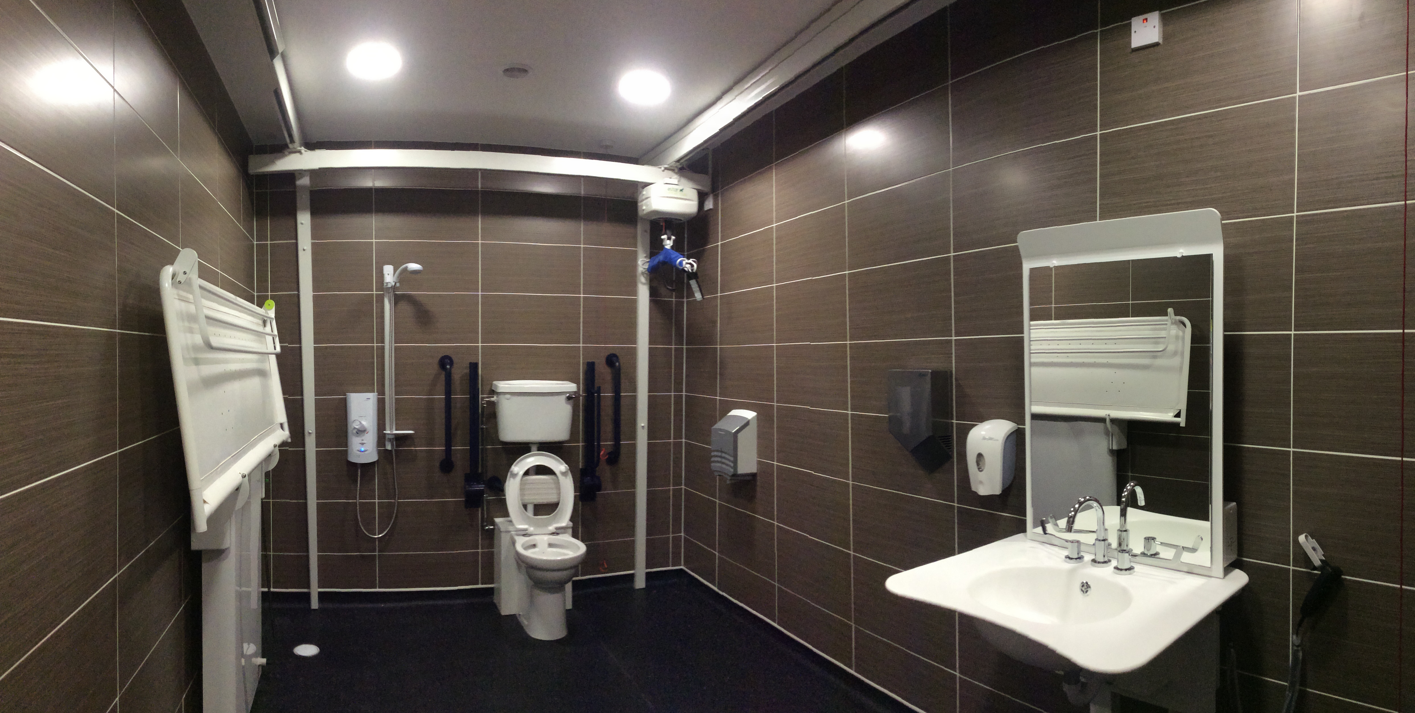

Other lessons learned: Clear information must be available. People are encouraged to work with the Changing Places consortium through the process of installation.

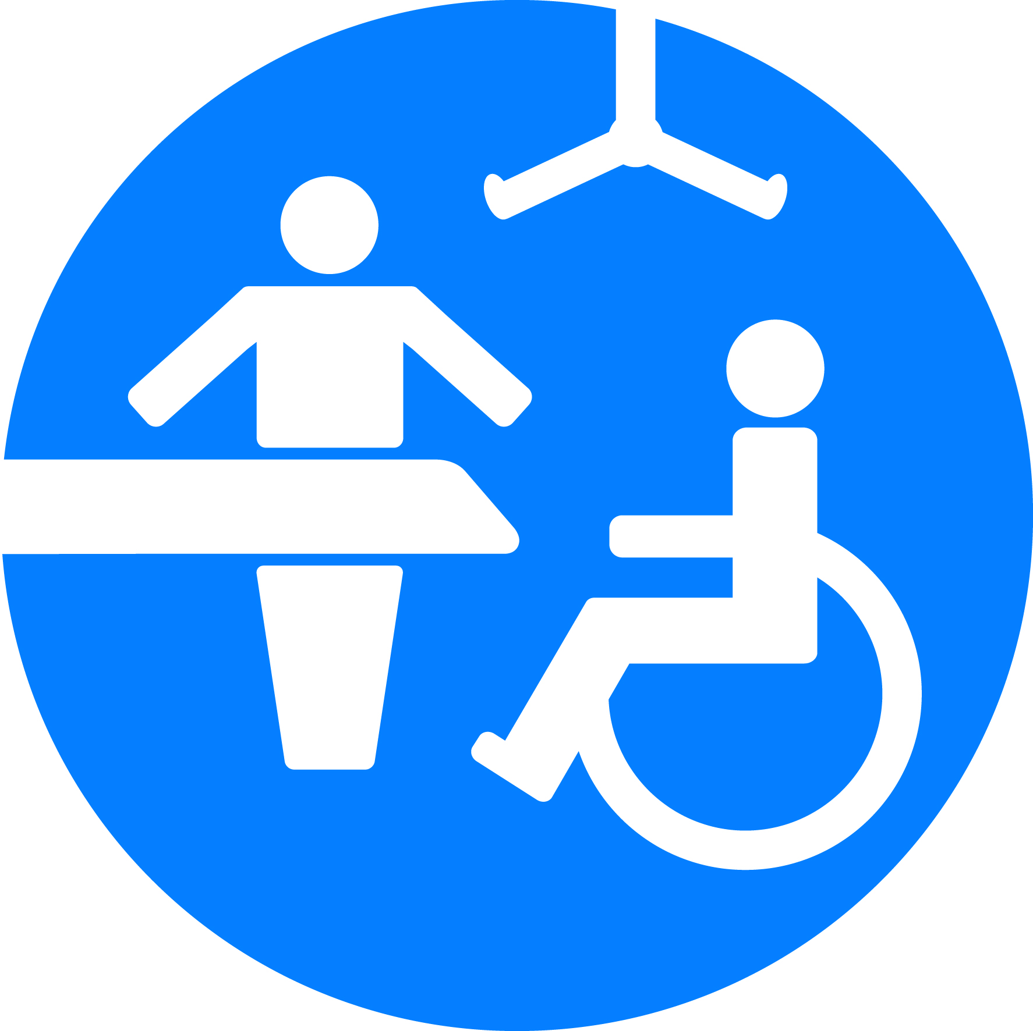

Contact:
Mr. Michael LE-SURF
Changing Places Consortium
Mencap, 123, Golden Lane
London EC1Y 0RT, United Kingdom
+44-20 7454 0454
www.changing-places.org

Case study 15: Accessible Musholm, a unique accessibility and universal designed Vacation – Sports – Conference Centre for people with physical, cognitive and communication disabilities (Denmark)
Name of organization/Government entity: Accessible Musholm

Thematic area of good practice example: Accessible tourism and conferences

Specific location: Korsør, Denmark

Duration of project/programme: 2008-2015

Beneficiaries of good practice example: Persons with any kind of physical, cognitive and communication disabilities, including both private persons and institutions.

Implementing agency/agencies: Musholm, Vacation – Sports – Conference

Source of funds: Arbejdsmarkedets Feriefond (The Labour Market Holiday Foundation), Realdania, A.P. Møller & Hustru Chastine Mc-Kinney Møllers Fond til Almene Formaal, The City of Slagelse, Muskelsvindfonden (Musclar Dystrophy Foundation of Denmark)
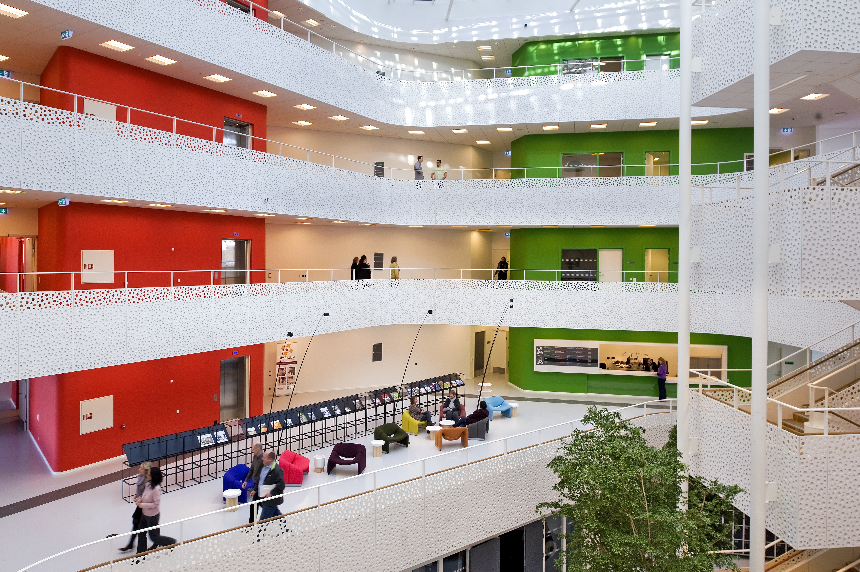
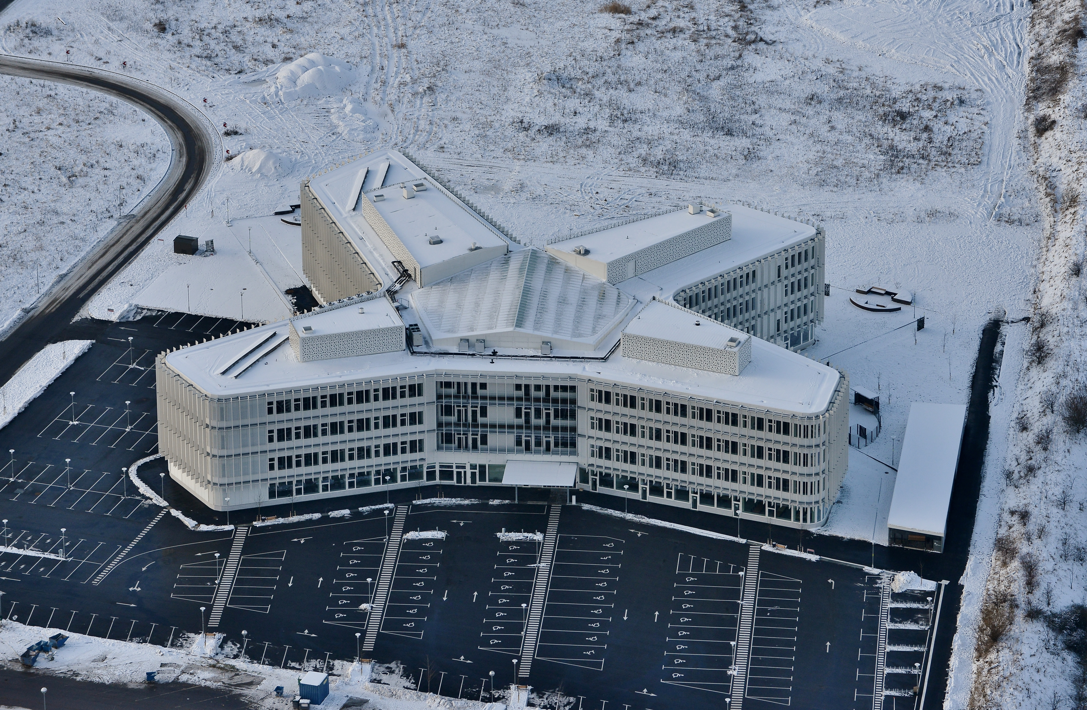

Brief background to the project: People with disabilities want exciting experiences during holidays, sports and conference activities. Yet, many resorts are not accessible. Not only due to physical boundaries, but also a lack of services, attitudes and hospitality that would show people with disabilities that they are welcome.

Overall objectives of the project/programme: The overall objective is to create a holiday resort where persons with disabilities can participate on an equal basis with others. At the Musholm resort, accessibility has been thoroughly incorporated, so it is hardly noticeable. Regardless of their age and disabilities, people are able to participate. Musholm includes a spectacular, circular sports arena for all kinds of indoor parasports, a restaurant, conference rooms and houses for rental.

The level-free centre, the wayfinding, the sport activities (especially the cableway), and the solutions in bathrooms, toilets and rental houses are unique, because a combination of beautiful design and accessibility has been created for many different kinds of disabilities to answer the need for highly personalized, custom-made solutions for individuals. The Chair of the Danish hotel business has described Musholm as an example for the hotel business, because its increased accessibility increases its competitiveness.

Process/strategy to implement the project/programme: In the design process, Musholm teamed up with numerous experts of various kinds. People with different types of disabilities, architects who can integrate solutions, and manufacturers of the various types of furniture and installations were included. This allowed to make the universal design as integrated and invisible as possible. Today, Musholm has following universal design solutions: a multi-purpose hall built for wheelchair sports, conferences and concerts, with a special anti-skid covering due to considerations for those with impaired hearing; sound installations as directional indicators; a snoezelen room/cinema; an aerial ropeway and climbing wall accessible for wheelchairs; specially designed toilets for different needs; a fitness area with a running belt for the walking-impaired; the possibility to control the room's lock/lighting/heating via mobile phone; wayfinding using colours, pictograms and guidance elements; 100 m experience ramp to sky lounge; and an accessible bathing jetty.

Changes achieved: Musholm gives people with disabilities a resort where they can visit and have an active vacation on an equal basis with others. Musholm also challenges stereotypes about people with disabilities, because people with and without disabilities will meet on an equal footing. Musholm is also a socio-economic enterprise: when a person visits the site, this helps promote employment for vulnerable groups. Moreover, all possible profits are reinvested in Musholm.

How change was monitored and evaluated: Musholm tries to improve the service for all guests and listens to feedback. This has affected the general design of every room on the resort.

Shortcomings and persistent challenges identified in the implementation of the project/programme: Musholm struggles to eliminate prejudices so that people without disabilities can see the person in the wheelchair and not only the wheelchair. This can be achieved by creating possibilities of interaction between people.

Other lessons learned: It is possible with a great team and hard work to create an invisible universal design that allows visitors to meet despite of differences. This also works as a showroom for other hotels and resorts.

Contact:
Ms. Gitte Fyrkov
gify@musholm.dk
Musholm, Vacation – Sports – Conference
www.musholm.dk

Case study 16: Public Plaza: Inclusive Public Spaces (USA)

Name of organization/Government entity: New York City (NYC) Department of Transportation (DOT)
Project/Programme title: Madison Square Plaza Project

Thematic area of good practice example: Public Space - Plaza Furniture within the pedestrian right of way

Specific location: Madison Square Public Plaza on East 23rd Street, Manhattan, New York

Duration of project/programme: 1 year

Beneficiaries of good practice example: New Yorkers and NYC visitors with disabilities

Implementing agency/agencies: NYC DOT

Source of funds: New York City DOT Capital Funds

Brief background to the project: NYC DOT works with selected not-for-profit organizations to create neighbourhood plazas throughout the City to transform underused streets into vibrant, social public spaces. The NYC Plaza Program is a key part of the City's effort to ensure that all New Yorkers live within a ten-minute walk of quality open space.

DOT funds the design and construction of plazas and with community input through public visioning workshops, assists partners in developing a conceptual design appropriate to the neighbourhood.

After restructuring the street use and building Madison Square plaza, DOT was approached by PASS (Pedestrians for Accessible and Safe Streets), an advocacy group for low vision and blind pedestrians in New York City. The team had concerns about the placement of round planters, granite blocks and detectible warning signs throughout the plaza.

Overall objectives of the project/programme: The main objectives of this project were to work with special interest groups including PASS and other stakeholders to understand the complications with the built plazas and identify actionable remedies to those complications.

Process/strategy to implement the project/programme: DOT, in close interaction with the NYC Mayor’s Office for People with Disabilities, an accessible design consultant and the PASS coalition, worked closely to identify areas of the Madison Square plaza that presented difficulties for pedestrians with disabilities, especially low-vision and/or blind pedestrians. Together, the group conducted several walkthroughs of the plaza and gathered data on concrete changes that would transform Madison Square plaza into an accessible space for all visitors.

Changes achieved: From the data collected, the team was able to clear intersections of all furniture and added detectible warning signs at the crosswalks to enhance navigation. Granite blocks were strategically placed to help detect edges of the plaza. Planters and other street furniture were placed closer together to create consistent and clear boundaries within the plaza and prohibit permeability into active traffic.

How change was monitored and evaluated: DOT’s plaza unit maintained an open dialogue with the Mayor’s Office for People with Disabilities and the PASS Coalition, who reported on the positive changes made to Madison Square plaza. The groups meet quarterly to discuss plazas and other subjects of interests.

Shortcomings and persistent challenges identified in the implementation of the project/programme: DOT continues its search for sustainable detectible materials that could be used to easily identify plazas’ boundaries. A lack of national standards and guidelines for accessibility in outdoor spaces continues to be a struggle.

Other lessons learned: From this project, DOT has learned the importance of actively seeking the engagement of the disability community. A quarterly meeting with the PASS Coalition has been established, and DOT also engages other stakeholders from the disability community for input in its projects. DOT also continues to work in close collaboration with the Mayor’s Office for People with Disabilities.

Contact:
Quemuel Arroyo |Policy Analyst for Accessibility
NYC Department of Transportation
qarroyo@dot.nyc.gov | 212-839-6426

Victor Calise | Commissioner
NYC Mayor’s Office for People with Disabilities
vcalise@cityhall.nyc.gov | 212-788-2835

Part Four: Strategies and innovations for promoting accessible urban development

Case study 18: Ecuador Lives Inclusion (Ecuador)
Name of organization/Government entity: Technical Secretary for the Inclusive Management on Disabilities of the Vice-Presidency of the Republic of Ecuador (SETEDIS)

Project/Programme title: Ecuador Lives Inclusion (Ecuador Vive la Inclusión)

Initiative selected as good practice example: Ecuadorian Methodology for Development Universal Accessibility Plans

Thematic area of good practice example: National and local experience in planning and building accessible and inclusive cities: infrastructure, housing and public spaces

Specific location: National (24 provinces)

Duration of project/programme: 2013 – ongoing

Beneficiaries of good practice example:
350,000 pregnant women, 1,500,000 children under five years old, 1,229,089 older adults and
374.251 persons with disabilities

Implementing agency/agencies: Technical Secretary for the Inclusive Management on Disabilities of the Vice-Presidency of the Republic of Ecuador (SETEDIS)

Source of funds: Government of the Republic of Ecuador

Brief background to the project: The Technical Secretariat for the Inclusive Management on Disabilities was created in 2013 to coordinate the transfer of programmes and projects from the Misión Solidaria Manuela Espejo to the guiding ministries; following Executive Directive No. 547, enacted January 14, 2015, it became the Technical Secretariat for the Inclusive Management on Disabilities.

Its roles include the coordination of cross-sector implementation of public policy in matters concerning disabilities such as the development and enactment of policy, plans and programmes to raise awareness about persons with disabilities within the initiative of Participatory and Productive Inclusion and Universal Access under the national programme Ecuador Lives Inclusion (Programa Ecuador Vive la Inclusion).

Social inclusion requires a systematic approach in which universal design plays a key role. The Ecuadorian Government is deploying efforts towards achieving inclusion, hence SETEDIS is working on the topic of "Universal Accessibility" (UA) as a strategic and priority project. The project, while having a greater impact on persons with disabilities, children, pregnant women, and the elderly, also has a positive impact for the entire population.

During the second semester of 2013, SETEDIS started its activities on UA, and identified several issues regarding public policies, effectively planning projects, defining priorities and establishing realistic goals, all of which mainly due to a lack of national information, indicators and methodologies.

This scenario promoted the creation of an innovative methodology to assess and measure UA, which facilitated developing accessibility plans and prioritizing their implementation.

Overall objectives of the project/programme:

- Promote the adoption and adaptation of universal accessibility norms.
- Implement accessibility adjustments by building capacity within national and local governments, civil society and the private sector, and by developing technical tools as essential factors to bridge and achieve inclusion.

Process/strategy to implement the project/programme:
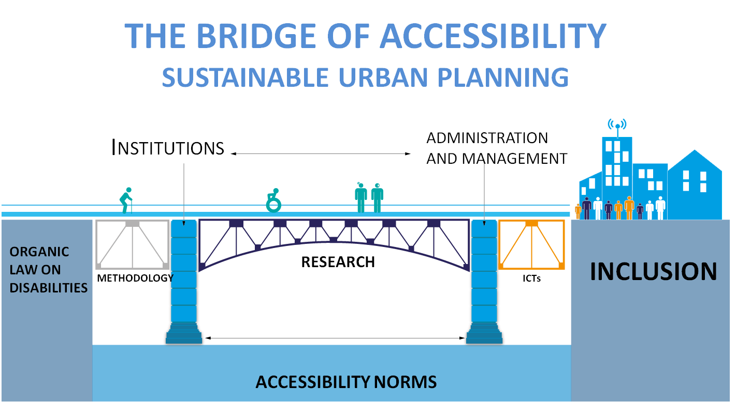

The treatment of persons with disabilities changed radically with the adoption of Ecuador’s new Constitution in 2008. Since then, work has been carried out to provide persons with disabilities with equal opportunities and to improve their living conditions. In addition, the Organic Law on Disability was adopted in 2012, and other national plans and legislation further promoted and protected their rights.

In terms of legislation, Ecuador has taken its biggest step in advocating for the Rights of Persons with Disabilities. In practice, however, an effective inclusion of persons with disabilities required a bridge where national and local governments, civil society, in particular Disable People Organizations (DPOs), and the private sector could join together in the implementation of Universal Accessibility.

The first step was the adoption and adaptation of universal accessibility norms. By 2013, the accessibility regulations only covered the physical standards. By late 2013, 16 norms and standards were introduced in Ecuador, including aspects of information, communication, transportation and technology.

The second step was to address the lack of knowledge about the topic as well as of qualified professionals, which constitute a major obstacle for the advancement in accessibility at a national scope. As a response, SETEDIS created a methodology and an index on accessibility, and built capacity in urban planning and design professionals.

At present, complementary initiatives are being developed, which are based on a cross-sector implementation strategy of public policy, such as:

- incorporating Universal Accessibility and Universal Design into professional curricula;
- providing technical assistance to Decentralized Autonomous Governments on the design and adoption of Ordinances;
- incorporating a chapter on Universal Accessibility into the Ecuadorian Building Standard (NEC), mandatory regulations for the building industry;
- creating an Accessibility recognition seal;
- applying accessibility principles in the e-government project law.

Changes achieved:
The general results reveal a worrying actual scenario in matters of inclusion; also, it is proved that the methodology can be applied in further studies of universal design with minimum adaptations.
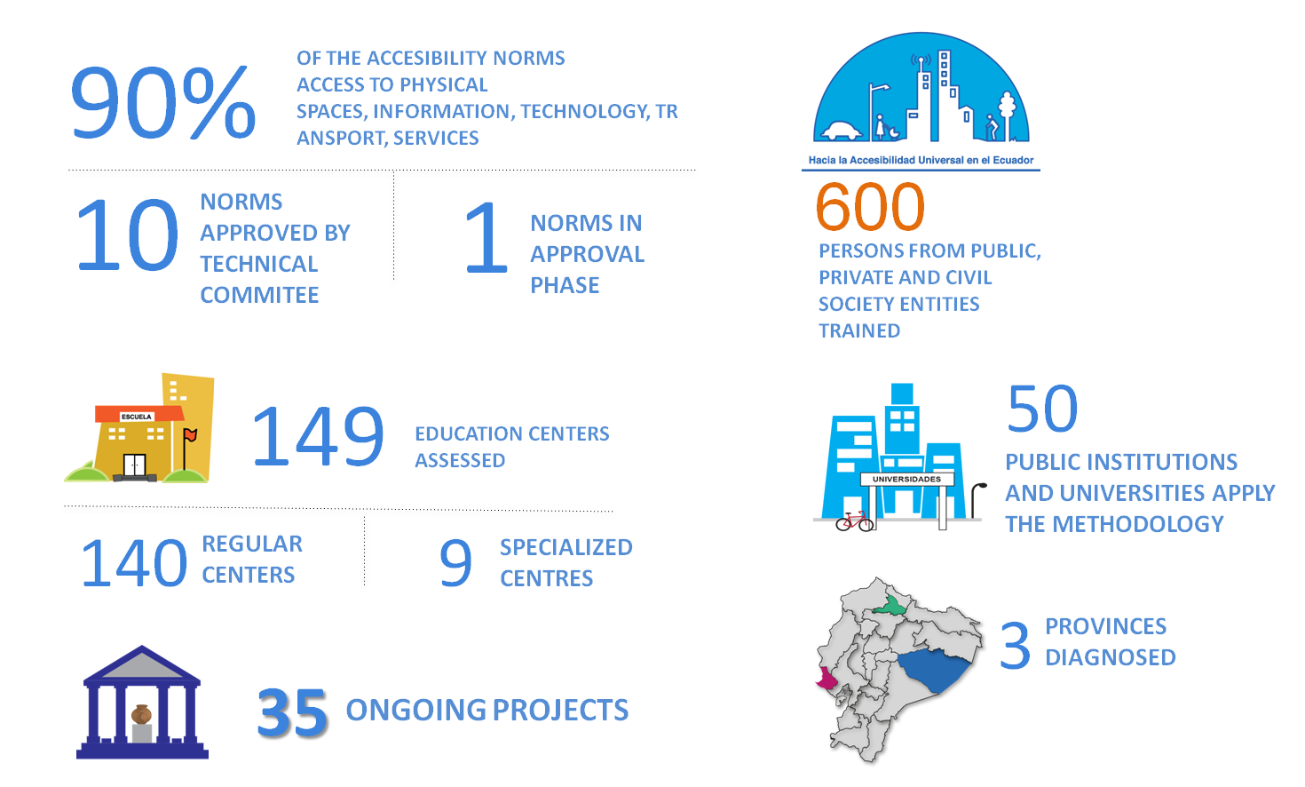
Some of the main achievements are:

Universal access is an issue that cuts across disabilities and sectors, and therefore, constitutes the very basis of empowerment of people with disabilities. The Ecuadorian Universal Accessibility strategy is in line with Participative Inclusion, which has developed 140 intersectorial networks of territorial coordination.
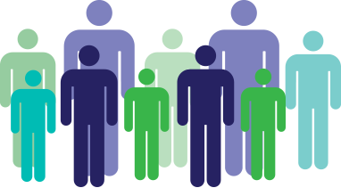
Circuits count with a strategy of Inclusive Community Development
Persons participated in the process
90
64.000
Intersectoral Networks of Territorial Coordination
140
Public and Private Institutions are Part of the Network
500

How change was monitored and evaluated: The application of the methodology allowed to gather national data on universal accessibility. It constitutes the baseline for upcoming evaluations in the implementation of universal adjustment.
The methodology includes an index and three core indicators: safety, autonomy and comfort. During 2014, the methodology with its index was tested and validated in two studies, a study of 149 public schools and an analysis of accessibility in three provinces of Ecuador. Both studies were carried out in a participatory process that took into account users' experiences and opinions.

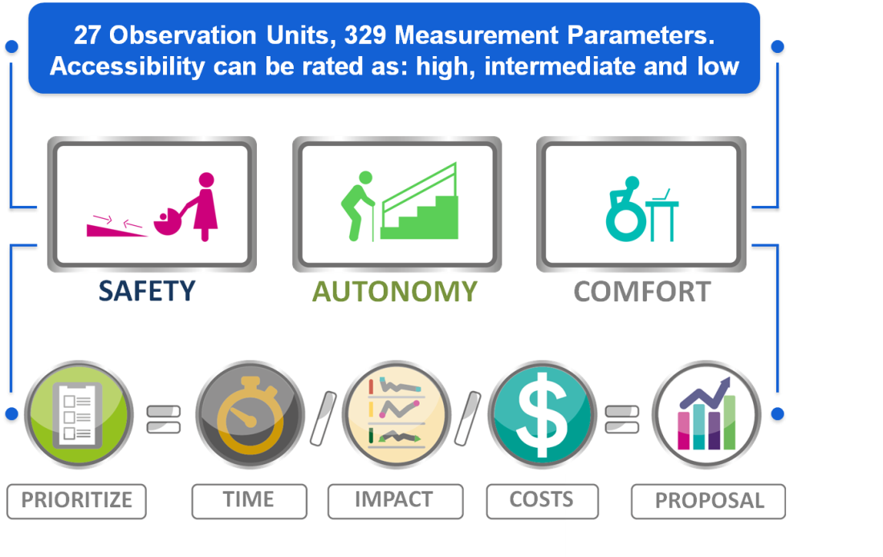

A Principal Components Analysis (PCA) was applied to obtain values and vectors of the sampling covariance matrix, which resulted from the main data matrix. PCA determines the Ecuadorian accessibility index as follows:
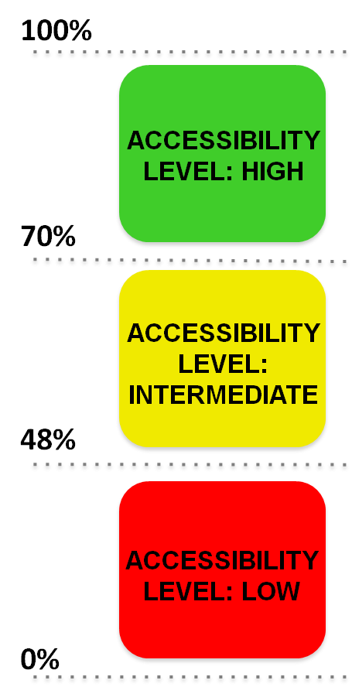

47%
LOW
GENERAL ACCESSIBILITY LEVEL IN ECUADOR

Shortcomings and persistent challenges identified in the implementation of the
project/programme: As a result of the methodology and the studies, resources should be prioritized to make accessibility adjustments in public schools by the Ministry of Education; governmental free service should be created for assessing public and private entities on developing and implementing their own “accessibility plans”, among others.
The main challenge identified is “the mirage of the wheelchair ramp”, universal accessibility is often reduced to describing facilities or amenities to assist people with impaired mobility. The implementation of accessibility adjustments and their proper maintenance requires the development of an accessibility management system by the Decentralized Autonomous Governments and the political decision to mobilize adequate funds.

Contact:
Ms. Maria Daniela Navas Perrone
Technical Secretary for the Inclusive Management on Disabilities, Vice-Presidency of the Republic of Ecuador (SETEDIS)

Email: santiago.santos@setedis.gob.ec

Case study 19: Supporting architects and urban planners to understand accessibility (The Global Alliance on Accessible Technologies and Environments, GAATES)

Name of organization/Government entity: The Global Alliance on Accessible Technologies and Environments (GAATES)
Project/Programme title: GAATES: Supporting architects and urban planners to understand accessibility

Thematic area of good practice example: Urban planning, engineering, architecture – helping design professionals to understand their obligations under Accessibility for Ontarians with Disabilities Act (AODA), Integrated Accessibility Standard (IAS), and specifically, the section on the Design of Public Spaces.

Specific location: Ontario, Canada

Duration of project/programme: The course is ongoing, and once registered, individuals can learn and take the quizzes at their own pace, whenever it is convenient for them. The course is designed to meet the continuing education needs of architects, landscape architects and urban planners, but is open to anyone interested in or working in relation to the accessible design and implementation of public spaces.

Beneficiaries of good practice example: The beneficiaries include all persons of society, but especially persons with disabilities, who will benefit from more accessible and inclusive accessible public spaces.
Implementing agency/agencies: GAATES offers this course in association with the following project partners: Ontario Association of Architects, Ontario Association of Landscape Architects, Association of Registered Interior Designers of Ontario, Ontario Professional Planners Institute, Association of Architectural Technologists of Ontario, and Ontario Association of Certified Engineering Technicians and Technologists.
Source of funds: The development of the Illustrated Technical Guide and the online course were originally funded by the Government of Ontario as part of the Enabling Change programme. The operation of the online course and programme is now self-sustaining.

Brief background to the project: In 2005, the Government of Ontario, Canada passed the Accessibility for Ontarians with Disabilities Act, which aims at improving accessibility standards for Ontarians with physical and mental disabilities. This statute was complex and its content largely unknown to small businesses and in particular to architects, landscape architects, urban planners, engineers and other design professionals.

Overall objectives of the project/programme: The aim of this project is to support architects, urban planners, and engineers as well as small businesses to help them understand their obligations under the Accessibility for Ontarians with Disabilities Act (AODA) and to support them in the implementation process. The GAATES project team, which consists of people with various disabilities, developed a set of publications, a technology vendor database, and learning and reference resources – all written in plain language and accessible online.

Process/strategy to implement the project/programme:
To address the lack of understanding of the new legislation, the project staff have developed a number of publications, an information and communication technology vendor database, as well as learning and reference resources consisting of an online course and an illustrated technical guide. The publications, which are all available in accessible formats, make clear the obligations under the new law. They also show small businesses how to: (i) provide information to their clients in formats that are accessible to everyone; and (ii) communicate with their clients in an inclusive manner. The vendor database gives businesses the opportunity to search for expertise within specific areas regulated by the AODA. For example, if a business looks for a sign language interpreter or a company to create accessible documents, it can use these terms as search criteria, and the database will provide contact information for vendors who can provide the services. The online course, which costs 100 Canadian dollars (approx. US$72), focuses on the AODA Accessibility Standard for the Design of Public Spaces (AODA DOPS) and provides an overview of the obligations of businesses to comply with the AODA-DOPS and the technical requirements of the legislation. The course was developed on a fully accessible learning platform. The various resources and the online course have been developed under the guidance of a steering committee, which represents various professional associations of Ontario and includes persons with disabilities.

Changes achieved:
The various project publications have been downloaded more than 8,250 times.
The ICT vendor database has been accessed about 150 times per month, over 5,000 times to date.
Since the launch of the website, over 175 design professionals have subscribed to it.

How change was monitored and evaluated: The Government of Ontario is responsible for the monitoring of the implementation of the accessible public spaces since they are designed and built as part of ongoing development projects across the province. GAATES continues to provide the ongoing programme support.

Shortcomings and persistent challenges identified in the implementation of the project/programme: The platform on which the course is hosted can be a challenge for navigation for course takers because it is not as intuitive as it could have been.

Other lessons learned: GAATES will continue to offer the various publications free-of-charge through the GAATES website, as well as the for-fee online course. The lessons learned in creating fully accessible publications and a fully accessible online course will be transferred to other GAATES projects.

The Accessibility Standard for the Design of Public Spaces: A GAATES Online Learning Course: http://gaates.org/the-accessibility-standard-for-the-design-of-public-spaces-gaates-online-learning-course/
The Illustrated Technical Guide to the Accessibility Standard for the Design of Public Spaces
Download the Illustrated Guide (PDF format, 75.6 MB) Download PDFORView the Illustrated Guide on the Web
Contact:
Ms. Marnie Peters
GAATES
Ottawa, CANADA
+1 613 725 0566
gaates.marnie.peters@gmail.com

Case study 20: Accessibility, Civic Consciousness, Employment and Social Support for People with Disabilities (Uzbekistan)

Thematic area of the best practice example: promotion of accessibility

Specific location: Uzbekistan: Samarkand, Shakhrizabz and Tashkent

Duration of the project: September 2008 – April 2011

Beneficiaries of the good practice: People with disabilities, the State Committee on Architecture and Construction, the Ministry of Labour and Social Security, local government authorities and DPOs.

Implementing agency/agencies: UNDP with Ministry of Labour and Social Security

Source of funds: Target for Resource Assignments from the Core (TRAC)/UNDP, UNICEF Uzbekistan

Brief background to the project /programme: Among the Commonwealth of Independent States (CIS), Uzbekistan was one of the first to focus on the problem of disability and the first to pass the Law “On Social Protection of the Disabled”, on 18 November 1991, which served as an example for the development of similar laws in other CIS Republics. In July 2008, the Government approved the new version of this law, which includes a detailed description of mechanisms for ensuring the equal rights of persons with disabilities and increases accountability for breaching the law. The new version of the law conforms to the norms and principles of the CRPD, which was signed by Uzbekistan on 27 February 2009. Moreover, in 2002, Uzbekistan developed State Rules and Standards on the Provision of Accessibility for People with Disabilities. Nevertheless, because of physical barriers, access to services and participation in socio-political life were often impossible for people with physical disabilities.

Overall objectives of the project/programme: The overall goal of the project was to widen social inclusion of people with disabilities by increasing public awareness and breaking stigma, improving mechanisms of implementation of national legislation on disability issues, promoting accessibility, and creating a system of social support in the employment of people with disabilities. The specific objectives were to develop by-laws for the enforcement of existing legislation, enhance the capacity of responsible agencies and establish effective monitoring of accessibility systems, as well as to raise awareness of accessibility norms among specialists and the general population.

Process/strategy used to implement the project/programme:
The following activities were undertaken:

- a public awareness-raising campaign to promote a rights-based approach to accessibility, which included the dissemination of posters in social agencies and educational institutions, the placing of banners on streets, and the conducting of TV and radio talk shows, TV broadcasts of social animated films and short documentaries;

- selection by local authorities of 30 pilot public buildings (schools, colleges, hospitals, drugstores, employment services, etc.) in Tashkent, Samarkand and Shakhrisabz to provide full accessibility for people with physical impairments;

- a training programme, including disability equality training, for specialists from the State;

- the Committee on Architecture and Construction and its regional branches (people with disabilities were co-trainers);

- monitoring of accessibility of public buildings (over 2,800 of them) with the participation of wheelchair users;

- support to the development of by-laws related to accessibility issues in the framework of the enforcement of the law on social protection of persons with disabilities in Uzbekistan;

- distribution of 3,000 toolkits on the provision of accessibility among specialists and DPOs.

Changes achieved:
The project has achieved results in the following areas:

Legislation and policies: The Resolution of the Cabinet of Ministers, “On measures of imposing fines to organizations for violation of the legislation on social protection of persons with disabilities”, was adopted on 5 January 2011. It establishes the mechanisms for monitoring accessibility and gives authority to inspectors of the Ministry of Labour and Social Security to impose fines for breaking accessibility standards.

Capacity-building: 143 specialists from the State Committee on Architecture and Construction and its regional branches improved their knowledge and skills on the provision of accessibility.

Accessibility: As a result of monitoring, Accessibility City Guides to Tashkent and Samarkand were developed and published in 2011, which target persons with physical impairments. Also, 28 out of 30 pilot public buildings are now fully accessible for wheelchair users; more than 70 per cent of newly constructed buildings in Samarkand and Shakhrisabz are also accessible.

Shortcomings or persistent challenges identified in the implementation of the project/programme: There are no national standards on accessibility and of information on accessibility in general for persons with different types of impairments, which narrowed the focus of the interventions.

It would have been useful to start developing national accessibility standards, based on international experience, for persons with different types of impairments. Standards of accessibility of information could have been introduced.

Other lessons learned: The raising of awareness on disability issues of specialists working in government agencies led to a sharp increase in the number of newly constructed, accessible buildings. Presentations made by persons with disabilities on the impact of physical barriers on their lives helped change people’s understanding of the issue.

Contact:
Dr Yana Chicherina, “Inclusive Employment and Social Partnership” Project Manager. Skype:
yana_chicherina; e-mail: yana.chicherina@undpaffiliates.org.
Ms. Aziza Umarova, Head of Good Governance Unit, UNDP Uzbekistan.
E-mail: Aziza.Umarova@undp.org; tel.: +998 71 1203459/64.

Case study 21: League of Accessible and Historical Cities (Italy, Denmark, France, Spain, Bulgaria)

Name of organization/Government entity: European Foundation Centre

Initiative selected as good practice example: League of Accessible and Historical Cities (LHAC)

Thematic area of good practice example: Accessibility in Historical Cities

Specific location: Italy, Denmark, France, Spain, Bulgaria

Duration of project/programme: 2010-2015

Beneficiaries of good practice example: The project benefits all people with disabilities, especially tourists travelling with their families and friends. It goes even further by benefitting all people living in these historical cities, as well as people with a temporary disability, the elderly people, parents with strollers, among others.

Implementing agency/agencies: European Foundation Centre – coordinating organization

City/country implementing organization:
Avila (Spain) – Fundación ONCE;
Lucca (Italy) – Fondazione Banca Monte di Lucca;
Mulhouse (France) – Fondation Réunica, Fondation de France, Centre Français des Fonds et Fondations;
Torino (Italy) – Fondazione CRT;
Viborg (Denmark) – Realdania Foundation, Bevica Foundation, The Danish Disability Foundation and The Labour Market Holiday Fund;
Sozopol (Bulgaria) – Sozopol Foundation

Source of funds: The financing of the project comes from six foundations, which invested over EUR 7 million in total in the six historical cities where the project has been implemented.

Brief background to the project: The project aims at allowing all people with disabilities and others to fully enjoy leisure and cultural activities, and at stimulating tourism among the 80 million people with disabilities living in Europe. From this point of view, the project is therefore expected to contribute to the cities´ long-term cultural and social development. Improved access to a city’s cultural heritage makes it more dynamic and attractive to its residents and tourists, and thereby increases its economic profit

Overall objectives of the project/programme: The League of Accessible and Historical Cities (LHAC) project is implemented in six cities with the aim of improving the accessibility of historical towns in Europe for all. Being a replicable model, it promotes the development of responsible tourism and the protection of historical heritage at a larger scale.

Process/strategy to implement the project/programme: The project is based on a common methodology and framework provided by a technical accessibility consultancy. In addition, each city had to face its own specificities, legislations, partners and finances. All of these characteristics led to different approaches adopted by each Foundation leading in each city and to a method, which greatly enriched the project and facilitated mutual learning.

The common element revolves the idea of fully accessible routes that were implemented in each city. The routes include parks, restaurants, shops, tourist information centres and link some of the outstanding heritage sites, museums, buildings and other features of the cities by means of a continuous, signposted, pedestrian pathway provided with interpretive information about the places which are encountered on the route. Although creating an accessible route is to be considered as a goal in itself, it represents only a part of a larger process to ensure a wider accessible urban environment. The LHAC is based on a philosophy that embraces the strength of mutual learning as a way to overcome difficulties.

The network acts as a hub for good practice exchange among the foundations and the cities involved. The project therefore focuses not only on the development of innovative solutions, but also on the creation of new forms of interactions to tackle a complex social issue such as the equal and full participation of people with disabilities in society. As a result, a European network has been created, which goes beyond the mere sharing of information by acting jointly with several European countries.

Changes achieved: The LHAC serves as example for other cities willing to improve accessibility. A best practice guide has been published as a tool for actors and stakeholders in other historical cities – including foundations, public authorities, chambers of commerce, tourist destination managers, heritage associations, disability organizations and others – who are interested in exploring and examining the possibility of establishing similar accessible routes.

How change was monitored and evaluated: Extensive evaluation is available at: www.lhac.eu/resources/toolip/doc/2015/07/23/evaluation-last-version-excel.pdf

Shortcomings and persistent challenges identified in the implementation of the project/programme: The main obstacle is still the lack of a common European regulatory framework that defines accessibility standards.

Other lessons learned: An important result of this project is that this collaboration sparked another project that has been founded by the European Commission: Three foundations have been collaborating with other organizations (mainly local and regional autorities and travel agencies) to develop the STRING PROJECT (Smart Tourist Routes for Inclusive Groups (http://www.stringbox.eu/en/). However, there is the possibility based on the foundations’ interest to start new collaborations based on this model and to strongly tackle other issues that will complement the itineraries (e.g. accessibility in museums).
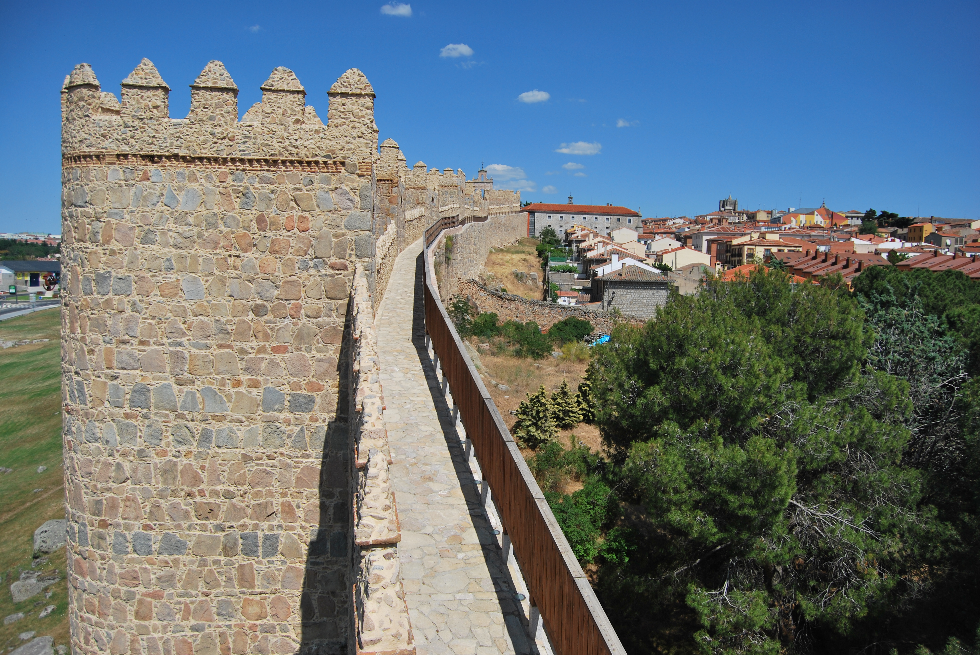
Contact:

Balmas Silvia
sbalmas@efc.be

European Foundation Centre, Belgium
www.efc.be

Case study 22: Aha! (Accessibility Help & Advice), Mapathon of accessible places and inclusive customer service workshops (Canada)

Name of organization/Government entity: Inclusive Design Research Centre, OCAD University and AXS Map

Thematic area of good practice example: Wayfinding, Education and Awareness, Community and Youth Engagement, Crowdsourcing

Specific location: Multiple locations globally, see www.axsmap.com

Duration of project/programme: Ongoing since 2012

Beneficiaries of good practice example: Persons with disabilities, businesses, public venues, youth, community members, tourists and travellers

Implementing agency/agencies: Inclusive Design Research Centre, AXS Map, school boards, community organizations

Source of funds: The Government of Ontario

Brief background to the project: A first step to creating accessible urban spaces is general awareness of accessibility principles and an understanding of the benefits of inclusive design within a community. Aha! provides training and resources to businesses on how to become accessible. A primary outreach technique is mapathons that use the AXS Map application.

AXS Map is a web and mobile mapping database that invites community members to share reviews on the accessibility of businesses and places. The database is populated in part through community events called Mapathons, in which teams canvas neighbourhoods to identify the accessibility of all businesses and public spaces. The Aha! mapathons are often used as experiential learning for school children.

The Mapathon community events spark a culture shift within a community, maps out accessible businesses and venues for persons with disabilities, provides incentives for businesses that make accessibility improvements, educates business owners and encourages continuous improvement on the part of property owners and managers.

Overall objectives of the project/programme:

- To provide persons with disabilities with information about the accessibility of businesses and other public spaces.

- To educate business owners and property owners regarding strategies and benefits of inclusion.

- To provide incentives for continuous improvement of accessibility within a community.

- To raise awareness of accessibility among school children, thereby encouraging a culture shift.

- To connect communities globally in the collective effort of inclusive design of urban spaces.

Process/strategy to implement the project/programme: The Aha! project was implemented by a diverse team of students who organized mapathons throughout Ontario, Canada. The team used the mapathon opportunity to educate participants about accessibility and inclusion and to engage business owners in discussions and workshops on accessibility. Materials for workshops were developed by stakeholders.

Changes achieved: Aha! has created the most successful mapathon, and AXS Map has over 100,000 businesses mapped around the globe.

How change was monitored and evaluated: Usage metrics gathered on the AXS Maps site, as well as qualitative and anecdotal data gathered during Mapathons and aha! workshops are being used to monitor and evaluate outcomes.

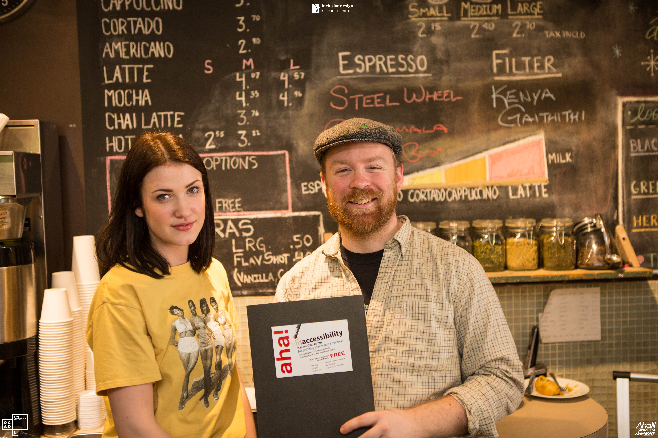

Shortcomings and persistent challenges identified in the implementation of the project/programme: While the programme addresses the accessibility of businesses and public spaces, the accessibility of the urban infrastructure (sidewalks, roads, etc.) can continue to cause barriers to access. The aha! mapathons reveal that there are many misconceptions about accessibility and persons with disabilities. There appears to be a common resistance to accessibility compliance even if there are building codes and laws related to accessibility.

Other lessons learned: School children are ideal ambassadors for inclusive design. In talking to businesses they are persuasive and disarming educators and see accessibility as a non-optional common goal. Engaging the larger community in reviewing accessibility creates community investment in the effort. Linking communities globally in a common map and database elicits community pride. Small business owners are more responsive to training at their premises.

Contact:
Inclusive Design Research Centre, OCAD University, info@idrc.ocadu.ca
Prof. Jutta Treviranus, Director, jtreviranus@ocadu.ca
Dr. David Pereyra, aha! Project Coordinator, dpereyra@ocadu.ca

Case study 23: The Forum “One Quarter for All” (Germany)

Name of organization/Government entity: Civil Society Initiative “Q8: Eine Mitte für Alle ”

Thematic area of good practice example: Inclusive Urban Development

Specific location: Hamburg-Altona, Germany

Duration of project/programme: 2012 - open-ended

Beneficiaries of good practice example: Future accommodation/facility users

Implementing agency/agencies: Civic initiative started by “Q8”, an activity of “Evangelische Stiftung Alsterdorf”

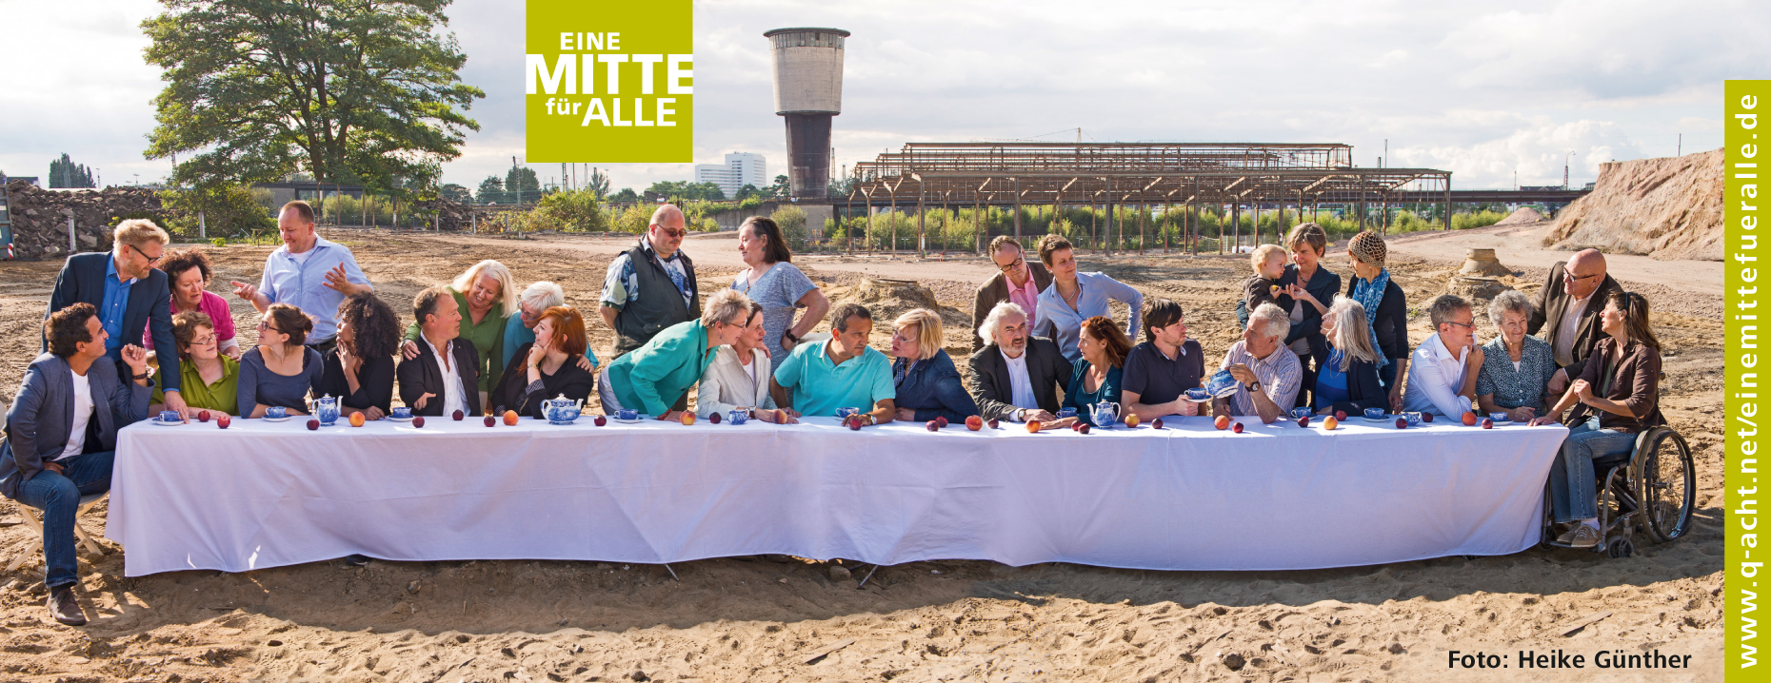

Brief background to the project: The newly developing quarter Mitte Altona is Hamburg’s second-largest urban project and comprises 3,500 flats in a central location. In 2012, when the plans gained more public attention, the Forum decided to pursue an ambitious goal: to develop this project as the first inclusive quarter in Hamburg.

Overall objectives of the project/programme: How to develop a quarter in which everyone is an inclusive participant? How to mould the quarter’s conditions in such a way that all persons are part of local life and obtain the support they require? How to include all-encompassing accessibility as a planning criterion for the new quarter? With these questions the civic initiative started the project in order to elaborate responses and solve possible problems before they occur.

Process/strategy to implement the project/programme: With the support of the Q8 initiative participants from the community, politics, administration, religious communities, associations, foundations, local initiatives and joint building ventures established the Forum, One Quarter for All. It developed 30 goals and associated recommendations for inclusive architectural and urban development. The functioning of the Forum and its working results reflect a systematic and exemplary combination of a bottom-up process with the aims of the United Nations Convention on the Rights of Persons with Disabilities.

Changes achieved: The informal, highly efficient project One Quarter for All triggers a new approach for politics and administration in Hamburg in favour of social inclusion in urban development. The project has shown a demonstrable effect: politics and administration have adopted the initiative’s postulations. One Quarter for All is recommend in the current Hamburg state government programme to be employed in the future as best practice for all larger development projects in the city state.

How change was monitored and evaluated: The Forum significantly contributed to the achievement that inclusion has been made an important component of the city’s development contract with the investors within the Mitte Altona project.

In 2013, One Quarter for All was bestowed the Senator-Neumann Award for “outstanding and innovative projects promoting an inclusive society”. Within the framework of the zero project conference on the issue of political participation and self-determined life in 2015, the Forum was selected as one of the 30 ‘innovative practices’.

Shortcomings and persistent challenges identified in the implementation of the project/programme: One Quarter for All is breaking new ground in the rarely explored field of inclusive urban development. In this areas it encounters topics that require new approaches from the ground up to be further engineered together with all stakeholders involved in the quarter’s development.

Other lessons learned: Comprehensive, circumspect and constructive collaboration with citizens, politics, local institutions, economy and administration is of paramount importance for success in the creation of a really inclusive quarter.

Contact:
Forum Eine Mitte für Alle
Mail: c/o Q8, Ms Agathe Bogacz
Max-Brauer-Allee 50, 22765 Hamburg
+ 49 40 35748153
a.bogacz@q-acht.net
www.q-acht.net/eine-mitte-fuer-alle.html

Case study 24: Help me help you: accessibility of public services (Israel)

Name of organization/Government entity: Access Israel

Thematic area of good practice example: Accessibility of public services

Specific location: Israel

Duration of project/programme: 2010-2016

Beneficiaries of good practice example: The programme promotes better service for residents with all kinds of disabilities, by exposing municipality personnel to the world of persons with disabilities, including accessibility arrangements within the organization, in order to provide equal and accessible services.

Implementing agency/agencies: Access Israel’s Accessibility Training Department

Source of funds: The Project is funded partially by the Municipality (25%) and the rest (75%) subsidized by the Ministry of Welfare and/or Philip Morris Corp.

Brief background to the project: Under Israeli regulation, every municipality is required to provide its staff with accessible service training, in which they are educated about disabled people in general, and gain knowledge and practical skills in accessible service. However, local authorities in Israel do not have the financial resources and the knowhow to do this.

Overall objectives of the project/programme: The Programme provides the municipality service providers with tools on how to assist people with disabilities and offer accessible service, allowing persons with disabilities to receive the service offered by the municipality with dignity, equality and independence. The advantage of the Project is its immediate effect on the quality of accessible service granted in the municipality.

Process/strategy to implement the project/programme: Access Israel developed a unique model for training towards accessible service. This includes a preparatory session, a tour of the accessibility in municipality’s jurisdiction and a survey of accessibility-related complaints within the authority. These activities are followed by a one-day seminar in which participants meet people with various disabilities, learn about the authority's accessibility resources and acquire tools necessary to perform various services. Participants then experience and feel what it is like to "walk in a disabled person's shoes" in a participatory way, following an interactive lecture about specific local adaptations, simulations of accessible service, performed by instructors with disabilities, whereby service providers are given immediate and practical tools to provide accessible services.

This unique project succeeds, at a low cost, in equipping service providers with professional tools tailored to their specific local authority, which have shown immediate improvement of quality of service. This is a stigma-breaking programme, generating dialogue between residents with disabilities and service providers in the authority. Having persons with disabilities as instructors helps create a positive perception and understanding of the capability of persons with disabilities, promoting equal and respectful integration.

Changes achieved: The project proved highly successful in local authorities who had adopted the programme and provided the workshop. Feedback from these local authorities show that staff views of persons with disabilities have shifted, and new accessibility protocols and arrangements were developed and put in place for residents with disabilities. Having exposed workers to the value of inclusion, the project has opened the door to other inclusive ventures.

How change was monitored and evaluated: Participants fill out a simple survey on the project. Access Israel keeps in touch with the municipalities and is able to follow-up on the positive effects of the programme. Several municipalities were satisfied with it and requested additional workshops.

Shortcomings and persistent challenges identified in the implementation of the project/programme: Many municipalities showed reluctance at first in enabling the initial meeting and survey of the municipality with a focus on disabilities, afraid to open a Pandora’s box of complaints and have to deal with stigmas. In addition, regardless of the success of those who participated, only 45 municipalities have participated from more than 300 municipalities in Israel - funding and prejudice prove to be the biggest obstacles.

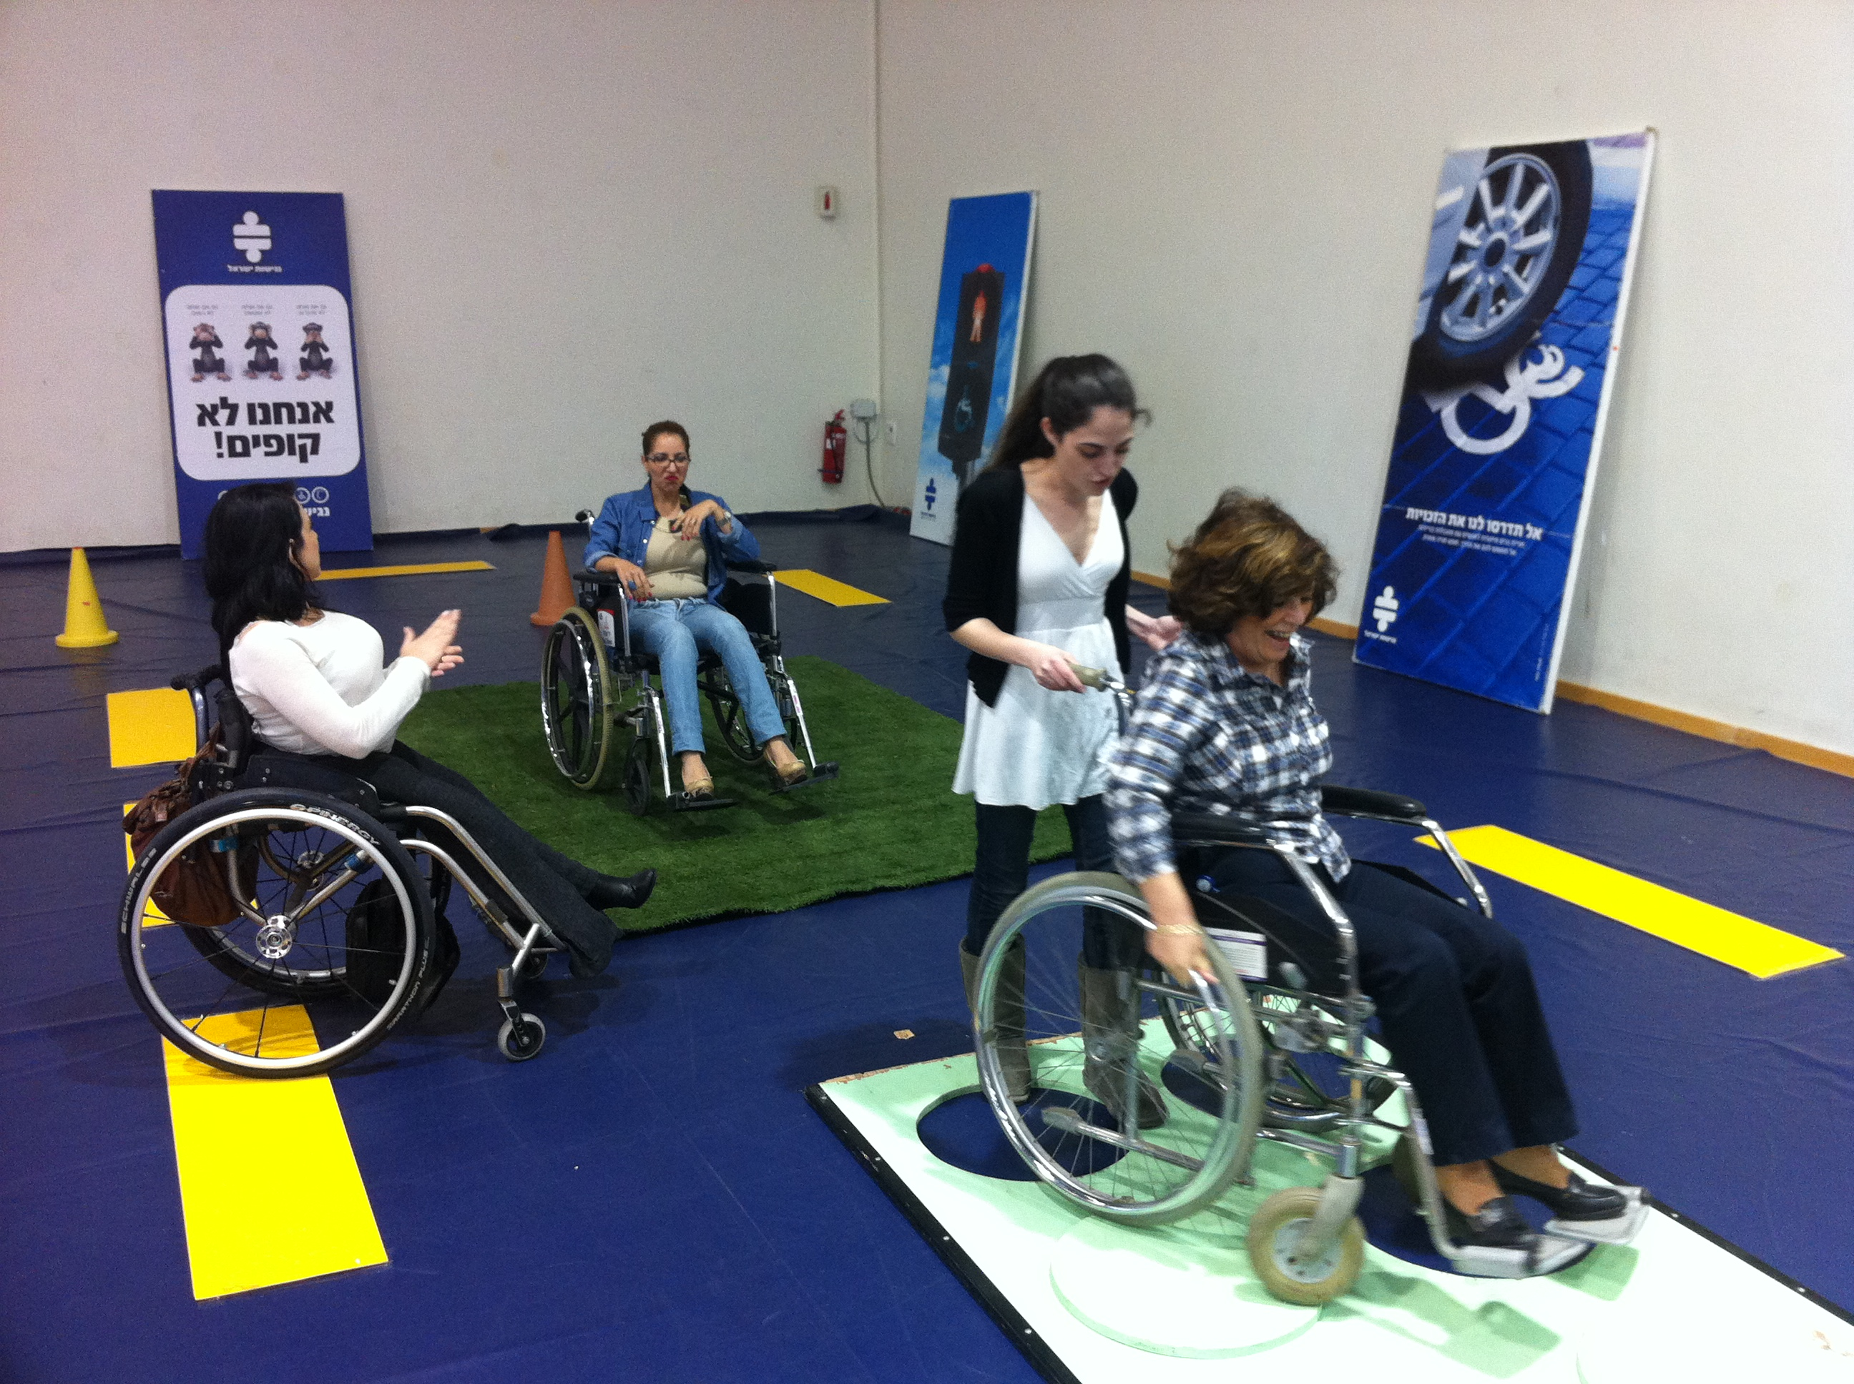

Other lessons learned: Breaking the Glass Ceiling is not a cliché; it is reality. This project reflects a shift in views among service providers in all areas of service within the local authority, improving service to disabled people as well as to the entire population. In local authorities where the project was implemented, disabled people have been greatly empowered when integrated as instructors, leading rather than being led.

The project has created a real buzz and became popular because of the extremely positive reactions received by those who have participated in these programmes. The budget is being reduced by including more local persons with disabilities in the programme.

Contact:
Mr. Or Cohen
Access Israel
Or@aisrael.o

Final words:Promoting accessibility as a public good, building sustainable and inclusive urban development for all∗

“The most difficult barrier to overcome is the human attitude. Attitude of human being make the world inaccessible… Change the discriminatory mentality toward a culture of inclusion and accessibility is imperative for an agenda of true urban development.”

Lenin Moreno, Special Envoy on Disability and Accessibility (Ecuador), message delivered at the Forum on Disability Inclusion and Accessible Urban Development, Nairobi, 28 October 2015.

After more than 30 years of normative guidance on the central role of accessibility of the general systems of society in promoting equalization of opportunities for persons with disabilities, the question arises as to why accessibility in the built environment, in transport and public accommodations and in information and communication technology is not yet the “new normal”. Rather, environmental accessibility is most often – but not always – a product of regulation, administrative guidance or judicial actions.

Accessibility following the principles of universal design refers to solutions that are intuitive to use, require little effort and respond to needs, interests and capabilities of a wide-range of end users, equally – persons with disabilities and non-disabled persons alike. Accessibility solutions are efficient in that one set of designs or procedures are produced to respond to a wide-range of expected end-user needs, interests and capabilities; they generally involve end-user input on performance requirements and build on feedback on actual usage from diverse communities of interest. Accessibility solutions are cost-effective in that designs generally do not require costly retrofitting to respond to new accessibility requirements; end-user feedback contributes to solutions that deliver enhanced accessibility and usability as required.

Accessibility solutions built upon basic concepts and principles of universal design may not always reflect a strict universal design construct. This distinction can be seen by recalling the basic concepts of universal design:
(a) Equitable use: the design is useful and relevant to a wide group of end-users;
(b) Flexibility in use: the design accommodates a wide range of individual preferences and abilities;
(c) Simple and intuitive use: the design is easy to understand regardless of the knowledge, experience, language skills or concentration level of the end-user;
(d) Perceptive information: the design communicates information effectively to the user regardless of the ambient condition or the sensory abilities of the end-user;
(e) Tolerance for error: the design minimizes the hazards and adverse consequences of unintended actions by the end-user;
(f) Low physical effort: the design can be used easily, efficiently and comfortably with a minimum of fatigue;
(g) Size and space: the size and space for approach, reach, manipulation and use should be appropriate regardless of the body size, posture or mobility of the end-user.

While universal designs provide intuitive ease of use and allow for end-user error, they do not specifically and fully address the provision of accessibility for a diverse range of end-users as set forth in Article 9 (Accessibility) of the Convention on the Rights of Persons with Disabilities.

This publication aims to illustrate good practices and present options for promoting environmental accessibility in the context of urban development. It is premised on the notion that environmental accessibility is a member of the set of global public goods and not a defined benefit for specific members of the population. Once provided, no one person can be excluded from accessible environments. The benefit that any one end-user can experience from accessible environments, urban infrastructure or information and communication technology does not diminish opportunities for others to enjoy the “ease and flexibility” of accessible environments.

Addressing environmental accessibility as an issue in the provision of a global public good in the context of development would move budget debates from questions as to how to, and who should fund disability-specific and accessible infrastructure and services, on to decisions about maximizing public welfare and levels of living within available resources for urban development.

It is possible to cite a number of examples of accessibility that are good practices in daily life, from small appliances, to larger and essential technologies and public infrastructure. A number of factors have been identified with the increase in the production of accessible designs: the gaining of a market share among under-served populations; pre-emptive responses to forthcoming regulatory actions; the growing use of mobile access to information and communication technologies, which requires efficient and usable designs with increasing accessibility to capture and retain an extensive range of end-users; and population ageing, which has been accelerating globally.

An everyday example of accessibility can be found in digital rice cookers produced by the Toshiba Corporation: the user interface is in English and also in braille. The devices are on offer at Toshiba dealers and do not involve an extra visit to service organization for the visually impaired, since the Braille option is a given, not an extra charge.

The example of the above approach needs to be scaled up for many more small appliances. To achieve this, appliance producers need to think of opportunities of meeting under-served consumers with accessible interface options.

In the field of technology, a major development is the decision by Internet browser software publishers to include – at no charge – the option to increase the size of content displayed. Previously, such a capacity was an extra-charge item for end-users who were unable to work with a conventional display. Experience suggests, however, that accessible information and communication technology is always ‘under construction’: the rapid pace of developments in Internet-enabled services and content can often present challenges to end-users who may have sensory, physical or intellectual impairments. Often, regulatory or administrative guidance is required to ensure content developers and service providers respond to recognised standards for accessible information and communication goods and services, many of which have been developed by the World Wide Web Consortium (W3C).

Experience also suggests that designs providing accessible environments and facilities require both post-occupancy surveys to ensure that standards employed respond to actual end-user needs, and periodic monitoring in the light of changing technologies, end-user characteristics or service expansion. There are many examples that illustrate the cost-implications for post-construction as shown in two examples below. The first is of the United Nations House in Beirut, which houses both the United Nations Regional Economic and Social Commission for Western Asia and a number of United Nations system representative offices. The house was constructed in the late-20th century, together with the redevelopment of the Beirut Central Business District, as an accessible facility. However, post-occupancy surveys found areas, particularly for ease of entry and exit, where applicable standards did not produce accessible solutions for local users; retrofits were budgeted and implemented to meet actual end-user accessibility needs.

The second example is of the late-20th century urban infrastructure related to the Skytrain system of Bangkok, Thailand. At the time of design and construction, developers provided only limited access to Skytrain stations by lift; passengers with mobility issues and parents with children in strollers were at a severe disadvantage in using this quick and efficient transport system. Interested civil society organizations soon took the case of unequal access to the court system and recently won a judgment that Skytrain must provide ease of access at all current and planned stations, which is currently being undertaken at considerable costs. At the initial design stage, developers argued that the available budget did not allow for provision of lifts at all stations; a decision was made to provide lifts at a limited set of stations, mainly with high-levels of tourist traffic. In essence, the Skytrain management at the time applied a classic corner solution to facility use and access rather than construct an appropriate welfare function that would maximize benefits for a wide range of potential end-users.

The above examples, and indeed the case studies illustrated in this publication, demonstrate that accessibility is and shall be regarded and promoted proactively as a public good and a framework for efficient solutions in the context of inclusive and sustainable urban development.

The World Urbanization Prospects (2014). United Nations Department of Economic and Social Affairs.
“Accessibility”, in this publication refers to a feature or quality of any physical or virtual environment, space, facility or service that is capable of accommodating the needs of users of varying abilities or disabilities to understand, get access to or interact with. Accessibility also refers to technical standards that are mandated nationally or internationally for the design and construction of a physical or virtual environment, space, facility and service.
The European Union and 166 countries are currently States Parties to the CRPD. According to the Convention on the Rights of Persons with Disabilities, Article 2, “Universal design” means the design of products, environments, programmes and services to be usable by all people, to the greatest extent possible, without the need for adaptation or specialized design. “Universal design” shall not exclude assistive devices for particular groups of persons with disabilities where this is needed.
As of 15 July 2016, there are 165 States and European Union party to the Convention.
Convention on the Rights of Persons with Disabilities, Article 4 – General obligations
Ibid., Article 9.
Transforming Our World: The 2030 Agenda for Sustainable Development. Available at https://sustainabledevelopment.un.org/content/documents/7891Transforming%20Our%20World.pdf
UN Secretary-General’s Special Envoy on Disability and Accessibility, 8th session of the Opening Working Group of the General Assembly on the Sustainable Development Goals, February 2014.
Secretary-General’s Bulletin on Employment and accessibility for staff members with disabilities in the United Nations Secretariat (ST/SGB/2014/3).
The World Bank (2008). Design for All: Implications for Bank Operations. http://siteresources.worldbank.org/DISABILITY/Resources/Universal_Design.pdf
Ratzka.Report of the CIB Expert Seminar on Building Non-Handicapping Environments (Budapest, 1991). www.independentliving.org/cib/cibbudapest28.html.
The World Bank (2008). Design for All: Implications for Bank Operations.
Murray, B. (2012). Brief profile on people with disabilities. Employment for social justice and a Fair globalization paper. International Labour Office, Geneva. www.ilo.org/employment/Whatwedo/Publications/WCMS_140958/lang--en/index.htm
According to General Comment No. 2 that was issued by the Committee on the Rights of Persons with disabilities, States parties have obligations, under the Convention, to adopt, promulgate and monitor national accessibility standards; to establish minimum standards for the accessibility of different services provided by public and private enterprises for persons with disabilities with different types of impairments; when reviewing their accessibility legislation, States Parties must consider and where necessary amend laws to prohibit discrimination on the basis of disability and to consider their laws on public procurement to ensure that their public procurement procedures incorporate accessibility requirements; States Parties should also adopt action plans and strategies to identify exiting barriers to accessibility, set time frames with specific deadlines and provide both the human and material resources necessary to remove the barriers, among others.
UNDESA/DSPD Forum: Disability Inclusion and Accessible Urban Development, Nairobi, 28-30 October 2015.
CRPD/C/GC/2. https://documents-dds-ny.un.org/doc/UNDOC/GEN/G14/033/13/PDF/G1403313.pdf?OpenElement
UNDESA. 2011. Best practices for including persons with disabilities in all aspects of development efforts; Australian Agency for International Development. 2008. Development for All: Towards a disability-inclusive Australian aid program 2009-2014, Canberra, AusAID; European Disability Action for Mainstreaming Assessment Tool: A Practical Tool for Effective Disability Mainstreaming in Policy and Practice, Leonard Cheshire International, 2006; Swedish International Development Cooperation Agency (SIDA). 2009. Human Rights for People with Disabilities: Sida’s plan for work; Lord, Janet et al., 2010. CRPD and WHO. 2009. Disability and International Cooperation and Development: A Review of Policies and Practices, World Bank; Mainstreaming Disability in MDG Policies, Processes and Mechanisms: Development for All, report of the Expert Group Meeting, organized by the Secretariat for the CRPD, Division for Social Policy and Development, DESA in collaboration with the World Health Organization (WHO), April 2009; NORAD. 2011. Evaluation of Norwegian support to promote the rights of persons with disabilities, inception report, draft version, October 2011; Priestley, M. 2009. Targeting and mainstreaming disability in the 2008-2010 National Strategy Reports for Social Protection and Social Inclusion, University of Leeds; United Nations. 2010. UN Expert Group Meeting on Accessibility: Innovative and cost-effective approaches for inclusive and accessible development, June 2010; UNNATI (Organisation for Development Education). 2011. Realising UNCRPD: Learning from Inclusive Practices: Case Studies in Education and Employment; Voluntary Service Overseas (VSO). 2006. A Handbook on Mainstreaming Disability.
Flywheel is an e-Hail application available at: www.flywheelnow.com.
E-hailing is the process of ordering any form of transportation pick up via virtual devices: computer or mobile device.
∗ Special appreciation goes to Mr. Clinton E. Rapley, Director of Planning Services, Associates for International Management who shared inputs at the DESA-UN Habitat Forum on Disability Inclusion and Accessible Urban Development, Nairobi, 28 October 2015. World Programme of Action concerning Disabled Persons, United Nations General Assembly Resolution, (A/37/351/Add.1 andAdd.1/Corr.1, Annex).
Report. International Seminar on Environmental Accessibility, Beirut, 30 November - 3 December 1999 (United Nations document: E/ESCWA/HS/2000/1), p. 4.
General Assembly Resolution 61/106, annex.
The World Wide Web Consortium (W3C) is an international community that develops open standards to ensure the long-term growth of the web: www.w3.org.

