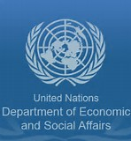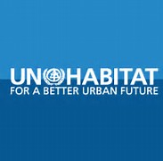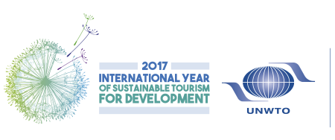
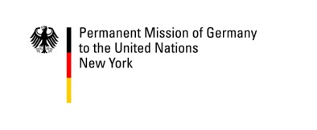
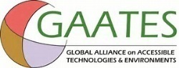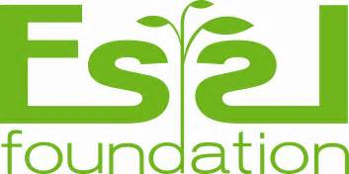

FORUM ON
ADVANCING ACCESSIBLE AND INCLUSIVE URBAN DEVELOPMENT FOR ALL
UNDESA/DSPD & UN Habitat III Secretariat

Conference Room 12, United Nations Headquarters, New York
14 June 2017, Wednesday, 3-6pm

Concept Note

Urbanisation is one of the most important global trends of the 21st century. According to the United Nations, by 2050, about 6.25 billion people, or 66 percent of the world population, will be living in urban areas.

Through the adoption of the 2030 Agenda for Sustainable Development (SDGs) and the New Urban Agenda, the international community recognises the importance of accessibility in the urban contexts and of giving particular attention to addressing multiple forms of discrimination faced by, inter alia, persons with disabilities, older persons and other social groups who often experience disadvantage and exclusion partly due to lack of environmental accessibility in urban and rural settings. This has been a major challenge to the achievement of accessible, inclusive and equitable urban development, as well as the full enjoyment of human rights by persons with disabilities.

As Member States are now taking actions to implement the SDGs and the New Urban Agenda, there is an urgent need to go beyond the level of existing normative frameworks, to fully appreciate and capture the socio-economic benefits of universal design and accessibility, so as to better inform and improve urban policy and practices and to galvanise the efforts from both public and private sectors in the sectors.
In conjunction with the 10th Session of the Conference of States Parties to the Convention on the Rights of Persons with Disabilities and prior to the High Level Meeting of the President of General Assembly on the UN Habitat, the UN Department of Economic and Social Affairs ( through its Secretariat for the Convention on the Rights of persons with disabilities of Division for Social Policy and Development) and the Habitat III Secretariat, in collaboration with their global partners, will organize the Forum to follow up its High Level Forum on Disability Inclusion and Accessible Urban Development (Quito, Oct 2016) in New York on 14 June 2017, with aims to make a contribution to the implementation of the New Urban Agenda from a perspective of accessibility and inclusion of persons with disabilities, older persons, children and other vulnerable social groups.
The Forum will bring together experts, urban policy-makers and practitioners from Governments, including local authorities, UN system and civil society active in both urban sectors and disability communities, especially organisations representing persons with disabilities and older persons and will (1) discuss and share expertise and experience in promoting universal design and accessibility, including through taking an integrated approach and capturing socio-economic benefits of accessibility in urban development contexts; (2) generate a set of recommendations for actions and partnership at the global and local levels for the implementation of the New Urban Agenda and the SDGs and for the promotion of accessible and inclusive urban development for all.

Organisers, cosponsors and participants
The UN Department of Economic and Social Affairs ( represented by the Secretariat for the Convention on the Rights of Persons with Disabilities, Division for Social Policy and Development ), the Habitat III Secretariat/UN Habitat , with the co-sponsorship and support from UNWTO, UNESCAP, the Habitat General Assembly of Partners, Global Alliance on Accessible Technologies and Environments, International Transport Forum (OECD), Rehabilitation International, Essl Foundation, FIA Foundation and Governments of Ecuador, Germany, Singapore and Oslo City as well as New York City.
The meeting welcomes all delegations, UN agencies, international organisations, think tanks and development practitioners who are interested in urban planning and development and disability issues to participate the meeting.

Working language and accessibility arrangements
The United Nations secretariat and the hosts of the meeting commit to making the meeting to be accessible to all participants. In this regard, real time closed captioning will be provided on demand and sign language interpretation may be provided when requested in advance of the meeting. English will be the working language of the Forum.
Contact
Secretariat for the Convention on the Rights of Persons with Disabilities via email enable@un.org, zhangg@un.org and visit the UN ENABLE website www.un.org/disabilities for further details about the Conference of States Parties and the Forum.

United Nations (2014). World Urbanization Prospects: The 2014 Revision. New York: Department of Economic and Social Affairs, ST/ESA/SER.A/366.
Transforming our world: the 2030 Agenda for Sustainable Development, Goal 11
New Urban Agenda, paragraph, paragraph 20, 36.
Designing for accessibility is designing for the widest range of abilities of people in the widest possible range of situations. “Accessibility” in this document refers to a feature or quality of any physical or virtual environment, space, facility or service that is capable of accommodating the needs of users of varying abilities to understand, get access to, or interact with.
“ Universal design” means the design of products, environments, programmes and services to be usable by all people, to the greatest extent possible, without the need for adaption or specialised design. ( Article 2, Convention on the Rights of Persons with Disabilities)
173 countries and European Union ratified the Convention.
Illustrated examples can be found in some studies such as those contained in UN publication titled “ Good Practices of Accessible Urban Development: Making urban environments inclusive and fully accessible to All ( ST,ESA/364, New York, October 2016)

