**

**REPUBLICA DEL ECUADOR**

**MISION PERMANENTE ANTE**

**LAS NACIONES UNIDAS**



Barbados

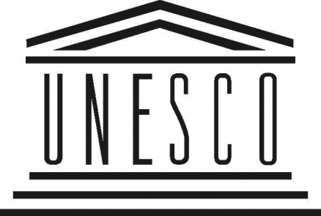

**UN DESA**

*INVITATION*

**DESA/DSPD Forum on Disability and Development**

**Operationalizing the Post-2015 Development Agenda for Persons with Disabilities**

United Nations Headquarters New York

Conference Room 6 (TBC) | 12 June 2015 | 10 am – 1 pm

|  |  |
| --- | --- |
| As the 2015 deadline for the Millennium Development Goals draws closer, the international community is finalizing a post-2015 development agenda. The emerging agenda will include the Sustainable Development Goals and the recently adopted Sendai Framework for Disaster Risk Reduction 2015-2030 among others.  The Forum will brainstorm on issues and strategies to overcome challenges and to further mainstreaming of disability in global development agenda beyond 2015, with its focus around two specific topics: 1) disability-inclusive disaster risk reduction and humanitarian response, and 2) inclusive and sustainable urban development.  The roundtable style event will discuss and identify entry points and emerging opportunities for actions and strategies to further mainstream disability in critical areas of the post 2015 development agenda. This will be guided by a focus on disability-inclusive disaster risk reduction and resilience - humanitarian crises responses and urban development among other areas that are critical to sustainable development beyond 2015. | |
| **Tentative programme** | |
| **Opening**  Mr.Thomas Gass, Assistant Secretary-General for Policy Coordination and Inter-Agency Affairs, DESA  H.E. Ambassador Koki Muli Grignon, Deputy Permanent Representative of Kenya to the United Nations  Professor Nora Groce, University of London | **Round Table 2: Inclusive and Sustainable Urban Development**  Ms. Yamina Djacta, UN Habitat  Dr. Alex Camacho, Vice Presidency of Ecuador  Mr. Indrajit Banerjee, UNESCO  Mr. Mukhtar AlShibani,GAATES  Mr. Michael Replogle, Deputy Commissioner on Transportation, New York City  Dr. Michael Fembek, Zero Project  Ms. Gian Wild, AccessibilityOz  Mr. Yasunobu Ishii, The Nippon Foundation  Mr. Javed Abidi, Disabled People’s International  Google (tbc) |
| **Round Table 1: Disability-Inclusive Disaster Risk Reduction, Resilience and Humanitarian Response**  Ms. Elina Palm, UNISDR  Dr. Hiroshi Kawamura , Disability Inclusive DRR Caucus  H.H. Senator Kerryann Ifill, President of the Senate of Barbados  Professor Tatsuki Shigeo, Doshisha University  Ms. Tiziana Oliva , Leonard Cheshire Disability  Dr. Elizabeth Lockwood, CBM  Prof. Mary Crock, University of Sydney  Ms Tiziana Oliva , Leonard Cheshire Disability  100 World Resilient Cities |