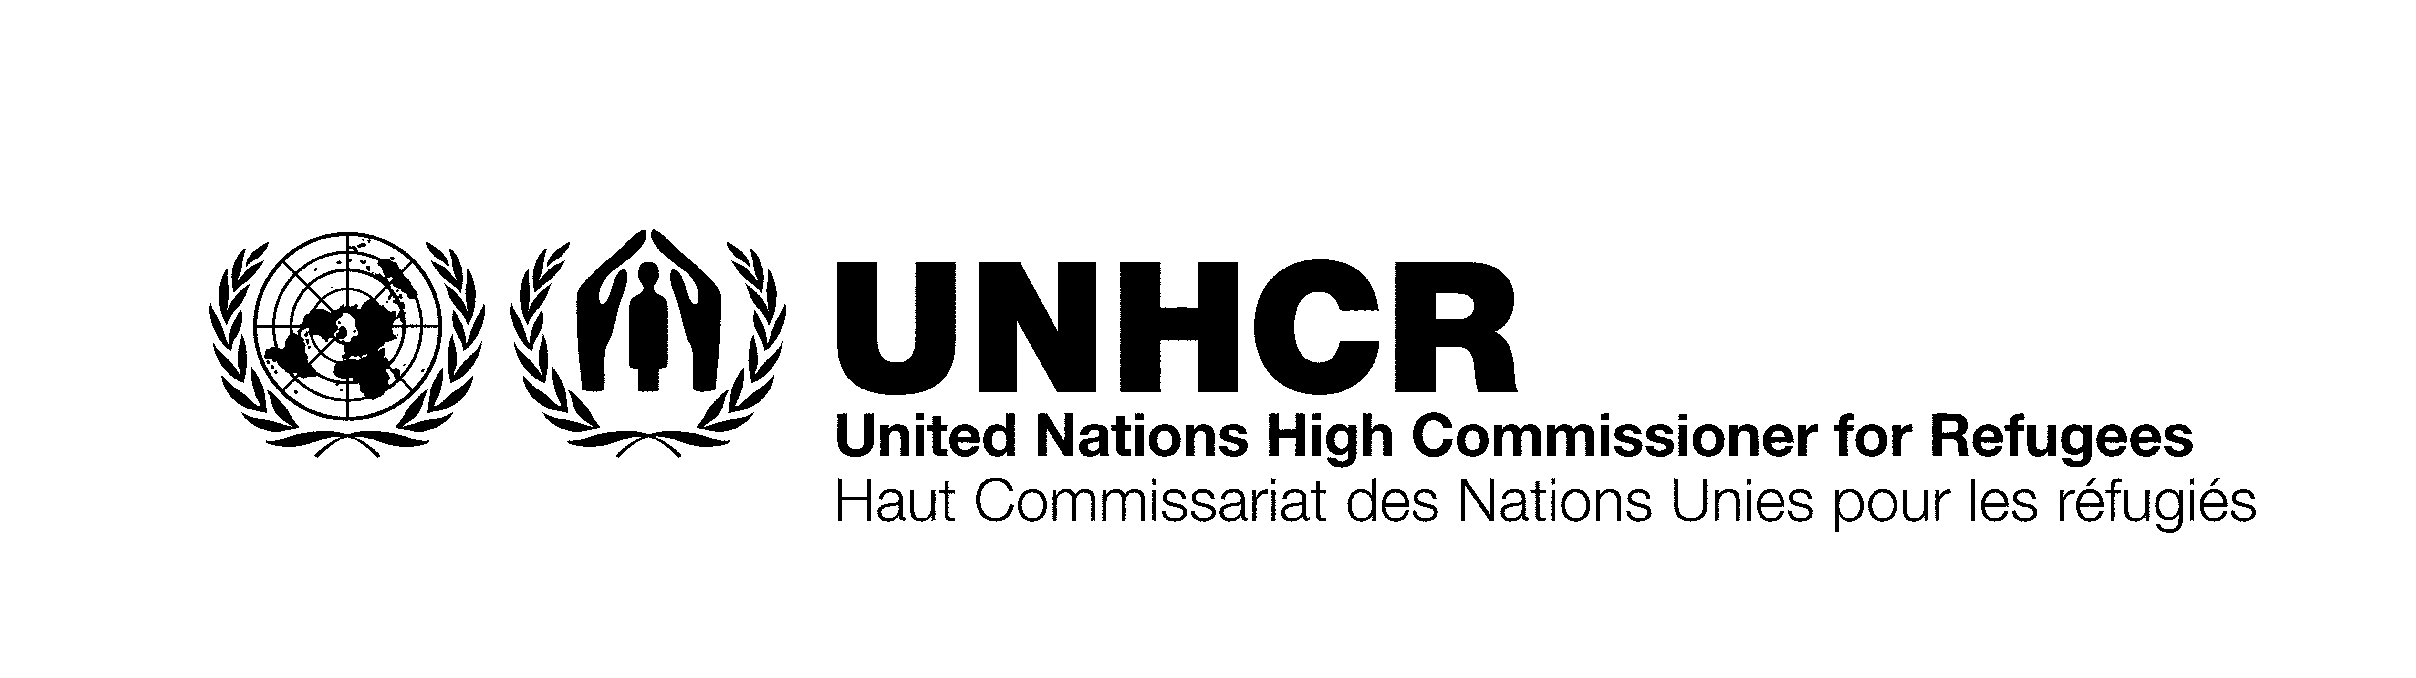

Conference of the States Parties to the
Convention on the Rights of Persons with Disabilities
Udo Janz, Director UNHCR New York Office
3 September 2010, Conference Room 2 UN Secretariat

There are some 40 million refugees and internally displaced persons (IDPs) as a result of conflict throughout the world today. WHO estimates that 10% of the global population is living with a disability. Among displaced populations, this figure is often higher. Impairment and disability are increased in conflict due to physical violence such as torture and rape and in natural disasters through injuries caused by the disaster.

Persons with disabilities have the same protection risks as other refugees and IDPs. However, due to their disability, there is often a heightened risk and doubled vulnerability. In addition, loss and/or separation from family members directly affects access to services such as sanitary facilities, water, food aid, shelter, public buildings, information, language & communication. Often, refugees with disabilities are ‘invisible’ and it is more difficult to find out about their needs.

Displaced persons with disabilities face many of the same challenges as those in a normal situation, plus additional hardships such as: difficulties in accessing asylum, registration and protection; marginalization, neglect, psychological and physical abuse including sexual and gender based violence; exclusion from the access to mainstream services and lack of specialized assistance; lack of opportunities for education including special education and skills training; obstacles to durable solutions including return, local integration and resettlement; and limited awareness among UNHCR staff and partners how to identify and include persons with disabilities in programmes.

To address the needs of refugees with disabilities, UNHCR pursues a multi-pronged approach on different levels. First, through the development of policy directives and clearly defined accountability mechanisms, guidance is provided to field operations on how to work with persons with disabilities and how to systematically track their progress. Second, UNHCR pursues targeted assistance, namely projects aimed directly at improving situations for persons with disabilities. Third, UNHCR works on capacity building and attitudinal change of staff and partners to increase their awareness and skills. Fourth, individual identification and registration of disabled persons is undertaken to understand and address particular needs. Finally, UNHCR is promoting access for refugees to national systems for persons with disabilities, from which they are often excluded.

First, the policy directives. The age, gender and diversity mainstreaming is a process that increases the organization's capacity to provide protection to all persons of concern to UNHCR, taking into consideration the needs of different groups. The protection of persons with disability falls under the diversity aspect. To better understand the specific situation, needs, and coping mechanism of refugees with disabilities, this group is included in the annual participatory assessments which are the basis for the annual program planning. Through focus group discussions, their needs and ideas are identified and incorporated into the planning. An accountability framework for senior managers ensures the implementation of the protection of persons with specific needs such as disabilities.

In 2010, the protection of persons with disabilities has been chosen as a theme for a Conclusion by UNHCR’s Executive Committee, and a draft has been prepared. If accepted, it will provide the framework for UNHCR's work with persons with disabilities. It will take note of the Convention on the Rights of Persons with Disabilities, and enhance its implementation.

In terms of UNHCR’s internal directives, the Policy on the Employment of Persons with Disabilities includes the accessibility of UNHCR premises for staff with disabilities. Offices and premises are being adjusted, both for staff and refugees.

Second, I will provide 3 examples of targeted assistance programmes: in Syria, Yemen and the Central African Republic (CAR). In Syria, of more than 215,000 Iraqi refugees registered with UNHCR, there are currently about 84,000 refugees considered as having specific needs. More than 30,000 or around 14% have various forms of mental health and psychological problems, including survivors of torture or sex and gender based violence. More than 3000 cases have been identified by registration to have mental disabilities. More than 2,000 are extremely vulnerable due to their severe psychosocial condition and in need of follow up and specialized services.

5182 persons are receiving monthly financial assistance through Automatic Teller Machine (ATM) cards. This figure represents 75% of the identified persons with disabilities. The ATM cards increase independence and self-determination. In addition, they also receive food and non-food items, have access to medical services, psychological support and are given priority to access UNHCR premises.

A system of community-outreach volunteers has been developed to provide support and assistance to persons with disabilities. They conduct an average of 190 home visits per month and are able to reach hundreds of persons with specific needs, providing a wide range of moral, material and social support. The volunteers help to assess health and social services, enroll children with disabilities in education programmes, and help them to integrate into the community. These activities help to prevent further impoverishment and isolation.

In Yemen, some 140,000 refugees, mostly of Somali origin, are spread in camps and urban areas. In 2009 in Yemen, a network of specialized partners and local organizations was established which support persons with disabilities. A UNHCR partner, the Association for Developing Persons with Special Needs, provides medical services and physiotherapy, assistive devices, education, capacity building and training for UNHCR staff.

Displaced persons with disabilities are supported through: counseling by community-based rehabilitation and social workers; partial social assistance to the most vulnerable; and medical attention. Mental health has been mainstreamed in primary health centers. For refugee children with disabilities, special education is available and transport to school is organized. Community based rehabilitation helps integrate children with disabilities in the communities and in local schools.

In the Central African Republic (CAR), there are some 30,000 refugees, primarily from the Democratic Republic of Congo, and an estimated 197,000 internally displaced persons. Participatory assessments with hundreds of disabled persons in displacement demonstrated the additional difficulties in fleeing their homes and finding asylum, and heightened risk due to sensory, physical, mental and/or intellectual diabilities. They identified their main needs to be security; assistance to return to their places of residence; reunions with family and caregivers; and livelihood activities.

Self-help groups and organizations of persons with disabilities were identified and supported in organizational management, identifying priorities, access to livelihood activities, and advocacy and awareness programmes for persons with disabilities. Through strengthening these organizations, UNHCR ensures that persons with disabilities have a voice and receive better assistance.

The third area of UNHCR’s response is capacity building and change of attitude within UNHCR. The development of a global online staff learning program for UNHCR field staff including modules on persons with disabilities is underway, and will be available in 2011. This program is developed is being developed in the Global Learning Centre in Budapest. And in addition to this, country operations conduct in-country sensitization programs for staff and partners.

Fourth, the individual registration and case management system enhances protection and assistance. Persons with disabilities are difficult to identify in displaced populations, and sometimes do not want to be identified as having a disability. UNHCR tries to register all persons of concern individually, including persons with disabilities. After registration, UNHCR assesses if a person is in a situation of increased risk and if follow up is needed. The Heightened Risk Identification Tool is a checklist to identify any particular needs. With a simple ranking, a person can be identified as being at low, medium or high risk. After the assessment, action can be taken on the basis of the assessment. Individual case management systems are used to provide a referral system to specialized partners, for example in the areas of education, psycho-social and healthcare.

Fifth, UNHCR facilitates access to national systems, in light of the fact that non-nationals are often excluded from public and private systems to support persons with disabilities. UNHCR promotes the inclusion of refugees into these systems. As laid down in the CRPD in Articles 11 and 32, all persons with disabilities should received support in emergencies and States having signed the Convention have agreed to international cooperation.

In closing, allow me to pay homage to the remarkable strength demonstrated by disabled persons who manage to flee their places of origin and find safety. While there have been some practical improvements in local, national and international community efforts to assist them, I am sure you will agree that considerable work remains to be done. For the future, let us aim for: universal signing and ratification of the CRPD and its
Optional Protocol; national legislation incorporating the provisions of the CRPD; policies and practices to implement the CPRD provisions; and full involvement of persons of impaired and disabled persons. For more information about the points I have raised today, please refer to UNHCR’s website.

Thank you for your attention.

