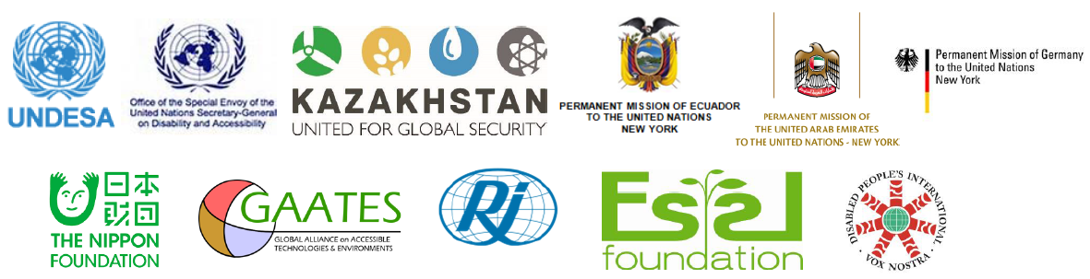

**Forum on Ways forward Towards a Disability Inclusive and Accessible New Urban Agenda**

**14 June 2016, 1:15-3.00pm**

**Conference room 7, UNHQs New York**

|  |
| --- |
| With 60 per cent of the world’s population predicted to be living in cities by 2030, urbanization is one of the most significant global trends of the 21st century. For persons with disabilities across the world, ill planned and developed towns and cities that lacks of accessibility often present a combination of physical, environmental, technical and social barriers to infrastructures, facilities and public services.  As member states are negotiating the zero draft of the New Urban Agenda to be considered for adoption at the Habitat III in October 2016, the international community is now faced with another great opportunity and challenge to ensure the New Urban Agenda to be accessible to and inclusive of all urban habitants, including persons with disabilities.  Making cities and towns accessible and inclusive for all, including persons with disabilities, is essential for sustainable urban development and also a human right imperative. |

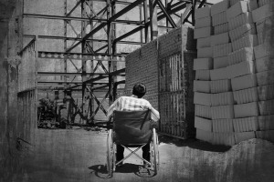

**Special notes:**

This event will be conducted in English and open to all interested stakeholders working in the field of disability and urban development.

Presentations and outcome of the event will be posted in the UN EANBLE website: [www.un.org/disabilities](http://www.un.org/disabilities)

For further information, please contact Mr. Eric Guozhong ZHANG, Secretariat for the Convention on the Rights of Persons with Disabilities (DSPD/UNDESA) via email to [zhangg@un.org](mailto:zhangg@un.org)

**Opening**

Welcome remarks

Moderator: DESA/DSPD/SCRPD

**Roundtable dialogue**

* Mr. Gustavo Giler Alarcón, Technical Secretary for the Inclusive Management on Disabilities of the Vice-presidency , Republic of Ecuador
* Mr. Jamal Jama Al Musharakh , UAE
* Kazakhstan
* Indonesia
* Mr. Luis Gallegos, The Nippon Foundation
* Dr. Victor Pineda , Disability Inclusive and Accessible Urban Development Network
* Mr. Mohkatar Al Shibani, GAATES
* Mr Martin Essl, Essl Foundation
* Mr. Jan Monsbakke, Rehabilitation International
* Ms. Xu Ling, China Disabled Persons’ Federation

**Q&A and interactive discussions**

Discussants and participants