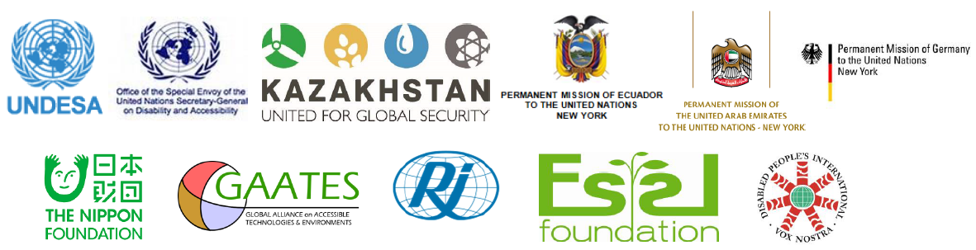
Forum on Ways forward Towards a Disability Inclusive and
Accessible New Urban Agenda
Organized by: UNDESA Division for Social Policy and Development
In partnership with: Ecuador, UAE, Kazakhstan, Germany, Indonesia (tbc), UN Secretary-General’s Special Envoy on Disability and Accessibility, Global Alliance on Assistive Technologies and System, Disabled People’s International, Rehabilitation International, Nippon Foundation, Essl Foundation
14 June 2016, 1:15-3.00pm
Conference room 7, UNHQs New York
Background
Urbanization is one of the most significant global trends of the 21st century. With 60 per cent of the world’s population predicted to be living in cities by 2030, it is a growing force that is influencing and transforming development in many parts of the world – in both developed and developing countries. For estimated over one billion persons with disabilities across the world, ill planned and developed towns and cities that lacks of accessibility often present a combination of physical, environmental, technical and social barriers to physical and virtual infrastructures, facilities and public services. Poor planning and unregulated urban development can have particularly devastating consequences for persons with disabilities. The United Nations Transforming our world: the 2030 Agenda for Sustainable Development adopted in September 2015 recognizes among other issues, the importance of accessibility and inclusion for persons with disabilities in urban development contexts.
As member states are negotiating the zero draft of the New Urban Agenda to be considered for adoption at the Habitat III in Oct 2016, the international community is now faced with another great opportunity and challenge to ensure the New Urban Agenda to be accessible to and inclusive of all urban users, including persons with disabilities. Making cities and towns accessible and inclusive for all people, including persons with disabilities is essential for sustainable urban development and also a human right imperative.
UNDESA Forum: Ways forward Towards a Disability Inclusive and Accessible New Urban Agenda
The Department of Economic and Social Affairs through its Division for Social Policy and Development (DESA/DSPD) in partnership with Governments of Ecuador, UAE, Kazakhstan, Germany, Indonesia (tbc), UN Secretary-General’s Special Envoy on Disability and Accessibility, Nippon Foundation, Essl Foundation, Global Alliance on Assistive Technologies and Environments, Disabled People’s International and Rehabilitation International, will organize a round-table dialogues styled Forum : Towards Disability Inclusive and Accessible New Urban Agenda in the United Nations Headquarters New York, Conference room 7, on 14 June 2016 in the lead up to the UN HABITAT III.

Objectives and outcome The Forum aims to promote the world´s urban development to be inclusive of and accessible to all including persons with disabilities. Through a moderated dialogue among policy makers and experts on pertinent issues concerning disability inclusion and accessible urban development, the Forum expects to make a concrete contribution to inform the ongoing Habitat III processes, especially the negotiations for the outcome New Urban Agenda. Presentations and key findings and recommendations from the Forum will be posted on the United Nations Enable website www.un.org/disabilities.

Tentative programme will include: Opening remarks by the host to set the base. Roundtable dialogue among presenters will review policy frameworks and practices with a focus on experience and lessons learned, and good examples, in successfully planning and building accessible urban development that are inclusive of persons with disabilities and benefits all urban residents. Also, the role of national and local governments as well as broad civil society especially organizations of persons with disabilities (DPO´s) in this endeavor shall be identified to inform the New Urban Agenda and its implementation.

Suggested guiding questions
- Please use a concrete example in any country to showcase how and why some urban development programmes or projects have proved to be successful in promoting accessibility and inclusion of all urban dwellers especially persons with disabilities?
What specific roles were played by Government/s, urban development practitioners, and civil society including DPOs in that particular exemplar case?
- Supposing you are now invited to attend the UN Habitat III zero draft negotiations as your governmental delegate or NGO representative, what 3 key messages that you want to inform and include in the New Urban Agenda, in order to promote accessible and disability inclusive urban development?
Contact
For more information or enquiry, contact Mr. Eric Guozhong ZHANG, Secretariat for the Convention on the Rights of persons with disabilities (DSPD, UNDESA) via email to zhangg@un.org

Accessibility is broadly understood in this note as products, services, built environments and information communication technologies that respond to the interests, needs and capabilities of a wide range of end users, persons with disabilities and many other urban dwellers with access needs in particular. To a great extent, accessibility or universal design can be seen as a public good that benefits all in general population and should therefore be considered a central component of good urban policy to achieve inclusive urban agenda. A city that is well developed is well designed to be accessible to and for all.

