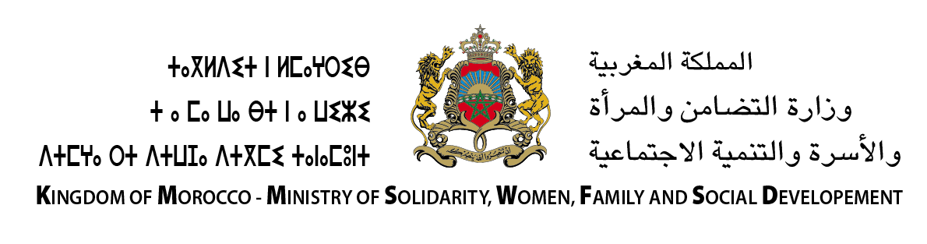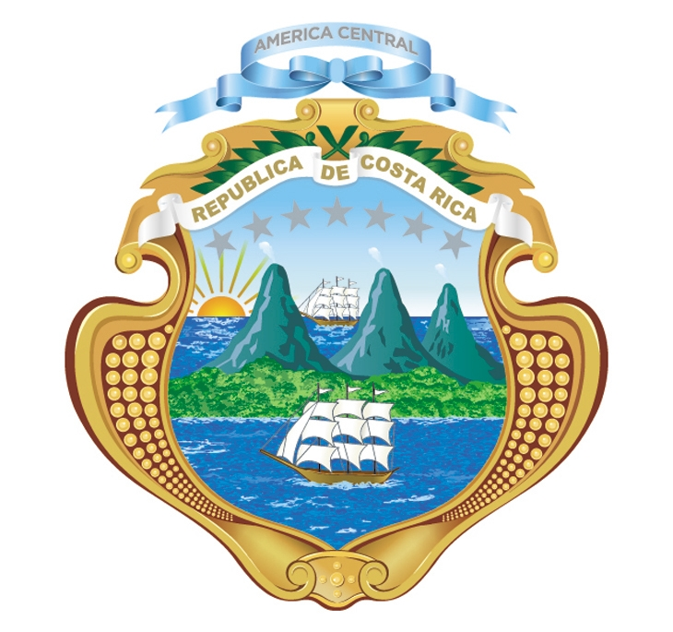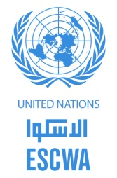

The Permanent Mission of Jordan

to the United Nation¥s

***9th session of the Conference of States Parties to the Convention on the Rights of Persons with Disabilities***

**Side event**

**Developing strong and inclusive institutional frameworks for the CRPD: Operationalizing and implementing Article 33**

**Wednesday, 15 June from 1.15 – 2.30 pm**

**Conference Room 12**

The Convention on the Rights of Persons with Disabilities is one of the first human rights treaties to include requirements on national implementation and monitoring of commitments. Institutional set-ups – focal points, coordination mechanisms and independent monitoring frameworks – are crucial and represent a determining factor so that CRPD provisions translate from paper into real progress on the ground. National institutions can also act as a central channel for the participation of persons with disabilities, and thus contribute to ensuring that laws, policies and programmes abide by the principle of ‘nothing about us without us’.

As States parties enter into the second decade of the Convention and begin implementation of the 2030 Agenda, there is a need for enhanced experience and information sharing on the realization of Article 33 at country level. By exchanging good practices and lessons learned, stakeholders can capitalize on breakthroughs made elsewhere, and avoid potential pitfalls along the way. This side event aims to contribute to this global discussion, and to provide a platform for discussing concrete policy options on strong and effective institutions for the implementation and monitoring of the Convention.

Opening remarks

* Akiko Ito, Chief, Secretariat for the Convention on the Rights of Persons with Disabilities, UN DESA

Panelists:

* Silvia Quan, Vice Chair, Committee on the Rights of Persons with Disabilities
* Brahim Zerouki, Directorate for the Promotion of the Rights of Persons with Disabilities, Ministry of Solidarity, Women, Family and Social Development, Kingdom of Morocco
* Amal Nahhas, Secretary-General, Higher Council on the Affairs of Persons with Disabilities, Hashemite Kingdom of Jordan
* Lauro Purcil, Senior Founding Member, ASEAN Disability Forum, and Representative of the International Disability Alliance

Moderated by Gisela Nauk, Chief, Inclusive Social Development Section, UN ESCWA

*CART (live captioning) will be provided. For more information, please contact Miranda Fajerman (*[*fajerman@un.org*](mailto:fajerman@un.org)*) or Alexandra Heinsjo Jackson (*[*heinsjo-jackson@un.org*](mailto:heinsjo-jackson@un.org)*).*