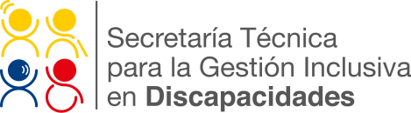

Quito, May 3, 2016

Productive Inclusion and Universal Accessibility: alternatives for development in the aftermath of the earthquake in Ecuador.

IDENTIFICATION

At this time, in the Ecuadorian province of Manabí, 1,412 persons with disabilities have been identified in the areas affected by the 7.8 magnitude earthquake that struck this South American nation on April 16, 2016. The ongoing process of identification and geo-location of persons with disabilities in the areas affected by the earthquake is being led by the Technical Secretariat for the Inclusive Management on Disabilities (SETEDIS) of the Vice Presidency of the Republic of Ecuador.

157 volunteers including psychologists, physicians, medical emergency technicians, nurses, and Inclusive Disaster Risk Management specialists, are working in the most affected zones in the cities of Portoviejo, Manta, Chone, Calceta, Crucita, Jama and San Vicente. These volunteers have visited hospitals, homes, and shelters to gather the following information about persons with disabilities: current location, mobility situation, requirement of technical aids, and the condition of homes, among other items. The aim of this activity is to coordinate actions with emergency agencies and to support the Armed Forces and the Ministry of Health, respectively, in the delivery of humanitarian aid and of technical aids to persons with disabilities.

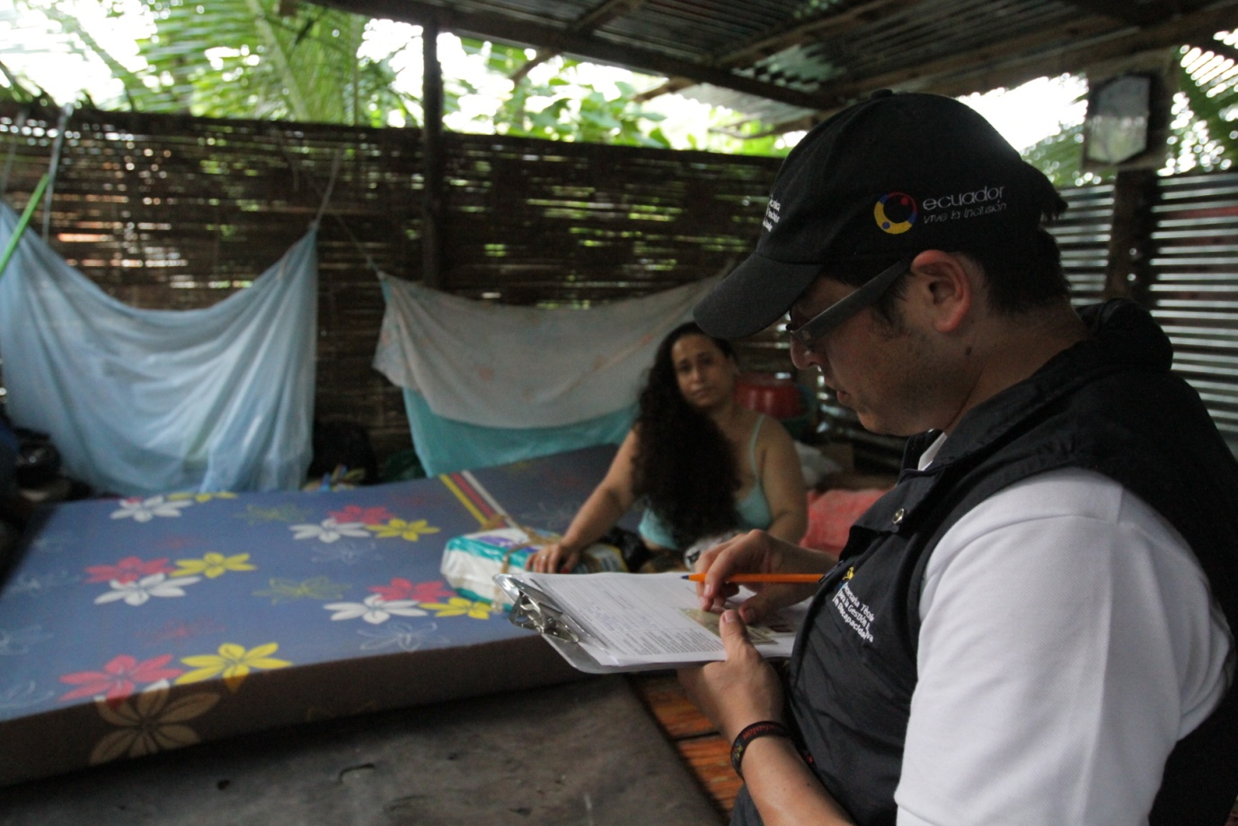

PROVINCE OF MANABÍ
PERSONS WITH DISABILITIES RECEIVING CARE:
-Hearing Disability: 72
-Physical Disability: 788
-Intellectual Disability: 231
-Visual Disability: 129
-Other: 192

PERSONS WITH DISABILITIES LOCATED AT SHELTERS:
-Portoviejo Former Airport: 42
-ECU 911 Emergency Operations Command Center in Portoviejo: 33
- Mi Esperanza Shelter: 16

Meanwhile, in the province of Esmeraldas, seven brigades have identified 108 persons with disabilities: 5 with hearing disabilities, 44 with physical disabilities, 41 with intellectual disabilities, 8 with visual disabilities and 10 with other disabilities. Also, 22 persons with disabilities have been located in shelters.

PROVINCE OF ESMERALDAS
PERSONS WITH DISABILITIES LOCATED AT SHELTERS:

-Ministry of Environment Shelter: 9
-Pueblo Nuevo Shelter: 7
-Dalia Perdomo Shelter: 6

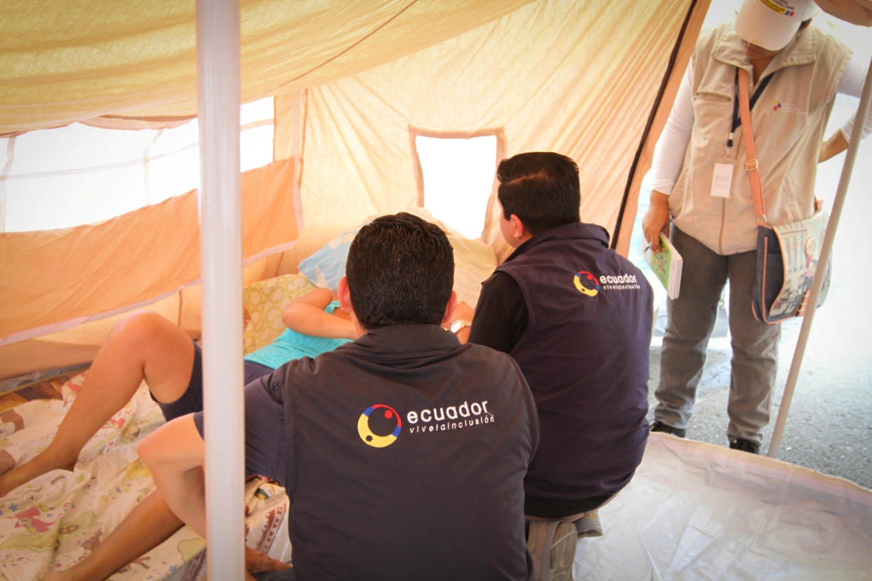

ALTERNATIVES FOR DEVELOPMENT

As part of SETEDIS’ program of Productive Inclusion –advisory and support for small businesses of persons with disabilities and their families– several teams were deployed to assess the condition of the businesses of persons with disabilities in the areas affected by the earthquake. This assessment included criteria such as structural damage analysis, loss of raw materials, loss of fixed assets, loss of products, and income reduction. After the assessment phase, SETEDIS has proposed the following actions:

- Inter-institutional coordination within the Committee for Reconstruction, Reactivation, and Employment.
- Direct coordination with the National Development Bank for suspending payment collection and coactive debt collection, as well as loan refinance.
- Public-private partnerships for the identification of economic reactivation funds and the recovery of fixed assets and markets, which will favor the livelihood, development and economic independence of the persons with disabilities and their families.

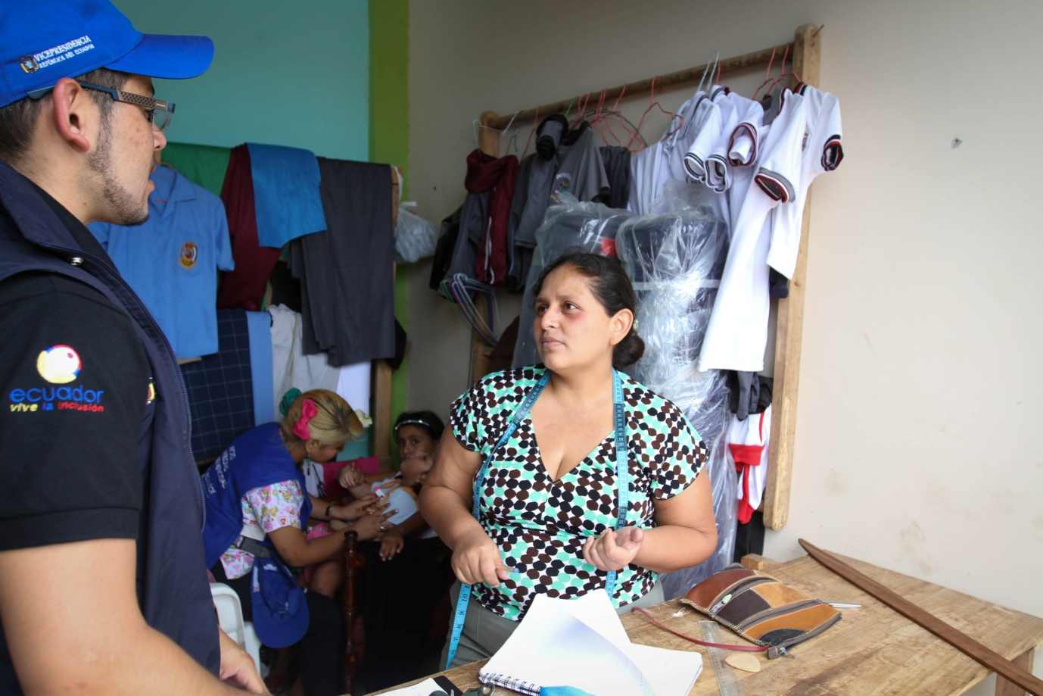

In the areas of Universal Accesibility and Inclusive Disaster Risk Management, SETEDIS has given technical advisory for the design of temporary shelters, so as to provide inclusive spaces for persons with disabilities, pregnant women, and older persons. The measures recommended by SETEDIS include: accessible restrooms and the construction of connection circuits between the access points and service areas on firm and stable ground.

Additionally, several projects are being planned for the recovery and reconstruction phases. These are related to the adoption and application of Universal Accessibility norms for physical environments, transport, and communication and information services in the urban planning for the affected cities.

In the area of Participative Inclusion, SETEDIS will strengthen the participation of persons with disabilities in their communities, through the already established Enforceability Committees. This will allow persons with disabilities to become active participants in the recovery and reconstruction of their communities, in terms of inclusion and accessibility.

