PFII/2018/EGM
Original: English

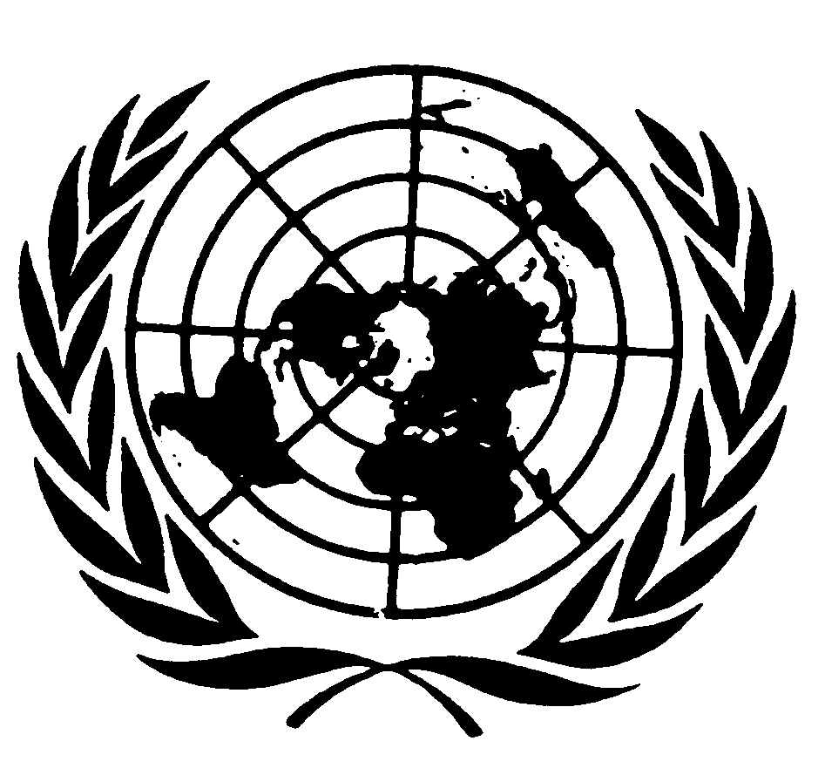

UNITED NATIONS NATIONS UNIES

DEPARTMENT OF ECONOMIC AND SOCIAL AFFAIRS
Division for Social Policy and Development
Secretariat of the Permanent Forum on Indigenous Issues

International Expert Group Meeting

Programme of Work

Sustainable Development in the Territories of Indigenous Peoples

23-25 January 2018, New York

UNHQ, Room 5

Prepared by the Secretariat of the United Nations Permanent Forum on Indigenous Issues
Division for Social Policy and Development
Department of Economic and Social Affairs
United Nations

Tuesday 23 January 2018
10.00 am – 1.00 pm
Opening Remarks
- Ms. Daniela Bas, Director, Division for Social Policy and Development, Department of Economic and Social Affairs
- Ms. Mariam Wallet Aboubakrine, Chairperson of the Permanent Forum on Indigenous Issues

1. Introduction: Sustainable Development in the territories of indigenous peoples
Moderator: Ms. Chandra Roy-Henriksen, Chief, SPFII/DSPD/UN-DESA
Presentations by:
Ms. Joan Carling
Mr. Eirik Larsen
Discussants:
Mr. Jens Dahl
Ms. Carla Fredricks

General Discussion

3.00pm – 6.00pm
2. Regional cases of autonomy in the territories of indigenous peoples
Moderator: Ms. Victoria Tauli-Corpuz, Special Rapporteur on the Rights of Indigenous Peoples
10.00 am – 1.00 pm
Presentations by:
Mr. Shapiom Noningo
Ms. Mai Thin Yumon

Discussants:
Ms. Carolina Gil Sanchez
Ms. Betty Lyons
General Discussion

Wednesday 24 January 2018
10.00 am – 1.00 pm
2. The Challenge from land grabbing and natural resource extraction and large-scale development projects
Moderator:
Ms. Terri Henry, Vice-Chair Permanent Forum on Indigenous Issues
Presentations by:
Mr. Elifuraha Laltaika & Ms. Kelly Askew
Mr. Jérémie Gilbert

Discussant:
Ms. Victoria Tauli-Corpuz
Mr. Alejandro Parellada
General Discussion

3.00pm – 6.00pm
4. Indigenous visions for sustainable development
Moderator: Mr. Albert Barume, Chair Expert Mechanism on the Rights of Indigenous Peoples
Presentations by:
Mr. Ricardo Niño Izquierdo
Ms. Janie Simms Hipp
Discussant:
Mr. Paul Joffe
Mr. Diego Tituana

Thursday 25 January 2018
10.00 am – 1.00 pm
5. The United Nations System and Article 4 of the United Nations Declaration on the Rights of Indigenous Peoples
Moderator: Mr. Kenneth Deer
Presentations by:
Ms. Victoria Tauli-Corpuz, Special Rapporteur on the Rights of Indigenous Peoples
Discussant:
Representatives from UN System TBC
3.00pm – 6.00pm
6. Analysis and policy recommendations
Moderator: Mr. Jens Dahl, Vice-Chair Permanent Forum on Indigenous Issues
General Discussion

Closing Remarks
Ms. Mariam Wallet Aboubakrine, Chair Permanent Forum on Indigenous Issues
_____________

