An important feature of Indico is that it allows each ECOSOC-accredited NGO and Accredited NGOs to the Conference of States Parties (COSP) to designate up to two (2) Conference Focal Points, who will review the individual registrations of members of their organization for all events that use the platform. While each representative will register through their own individual Indico account, the Conference Focal Points can review and approve/reject their own organization’s participants. This allows for improved coordination and validation of registrations.
In order for your organization’s registrations to be processed in Indico, you MUST designate at least one Conference Focal Point (and preferably another one for backup). This is done through your organization’s profile in the Integrated Civil Society Organisations System (iCSO).
Once the Conference Focal Points are designated in iCSO, they will be made available in Indico in about a week. Please designate your Conference Focal Points as soon as possible to avoid delays which may prevent your organization from participating in events.
This guide contains the following sections:
- Detailed instructions for designating Conference Focal Points in iCSO
- Detailed instructions for activating your Indico account
- Detailed instructions for approving participants in Indico
- Additional help
* Please note that these instructions only apply to NGOs in consultative status with ECOSOC and Accredited NGOs to the Conference of States Parties (COSP). If not, you do NOT need to designate Conference Focal Points.
How to designate your organization’s Conference Focal Points
*** Detailed screenshot instructions on the next page ***

- As head of your organization, use the main organization account to
log in to http://esango.un.org/civilsociety/login.do
- Navigate to Profile > Contacts & Participation from the menu bar
- Add a new contact with the Conference Focal Point type, or add this contact type to an existing contact
Requirements for Conference Focal Points
- A unique, personal email address must be specified. Do not use a generic email.
- No more than two (2) Conference Focal Points will be permitted for each organization. Similarly, if the same person appears multiple times in the contact list, they should only be designated once, with their most current contact information.
- Conference Focal Points must be unique for each organization; different organizations cannot share the same Conference Focal Points.

- Once logged into iCSO (http://esango.un.org/civilsociety/login.do), Navigate to Profile > Contacts & Participation from the menu bar. | 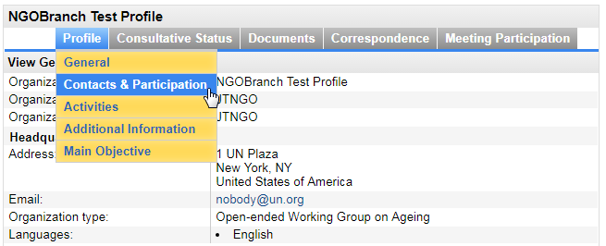
- Click on New contact to add a new contact, or assign this contact type to an existing contact. | 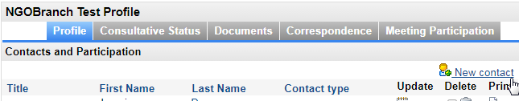

- Designate the contact with the Conference Focal Point type. | 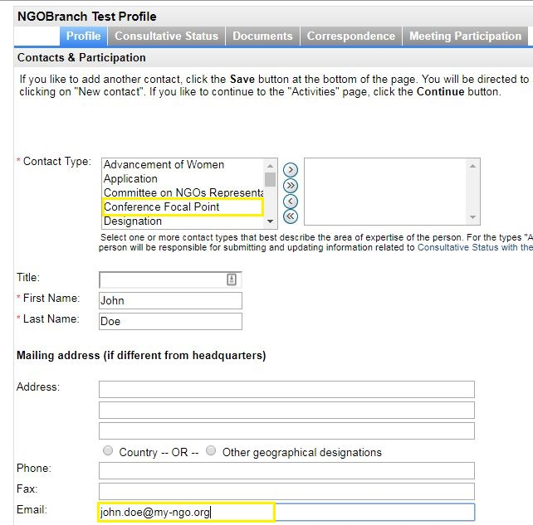
- Ensure that the person’s unique, personal email address is specified. This email address will become the person’s Indico user name, or must match their Indico user name if they already have an account.

Do not use the same email address for multiple contacts.

* Please note that once the Conference Focal Points are designated in iCSO, they will be made available in Indico in about a week.
If you are a designated Conference Focal Point and have never used Indico before, you will need to activate your account according to the instructions below. Your account has already been created using the email address that you provided in iCSO for the Conference Focal Point, but you will need to set a password.
Note: Conference Focal Points who already have an account in Indico and are properly designated in iCSO (i.e. with their Indico login as email address) will automatically be granted review and approval privileges, and do not need to complete this step.

- Go to Indico at https://reg.unog.ch and click on Login. | 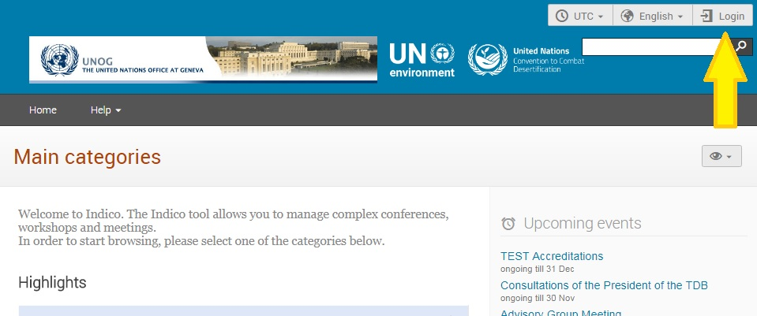
- Click on the Reset password bar. | 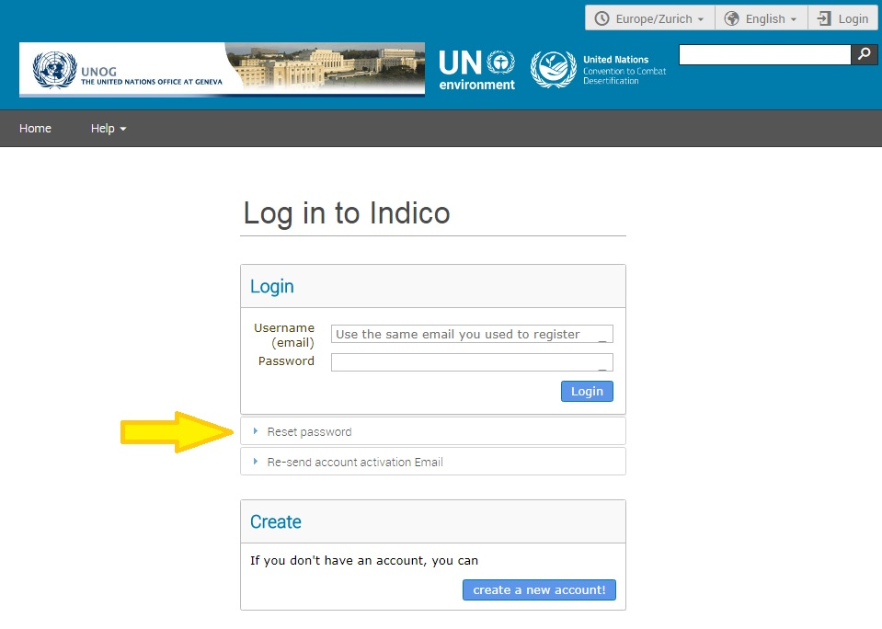
- Enter your email address (the same one used for your Conference Focal Point designation in iCSO). This is your Indico user name.  Then click on Reset my password. | 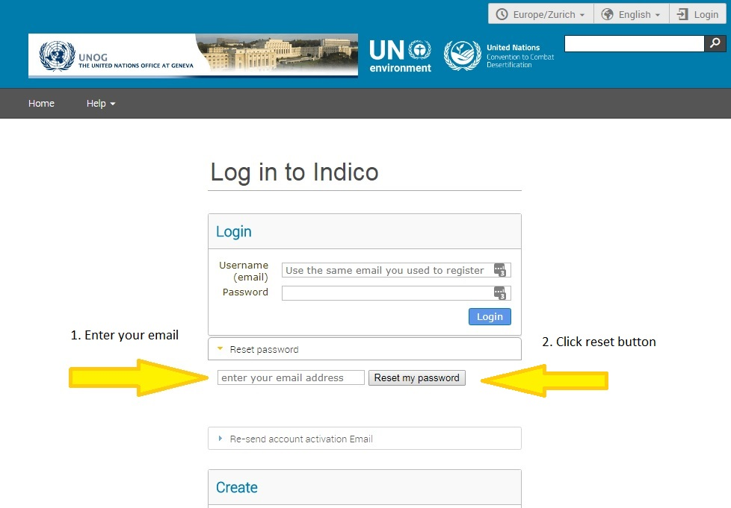
- You will receive an email at the address you entered with instructions for setting a password. Once set, you will use this email address and password to log in to Indico.

Verifying and approving your organization’s registrations
As a Conference Focal Point of your organization, you are responsible for verifying and approving the representatives of your organization after they register in Indico through their own individual accounts.
(If you plan to attend an event yourself as a representative of your organization, you must also register and approve yourself!)

- Log in to Indico from any page (e.g. the home page or your event page).  https://reg.unog.ch/ | 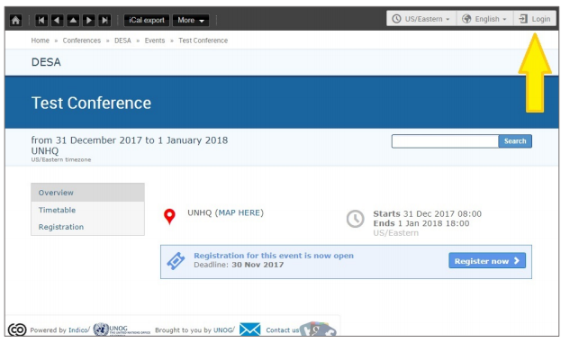
- Click the pencil icon on the top menu bar to switch to the registration management area | 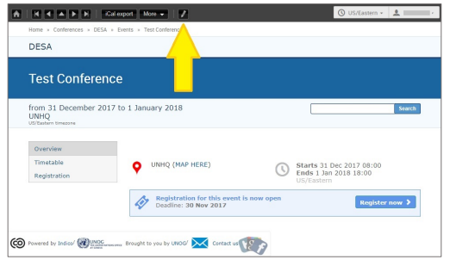
- Click on the checkbox to approve registrants. Each participant will receive an automated email notification containing the official confirmation letter when their registration has been approved or rejected.  If someone who is not a representative of your organization has attempted to register, please check the Rejected checkbox. | 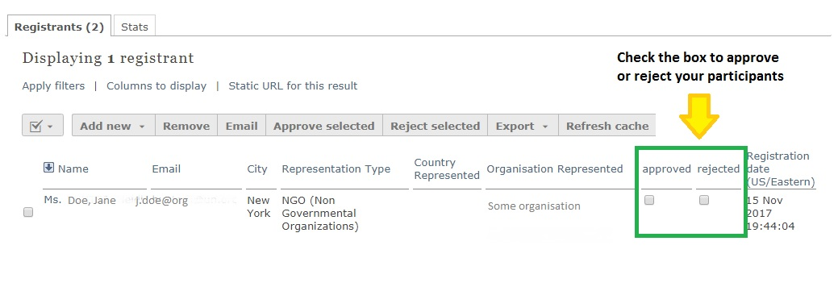
- To switch back to the event page, click on the button Switch to event page. | 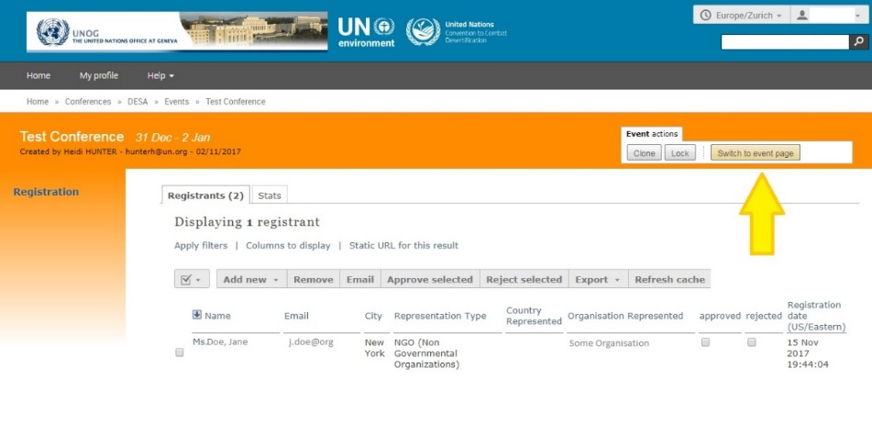
- Please be reminded that each participant will need to register themselves so that Conference Focal Points can see and approve her or his registration:  We encourage Conference Focal Points to check back in Indico regularly to approve new representatives.  Representatives need to be approved before the registration deadline of 28 May 2018 to be able to participate in the COSP11 session. | 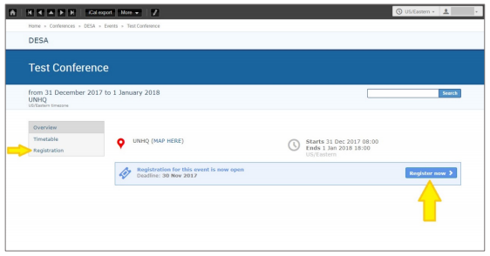

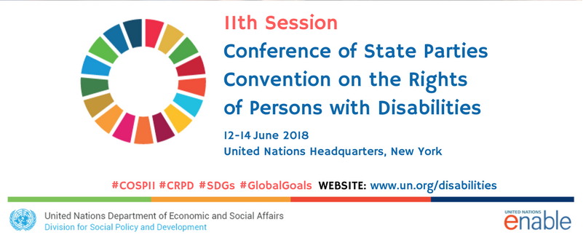

For more information on the 11th session of the Conference of States Parties to the CRPD (COSP11),

Please visit: http://bit.ly/UN-COSP11

If you have questions, please contact ngo@un.org and enable@un.org.

